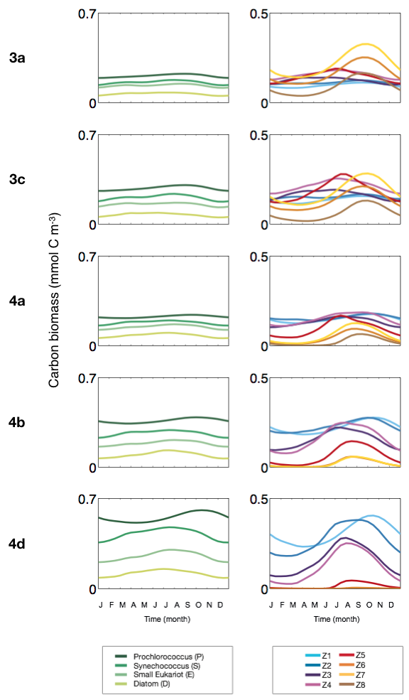
S3 Fig. Seasonal variation of (column 1) the 4 plankton functional types (mmol C m⁻³) and (column 2) detailed size classes of zooplankton (mmol C m⁻³).

