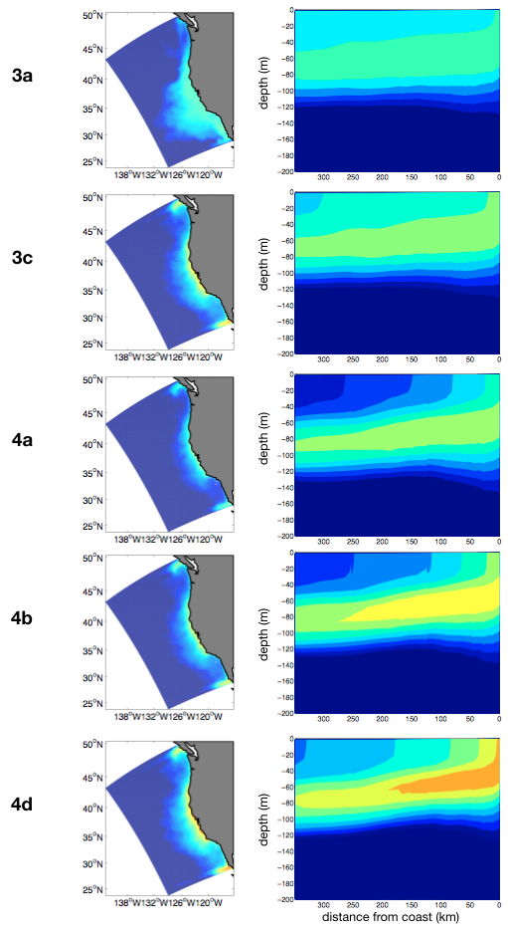
S5 Fig. (column 1) Annual mean surface chlorophyll-a concentration (mg Chl-a m⁻³); (column 2) Vertical sections of annual mean chlorophyll-a concentration across CalCOFI line 70 (mg Chl-a m-3). Results correspond to model outputs for grazing cases 3 and 4 not shown in the core paper.

