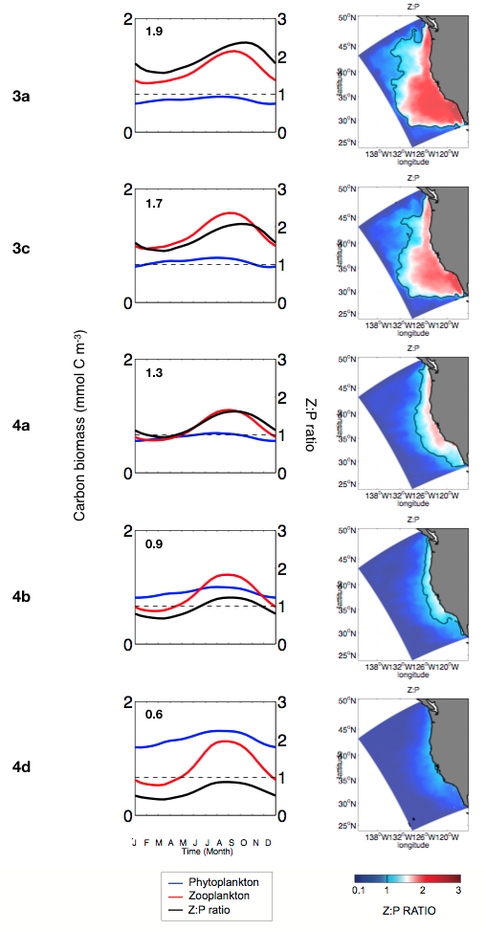
S6 Fig. Z:P ratio. (column 1) Seasonal variation of total phytoplankton biomass (blue), total zooplankton biomass (red) and the associated Z:P ratio (black). The number in the upper-left corner indicates the seasonal mean of the Z:P ratio. (column 2) Spatial distribution of the annual-mean Z:P ratio. The solid black line indicates Z:P =1. Results correspond to model outputs for grazing cases 3 and 4 not shown in the core paper.

