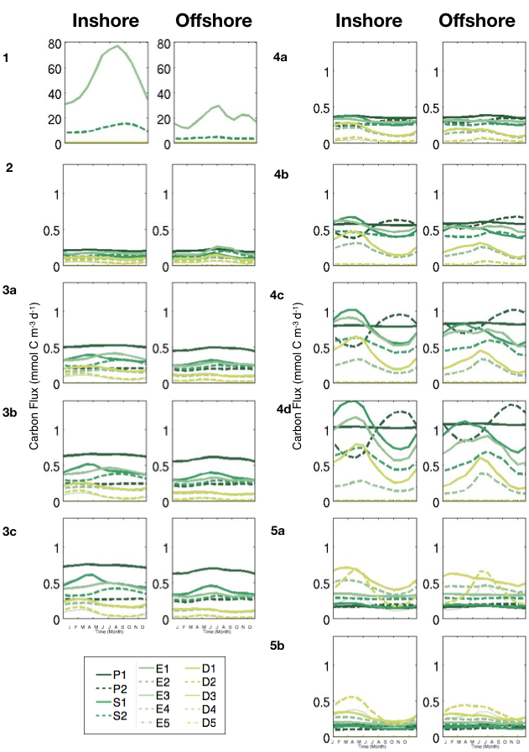
S8 Fig. Comparison of phytoplankton concentrations between coastal (0-100km) and offshore region (300- 400km), in the Southern CCS (+/- 0.5˚ around line 90 of CalCOFI): seasonal variation of detailed pfts accounting for emergent phytoplankton size classes (in mmol C m⁻³).

