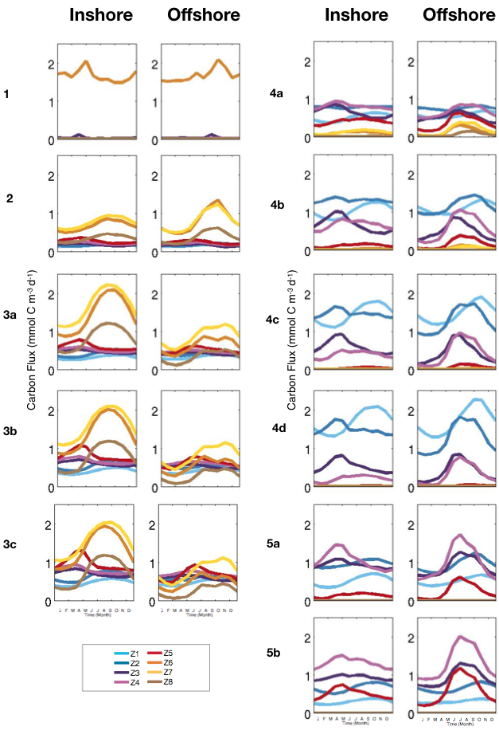
S9 Fig. Comparison of zooplankton concentrations between coastal (0-100km) and offshore region (300-400km), in the Southern CCS (+/- 0.5˚ around line 90 of CalCOFI): seasonal variation of detailed size classes of zooplankton (mmol C m⁻³).

