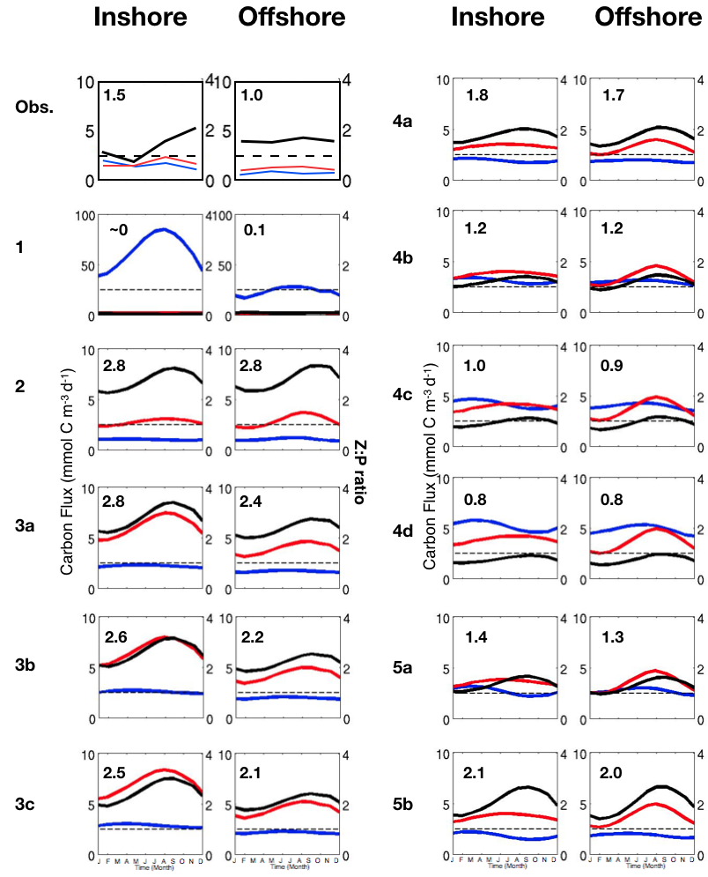
S10 Fig. Comparison of Z:P ratio between coastal (0-100km) and offshore region (300-400km), in the Southern CCS (+/- 0.5˚ around line 90 of CalCOFI): Seasonal variation of total phytoplankton biomass (blue), total zooplankton biomass (red) and the associated Z:P ratio (black) from observations (CalCOFI data) and the different numerical experiments. The number in the upper-left corner indicates the seasonal mean of the Z:P ratio.

