Geophysical Research Letters
Supporting Information for
Data-Driven Clustering Reveals More Than 900 Small Magnitude Slow Earthquakes and Their Characteristics
Aiken, C.¹ and Obara, K.²
¹ IFREMER – REM- Géosciences Marines – LAD, Plouzané, France 29280;
² Earthquake Research Institute, University of Tokyo, Bunkyo, Tokyo 113-0032, Japan.

Contents of this file

Text S1 to S3
Figures S1 to S9
Introduction
This supporting information includes details on the catalog data (Text S1), clustering methods (Text S2), and how properties of the slow earthquakes were determined (Text S3). Nine supporting figures are included in this document that support either the information presented in this document or the main text.

Text S1. Catalog Data
The Nankai subduction zone tremor catalog (Idehara et al., 2014) used in this study is based on auto-detection and source location methods (Ide, 2010a). The un-clustered tremor catalog contains 82,275 events between April 2004 and March 2013. Their locations exhibit large vertical scattering, typical for tremors because of their emergent arrivals and use of the envelope cross-correlation method for locating them (Ide, 2010b). The tremor locations were constrained by applying a similar method to earthquakes, which are more easily locatable than tremor (Ide, 2010b). Their source time function is estimated from stacked envelopes aligned on the wave arrival from the source location, and the event duration is the period for which the amplitude exceeds half of the maximum (Ide, 2010b). The moment magnitudes (M_{w}) listed in the tremor catalog were derived from the source time function and event duration. That is, the amplitude of the source time function is proportional to moment rate, which can be approximated as moment divided by event duration.
A “clustered” version of the tremor catalog contains 55,127 tremor events, about 30,000 events fewer than the full catalog (Idehara et al., 2014). However, this “clustered” tremor catalog is simply a list of tremor events that fit into clustering criteria of < 10 km, < 1 hour, and it is not a catalog of clustered events, i.e. slow earthquakes, as we present here. Unfortunately, both the “clustered” and un-clustered tremor catalogs contain earthquakes, despite being classified as tremor catalogs. Most events follow the known seismic moment-duration scaling for tremor, i.e. M₀ ~ τ (Ide et al., 2007). However, some shorter duration events in the tremor catalogs have excessively large M₀ - a red flag that earthquakes are in the tremor catalog (Figure S1). A direct comparison between the Japan Meteorological Agency (JMA) unified hypocenter earthquake catalog and some of the events in the tremor catalogs confirmed this hypothesis. For simplicity, we assumed that any events outside a top error bound of the M₀ ~ τ relationship for tremor are actually earthquakes, i.e. 732 events. Thus, for our analysis we use the full un-clustered tremor catalog less those 732 events, resulting in 81,543 tremor events for clustering.
The LFE catalog used in this study is a subset of the JMA unified hypocenter catalog. LFE is the elementary process of tectonic tremor, such that a tremor signal is composed of a number of isolated LFEs (Shelly et al., 2007; Shelly et al., 2011). While LFEs and tremor are equivalent representations of slow earthquake phenomena, they are, however, detected by different methods. LFE is usually included in a tremor signal; however, sometimes LFEs are recorded as occurring independently of tremor or vice versa. Therefore, in this study, we use the LFE catalog as a supplement for tremor. For consistency, we selected LFEs that lie within the same spatial and temporal boundaries as the tremor catalog, which resulted in ~20,000 LFEs.

Text S2. Slow Earthquake Cluster Identification
With clustering algorithms, the number of clusters and completeness of cluster detection is dependent upon the criteria chosen. However, in our study, our clustering criteria are not subjectively set; They are data-driven, such that the clustering criteria are inherent to the catalogs themselves and to the method used to build the slow earthquake catalog. Our nearest neighbors clustering algorithm is a 2-step process modified from a previous study (Zaliapin and Ben-Zion, 2013). In the first step, we identified the nearest neighbors by treating each event in the catalog as the child of some parent event that occurs before, i.e. its nearest neighbor. Essentially, the nearest neighbor is the event that occurs before the child that also has the lowest η = dt x dr value, where dt is time difference and dr is Cartesian distance. We do not consider magnitude as part of this equation because we want to identify all types of sequences and not just mainshock-aftershock sequences. The nature of η is intended to minimize the time and distance separation between events and separates related and unrelated events in a 2D distribution of nearest neighbors in space and time. In previous studies, the η value is the only threshold for clustering events (Zaliapin and Ben-Zion, 2013). However, due to the extensive area and time period the tremor and LFE catalogs cover, the η value cannot be used by itself to cluster events. We found when using the η value as the sole clustering criteria that events far apart but close in time as well as events close in space but far in time were clustered together (Figure S2). Therefore, we imposed 3 thresholds - the maximum time between related events (dt_{max}), the maximum Cartesian distance between related events (dr_{max}) and η as described previously. In this way, related events had small inter-event times and small separation distances. Unrelated events had either 1) small inter-event times and large separation distances, 2) small separation distances and large inter-event times, or 3) large inter-event times and large separation distances.
Based on 2D nearest neighbor distributions of both the tremor and LFE catalogs (Figure S2), we found that the threshold values for clustering were η_{max} = 1, dt_{max} = 4.8 hours (0.2 days), dr_{max} = 15 km. Our criteria are slightly bigger than previous studies that imposed a separation distance of < 10 km and inter-event time of < 1 hour as clustering criteria (Idehara et al., 2014). Because our clustering criteria are similar for tremors and LFEs, we combined the tremor and LFE catalog into a single catalog. This is also beneficial to the study because an inherent feature of catalogs is that they are often incomplete. Then, using our data-driven criteria, we treated each event in the combined catalog as a parent and found its children using the inter-event time, Cartesian distance, and η value thresholds as previously defined. For children that were also parents, these clusters were grouped together so that parents, children, and grandchildren formed a single cluster. We considered tremor only, LFE only, and mixed event type clusters as a potential proxy for a slow earthquake. Initial clustering resulted in 7,253 clusters - 3,618 tremor only clusters, 938 LFE only clusters, and 2,697 clusters containing both tremors and LFEs. An example of a detected mixed event type slow earthquake can be seen in Fig. 1C. Of the 6,315 clusters that contain tremor events, 5165 (~80%) were also detected by a previous study (Idehara et al., 2014). However, the majority of their tremor clusters contained < 80% of the events in our clusters with only approximately 20% of our clusters being fully detected by their criteria (Figure S3).
By default, the nearest neighbors clustering method behaves such that a cluster can contain as few as 2 events (Figure S4). Because 2 events in a cluster do not provide enough information for investigating the nature of slow earthquakes, we consider only clusters containing ≥ 20 events to be slow earthquakes for the purposes of this study. This minimum event threshold results in 940 clusters, of which 122 contain only tremors, 4 contain only LFEs, and the rest contain some combination of both event types. A visual inspection of the clusters revealed that the 4 LFE only clusters occur in Chugoku and Konshin’etsu regions, and thus, these clusters likely did not occur on the Nankai subduction zone plate interface, which is the focus of this study. Therefore, we excluded the 4 LFE only clusters from the analysis, leaving 936 tremor and mixed-type clusters, i.e. slow earthquake clusters.

Text S3. Slow Earthquake Cluster Properties
In this section, the methods for determining macro- and micro-characteristics of the 936 slow earthquake clusters (SECs) are outlined. Some of these characteristics are provided in the SEC catalog (Aiken and Obara, 2021). Other characteristics are used to analyze the behaviors of slow earthquakes and are discussed in more detail in the main text. In general, we assume that the properties of tremor and LFEs within a defined slow earthquake cluster are summative and characteristic of the slow earthquake as a whole entity. Double detections (between the tremor and LFE catalogs) were removed prior to estimating the source properties and characteristics.

Magnitude
In general, it is best practice to estimate the magnitude of slow earthquake clusters using geodetic data (e.g. Sekine et al., 2010). However, because we are limited in our study to tremor and LFE catalogs, we estimated the magnitude of a slow earthquake cluster (SEC) from the sum of the individual event seismic moments within the SEC such that:

$$M_{0}= \sum_{i}^{N}{{10}^{1.5M_{i}+9.1} (1)}$$
$$M_{w} = \frac{2}{3}\log_{10}{M_{0}}- 9.1 (2)$$

where M_{i} is the magnitude reported in the tremor or LFE catalog, M₀ is the cumulative seismic moment of each event i in the cluster, and M_{w} is the total moment magnitude of a SEC. It should be noted that the tremor catalog reports M_{w}, while the LFE catalog reports M_{JMA}. M_{JMA} of LFEs are strongly underestimated because the magnitude is estimated from the peak velocities of the raw seismograms. Because LFEs are deficient in high frequencies, this results in lower peak velocities and therefore lowers M_{JMA}. However, we treat all magnitudes as if they are M_{w} when converting to seismic moment. Thus, our SEC magnitudes likely underestimate the total energy being released because we estimate from only seismological data and also because M_{JMA} magnitudes are likely undervalued. As an example, a slow slip event occurring on 16-20 April 2006 along the Nankai subduction has an estimated M_{w}6.0 from geodetic data (Sekine et al., 2010). However, we detected this event as 4 individual SECs with M1.2, M1.8, M1.3, and M1.1. These four SECs sum to a M_{w}1.9 event, about 7 orders of magnitude lower in cumulative seismic moment than this slow slip event’s geodetic moment.

Duration
The duration of a slow earthquake cluster (SEC) is simply estimated as t_{last} – t_{first}, where t_{last} is the origin time of the last event in the SEC and t_{first} is the origin time of the first event. In the case that the last event in the SEC is a tremor event, then t_{last} is adjusted by adding its duration to its origin time, as the duration of events in the tremor catalog can range anywhere from 30 seconds to 300 seconds. We do not add the duration of LFEs to t_{last} because that information was unavailable. However, we expect little change in t_{last} when the last event is an LFE as their durations are much shorter than tremor.

Rupture Dimensions
The rupture dimensions of each slow earthquake cluster (SEC) were determined from the spatial distribution of the individual events within its cluster (Figure 1c, main text). Such a method has been used to outline the rupture area of mainshocks by using locations of early aftershocks (Lay and Wallace, 1995). We note that the depths of the tremors and LFEs do vary as a result of location errors and do not delineate slow earthquake movement along the plate interface distinctly. Therefore, we determined SEC rupture dimensions using horizontal locations of events in the SECs, i.e. longitudes and latitudes.
We estimated the aspect ratio of the rupture area by projecting longitude and latitude locations in the along-strike and along-dip directions. We performed a principal component analysis (PCA) on all tremor locations in regions 1-4 and regions 5-7, separately to determine the strike of the Nankai subduction zone (Figure 1b, main text). From the PCA analysis, we estimated the strikes to be 65º/245º in the west portion of the subduction zone and 57º/237º in the east as measured from North, an average of 61º/241º. For each SEC, we then projected its longitudes and latitudes to its respective strike, computing the SEC rupture length (L) as the along-strike distance and its rupture width (W) as its along-dip distance, i.e. perpendicular to the strike, in accordance with previous works (Figure S5). The rupture areas of the SECs are certainly not rectangular (e.g., Figure 1c, main text), and again, the events were not rotated to the plate interface because the depths of the events are widely scattered. However, this method provides an approximation of the ruptured plane dimensions comparable to other studies.
We determined the rupture area of each SEC by computing a concave hull from the longitudes and latitudes of each slow earthquake’s events (e.g., Figure 1c, main text). The concave hulls were transformed to the EPSG:4326 spatial reference, deriving area in km². While not exact, the concave hull approach gives a closer approximation of the area over which the SEC ruptures, compared to a simple rectangular area (L x W) approximation. However, both the rupture width (W) and rupture area provide only an apparent rupture width and area of a SEC, as visualized at Earth’s surface (e.g., Figure 1c, main text; Figure S5).
To gain a more accurate assessment of the rupture area on the plate interface, we assume that the dip of the subduction zone is constant along the entire length of the Nankai subduction zone (30º) based on previous works (Ide, 2012). We then use this dip to estimate a ‘true’ rupture area of the SECs on the plate interface. A projection of the area to a plate interface dipping 30º roughly adds 15% to the apparent rupture area, such that the width increases by 15%. There is no change in length, i.e. along the strike of fault. The SEC catalog (Aiken and Obara, 2021) shows rupture areas and rupture widths that have been adjusted in this way by adding 15% to their values. This correction is not exact, but the width and concave hull area adjustments provide more realistic values of SEC rupture areas on the plate interface.

Inter-event Rupture Directivity and Speed
We determined the inter-event directivity of the slow earthquake cluster (SEC) rupture from its inter-event azimuths. For each SEC, the inter-event azimuths are calculated as the direction from north between sequential events (Figure S6). The inter-event azimuths are, of course, not normally distributed. However, we assume that the maximum(s) of a histogram of the inter-event azimuths for each region indicates the preferred direction of rupture (e.g., Figure 4a, main text).
For rupture speed, we calculated the Cartesian distances (dr) and time difference (dt) between sequential events during each SEC and use a simple v = dr/dt approximation for rupture speed (v) between event pairs (Figure S6). We note that SECs are sometimes conglomerates of clusters (due to the parent-child multi-level grouping), and this amassing of family clusters may result in SECs that rupture bilaterally, practically simultaneously. Such a scenario would greatly influence the rupture speed calculation. For instance, if two sequential events occur nearly simultaneously but further apart than some of their spatially closer neighbors, then the rupture velocity will appear to be much larger than two events closer in space and time. Thus, inter-event Cartesian distances and inter-event times may not always be able to account for the rupture speed between sequential events in a bilateral rupture. However, we use the log-distribution of inter-event rupture speeds to characterize the average rupture speeds in the different regions, and because this bilateral rupture is not frequent, erroneous inter-event rupture speed values typically fall on the distribution edges as outliers.

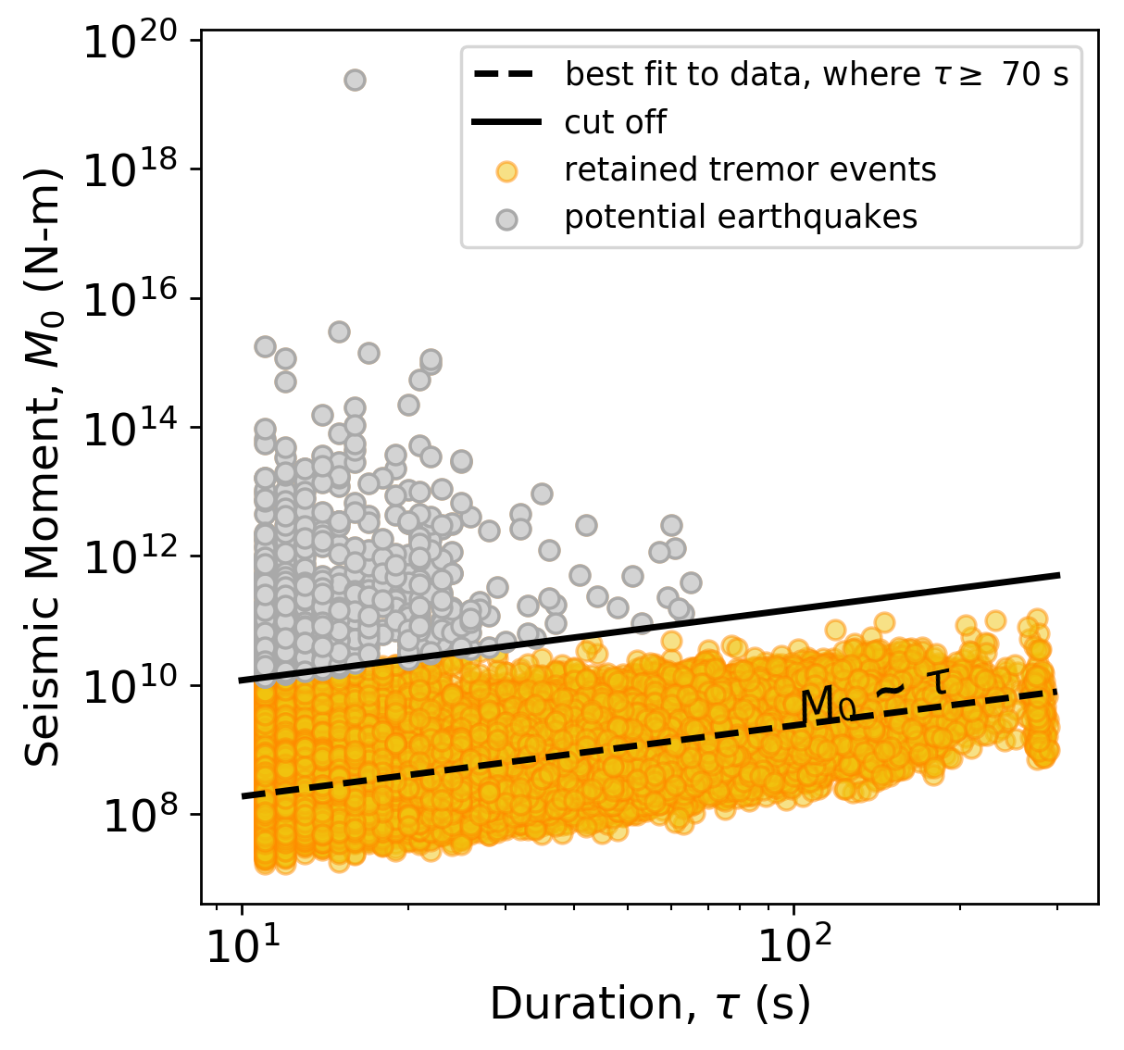
Figure S1. Seismic moment vs. duration for the entire tremor catalog. As can be seen, there are many events with very short durations and large seismic moments that do not fit the general trend of the typical M₀ ~ τ relationship for tremor (dashed line). Some events were confirmed to be earthquakes through catalog comparison, and thus, an upper cutoff (solid line) was applied to remove suspected non-tremor like events from the tremor catalog before clustering.

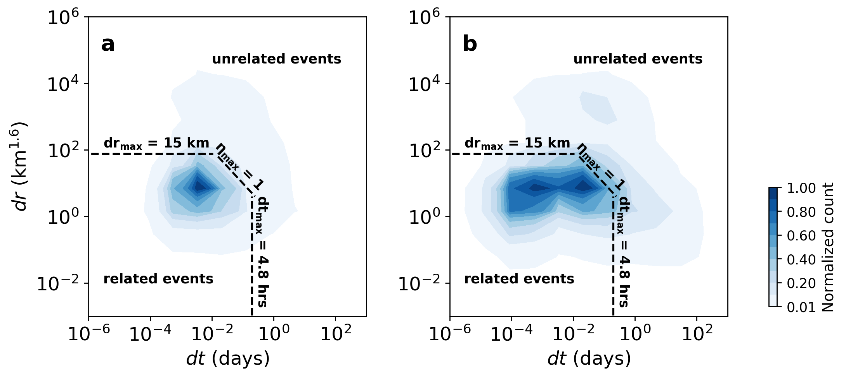
Figure S2. Nearest neighbor 2D histograms for determing the clustering criteria. The histograms are separation distance (dr) vs. inter-event time (dt) for nearest neighbors in the (a) tremor catalog and (b) low-frequency earthquake catalog, similar to (Zaliapin and Ben-Zion, 2013). Events in each catalog were clustered according to the criteria shown: dt ≤ 4.8 hours (0.2 days), dr ≤ 15 km, and η ≤ 1. The distance axis is rescaled (power of 1.6) to better demonstrate the distribution.

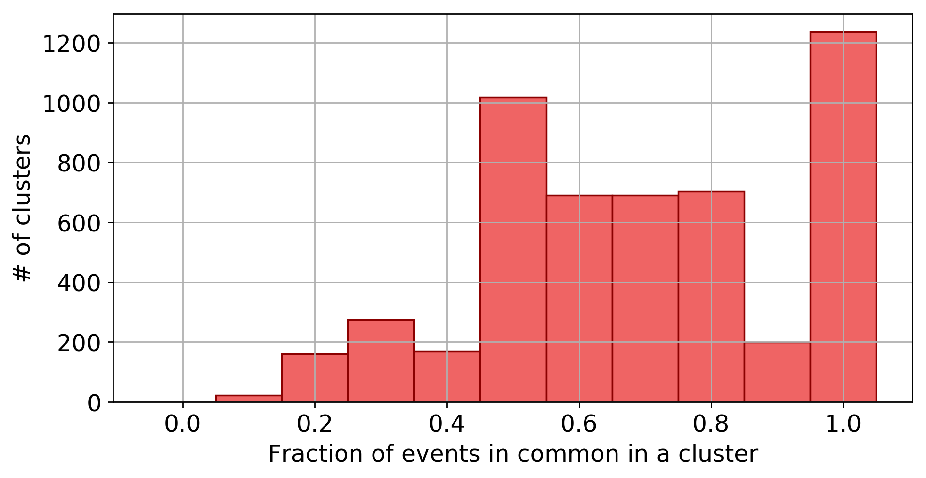

Figure S3. Distributions of the fraction of shared events between this study and Idehara et al. (2014). The fraction of events in common in a cluster is the number of tremor events in our cluster matching that of (Idehara et al., 2014) divided by the total number of tremor events in our cluster. Roughly 1240 of our clusters were fully detected by the clustering criteria of (Idehara et al., 2014), i.e. ~20% of the 6,315 tremor clusters we detected. The rest of the clusters were either undetected or only partially detected.
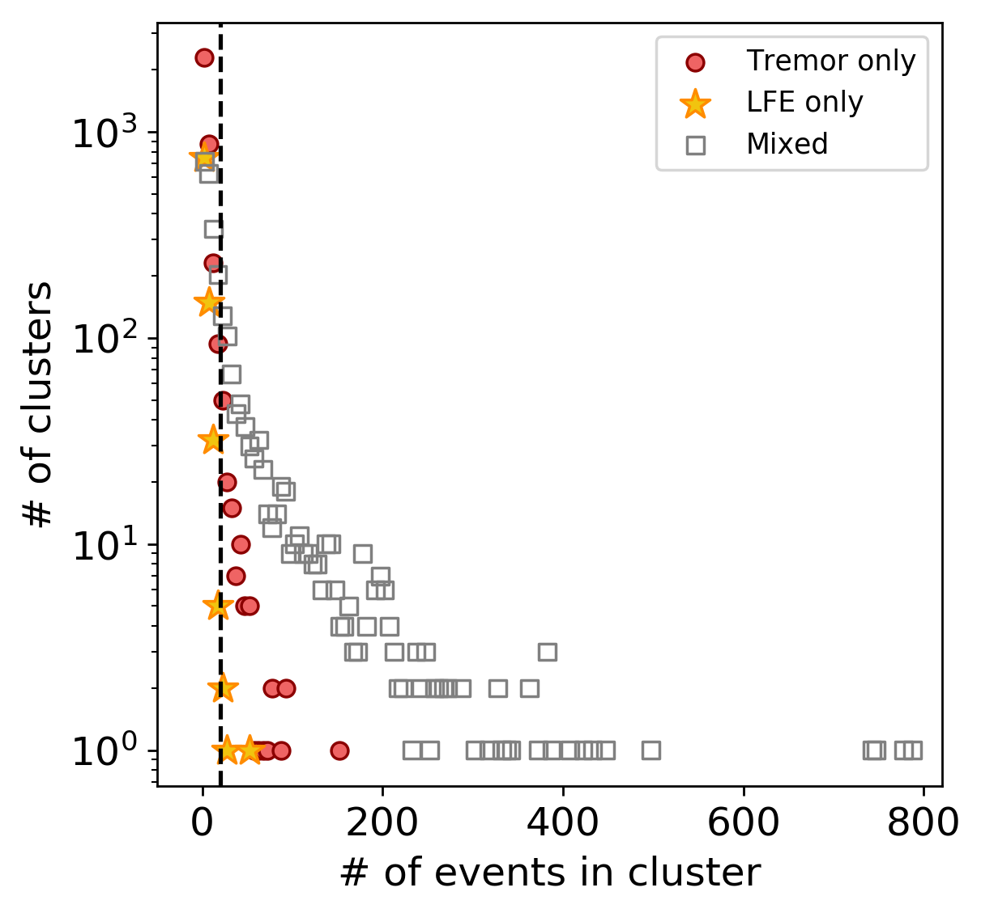
Figure S4. Distributions of the number of events in clusters of different types. Types include: tremors only, LFEs only, or both tremors and LFEs (i.e. mixed). The dashed line marks the threshold for classifying a slow earthquake cluster, i.e. clusters containing a minimum of 20 events.

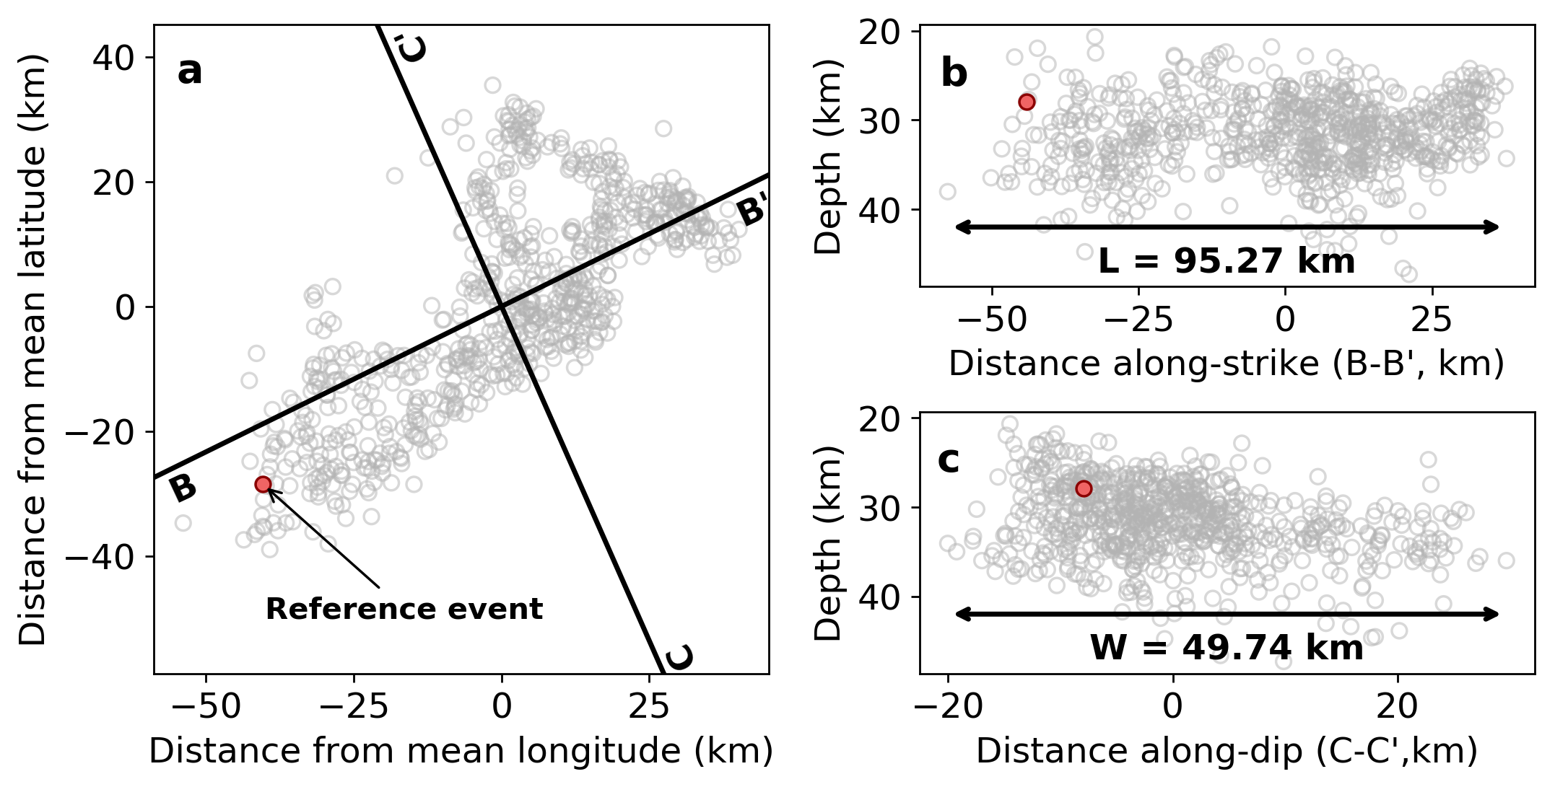

Figure S5. Example of estimating the rupture length (L) and width (W) of a slow earthquake cluster (SEC). This SEC was detected in the Western Shikoku region and began May 25, 2012. (a) Map view of the SEC as identified from the combined tremor and low-frequency earthquake catalogs. All events despite their type (tremor/LFE) are marked as circles. The solid black line mark profiles along-strike and along-dip directions, as shown in (b) and (c), respectively. A reference event is indicated in purple. (b) Depth vs. distance along the strike direction, B-B’ in (a). Length estimate (L) is shown. (c) Depth vs. distance along the dip direction, C-C’ in (a). Width estimate (W) is shown. In this example, W is actually apparent width because the events were not rotated to the plate interface due to the scattered event depths.

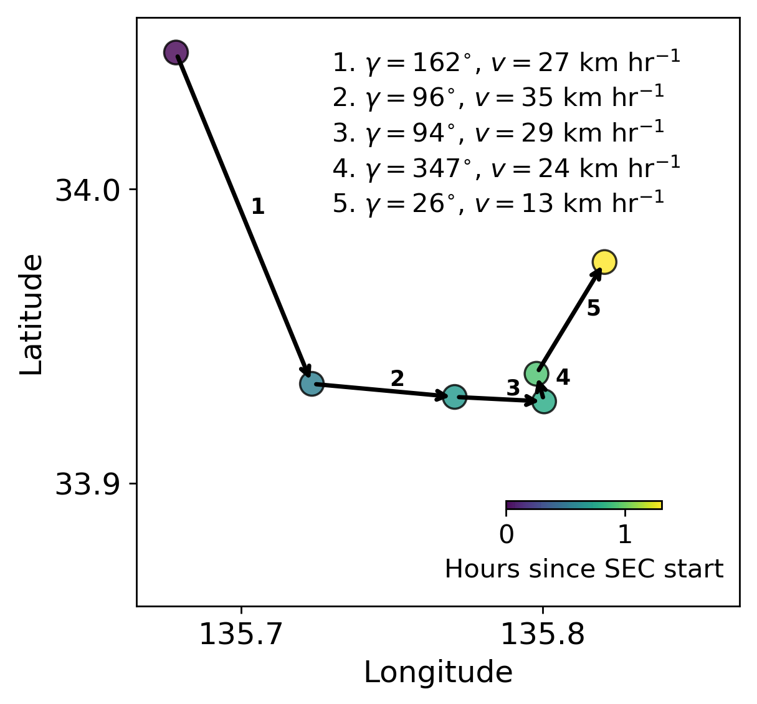
Figure S6. Example of estimating inter-event rupture azimuth and speed. The first 6 events of a slow earthquake cluster (SEC) detected in the Southern Kii region are shown. The SEC began April 28, 2004. The circles represent individual tremor events within the SEC, colored by time since it began. The numbers represent the progression of the SEC in time and correspond to the inter-event rupture azimuth (γ) and speeds (v) listed. Interevent azimuths and rupture speeds for all SECs are calculated in this way. The azimuths are separated by region and then binned by azimuth to produce Figure 4a in the main text. Rupture speed is also separated by region, and the mean and standard deviation of log₁₀(v) (se also Figure S9) are shown in Figure 4b in the main text.

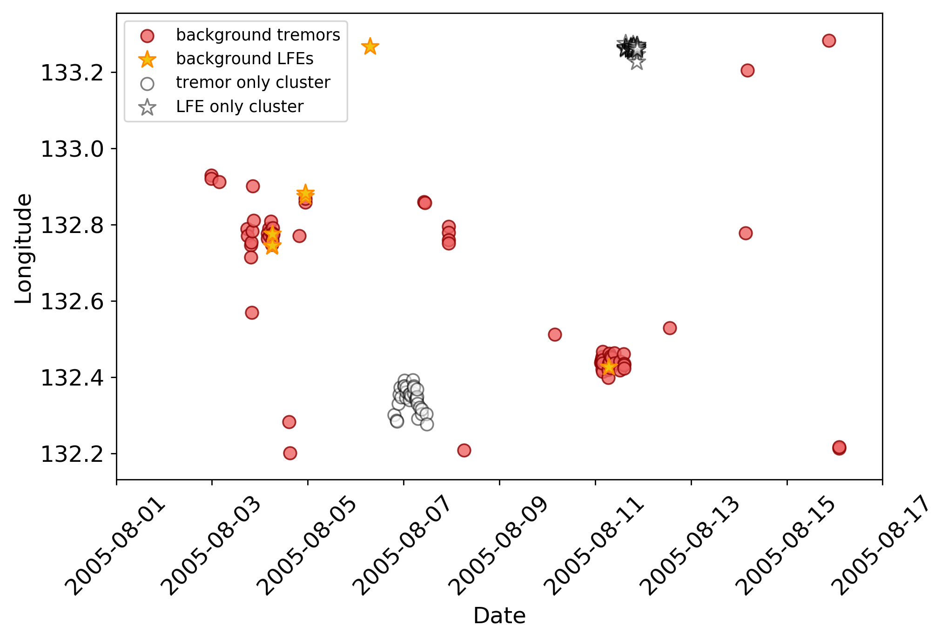
Figure S7. Single-type cluster examples. Example of slow earthquake cluster (SEC) detections containing only tremors (dark purple circles) or only LFEs (light purple stars). Other tremors and LFEs in the same longitudinal range that sometimes cluster together in space in time are in black circles and gray stars, respectively. The tremor only cluster (dark purple circles) contains about 30 events. The LFE only cluster (light purple stars) contains about 50 events.

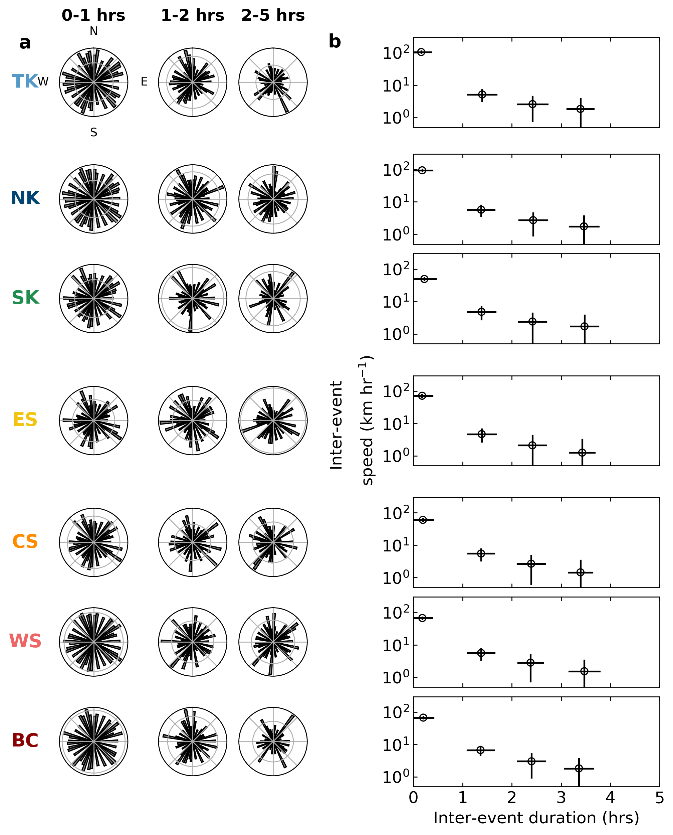
Figure S8. Inter-event rupture azimuths and speeds by inter-event duration. Each row demonstrates a specific region: BC = Bungo Channel, WS = Western Shikoku, CS = Central Shikoku, ES = Eastern Shikoku, SK = Southern Kii, NK = Northern Kii, and TK = Tokai. (a) Distribution of inter-event azimuths for inter-event durations of 0-1 hours, 1-2 hours, 2-5 hours, as the maximum interevent time is 4.8 hours (see Methods: Slow Earthquake Cluster Identification). As can be seen, there is no obvious dependence of inter-event duration on rupture direction. (b) Inter-event rupture speed vs. inter-event duration. Inter-event durations < 1 hour exhibit an order of magnitude faster speeds than inter-event durations > 1 hour.

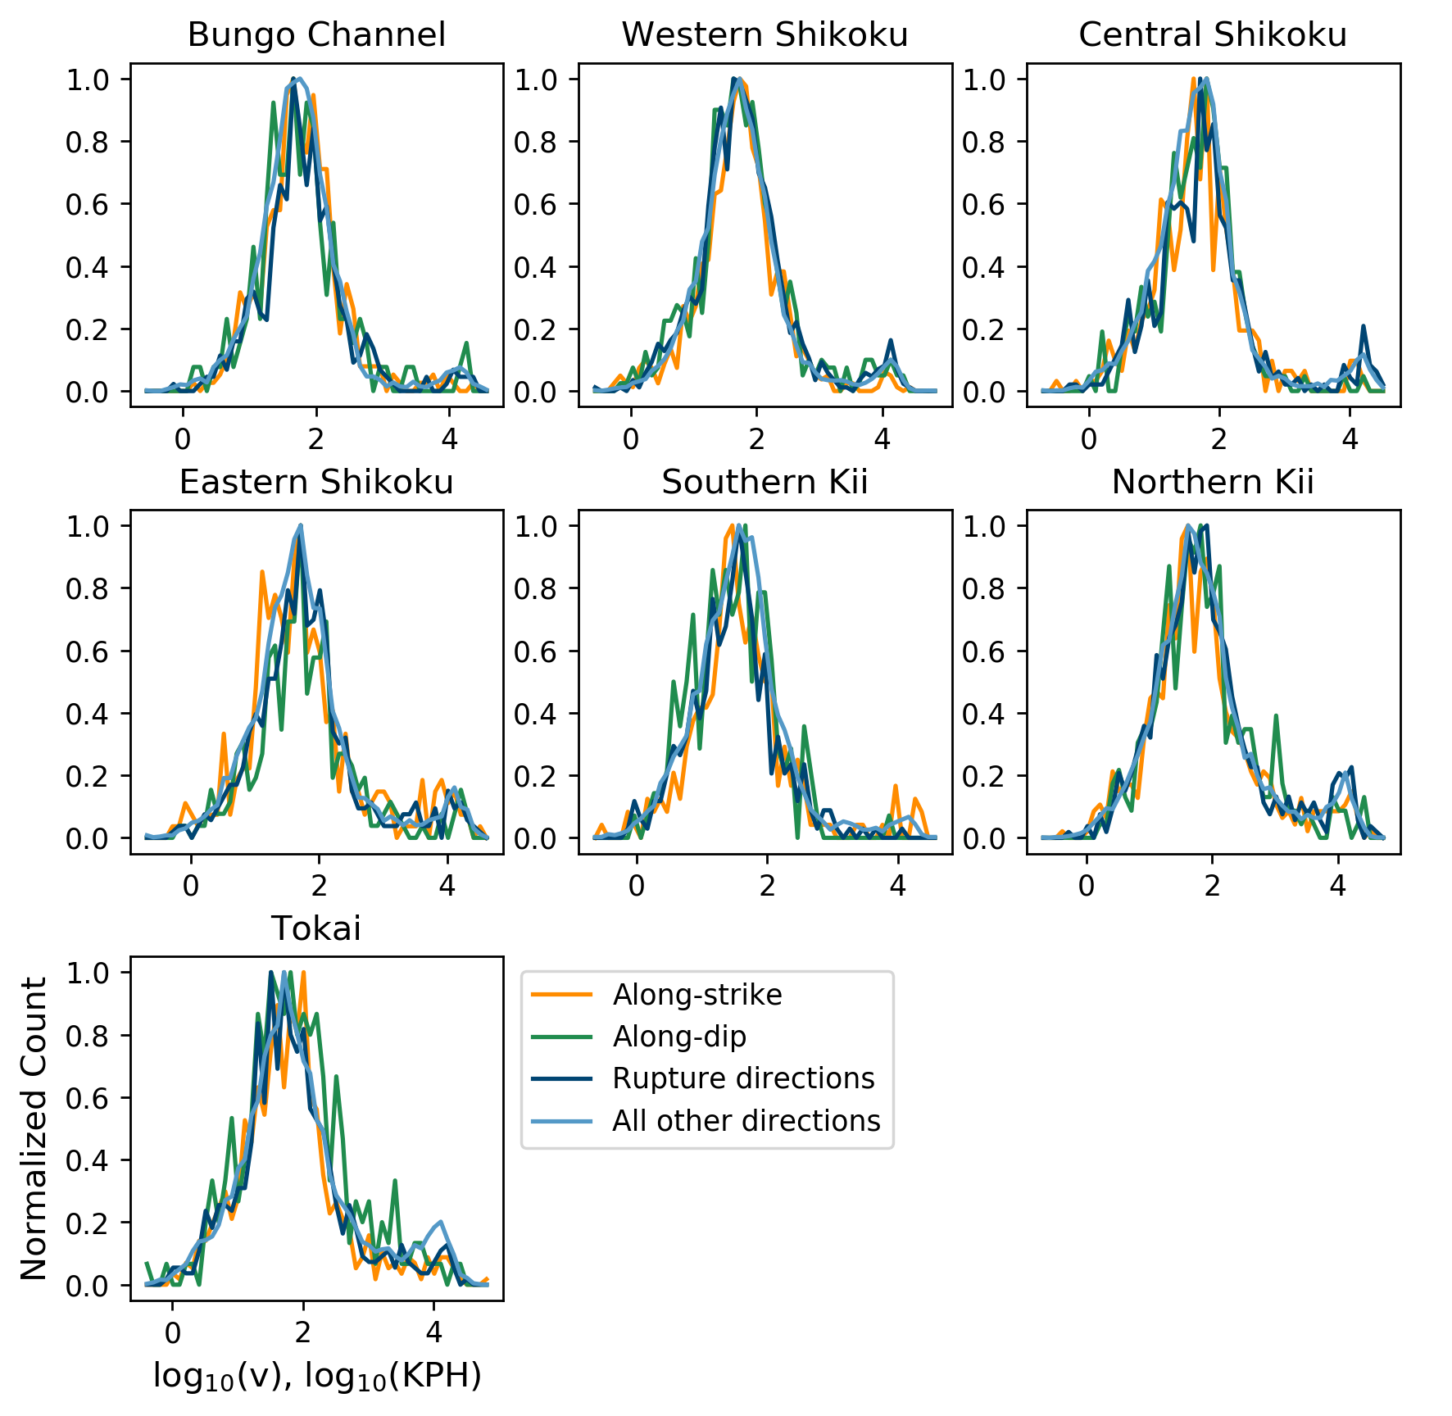
Figure S9. Rupture speeds between successive events in slow earthquake clusters of different regions. The rupture speeds are log-normally distributed in each of the data samples made in the along-strike, along-dip, preferred rupture directions (from inter-event azimuths; Figure 4a), and all other directions.

