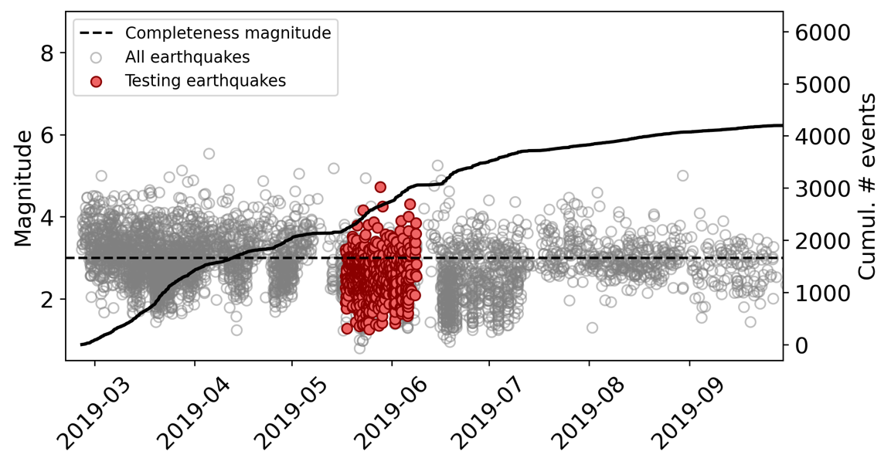
Figure S1. Magnitudes in time for relocated earthquakes (gray circles) and testing earthquakes (red). The solid line is the cumulative number of events over time (all earthquakes).

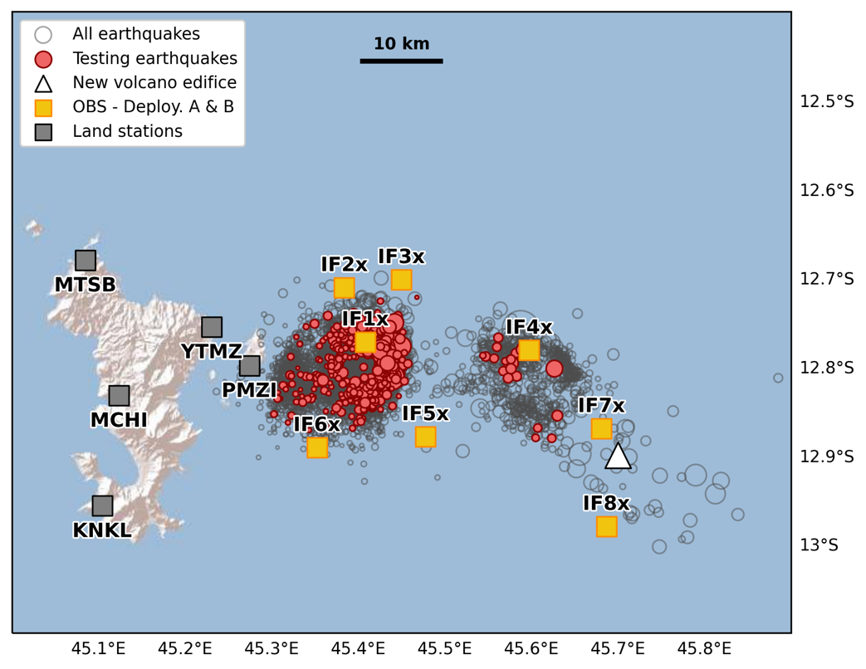
Figure S2. Map of select land stations and OBS used to relocate earthquakes recorded during the 17 May 2019 to 10 June 2019 deployment. All testing earthquakes shown in Figure 1 in the main text and Figure S1 in the supplement were located with at least these stations.

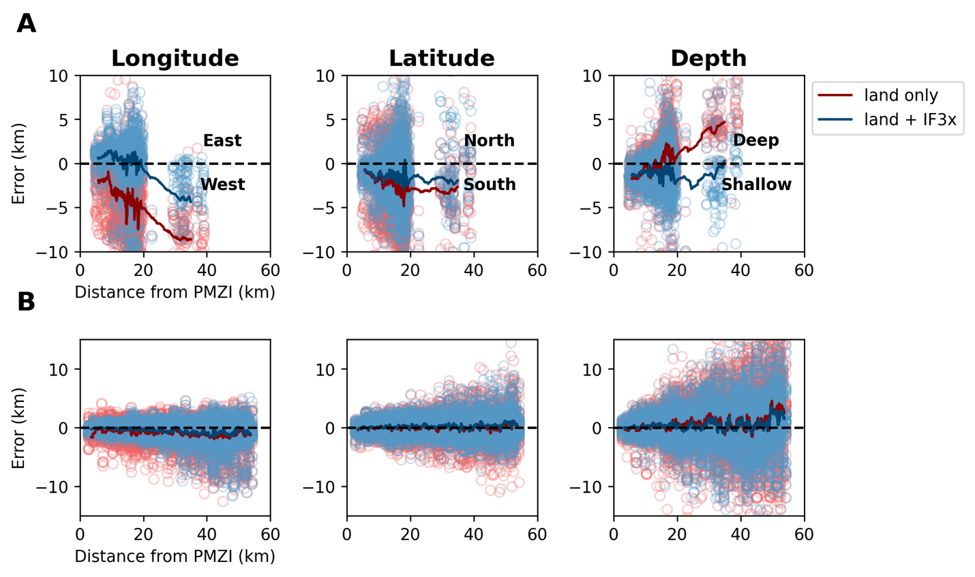
Figure S3. Location errors vs. horizontal distance to station PMZI on Petite Terre. The columns represent the longitude, latitude, and depth errors for A) real deep events and B) synthetic shallow events. Red = land network only relocations; Blue = land network + site IF3x relocations. Circles = all data. Lines = rolling mean of 100 relocation samples. Longitude and depth errors for real deep events demonstrate a striking improvement from the OBS in the first 20 km from the land network, with less improvement for events further away. Synthetic shallow events do not have as clear as an improvement over the land network. The improvement appears to come from reducing the standard deviations of the errors, and not really the mean errors.

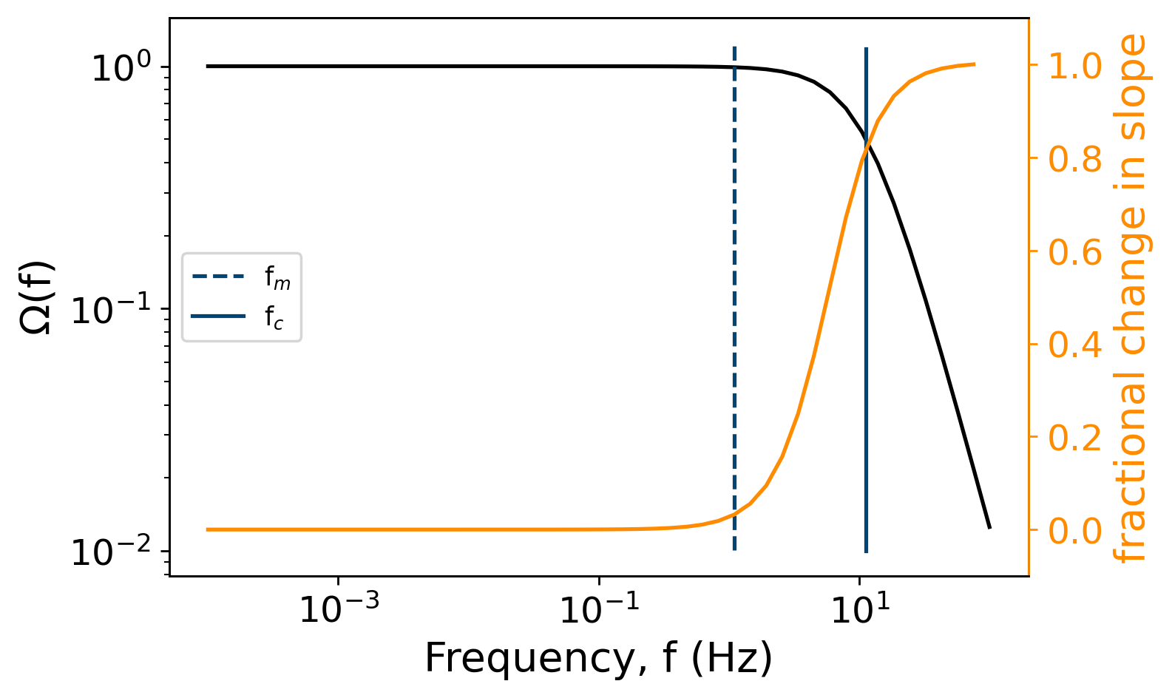

Figure S4. Example of the Brune spectrum modeling for a magnitude 3 earthquake located at 45.42ºE, 12.80ºS and 26 km deep. The maximum frequency (f_{m}) marks where the difference in the slope change from where the Brune source spectrum is maximum, i.e. flat, and the slope changes more than 1%. The corner frequency (f_{c}) is as it is calculated using its seismic moment (M₀) and estimated crack length (r) equations in the main text.

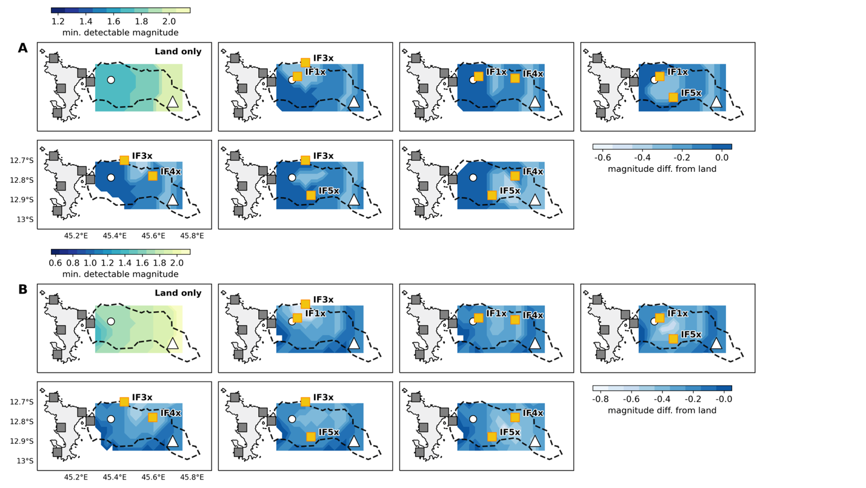
Figure S5. Map view of detectable magnitude difference from land network when adding 2 seafloor sites. A) Deep events (24 km depth). B) Shallow events (4 km depth). The land network detectable magnitudes are shown in the top left panel and have the associated blue-green-yellow color. Differences of magnitude detectability compared to the land network are shown in the blue scale color, such that lighter areas are where the magnitude detection threshold has been lowered compared to the land network alone. Other symbols and notation are the same as Figure 10.

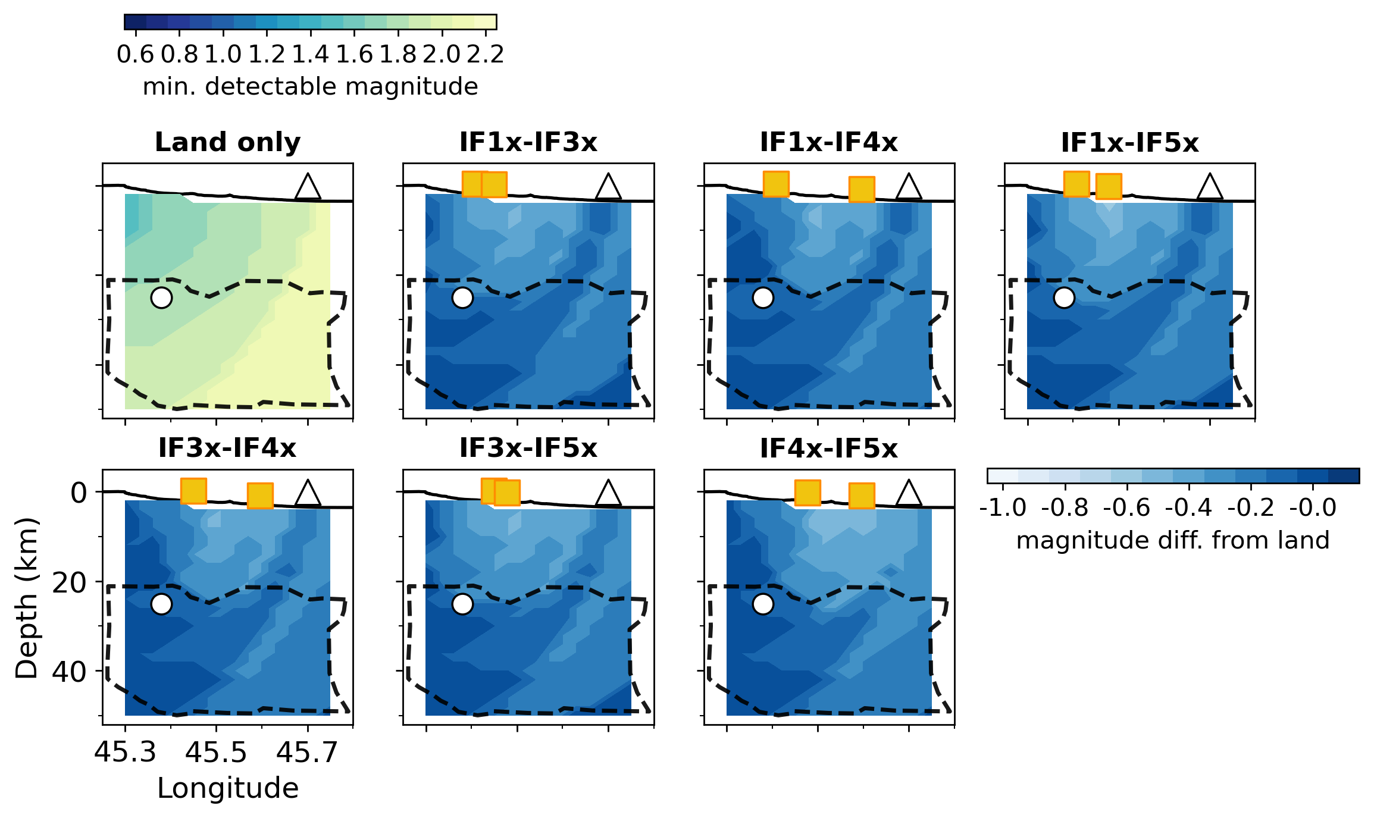
Figure S6. Depth cross-sections along profile C-C’ of detectable magnitude difference from land network when adding 2 seafloor sites. Profile C-C’ can be seen in Figure 3 in the main text. Here, the land network detectable magnitudes are shown in the top left panel and have the associated blue-green-yellow color. Differences of magnitude detectability compared to the land network are shown in the blue scale color, such that lighter areas are where the magnitude detection threshold has been lowered compared to the land network alone. Other symbols and notation are the same as Figure 11.

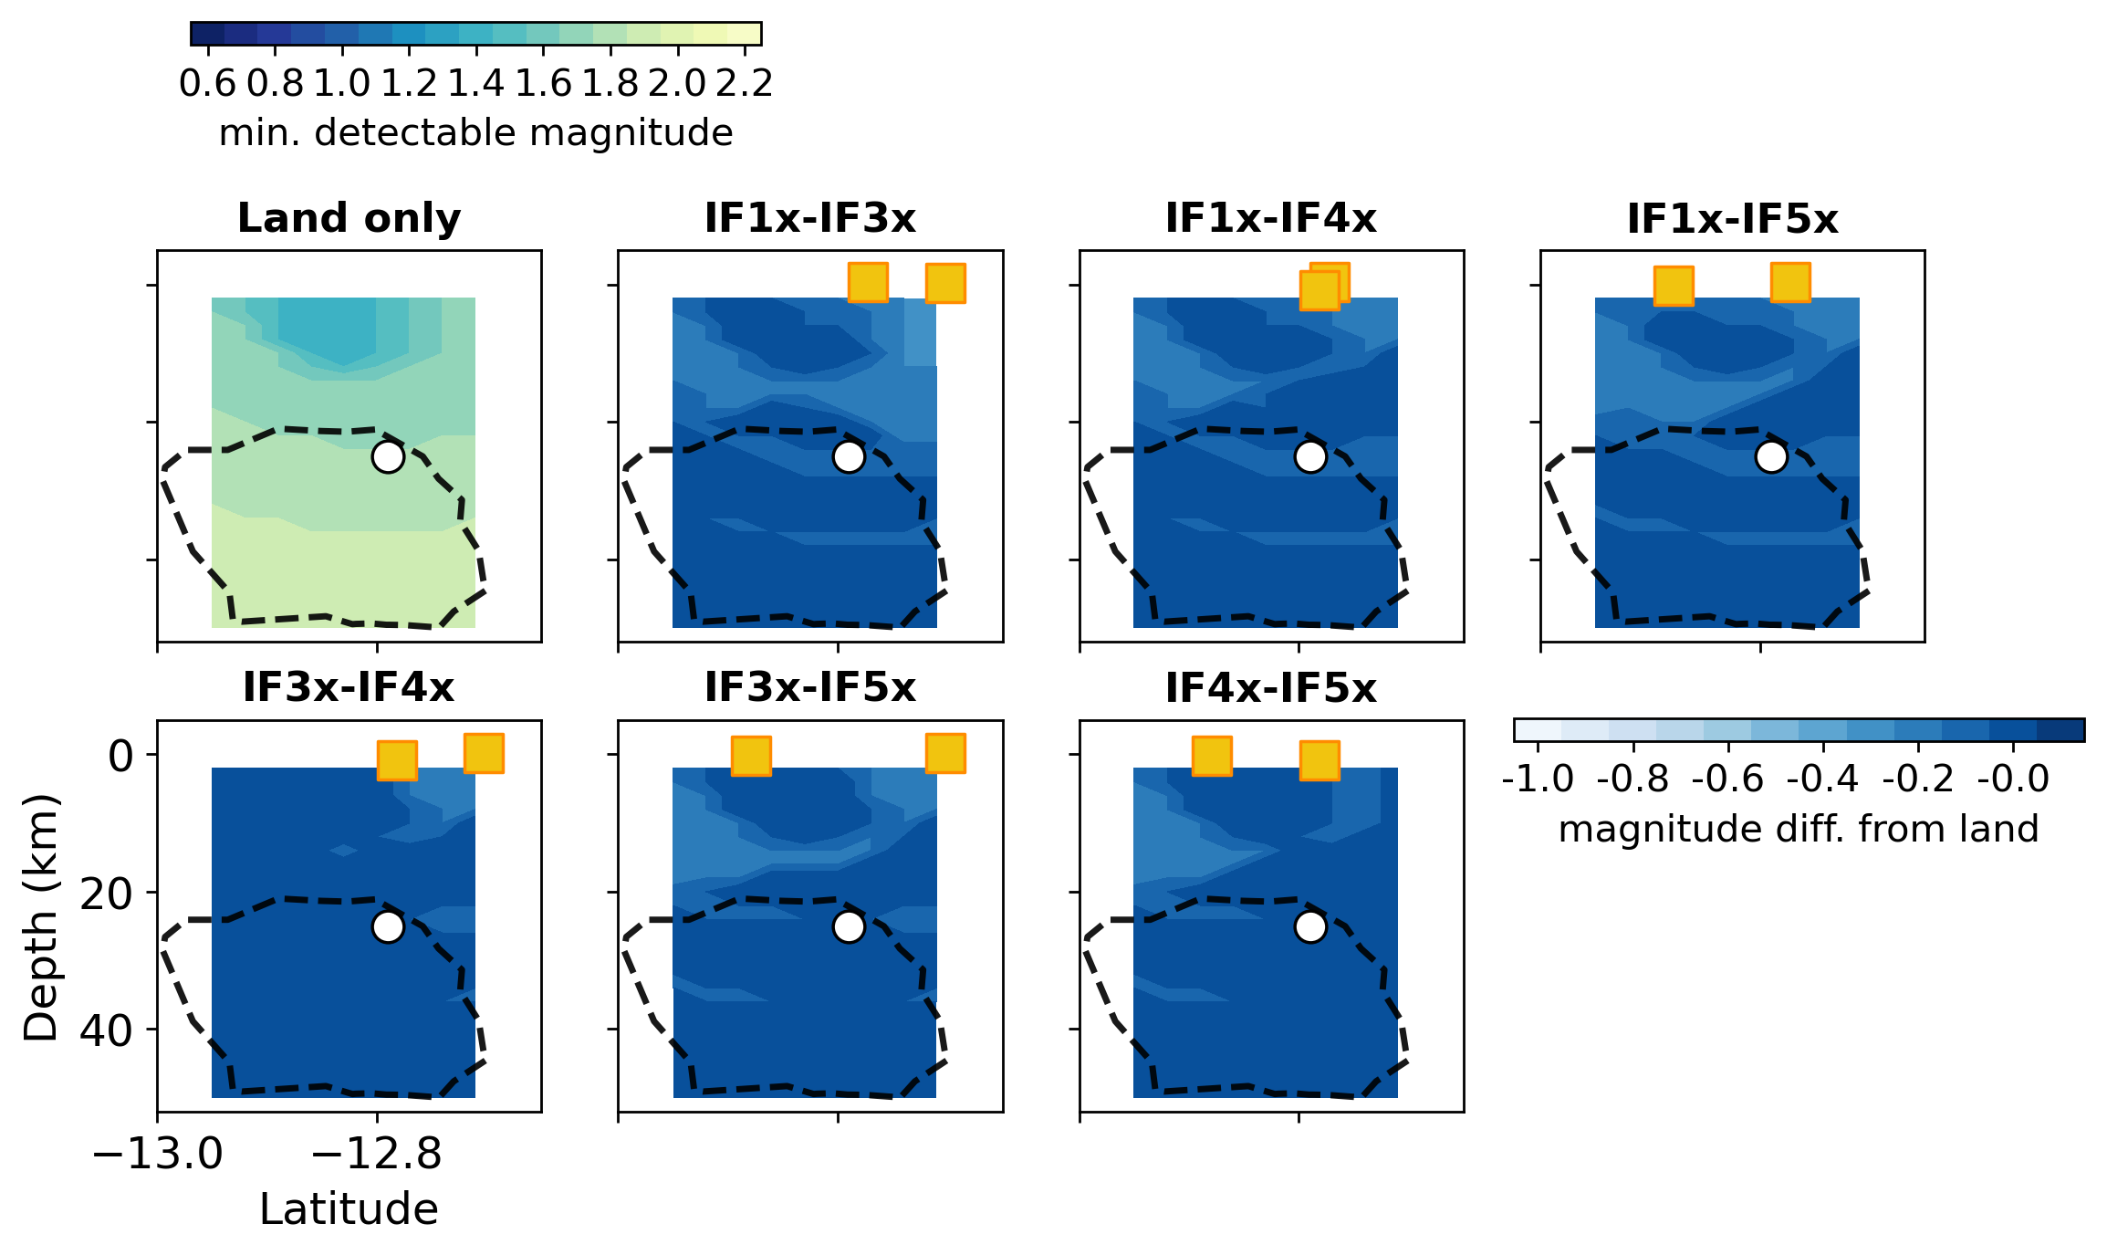
Figure S7. Same as Figure S4 except along a North-South transect at longitude 45.3°.

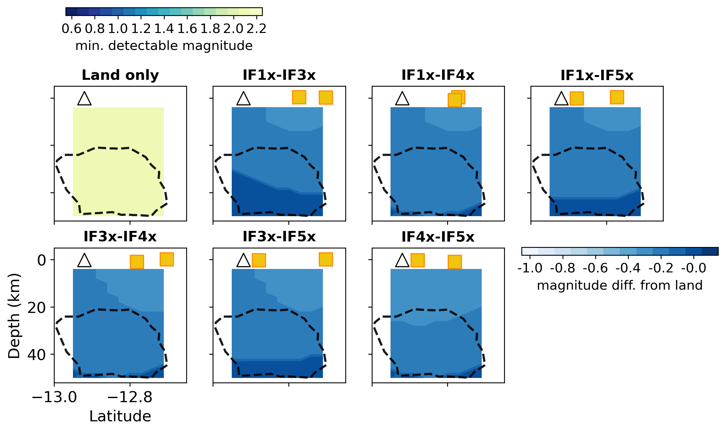
Figure S8. Same as Figure S4 except along a North-South transect at longitude of 45.75°.

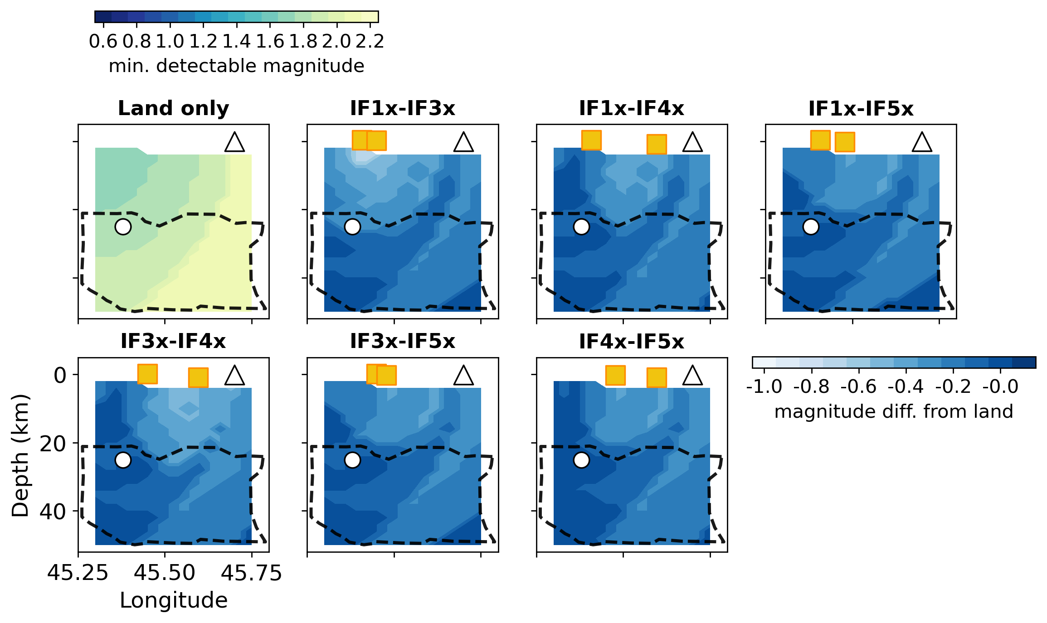
Figure S9. Same as Figure S4 except along an East-West transect at latitude of -12.71°.

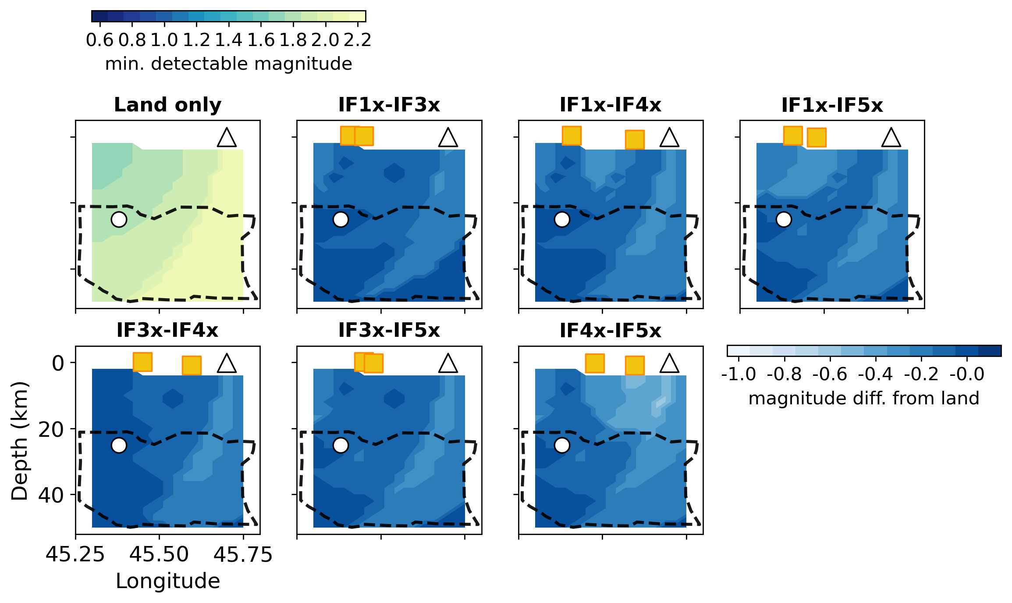
Figure S10. Same as Figure S4 except along an East-West transect at latitude of -12.95°.

Table S1. Station information.
Station Name | Site Type | Longitude | Latitude | Elevation (bsl*, km)
MTSB | onshore | 45.084700 | -12.680400 | 0.050
YTMZ | onshore | 45.230700 | -12.755700 | 0.034
PMZI | onshore | 45.274297 | -12.799310 | 0.010
MCHI | onshore | 45.123657 | -12.832891 | 0.130
KNKL | onshore | 45.104197 | -12.957126 | 0.024
IF1x | seafloor | 45.408100 | -12.772400 | -1.693
IF2x | seafloor | 45.384170 | -12.711330 | -1.224
IF4x | seafloor | 45.596670 | -12.781670 | -2.978
IF6x | seafloor | 45.352670 | -12.890170 | -1.732
*bsl = below sea level

Table S2. MAYOBS velocity model (Saurel et al., 2021).
Top of layer depth (km) | Vp  (km s⁻¹) | Vp gradient  (km s⁻¹/km) | Vs  (km s⁻¹) | Vs gradient  (km s⁻¹/km)
0 | 3.58 | 0.00 | 2.16 | 0.00
0.4 | 3.58 | 0.95 | 2.16 | 0.57
1.84 | 4.95 | 0.09 | 2.98 | 0.06
3.94 | 5.15 | 0.21 | 3.10 | 0.13
7.04 | 5.81 | 0.08 | 3.50 | 0.05
11.77 | 6.19 | 0.05 | 3.73 | 0.03
20.97 | 6.64 | 0.03 | 4.00 | 0.02
42.37 | 7.30 | 0.00 | 4.40 | 0.00

Table S3. The ak135 global velocity model.*
Top of layer  depth (km) | Vp (km s⁻¹) | Vs (km s⁻¹)
0.0 | 5.8 | 3.46
20.0 | 5.8 | 3.46
20.0 | 6.5 | 3.85
35.00 | 6.5 | 3.85
35.00 | 8.04 | 4.48
77.50 | 8.0450 | 4.49
120.00 | 8.05 | 4.50
*This is a shortened version because the full version has 135 layers. When predicting travel times for synthetic sources, Table S2 is combined with the above velocity model for all depths ≥ 77.50 km down to 6371 km (Kennett et al., 1995).

