Supplementary materials
1996 | 1997 | 1998 | 1999 | 2000 | 2001 | 2002 | 2008 | 2009 | 2010 | 2017 | 2018 | 2019 | Grouping
30 | 37 | 21 | 1 | 38 | 40 | 1 | 12 | 15 | 34 | 12 | 12 | 12 | 1
33 | 3 | 18 | 4 | 3 | 3 | 2 | 15 | 3 | 8 | 15 | 15 | 15 | 2
32 | 2 | 19 | 3 | 2 | 2 | 3 | 14 | 2 | 9 | 14 | 14 | 14 | 3
31 | 1 | 20 | 2 | 1 | 1 | 4 | 13 | 1 | 10 | 13 | 13 | 13 | 4
29 | 36 | 22 | 40 | 39 | 41 | 5 | 11 | 14 | 35 | 11 | 11 | 11 | 5
55 | 42 | 10 | 26 | 28 | 37 | 7 | 37 | 34 | 32 | 37 | 37 | 37 | 6
56 | 41 | 9 | 25 | 29 | 36 | 8 | 36 | 33 | 31 | 36 | 36 | 36 | 7
20 | 20 | 5 | 32 | 37 | 30 | 15 | 47 | 59 | 46 | 46 | 46 | 46 | 8
40 | 12 | 11 | 37 | 27 | 38 | 18 | 32 | 24 | 21 | 32 | 32 | 32 | 9
39 | 11 | 39 | 38 | 26 | 39 | 19 | 31 | 39 | 36 | 31 | 31 | 31 | 10
25 | 34 | 41 | 42 | 41 | 43 | 21 | 26 | 40 | 38 | 26 | 26 | 26 | 11
43 | 13 | 36 | 20 | 24 | 26 | 22 | 10 | 26 | 23 | 10 | 10 | 10 | 12
42 | 14 | 35 | 27 | 25 | 27 | 23 | 30 | 25 | 22 | 30 | 30 | 30 | 13
54 | 31 | 23 | 28 | 23 | 25 | 24 | 24 | 27 | 40 | 24 | 24 | 24 | 14
7 | 9 | 12 | 10 | 9 | 9 | 25 | 7 | 9 | 2 | 7 | 7 | 7 | 15
6 | 8 | 13 | 9 | 8 | 8 | 26 | 5 | 3 | 7 | 5 | 5 | 5 | 16
5 | 7 | 14 | 8 | 7 | 7 | 27 | 6 | 4 | 8 | 6 | 6 | 6 | 17
4 | 6 | 15 | 7 | 6 | 6 | 28 | 4 | 6 | 5 | 4 | 4 | 4 | 18
2 | 5 | 16 | 6 | 5 | 5 | 29 | 3 | 5 | 6 | 3 | 3 | 3 | 19
35 | 4 | 17 | 5 | 4 | 4 | 30 | 2 | 4 | 7 | 2 | 2 | 2 | 20
8 | 10 | 30 | 11 | 10 | 10 | 31 | 8 | 10 | 1 | 8 | 8 | 8 | 21
36 | 38 | 31 | 12 | 11 | 14 | 32 | 1 | 16 | 11 | 1 | 1 | 1 | 22
9 | 24 | 32 | 15 | 15 | 15 | 33 | 9 | 11 | 14 | 9 | 9 | 9 | 23
10 | 23 | 29 | 16 | 16 | 11 | 34 | 18 | 12 | 20 | 18 | 18 | 18 | 24
11 | 25 | 33 | 17 | 14 | 16 | 35 | 17 | 17 | 33 | 17 | 17 | 17 | 25
49 | 29 | 25 | 23 | 22 | 22 | 39 | 21 | 23 | 17 | 21 | 21 | 21 | 26
51 | 30 | 26 | 22 | 20 | 21 | 40 | 23 | 21 | 18 | 23 | 23 | 23 | 27
48 | 28 | 27 | 21 | 19 | 19 | 41 | 20 | 20 | 15 | 20 | 20 | 20 | 28
46 | 26 | 34 | 18 | 18 | 17 | 43 | 16 | 18 | 39 | 16 | 16 | 16 | 29
13 | 45 | 44 | 45 | 43 | 45 | 45 | 41 | 36 | 42 | 41 | 41 | 41 | 30
12 | 46 | 43 | 44 | 42 | 46 | 46 | 40 | 37 | 43 | 40 | 40 | 40 | 31
14 | 44 | 45 | 46 | 44 | 44 | 47 | 38 | 35 | 41 | 38 | 38 | 38 | 32
Table A.1: Sample locations in closest proximity to each other among years. Each column contains the number given to the haul at a given set of coordinates. Hauls that were the closest and performed each year were regrouped and a new number was given.

Figure A.1: Matrices showing the values of pairwise comparison, per year, for the global index of colocation (GIC) and local index of colocation (LIC) for the three species of flatfishes
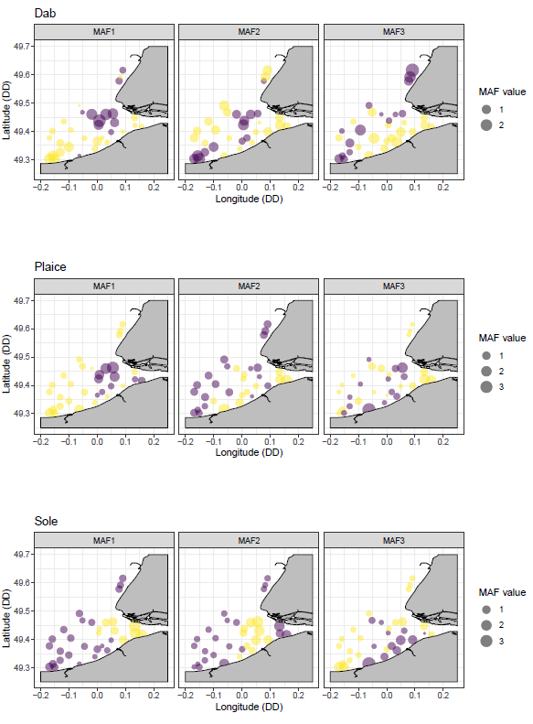
Figure A.2: Mapping of the scores obtained for the first three Min Max Autocorrelation Factors (MAF) in the study area for the three species of flatfishes. The size of the point is proportional to the absolute value of the MAF. The colour segregates positive from negative values. Coordinates are in decimal degree (DD).

Figure A.3: Mean annual density for the three flatfish species. Gaps represent the temporal discontinuity in the survey
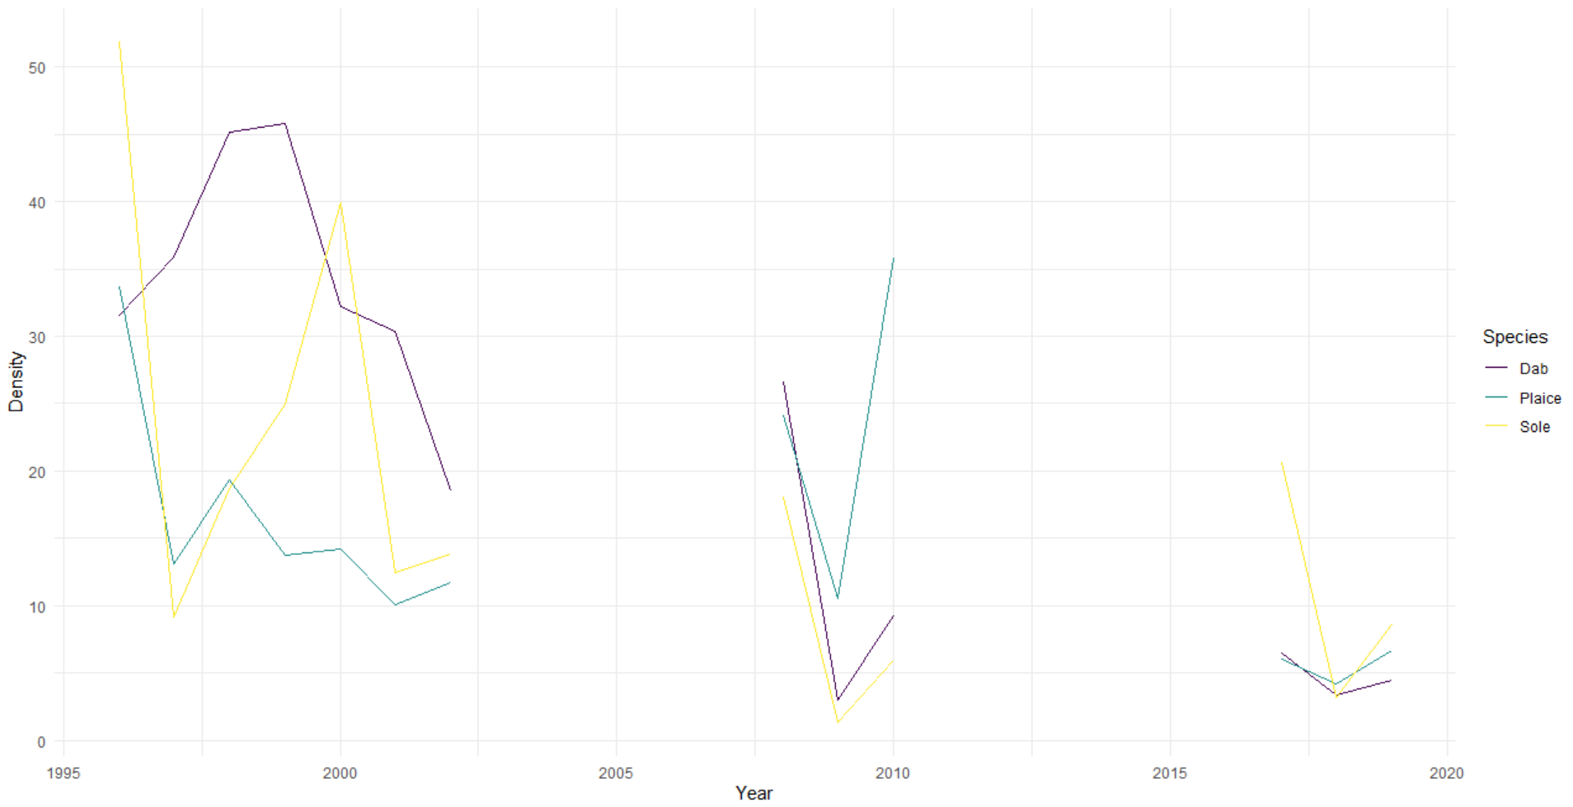
Figure A.4: Position of the centres of gravity across the years for the three species of flatfishes studied with the years indicated. Coordinates are in decimal degree (DD).
