Global Biogeochemical Cycles
Supporting Information for
Quantifying errors in observationally-based estimates of ocean carbon sink variability
Lucas Gloege^{1*}, Galen A. McKinley¹, Peter Landschützer², Amanda R. Fay¹, Thomas L. Frölicher^{3,4}, John C. Fyfe⁵, Tatiana Ilyina², Steve Jones⁶, Nicole S. Lovenduski⁷, Keith B. Rodgers^{8,9}, Sarah Schlunegger¹⁰, Yohei Takano^{2,11}
¹ Lamont-Doherty Earth Observatory, Palisades, NY 10964 USA
² Max Planck Institute for Meteorology, Hamburg, Germany
³ Climate and Environmental Physics, University of Bern, Bern, Switzerland
⁴ Oeschger Centre for Climate Change Research, University of Bern, Bern, Switzerland
⁵ Environment and Climate Change Canada, Victoria, Canada
⁶ University of Bergen, Bergen, Norway
⁷ University of Colorado, Boulder, CO 80309 USA
⁸ Center for Climate Physics, Institute for Basic Science, Busan, South Korea
⁹ Pusan National University, Busan, South Korea
¹⁰ Princeton University, Princeton, NJ 08544 USA
¹¹ Los Alamos National Laboratory, Los Alamos, NM 57544 USA

Contents of this file

Text S1
Figure S1

Text S1.
Air-sea CO₂ flux ($F_{CO_{2}}$) is calculated in mol C m⁻² yr⁻¹ for each month at each 1°x1° spatial location using the (Wanninkhof, 1992) parameterization (Equation 1).

$$\bar{F_{CO_{2}}}=\bar{k_{w}}\bar{S_{CO_{w}}}(1-{\bar{f_{ice}})(\bar{pCO_{2,atm-moist}}-\bar{pCO_{2,ocean}}) Equation 1}_{}$$

which parameterizes $F_{CO_{2}}$ as a function of the gas transfer velocity ($k_{w}$), CO₂ solubility ($S_{CO_{2}}$), ice fraction ($f_{ice}$), and partial pressure of CO₂ in moist air ($pC{O_{2,atm-moist}}^{}$) and surface ocean ($pCO_{2,ocean}$). Overbars denote monthly averages. We use the (Wanninkhof, 1992) gas transfer velocity with the (Sweeney et al., 2007) scale factor of 0.27 (Equation 2).

$$\bar{k_{w}}=0.27({\bar{u}}^{2}+\bar{u^{'2}}) (\bar{Sc}/660)^{-0.5} Equation 2$$

Because high-frequency output is not available for all large ensemble members, and to be consistent with the flux calculation used in the real-world application of the SOM-FFN flux product, we use ERA-interim 6-hourly global atmospheric reanalysis (Dee et al., 2011) as an estimate for the wind-speed variance ($\bar{u'^{2}}$).

Solubility is calculated following (Weiss, 1974) with the (Wanninkhof, 1992) Schmidt number (Sc). Partial pressure of moist air ($pCO_{2,atm-moist}$) is calculated following Equation 3.

$$pCO_{2,atm-moist}=xCO_{2}(P_{atm }-pH_{2}O) Equation 3$$

Where $xCO_{2}$is the dry air mixing ratio of atmospheric CO₂, $P_{atm }$ is the total atmospheric pressure, and $pH_{2}O$ is the saturation vapor pressure (Dickson et al., 2007).

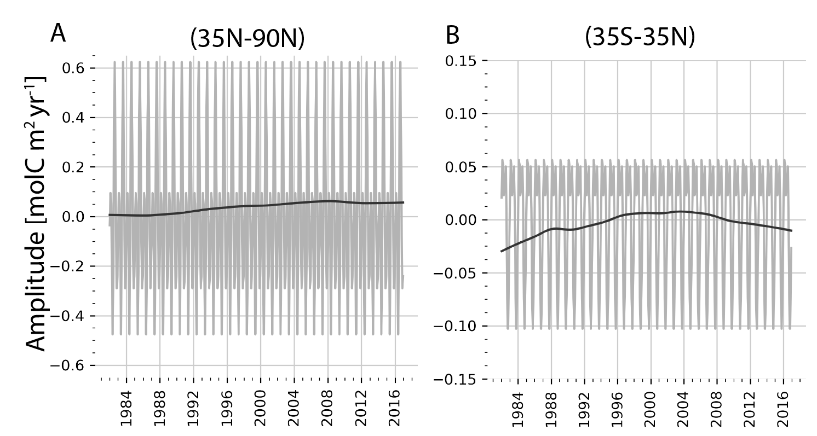Figure S1. The average seasonal cycle (gray) and decadal component (black) is displayed across A) 35°N - 90°N and B) 35°S - 35°N. Note different y-axis scales.

Dee, D. P., et al. (2011). The ERA-Interim reanalysis: Configuration and performance of the data assimilation system. Quarterly Journal of the Royal Meteorological Society, 137(656), 553–597. https://doi.org/10.1002/qj.828
Dickson, A. G., Sabine, C. L., Christian, J. R., Bargeron, C. P., & North Pacific Marine Science Organization (Eds.). (2007). Guide to best practices for ocean CO2 measurements. North Pacific Marine Science Organization.
Sweeney, C., Gloor, E., Jacobson, A. R., Key, R. M., McKinley, G., Sarmiento, J. L., & Wanninkhof, R. (2007). Constraining global air-sea gas exchange for CO2 with recent bomb 14C measurements. Global Biogeochemical Cycles, 21(2).
Wanninkhof, R. (1992). Relationship between wind speed and gas exchange over the ocean. Journal of Geophysical Research: Oceans, 97(C5), 7373–7382.
Weiss, R. F. (1974). Carbon dioxide in water and seawater: The solubility of a non-ideal gas. Marine Chemistry, 2(3), 203–215. https://doi.org/10.1016/0304-4203(74)90015-2

