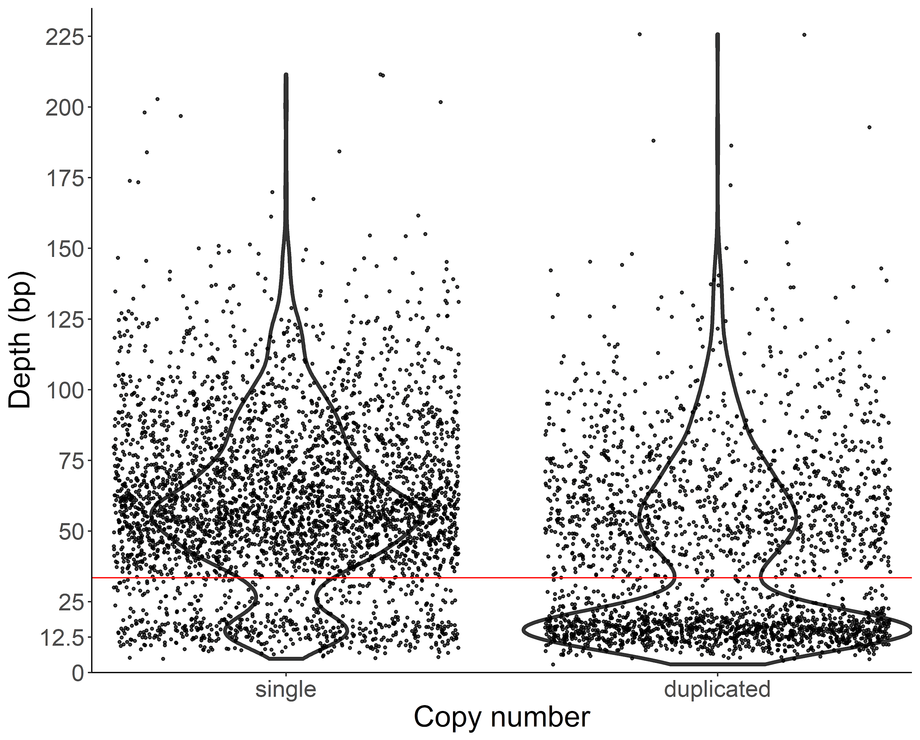
Supplemental Figure 1. Average coverage for each ortholog in the tetrapoda database. Orthologs are split by whether they are identified by BUSCO as present in the assembly as a single copy or duplicated copies.

