Supplementary materials
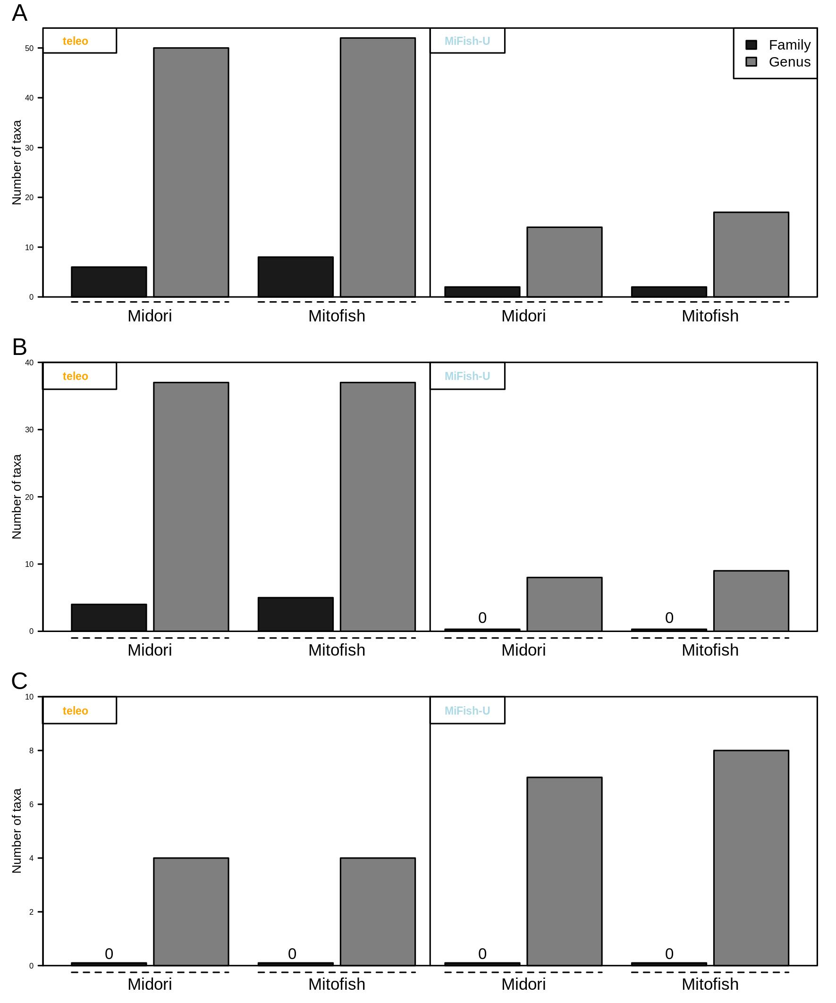
Figure S1 : Number of family and genus uniquely amplified by teleo and MiFish-U primers respectively considering one (A), two (B) and three (C) mismatches for the Midori and Mitofish database.

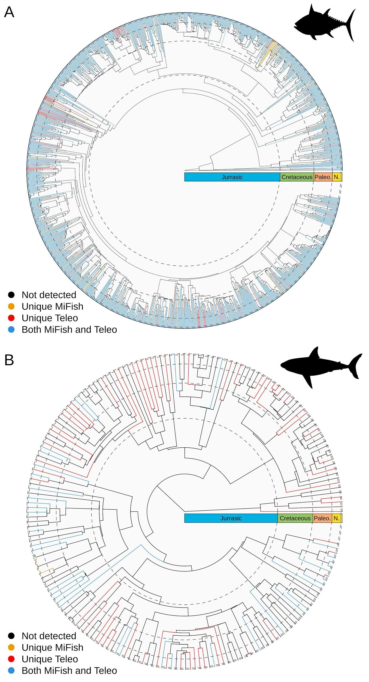
Figure S2. Phylogenetic distribution of the genera for Actinopterygii, (A) and Chondrichthyes (B), recovered uniquely by MiFish-U (in orange), uniquely by Teleo (in red) and by both primer pairs (in blue) considering the Mitofish database and allowing two mismatches. Families and genera not detected by either primer pairs are represented in black.

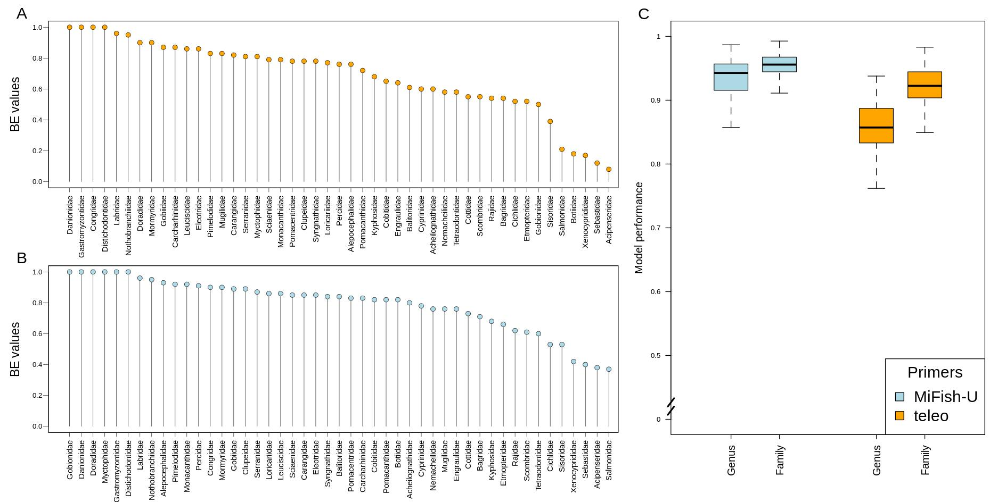
Figure S3. Lollipop plots of species-specificity of (A) teleo and (B) MiFish-U across the different families for the Mitofish database. (C) Boxplot showing the performance of the neural network to predict the taxonomic assignment at the genus and at the family level for both MiFish-U and teleo considering the Mitofish database.
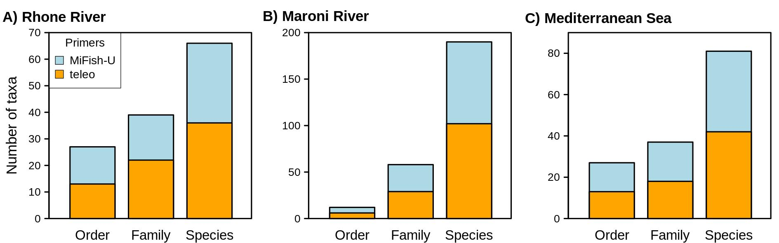
Figure S4. Number of orders, families and species identified by Mifish and teleo primers within the Rhone River (France; A), the Maroni River (French Guiana; B) and the Mediterranean Sea (France; C).

 | Maroni River |  | Mediterranean sea |  | Rhone River |  | CPCR
Step | MiFish | teleo | MiFish | teleo | MiFish | teleo | MiFish | teleo
Demultiplexing | 2592557 | 1143841 | 3466624 | 1124727 | 1210879 | 1194177 | 50935 | 392367
Quality filter | 1624184 | 962651 | 2108988 | 934021 | 650861 | 981794 | 29119 | 283331
Metazoa | 1460346 | 700809 | 816966 | 590340 | 305196 | 904341 | 29074 | 283253
Chordata | 1460346 | 700809 | 816966 | 590340 | 305196 | 904341 | 29074 | 283253
Aves |  |  |  |  |  | 2110
Mammalia |  | 590 | 10044 | 4611 | 796 | 12870 | 29074 | 283253
Actinopteri | 1460346 | 700207 | 806922 | 585194 | 304400 | 887974
Chondrichthyes |  | 12 |  | 535
Hyperoartia |  |  |  |  |  | 1387
Table S1. Number of reads during the filtration process. After demultiplexing and quality filtering (i.e. sequences longer than 20 bp, MOTU represented by more than 10 reads and MOTU), remaining reads are classified successively to Metazoa, Chordata, Aves, Mammalia, Actinopteri, Chondrichthyes and Hyperoartia using a conservative 98% identity threshold with the reference bases (EMBL for non-fish, and local databases for Actinopteri, Chondrichthyes and Hyperoartia). The CPCR corresponds to the control PCR and the reads of Mammalia correspond with human contamination.

