Supplementary Materials for

An Indo-Pacific see-saw wobbles the Earth at intraseasonal timescales
M. Afroosa^{1,6†},B. Rohith^{1†},Arya Paul^{1*}, Fabien Durand^{2,5}, Romain Bourdallé-Badie³, P.V. Sreedevi^{1,7}, Olivier de Viron⁴, Valérie Ballu⁴, S.S.C. Shenoi¹

Correspondence to: aryapaul@incois.gov.in.

This PDF file includes:

Methods
Figs. S1 to S4
Methods

SM1. Model

The state-of-the-art Ocean/Sea-ice general circulation model (OGCM) - Nucleus for European Modeling of the Ocean (NEMO-version 3.6 stable)¹¹ is used in this study. The ocean component of NEMO is based on version 9.1 of the OPA primitive equation z-level model with hydrostatic and Boussinesq approximations^{26,27}. This OGCM is coupled to the Louvain la Neuve (LIM3) sea ice model²⁸. All simulations analyzed in this study are performed using the NEMO-based eddy resolving model configuration (ORCA12) developed under the Copernicus Marine Environment Monitoring Service (CMEMS) framework²⁹.
The NEMO-ORCA12 is a global ocean configuration with an orthogonal, curvilinear, tripolar Arakawa C-type grid with a nominal resolution of 1/12°³⁰. In the tripolar ORCA12 grid, the horizontal resolution gets finer with increasing latitude, i.e., 9 km at the equator, 7 km at mid-latitudes and 2 km near the poles³¹. Our model set-up consists of 75 vertical levels and a partial cell representation of bottom topography^{32,33}. The resolution of this vertical discretization decreases from 1 m at the surface to 200 m in the deep ocean. The NEMO-ORCA12 configuration uses a non-linear free surface with a split-explicit formulation to compute barotropic and baroclinic modes³⁴. A baroclinic time step of 360 seconds and a barotropic time step of 12 seconds are used. Momentum advection scheme is a 3rd order Upstream Biased Scheme³⁵ that contains a biharmonic like dissipation term. A total variance diminishing advection scheme is used for the tracers^{36,37}, and the mixing scheme is k-ε³⁸ based on Generic Length Scale (GLS) turbulent closure scheme^{39,40}.
The model requires the following fluxes - wind, radiative fluxes, air temperature, rain and specific humidity. There is no atmospheric pressure gradient forcing in the model as the effect of atmospheric pressure on open ocean bottom pressure is negligible at time scales longer than ~ 3 days⁴¹. Snow and river runoff fluxes are monthly climatological forcings obtained from climatology⁴². ETOPO1⁴³ and GEBCO_08⁴⁴ have been combined to derive ORCA12 bathymetry ³². The minimum depth in the model is set to 12 m. Regions shallower than 12 m are deepened to the minimum depth. The above configuration is the same across the control run and the two sensitivity experiments. Ocean bottom pressure (in decibars) is computed within the model. We obtain intraseasonal equivalent water depth (EWD) from the model-derived ocean bottom pressure by scaling it with density and applying a lanczos filter⁴⁵ .

SM1.1. Control Run

The global NEMO is run for the period 2009-2019 starting from an initial condition obtained from a 30 year spin-up of the model using ERA-Interim ECMWF reanalysis⁴⁶. Subsequently, the model is forced with six-hourly National Centre for Medium Range Weather Forecasting (NCMRWF) fluxes⁴⁷ from January 2009 and is run till August 2019. Sea surface temperature (SST) and Sea surface salinity (SSS) were weakly restored to the monthly climatological values derived from World Ocean Atlas 2013 (WOA13)^{48,49}. The restoration time scale is 2 months.

SM1.2. Sensitivity experiment: MC-EXP

To understand the importance of MJO winds over the Maritime Continent in establishing the seesaw in the Indo-Pacific oceanic mass, a sensitivity experiment (MC-EXP) is carried out by restricting the wind forcing to the boxed region (90°E-140°E, 32°S-2°N, black box in Fig.2b and zero elsewhere. All other fluxes are prescribed across the globe. The wind mask was created using a hyperbolic tangent function. To avoid numerical instabilities, the winds at the edges of the box are smoothly decayed to zero over a length scale of 300 km.
The 6-hourly NCMRWF⁴³ forcing is used for the wind while the rest of the fluxes are climatological and taken from CORE-II climatology fluxes⁵⁰ . The simulation is performed for the period 2009-2019 starting from the same initial condition as the control run. In this experiment, SST and SSS were restored strongly (time scale of 12 hours) to the climatological values derived from World Ocean Atlas 2013 (WOA13)^{48,49}. This is done to keep the baroclinic structure of the ocean close to reality in the absence of wind fluxes outside the Maritime Continent.

SM2. BPR data processing

The Bottom Pressure Recorder (BPR) measures ocean bottom pressure in pounds per square inch absolute (PSIA). This information is disseminated as Equivalent Water Depth (EWD) after applying a constant 670.0 mm of water/PSIA conversion factor. The BPRs have a time resolution of 15 minutes when operating in the normal mode. However, we chose hourly data by sub-sampling only the zero^{th} minute of every hour from the normal mode data.The hourly data are subjected to TASK2000⁵¹ software to remove tidal frequencies. For this study, a total of 82 BPRs were processed. All the BPRs were processed using the method described in ref.³ and a continuous de-tided daily time series was constructed. Intraseasonal EWDA were estimated from the daily time series using the lanczos filter⁴⁵.

SM3. Estimation of ocean excitation functions from the model

Changes in polar motion of the solid earth due to the ocean can be attributed to the changes in ocean mass distribution and/or changes in ocean currents⁵². Daily excitations in polar motion due to oceanic mass and currents are computed from our model using the algorithm adapted from ref.⁶. The polar motion excitation functions χ₁ and χ₂ describe the effective changes in the angular momentum components about two equatorial axes conventionally taken to point towards the Greenwich (x axis) and 90°E meridians (y axis), respectively. These two excitation functions, χ₁ and χ₂, can be expressed as the sum of a mass term and a motion term (see equation (1)),

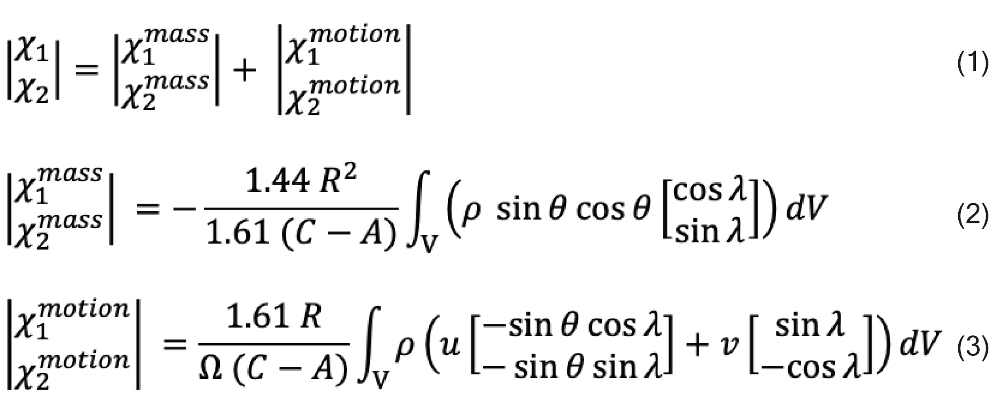

From the model, the changes in the excitation function due to the oceanic mass redistribution (equation (2)) were computed by integrating the density (ρ) over the ocean volume (V). Similarly, changes due to the currents (equation (3)) were computed by integrating density (ρ) multiplied by the zonal ($u$) and meridional ($v$) currents over the ocean volume. Partial cell representation of bottom topography in the model was accounted for during the vertical integration along the depth of the ocean. In equation (2) and (3), R (6371 km) and Ω (7.2921x10⁻⁵ s⁻¹) are the Earth’s mean radius and angular velocity respectively, A (7.0161x10³⁷ kg m²) and C (7.041x10³⁷ kg m²) are the equatorial and polar moments of inertia of the solid Earth. λ and θ represent the longitude and latitude. The factor of 1.44 accounts for the yielding of the solid Earth to imposed surface loads, and the factor of 1.61 includes the effect of core decoupling. Intraseasonal χ₁ and χ₂ were obtained from the daily χ₁ and χ₂ using lanczos filter⁴⁵.

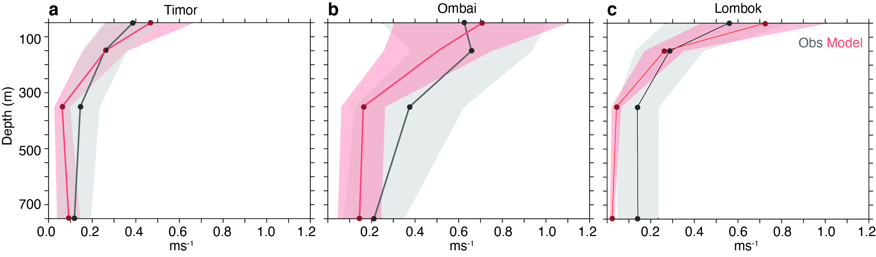
Fig. S1.
Model validation of ITF speeds. Plot of mean speed (solid lines) and its standard deviation (shaded) through (a) Timor (122.95°E, 11.36°S) (b) Ombai (125°E, 8.53°S) (c) Lombok strait (115.89°E, 8.4°S) from the control run (red, 2009-19) and INSTANT mooring observations (black, 2004-2006).

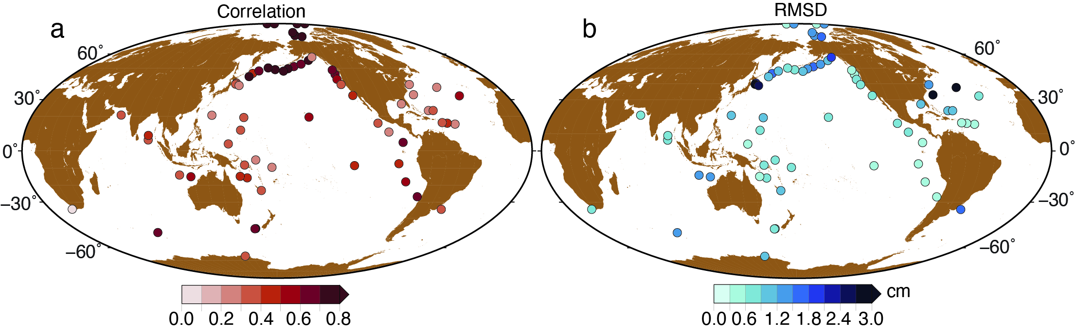
Fig. S2.
Model validation of EWDA. (a) Correlation (>90% significance) and (b) Root Mean Squared Deviation (RMSD) between intraseasonal EWDA from BPRs (>90% significance) and the control run at respective BPR locations during 2009-2019.

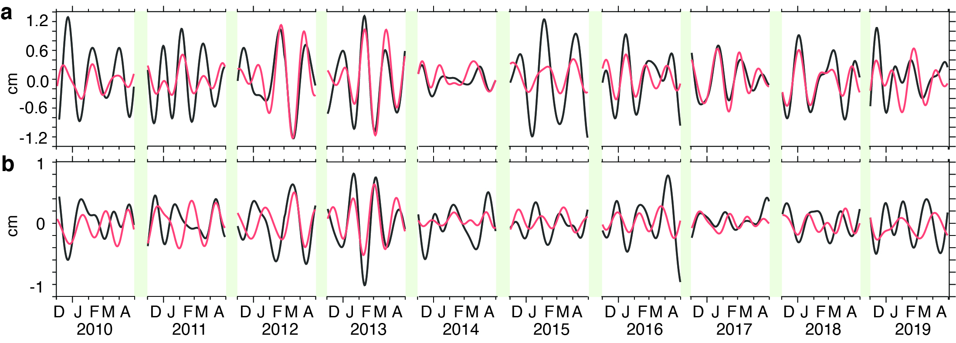

Fig. S3.
Basin-wide averaged EWDA. Plot of spatially averaged EWDA computed over (a) the Indian basin (red shaded region in Fig.2d) and (b) the Pacific basin (blue shaded region in Fig.2d) during December-April of 2009-2019 from the control run (black) and MC-EXP (red).

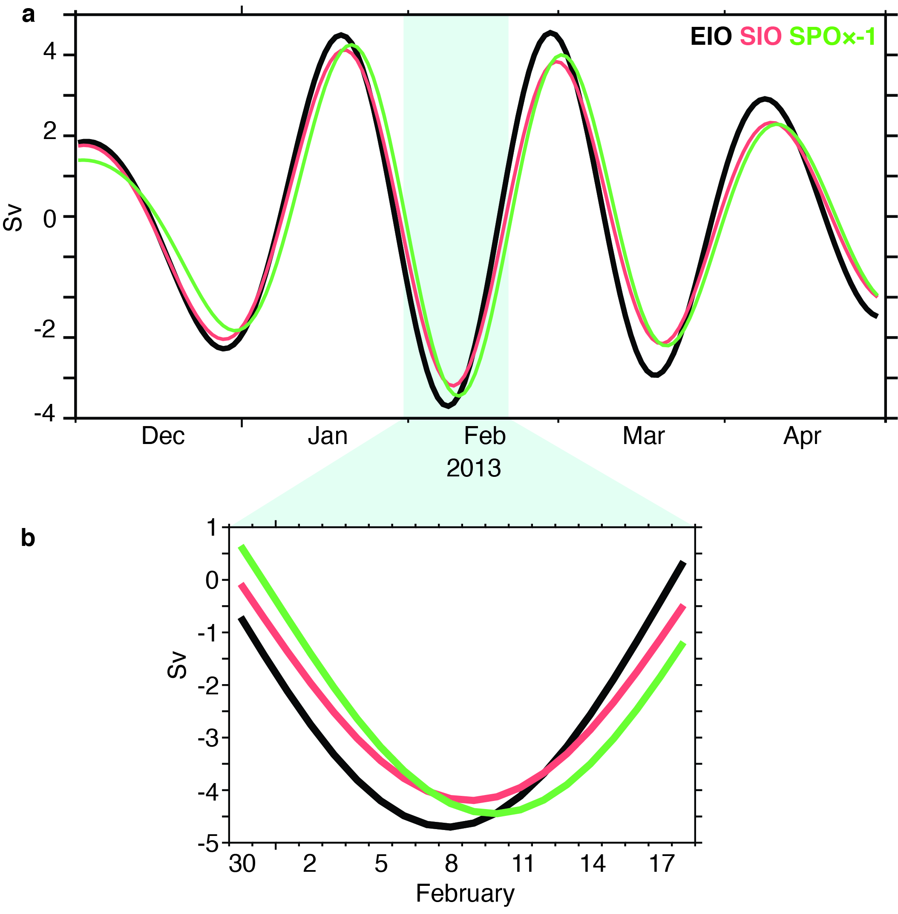

Fig. S4.
Volume transport : (a) Time series of intraseasonal volume transport (in Sv) across the control sections shown on Fig.2d, namely Eastern Indian Ocean (EIO, black curve), Southern Indian Ocean (SIO, red curve) and Southern Pacific Ocean (SPO, green curve, multiplied by -1 to illustrate the delay in phase) during December to April of 2012-13. (b) Inset of (a) for one peak event in February 2013.

