Combes et al. (2019)
Supplementary Material

Supplementary Text 1: list of the references used to identify the location of cold seeps in the North Atlantic and Mediterranean. A total of 41 cold seeps and mud volcanoes were located in the planning region.
Amon, D.J., Gobin, J., Van Dover, C.L., Levin, L.A., Marsh, L., Raineault, N.A., 2017. Characterization of Methane-Seep Communities in a Deep-Sea Area Designated for Oil and Natural Gas Exploitation Off Trinidad and Tobago. Frontiers in Marine Science 4 (342), https://doi.org/10.3389/fmars.2017.00342.
Bourque, J.R., Robertson, C.M., Brooke, S., Demopoulos, A.W.J., 2017. Macrofaunal communities associated with chemosynthetic habitats from the U.S. Atlantic margin: A comparison among depth and habitat types. Deep Sea Research Part II: Topical Studies in Oceanography 137, 42-55, https://doi.org/10.1016/j.dsr2.2016.04.012.
Neat, F.C., Jamieson, A.J., Stewart, H.A., Narayanaswamy, B.E., Collie, N., Stewart, M., Linley, T.D., 2018. Visual evidence of reduced seafloor conditions and indications of a cold-seep ecosystem from the Hatton–Rockall basin (NE Atlantic). Journal of the Marine Biological Association of the United Kingdom, 1-7, https://doi.org/10.1017/S0025315418000115.
Rodrigues, C.F., Hilário, A., Cunha, M.R., 2013. Chemosymbiotic species from the Gulf of Cadiz (NE Atlantic): distribution, life styles and nutritional patterns. Biogeosciences 10 (4), 2569-2581, https://doi.org/10.5194/bg-10-2569-2013.
Åström, E.K.L., Carroll, M.L., Ambrose Jr., W.G., Sen, A., Silyakova, A., Carroll, J., 2018. Methane cold seeps as biological oases in the high-Arctic deep sea. Limnology and Oceanography 63 (S1), S209-S231, https://doi.org/10.1002/lno.10732.
Sen, A., Duperron, S., Hourdez, S., Piquet, B., Léger, N., Gebruk, A., Le Port, A.-S., Svenning, M.M., Andersen, A.C., 2018. Cryptic frenulates are the dominant chemosymbiotrophic fauna at Arctic and high latitude Atlantic cold seeps. PloS One 13 (12), e0209273, https://doi.org/10.1371/journal.pone.0209273.
Decker, C., Olu, K., 2012. Habitat heterogeneity influences cold-seep macrofaunal communities within and among seeps along the Norwegian margin – Part 2: contribution of chemosynthesis and nutritional patterns. Marine Ecology 33 (2), 231-245, https://doi.org/10.1111/j.1439-0485.2011.00486.x.
Van Dover, C.L., Aharon, P., Bernhard, J.M., Caylor, E., Doerries, M., Flickinger, W., Gilhooly, W., Goffredi, S.K., Knick, K.E., Macko, S.A., Rapoport, S., Raulfs, E.C., Ruppel, C., Salerno, J.L., Seitz, R.D., Sen Gupta, B.K., Shank, T., Turnipseed, M., Vrijenhoek, R., 2003. Blake Ridge methane seeps: characterization of a soft-sediment, chemosynthetically based ecosystem. Deep Sea Research Part I: Oceanographic Research Papers 50 (2), 281-300, https://doi.org/10.1016/S0967-0637(02)00162-0.
Ritt, B., Sarrazin, J., Caprais, J.-C., Noël, P., Gauthier, O., Pierre, C., Henry, P., Desbruyères, D., 2010. First insights into the structure and environmental setting of cold-seep communities in the Marmara Sea. Deep Sea Research Part I: Oceanographic Research Papers 57 (9), 1120-1136, https://doi.org/10.1016/j.dsr.2010.05.011.
Ritt, B., Desbruyères, D., Caprais, J.C., Gauthier, O., Ruffine, L., Buscail, R., Olu-Le Roy, K., Sarrazin, J., 2012. Seep communities from two mud volcanoes in the deep eastern Mediterranean Sea: faunal composition, spatial patterns and environmental control. Marine Ecology Progress Series 466, 93-119, https://doi.org/10.3354/meps09896.
Ritt, B., Pierre, C., Gauthier, O., Wenzhöfer, F., Boetius, A., Sarrazin, J., 2011. Diversity and distribution of cold-seep fauna associated with different geological and environmental settings at mud volcanoes and pockmarks of the Nile Deep-Sea Fan. Marine Biology 158 (6), 1187-1210, https://doi.org/10.1007/s00227-011-1679-6.

Supplementary Figure 1: Known and probable VMEs used as conservation features.
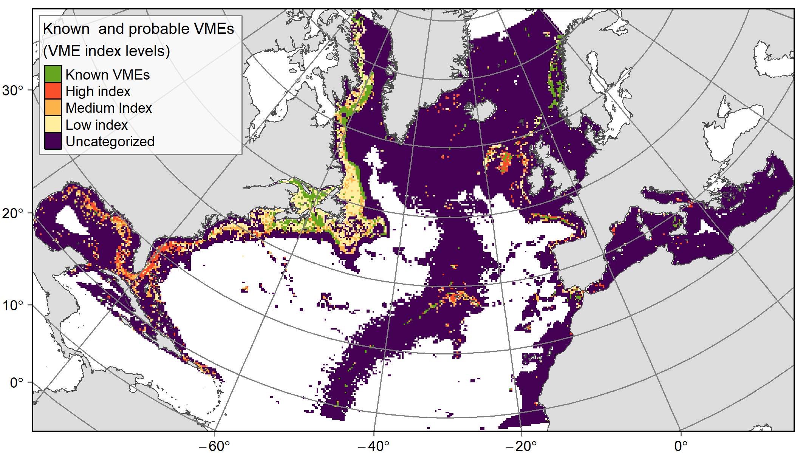
Figure 1. Known and probable VMEs used as conservation features. These areas were prioritized according to their VME likelihood: known VMEs (including hydrothermal vents) were highly prioritized (60% target), followed by probable VMEs with high likelihood index value (50% target), medium likelihood index value (30% target) and low likelihood index value (15%). Layers are available at: http://dx.doi.org/10.12770/3f14f4aa-ffaa-4152-865f-01be69048fce.

Supplementary Figure 2: Species richness calculated using the present habitat suitability predictions for the 7 invertebrate VME indicator species.
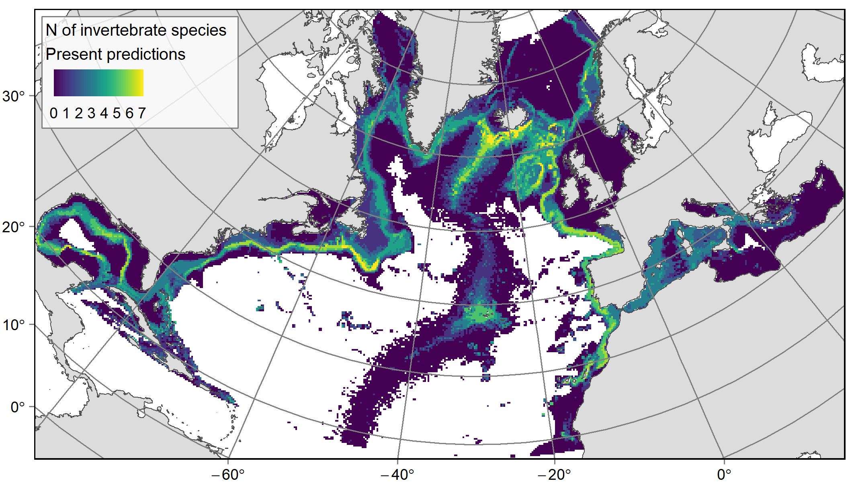
Figure 2. Species richness calculated using the present habitat suitability predictions for the 7 invertebrate VME indicator species used as conservation features. The values illustrate the number of species for which presence of suitable habitat was predicted in the PUs under present day environmental conditions. Note: individual maps for each species are available for download on the IFREMER spatial data server at http://dx.doi.org/10.12770/786ae295-0922-4616-b5e0-db799f387fcc .

Supplementary Figure 3: Species richness calculated using the future climate refugia predictions for the 7 invertebrate VME indicator species used as conservation features.
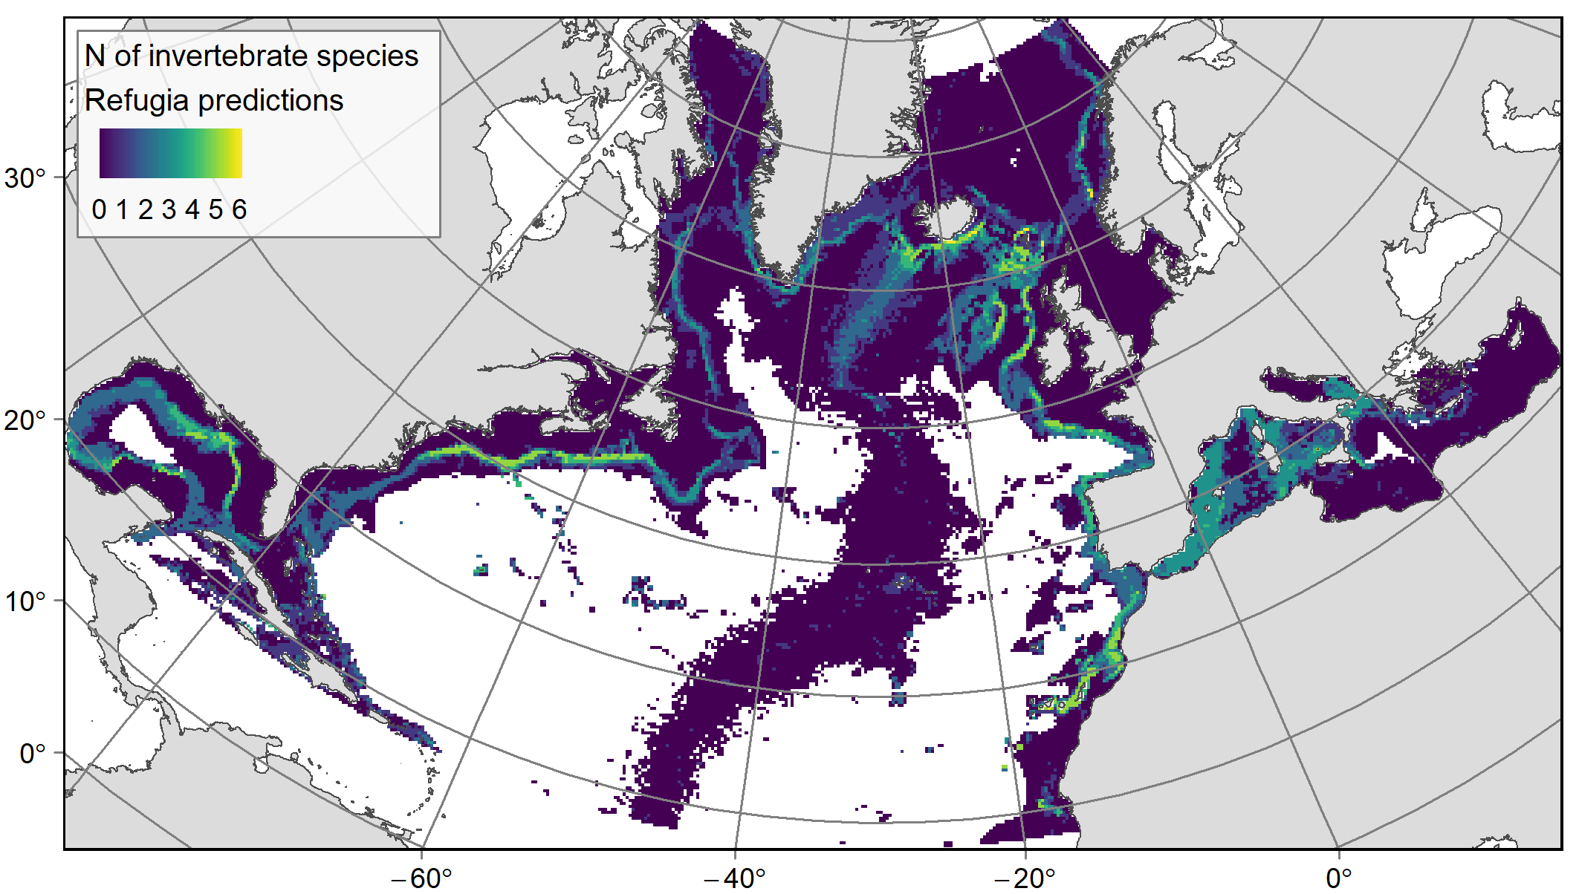
Figure 3. Species richness calculated using the future climate refugia predictions for the 7 invertebrate VME indicator species used as conservation features. The values illustrate the number of species for which presence of climate refugia (i.e. areas that are already suitable and that will remain suitable under future environmental conditions) was predicted in the PUs. Note: individual maps for each species are available for download on the IFREMER spatial data server at http://dx.doi.org/10.12770/786ae295-0922-4616-b5e0-db799f387fcc .

Supplementary Figure 4: Species richness calculated using the future climate refugia predictions for the 6 demersal fish species used as conservation features.
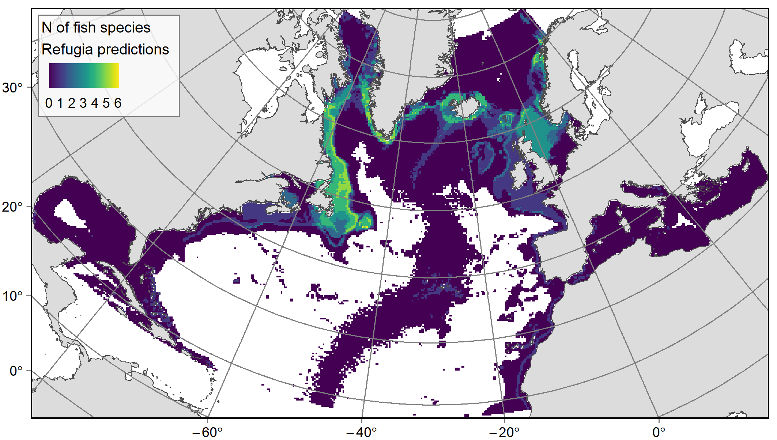
Figure 4. Species richness calculated using the future climate refugia predictions for the 6 demersal fish species used as conservation features. The values illustrate the number of species for which presence of climate refugia (i.e. areas that are already suitable and that will remain suitable under future environmental conditions) was predicted in the PUs. Note: individual maps for each species are available for download on the IFREMER spatial data server at http://dx.doi.org/10.12770/786ae295-0922-4616-b5e0-db799f387fcc .

Supplementary Figure 5: Geomorphotypes used as conservation features.
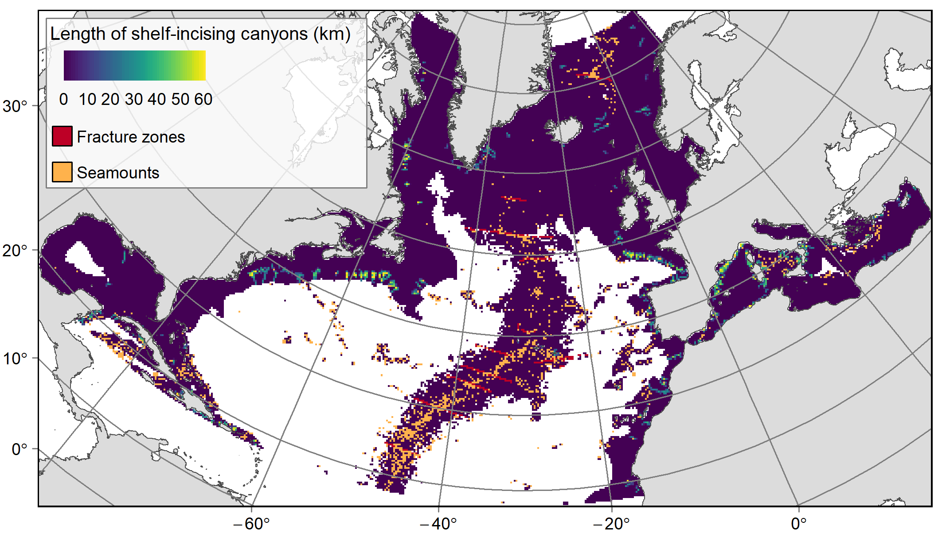
Figure 5. Geomorphotypes used as conservation features. Shelf-incising canyons were prioritized according to their length, while the presence of the feature was used for fracture zones and seamounts. Layers are available at: http://dx.doi.org/10.12770/66c5957b-6cb5-4fce-9ca5-1cb609fa39b5.

Supplementary Table 1: Representativity of features in the study area and coverage by conservation solutions and current protection measures
Table 1. Relative cover, conservation targets, and proportion of features included in priority areas and in currently protected or significant areas. The priority areas correspond to PUs selected at least in 50% or in 75% of selection frequency of the ‘management’ scenario. *: for canyons, their total length was calculated in PUs rather than their cover, thus the calculated proportions were based on length.
Feature | N of PUs  (% of study area) | Cons. target (%) | Priority areas (%) |  | Current protection measures (%)
 |  |  | ‘priority’  (≥ 50% of frequency) | ‘core priority’  ≥ 75% of frequency | Closures & reserves | Other MPAs | EBSAs
Fracture zones | 313 (0.99) | 60 | 53.67 | 31.63 | 11.78 | 2.14 | 6.56
Canyons | 30048km* in 1335 PUs (4.24) | 60 | 60.26* | 54.22* | 7.15* | 22.04* | 8.85*
Seamounts | 1561 (4.95) | 60 | 64.51 | 32.48 | 9.66 | 7.98 | 11.88
Unequivocal VMEs | 953 (3.02) | 60 | 64.22 | 44.7 | 15.61 | 7.26 | 3.3
VME index low | 1777 (5.64) | 15 | 28.53 | 9.23 | 5.43 | 15.11 | 2.43
VME index mid | 1029 (3.26) | 30 | 33.04 | 20.31 | 8.1 | 20.96 | 4.12
VME index high | 584 (1.85) | 50 | 45.89 | 31.85 | 16.54 | 23.3 | 2.23
Refugia Acanella arbuscula | 2321 (7.36) | 70 | 72.21 | 53.81 | 5.17 | 9.66 | 6.93
Refugia Acanthogorgia armata | 865 (2.74) | 80 | 83.93 | 71.56 | 4.06 | 16.58 | 1.79
Refugia Desmophyllum dianthus | 6775 (21.5) | 30 | 32.01 | 20.34 | 8.19 | 10.02 | 8.48
Refugia Lophelia pertusa | 2084 (6.61) | 70 | 74.42 | 50.43 | 5.64 | 14.31 | 11.57
Refugia Madrepora oculata | 4878 (15.48) | 30 | 36.88 | 23.35 | 7.66 | 12.01 | 7.98
Refugia Paragorgia arborea | 1 (0) | 80 | 100 | 100 | 0 | 0 | 0

Table 1 (continued)
Feature | N of PUs  (% of study area) | Cons. target (%) | Priority areas (%) |  | Current protection measures (%)
 |  |  | ‘priority’  (≥ 50% of frequency) | ‘core priority’  ≥ 75% of frequency | Closures & reserves | Other MPAs | EBSAs
Present-day Acanella arbuscula | 4281.8 (13.59) | 30 | 40.17 | 27.28 | 7.63 | 6.28 | 3.88
Present-day Acanthogorgia armata | 1831 (5.81) | 50 | 59.69 | 45.75 | 7.68 | 8.42 | 5.02
Present-day Desmophyllum dianthus | 4961.8 (15.74) | 30 | 32.59 | 20.83 | 8.11 | 9.78 | 6.78
Present-day Lophelia pertusa | 3496.5 (11.09) | 30 | 40.56 | 25.85 | 6.91 | 14.85 | 4.54
Present-day Madrepora oculata | 3944.6 (12.52) | 30 | 34.81 | 21.29 | 7.12 | 15.41 | 7.39
Present-day Paragorgia arborea | 2054.2 (6.52) | 50 | 58.8 | 34.02 | 5.72 | 3.49 | 1.51
Refugia Coryphaenoides rupestris | 2424 (7.69) | 50 | 58.5 | 41.21 | 10.57 | 3.73 | 3.78
Refugia Gadus morhua | 2402 (7.62) | 50 | 57.99 | 23.77 | 2.48 | 2.89 | 0.23
Refugia Helicolenus dactylopterus | 3319 (10.53) | 30 | 39.14 | 19.83 | 3.04 | 17.75 | 1.94
Refugia Hippoglossoides platessoides | 2702 (8.57) | 50 | 57.03 | 26.2 | 2.88 | 2.25 | 0.36
Refugia Reinhardtius hippoglossoides | 2080 (6.6) | 50 | 52.55 | 28.8 | 6.51 | 1.78 | 2.06
Refugia Sebastes mentella | 1712 (5.43) | 50 | 62.5 | 36.16 | 7.38 | 0.55 | 2.23
Refugia Geodia barretti | 1160 (3.68) | 80 | 89.05 | 60.6 | 5.63 | 2.18 | 1.59
Present-day Geodia barretti | 1944.1 (6.17) | 50 | 63.95 | 39.36 | 8.43 | 1.41 | 3.34

Supplementary Figure 6: Protected areas and EBSAs.
Figure 6. Protected areas and EBSAs over the planning area. Note: in case of two categories overlapping (e.g. an MPA within an EBSA), the category providing the higher protection level (e.g. the MPA) was kept for the considered area. The location and name of the main MPAs or EBSAs designed for protecting VMEs are displayed. Acronyms: FRA: Fisheries Restricted Area; GFCM: General Fisheries Commission for the Mediterranean; HAPC: deepwater coral Habitat Areas of Particular Concern; NAFO: NorthWest Atlantic Fisheries Organization; NEAFC: North-East Atlantic Fisheries Commission; SAFMC: South Atlantic Fish Management Council. Layer available at: http://dx.doi.org/10.12770/debcbd09-4a36-48f3-a7c8-38f313eedd1b.

Supplementary Figure 7: Fishing catch index and deep-sea mining exploration contracts.
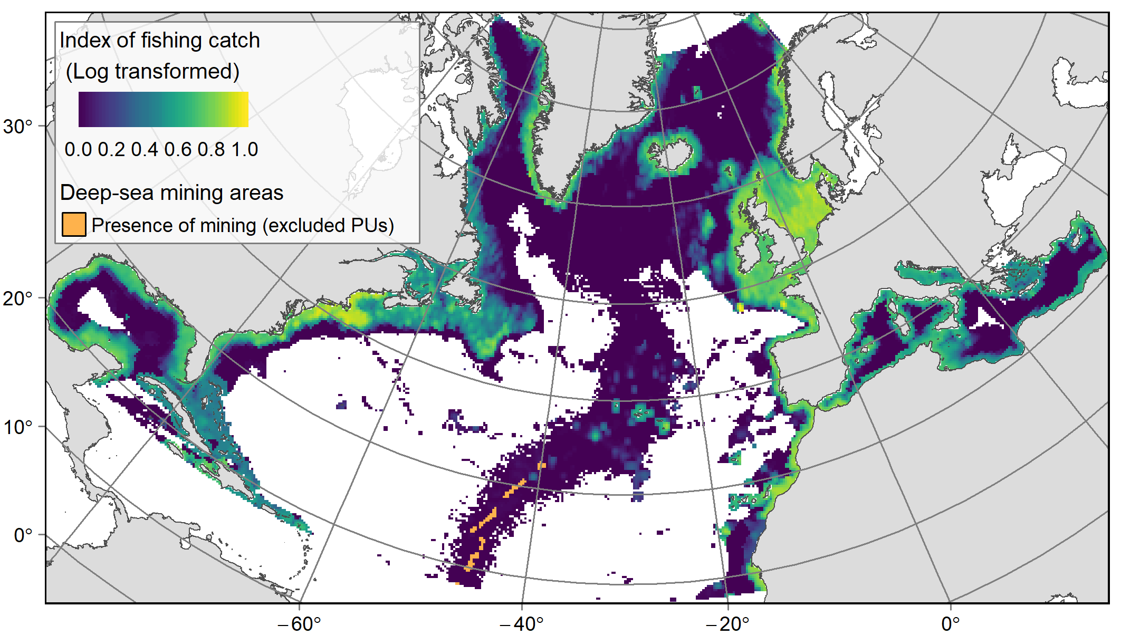
Figure 7. Fishing catch index, calculated over the 2010-2015 period from fisheries using bottom towed gears (dredges, bottom trawls, and Danish seines), and location of deep-sea mining exploration contracts. Layer are available at: http://dx.doi.org/10.12770/79f078bf-7f80-4efc-a5b4-9e01609b6a51; and http://dx.doi.org/10.12770/4ab2fb42-ba5b-418d-9675-a642edfaca70.

Supplementary Figure 8: Evolution of the cost of solutions through solving
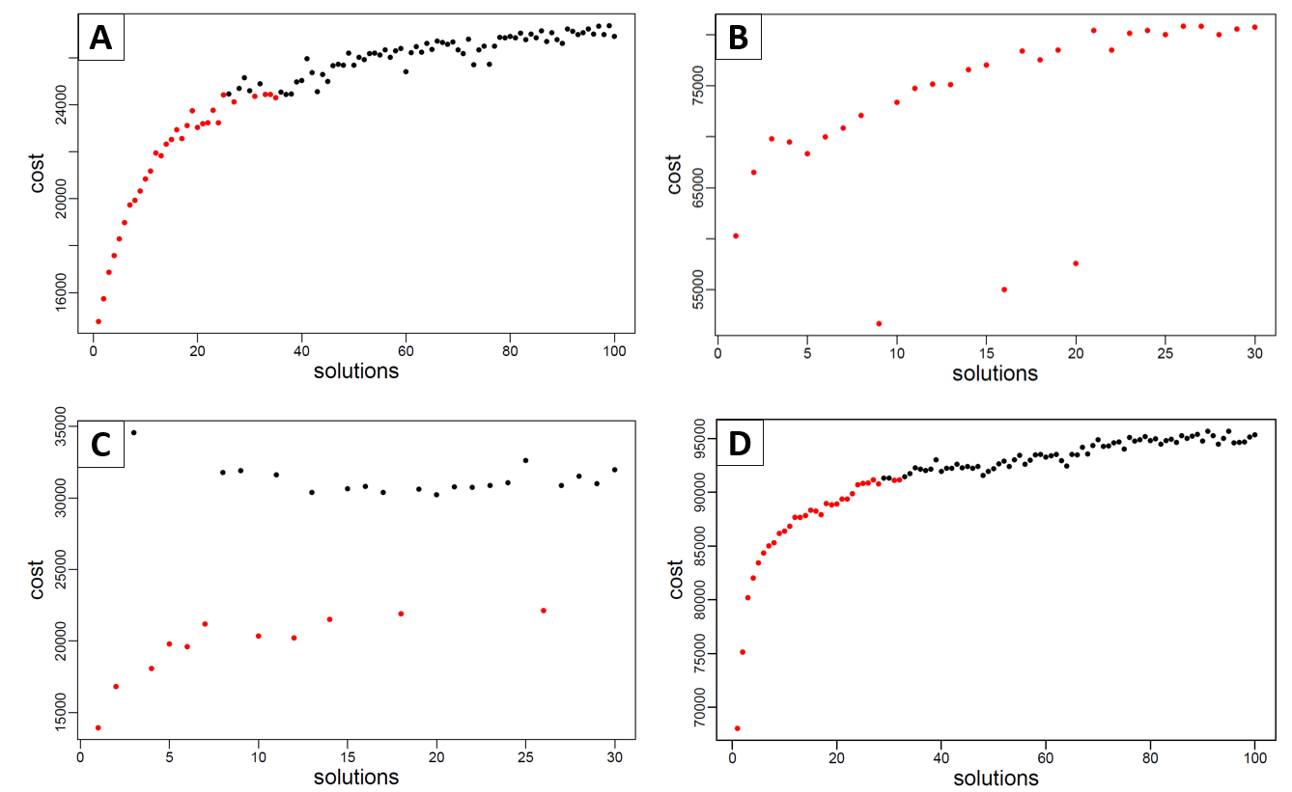
Figure 8. Cost of all the solutions, ordered by solving iterations, for the scenarios ‘base’ (A), ‘base - small planning area’ (B), ‘connectivity’ (C), ‘management’ (D). The solutions selected to calculate selection frequencies, with the lower cost (A, B, D), or that did not reach the solving time limit (C) are displayed in red.

