Supporting Information

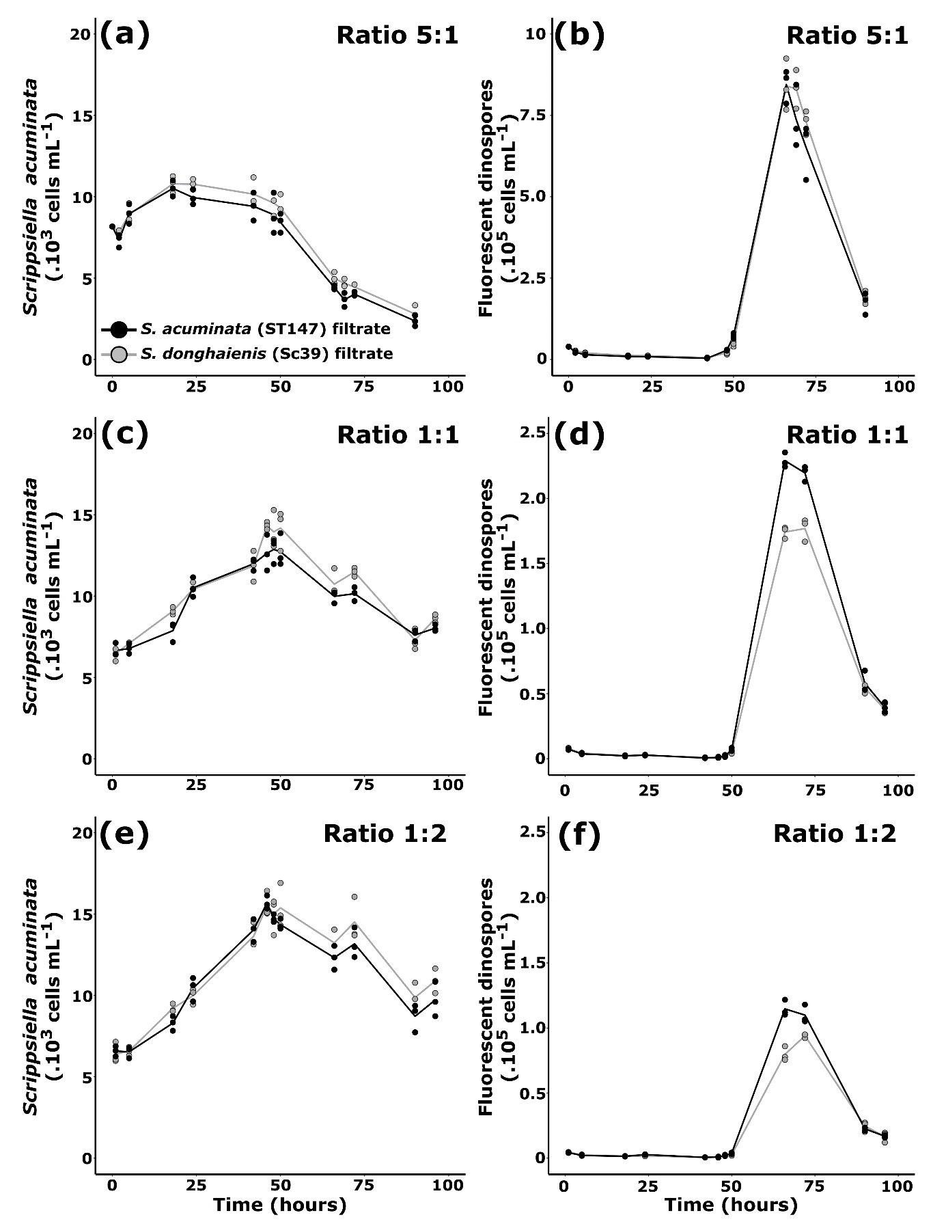

Figure S2: Effect of Sc39 S. donghaienis filtrates (Theoretical cell concentration = 7000 cells ml⁻¹ for (a) and (b), 10000 cells mL⁻¹ for (c, d, e, f) on the infectivity of A25 dinospores to S. acuminata (ST147). Infections were performed at three different dinospores: S. acuminata ratios; 5:1(a, b),1:1 (C and D) and 1:2 (e, f). The densities of the host ST147 during the infection cycle are shown in graphs (a, c, e). The density of fluorescent dinospores are shown in graphs (b, d, f). The controls (Filtrate ST147) are shown in black while the conditions in presence of Sc39 filtrate are shown in grey.

