Supplementary Information for
Moving reference point goalposts and implications for fisheries sustainability

Paula Silvar-Viladomiu¹, Cóilín Minto¹, Ghassen Halouani^{1,2}, Luke Batts¹, Deirdre Brophy¹, Colm Lordan³, David G. Reid³.
¹Galway-Mayo Institute of Technology GMIT, Dublin road, Galway, Ireland.
2IFREMER, Unité halieutique Manche Mer du Nord Ifremer, HMMN, F62200 Boulogne sur mer, France.
³Marine Institute, Rinville, Oranmore, Co. Galway, Ireland.

*Paula Silvar-Viladomiu.
Email: paula.silvarviladomiu@research.gmit.ie

This PDF file includes:

Tables SI1 to SI2
Figures SI1 to SI10

Table SI1. Table with the list of events of change in reference points. The super-indexes represent: 1, stocks with no comparable reference points (i.e. use of a different definition of F); 2, stocks with substituted relative reference point for their absolute value; 3, duplicated stock. Asterisks for relative reference points or substituted values. The events 1 and 3 were removed from the analysis.

ID | event | F_{MSY} (y-1) | F_{MSY} (y) | MSYB_{trigger} (y-1) | MSYB_{trigger} (y) | Stock Key Description | Scientific name | Abbreviated name
1 | ank.27.8c9a 2012¹ | 0.43 | 1.00* | NA | NA | Black-bellied anglerfish in divisions 8.c and 9.a (Cantabrian Sea, Atlantic Iberian waters) | Lophius budegassa | Black-bellied anglerfish in CaS,AI
2 | bli.27.5b67 2016 | 0.07 | 0.12 | NA | NA | Blue ling in subareas 6-7 and Division 5.b (Celtic Seas, English Channel, and Faroes grounds) | Molva dypterygia | Blue ling in CS,EC,FG
3 | bss.27.4bc7ad-h 2016 | NA | NA | 8000 | 12673 | Seabass in Divisions 4.b-c, 7.a, and 7.d-h (central and southern North Sea, Irish Sea, English Channel, Bristol Channel, and Celtic Sea) | Dicentrarchus labrax | Seabass in NS,IS,EC,BC,CS
4 | bss.27.4bc7ad-h 2018 | NA | NA | 12673 | 13465 | Seabass in Divisions 4.b-c, 7.a, and 7.d-h (central and southern North Sea, Irish Sea, English Channel, Bristol Channel, and Celtic Sea) | Dicentrarchus labrax | Seabass in NS,IS,EC,BC,CS
5 | bss.27.4bc7ad-h 2019 | 0.20 | 0.17 | 13465 | 14439 | Seabass in Divisions 4.b-c, 7.a, and 7.d-h (central and southern North Sea, Irish Sea, English Channel, Bristol Channel, and Celtic Sea) | Dicentrarchus labrax | Seabass in NS,IS,EC,BC,CS
6 | cod.27.22-24 2012 | 0.24 | 0.25 | NA | NA | Cod in subdivisions 22-24, western Baltic stock (western Baltic Sea) | Gadus morhua | Cod in wBS
7 | cod.27.22-24 2014 | 0.25 | 0.26 | 23000 | 36400 | Cod in subdivisions 22-24, western Baltic stock (western Baltic Sea) | Gadus morhua | Cod in wBS
8 | cod.27.22-24 2015 | NA | NA | 36400 | 38400 | Cod in subdivisions 22-24, western Baltic stock (western Baltic Sea) | Gadus morhua | Cod in wBS
9 | cod.27.22-24 2019 | NA | NA | 38400 | 21876 | Cod in subdivisions 22-24, western Baltic stock (western Baltic Sea) | Gadus morhua | Cod in wBS
10 | cod.27.24-32 2013 | 0.30 | 0.46 | NA | NA | Cod in subdivisions 24-32, eastern Baltic stock (eastern Baltic Sea) | Gadus morhua | Cod in eBS
11 | cod.27.47d20 2015 | 0.19 | 0.33 | 150000 | 165000 | Cod in Subarea 4, Division 7.d, and Subdivision 20 (North Sea, eastern English Channel, Skagerrak) | Gadus morhua | Cod in NS,eEC,S
12 | cod.27.47d20 2017 | 0.33 | 0.31 | 165000 | 150000 | Cod in Subarea 4, Division 7.d, and Subdivision 20 (North Sea, eastern English Channel, Skagerrak) | Gadus morhua | Cod in NS,eEC,S
13 | cod.27.5b1 2017 | 0.32 | 0.23 | 40000 | 29226 | Codin Subdivision 5.b.1 (Faroe Plateau) | Gadus morhua | Cod in FP
14 | cod.27.6a 2016 | 0.19 | 0.17 | 22000 | 20000 | Cod in Division 6.a (West of Scotland) | Gadus morhua | Cod in WS
15 | cod.27.6a 2019 | 0.17 | 0.29 | NA | NA | Cod in Division 6.a (West of Scotland) | Gadus morhua | Cod in WS
16 | cod.27.7a 2016 | 0.40 | 0.37 | NA | NA | Cod in Division 7.a (Irish Sea) | Gadus morhua | Cod in IS
17 | cod.27.7a 2017 | 0.37 | 0.31 | 10000 | 8616 | Cod in Division 7.a (Irish Sea) | Gadus morhua | Cod in IS
18 | cod.27.7a 2018 | 0.31 | 0.44 | NA | NA | Cod in Division 7.a (Irish Sea) | Gadus morhua | Cod in IS
19 | cod.27.7e-k 2015 | 0.40 | 0.32 | NA | NA | Cod in divisions 7.e-k (eastern English Channel and southern Celtic Seas) | Gadus morhua | Cod in eEC,CS
20 | cod.27.7e-k 2016 | 0.32 | 0.35 | NA | NA | Cod in divisions 7.e-k (eastern English Channel and southern Celtic Seas) | Gadus morhua | Cod in eEC,CS
21 | dgs.27.nea 2016 | NA | NA | 963700 | 964563 | Spurdog in Subareas 1-10, 12 and 14 (the Northeast Atlantic and adjacent waters) | Squalus acanthias | Spurdog in NA
22 | dgs.27.nea 2018 | NA | NA | 964563 | 683340 | Spurdog in Subareas 1-10, 12 and 14 (the Northeast Atlantic and adjacent waters) | Squalus acanthias | Spurdog in NA
23 | had.27.46a20 2017 | 0.30 | 0.19 | NA | NA | Haddock in Subarea 4, Division 6.a, and Subdivision 20 (North Sea, West of Scotland, Skagerrak) | Melanogrammus aeglefinus | Haddock in NS,WS,S
24 | had.27.6a 2017³ | 0.30 | 0.19 | NA | NA | Haddock in Division 6.a | Melanogrammus aeglefinus | Haddock in NS
25 | had.27.5b 2017 | 0.25 | 0.16 | 35000 | 22843 | Haddock in Division 5.b (Faroes grounds) | Melanogrammus aeglefinus | Haddock in FG
26 | had.27.6b 2014 | 0.30 | 0.20 | NA | NA | Haddock in Division 6.b (Rockall) | Melanogrammus aeglefinus | Haddock in R
27 | had.27.6b 2016 | NA | NA | 9000 | 10200 | Haddock in Division 6.b (Rockall) | Melanogrammus aeglefinus | Haddock in R
28 | had.27.6b 2019 | 0.20 | 0.17 | 10200 | 3712 | Haddock in Division 6.b (Rockall) | Melanogrammus aeglefinus | Haddock in R
29 | had.27.7a 2017 | NA | NA | 3093 | 2944 | Haddock in Division 7.a (Irish Sea) | Melanogrammus aeglefinus | Haddock in IS
30 | had.27.7a 2018 | 0.27 | 0.28 | 2944 | 4280 | Haddock in Division 7.a (Irish Sea) | Melanogrammus aeglefinus | Haddock in IS
31 | had.27.7b-k 2014 | 0.28 | 0.33 | NA | NA | Haddock in Divisions 7.b-k (southern Celtic Seas and English Channel) | Melanogrammus aeglefinus | Haddock in CS,EC
32 | had.27.7b-k 2015 | 0.33 | 0.40 | 7500 | 10000 | Haddock in Divisions 7.b-k (southern Celtic Seas and English Channel) | Melanogrammus aeglefinus | Haddock in CS,EC
33 | her.27.1-24a514a 2018 | 0.15 | 0.16 | 5000000 | 3184000 | Herring in subareas 1, 2, 5 and divisions 4.a and 14.a, Norwegian spring-spawning herring (the Northeast Atlantic and Arctic Ocean) | Clupea harengus | Herring in NA,AO
34 | her.27.20-24 2015 | 0.28 | 0.32 | NA | NA | Herring in subdivisions 20-24, spring spawners (Skagerrak, Kattegat, and western Baltic) | Clupea harengus | Herring in S,K,wBS
35 | her.27.20-24 2018 | 0.32 | 0.31 | 110000 | 150000 | Herring in subdivisions 20-24, spring spawners (Skagerrak, Kattegat, and western Baltic) | Clupea harengus | Herring in S,K,wBS
36 | her.27.25-2932 2013 | 0.16 | 0.26 | NA | NA | Herring in subdivisions 25-29 and 32, excluding the Gulf of Riga (central Baltic Sea) | Clupea harengus | Herring in cBS
37 | her.27.25-2932 2015 | 0.26 | 0.22 | NA | NA | Herring in subdivisions 25-29 and 32, excluding the Gulf of Riga (central Baltic Sea) | Clupea harengus | Herring in cBS
38 | her.27.28 2015 | 0.35 | 0.32 | NA | NA | Herring in Subdivision 28.1 (Gulf of Riga) | Clupea harengus | Herring in GR
39 | her.27.3031 2013 | 0.19 | 0.15 | 200000 | 316000 | Herring in Subdivisions 30 and 31 (Gulf of Bothnia) | Clupea harengus | Herring in GB
40 | her.27.3031 2017 | 0.15 | 0.21 | 316000 | 283180 | Herring in Subdivisions 30 and 31 (Gulf of Bothnia) | Clupea harengus | Herring in GB
41 | her.27.3a47d 2016 | 0.27 | 0.33 | NA | NA | Herring in Subarea 4 and divisions 3.a and 7.d, autumn spawners (North Sea, Skagerrak and Kattegat, eastern English Channel) | Clupea harengus | Herring in NS,S,K,eEC
42 | her.27.3a47d 2018 | 0.33 | 0.26 | 1500000 | 1400000 | Herring in Subarea 4 and divisions 3.a and 7.d, autumn spawners (North Sea, Skagerrak and Kattegat, eastern English Channel) | Clupea harengus | Herring in NS,S,K,eEC
43 | her.27.6a7bc 2017² | 0.25* | 0.16 | NA | NA | Herring in divisions 6.a and 7.b-c (West of Scotland, West of Ireland) | Clupea harengus | Herring in WS,WI
44 | her.27.irls 2014 | 0.25 | 0.37 | NA | NA | Herring in divisions 7.a South of 52°30’N, 7.g-h, and 7.j-k (Irish Sea, Celtic Sea, and southwest of Ireland) | Clupea harengus | Herring in IS,CS
45 | her.27.irls 2015 | 0.37 | 0.26 | 61000 | 54000 | Herring in divisions 7.a South of 52°30’N, 7.g-h, and 7.j-k (Irish Sea, Celtic Sea, and southwest of Ireland) | Clupea harengus | Herring in IS,CS
46 | her.27.nirs 2017 | NA | NA | 9500 | 11800 | Herring in Division 7.a North of 52°30’N (Irish Sea) | Clupea harengus | Herring in IS
47 | hke.27.3a46-8abd 2014 | 0.24 | 0.27 | NA | NA | Hake in subareas 4, 6, and 7, and divisions 3.a, 8.a-b, and 8.d, Northern stock (Greater North Sea, Celtic Seas, and the northern Bay of Biscay) | Merluccius merluccius | Hake in NS,CS,nBB
48 | hke.27.3a46-8abd 2016 | 0.27 | 0.28 | 46200 | 45000 | Hake in subareas 4, 6, and 7, and divisions 3.a, 8.a-b, and 8.d, Northern stock (Greater North Sea, Celtic Seas, and the northern Bay of Biscay) | Merluccius merluccius | Hake in NS,CS,nBB
49 | hke.27.3a46-8abd 2019 | 0.28 | 0.27 | 45000 | 56000 | Hake in subareas 4, 6, and 7, and divisions 3.a, 8.a-b, and 8.d, Northern stock (Greater North Sea, Celtic Seas, and the northern Bay of Biscay) | Merluccius merluccius | Hake in NS,CS,nBB
50 | hke.27.8c9a 2016 | 0.24 | 0.25 | NA | NA | Hake in divisions 8.c and 9.a, Southern stock (Cantabrian Sea and Atlantic Iberian waters) | Merluccius merluccius | Hake in CaS,AI
51 | hom.27.2a4a5b6a7a-ce-k8 2017 | 0.13 | 0.11 | 634577 | 911588 | Horse mackerel in Subarea 8 and divisions 2.a, 4.a, 5.b, 6.a, 7.a-c,e-k (the Northeast Atlantic) | Trachurus trachurus | Horse mackerel in NA
52 | hom.27.2a4a5b6a7a-ce-k8 2019 | 0.11 | 0.07 | 911587 | 1168270 | Horse mackerel in Subarea 8 and divisions 2.a, 4.a, 5.b, 6.a, 7.a-c,e-k (the Northeast Atlantic) | Trachurus trachurus | Horse mackerel in NA
53 | ldb.27.8c9a 2014 | 0.18 | 0.17 | NA | NA | Four-spot megrim in divisions 8.c and 9.a (southern Bay of Biscay and Atlantic Iberian waters East) | Lepidorhombus boscii | Megrim in sBB,AI
54 | ldb.27.8c9a 2016 | 0.17 | 0.19 | NA | NA | Four-spot megrim in divisions 8.c and 9.a (southern Bay of Biscay and Atlantic Iberian waters East) | Lepidorhombus boscii | Megrim in sBB,AI
55 | mac.27.nea 2015 | 0.25 | 0.22 | NA | NA | Mackerel in subareas 1-8 and 14 and division 9.a (the Northeast Atlantic and adjacent waters) | Scomber scombrus | Mackerel in NA
56 | mac.27.nea 2017 | 0.22 | 0.21 | 3000000 | 2570000 | Mackerel in subareas 1-8 and 14 and division 9.a (the Northeast Atlantic and adjacent waters) | Scomber scombrus | Mackerel in NA
57 | mac.27.nea 2018 | 0.21 | 0.23 | 2570000 | 2500000 | Mackerel in subareas 1-8 and 14 and division 9.a (the Northeast Atlantic and adjacent waters) | Scomber scombrus | Mackerel in NA
58 | meg.27.8c9a 2016 | 0.17 | 0.19 | 910 | 980 | Megrim in divisions 8.c and 9.a (Cantabrian Sea and Atlantic Iberian waters) | Lepidorhombus whiffiagonis | Megrim in CaS,AI
59 | mon.27.8c9a 2016 | 0.19 | 0.31 | NA | NA | White anglerfish in divisions 8.c and 9.a (Cantabrian Sea and Atlantic Iberian waters) | Lophius piscatorius | White anglerfish in CaS,AI
60 | mon.27.8c9a 2018 | 0.31 | 0.24 | 5400 | 6283 | White anglerfish in divisions 8.c and 9.a (Cantabrian Sea and Atlantic Iberian waters) | Lophius piscatorius | White anglerfish in CaS,AI
61 | pil.27.8c9a 2019 | 0.12 | 0.03 | 446331 | 252523 | Sardine in divisions 8.c and 9.a (Cantabrian Sea and Atlantic Iberian waters) | Sardina pilchardus | Sardine in CaS,AI
62 | ple.27.420 2015 | 0.25 | 0.19 | NA | NA | Plaice in Subarea 4 (North Sea) and Subdivision 20 (Skagerrak) | Pleuronectes platessa | Plaice in NS,S
63 | ple.27.420 2017 | 0.19 | 0.21 | 230000 | 564599 | Plaice in Subarea 4 (North Sea) and Subdivision 20 (Skagerrak) | Pleuronectes platessa | Plaice in NS,S
64 | ple.27.7a 2019 | 0.17 | 0.20 | 10392 | 8757 | Plaice in Division 7.a (Irish Sea) | Pleuronectes platessa | Plaice in IS
65 | ple.27.7d 2015² | 0.15* | 0.25 | NA | NA | Plaice in Division 7.d (eastern English Channel) | Pleuronectes platessa | Plaice in eEC
66 | ple.27.7e 2015^{1,2} | 0.24 | 0.56* | 1650 | 2400* | Plaice in Division 7.e (western English Channel) | Pleuronectes platessa | Plaice in wEC
67 | pok.27.3a46 2015 | 0.30 | 0.32 | NA | NA | Saithe in Subareas 4, 6 and Division 3.a (North Sea, Rockall and West of Scotland, Skagerrak and Kattegat) | Pollachius virens | Saithe in NS,R,WS,S,K
68 | pok.27.3a46 2016 | 0.32 | 0.36 | 200000 | 150000 | Saithe in Subareas 4, 6 and Division 3.a (North Sea, Rockall and West of Scotland, Skagerrak and Kattegat) | Pollachius virens | Saithe in NS,R,WS,S,K
69 | pok.27.3a46 2019 | 0.36 | 0.36 | NA | NA | Saithe in Subareas 4, 6 and Division 3.a (North Sea, Rockall and West of Scotland, Skagerrak and Kattegat) | Pollachius virens | Saithe in NS,R,WS,S,K
70 | pok.27.5b 2014 | 0.28 | 0.30 | NA | NA | Saithe in Division 5.b (Faroes grounds) | Pollachius virens | Saithe in FG
71 | pok.27.5b 2017 | NA | NA | 55000 | 41400 | Saithe in Division 5.b (Faroes grounds) | Pollachius virens | Saithe in FG
72 | pra.27.3a4a 2015¹ | 1.00 | 0.62 | NA | NA | Northern shrimp in divisions 3.a and 4.a East (Skagerrak and Kattegat and northern North Sea in the Norwegian Deep) | Pandalus borealis | Northern shrimp in S,K,NS
73 | pra.27.3a4a 2019 | 0.62 | 0.60 | NA | NA | Northern shrimp in divisions 3.a and 4.a East (Skagerrak and Kattegat and northern North Sea in the Norwegian Deep) | Pandalus borealis | Northern shrimp in S,K,NS
74 | sol.27.20-24 2013 | 0.38 | 0.30 | NA | NA | Sole in subdivisions 20-24 (Skagerrak and Kattegat, western Baltic Sea) | Solea solea | Sole in S,K,wBS
75 | sol.27.20-24 2014 | 0.30 | 0.32 | NA | NA | Sole in subdivisions 20-24 (Skagerrak and Kattegat, western Baltic Sea) | Solea solea | Sole in S,K,wBS
76 | sol.27.20-24 2015 | 0.32 | 0.23 | 2000 | 2600 | Sole in subdivisions 20-24 (Skagerrak and Kattegat, western Baltic Sea) | Solea solea | Sole in S,K,wBS
77 | sol.27.4 2015 | 0.22 | 0.20 | 35000 | 37000 | Sole in Subarea 4 (North Sea) | Solea solea | Sole in NS
78 | sol.27.7a 2016 | 0.16 | 0.20 | 3100 | 3500 | Sole in Division 7.a (Irish Sea) | Solea solea | Sole in IS
79 | sol.27.7d 2015 | 0.29 | 0.30 | NA | NA | Sole in Division 7.d (eastern English Channel) | Solea solea | Sole in eEC
80 | sol.27.7d 2017 | 0.30 | 0.26 | 8000 | 19251 | Sole in Division 7.d (eastern English Channel) | Solea solea | Sole in eEC
81 | sol.27.7d 2019² | 0.26 | 0.19* | 19251 | 1572* | Sole in Division 7.d (eastern English Channel) | Solea solea | Sole in eEC
82 | sol.27.7e 2016 | 0.27 | 0.29 | 2800 | 2900 | Sole in Division 7.e (western English Channel) | Solea solea | Sole in wEC
83 | sol.27.7fg 2016 | 0.31 | 0.27 | 2200 | 2400 | Sole in divisions 7.f and 7.g (Bristol Channel, Celtic Sea) | Solea solea | Sole in BC,CS
84 | sol.27.7fg 2019 | 0.27 | 0.30 | 2400 | 2228 | Sole in divisions 7.f and 7.g (Bristol Channel, Celtic Sea) | Solea solea | Sole in BC,CS
85 | sol.27.8ab 2016 | 0.26 | 0.33 | 13000 | 10600 | Sole in divisions 8.a-b (northern and central Bay of Biscay) | Solea solea | Sole in BB
86 | spr.27.22-32 2013 | 0.35 | 0.29 | NA | NA | Sprat in Subdivisions 22-32 (Baltic Sea) | Sprattus sprattus | Sprat in BS
87 | spr.27.22-32 2015 | 0.29 | 0.26 | NA | NA | Sprat in Subdivisions 22-32 (Baltic Sea) | Sprattus sprattus | Sprat in BS
88 | spr.27.4 2015 | 1.20 | 0.70 | NA | NA | Sprat in Subarea 4 (North Sea) | Sprattus sprattus | Sprat in NS
89 | whb.27.1-91214 2014 | 0.22 | 0.30 | NA | NA | Blue whiting in subareas 1-9, 12, and 14 (Northeast Atlantic and adjacent waters) | Micromesistius poutassou | Blue whiting in NA
90 | whb.27.1-91214 2016 | 0.30 | 0.32 | NA | NA | Blue whiting in subareas 1-9, 12, and 14 (Northeast Atlantic and adjacent waters) | Micromesistius poutassou | Blue whiting in NA
91 | whg.27.47d 2018 | 0.15 | 0.17 | 241837 | 166708 | Whiting in Subarea 4 and Division 7.d (North Sea and eastern English Channel) | Merlangius merlangus | Whiting in NS,eEC
92 | whg.27.7b-ce-k 2014 | 0.36 | 0.32 | 21000 | 40000 | Whiting in divisions 7.b-c and 7.e-k (southern Celtic Seas and eastern English Channel) | Merlangius merlangus | Whiting in CS,eEC
93 | whg.27.7b-ce-k 2016 | 0.32 | 0.52 | 40000 | 35000 | Whiting in divisions 7.b-c and 7.e-k (southern Celtic Seas and eastern English Channel) | Merlangius merlangus | Whiting in CS,eEC

Table SI2. Description of covariates.
 | Covariate | Definition
Common | (1) Revision_Assessment_Stock_definition | Revision of the stock definition. Occurrence of a modification of stock definition, e.g. stocks merged, separated, added divisions.
Common | (2) Revision_Assessment_input_data_  FisheriesDependent | Revision of assessment data fisheries dependent. Occurrence, e.g. inclusion, exclusion or revision of discard and commercial index, revision of weights at age.
Common | (3) Revision_Assessment_input_data_  FisheriesIndependent | Revision of assessment data fisheries independent. Occurrence, e.g. inclusion, exclusion or revision of survey index.
Common | (4) Revision_Assessment_maturity | Revision of assessment maturity. Occurrence of revision of maturity, e.g. updates, revised assumptions, modify estimation method.
Common | (5) Revision_Assessment_M | Revision of assessment natural mortality (M). Occurrence of revision of natural mortality parameter, e.g. multispecies model update of M, modification of assumptions or method to estimate M.
Common | (6) Revision_Assessment_methodology | Revision of assessment methodology. Occurrence of heterogeneous group of revisions comprising, e.g. modify settings and assumptions of the model, estimation improvements and corrections of the models, methodological updates and revision of age range for F.
Common | (7) Revision_Assessment_type | Revision of assessment type model. Categories of revision of the selected assessment model by levels of previous post modification of assessment model. Assessment types:  XSA -Extended Survivor Analysis  SAM -State-space assessment model  ADAPT -Age Structured Assessment Procedure  AartsPoos - Aarts and Poos Model  SS3 -Stock Synthesis 3
F_{MSY} | (8) Revision_RP_FMSY_definition | Revision of F_{MSY} definition of technical basis, categories specifying levels by previous post type of modifications. F_{MSY} definitions:  - F_{MSY}  - Proxies from per recruit analysis: F_{max}, F0.1, F_{SPR50%}, F_{SPR40%}, F_{SPR30%}, F_{SPR35%}  - F_{MSY} provisional derived from simulation frameworks  - F_{MSY} analogy from other stocks  - F_{P.05} upper F limit that is considered precautionary for MSY rules  - F_{PA} Precautionary approach fishing mortality
F_{MSY} | (9) Revision_RP_SR_functional_form | Revision of stock recruitment functional form or combination of forms selected to model the stock recruitment relationship. Occurrence of revision of the functional from used to estimate stock-recruitment relationship
F_{MSY} | (10) Revision_RP_input_timeseriesRecruitment | Revision of input recruitment time series to estimate the reference point. Occurrence of revision of the time-series of recruitment input for the estimation of F_{MSY}, e.g. shorter recruitment time series, longer recruitment window. ICES guidelines recommends full time series unless strong evidence exists that a consistent change has occurred.
F_{MSY} | (11) Revision_RP_input_parameterstimeseries | Revision of input parameters time series related to the productivity of the stock. Occurrence of revisions of time window of biological parameters (weights, maturity, natural mortality) or fishery parameters (selectivity) imputed to estimate F_{MSY}, ICES guidelines recommend by default be derived from the last 10 years but it can be shortened (5 years) when persistent trends are present or longed, when there is no evidence of temporal trends.
MSB_{trigger} | (12) Revision_RP_MSYBtrigger_tb | Revision of MSYB_{trigger} technical basis. Categories with levels of specific re-evaluations of MSYB_{trigger} technical basis. For instance, some technical basis of MSYB_{trigger} can be:  • B_{pa}  • MSYB_{trigger} as the 5th percentile on the distribution of SSB when fishing at F_{MSY}  • Other stock specific
MSB_{trigger} | (13) Revision_RP_Blim_tb | Revision of B_{lim} technical basis. Categories with levels of specific re-evaluations of B_{lim} technical basis. The selection of Blim depends on the type of stock recruitment relationship. For instance, some technical basis of B_{lim} can be:  • B_{loss}  • Break point of the segmented regression  • Other stock specific
MSB_{trigger} | (14) Revision_RP_Bpa_tb | Occurrence revision of B_{pa} technical basis e.g. revision of technical basis or how uncertainty is taken into account.

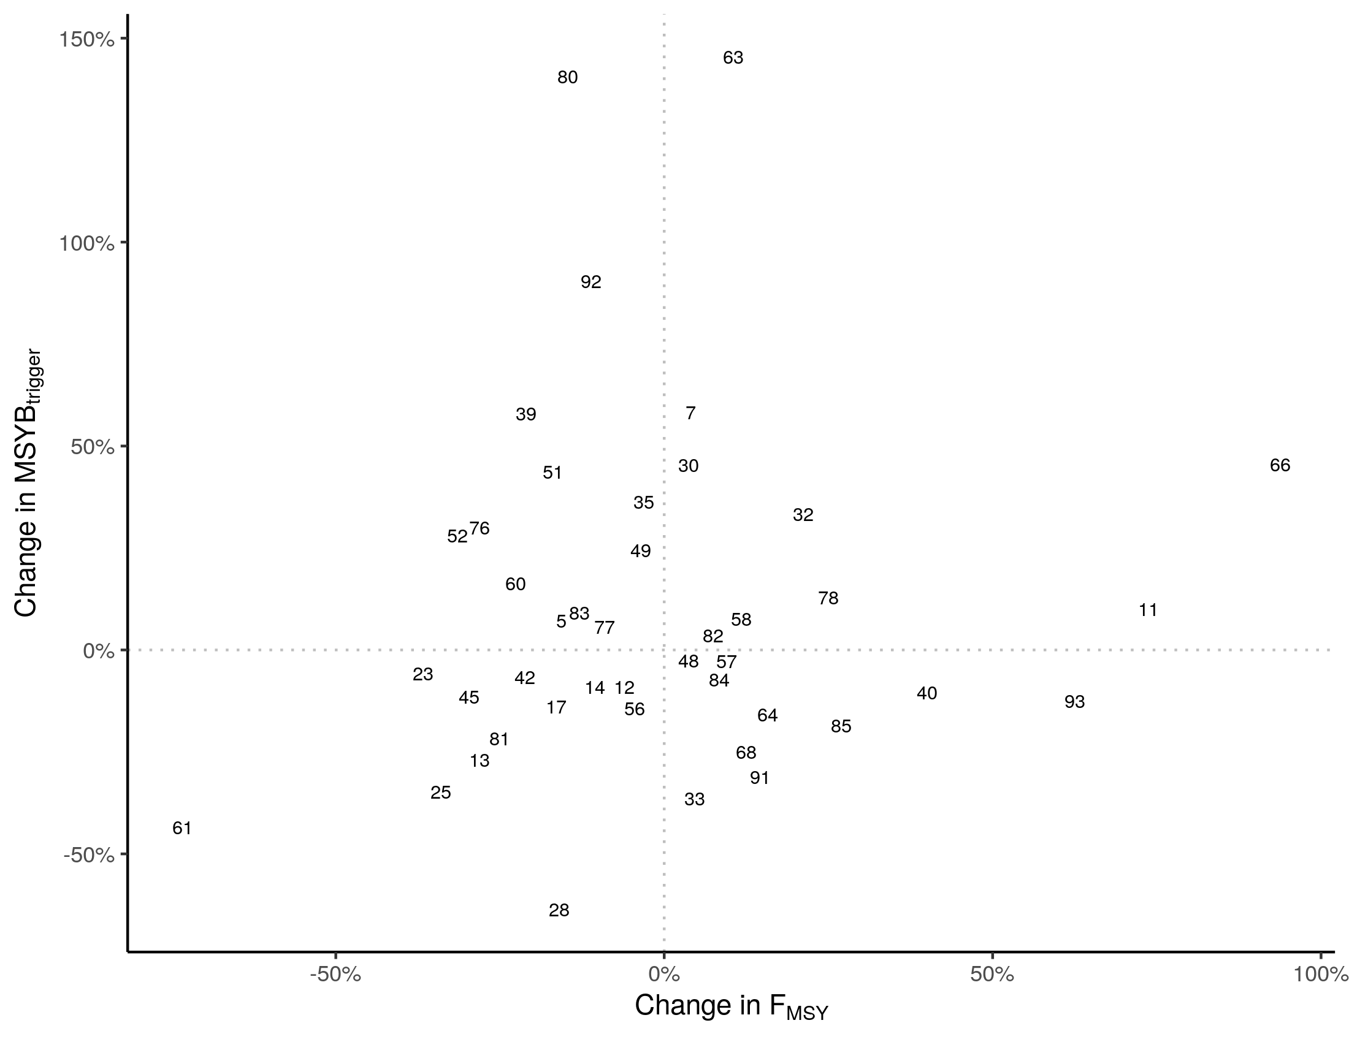
Fig. SI1 Relationship between simultaneous changes in F_{MSY} and MSYB_{trigger}, measured in percentage change relative to the preceding assessment. The plot numbers correspond to the event id in Table SI1.
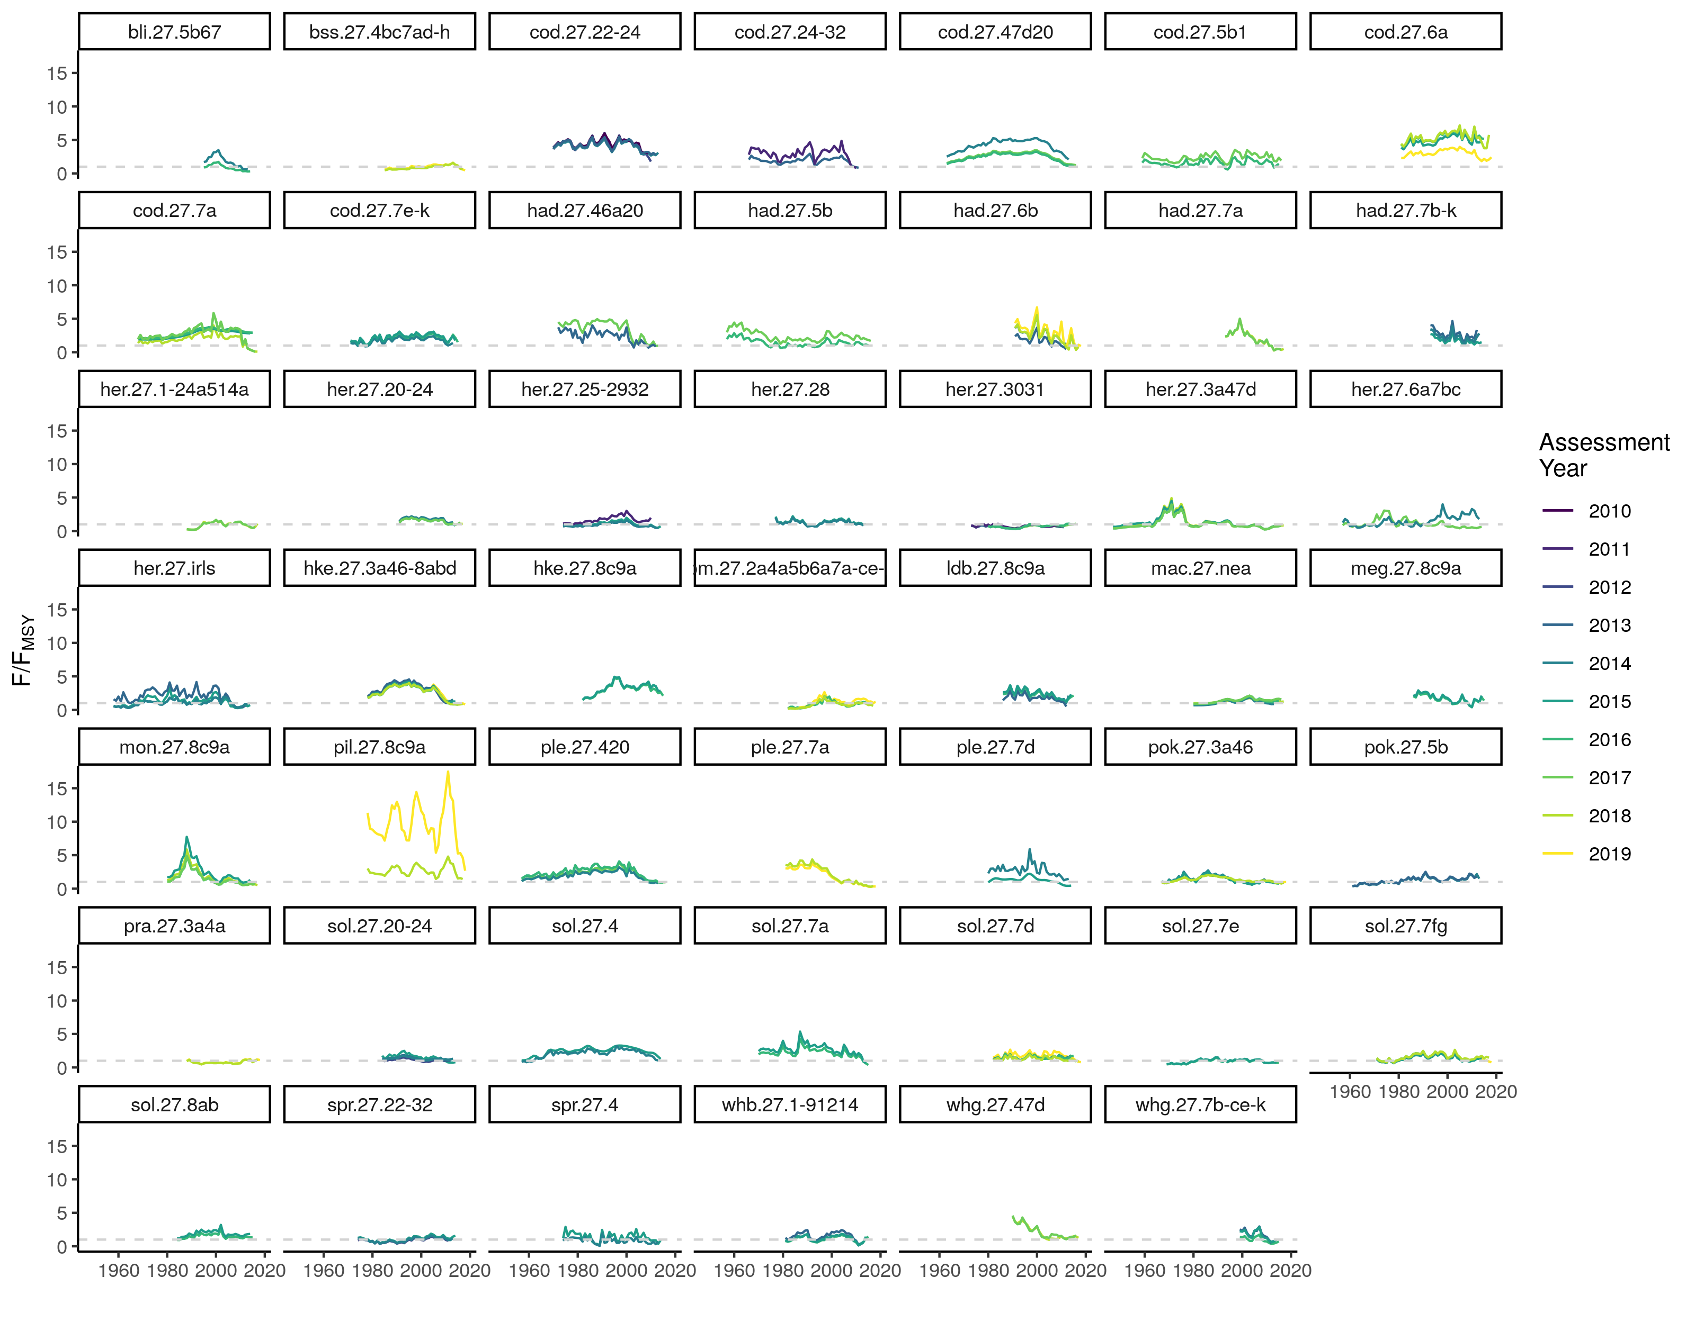
Fig. SI2. Relative fishing mortality rate (F/F_{MSY}) time series when a change in F_{MSY} was implemented. Colour shows the assessment year (y). The horizontal dotted line represents status = 1.
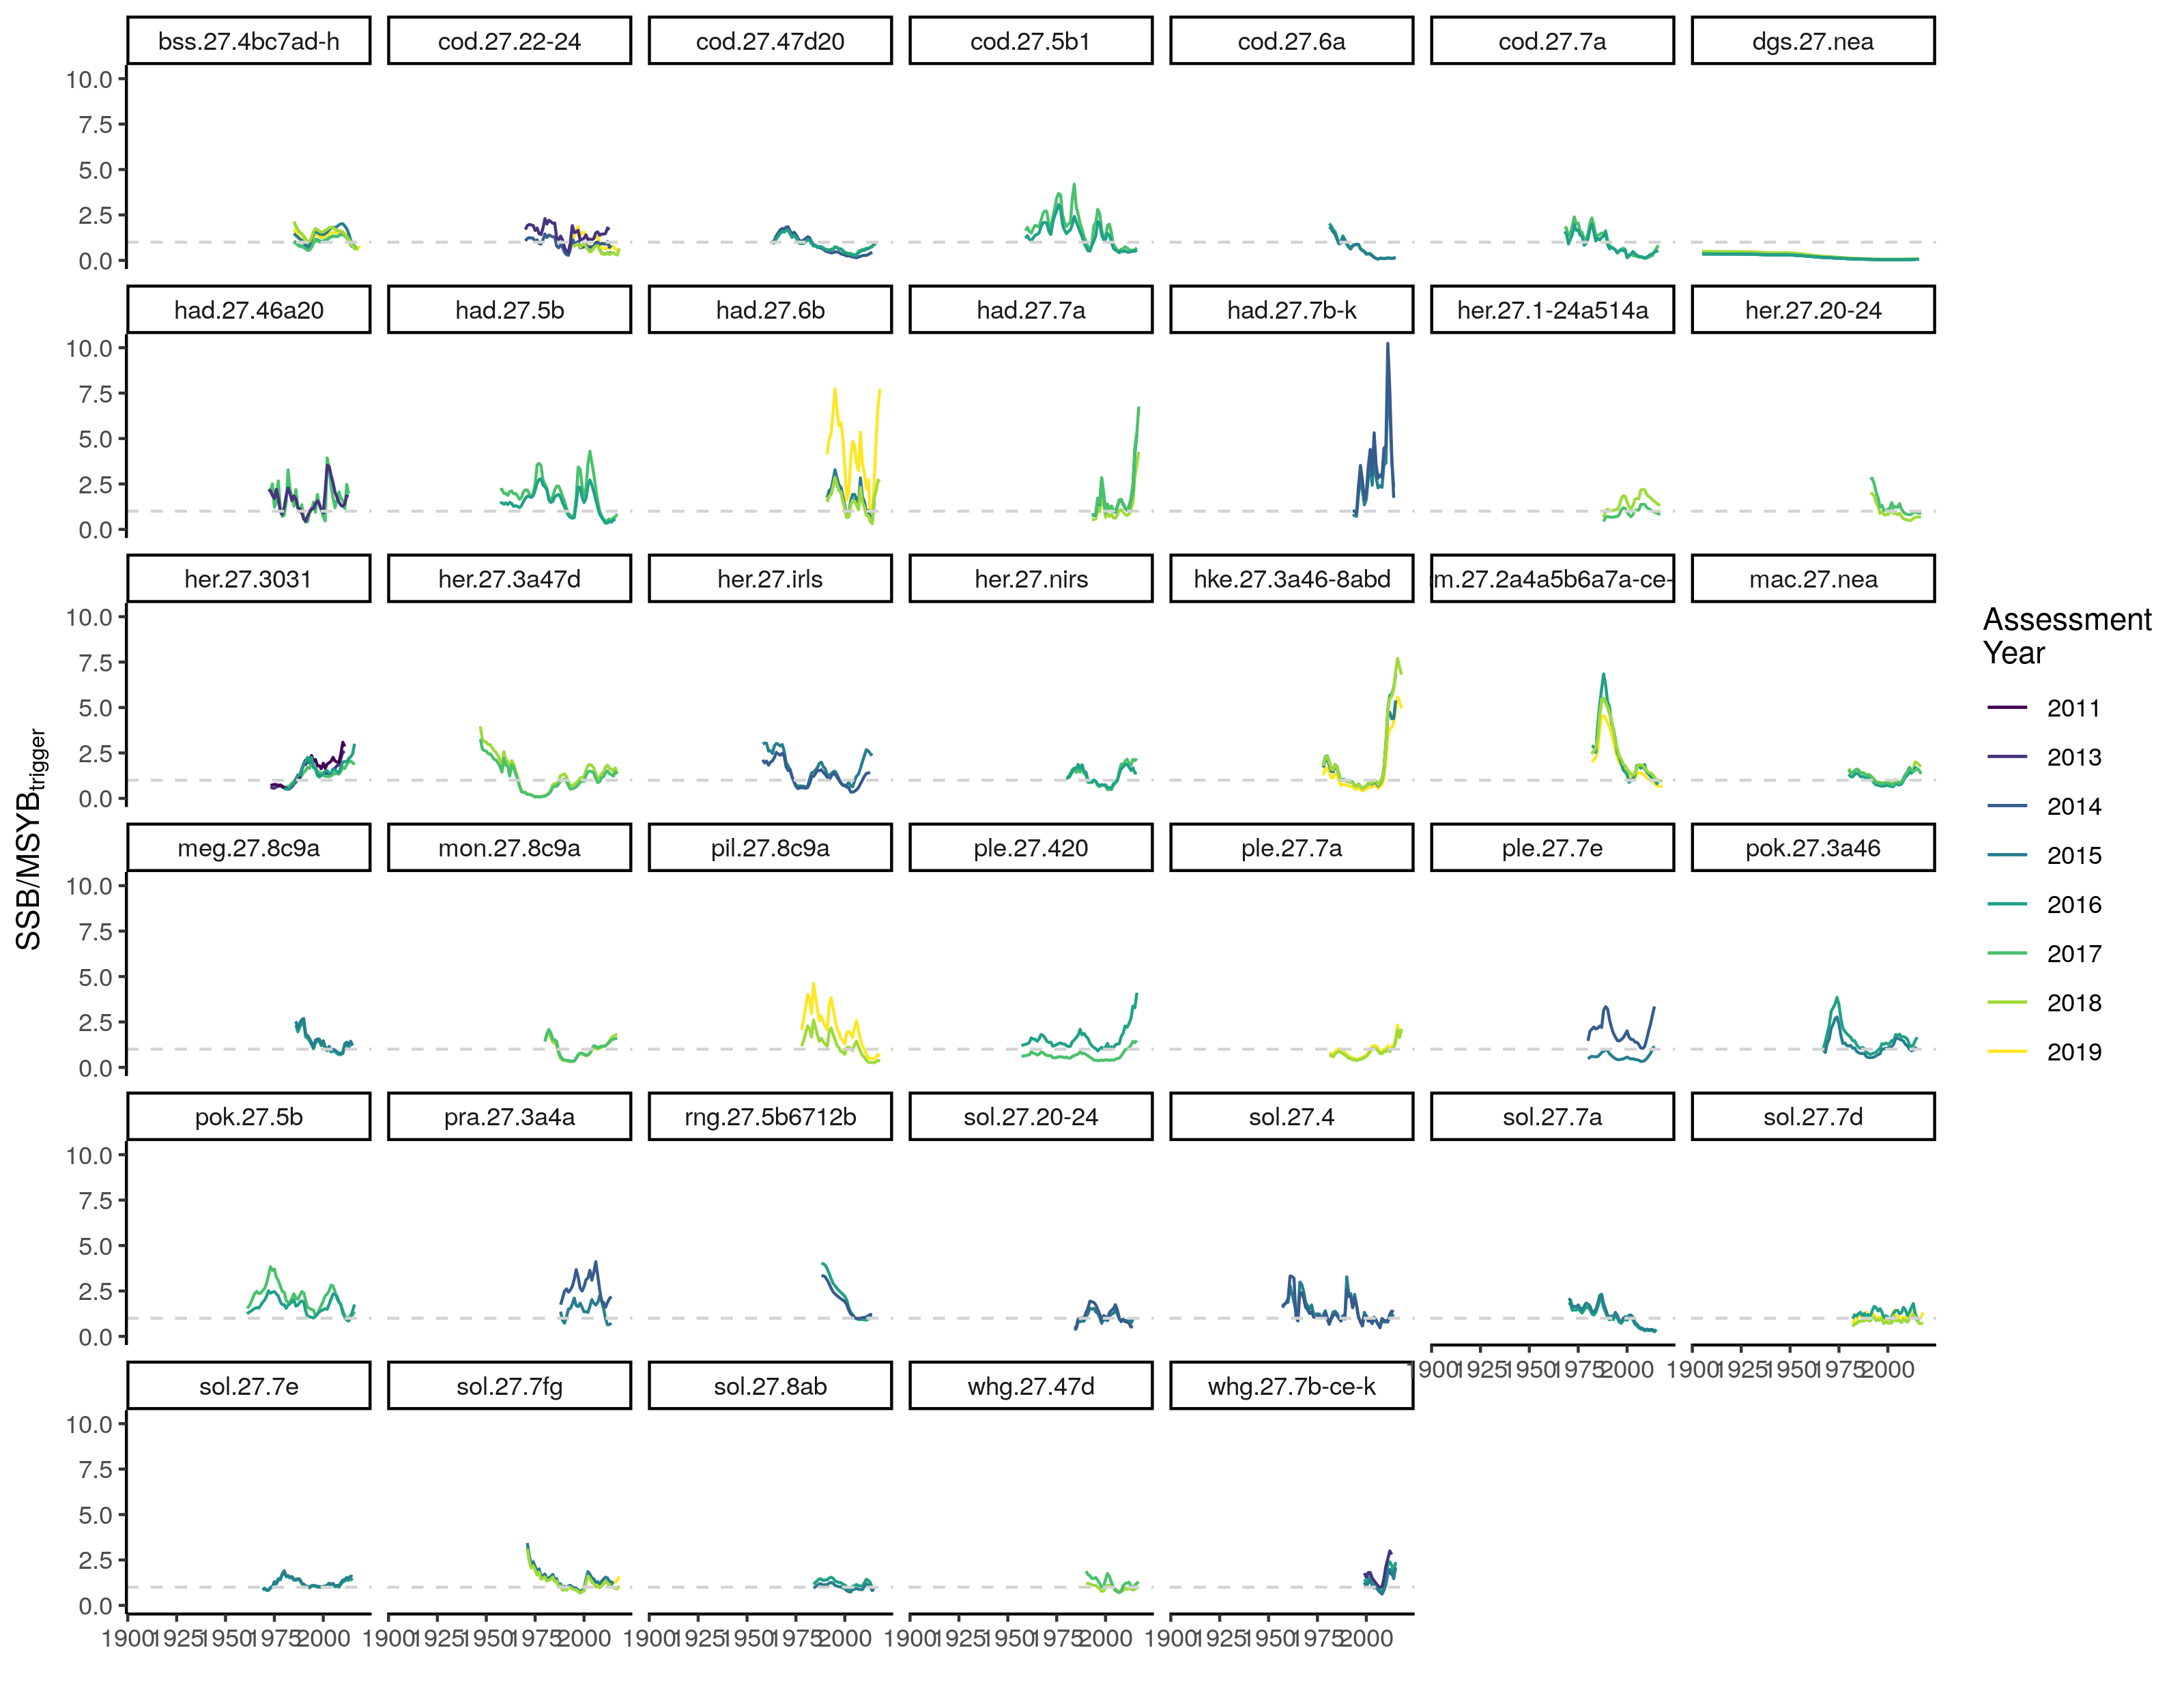
Fig. SI3. Relative biomass (SSB/MSYB_{trigger}) time series when a change in MSYB_{trigger} was implemented. Colour shows the assessment year (y). The horizontal dotted line represents status = 1.
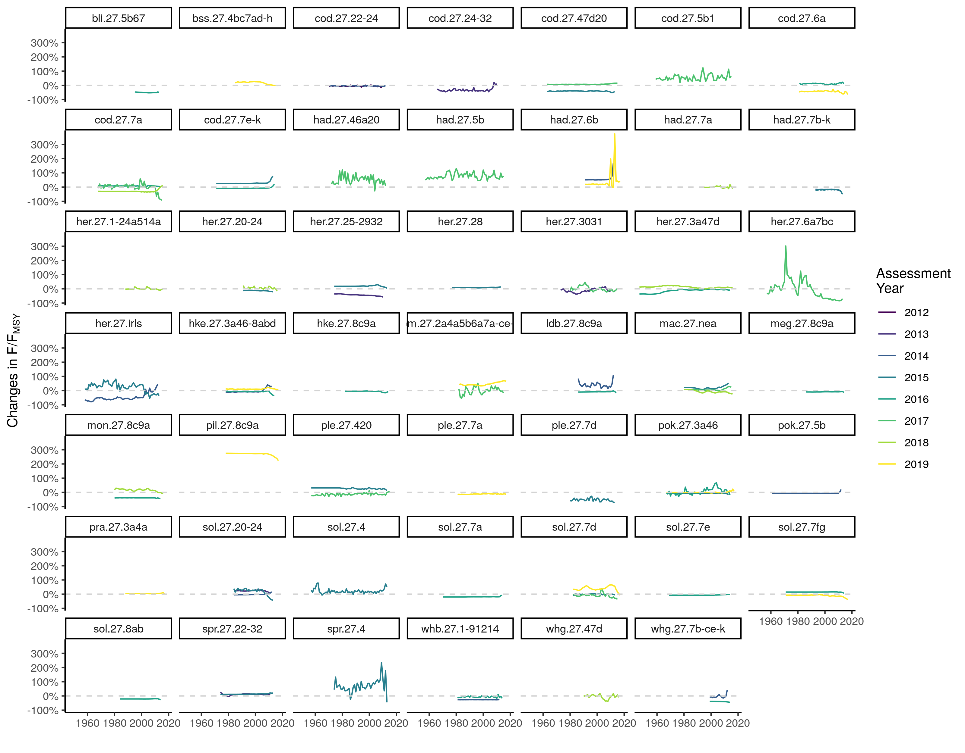
Fig. SI4. Timelines of relative fishing mortality rate (F/F_{MSY}) proportional changes of assessment year (y) relative to the previous (y-1), for assessments in which changes in F_{MSY} were implemented.

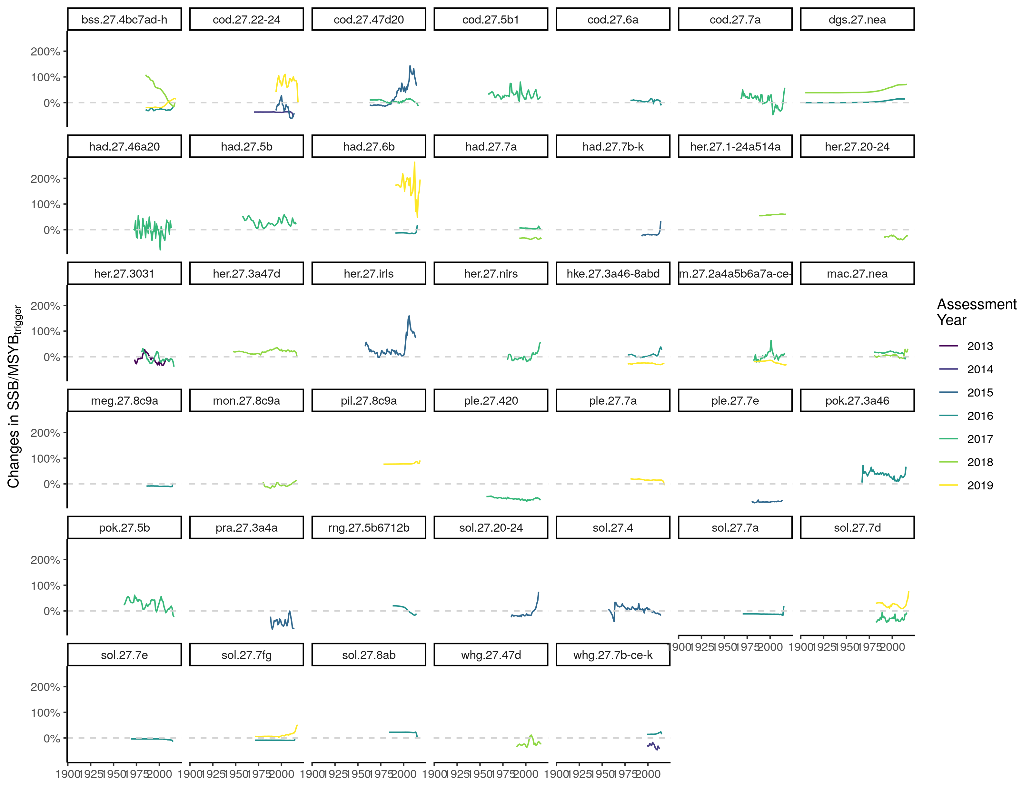
Fig. SI5. Timelines of relative fishing mortality rate (SSB/MSYB_{trigger}) proportional changes of assessment year (y) relative to the previous (y-1), for assessments in which changes in MSYB_{trigger} were implemented.

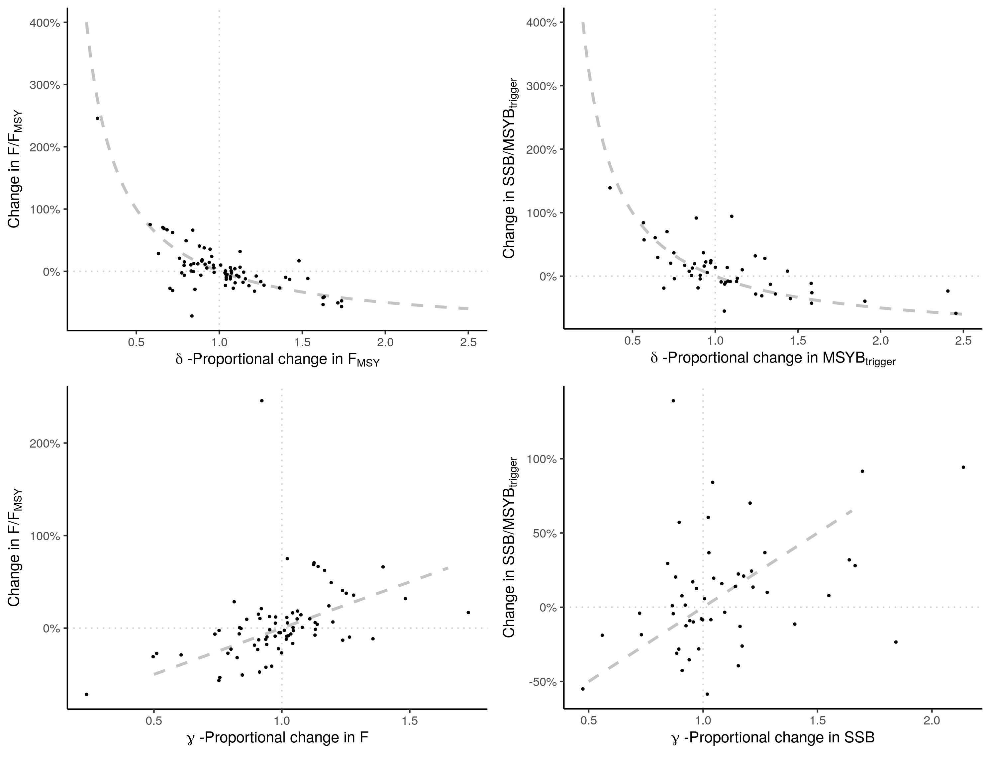
Fig. SI6. Marginal relationship between average change in status and δ, proportional change in reference point, at the top panel; and γ, proportional change in rate (left) or state (right), at the bottom panel considering the recent 5 years of overlap. Grey line shows the expected change with a change in δ or γ.

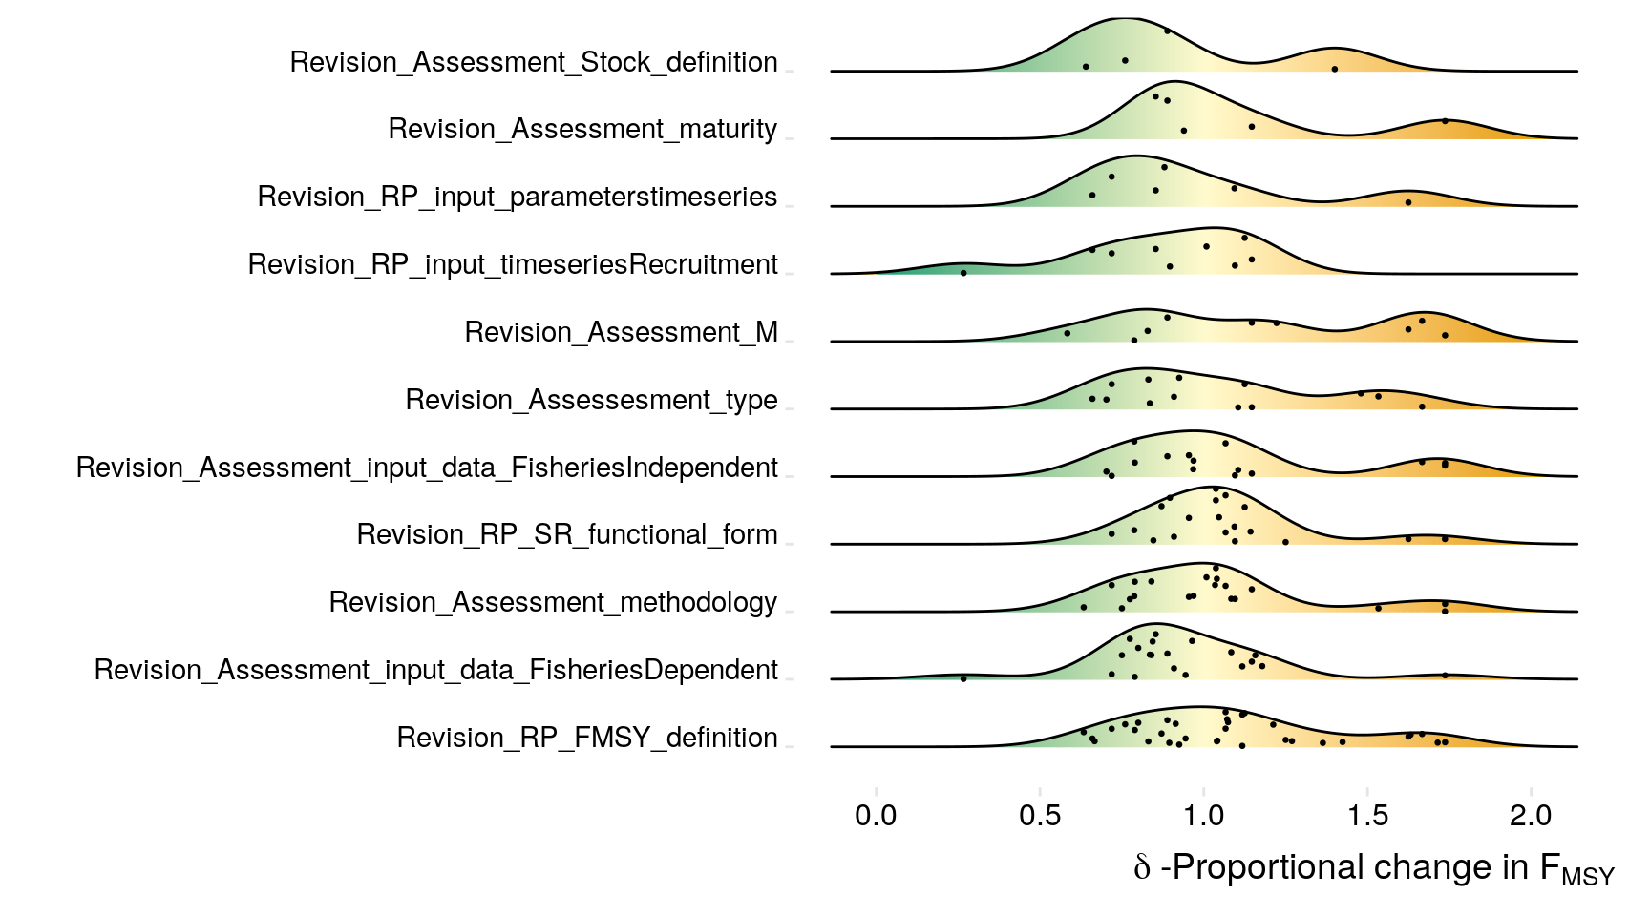
Fig. SI7. Distribution of changes in F_{MSY} segregated by covariate. Warm colours are increase and cool colours are decrease of F_{MSY} advised value. Covariates are ordered vertically based on frequency of observed changes, more frequent in lower panels.

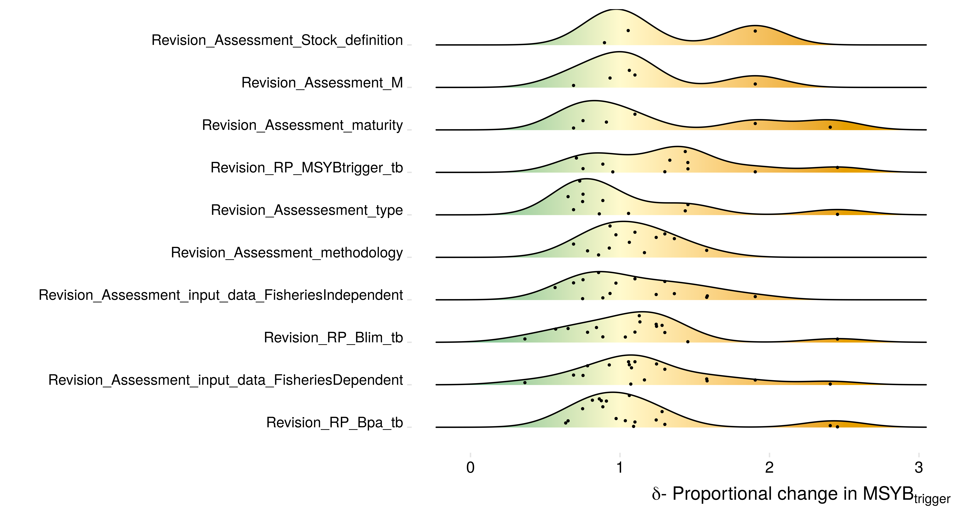
Fig. SI8. Distribution of changes in MSYB_{trigger} segregated by covariate. Warm colours are percentage increase and cool colours are percentage of decrease of MSYB_{trigger} advised value. Covariates are ordered vertically based on frequency of observed changes, more frequent in lower panels.

Fig. SI9. Probability of observing revision “A” when observing revision “B” for changes in F_{MSY}.

Fig. SI10. Probability of observing revision “A” when observing revision “B” for changes in MSYB_{trigger}.

