Supplement
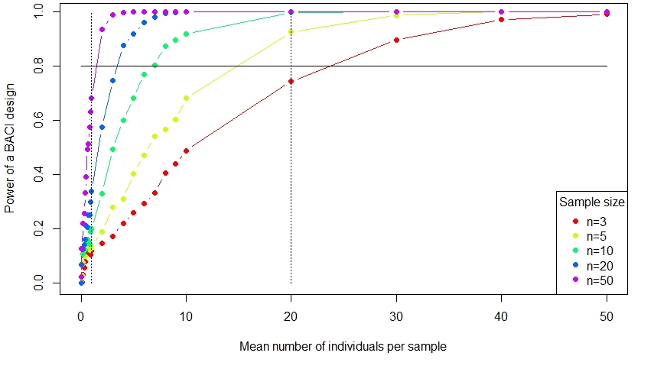
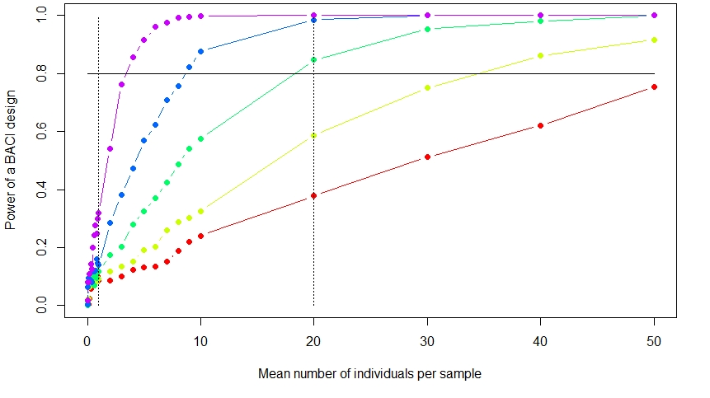
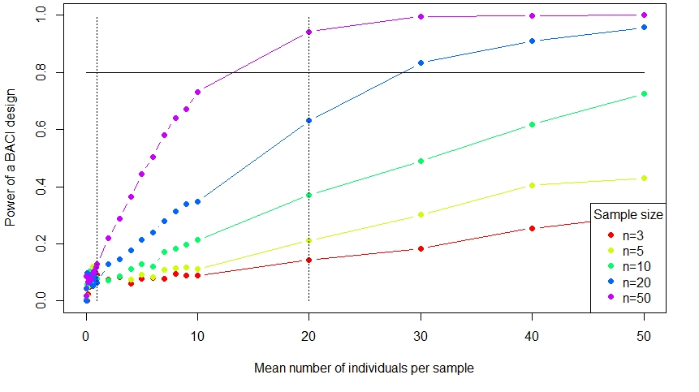
Figure S1. Statistical power of a BACI ANOVA as function of the mean number of individuals per sample and replication. The analysis of variance assumes that the disturbance is the only source of variance and that individuals are randomly distributed (Poisson distribution). The probability of type I error is 0.05. Top – Power of analysis to detect a 90% change in abundance due to the disturbance, Middle - Power of analysis to detect a 50% change in abundance due to the disturbance, Bottom - Power of analysis to detect a 25% change in abundance due to the disturbance.

