To be submitted to Frontiers in Marine Science
Supplementary material to
Identifying priorities for the protection of deep Mediterranean Sea ecosystems through an integrated approach

Fanelli Emanuela^{1,2*}, Bianchelli Silvia¹, Foglini Federica³, Canals Miquel⁴, Castellan Giorgio³, Güell-Bujons Queralt⁴, Galil Bella⁵, Goren Menachem⁵, Evans Julian⁶, Fabri Marie Claire⁷, Vaz, Sandrine.⁸, Ciuffardi Tiziana⁹, Schembri Patrick Joseph⁶, Angeletti Lorenzo³, Taviani Marco^{2,3,10}, Danovaro Roberto^{1,2}

¹Department of Life and Environmental Sciences, Polytechnic University of Marche, 60131 Ancona, Italy. e.fanelli@univpm.it; silvia.bianchelli@univpm.it; r.danovaro@univpm.it
²Stazione Zoologica Anton Dohrn di Napoli, Villa Comunale, 80121 Napoli, Italy
³CNR-National Research Council, ISMAR-Institute of Marine Sciences, 40129 Bologna, Italy. federica.foglini@bo.ismar.cnr.it; giorgio.castellan@bo.ismar.cnr.it; lorenzo.angeletti@bo.ismar.cnr.it; marco.taviani@bo.ismar.cnr.it
⁴GRC Geociències Marines, Departament de Dinàmica de la Terra i de l'Oceà, Facultat de Ciències de la Terra, Universitat de Barcelona, 08028 Barcelona, Spain. miquelcanals@ub.edu; queraltguell@gmail.com.
⁵The Steinhardt Museum of Natural History, Tel Aviv University, 6997801 Tel Aviv, Israel. bgalil@tauex.tau.ac.il; gorenm@tauex.tau.ac.il
⁶Department of Biology, University of Malta, Msida MSD 2080, Malta. julian.evans@um.edu.mt; patrick.j.schembri@um.edu.mt
⁷Ifremer, Centre de Méditerranée, 83500 La Seyne sur Mer, France. marie.claire.fabri@ifremer.fr
⁸Ifremer, Centre de Méditerranée, 34200 Sète, France. Sandrine.Vaz@ifremer.fr
⁹Santa Teresa Research Centre, ENEA, 19039 Lerici (SP), Italy. tiziana.ciuffardi@enea.it;
¹⁰Woods Hole Oceanographic Institution, Woods Hole MA 02543-1050, Us
*corresponding author: Fanelli E., e.fanelli@univpm.it
Table S1. List of the international regulations (laws, codes etc.) concerning the management or protection of the marine environment and/or its resources, with a focus on the deep sea.

Law/Regulations/Code | Entry into force | Main scope | Application to deep sea | References
Habitat Directive (HD) | 1992 | The Habitats Directive ensures the conservation of a wide range of rare, threatened or endemic animal and plant species. Some 200 rare and characteristic habitat types are also targeted for conservation in their own right. | At European level, the Habitat Directive (48/92 EC) in its Appendix 2 includes also deep-sea ecosystems: “H1170 Reefs” and “H1180 Submarine structures made by leaking gases”, which include all cold-water corals, black corals, gorgonians as well as soft-bottom habitat forming species such as Lytocarpia myriophyllum, Isidella elongata and Funiculina quadrangularis. These facies deserve protection and indeed areas hosting these species can be designated as SCIs.
OSPAR | 1992 |  | The OSPAR recommends protection and conservation of hydrothermal vent fields as “priority habitats” (OSPAR, 2008a) in its maritime area (NE Atlantic).
UN Convention on the Law of the Sea (UNCLOS) | 1994 | Provides a legal order for the seas and oceans that promotes the equitable and efficient utilization of their resources, the conservation of their living resources and the study, protection and preservation of the marine environment | Recognizes the right of all states to access marine living resources in ABNJs, together with the obligation to cooperate with other states to protect and preserve the marine environment and the duty to protect and preserve rare or fragile ecosystems, and the habitat of depleted, threatened or endangered species and other forms of marine life. | UNGA, 1994; 1995; Van Dover et al., 2014; Danovaro et al., 2017
Implementing Agreements for UNCLOS | 1996 | To address certain difficulties with the seabed mining provisions contained in Part XI of the Convention, which had been raised, primarily by the industrialized countries, the Secretary-General convened in July 1990 a series of informal consultations which culminated in the adoption, on 28 July 1994, of the Agreement relating to the implementation of Part XI of the UNCLOS of 10 December 1982. | Related to the management of seafloor mining in international waters and of straddling and highly migratory fish stocks. The opportunity exists to implement guidelines for restoration and rehabilitation as part of a sustainable and ethical environmental management strategy to protect and preserve the marine environment, rare and fragile ecosystems, and vulnerable species, while allowing the responsible use of marine resources. However, these environmental obligations have been neither well specified nor implemented.
EC 2347/2002 | 2003 | Establishing specific access requirements and associated conditions applicable to fishing for deep-sea stocks | Define deep-sea fishing permit, effort restriction, fishing gear characteristics and fishing operations, vessel monitoring system, designated ports, observers | COUNCIL REGULATION (EC) No 2347/2002  of 16 December 2002
Convention on Biodiversity (CBD) - Decision VII/5 (paragraph 30) | 2004 | Global treaty concerned with the conservation and sustainable use of biodiversity | “Urgent need for international cooperation and action to improve conservation and sustainable use of biodiversity in marine areas beyond the limits of national jurisdiction”, through the establishment of marine protected areas that include seamounts, hydrothermal vents, cold-water corals, and/or other vulnerable ecosystems. | Bax et al., 2016; Van Dover et al., 2018
UNGA Res. 61/105 | 2007 | Sustainable fisheries, including through the 1995 Agreement for the Implementation of the Provisions of the UNCLOS of 10 December 1982 relating to the Conservation and Management of Straddling Fish Stocks and Highly Migratory Fish Stocks, and related instruments | Identification and protection of Vulnerable Marine Ecosystems (VMEs) and Ecologically or Biologically Significant Areas (EBSAs), as well as a call for networks of Chemosynthetic Ecosystem Reserves for deep-sea hydrothermal vent and seep ecosystems. | Rogers et al., 2010; Gilman et al., 2011; Taranto et al., 2012; Weaver and Johnson, 2012; Van Dover et al., 2012
EU Regulation 734/2008 | 2008 | Implement UNGA Resolution 61/105 | European Council requires the protection of hydrothermal vents from bottom fishing and explicitly includes hydrothermal vents in the list of VMEs. | EU 2008a (Article 2b)
Marine Strategy Framework Directive (MSFD) | 2008 | The MSFD aims to achieve Good Environmental Status (GES) of the EU's marine waters by 2020 and to protect the resource base upon which marine-related economic and social activities depend. | The species groups specified in Part II of the Annex to COMM/DEC/2017/848, include birds, deep-sea fish and cephalopods, in addition to deep-diving toothed cetaceans. COMM/DEC/2017/848 also includes deep-sea habitats: a) upper bathyal rocks and biogenic reefs, b) upper bathyal sediments, c) lower bathyal rock and biogenic reef, d) lower bathyal sediments, and e) abyssal seafloor. | EC 2008/56
ISBA Regulation 19/C/17 | 2013 | Decision of the Council of the International Seabed Authority relating to amendments to the Regulations on Prospecting and Exploration for Polymetallic Nodules in the Area and related matters | Establish a set of regulations for set of Regulations is to provide for prospecting and exploration for polymetallic nodules in the Area | https://isa.org.jm/files/files/documents/isba-19c-17_0.pdf
International Convention for the regulation of Whaling and its amendments | 1946 (last amendment in 2018) | Convention on the regulation of whaling established by the International Whaling Commission (IWC) and annually amended | Establish a “Moratorium” on commercial whaling since 1982 | https://archive.iwc.int/pages/view.php?ref=3606&k=
Bax, N. J., Cleary, J., Donnelly, B., Dunn, D. C., Dunstan, P. K., Fuller, M., & Halpin, P. N. (2016). Results of efforts by the Convention on Biological Diversity to describe ecologically or biologically significant marine areas. Conservation Biology, 30(3), 571-581.
Convention on Biological Diversity (2008), COP 9, Decision IX/20, UNEP/CBD/COP/DEC/IX/20, annex I.
Convention on Biological Diversity. Ecologically or Biologically Significant Areas (EBSAs). https://www.cbd.int/ebsa/). Accessed on 26/03/2019.
EU (2008a). Council of the European Union, COUNCIL REGULATION (EC) No 734/2008 of 15 July 2008 on the protection of vulnerable marine ecosystems in the high seas from the adverse impacts of bottom fishing gears, Off. J. Eur. Union (2008) 8–13.
EU (2008b). Marine Strategy Framework Directive (2008/56/EC)
EU (2015). Report from the commission to the European parliament and the council on the progress in establishing marine protected areas (as required by Article 21 of the Marine Strategy Framework Directive 2008/56/EC)
EU (2017). Commission Decision (EU) 2017/848 of 17 May 2017 laying down criteria and methodological standards on good environmental status of marine waters and specifications and standardised methods for monitoring and assessment, and repealing Decision 2010/477/EU.
Danovaro, R., Gambi, C., Dell'Anno, A., Corinaldesi, C., Fraschetti, S., Vanreusel, A., ... & Gooday, A. J. (2008). Exponential decline of deep-sea ecosystem functioning linked to benthic biodiversity loss. Current Biology, 18(1), 1-8.
De Santo, E.M., 2018. Implementation challenges of area-based management tools (ABMTs) for biodiversity beyond national jurisdiction (BBNJ). Marine Policy, 97, 34-43.
European Environment Agency EEA (2015). Marine protected areas in Europe's seas - An overview and perspectives for the future. Report No 3/2015, pp. 40.
Freestone D., Laffoley D., Douvere F., Badman T., (2017). World Heritage in the Deep Sea: An Idea Whose Time has Come, UNESCO, Paris, 2017〈http://whc.unesco.org/en/ news/1535/〉.
FAO, Food and Agriculture Organization of the United Nations (2009). International guidelines for the management of deep-sea fisheries in the high seas, Rome, Italy, 2009.
FAO. Code of conduct for responsible fisheries. Rome: FAO; 1995. 41 pp
GFCM (2017). Mid-term strategy (2017–2020) towards the sustainability of Mediterranean and Black Sea fisheries (Mid-term strategy). http://www.fao.org/gfcm/activities/fisheries/mid-term-strategy/en/
Gianni, M., Fuller, S. D., Currie, D. E. J., Schleit, K., Goldsworthy, L., Pike, B., ... & Friedman, A. (2016). How much longer will it take? A ten-year review of the implementation of United Nations General Assembly resolutions, 61(105), 64.
Gilman, E., Dunn, D., Read, A., Hyrenbach, K. D., & Warner, R. (2011). Designing criteria suites to identify discrete and networked sites of high value across manifestations of biodiversity. Biodiversity and Conservation, 20(14), 3363-3383.
Habitats Directive (92/43/EEC) (1992). Council Directive 92/43/EEC of 21 May 1992 on the conservation of natural habitats and of wild fauna and flora. Official Journal of the European Communities.
IDEM (2019). Deliverable 3.3: IDEM Report 3.3. Report on the indicators and thresholds to identify the GES and the key areas for design monitoring programs in the Mediterranean deep sea. IDEM (Implementation of the MSFD to the Deep Mediterranean Sea) Project. UNIVPM, CNR, CSIC, DFMR, ENEA, TAU, UB, UM, UNIVPM.
ISBA (2000). ISBA/6/A/18 Annex, regulation 31, part 7, p. 20, 2000.
ISBA (2010). International Seabed Authority, ISBA/16a/12/rev1 Decision of the Assembly of the International Seabed Authority relating to the regulations on prospecting and exploration for polymetallic sulphides in the Area, 2010. http://dx.doi.org/10.1163/157180811X576929.
IWC (2016). International Convention for the Regulation of Whaling, Schedule 2016 – as amended by the Commission at the 66th Meeting, October 2016, paragraph 10(e). 〈https//archive.iwc.int/pages/view.php?Ref=3606&k=〉
Jaeckel, A. L. (2017). The International Seabed Authority and the Precautionary Principle: Balancing Deep Seabed Mineral Mining and Marine Environmental Protection. Brill.
OSPAR, (2008a). Agreement 2008–07. Description of habitats on the OSPAR list of threatened and/or declining species and habitats, 2008. 〈https://www.ospar.org/convention/agreements/〉.
OSPAR, (2008b). OSPAR 2008-1. Code of Conduct for Responsible Marine Research in the Deep Seas and High Seas of the OSPAR Maritime Area, 2008. 〈https://www.ospar.org/convention/agreements/〉
OSPAR, (2014). OSPAR Recommendation 2014/11 on furthering the protection and conservation the of hydrothermal vents/fiels occuring on oceanic ridge in Region V of OSPAR maritime area, annex 16, 2014. 〈https://www.ospar.org/convention/agreements/〉, 〈https://www.ospar.org/meetings/archive?Q=&a=&y=1993&s=〉
UNCLOS III (1970). Article 136 declaration of principles governing the seabed and the ocean floor, and subsoil thereof, beyond the limits of national jurisdiction. G.A. Res. 2749.
UNGA (1995). Agreement for the implementation of the provisions of the United Nations Convention on the law of the sea of 10th December 1982 relating to the conservation and management of straddling fish stocks and highly migratory fish stocks. Document A/CONF.164/37. United Nations General Assembly; 8 September 1995.
UNGA (1994). Resolution 48/263 agreement relating to the implementation of part XI of the United Nations convention on the law of the sea of 10th December 1982. DocumentA/RES/48/26317. United Nations General Assembly; August 1994.
UNGA (2012). The future we want. Rio de Janeiro: United Nations General Assembly.

Table S2. Name, source and description of criteria used for the Multicriteria Decision Analysis (MCDA). Further information is available at IDEM WebGIS repository (http://www.msfd-idem.eu/).
Goal | Criteria | Source | Description
Nature Conservation | Species Distribution | coconetgis.ismar.cnr.it, data.unep-wcmc.org  IDEM partners | Sighting positions of relevant species in the deep Mediterranean Sea from open-access repository and IDEM partners.
 | Slope | emodnet-bathymetry.eu | Rate of change in elevation calculated from bathymetry
 | Nursery Areas  Spawning Grounds | Giannoulaki et al., 2013  Colloca et al. 2015 | Modelled probability presence of nursery areas and spawning grounds of several commercial fish fauna (Merluccius merluccius, Mullus barbatus, Pagellus erythrinus, Raja clavata, Galeus melastomus, Solea solea, Aristaeomorpha foliacea, Parapenaeus longirostris, Nephrops norvegicus, Eledone cirrhosa, Illex coindetii)
Activities Preservation | Fishery Effort | ISMAR-CNR (IDEM partner) | Average trawling fishing effort from AIS fishing vessels’ tracking systems in the Mediterranean Sea. The temporal extent of the data is from 2012-01-01 to 2014-12-31
 | Shipping intensity | emodnet-humanactivities.eu | Number of vessels per unit area (square kilometre) from ship positions retrieved from the Automatic Identification System (AIS) for the year 2018.
 | Oil and Gas fields | ISMAR-CNR (IDEM partner) | Major oil and natural gas fields georeferenced from nautical charts
 | Oil and Gas extraction sites | emodnet-humanactivities.eu | Offshore installations for hydrocarbon extraction including information on location, operator, water depth, production start, current status, category and function of the installation.

Table S3. List of the different ecological relevance criteria found in literature under revision for its application in the evaluation of deep Mediterranean key areas for monitoring and protection.
ID | ECOLOGICAL RELEVANCE CRITERIA REVISED | SELECTED?
 | CBA criteria for defining EBSA
1 | Uniqueness or rarity. Area contains either (i) unique, rare or endemic species, populations or communities, and/or (ii) unique, rare or distinct, habitats or ecosystems; and/or (iii) unique or unusual geomorphological or oceanographic features | YES
2 | Special importance for life history stages of species. Areas that are required for a population to survive and thrive. | YES
3 | Importance for threatened, endangered or declining species and/or habitats. Area containing habitat for the survival and recovery of endangered, threatened, declining species or area with significant assemblages of such species | YES
4 | Vulnerability, fragility, sensitivity, or slow recovery. Areas that contain a relatively high proportion of sensitive habitats, biotopes or species that are functionally fragile (highly susceptible to degradation or depletion by human activity or by natural events) or with slow recovery | YES
5 | Biological productivity. Area containing species, populations or communities with comparatively higher natural biological productivity | Encompassed within 42
6 | Biological diversity. Area contains comparatively higher diversity of ecosystems, habitats, communities, or species, or has higher genetic diversity | NO
7 | Naturalness. Area with a comparatively higher degree of naturalness as a result of the lack of or low level of human-induced disturbance or degradation. | NO
 | SPAMI selection criteria (Annex I of the SPA/BD Protocol to the Barcelona Convention
8 | Uniqueness. | CBA 1 (YES)
9 | Natural representativeness. The area has highly representative ecological processes, or community or habitat types or other natural characteristics. | YES
10 | Diversity. | CBA 6 (NO)
11 | Naturalness. | CBA 7 (NO)
12 | Presence of habitats that are critical to endangered, threatened or endemic species. | CBA 3 (YES)
13 | Cultural representativeness. The area has a high representative value with respect to the cultural heritage, due to the existence of environmentally sound traditional activities integrated with nature which support the well-being of local populations. | NO
14 | Area of special interest at the scientific, aesthetic, cultural or educational levels. Present a particular value for research in the field of natural sciences or for activities of environmental education or awareness or contain outstanding natural features, landscapes or seascapes | NO
15 | The existence of threats likely to impair the ecological, biological, aesthetic or cultural value of the area | NO
16 | The involvement and active participation of the public in general, and particularly of local communities, in the process of planning and management of the area | NO
17 | The existence of a body representing the public, professional, non-governmental sectors and the scientific community involved in the area | NO
18 | The existence in the area of opportunities for sustainable development | NO
19 | The existence of an integrated coastal management plan | NO
20 | The legal status requirements for an area that will guarantee the area’s effective long-term protection. | NO
 | Particularly Sensitive Sea Area criteria (International Maritime Organization 2006)
21 | Uniqueness or rarity | Already considered
22 | Critical habitat – A sea area that may be essential for the survival, function, or recovery of fish stocks or rare or endangered marine species, or for the support of large marine ecosystems | Already considered
23 | Dependency – An area where ecological processes are highly dependent on biotically structured systems. Dependency also embraces the migratory routes of fish, reptiles, birds, mammals, and invertebrates. | Encompassed within 2
24 | Representativeness – An area that is an outstanding and illustrative example of specific biodiversity, ecosystems, ecological or physiographic processes, or community or habitat types or other natural characteristics. | Already considered
25 | Diversity | Already considered
26 | Productivity. Such productivity is the net result of biological and physical processes which result in an increase in biomass in areas such as oceanic fronts, upwelling areas and some gyres | Encompassed within 42
27 | Spawning or breeding grounds | Encompassed within 27
28 | Naturalness | Already considered
29 | Integrity – An area that is a biologically functional unit, an effective, self-sustaining ecological entity. | Together with 40
30 | Fragility | Already considered
31 | Bio-geographic importance – An area that either contains rare biogeographic qualities or is representative of a biogeographic “type” or types, or contains unique or unusual biological, chemical, physical, or geological features. | YES
32 | Social or economic dependency – An area where the environmental quality and the use of living marine resources are of particular social or economic importance, including fishing, recreation, tourism, and the livelihoods of people who depend on access to the area. | NO
33 | Human dependency – An area that is of particular importance for the support of traditional subsistence or food production activities or for the protection of the cultural resources of the local human populations. | NO
34 | Cultural heritage – An area that is of particular importance because of the presence of significant historical and archaeological sites. | Already considered
35 | Research – An area that has high scientific interest. | Together with 36
36 | Baseline for monitoring studies – An area that provides suitable baseline conditions with regard to biota or environmental characteristics, because it has not had substantial perturbations or has been in such a state for a long period of time such that it is considered to be in a natural or near-natural condition. | Together with 37
37 | Education – An area that offers an exceptional opportunity to demonstrate particular natural phenomena. | NO
 | Habitats Directive 92/43/ EEC Annex III
38 | Degree of representativity of the natural habitat type on the site | Already considered
39 | Area of the site covered by the natural habitat type in relation to the total area covered by that habitat type within national territory | NO
40 | Degree of conservation of the structure and functions of the natural habitat type concerned and restoration possibilities | Together with 29
41 | Global assessment of the value of the site for conservation of the natural habitat type concerned | Together with 9
 | Other ones
42 | High-energy processes relevant for deep sea dynamics | YES
43 | Benthic-pelagic communication | YES
44 | Part of an already defined EBSA, MPA or other designated area | YES
45 | Presence of high value resources highly susceptible of suffering from exploitation | YES
 | Parameters and factors used for the multi criteria analysis (ISMAR team)
46 | Species occurrences. Classified in 6 classes based on the IUCN Red List of threatened species: DD (Data deficient), LC (Least concern), NT (Near Threatened), VU (Vulnerable), EN (Endangered) and CR (Critically Endangered). | Considered within CBA 3 (YES)
47 | Habitats. Presence/absence. | Already considered multiple criteria
48 | Nursery areas. Presence/absence. | Considered within CBA 2 (YES)
49 | FRAs. Presence/absence. | Considered within 44 (YES)

Table S4. List of the different anthropogenic threat criteria found in the literature under revision for its application in the evaluation of deep Mediterranean key areas for monitoring and protection.
ID | ANTHROPOGENIC THREAT CRITERIA REVISED | SELECTED?
 | Blue growth in the Mediterranean Sea. WWF Report (2015)
1 | Offshore oil and gas exploration and extraction | Considered within 24
2 | Maritime transport and ports | ?
3 | Professional fisheries | Considered within 23
4 | Recreational fisheries | NO
5 | Tourism | NO
6 | Marine renewable energy | NO
7 | Marine mining | Considered within 24
8 | Coastal development | NO
9 | Land-based pollution sources | Considered within 28
 | Micheli et al. (2013). Cumulative Human Impacts on Mediterranean and Black Sea Marine Ecosystems: Assessing Current Pressures and Opportunities
10 | Climatic divers. Temperature and UV increase, acidification | Considered within 25
11 | Land-based drivers. Nutrient input, organic pollution, urban runoff, risk of hypoxia and coastal population density. | Considered within 28
12 | Sea-based drivers. Commercial shipping, invasive species, oil spills and oil rings. | Split within different ones
13 | Fishing. All fishing gears and types. | Considered within 23
 | Korpinen et al. (2012). Human pressures and their potential impact on the Baltic Sea ecosystem
14 | Physical loss of seabed. Smothering by dumped material, sealing of seabed. | NO
15 | Physical damage to seabed. Changes in siltation, abrasion of seabed, selective extraction of non-living resources. | NO
16 | Other physical disturbance. Underwater noise. | Considered within 27
17 | Interference with hydrological processes. Changes in thermal regime, changes in salinity regime. | Considered within 25
18 | Contamination by hazardous substances. Introduction of synthetic compounds, introduction of non-synthetic substances and compounds, introduction of radio-nuclides. | Considered within 26
19 | Nutrient and organic matter enrichment. Inputs of nutrients, inputs of organic matter. | Considered within 22
20 | Biological disturbance. Introduction of microbial pathogens, selective extraction of species (e.g. fishing). | NO
 | Other criteria (based on information extracted from IDEM previous deliverables)
21 | Introduction of alien species (D2-based) | YES
22 | Areas with high artificial nutrient inputs delivered to the deep-sea. Considering zones with high risk of hypoxia or other alterations due to the increase of nutrient concentrations. (D5-based) | YES
23 | Intensive practice of fishing techniques (D6-based) | YES
24 | Deep sea exploration and exploitation activities for mineral, energy or bioprospecting resources (D6-based) | YES
25 | Crucial area for the detection of significant alterations of hydrological processes. Areas affected by climatic drivers where changes in thermal and salinity regimes and/or acidification processes are palpable. (D7-based) | YES
26 | Areas of accumulation, transport and dispersion of contaminants and/or litter (D8-D9-D10) | YES
27 | Areas of continuous and intense underwater noise (D11-based) | YES
28 | Critical area for the study of land-based drivers effects on deep-sea ecosystems. This criterion should consider suitable areas highly impacted by land-based pressures in order to monitor how these impacts are translated to deep sea ecosystems. | YES
29 | Area affected by an important data and knowledge scarcity that causes high uncertainty about the potential pressures and the impacts currently happening. | YES
 | Parameters and factors used for the multi criteria analysis (ISMAR team)
30 | Fishery pressure | Considered within 23
31 | Pollution pressure | Considered within 26

Table S5. List of all the potential areas, their final classification and the number of scores obtained determining their final selection as key area, based on the Expert evaluation. Green highlights the areas selected and thus provided with a descriptive sheet in Annex 1, and red those presented as potential areas requiring further revision. ST=straits or channels; DW=areas of formation of dense water; CS= canyon systems; CWC=cold-water coral reefs; SM=seamounts; OR=other types of features/habitats.

Code | Area proposed for evaluation | Classification | Number of scores/Total (209)
ST.1 | Strait of Gibraltar | TYPE 1 | 91
ST.2 | Eivissa and Mallorca channels | TYPE 1 | 74
ST.4 | (Deep basins of the) Sicilian Channel | TYPE 1 | 92
ST.5 | Otranto Strait | TYPE 1 | 77
ST.6 | Aegean Sea and Cretan northern Ionian Sea straits | TYPE 1 | 52
DW.1 | North-western Mediterranean dense water formation (MEDOC area) and spreading area | TYPE 1 | 85
DW.2 | Adriatic dense water formation and spreading area | TYPE 1 | 76
DW.3 | Aegean dense water formation and spreading area | TYPE 1 | 58
CS.1 | Canyon systems of the western Gulf of Lion and north Catalan margin | TYPE 1 | 105
CS.2 | Canyon systems of the southern Adriatic Sea | TYPE 1 | 81
CS.3 | Cassidaigne Canyon, eastern Gulf of Lion | TYPE 1 | 93
CS.4 | Levante Canyon, Ligurian Sea | TYPE 1 | 69
CS.5 | East Levantine canyons (ELCA) | TYPE 1 | 79
CWC.1 | CWC habitats of Santa Maria Di Leuca and nearby occurrences | TYPE 1 | 86
CWC.2 | CWC Western Mediterranean Northern Province | TYPE 1 | 38
CWC.3 | CWC Habitats of Bari Canyon System | TYPE 1 | 16
SM.1 | Seamounts of the Alborán Sea | TYPE 1 | 68
SM.2 | Eratosthenes Seamount | TYPE 1 | 85
SM.3 | Other seamounts 1 (e.g. Tyrrhenian Sea) | TYPE 1 | 55
OR.1 | Deep Nile Delta Fan | TYPE 1 | 71
OR.2 | Hellenic trench | TYPE 1 | 47
OR.3 | Levant Sea | TYPE 1 | 78
OR.4 | Eastern Corsican slope | TYPE 2 | 62

Annex 1. Descriptive sheets of the key areas selected on the base of Expert Evaluation (EE).
ST.1 STRAIT OF GIBRALTAR
BASIN: WESTER MEDITERRANEAN
ER SCORE: 2.21/3 AT SCORE: 1.93/3 CLASSIFICATION: TYPE 1

IDEM Key areas descriptive sheet

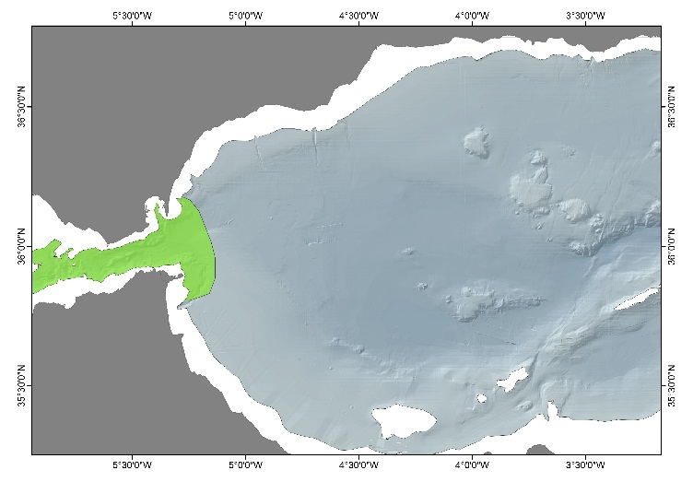
― INTRODUCTION TO THE AREA
Straits likely deserve being monitored by themselves independently if they are included in larger areas. As a transition zone between the Atlantic Ocean and the Mediterranean Sea, the Strait of Gibraltar is the only relevant zone of dynamic water exchange with a large ocean basin. The area is characterized by surface inflow of Atlantic water and a deep outflow of Mediterranean waters that foster the establishment of peculiar conditions determining and influencing the communities present. Thus, apart from the importance as water exchange zone, monitoring of the Gibraltar Strait is also highly relevant regarding the occurrences of deep-water corals communities and as habitat of a large number of cetacean and rare, unique species. Taking into account the importance of maritime traffic in the strait and the high occurrence of cetaceans, the monitoring of this region is highly relevant for Descriptor 11. Additionally, it encompasses other relevant deep-sea systems as pockmarks at water depths between 370 and 1020 m on either side of the Strait. Pockmarks are one of the seabed expressions of active fluid and/or gas flow and thus are highly interesting for the scientific community. Partly overlaps with SPAMI site "Southwestern Alborán".

― ECOLOGICAL RELEVANCE AND ANTHROPOGENIC THREATS OF THE AREA
Highly relevant ecological relevance criteria (>2.5): Uniqueness | Dependency | Importance for threatened, endangered or declining species and/or habitats | Vulnerability, fragility, sensitivity, or slow recover | Natural representativeness | Bio-geographic importance | High-energy processes relevant for deep sea dynamics | Water exchanges | Extreme scientific interest.
Highly important anthropogenic threat criteria (>2.5): Introduction of alien species (D2-based) | Persistent and intense underwater noise (D11-based) | Maritime traffic (D2, D8, D10 and D11-based).

― KEY REFERENCES: Candela, 1991; Álvarez-Pérez et al., 2005; de Stephanis et al., 2008; UNEP-MAP-RAC/SPA, 2010; León et al., 2014.

ST.2 EIVISSA AND MALLORCA CHANNELS
BASIN: WESTER MEDITERRANEAN
ER SCORE: 2.36/3 AT SCORE: 1.66/3 CLASSIFICATION: TYPE 1

IDEM Key areas descriptive sheet

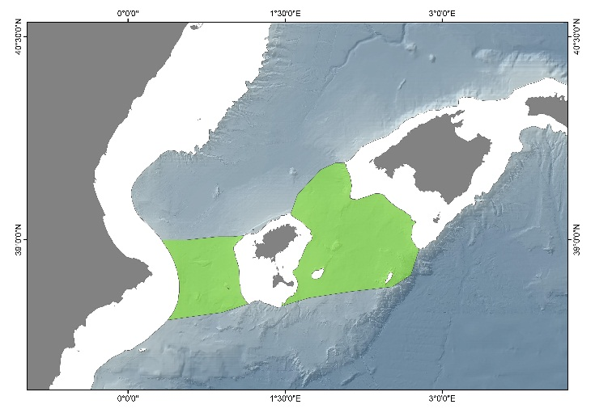
― INTRODUCTION TO THE AREA
Straits likely deserve being monitored by themselves independently if they are included in larger areas. These two deep channels are key for the north-south exchanges between the northern Gulf of Lion and the southern Algerian Basin since they are the only significant passages for the circulation of surface and intermediate waters. Apart from the relevance regarding water exchanges, peculiar characteristics of the channels also support the monitoring of these two areas. Both in the Eivissa and Mallorca channels, evidence of pockmarks and fluid escape features are present. Additionally, in the median depression of the Eivissa Channel a prominent 200m high seamount can be found and a volcanic field composed by 118 cone-shaped volcanic intrusions is described in the southeast of the Central Depression of the Mallorca Channel. Additionally, the area hosts large Isidella elongata meadows. This area is encompassed within the SPAMI site "Southern Balearic".

― ECOLOGICAL RELEVANCE AND ANTHROPOGENIC THREATS OF THE AREA
Highly relevant ecological relevance criteria (>2.5): Importance for threatened, endangered or declining species and/or habitats | Vulnerability, fragility, sensitivity, or slow recover | Existing MPAs | Extreme scientific interest.
Highly important anthropogenic threat criteria (>2.5): Overfishing and stock depletion (D3-based) | Intensive, sustained fishing (D6-based).

― KEY REFERENCES: Astraldi et al., 1999; Acosta et al., 2003; Lastras et al., 2004; UNEP-MAP-RAC/SPA, 2010; WGVME, 2018 and WGMPA, 2019.

ST.4 (DEEP BASINS OF THE) SICILIAN CHANNEL
BASIN: CENTRAL-IONIAN MEDITERRANEAN
ER SCORE: 2.55/3 AT SCORE: 2.02/3 CLASSIFICATION: TYPE 1

IDEM Key areas descriptive sheet

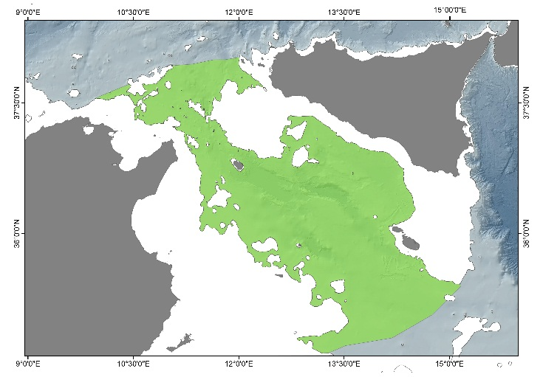
― INTRODUCTION TO THE AREA
The Sicilian Channel (Sicily Channel, Strait of Sicily) is the natural corridor connecting the East and West basins of the Mediterranean. The Siculo-Tunisian Sill, the narrower sector of the strait between the Tunisian and Sicilian coasts, reaches a maximum depth of 430 m. The complex physiography is predominantly shallow but includes the grabens (troughs) of the Pantelleria Rift System, with water depths greater than 1000 m in the otherwise shallow sea between Tunisia and Sicily, volcanic edifices and banks. Deep water masses flowing westwards are the Levantine Intermediate Water (LIW) and the upper layer of the Eastern Mediterranean Deep Water (EMDW) passing over the Siculo-Tunisian Sill on their way to the western Mediterranean (combined in the Eastern Overflow Water). The Pantelleria Rift System contains the Malta Trough (1721 m), Linosa Trough (1529 m) and Pantelleria Trough (1317 m) that serve as important conduits for the westward flow of LIW and EMDW. The present distribution of cold-water coral (CWC) frameworks in the Mediterranean is closely linked to the LIW flow, and the Sicilian Channel represents one of the eight major CWC provinces in the Mediterranean, bridging the gap between the CWC provinces in the South Adriatic/Santa Maria di Leuca, and south Sardinia. Open slopes dominated by bamboo coral or seapens, which can serve as essential habitats for some commercially-exploited species, are also known from the Sicilian Channel, while a pockmark field is present West of Gela Basin and hosts chemosynthesis-based communities. The entire area is included within the EBSA "Sicilian Channel" (Convention on Biological Diversity, https://www.cbd.int/ebsa/). Three FRAs for protection of essential fish habitats are established within the Sicilian Channel: the "East of Adventure Bank", "West of Gela Basin" and "East of Malta Bank" FRAs. There is partial overlap with the SPAMI sites "Northern Strait of Sicily" and "Tunisian Plateau". Within Maltese waters, five deep-water areas have been declared as pSCIs to form part of the Natura2000 network (https://era.org.mt/en/Pages/Natura-2000-Datasheets-Maps.aspx).

― ECOLOGICAL RELEVANCE AND ANTHROPOGENIC THREATS OF THE AREA
Highly relevant ecological relevance criteria (>2.5): Uniqueness | Dependency | Importance for threatened, endangered or declining species and/or habitats | Vulnerability, fragility, sensitivity, or slow recover | natural representativeness | Bio-geographic importance | Water exchanges | Existing MPA | Extreme scientific interest.
Highly important anthropogenic threat criteria (>2.5): Overfishing and stock depletion (D3-based) | Intensive, sustained fishing (D6-based) | Deep-sea exploration and production activities (D6-based) | Maritime traffic (D2, D8, D10 and D11-based).

― KEY REFERENCES: UNEP-MAP-RAC/SPA, 2010; Lauria et al., 2017; FAO, 2018; Convention on Biological Diversity (https://www.cbd.int/ebsa/); Natura2000 network (https://era.org.mt/en/Pages/Natura-2000-Datasheets-Maps.aspx).

ST.5 OTRANTO STRAIT
BASIN: CENTRAL-IONIAN MEDITERRANEAN
ER SCORE: 2.55/3 AT SCORE: 2.12/3 CLASSIFICATION: TYPE 1

IDEM Key areas descriptive sheet

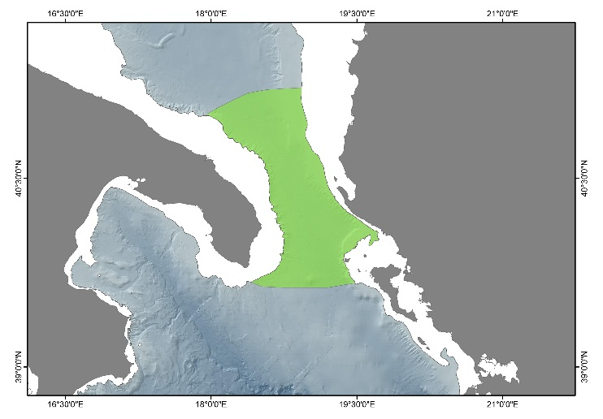
― INTRODUCTION TO THE AREA
The water masses circulation and exchanges through the Otranto Strait is crucial for the hydrodynamic budget of the Adriatic Sea as well as the deep thermohaline cell of the Eastern Mediterranean. During winter, the strong cooling associated with the northerly winds favors the formation of the Northern Adriatic Dense Water (NAdDW) in the northern part of the basin, and the Adriatic Deep Water (ADW) in the southern part. In the strait, a cyclonic gyre spreads the two deep waters into the Ionian Sea, one adjacent to the western shelf/slope and the other along the strait bottom, influencing the Mediterranean deep convection. The northern Adriatic Sea is also characterized by considerable freshwater run-off by rivers, forming a coastal relatively fresh current, the Adriatic Surface Water (ASW), flowing along the western shelf. To compensate for this outflow of fresher water, two saline water masses, the Ionian Surface Water (ISW) and the Levantine Intermediate Water (LIW), enter the perchè prima era strait e ora è channel?Adriatic Basin through the eastern side of Strait of Otranto. The Otranto Strait has been recently proposed as a Fishery Restricted Area to the GFCM due to the occurrence of large Isidella elongata meadows and Aristeomorpha foliacea nurseries. Although more data has been requested to the proponent group and further data are necessary, the area seems to be a hot spot of biodiversity also for other VME indicator species, such as Anthipathes dichotoma.

― ECOLOGICAL RELEVANCE AND ANTHROPOGENIC THREATS OF THE AREA
Highly relevant ecological relevance criteria (>2.5): Uniqueness | Vulnerability, fragility, sensitivity, or slow recover | Natural representativeness | High-energy processes relevant for deep sea dynamics | Water exchanges.
Highly important anthropogenic threat criteria (>2.5): Intensive, sustained fishing (D6-based) | Deep-sea exploration and production activities (D6-based) | Significant alterations of hydrological processes (D6-D7-based) | Persistent and intense underwater noise (D11-based) | Significant effects of land-sourced, coastal and surface drivers on deep-sea ecosystems (D5-D10-based) | Maritime traffic (D2, D8, D10 and D11-based).

― KEY REFERENCES: Pollak, 1951; Ovchinnikov et al., 1985; Malanotte-Rizzoli, 1991; Roether and Schlitzer, 1991; Vilibic and Orlic, 2002; Lembo, 2015; Bo et al. 2018; GFCM, 2019;

DW.1 NORTH WESTERN MEDITERRANEAN DENSE WATER FORMATION (MEDOC AREA) AND SPREADING AREA
BASIN: WESTER MEDITERRANEAN
ER SCORE: 2.54/3 AT SCORE: 2.16/3 CLASSIFICATION: TYPE 1

IDEM Key areas descriptive sheet

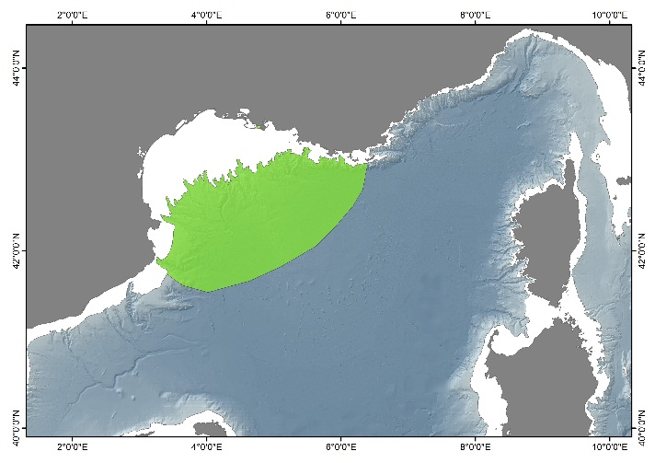
― INTRODUCTION TO THE AREA
Area highly relevant in terms of monitoring as one of the main drivers of the functioning of the deep Mediterranean Sea, and of the Mediterranean Sea as a whole. The area constitutes one of the three main areas of dense water formation (DWF) in the Mediterranean Sea. DWF is driven mainly by two processes: near-bottom currents driven by seawater density contrast, known as dense shelf water cascading (DSWC), and open sea convection. The Gulf of Lion located in the NW Mediterranean Sea is a micro-tidal and river-dominated continental margin with an intricate network of submarine canyons. The winter heat losses and evaporation induced by northern and northwesters winds promote cooling and densification of coastal waters that facilitate DSWC. The canyon systems perform as main conduits of the cascading shelf water transporting matter and energy to the deep basin, strongly influencing deep sea communities. In the open sea, the same cold and dry winds that cause the DSWC also generate the winter convection process in the region known as MEDOC area. The area partly overlaps with the CS.1 (Canyon systems of the western Gulf of Lion and north Catalan margin). It also includes FRAs regions for protecting deep-sea sensitive habitats, including vulnerable marine ecosystems (FAO, 2018) and partly overlaps with SPAMI site "Gulf of Lions Shelf and slope" (UNEP-MAP-RAC/SPA, 2010).

― ECOLOGICAL RELEVANCE AND ANTHROPOGENIC THREATS OF THE AREA
Highly relevant ecological relevance criteria (>2.5): Vulnerability, fragility, sensitivity, or slow recover | Natural representativeness | Integrity | High-energy processes relevant for deep sea dynamics | Water exchanges | Existing MPAs | Extreme scientific interest.
Highly important anthropogenic threat criteria (>2.5): Overfishing and stock depletion (D3-based) | Intensive, sustained fishing (D6-based) | Large-scale seascape change (D6-based) | Dispersal and accumulation of contaminants including marine litter (D8-D10-based) | Presence of contaminants in fish and other seafood for human consumption exceeding levels established in relevant standards (D9-based).

― KEY REFERENCES: Canals et al., 2006, 2009; Puig et al., 2008; Palanques et al., 2009; UNEP-MAP-RAC/SPA, 2010; FAO, 2018.

DW.2 ADRIATIC DENSE WATER FORMATION AND SPREADING AREA
BASIN: CENTRAL-IONIAN MEDITERRANEAN
ER SCORE: 2.59/3 AT SCORE: 2.15/3 CLASSIFICATION: TYPE 1

IDEM Key areas descriptive sheet

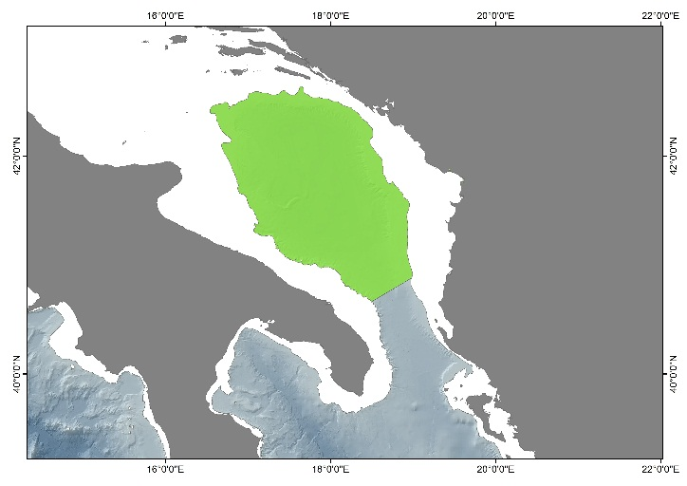
― INTRODUCTION TO THE AREA
In the Adriatic Sea, during winter, waters are subject to intense cooling, becoming dense enough to sink in the bottom layer and forming the North Adriatic Dense Water (NAdDW), in the northern part of the basin and the Adriatic Deep Water (ADW) in the southern part. These water masses outflow from the Otranto Strait, influencing the Mediterranean deep convection.

― ECOLOGICAL RELEVANCE AND ANTHROPOGENIC THREATS OF THE AREA
Highly relevant ecological relevance criteria (>2.5): Importance for threatened, endangered or declining species and/or habitats | Vulnerability, fragility, sensitivity, or slow recover | Bio-geographic importance |High-energy processes relevant for deep sea dynamics | Water exchanges | Existing MPAs | Extreme scientific interest.
Highly important anthropogenic threat criteria (>2.5): Overfishing and stock depletion (D3-based) | Intensive, sustained fishing (D6-based) | Large-scale seascape change (D6-based) | Significant alterations of hydrological processes (D6-D7-based) | Persistent and intense underwater noise (D11-based) | Significant effects of land-sourced, coastal and surface drivers on deep-sea ecosystems (D5-D10-based).

― KEY REFERENCES: Ovchinnikov et al., 1985 and Vilibic and Orlic, 2002.

CS.1 CANYON SYSTEMS OF THE WESTERN GULF OF LION AND NORTH CATALAN MARGIN
BASIN: WESTER MEDITERRANEAN
ER SCORE: 2.65/3 AT SCORE: 2.03/3 CLASSIFICATION: TYPE 1

IDEM Key areas descriptive sheet

― INTRODUCTION TO THE AREA
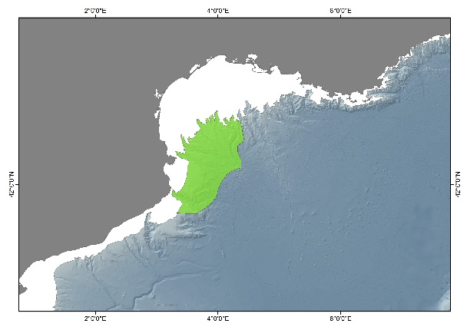
The area includes a set of submarine canyons incised into the continental shelf, which from est to west are Petit-Rhone, Montpellier, Sète, Hérault (Marti), Aude (Bourcart), Pruvost, Lacaze-Duthiers, Cap de Creus and La Fonera canyons. All these canyons but La Fonera form an underwater drainage system opening into Sète Canyon and then into the continental rise. La Fonera is the only isolated canyon in the group. Canyons cross the continental slope and have their distalmost reaches at depths in excess of 2000 m. The western canyons of Cap de Creus, and to a lesser extent Lacaze-Duthiers and La Fonera, constitute the main path for dense shelf water cascades (DSWC) carrying large amounts of sediment, organic carbon, chemical pollutants and litter. Some of these canyons host CWC habitats, some others host meadows of VMEs. The main direct anthropogenic threat they are exposed to is bottom trawling on their flanks down to 1000 m depth. However, the effects of trawling (e.g. resuspension, suffocation) extend much deeper, down to the canyons axes and beyond. This area partially overlaps with EBSA "North-western Mediterranean Benthic Ecosystems" (Convention on Biological Diversity, https://www.cbd.int/ebsa/), "South-West Gulf of Lion canyons system" marine area of INDEMARES proposed for SCI (INDEMARES project, https://www.indemares.es/en/home) and SPAMI site "Gulf of Lion Shelf and slope" (UNEP-MAP-RAC/SPA, 2010). Three of these features (CB, CP, CLD) are enclosed in the Gulf of Lion Marine Park (http://www.parc-marin-golfe-lion.fr/images/doc_link/juin_2013/perimetre_fevrier2013.pdf). Two small bottom impacting fishery permanent closures are located on the edge of two of CB and CS canyons (https://www.legifrance.gouv.fr/eli/arrete/2018/4/23/AGRM1733988A/jo/texte/fr). Petit-Rhône canyon also benefits from the relative protection of the Eastern Gulf of Lion Fishery Restricted Area (FAO, 2018).

― ECOLOGICAL RELEVANCE AND ANTHROPOGENIC THREATS OF THE AREA
Highly relevant ecological relevance criteria (>2.5): Dependency | Importance for threatened, endangered or declining species and/or habitats | Vulnerability, fragility, sensitivity, or slow recover | Natural representativeness | Bio-geographic importance | High-energy processes relevant for deep sea dynamics | Water exchanges | Existing MPAs | Extreme scientific interest.
Highly important anthropogenic threat criteria (>2.5): Overfishing and stock depletion (D3-based) | Intensive, sustained fishing (D6-based) | Large-scale seascape change (D6-based) | Dispersal and accumulation of contaminants including marine litter (D8-D10-based).

― KEY REFERENCES: Canals et al., 2006, 2013; Orejas et al., 2009; Fabri et al., 2014; Lastras et al., 2016; FAO, 2018; Convention on Biological Diversity, https://www.cbd.int/ebsa/; INDEMARES project, https://www.indemares.es/en/home; https://www.legifrance.gouv.fr/eli/arrete/2018/4/23/AGRM1733988A/jo/texte/fr;
http://www.parc-marin-golfe-lion.fr/images/doc_link/juin_2013/perimetre_fevrier2013.pdf.

CS.2 CANYON SYSTEMS OF THE SOUTHERN ADRIATIC SEA
BASIN: CENTRAL-IONIAN MEDITERRANEAN
ER SCORE: 2.83/3 AT SCORE: 2.18/3 FINAL CLASSIFICATION: TYPE 1

IDEM Key areas descriptive sheet

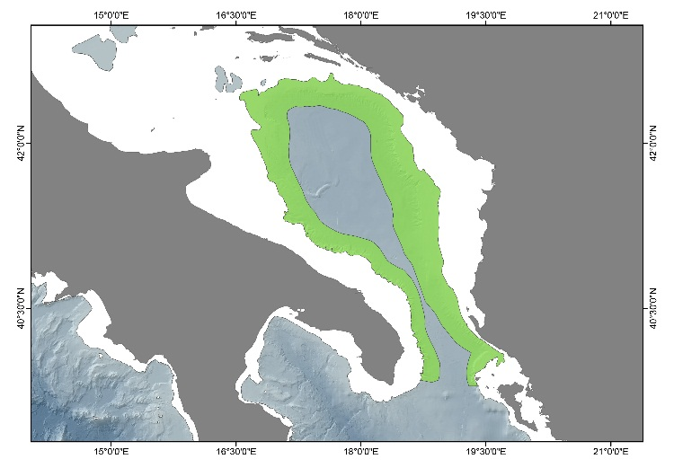
― INTRODUCTION TO THE AREA
The southern Adriatic Sea is characterized by an articulated and heterogeneous geomorphology along the margin, encompassing the Bari Canyon System (BCS) in the western part. The BCS is an erosional-depositional structure consisting of two almost parallel E-W oriented main branches, with sub-vertical flanks in its southern part and less abrupt flanks northward. The Bari Canyon represents an efficient channel transporting sediments and nutrients from the continental shelf down to the bathyal zone, being a-periodical impacted by dense water flow (North Adriatic Dense Water, NAdDW) developing from the northern Adriatic Sea and by the Levantine Intermediate Water (LIW) that generates in the Aegean Sea and flows through the entire Mediterranean Sea. The hydrodynamic of the canyon contribute to the sustention of deep-water ecosystems such as cold-water corals. The Canyon is also characterized by a-periodical dense water cascading, responsible, of erosional-sediment features (e.g., slope incision and dune field) in the area nearby of the Bari Canyon System.

― ECOLOGICAL RELEVANCE AND ANTHROPOGENIC THREATS OF THE AREA
Highly relevant ecological relevance criteria (>2.5): Uniqueness | Dependency | Importance for threatened, endangered or declining species and/or habitats | Vulnerability, fragility, sensitivity, or slow recover | Natural representativeness | Bio-geographic importance | Integrity | High-energy processes relevant for deep sea dynamics | Water exchanges | Extreme scientific interest.
Highly important anthropogenic threat criteria (>2.5): Overfishing and stock depletion (D3-based) | Deep-sea exploration and production activities (D6-based) | Persistent and intense underwater noise (D11-based) | Significant effects of land-sourced, coastal and surface drivers on deep-sea ecosystems (D5-D10-based).

― KEY REFERENCES: Trincardi et al., 2007; Turchetto et al., 2007; Freiwald et al., 2009; Angeletti et al., 2014; Foglini et al., 2016; Taviani et al., 2016.

CS.3 CASSIDAIGNE CANYON and EASTERN GULF OF LION
BASIN: WESTER MEDITERRANEAN
ER SCORE: 2.50/3 AT SCORE: 2.22/3 CLASSIFICATION: TYPE 1

IDEM Key areas descriptive sheet

― INTRODUCTION TO THE AREA
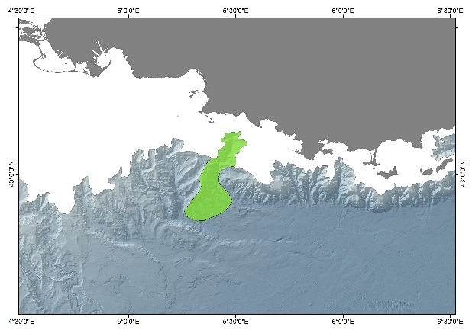
This area includes a set of submarine canyons incised into the continental shelf, which from east to west are the Cassidaigne, Planier, Marseille and Grand Rhône. The most intense upwelling of the Gulf of Lion is centred within the Cassidaigne canyon. During the upwelling events, deep- and thus colder-water is channelled along the canyon axis up onto the shelf. However, during downwelling events (mostly in winter), this process is reversed and bottom currents can carry huge amounts of sediment and organic matter to the deep ocean as they scour the shelf and slope seafloor. Cold-water corals have settled in the Cassidaigne canyon and formed large colonies, providing a structural habitat for other species. Nevertheless, the communities are physically impacted by discharges of bauxite residue discharges from an aluminium industry. Red bauxite has been discharged into the canyon since 1967 and red mud extends into the abyssal plain more than 50 km away from the pipe. The quantity of solid particles in the effluent has been progressively reduced, and the outflow was stopped at the end of 2015. Nevertheless, the industrial company concerned requested and was granted a six-year authorization starting in January 2016 for a different effluent containing only chemicals and no suspended matter. The Cassidaigne canyon is included in the Marine Protected Area (MPA) of the “Parc National des Calanques” since 2012 (www.calanques-parcnational.fr – Decree 2012-507). A small bottom impacting fishery permanent closure is located on the edge of the Grand Rhône canyon (https://www.legifrance.gouv.fr/eli/arrete/2018/4/23/AGRM1733988A/jo/texte/fr). Marseille and Grand-Rhône canyons also benefit from the relative protection of the Eastern Gulf of Lion Fishery Restricted Area (http://www.fao.org/gfcm/data/maps/fras/fr/).

― ECOLOGICAL RELEVANCE AND ANTHROPOGENIC THREATS OF THE AREA
Highly relevant ecological relevance criteria (>2.5): Dependency | Importance for threatened, endangered or declining species and/or habitats | Vulnerability, fragility, sensitivity, or slow recover | High-energy processes relevant for deep sea dynamics | Extreme scientific interest.
Highly important anthropogenic threat criteria (>2.5): Overfishing and stock depletion (D3-based) | Intensive, sustained fishing (D6-based) | Large-scale seascape change (D6-based) | Significant alterations of hydrological processes (D6-D7-based) | Dispersal and accumulation of contaminants including marine litter (D8-D10) | Presence of contaminants in fish and other seafood for human consumption exceeding levels established in relevant standards (D9-based) | Significant effects of land-sourced, coastal and surface drivers on deep-sea ecosystems (D5-D10-based).

― KEY REFERENCES: Millot, 1990; Alberola and Millot., 2003; Dauvin, 2010; Stora et al., 2011; Fontanier et al., 2012, 2015; Fabri et al., 2014, 2017 and Fabri et al., submitted. www.calanques-parcnational.fr, https://www.legifrance.gouv.fr/eli/arrete/2018/4/23/AGRM1733988A/jo/texte/fr. http://www.fao.org/gfcm/data/maps/fras/fr/,

CWC.1 CWC HABITATS OF SANTA MARIA DI LEUCA AND NEARBY OCCURRENCES
BASIN: CENTRAL-IONIAN MEDITERRANEAN
ER SCORE: 2.64/3 AT SCORE: 1.71/3 CLASSIFICATION: TYPE 1

IDEM Key areas descriptive sheet

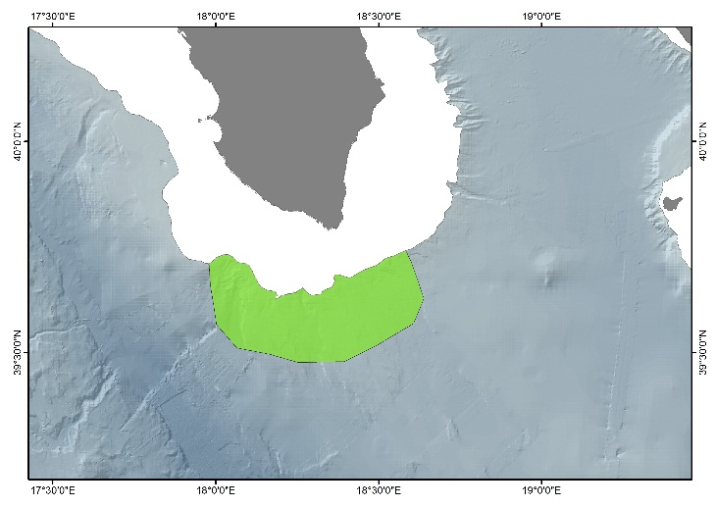
― INTRODUCTION TO THE AREA
The area is characterized by high density of Madrepora oculata and Desmophyllum pertusum (=Lophelia pertusa) bioconstructions, occurring both as isolated colonies and mounds (10–20 m high). The province is located between 300 and 1100 m depth off Apulia on a gently sloping plateau with a complex seabed topography. The area host a high-biodiversity megafaunal community, characterized by the presence of stony corals as Desmophyllum dianthus, Stenocyathus vermiformis and the yellow coral Dendrophyllia cornigera, antipatharians (Leiopathes glaberrima) and gorgonians (Callogorgia verticillata), often in association with sponges, such as Pachastrella monilifera and Poecillastra compressa. Here, in 2006, the GFCM established a Fishery Restricted Area (FRA) banning the use of towed gears due to the presence of priority commercial species (e.g. Aristaeomorpha foliacea, Aristeus antennatus, Merluccius merluccius, Nephrops norvegicus, Pagellus bogaraveo). In addition, the area represent an important migratory corridor for megafauna like the short-beaked common dolphin (Delphinus delphis) and marine turtles.

― ECOLOGICAL RELEVANCE AND ANTHROPOGENIC THREATS OF THE AREA
Highly relevant ecological relevance criteria (>2.5): Uniqueness | Dependency | Importance for threatened, endangered or declining species and/or habitats | Vulnerability, fragility, sensitivity, or slow recover | Natural representativeness | Bio-geographic importance | Integrity | Existing MPAs | Extreme scientific interest.
Highly important anthropogenic threat criteria (>2.5): Intensive, sustained fishing (D6-based).

― KEY REFERENCES: Tursi et al., 2004; Taviani et al., 2005a, b; Freiwald et al., 2009; Malinverno et al., 2010; Savini and Corselli, 2010; Vertino et al., 2010; Taviani et al., 2011: D'Onghia et al., 2012, 2017; Oceana, 2014; Savini et al., 2014; Bargain et al., 2017.

SM.2 ERATOSTHENES SEAMOUNT
BASIN: AEGEAN – LEVANTINE MEDITERRANEAN
ER SCORE: 2.50/3 AT SCORE: 1.99/3 CLASSIFICATION: TYPE 1

IDEM Key areas descriptive sheet

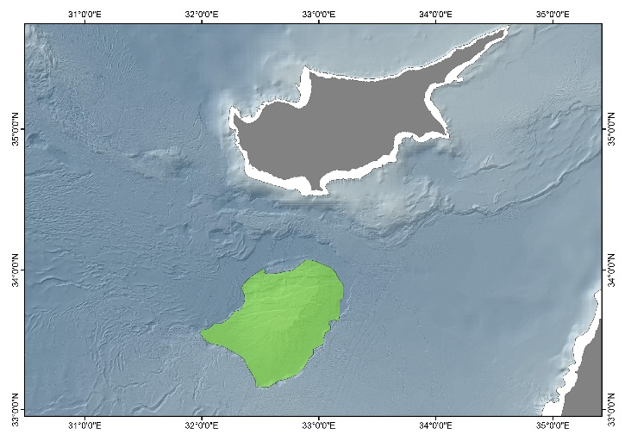
― INTRODUCTION TO THE AREA
The Eratosthenes Seamount (ca. 120 by 80 km) is located in the Eastern Mediterranean about 100 km south of western Cyprus, rising 2000 m above the surrounding abyssal plain. A single faunal investigation took place in 1994 and consisted of an hour haul of a 2 m wide beam-trawl across the seamount top, and 9 box core samples. Yet, these samples yielded a rich and diverse fauna. This notably comprises two species of scleractinian coral (Caryophyllia calveri, Desmophyllum dianthus), which were the first live records from the Levant Basin and significantly extended the species' depth ranges. During the Quarternary the eastern Mediterranean underwent a series of synchronous basin-wide anoxic episodes, the last in the early Holocene. If the anoxia left the seamount as an isolated refuge, and the anoxic episodes were of sufficient duration, its fauna would include taxa not found on the adjacent slope. These may include "relict" taxa that were once widespread but that are now restricted to the seamount, or endemic taxa that evolved in isolation on the seamount. The Eratosthenes Seamount would thus be a UNIQUE HABITAT worthy of detailed investigation and conservation. The 1994 benthos samples provide a glimpse of a deep Levant seamount fauna, in an area and depth commonly expected to be poor in faunal wealth. The surprising faunal diversity and density, and the unexpected presence of live scleractinians, suggests that investigation and conservation of Eratosthenes Seamount should be undertaken.

― ECOLOGICAL RELEVANCE AND ANTHROPOGENIC THREATS OF THE AREA
Highly relevant ecological relevance criteria (>2.5): Uniqueness | Importance for threatened, endangered or declining species and/or habitats | Vulnerability, fragility, sensitivity, or slow recover | Natural representativeness | Bio-geographic importance | Extreme scientific interest.
Highly important anthropogenic threat criteria (>2.5): Overfishing and stock depletion (D3-based) | Intensive, sustained fishing (D6-based).

― KEY REFERENCES: Galil and Zibrowius, 1998; Rubin-Blum et al., 2014.

OR.1 DEEP NILE DELTA FAN
BASIN: AEGEAN – LEVANTINE MEDITERRANEAN
ER SCORE: 2.61/3 AT SCORE: 2.53/3 CLASSIFICATION: TYPE 1

IDEM Key areas descriptive sheet

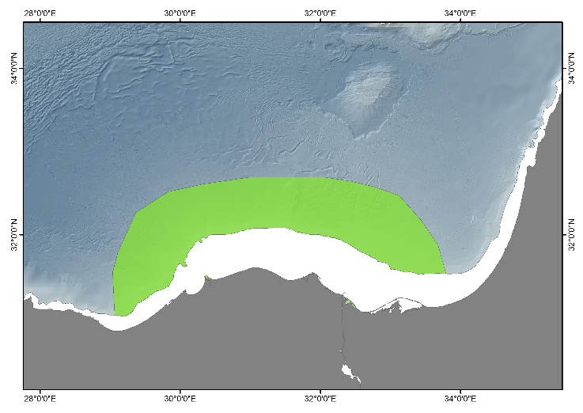
― INTRODUCTION TO THE AREA
The Nile Deep Sea Fan (NDSF) hosts numerous active fluid escape structures including several large gas emitting mud volcanoes characterized by emissions of thermogenic methane and higher hydrocarbons. The NDSF comprises 4 morpho-structural provinces. The faunal assemblages associated with the structures dominated by variable emissions of methane and heavier hydrocarbons and associated with a major thermal contribution are little known. Videographic surveying and sampling revealed patchy mats of sulphide-oxidizing bacteria and association of symbiont-bearing chemosynthetic bivalves and tubeworms (vestimentiferans and lamellibranchians). The environmental high heterogeneity is reflected in significant differences at different spatial scales: (1) the fauna of reduced habitats differed substantially in activity, diversity and biomass from the non-seep environment at similar water depth, (2) cold seep microhabitats showed differences in community structure and composition related to substratum type as well as to the intensity and location of fluid emissions. In view of the prospecting, bidding and extraction of extensive offshore gas and oil fields in the NDSF, and the vulnerability and low resilience of the biotic assemblages, a robust commitment for a coordinated, integrative research and conservation at national and regional levels, is required to achieve protection for the NDSF biota. The region still lacks comprehensive ecological characterization, including scientifically-sound habitat mapping, which is the principal requisite for informing policy makers.

― ECOLOGICAL RELEVANCE AND ANTHROPOGENIC THREATS OF THE AREA
Highly relevant ecological relevance criteria (>2.5): Uniqueness | Dependency | Importance for threatened, endangered or declining species and/or habitats | Vulnerability, fragility, sensitivity, or slow recover | Natural representativeness | Bio-geographic importance | Integrity | High-energy processes relevant for deep sea dynamics.
Highly important anthropogenic threat criteria (>2.5): Introduction of alien species (D2-based) | Overfishing and stock depletion (D3-based) | High artificial nutrient inputs delivered to the deep-sea (D5-based) | Intensive, sustained fishing (D6-based) | Deep-sea exploration and production activities (D6-based) | Persistent and intense underwater noise (D11-based) | Significant effects of land-sourced, coastal and surface drivers on deep-sea ecosystems (D5-D10-based).

― KEY REFERENCES: Dupre et al., 2007; Bayon et al., 2009; Huguen et al., 2009; Brissac et al., 2011; Ritt et al., 2011, 2012; Felden et al., 2013.

OR.3 LEVANT SEA (LEVANTINE SLOPE, BATHYAL SOFT BOTTOMS)
BASIN: AEGEAN – LEVANTINE MEDITERRANEAN
ER SCORE: 2.02/3 AT SCORE: 1.94/3E CLASSIFICATION: TYPE 1

IDEM Key areas descriptive sheet

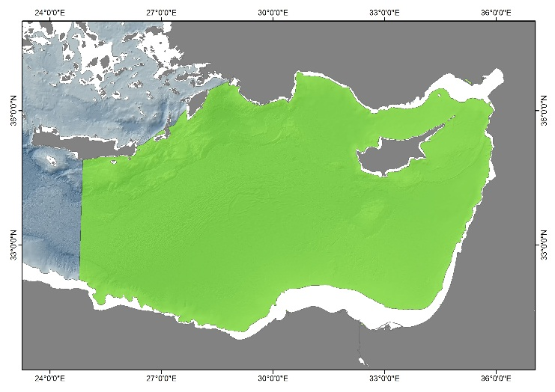
― INTRODUCTION TO THE AREA
The results of a recent IDEM-funded survey suggest that the megafauna of the soft bottom upper slope in the southern Levant Sea comprise distinct and unique assemblages, complementing more extensive studies of the bathyal biota, and differing in the composition and relative abundance of their taxa form slope habitats elsewhere in the Mediterranean Sea. Moreover, these assemblages comprise aggregations of regionally rare erect sponges, hydrozoans, anthozoans and brachiopod fields, which play a significant structural role in soft bottom ecosystems by furnishing the biota with spatially complex habitats. These ecosystem engineer/habitat former taxa are highly susceptible to human disturbance, thus their conservation is crucial for biodiversity preservation. In the Mediterranean Sea such habitats are associated with commercially important fishery grounds, and in consequence, have greatly declined over the past century. Yet, as the local bottom-trawling fishery has been mostly confined to the shelf and shelf edge, these vulnerable assemblages have survived. In view of the prospecting, bidding and extraction of extensive offshore gas and oil fields in the Levant Sea, and the vulnerability and low resilience of the soft bottom assemblages, a robust commitment for a coordinated, integrative research and conservation at national and regional levels, is required to achieve protection for the deep Levantine biota. The region still lacks comprehensive ecological characterization, including scientifically-sound habitat mapping, which is the principal requisite for informing policy makers. Additionally, the presence of NIS, including invasive NIS, beyond the shelf edge and deeper has been documented (thus far) from the Levant, plus an intriguing record off the Spanish Mediterranean coast. This is clearly an EMERGING issue and likely to increase with global change. We suggest that it is important AND PRUDENT to include the Levant in the suggestions for "sensitive areas" for NIS monitoring. It bears remembering that many of the marine NIS now established along the Mediterranean coast of Member States, had been recorded earlier in the Levant. It is likely, actually - it is certain, that a similar pattern will be forthcoming for upper slope NIS

― ECOLOGICAL RELEVANCE AND ANTHROPOGENIC THREATS OF THE AREA
Highly relevant ecological relevance criteria (>2.5): Vulnerability, fragility, sensitivity, or slow recover | Bio-geographic importance | Extreme scientific interest.
Highly important anthropogenic threat criteria (>2.5): Deep-sea exploration and production activities (D6-based) | Maritime traffic (D2, D8, D10 and D11-based).

― KEY REFERENCES: Galil, 2004; Goren and Galil, 2005; Goren et al., 2008; Danovaro et al., 2010.

List of papers, webpages and relevant IDEM reports consulted for expert evaluation
Acosta, J., Canals, M., López-Martı́nez, J., Muñoz, A., Herranz,P., Urgeles, R. et al. (2003). The Balearic Promontory geomorphology (western Mediterranean): morphostructure and active processes. Geomorphology, 49 (3-4), 177-204. https://doi.org/10.1016/S0169-555X(02)00168-X.
Alberola, C., Millot, C. (2003). Circulation in the French Mediterranean coastal zone near Marseilles: the influence of wind and the Northern Current. Continental Shelf Research 23, 6, 587-610. https://doi.org/10.1016/s0278-4343(03)00002-5.
Álvarez-Pérez G., Busquets P., De Mol B., Sandoval N.G., Canals M., Casamor J.L. (2005) Deep-water coral occurrences in the Strait of Gibraltar. In: Freiwald A., Roberts J.M. (eds) Cold-Water Corals and Ecosystems. Erlangen Earth Conference Series. Springer, Berlin, Heidelberg. https://doi.org/10.1007/3-540-27673-4_10.
Angeletti, L., Taviani, M., Canese, S., Foglini, F., Mastrototaro, F., Argnani, A. et al. (2014). New deep-water cnidarian sites in the southern Adriatic Sea. Mediterranean Marine Science, (2), 263-273. https://doi.org/10.12681/mms.558.
Astraldi, M., Balopoulos, S., Candela, J., Font, J., Gacic, M., Gasparini, G.P. et al. (1999). The role of straits and channels in understanding the characteristics of Mediterranean circulation. Progress in Oceanography, 44(1-3), 65-108. https://doi.org/10.1016/S0079-6611(99)00021-X.
Bargain, A., Marchese, F., Savini, A., Taviani, M., Fabri, M.C. (2017). Santa Maria di Leuca Province (Mediterranean Sea): Identification of Suitable Mounds for Cold-Water Coral Settlement Using Geomorphometric Proxies and Maxent Methods. Frontiers in Marine Science 4, 338. https://doi.org/10.3389/fmars.2017.00338
Basset, A., Barbone, E., Borja, A., Brucet, S., Pinna, M., Quintana, X. D. et al. (2012). A benthic macroinvertebrate size spectra index for implementing the Water Framework Directive in coastal lagoons in Mediterranean and Black Sea ecoregions. Ecological Indicators, 12(1), 72–83. https://doi.org/10.1016/j.ecolind.2011.06.012.
Bayon, G., Loncke, L., Dupre, S., Caprais, J.C., Ducassou, E., Duperron, S. et al. (2009). Multi-disciplinary investigation of fluid seepage on an unstable margin: The case of the Central Nile deep sea fan. Marine Geology 261, 1-4, 92-104. https://doi.org/10.1016/j.margeo.2008.10.008.
Bianchelli, S., Pusceddu, A., Buschi, E., Danovaro, R. (2016). Trophic status and meiofauna biodiversity in the Northern Adriatic Sea: insights for the assessment of good environmental status. Marine Environmental Research, 113, 18-30. https://doi.org/10.1016/j.marenvres.2015.10.010.
Bo, M., Barucca, M., Biscotti, M. A., Brugler, M. R., Canapa, A., Canese, S. et al. (2018). Phylogenetic relationships of Mediterranean black corals (Cnidaria: Anthozoa: Hexacorallia) and implications for classification within the order Antipatharia. Invertebrate systematics, 32(5), 1102-1110. https://doi.org/10.1071/IS17043.
Bolam, S.G., Coggan, R.C., Eggleton, J., Diesing, M., and Stephens, D. (2014). Sensitivity of macrobenthic secondary production to trawling in the English sector of the Greater North Sea: A biological trait approach. Journal of Sea Research, 85, 162–177. https://doi.org/10.1016/j.seares.2013.05.003.
Borja, A., Franco, F., Valencia, V., Bald, J., Muxica, I., Belzunce, M.J., Solaun, O. (2004). Implementation of the European water framework directive from the Basque country (northern Spain): a methodological approach. Marine Pollution Bulletin, 48 (3–4), 209-218. https://doi.org/10.1016/j.marpolbul.2003.12.001.
Borja, A., Franco, J., Pérez, V. (2000). A Marine Biotic Index to Establish the Ecological Quality of Soft-Bottom Benthos Within European Estuarine and Coastal Environments. Marine Pollution Bulletin, 40(12), 1100–1114. https://doi.org/10.1016/S0025-326X(00)00061-8.
Borja. Á., and Grémare, A. (2012). The importance of setting targets and reference conditions in assessing marine ecosystem quality. Ecological Indicators. 12(1). 1–7. https://doi.org/10.1016/J.ECOLIND.2011.06.018.
Brissac, T., Rodrigues, C.F., Gros, O., Duperron, S. (2011). Characterization of bacterial symbioses in Myrtea sp. (Bivalvia: Lucinidae) and Thyasira sp. (Bivalvia: Thyasiridae) from a cold seep in the Eastern Mediterranean. Marine Ecology-an Evolutionary Perspective 32, 2, 198-210. https://doi.org/10.1111/j.1439-0485.2010.00413.x.
Canals, M., Company, J. B., Martín, D., Sanchez-Vidal, A., Ramirez-Llodra, E. (2013). Integrated study of Mediterranean deep canyons: novel results and future challenges. Progress in Oceanography, 118, 1-27. https://doi.org/10.1016/j.pocean.2013.09.004.
Canals, M., Danovaro, R., Heussner, S., Lykousis, V., Puig, P., Trincardi, F. et al. (2009). Cascades in Mediterranean submarine grand canyons. Oceanography, 22(1), 26-43. Retrieved from http://www.jstor.org/stable/24860920.
Canals, M., Puig, P., de Madron, X. D., Heussner, S., Palanques, A., and Fabres, J. (2006). Flushing submarine canyons. Nature, 444(7117), 354. https://doi.org/10.1038/nature05271.
Candela, J. (1991). The Gibraltar Strait and its role in the dynamics of the Mediterranean Sea. Dynamic Atmosphere Oceans, 15 (3-5), 7313-7335. https://doi.org/10.1016/0377-0265(91)90023-9.
Casini, M., Hjelm, J., Molinero, J.C., Lövgren, J., Cardinale, M., Bartolino, V. et al. (2009). Trophic cascades promote threshold-like shifts in pelagic marine ecosystems. Proceedings of the National Academy of Sciences. 106(1). 197-202. https://doi.org/10.1073/pnas.0806649105.
Collie, J.S., Hall, S.J., Kaiser, M.J., Poiner, I.R. (2000). A quantitative analysis of fishing impacts on shelf-sea benthos. Journal of Animal Ecology, 69, 785-798. https://doi.org/10.1046/j.1365-2656.2000.00434.x
Combes Magali, Vaz Sandrine (2019). Systematic conservation planning for the North-Atlantic deep sea. SEANOE. https://doi.org/10.17882/62541
COP19 and UNEP/MAP-SPA/RAC. (2016). Decision IG.22/10. Implementing the Marine Litter Regional Plan in the Mediterranean (Fishing for Litter Guidelines, Assessment Report, Baselines Values, and Reduction Targets). 32pp.
D’Onghia, G., Calculli, C., Capezzuto, F., Carlucci, R., Carluccio, A., Grehan, A. et al. (2017). Anthropogenic impact in the Santa Maria di Leuca cold-water coral province (Mediterranean Sea): observations and conservation straits. Deep Sea Research Part II: Topical Studies in Oceanography, 145, 87-101. https://doi.org/10.1016/j.dsr2.2016.02.012.
Danovaro, R., Company, JB., Corinaldesi, C., D'Onghia, G., Galil, B., Gambi, C. et al. (2010) Deep-Sea Biodiversity in the Mediterranean Sea: The Known, the Unknown, and the Unknowable. PLOS ONE 5(8): e11832. https://doi.org/10.1371/journal.pone.0011832
Dauvin, J.C. (2010). Towards an impact assessment of bauxite red mud waste on the knowledge of the structure and functions of bathyal ecosystems: The example of the Cassidaigne canyon (north-western Mediterranean Sea). Marine Pollution Bulletin 60, 2, 197-206. https://doi.org/10.1016/j.marpolbul.2009.09.026.
De Stephanis, R., Cornulier, T., Verborgh, P., Sierra, J. S., Gimeno, N. P., Guinet, C. (2008). Summer spatial distribution of cetaceans in the Strait of Gibraltar in relation to the oceanographic context. Marine Ecology Progress Series, 353, 275-288. https://doi.org/10.3354/meps07164.
Dell'Anno, A., Mei, M.L., Pusceddu, A., Danovaro, R. (2002). Assessing the trophic state and eutrophication of coastal marine systems: a new approach based on the biochemical composition of sediment organic matter. Marine Pollution Bulletin 44, 7, 611-622. https://doi.org/10.1016/S0025-326X(01)00302-2.
DEVOTES Project. (2014). DEVOTES. The WP3 indicator catalogue software. Introduction to the usage of DEVOTool 0.64. Obtained from: www.devotes-project.eu
D'Onghia, G., Maiorano, P., Carlucci, R., Capezzuto, F., Carluccio, A., Tursi, A., Sion, L. (2012). Comparing deep-sea fish fauna between coral and non-coral “megahabitats” in the Santa Maria di Leuca cold-water coral province (Mediterranean Sea). PLoS One, 7(9), e44509. https://doi.org/10.1371/journal.pone.0044509.
Directive 2008/105/EC. Directive 2008/105/EC of the European Parliament and of the Council of 16 December 2008 on environmental quality standards in the field of water policy, amending and subsequently repealing Council Directives 82/176/EEC, 83/513/EEC, 84/156/EEC, 84/491/EEC, 86/280/EEC and amending Directive 2000/60/EC of the European Parliament and of the Council. Official Journal of the European Union.
Duplisea, D.E., Jennings, S., Warr, K.J., Dinmore, T.A. (2002). A size-based model of the impacts of bottom trawling on benthic community structure. Canadian Journal of Fisheries and Aquatic Sciences, 59:1785-1795. https://doi.org/10.1139/f02-148.
Dupre, S., Woodside, J., Foucher, J.P., de Lange, G., Mascle, J., Boetius, A. et al. (2007). Seafloor geological studies above active gas chimneys off Egypt (Central nile deep sea fan). Deep-Sea Research Part I-Oceanographic Research Papers 54, 7, 1146-1172. https://doi.org/10.1016/j.dsr.2007.03.007.
Eigaard, O. R., Bastardie, F., Hintzen, N. T., Buhl-Mortensen, L.,Buhl-Mortensen, P., Catarino, R., Dinesen, G. E., et al. (2015). Benthic impact of fisheries in European waters: the distribution and intensity of bottom trawling. BENTHIS Deliverable 2.3. 30 pp.
Eigaard, O. R., Bastardie, F., Hintzen, N. T., Buhl-Mortensen, L., Buhl-Mortensen, P., Catarino, R. et al. (2016). The footprint of bottom trawling in European waters: distribution, intensity, and seabed integrity. ICES Journal of Marine Science: Journal Du Conseil, 74(3), fsw194. https://doi.org/10.1093/icesjms/fsw194
Eigaard, O. R., Bastardie, F., Hintzen, N. T., Buhl-Mortensen, L., Buhl-Mortensen, P., Catarino, R. et al. (2017). The footprint of bottom trawling in European waters: Distribution, intensity, and seabed integrity. ICES Journal of Marine Science, 74(3), 847–865. https://doi.org/10.1093/icesjms/fsw194.
European Commission. (2001). Commission regulation (EC) No 466/2001 of 8 March 2001 setting maximum levels for certain contaminants in foodstuffs. Official Journal of the European Communities.
European Commission. (2017). Commission Decision (EU) 2017/848 laying down criteria and methodological standards on good environmental status of marine waters and specifications and standardised methods for monitoring and assessment and repealing Decision 2010/477/EU. Official Journal of the European Union.
Fabri, M.C., Bargain, A., Pairaud, I., Pedel, L., Taupier-Letage, I. (2017). Cold-water coral ecosystems in Cassidaigne Canyon: An assessment of their environmental living conditions. Deep Sea Research Part II: Topical Studies in Oceanography 137, 436-453. https://dx.doi.org/10.1016/j.dsr2.2016.06.006.
Fabri, M.C., Pedel, L., Beuck, L., Galgani, F., Hebbeln, D., Freiwald, A. (2014). Megafauna of vulnerable marine ecosystems in French Mediterranean submarine canyons: Spatial distribution and anthropogenic impacts, Deep-Sea Research Part Ii-Topical Studies in Oceanography 104, 184-207. https://doi.org/10.1016/j.dsr2.2013.06.016.
Fabri, M.C., Vinha, B., Allais, A.G., Bouhier, M.-E., Dugornay, O., Gaillot, A., Arnaubec, A., (2019). Evaluating the ecological status of cold-water coral habitats using non-invasive methods: An example from Cassidaigne canyon, northwestern Mediterranean Sea, Progress in Oceanography, 178, 102172 .
FAO. Food and Agriculture Organization of the United Nations. (2018). The State of Mediterranean and Black Sea Fisheries. General Fisheries Commission for the Mediterranean. Rome. 172 pp.
Felden, J., Lichtschlag, A., Wenzhofer, F., de Beer, D., Feseker, T., Ristova, P.P. et al. (2013). Limitations of microbial hydrocarbon degradation at the Amon mud volcano (Nile deep-sea fan). Biogeosciences 10, 5, 3269-3283. https://doi.org/10.5194/bg-10-3269-2013.
Foglini, F., Campiani, E., and Trincardi, F. (2016). The reshaping of the South West Adriatic Margin by cascading of dense shelf waters. Marine Geology, 375, 64-81. https://doi.org/10.1016/j.margeo.2015.08.011.
Foglini, F., Grande, V., Marchese, F., Bracchi, V.A., Prampolini, M., Angeletti, L. et al. (2019). Application of Hyperspectral Imaging to Underwater Habitat Mapping, Southern Adriatic Sea. Sensors, 19, 2261. https://doi.org/10.3390/s19102261.
Fontanier, C., Biscara, L., Mamo, B., Delord, E. (2015). Deep-sea benthic foraminifera in an area around the Cassidaigne Canyon (NW Mediterranean) affected by bauxite discharges. Marine Biodiversity 44, 4, https://doi.org/10.1007/s12526-014-0281-9.
Fontanier, C., Fabri, M.C., Buscail, R., Biscara, L., Koho, K., Reichart, G.J. et al. (2012). Deep-sea foraminifera from the Cassidaigne Canyon (NW Mediterranean): Assessing the environmental impact of bauxite red mud disposal. Marine Pollution Bulletin 64, 9, 1895-1910. https://doi.org/10.1016/j.marpolbul.2012.06.016.
Freiwald, A., Beuck, L., Rüggeberg, A., Taviani, M., Hebbeln, D., R/V Meteor Cruise M70-1 Participants. (2009). The white coral community in the central Mediterranean Sea revealed by ROV surveys. Oceanography, 22(1), 58-74. https://doi.org/10.5670/oceanog.2009.06.
Galil, B. and Zibrowius, H. (1998). First benthos samples from Eratosthenes Seamount, eastern Mediterranean. Marine Biodiversity 28, 4-6, 111-122. https://doi.org/10.1007/BF03043142.
Galil, B. (2004). The limit of the sea: the bathyal fauna of the Levantine Sea. Scientia Marina, 68: 63-72. https://doi.org/10.3989/scimar.2004.68s363.
GFCM, 2019. Report of the third meeting of the Working Group on Marine Protected Areas (WGMPA), FAO HQ, Italy, 18–21 February 2019.
Gonzalez. D., Coughan. C., Stips. A., Stolk. A., Gonzalez Pola. C., Moreno Aranda. I.M. et al. (2015). Review of the Commission Decision 2010/477/EU concerning MSFD criteria for assessing Good Environmental Status. Descriptor 7. EUR 27544 EN. https://doi.org/10.2788/435059. http://mcc.jrc.ec.europa.eu/documents/201603310431.pdf.
Goren, M., and Galil, B. S. (2005). A review of changes in the fish assemblages of Levantine inland and marine ecosystems following the introduction of non‐native fishes. Journal of Applied Ichthyology, 21(4), 364-370. https://doi.org/10.1111/j.1439-0426.2005.00674.x.
Goren, M., Mienis, H., Galil, B. (2008). Not so poor—more deep-sea records from the Levant Sea, eastern Mediterranean. Marine Biodiversity Records, 1, E43. https://doi.org/10.1017/S1755267206005203.
Greenstreet, S.P.R., Rogers, S.I., Rice, J.C., Piet, G.J., Guirey, E.J., Fraser, H.M and Fryer, R.J. (2011). Development of the EcoQO for the North Sea fish community. ICES Journal of Marine Science 68(1). 1-11. https://doi.org/10.1093/icesjms/fsq156.
Gulland. A. J. and Boerema. K. L. (1973). Scientific advice on catch levels. Fish. Bull. 71. NO.2 325-335.
Habitats Directive (92/43/EEC). (1992). Council Directive 92/43/EEC of 21 May 1992 on the conservation of natural habitats and of wild fauna and flora. Official Journal of the European Communities.
Halpern, B., Walbridge, S., Selkoe, K., Kappel, C., Micheli, F., D'Agrosa, C. et al. (2008). A global map of human impact on marine ecosystems. Science 319(5865), 948–952. https://doi.org/10.1126/science.1149345
HELCOM. (2012a). Helsinki Commission. Development of a set of core indicators: Interim report of the HELCOM CORESET project. PART A: Descriptions of the selection process. Baltic Sea Environment Proceedings No. 129A.
HELCOM. (2012b). Helsinki Commission. Development of a set of core indicators: Interim report of the HELCOM CORESET project. PART B: Descriptions of the indicators. Baltic Sea Environment Proceedings No. 129B.
Hiddink, J. G., Jennings, S., Kaiser, M. J. (2006). Indicators of the Ecological Impact of Bottom-Trawl Disturbance on Seabed Communities. Ecosystems, 9(7), 1190–1199. https://doi.org/10.1007/s10021-005-0164-9.
Hilborn. R. and Walters. C.J. (1992). Quantitative fisheries stock assessment: Choice, dynamics and uncertainty. Chapman and Hall. New York. 570pp.
Huguen, C., Foucher, J.P., Mascle, J., Ondreas, H., Thouement, M., Gontharet, S. et al. (2009). Menes caldera, a highly active site of brine seepage in the Eastern Mediterranean sea: "In situ" observations from the NAUTINIL expedition (2003). Marine Geology 261, 1-4, 138-152. https://doi.org/10.1016/j.margeo.2009.02.005.
Hyland, J., Balthis, L., Karakassis, I., Magni, P., Petrov, A., Shine, J. et al. (2005). Organic carbon content of sediments as an indicator of stress in the marine benthos. Marine Ecology Progress Series, 295, 91–103. https://doi.org/10.3354/meps295091.
ICES WKGMSFDD3‐II. (2015b). Report of the workshop on guidance for the review of MSFD decision descriptor 3 ‐ commercial fish and shellfish II (WKGMSFDD3‐II). ICES Headquarters. Denmark. ICES
ICES WKGMSFDD6. (2014). ICES ACOM COMMITTEE. Report of the Workshop to review the 2010 Commission Decision on criteria and methodological standards on good environmental status (GES) of marine waters; Descriptor 6. ICES Headquarters. Denmark.
ICG-COBAM. (2013). OSPAR Intersessional Correspondence Group on the Coordination of Biodiversity Assessment and Monitoring (ICG-COBAM) for the OSPAR Biodiversity Committee. Development of a OSPAR common set biodiversity indicators.
Jessen, C., Bednarz, V.N., Rix, L., Teichberg, M., Wild, C. (2015). Marine eutrophication. In Environmental indicators (pp. 177-203). Publisher: Springer. Editors: R.H. Armon, O. Hänninen. https://doi.org/10.1007/978-94-017-9499-2_11.
Kaiser, M.J., Clarke, K.R., Hinz, H., Austen, M.C.V., Somerfield, P.J. and Karakassis, I. (2006). Global analysis of response and recovery of benthic biota to fishing. Marine Ecology Progress Series, 311:1-14. https://doi.org/10.3354/meps311001.
Korpinen, S., Meski, L., Andersen, J. H., Laamanen, M. (2012). Human pressures and their potential impact on the Baltic Sea ecosystem. Ecological Indicators. 15(1). 105–114. https://doi.org/10.1016/j.ecolind.2011.09.023.
Labrune, C., Amouroux, J. M., Sarda, R., Dutrieux, E., Thorin, S., Rosenberg, R., Grémare, A. (2006). Characterization of the ecological quality of the coastal Gulf of Lions (NW Mediterranean). A comparative approach based on three biotic indices. Marine Pollution Bulletin, 52(1), 34–47. https://doi.org/10.1016/j.marpolbul.2005.08.005.
Lastras, G., Canals, M., Ballesteros, E., Gili, J. M., Sanchez-Vidal, A. (2016). Cold-Water corals and anthropogenic impacts in La Fonera submarine canyon head, Northwestern Mediterranean Sea. PloS one, 11(5), e0155729. https://doi.org/10.1371/journal.pone.0155729.
Lastras, G., Canals, M., Urgeles, R., Hughes‐Clarke, J. E., Acosta, J. (2004). Shallow slides and pockmark swarms in the Eivissa Channel, western Mediterranean Sea. Sedimentology, 51(4), 837-850. https://doi.org/10.1111/j.1365-3091.2004.00654.x.
Lauria, V., Garofalo, G., Fiorentino, F., Massi, D., Milisenda, G., Piraino, S. et al. (2017). Species distribution models of two critically endangered deep-sea octocorals reveal fishing impacts on vulnerable marine ecosystems in central Mediterranean Sea. Scientific reports, 7(1), 8049. https://doi.org/10.1038/s41598-017-08386-z.
Lembo G. (2015). Programma nazionale Italiano per la raccolta di dati alieutici 2015 Campagne di ricerca in mare Sezione G. Relazione finale GSA18. COISPA, Itay: pp. 52.
León, R., Somoza, L., Medialdea, T., González, F.J., Gimenez-Moreno, C.J., Pérez-López, R. (2014). Pockmarks on either side of the Strait of Gibraltar: formation from overpressured shallow contourite gas reservoirs and internal wave action during the last glacial sea-level lowstand? Geo-Marine Letters (2014) 34: 131. https://doi.org/10.1007/s00367-014-0358-2.
Link. J.S. (2005). Translating ecosystem indicators into decision criteria. ICES Journal of Marine Science. 62: 569-576. https://doi.org/doi:10.1016/j.icesjms.2004.12.015.
Malanotte-Rizzoli, P., and Bergamasco, A. (1991). The wind and thermally driven circulation of the eastern Mediterranean Sea. Part II: The baroclinic case. Dynamics of Atmospheres and Oceans, 15(3-5), 355-419. https://doi.org/10.1016/0377-0265(91)90026-C.
Malinverno, E., Taviani, M., Rosso, A., Violanti, D., Villa, I., Savini, A. et al. (2010). Stratigraphic framework of the Apulian deep-water coral province, Ionian Sea. Deep Sea Research Part II: Topical Studies in Oceanography, 57(5-6), 345-359. https://doi.org/10.1016/j.dsr2.2009.08.025.
Marine Strategy Framework Directive (2008/56/EC). (2008). Directive 2008/56/EC of the European Parliament and of the Council of 17 June 2008 establishing a framework for Community action in the field of marine environmental policy (Marine Strategy Framework Directive). Official Journal of the European Union.
Massutí, E., Gordon, J.D.M., Moranta, J., Swan, S.C., Stefanescu, C., Merrett, N.R. (2004). Mediterranean and Atlantic deep-sea fish assemblages: Differences in biomass composition and size-related structure. Scientia Marina. 68. 101-115.
MedPAN UNEP/MAP RAC/SPA. (2016). The 2016 status of Marine Protected Areas in the Mediterranean. Main Findings.
Micheli, F., Halpern, B.S., Walbridge, S., Ciriaco, S., Ferretti, F., Fraschetti, S. et al. (2013). Cumulative human impacts on Mediterranean and Black Sea marine ecosystems: Assessing current pressures and opportunities. PLoS ONE. 8(12). https://doi.org/10.1371/journal.pone.0079889.
Millot, C., 1990. The Gulf of Lions' hydrodynamics. Continental Shelf Research 10, 9-11, 885-894, https://doi.org/10.1016/0278-4343(90)90065-T.
Modica L., Velasco F., Preciado I., Soto M., Greenstreet S.P.R. (2014). Development of the large fish indicator and associated target for a Northeast Atlantic fish community, ICES Journal of Marine Science, 71(9), 2403–2415. https://doi.org/10.1093/icesjms/fsu101.
Moffat. C., Aish. A., Hawkridge. J.M., Miles. H., Mitchell. P.I., McQuatters-Gollop. A. et al. (2011). Advice on United Kingdom biodiversity indicators and targets for the Marine Strategy Framework Directive. Healthy and biologically diverse seas evidence group report to the Department for Environment. Food and Rural Affairs. 210pp.
Nöges P., Toth, L.G., van de Bund, W., Cardoso, A.C., Haastrup, P., Wuertz, J. et al. (2005). The Water Framework Directive final intercalibration register for lakes, rivers, coastal and transitional waters: overview and analysis of metadata. Institute for Environment and Sustainability, Inland and Marine Waters Unit, Joint Research Centre, European Commission, Ispra (VA), Italy. 137pp.
Oceana (2014). Scientific Information to Describe Areas Meeting Scientific Criteria for Mediterranean EBSAs. Malaga Spain, 7-11.04.2014.
Orejas, C., Gori, A., Iacono, C. L., Puig, P., Gili, J. M., Dale, M. R. (2009). Cold-water corals in the Cap de Creus canyon, northwestern Mediterranean: spatial distribution, density and anthropogenic impact. Marine Ecology Progress Series, 397, 37-51. https://doi.org/10.3354/meps08314.
Ovchinnikov, I. M., Zats, V. I., Krivosheya, V. G., Udodov, A. I. (1985). Formation of deep Eastern Mediterranean waters in the Adriatic Sea. Oceanology, 25(6), 704-707.
Palanques, A., Puig, P., Latasa, M., Scharek, R. (2009). Deep sediment transport induced by storms and dense shelf-water cascading in the northwestern Mediterranean basin. Deep Sea Research Part I: Oceanographic Research Papers, 56(3), 425-434. https://doi.org/10.1016/j.dsr.2008.11.002.
Piante. C. and Ody. D. (2015). Blue Growth in the Mediterranean Sea: the Challenge of Good Environmental Status. MedTrends Project. WWF-France. 192 p.
Pielou, E. C. (1975). Ecological diversity (No. 574.524018 P5).
Pinedo, S., and Jordana, E. (2008). Spain (Catalonia and Balearic Islands). Water Framework Directive Intercalibration Technical Report. Part, 3, 62-70.
Pitcher, R.C., Ellis, N., Jennings, S., Hiddink, J.G., Mazor, T., Kaiser, M.J. et al. (2017). Estimating the sustainability of towed fishing-gear impacts on seabed habitats: a simple quantitative risk assessment method applicable to data-limited fisheries. Methods in Ecology and Evolution 2017,8, 472-480. https://doi.org/10.1111/2041-210X.12705.
Pollak, M. J. (1951). The sources of the deep water of the eastern Mediterranean Sea. Journal of Marine Research, 10(1), 128-152.
Puig, P., Font, J., Palanques, A., Sardà, F. (2008). Monitoring dense shelf water cascades: an assessment tool for understanding deep-sea ecosystems functioning. CIESM Workshop Monographs 34: 81-86. http://www.ciesm.org/online/monographs/LaSpezia.html.
Pusceddu, A., Bianchelli, S., Gambi, C., Danovaro, R. (2011). Assessment of benthic trophic status of marine coastal ecosystems: Significance of meiofaunal rare taxa. Estuarine. Coastal and Shelf Science. 93(4). 420-430. https://doi.org/10.1016/j.ecss.2011.05.012.
Pusceddu, A., Dell’Anno, A., Fabiano, M., Danovaro, R. (2009). Quantity and bioavailability of sediment organic matter as signatures of benthic trophic status. Marine Ecology Progress Series. 375. 41-52. https://doi.org/10.3354/meps07735.
Rijnsdorp, A. D., Bastardie, F., Bolam, S. G., Buhl-Mortensen, L., Eigaard, O. R., Hamon, K. G. et al. (2016). Towards a framework for the quantitative assessment of trawling impact on the seabed and benthic ecosystem. ICES Journal of Marine Science: Journal Du Conseil, 73(suppl 1), i127–i138. https://doi.org/10.1093/icesjms/fsv207.
Ritt, B., Desbruyeres, D., Caprais, J.C., Gauthier, O., Ruffine, L., Buscail, R. et al. (2012). Seep communities from two mud volcanoes in the deep eastern Mediterranean Sea: faunal composition, spatial patterns and environmental control. Marine Ecology Progress Series 466, 93-+. https://doi.org/10.3354/meps09896.
Ritt, B., Pierre, C., Gauthier, O., Wenzhöfer, F., Boetius, A., and Sarrazin, J. (2011). Diversity and distribution of cold-seep fauna associated with different geological and environmental settings at mud volcanoes and pockmarks of the Nile Deep-Sea Fan. Marine Biology, 158(6), 1187-1210. https://doi.org/10.1007/s00227-011-1679-6.
Ritt, B., Pierre, C., Gauthier, O., Wenzhofer, F., Boetius, A., Sarrazin, J. (2011). Diversity and distribution of cold-seep fauna associated with different geological and environmental settings at mud volcanoes and pockmarks of the Nile Deep-Sea Fan. Marine Biology 158, 6, 1187-1210. https://doi.org/10.1007/s00227-011-1679-6.
Roether, W., and Schlitzer, R. (1991). Eastern Mediterranean deep water renewal on the basis of chlorofluoromethane and tritium data. Dynamics of Atmospheres and Oceans, 15(3-5), 333-354. https://doi.org/10.1016/0377-0265(91)90025-B.
Rosenberg, R., Blomqvist, M., C Nilsson, H., Cederwall, H., Dimming, A. (2004). Marine quality assessment by use of benthic species-abundance distributions: a proposed new protocol within the European Union Water Framework Directive. Marine Pollution Bulletin, 49(9–10), 728–739. https://doi.org/10.1016/j.marpolbul.2004.05.013.
Rubin-Blum, M., Tsadok, R., Shemesh, E., Goodman-Tchernov, B.N., Austin, J.A., Coleman, D.F. et al. (2014). Distribution of the Lamellibrachia spp. (Siboglinidae, Annelida) and their trophosome endosymbiont phylotypes in the Mediterranean Sea. Marine Biology 161, 6, 1229-1239, https://doi.org/10.1007/s00227-014-2413-y.
Savini, A., and Corselli, C. (2010). High-resolution bathymetry and acoustic geophysical data from Santa Maria di Leuca Cold Water Coral province (Northern Ionian Sea—Apulian continental slope). Deep Sea Research Part II: Topical Studies in Oceanography, 57(5-6), 326-344. https://doi.org/10.1016/j.dsr2.2009.08.014.
Savini, A., Vertino, A., Marchese, F., Beuck, L., Freiwald, A. (2014). Mapping cold-water coral habitats at different scales within the Northern Ionian Sea (Central Mediterranean): an assessment of coral coverage and associated vulnerability. PLoS One, 9(1), e87108. https://doi.org/10.1371/journal.pone.0087108.
Schroeder, K., Chiggiato, J., Josey, S.A., Borghini, M., Aracri, S., Sparnocchia, S. (2017). Rapid response to climate change in a marginal sea. Scientific Reports. 7(1). 4065. https://doi.org/10.1038/s41598-017-04455-5.
Shephard S., Reid D. G., Greenstreet S. (2011). Interpreting the large fish indicator for the Celtic Sea. ICES Journal of Marine Science, 68: 1963-1972. https://doi.org/10.1093/icesjms/fsr114.
Simboura, N., and Zenetos, A. (2002). Benthic indicators to use in Ecological Quality classification of Mediterranean soft bottom marine ecosystems, including a new Biotic Index. Mediterranean Marine Science, 3(2), 77. https://doi.org/10.12681/mms.249.
Simboura. N. and Argyrou. M. (2010). An insight into the performance of benthic classification indices tested in Eastern Mediterranean coastal waters. Marine Pollution Bulletin. 60(5). 701-709. https://doi.org/10.1016/j.marpolbul.2009.12.005
Stora, G., Arnoux, A., Duport, E., Re, C., Gerino, M., Desrosiers, G., Gilbert, F. (2011). Impact of Red Mud Deposits in the Canyon of Cassidaigne on the Macrobenthos of the Mediterranean Continental Slope.[Ceccaldi, H.J., Dekeyser, I., Girault, M., Stora, G. (Eds.)] Global Change: Mankind-Marine Environment Interactions, pp. 397-400. https://doi.org/10.1007/978-90-481-8630-3_72.
Taviani, M., Angeletti, L., Beuck, L., Campiani, E., Canese, S., Foglini, F. et al. (2016). Reprint of: On and off the beaten track: Megafaunal sessile life and Adriatic cascading processes'. Marine Geology, 375, 146-160. https://doi.org/10.1016/j.margeo.2015.10.003.
Taviani, M., Remia, A., Corselli, C., Freiwald, A., Malinverno, E., Mastrototaro, F. et al. (2005a). First geo-marine survey of living cold-water Lophelia reefs in the Ionian Sea (Mediterranean basin). Facies, 50(3-4), 409-417. https://doi.org/10.1007/s10347-004-0039-0.
Taviani, M., Freiwald, A., and Zibrowius, H. (2005b). Deep coral growth in the Mediterranean Sea: an overview. In Cold-water corals and ecosystems (pp. 137-156). Springer, Berlin, Heidelberg. https://doi.org/10.1007/3-540-27673-4_7.
Taviani, M., Vertino, A., Correa, M. L., Savini, A., De Mol, B., Remia, A. et al. (2011). Pleistocene to Recent scleractinian deep-water corals and coral facies in the Eastern Mediterranean. Facies, 57(4), 579-603. https://doi.org/10.1007/s10347-010-0247-8.
TG Noise. (2018). MSFD Common Implementation Strategy - Technical Group on Underwater Noise (TG-NOISE). Thematic workshop: Towards thresholds for underwater noise Common approaches for interpretation of data obtained in (Joint) Monitoring Programmes – Part 2. Brussels. 7-8.11.2018.
Thrush, S. F., Lundquist, C. J., and Hewitt, J. E. (2005). Spatial and temporal scales of disturbance to the seafloor: a generalized framework for active habitat management. American Fisheries Society Symposium, 41: 639–649.
Trenkel. V. (2006). Méthodes d'évaluation des ressources marines vivantes pour une exploitation durable. HDR. http://archimer.ifremer.fr/doc/00000/1545/.
Turchetto, M., Boldrin, A., Langone, L., Miserocchi, S., Tesi, T., Foglini, F. (2007). Particle transport in the Bari canyon (southern Adriatic Sea). Marine Geology, 246(2-4), 231-247. https://doi.org/10.1016/j.margeo.2007.02.007.
Tursi, A., Mastrototaro, F., Matarrese, A., Maiorano, P., D'Onghia, G. (2004). Biodiversity of the white coral reefs in the Ionian Sea (Central Mediterranean). Chemistry and Ecology, 20(sup1), 107-116. https://doi.org/10.1080/02757540310001629170.
UNEP-MAP-RAC/SPA. (2010). Overview of scientific findings and criteria relevant to identifying SPAMIs in the Mediterranean open seas, including the deep sea. By Notarbartolo di Sciara. G. and Agardy. T. Ed. RAC/SPA. Tunis: 71pp
Van Denderen, P.D., Bolam, S.G., Hiddink, J.G., Jennings, S., Kenny, A., Rijnsdorp, A., van Kooten, T. (2015). Similar effects of bottom trawling and natural disturbance on composition and function of benthic communities across habitats. Marine Ecology Progress Series, 541:31-43. https://doi.org/10.3354/meps11550
Vertino, A., Savini, A., Rosso, A., Di Geronimo, I., Mastrototaro, F., Sanfilippo, R. et al. (2010). Benthic habitat characterization and distribution from two representative sites of the deep-water SML Coral Province (Mediterranean). Deep Sea Research Part II: Topical Studies in Oceanography, 57(5-6), 380-396. https://doi.org/10.1016/j.dsr2.2009.08.023.
Vilibić, I., and Orlić, M. (2002). Adriatic water masses, their rates of formation and transport through the Otranto Strait. Deep Sea Research Part I: Oceanographic Research Papers, 49(8), 1321-1340. https://doi.org/10.1016/S0967-0637(02)00028-6.
WGMPA, Working Group on Marine Protected Areas. (2019). Report of the Working Group on Marine Protected Areas (WGMPA), including a session on essential fish habitats (EFH). Scientific Advisory Committee on Fisheries (SAC). Food and Agriculture Organization of the United Nations. General Fisheries Commission of the Mediterranean. FAO headquarters, Rome, Italy, 18 –21 February 2019.
WGVME, Working Group on Vulnerable Marine Ecosystems. (2018). Report of the second meeting of the Working Group on Vulnerable Marine Ecosystems (WGVME). Scientific Advisory Committee on Fisheries (SAC). Food and Agriculture Organization of the United Nations. General Fisheries Commission of the Mediterranean. FAO headquarters, Rome, Italy, 26 –28 February 2018.

WEBPAGES
Natura2000 network. https://era.org.mt/en/Pages/Natura-2000-Datasheets-Maps.aspx). Last access on: 16/05/2019.
OSPAR. Intermediate Assessment 2017. https://oap.ospar.org/en/ospar-assessments/intermediate-assessment-2017/. Accessed on: 08/01/2019
UNEP-MAP. 2017. Mediterranean 2017 Quality Status Report. https://www.medqsr.org/. Accessed on: 08/01/2019
Convention on Biological Diversity. Ecologically or Biologically Significant Areas (EBSAs). https://www.cbd.int/ebsa/). Accessed on: 26/03/2019
International Maritime Organization. Particularly Sensitive Sea Areas (PSSA) http://www.imo.org/en/OurWork/Environment/PSSAs/Pages/Default.aspx). Accessed on: 26/03/2019
IDEMARES project. Marine areas proposed for SCI. (https://www.indemares.es/en/home). Accessed on: 26/03/2019.
https://www.legifrance.gouv.fr/eli/arrete/2018/4/23/AGRM1733988A/jo/texte/fr. Last access on: 16/05/2019.
http://www.parc-marin-golfe-lion.fr/images/doc_link/juin_2013/perimetre_fevrier2013.pdf. Last access on: 16/05/2019.

RELEVANT IDEM DOCUMENTS
IDEM Project (2018a). Deliverable 2.1: IDEM Report 2.1. Review and collection of the available datasets on indicators and human pressures/impacts on Mediterranean deep sea ecosystems. IDEM (Implementation of the MSFD to the Deep Mediterranean Sea) Project. UNIVPM, CNR, CSIC, DFMR, ENEA, TAU, UB, UM, UNIVPM.
IDEM Project (2018b). Deliverable2.2: IDEM Report 2.2 on the first assessment of the deep Mediterranean environmental status. IDEM (Implementation of the MSFD to the Deep Mediterranean Sea) Project. UNIVPM, CNR, CSIC, DFMR, ENEA, TAU, UB, UM, UNIVPM.
IDEM Project (2018c). Deliverable 2.3: IDEM Report 2.3 on habitat/ecosystems/pressure mapping in GIS. IDEM (Implementation of the MSFD to the Deep Mediterranean Sea) Project. UNIVPM, CNR, CSIC, DFMR, ENEA, TAU, UB, UM, UNIVPM.
IDEM Project (2019a). Deliverable 3.1: IDEM Report 3.1. Report on gaps in data related to indicators, sub‐basins, deep‐sea ecosystems and human pressures/impacts. IDEM (Implementation of the MSFD to the Deep Mediterranean Sea) Project. UNIVPM, CNR, CSIC, DFMR, ENEA, TAU, UB, UM, UNIVPM.
IDEM Project (2019b). Deliverable 3.2: IDEM Report 3.2. Report 3.2. Report on the revision of MSFD descriptors/criteria/indicators to be applied on the deep-sea ecosystems. IDEM (Implementation of the MSFD to the Deep Mediterranean Sea) Project. UNIVPM, CNR, CSIC, DFMR, ENEA, TAU, UB, UM, UNIVPM.
IDEM Project (2019c). Supporting document of the Report 3.2: Task 3.2 Database of the IDEM criteria and indicators. IDEM (Implementation of the MSFD to the Deep Mediterranean Sea) Project. UNIVPM, CNR, CSIC, DFMR, ENEA, TAU, UB, UM, UNIVPM. Supplementary document.
IDEM Project (2019d). Deliverable 3.3: IDEM Report 3.3. Report on the indicators and thresholds to identify the GES and the key areas for design monitoring programs in the Mediterranean deep sea. IDEM (Implementation of the MSFD to the Deep Mediterranean Sea) Project. UNIVPM, CNR, CSIC, DFMR, ENEA, TAU, UB, UM, UNIVPM. (Present document).
IDEM Project (2019e). Deliverable 4.3: IDEM Report 4.3. Report 4.3. Report on guidelines to define deep-sea protected areas. IDEM (Implementation of the MSFD to the Deep Mediterranean Sea) Project. UNIVPM, CNR, CSIC, DFMR, ENEA, TAU, UB, UM, UNIVPM.

