Supplementary Material 7

Indicator template sheet (with an example)

Link with conservation objectives
Conservation goal | Biodiversity conservation or Sustainable exploitation
Objective | Maintain communities and species representative of the ecosystem
Relevance of the indicator | Overall abundance density informs on the overall status of the fish assemblage in the area. It strongly depends on habitat and is sensitive to schooling species.
Computation of the indicator: Abundance density per observation unit (in ind./100m²). It is the average over three rotations of the number of fish observed within a 5 m radius around the STAVIRO during one rotation.

Plots
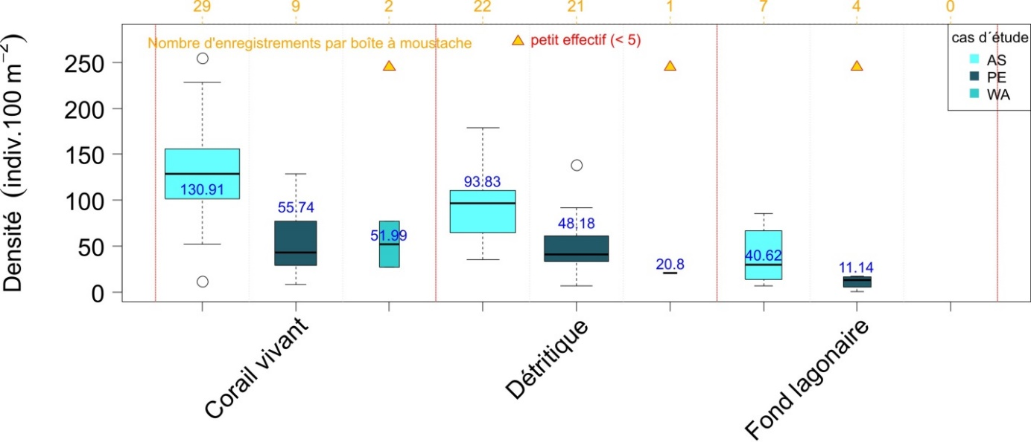
Example: Abundance density as a function of habitat and site (Astrolabe, Petrie, Walpole, from left to right).

Contrary to other areas, the high abundances observed in Astrolabe and Petrie are not explained by some large schools of fish, but rather reflect a very abundant fish assemblage, mainly Acanthuridae, Lutjanidae, Labridae and Scaridae (in particular Acanthurus olivaceus, Macolor niger, Thalassoma sp., Hipposcarus longiceps).

Statistical tests and results
Abundance density significantly differs between the three sites (p<10⁻¹³) and according to habitat (p<10⁻⁹). Differences between sites marginally depend on habitat (p<0.1).
Abundance density is very high on the Live Coral habitat, at both Astrolabe and Petrie. Abundance density is higher on this habitat than on other habitats, and higher at Astrolabe than at the other sites.
Fishes are significantly more abundant at Astrolabe than at Petrie on the Live Coral (p<0.01) and Debris (p<0.001) habitats. No significant difference for Walpole due to a low number of observations at this site.

Scoring STAVIRO at the scale of New Caledonia
- Astrolabe : Ecological status for this indicator is either good or excellent. Status is homogeneous within each habitat, with e.g. 90% of stations good or excellent in the Live Coral and in the Debris habitats.
- Petrie : Status is less outstanding than at Astrolabe, but remains good on the Live Coral and Debris habitats. Status is good on the external slope in the Live Coral habitat. 70% (resp. 75%) of stations display good or excellent status on the Live Coral (resp. Debris) habitat.
- Walpole : Two stations with a medium status and one with a good status.
- No station in a bad ecological status at these sites.

Pétrie | Astrolabe
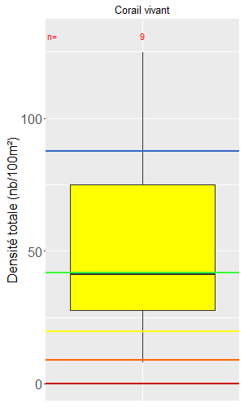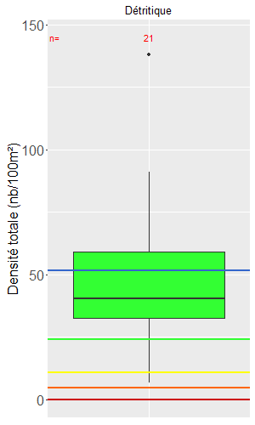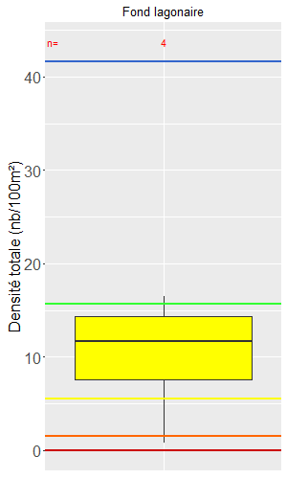 | 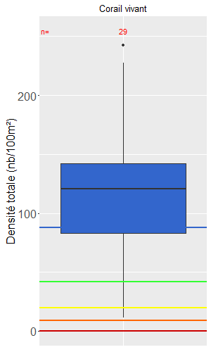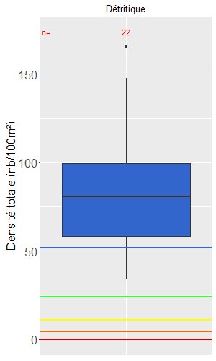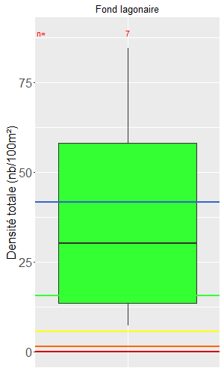

Summary

Indicator | Comment
Abundance density | - Highly abundant fish assemblage at Astrolabe, mostly on the Live Coral habitat, but also on the Debris and Sandy habitats.  - Fishes are significantly more abundant at Astrolabe than at Petrie on the Live Coral and Debris habitats.  - Astrolabe : Outstanding ecological status with 90% of stations with a good or excellent score, and all stations on the external slope excellent (stations corresponding to Petit Astrolabe)  - Pétrie : Medium to good ecological status on the Live Coral and Debris habitats, 75% of stations excellent on the external slope  - Walpole : Medium to good ecological status on the Live Coral and Debris habitats (3 stations only)  - No station in a bad ecological status at these sites

