Supplementary 1

Table S1: Summary of environmental variables used for the predator distribution models. Unit, source and resolution are detailed for each variable. NASC: Nautical Area Scattering Coefficient.

Variable | Unit | Source | Temporal resolution | Spatial resolution
Bathymetry | km | ZoNéCo, 2013 | - | 500 m
Sea surface temperature | °C | Advanced very high-resolution radiometer (AVHRR) infrared satellite | Week | ¼ degree
Chlorophyll-a | mg/m³ | GlobColour-processor versions : MODIS 2014.0.1/VIIRSN 2014.0.2 | Week | ¼ degree
Depth of the 20°C isotherm | m | ARMOR3D | Week | ¼ degree
NASC (prey biomass index proxy) | m²/nmi² | Receveur et al., 2019 | Week | ¼ degree

Table S2: Seabird population size estimates (in breeding pairs) by geographic ensemble in New Caledonia.

Geographic ensemble | Species
 | Ardenna pacifica (WTSH) | Pseudobulweria rostrata (TAPET) | Sula sula (RFBO)
Chesterfield-Bampton & Bellona | 113 265 ª | - | 8 800 ª
D’Entrecasteaux | 4 176 ^{b} | - | 2 883 ^{b}
Northern lagoon | 35 573 ^{c} | 1 ^{c} | -
Grande Terre | 22 700 ^{d} | 1 000 - 5 000 ^{h} | -
Southern lagoon | 500 000 e | 100 e | 18 e
Loyalty Islands | 1 410 - 1 660 ^{f} | 5 ^{f} | > 12 ^{f}
Walpole | - | - | 4 300 ^{j}
Matthew & Hunter | 275 ^{g} | - | 810 ^{g}
Total for New Caledonia | > 677 399 | > 15 000 ^{i} | > 16 820
ª Borsa P. 2019. Sites prioritaires pour la conservation des oiseaux marins et des tortues marines des atolls Chesterfield-Bampton et Bellona. Institut de recherche pour le développement, Nouméa, 28 p., https://hal.archives-ouvertes.fr/ird-02049265
^{b} Robinet O., Sirgouant S., Bretagnolle V. 1997. Marine birds of d'Entrecasteaux Reefs (New Caledonia, southwestern Pacific): diversity, abundance, trends and threats. Colonial Waterbirds 20:282-290.
^{c} Baudat-Franceschi J., Spaggiari J., Barré N. 2013. Oiseaux nicheurs d'intérêt pour la conservation.RAP Bulletin of Biological assessment 53:136-142., http://www.bioone.org/doi/full/10.1896/054.053.0114
^{d} Weimerskirch H., de Grissac S., Ravache A., Prudor A., Corbeau A., Congdon B.C., McDuie F., Bourgeois K., Dromzée S., Butscher J., Menkes C., Allain V., Vidal E., Jaeger A., Borsa P. 2020. At-sea movements of wedge-tailed shearwaters during and outside the breeding season from four colonies in New Caledonia. Marine Ecology Progress Series 633:225–238. doi: 10.3354/meps13171
^{e} Pandolfi-Benoit M., Bretagnolle V. 2002. Seabirds of the southern lagoon of New Caledonia: distribution, abundance and threats. Waterbirds 25:202-213.
^{f} Barré N., Villard P., Manceau N., Monimeau L., Ménard C. 2006. Les oiseaux de l’archipel des Loyauté (Nouvelle-Calédonie) : Inventaire et éléments d’écologie et de biogéographie. Revue d’Écologie (Terre et Vie) 61:175-194.
^{g} Borsa P., Baudat-Franceschi J. 2019. Synthèse des observations sur l’avifaune marine des îles Matthew et Hunter (Parc naturel de la mer de Corail), 1973-2018. Institut de recherche pour le développement, Nouméa, 41 p., https://hal.ird.fr/ird-02300763
^{h} Villard P., Dano S., Bretagnolle V. 2006. Morphometrics and the breeding biology of the Tahiti Petrel Pseudobulweria rostrata. Ibis 148:285-291.
^{i} Borsa P. 2008. Mission ornithologique à l'îlot Loop (îles Chesterfield) et transects en mer de Corail et dans le bassin des Loyauté, 20-28 octobre 2008. Institut de recherche pour le développement, Nouméa, 13 p., https://hal.archives-ouvertes.fr/hal-00552296
^{j} Baudat-Franceschi J., Bachy P. 2013. Inventaire ornithologique de Walpole, mission du 13 au 23 mai 2013. Société calédonienne d’ornithologie, Nouméa, 24 p.

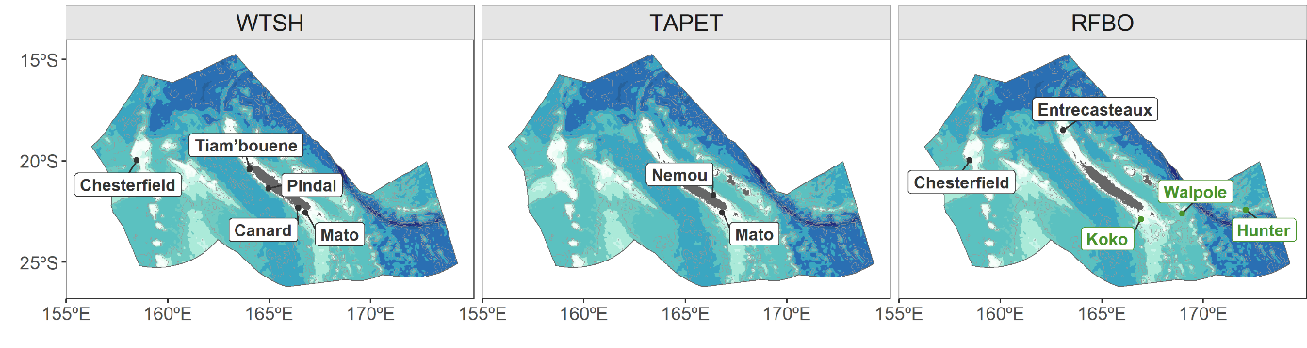
Figure S2: Breeding sites of the GPS-tracked seabirds sampled in the present study in black (WTSH: Wedge-tailed shearwater; TAPET: Tahiti petrel; RFBO: Red-footed booby). Green points and names indicate the none-sampled but known RFBO colonies that are used for the spatial predictions.

Supplementary 2: acoustic modelling

Reference publication : Receveur, A., Menkes, C., Allain, V., Lebourges-Dhaussy, A., Nerini, D., Mangeas, M., Ménard, F., 2019. Seasonal and spatial variability in the vertical distribution of pelagic forage fauna in the Southwest Pacific. Deep Sea Research Part II: Topical Studies in Oceanography 175, 104655. https://doi.org/10.1016/j.dsr2.2019.104655.

Table S3: Cruise details, with the cruise name, dates, the number of 0.1nm bins per cruise, and the DOI of each cruise.

Cruise name | Start | End | Number of 0.1nm bins | DOI
Nectalis1 (N1) | 30/07/2011 | 15/08/2011 | 3681 | 10.17600/11100050
Nectalis2 (N2) | 26/11/2011 | 14/12/2011 | 2896 | 10.17600/11100070
Nectalis3 (N3) | 21/11/2014 | 08/12/2014 | 3617 | 10.17600/14004900
Nectalis4 (N4) | 19/10/2015 | 25/10/2015 | 1034 | 10.17600/15004000
Nectalis5 (N5) | 23/11/2016 | 06/12/2016 | 3989 | 10.17600/16004200
Puffalis (PUFF) | 18/03/2017 | 31/03/2017 | 1498 | 10.17600/17003300

Figure S3: Cruise tracks of the R/V Alis with EK60 echosounder (colored lines) in the New Caledonian exclusive economic zone. Black boxes show CTD stations. The background grey colors represent the relative seabed depth (where lighter colors are shallower). Note that N1 and N2 tracks partially overlap but N2 track has been slightly shifted to the north for visualization purposes.

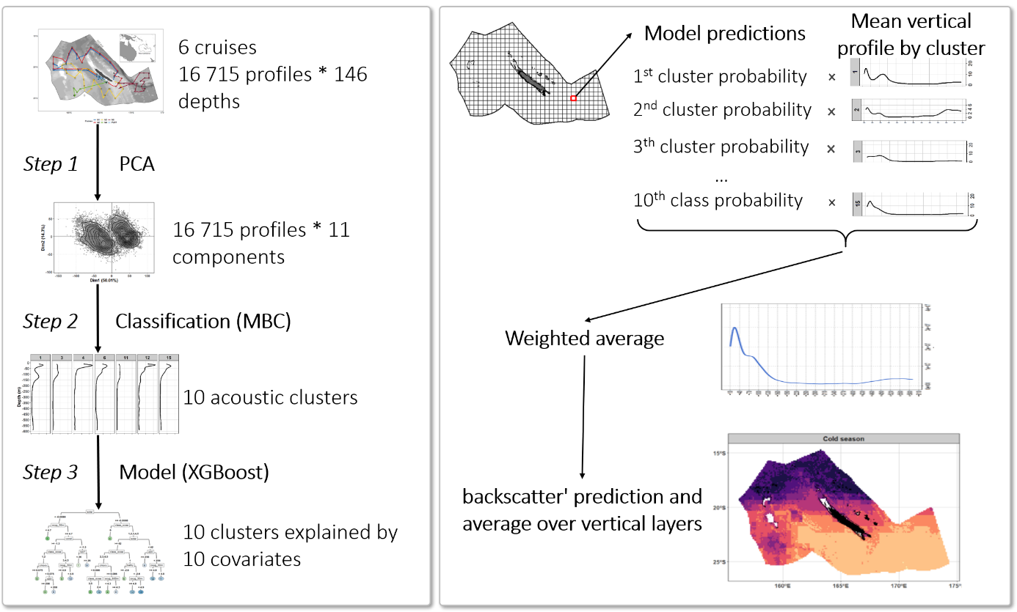
Figure S4: Diagram explaining the different steps of the analysis.

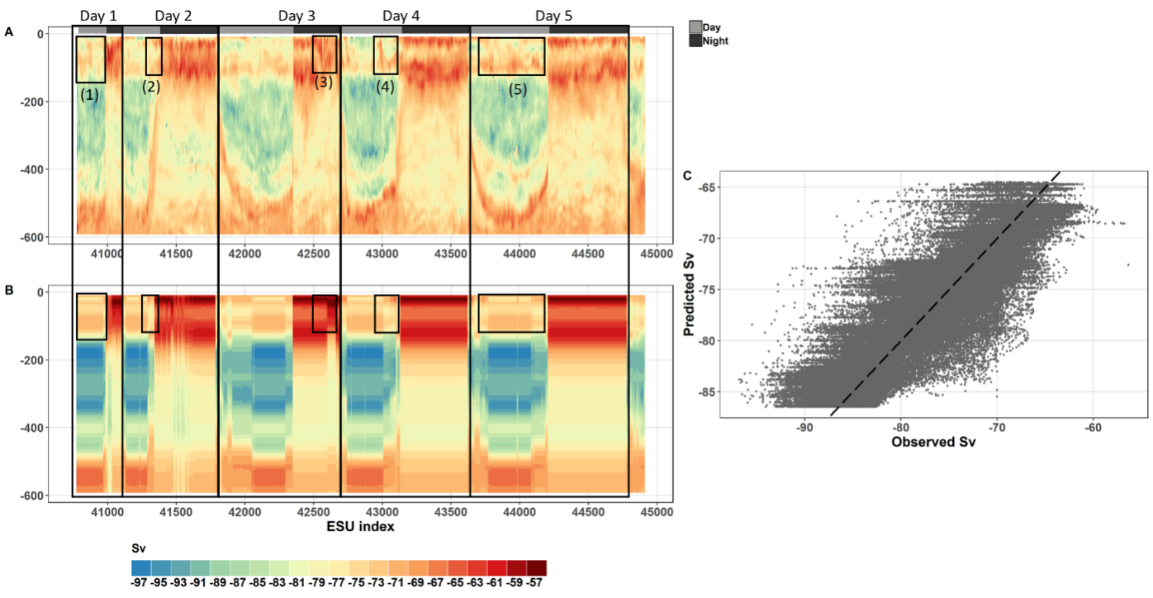
Figure S5: N4 echogram observed (panel A) and predicted (panel B). Scatter plot of predicted values as a function of observed values with y = x dashed line over all data of N4 (panel C). Boxes drawn on the plots are discussed in the main text as box (1), (2), etc.

Supplementary 3: R code
library(ggplot2)
library(mgcv)
library(dplyr)

######################################################################################################## Data loading ################################
########## Fishes datasets (logbook of NC longliners) ##########
load(file = ‘C:/df_ALB.Rdata’)
load(file = ‘C:/df_YFT.Rdata’)
load(file = ‘C:/df_DOL.Rdata’)

summary(df_ALB)

## n_ALB_caught n_hook year month
## Min. : 0.00 Min. : 175 Min. :2010 Min. : 1.000
## 1st Qu.:12.00 1st Qu.:1800 1st Qu.:2012 1 st Qu.: 4.000
## Median :30.00 Median :2000 Median :2015 Median : 6.000
## Mean :39.15 Mean :1964 Mean :2014 Mean : 6.454
## 3rd Qu.:57.00 3rd Qu.:2100 3rd Qu.:2017 3rd Qu. : 9.000
## Max. :198.00 Max. :4450 Max. :2018 Max. :12.000
## day vessel_code lon lat
## Min. : 1.05 1248 : 8034 Min. :156.9 Min. :-25.65
## 1st Qu.: 8.02 0211 : 7638 1st Qu.:160.3 1st Qu.:-22.13
## Median :16.05 7430 : 5598 Median :162.6 Median :-21.03
## Mean :15.72 2761 : 5460 Mean :162.6 Mean :-21.00
## 3rd Qu.:23.05 7350 : 5220 3rd Qu.:164.6 3rd Qu.:-19.97
## Max. :31.0 (Other):12873 Max. :172.6 Max. :-14.85
## bathy SST chloro d20
## Min. :0.00396 Min. :20.65 Min. :0.01688 Min. :69.16
## 1st Qu.:1.98710 1st Qu.:24.27 1st Qu.:0.05962 1st Qu.:191.32
## Median :2.39458 Median :25.61 Median :0.07996 Median :208.98
## Mean :2.53872 Mean :25.57 Mean :0.09147 Mean :207.60
## 3rd Qu.:3.37107 3rd Qu.:26.92 3rd Qu.:0.11350 3rd Qu.:226.49
## Max. :5.95959 Max. :30.37 Max. :0.58071 Max. :283.39
## NASC vertical_layer
## Min. :0.3300 Epi:14941
## 1st Qu.:0.5336 Upper_meso:14941
## Median :1.5905 Lower_meso:14941
## Mean :1.7010
## 3rd Qu.:2.7181
## Max. :4.1644
df_ALB$log_chloro <- log(df_ALB$chloro + 1)
## the two other fish datasets are built in the same way.
########## Cetaceans datasets (REMMOA survey) ##########
load(file = ‘C:/df_DELPH.Rdata’)
load(file = ‘C:/df_GLOB.Rdata’)
load(file = ‘C:/df_ZIPH.Rdata’)

summary(df_DELPH)

## n_individuals transect_length year month
## Min. : 0.00 Min. : 175 Min. :2014 Min. :10.00
## 1st Qu.:12.00 1st Qu.:1800 1st Qu.:2014 1st Qu.:10.00
## Median :30.00 Median :2000 Median :2014 Median :11.00
## Mean :39.15 Mean :1964 Mean :2014 Mean :10.82
## 3rd Qu.:57.00 3rd Qu.:2100 3rd Qu.:2014 3rd Qu.:11.00
## Max. :198.00 Max. :4450 Max. :2014 Max. :12.00
## day ESW lon lat
## Min. : 1.0 Min. :0.199 Min. :160.2 Min. :-25.39
## 1st Qu.:12.0 1st Qu.:0.200 1st Qu.:163.6 1st Qu.:-22.81
## Median :17.0 Median :0.200 Median :165.4 Median :-21.38
## Mean :18.1 Mean :0.204 Mean :165.5 Mean :-21.38
##3rd Qu.:27.0 3rd Qu.:0.216 3rd Qu.:167.4 3rd Qu.:-19.93
## Max. :31.0 Max. :0.254 Max. :171.0 Max. :-17.63
## bathy SST chloro d20
## Min. :0.002 Min. :21.53 Min. :0.03971 Min. :44.62
## 1st Qu.:1.579 1st Qu.:23.64 1st Qu.:0.05968 1st Qu.:190.17
## Median :2.574 Median :25.15 Median :0.06823 Median :218.53
## Mean :2.527 Mean :25.13 Mean :0.07534 Mean :207.38
## 3rd Qu.:3.519 3rd Qu.:26.33 3rd Qu.:0.08181 3rd Qu.:236.03
## Max. :4.943 Max. :28.67 Max. :0.24861 Max. :277.47
## NASC vertical_layer
## Min. :0.2178 Epi:15079
## 1st Qu.:0.2766 Upper_meso:15079
## Median :1.2326 Lower_meso:15079
## Mean :1.2701
## 3rd Qu.:2.2815
## Max. :2.4965
df_DELPH$surface <- 2 *df_DELPH$transect_length *df_DELPH$ESW
## the two other cetacean datasets are built in the same way.
########## Seabirds datasets (tracking) ##########
load(file = ‘C:/df_WTSH.Rdata’)
load(file = ‘C:/df_TAPET.Rdata’)
load(file = ‘C:/df_RFBO.Rdata’)

summary(df_WTSH)

## foraging_behaviour foraging_factor foraging_numeric year
## commuting :6030 Dont eat:10402 Min. :0.0000 Min. :2017
## DD : 52 Eat : 7070 1st Qu.:0.0000 1st Qu.:2017
## foraging :7070 Median :0.0000 Median :2017
## resting :4320 Mean :0.4046 Mean :2018
## 3rd Qu.:1.0000 3rd Qu.:2019
## Max. :1.0000 Max. :2019
## month day lon lat hour
## Min. :3.0 Min. : 1.0 Min. :156.8 Min. :-26.3 Length:17472
## 1st Qu.:3.0 1st Qu.: 7.0 1st Qu.:160.5 1st Qu.:-21.2 Class :char
## Median :4.0 Median :13.0 Median :164.5 Median :-20.3 Mode :char
## Mean :3.7 Mean :11.9 Mean :163.7 Mean :-20.4
## 3rd Qu.:4.0 3rd Qu.:17.0 3rd Qu.:166.3 3rd Qu.:-19.2
## Max. :4.0 Max. :27.0 Max. :170.4 Max. :-15.6
## bathymetry SST chlorophyll d20
## Min. :0.0004 Min. :24.96 Min. :0.02971 Min. :94.28
## 1st Qu.:1.8990 1st Qu.:26.82 1st Qu.:0.09709 1st Qu.:179.53
## Median :2.6146 Median :27.70 Median :0.11071 Median :197.03
## Mean :2.6503 Mean :27.61 Mean :0.12411 Mean :195.08
## 3rd Qu.:3.5237 3rd Qu.:28.44 3rd Qu.:0.13703 3rd Qu.:213.84
## Max. :7.0341 Max. :29.75 Max. :0.60467 Max. :248.29
## NASC moment Individu
## Min. :1.596 Day :8737 FS101257: 777
## 1st Qu.: 2.655 Night:8735 FS101268: 589
## Median :4.188 FS101280: 546
## Mean :6.192 FS101212: 530
## 3rd Qu.:9.708 FS107228:492
## Max. :17.766 (Other) :8745
## the two other seabird datasets are built in the same way.
###########################################################################
################################# Modelling ###############################
#### ALBACORE
model_alb<- gam(n_ALB ~ offset(n_hook) +
s(NASC, k = 24, bs = "cr", by = vertical_layer) +
s(SST, k = 8, bs = "cr") +
s(log_chloro, k = 8, bs = "cr") +
s(d20, k = 8, bs = "cr") +
s(bathy, k = 8, bs = "cr") +
s(year, k = 8, bs = "cr") +
s(vessel_code, bs = "re") +
s(lon, lat, bs = 'gp', k = 30),
gamma= 1.4,
data= df_ALB,
family=nb(link ='log'),
method="REML")
#### YELLOWFIN
model_yft<- gam(n_YFT ~ offset(n_hook) +
s(NASC, k = 24, bs = "cr", by = vertical_layer) +
s(SST, k = 8, bs = "cr") +
s(log_chloro, k = 8, bs = "cr") +
s(d20, k = 8, bs = "cr") +
s(bathy, k = 8, bs = "cr") +
s(year, k = 8, bs = "cr") +
s(vessel_code, bs = "re") +
s(lon, lat, bs = 'gp', k = 30),
gamma= 1.4,
data= df_YFT,
family=nb(link ='log'),
method="REML")
#### DOLPHINFISH
model_dol<- gam(n_DOL ~ offset(n_hook) +
s(NASC, k = 24, bs = "cr", by = vertical_layer) +
s(SST, k = 8, bs = "cr") +
s(log_chloro, k = 8, bs = "cr") +
s(d20, k = 8, bs = "cr") +
s(bathy, k = 8, bs = "cr") +
s(year, k = 8, bs = "cr") +
s(vessel_code, bs = "re") +
s(lon, lat, bs = 'gp', k = 30),
gamma= 1.4,
data= df_DOL,
family=nb(link ='log'),
method="REML")
#### DELPHINAE
model_delph = gam(n_individuals ~ offset(log_surface) +
s(NASC, k = 16, bs= "cr", by = vertical_layer) +
s(SST, k= 8, bs= "cr") +
s(log_chloro, k = 8, bs = "cr") +
s(d20, k = 8, bs= "cr") +
s(bathy,k = 8, bs= "cr"),
family= tw(link ='log'),
method= "REML",
data= df_DELPH)
#### GLOBICEPHALINAE
model_glo = gam(n_individuals ~ offset(log_surface) +
s(NASC, k = 16, bs = "cr", by = vertical_layer) +
s(SST, k = 4, bs = "cr") +
s(log_chloro, k = 4, bs = "cr") +
s(d20, k = 4, bs = "cr") +
s(bathy,k = 4, bs = "cr"),
family= tw(link ='log'),
method= "REML",
data= df_GLOB)
#### ZIPHIIDAE
model_zip = gam(n_individuals ~ offset(log_surface) +
s(NASC, k = 16, bs = "cr", by = vertical_layer) +
s(SST, k = 4, bs = "cr") +
s(log_chloro, k = 4, bs= "cr") +
s(d20, k = 4, bs = "cr") +
s(bathy,k = 4, bs = "cr"),
family= tw(link ='log'),
method= "REML",
data= df_ZIPH)
#### WEDGE-TAILED SHEARWATER
model_wtsh = gamm(foraging_numeric ~ s(NASC, k = 8, bs= "cr", by = moment) +
s(SST, k = 4, bs= "cr") +
s(log_chloro, k = 4, bs = "cr") +
s(d20, k = 4, bs= "cr") +
s(bathy, k = 4, bs= "cr"),
data = df_puffin,
method="REML",
correlation = corARMA(form = ~ 1 | Individu, p = 2),
family = binomial)
#### TAHITI PETREL
model_tapet = gamm(foraging_numeric ~ s(NASC, k = 8, bs = "cr", by = moment) +
s(SST, k = 4, bs = "cr") +
s(log_chloro, k = 4, bs = "cr") +
s(d20, k = 4, bs = "cr") +
s(bathy, k = 4, bs = "cr"),
data = df_puffin,
method="REML",
correlation = corARMA(form = ~ 1 | Individu, p = 2),
family = binomial)
#### RED-FOOTED BOODY
model_rfbo = gamm(foraging_numeric ~ s(NASC, k = 8, bs = "cr", by = moment) +
s(SST, k = 4, bs = "cr") +
s(log_chloro, k = 4, bs = "cr") +
s(d20, k = 4, bs = "cr") +
s(bathy, k = 4, bs = "cr"),
data = df_puffin,
method="REML",
correlation = corARMA(form = ~ 1 | Individu, p = 2),
family = binomial)

###########################################################################
############################## Prediction #################################
########## Fish
load(file ='df_grid_for_pred_fish.Rdata')

data.table(df_grid_for_pred_fish)
lon lat vertical_layer date SST d20 chloro NASC bathy
156.05 -19.30 epi 2010-01-01 26.80 237.25 0.023 3.698 2.85
156.05 -19.30 epi 2010-01-08 27.30 229.75 0.023 3.697 2.85
156.05 -19.30 epi 2010-01-15 27.25 227.95 0.039 3.733 2.85
156.05 -19.30 epi 2010-01-22 28.13 235.14 0.060 3.728 2.85
156.05 -19.30 epi 2010-01-29 27.99 248.44 0.029 3.734 2.85
---
174.30 -25.05 uper_meso 2018-12-03 23.53 136.39 0.088 1.807 4.46
174.30 -25.05 uper_meso 2018-12-10 23.88 158.98 0.069 1.947 4.46
174.30 -25.05 uper_meso 2018-12-17 25.16 171.19 0.082 1.850 4.46
174.30 -25.05 uper_meso 2018-12-24 25.45 191.67 0.073 1.971 4.46
174.30 -25.05 uper_meso 2018-12-31 26.26 221.23 0.081 1.896 4.46

df_grid_for_pred_fish$vessel_code <- "24080"
df_grid_for_pred_fish$n_hook <- mean(df_ALB$n_hook)
df_grid_for_pred_fish$log_chloro <- log(df_grid_for_pred_fish$chloro + 1)
## this next table was extracted from the observed dataset (df_ALB) to have the min and the max of each variable and therefore avoid extrapolation
df_min_max_alb
sp variable max min
1 ALB bathy 5.9596 0.0040
2 ALB SST 30.374 20.651
3 ALB d20 283.39 69.162
4 ALB log_chloro 0.4579 0.0167
5 ALB NASC 4.1644 0.3300

df_grid_for_pred_fish$extrapolation <-ifelse(df_grid_for_pred_fish$bathy %between%
c(df_min_max_alb[df_min_max_alb$variable == 'bathy', 'min'],
df_min_max_alb[df_min_max_alb$variable == 'bathy', 'max']) &
df_grid_for_pred_fish$log_chloro %between%
c(df_min_max_alb[df_min_max_alb$variable == 'log_chloro', 'min'],
df_min_max_alb[df_min_max_alb$variable == 'log_chloro', 'max']) &
df_grid_for_pred_fish$d20 %between%
c(df_min_max_alb[df_min_max_alb$variable == 'd20', 'min'],
df_min_max_alb[df_min_max_alb$variable == 'd20', 'max']) &
df_grid_for_pred_fish$SST %between%
c(df_min_max_alb[df_min_max_alb$variable == 'SST', 'min'],
df_min_max_alb[df_min_max_alb$variable == 'SST', 'max'])&
df_grid_for_pred_fish$NASC%between%
c(df_min_max_alb[df_min_max_alb$variable == 'NASC', 'min'],
df_min_max_alb[df_min_max_alb$variable == 'NASC', 'max']),
'NO', 'YES')
df_grid_for_pred_fish <- df_grid_for_pred_fish %>%
dplyr::filter(extrapolation == 'NO') %>%
dplyr::select(extrapolation)
df_grid_for_pred_fish$pred_alb <- predict(model_alb, df_grid_for_pred_fish, 'response')
df_grid_for_pred_fish$pred_alb_SE<- predict(model_alb, df_grid_for_pred_fish, 'response', se =TRUE)$se

df_grid_for_pred_fish$month<- substr(df_grid_for_pred_fish$date, 6, 7)

df_grid_for_pred_fish2 <- df_grid_for_pred_fish %>%
group_by(month, lon, lat) %>%
summarize(pred_nb_alb = mean(pred_nb_alb/hook),
pred_nb_alb_se = mean(pred_nb_alb_se/hook))

## and in the same way, predictions were for the two other fish species
########## Cetacean
load(file ='df_grid_for_pred_cetacean.Rdata')

data.table(df_grid_for_pred_cetacean)## only months 10, 11 and 12 (sampled month)
vertical_layer NASC date lon lat SST d20 chloro bathy
epi 1.10 2010-10-05 163.05 -14.55 26.83 262.30 0.0485 4.31
up_meso 0.32 2010-10-05 163.05 -14.55 26.83 262.30 0.0485 4.31
low_meso 2.26 2010-10-05 163.05 -14.55 26.83 262.30 0.0485 4.31
epi 1.10 2010-10-05 163.30 -14.55 26.76 261.34 0.0426 3.95
up_meso 0.32 2010-10-05 163.30 -14.55 26.76 261.34 0.0426 3.95
--- eepi 1.02 2018-12-30 166.05 -26.55 23.88 82.65 0.0661 3.57
up_meso 0.35 2018-12-30 166.05 -26.55 23.88 82.65 0.0661 3.57
low_meso 1.86 2018-12-30 166.05 -26.55 23.88 82.65 0.0661 3.57
epi 1.16 2018-12-30 166.30 -26.55 23.92 79.67 0.0632 3.56
up_meso 0.27 2018-12-30 163.30 -26.55 23.92 79.67 0.0632 3.56

df_grid_for_pred_cetacean$surface<- mean(df_DELPH$surface)
df_grid_for_pred_cetacean$log_surface<- log(df_grid_for_pred_cetacean$surface)
df_grid_for_pred_cetacean$log_chloro <- log(df_grid_for_pred_cetacean$chloro + 1)
df_min_max_delph
sp variable max min
1 DELPH bathy 4.943 0.002
2 DELPH SST 28.67 21.53
3 DELPH d20 277.47 44.62
4 DELPH log_chloro 0.2220 0.039
5 DELPH NASC 2.4965 0.218

df_grid_for_pred_cetacean$extrapolation <-ifelse(df_grid_for_pred_cetacean$bathy %between%
c(df_min_max_delph[df_min_max_delph$variable == 'bathy', 'min'],
df_min_max_delph[df_min_max_delph$variable == 'bathy', 'max']) &
df_grid_for_pred_cetacean$log_chloro %between%
c(df_min_max_delph[df_min_max_delph$variable == 'log_chloro', 'min'],
df_min_max_delph[df_min_max_delph$variable == 'log_chloro', 'max']) &
df_grid_for_pred_cetacean$d20 %between%
c(df_min_max_delph[df_min_max_delph$variable == 'd20', 'min'],
df_min_max_delph[df_min_max_delph$variable == 'd20', 'max']) &
df_grid_for_pred_cetacean$SST %between%
c(df_min_max_delph[df_min_max_delph$variable == 'SST', 'min'],
df_min_max_delph[df_min_max_delph$variable == 'SST', 'max'])&
df_grid_for_pred_cetacean$NASC%between%
c(df_min_max_delph[df_min_max_delph$variable == 'NASC', 'min'],
df_min_max_delph[df_min_max_delph$variable == 'NASC', 'max']),
'NO', 'YES')

df_grid_for_pred_cetacean <- df_grid_for_pred_cetacean %>%
dplyr::filter(extrapolation == 'NO') %>%
dplyr::select(extrapolation)
df_grid_for_pred_cetacean$pred_delph <- predict(model_delph,
df_grid_for_pred_cetacean, 'response')
df_grid_for_pred_cetacean$pred_delph_SE <- predict(model_delph,
df_grid_for_pred_cetacean,
'response', se =TRUE)$se

df_grid_for_pred_cetacean$month<- substr(df_grid_for_pred_cetacean$date, 6, 7)

df_grid_for_pred_cetacean2 <- df_grid_for_pred_cetacean %>%
group_by(month, lon, lat) %>%
summarize(pred_delph = mean((pred_delph/surface)),
pred_delph_se = mean((pred_delph_SE/surface)))

########## Seabirds
load(file ='df_grid_for_pred_wtsh.Rdata')

data.table(df_grid_for_pred_wtsh) ## only months 5 and 6
moment NASC date lon lat SST d20 bathy chloro
Night 10.409 2010-05-07 163.05 -14.85 28.761 239.29 4.312 0.1238
Day 2.4979 2010-05-07 163.05 -14.85 28.761 239.29 4.312 0.1238
Night 10.200 2010-05-07 162.30 -14.05 28.690 236.55 4.598 0.1355
Day 2.5698 2010-05-07 162.30 -14.05 28.690 236.55 4.598 0.1355
----
Night 12.590 2018-06-29 165.85 -26.30 22.037 125.12 3.448 0.1778
Day 2.8979 2018-06-29 165.85 -26.30 22.037 125.12 3.448 0.1778
Night 12.591 2018-06-29 166.05 -26.30 22.452 132.35 3.574 0.1822
Day 2.7207 2018-06-29 166.05 -26.30 22.452 132.35 3.574 0.1822

df_grid_for_pred_wtsh$log_chloro <- log(df_grid_for_pred_wtsh$chloro + 1)
df_min_max_wtsh
sp variable max min
1 WTSH bathy 7.034 0.0004
2 WTSH SST 29.75 24.96
3 WTSH d20 248.29 94.28
4 WTSH log_chloro 0.4729 0.0293
5 WTSH NASC 17.766 1.596

df_grid_for_pred_wtsh$extrapolation <-ifelse(df_grid_for_pred_wtsh$bathy %between%
c(df_min_max_wtsh[df_min_max_wtsh$variable == 'bathy', 'min'],
df_min_max_wtsh[df_min_max_wtsh$variable == 'bathy', 'max']) &
df_grid_for_pred_wtsh$log_chloro %between%
c(df_min_max_wtsh[df_min_max_wtsh$variable == 'log_chloro', 'min'],
df_min_max_wtsh[df_min_max_wtsh$variable == 'log_chloro', 'max']) &
df_grid_for_pred_wtsh$d20 %between%
c(df_min_max_wtsh[df_min_max_wtsh$variable == 'd20', 'min'],
df_min_max_wtsh[df_min_max_wtsh$variable == 'd20', 'max']) &
df_grid_for_pred_wtsh$SST %between%
c(df_min_max_wtsh[df_min_max_wtsh$variable == 'SST', 'min'],
df_min_max_wtsh[df_min_max_wtsh$variable == 'SST', 'max'])&
df_grid_for_pred_wtsh$NASC%between%
c(df_min_max_wtsh[df_min_max_wtsh$variable == 'NASC', 'min'],
df_min_max_wtsh[df_min_max_wtsh$variable == 'NASC', 'max']),
'NO', 'YES')

df_grid_for_pred_wtsh <- df_grid_for_pred_wtsh %>%
dplyr::filter(extrapolation == 'NO') %>%
dplyr::select(extrapolation)
df_grid_for_pred_wtsh$pred_wtsh <- predict(model_wtsh, df_grid_for_pred_wtshs,
'response')
df_grid_for_pred_wtsh$pred_wtsh_SE <- predict(model_wtsh,
df_grid_for_pred_wtshs,
'response', se =TRUE)$se

df_grid_for_pred_wtsh$month<- substr(df_grid_for_pred_wtshs$date, 6, 7)

df_grid_for_pred_wtsh2 <- df_grid_for_pred_wtsh %>%
group_by(month, lon, lat) %>%
summarize(pred_wtsh= mean((pred_wtsh)),
pred_wtsh_se = mean((pred_wtsh_SE)))

Supplementary 4: uncertainty maps of predictions
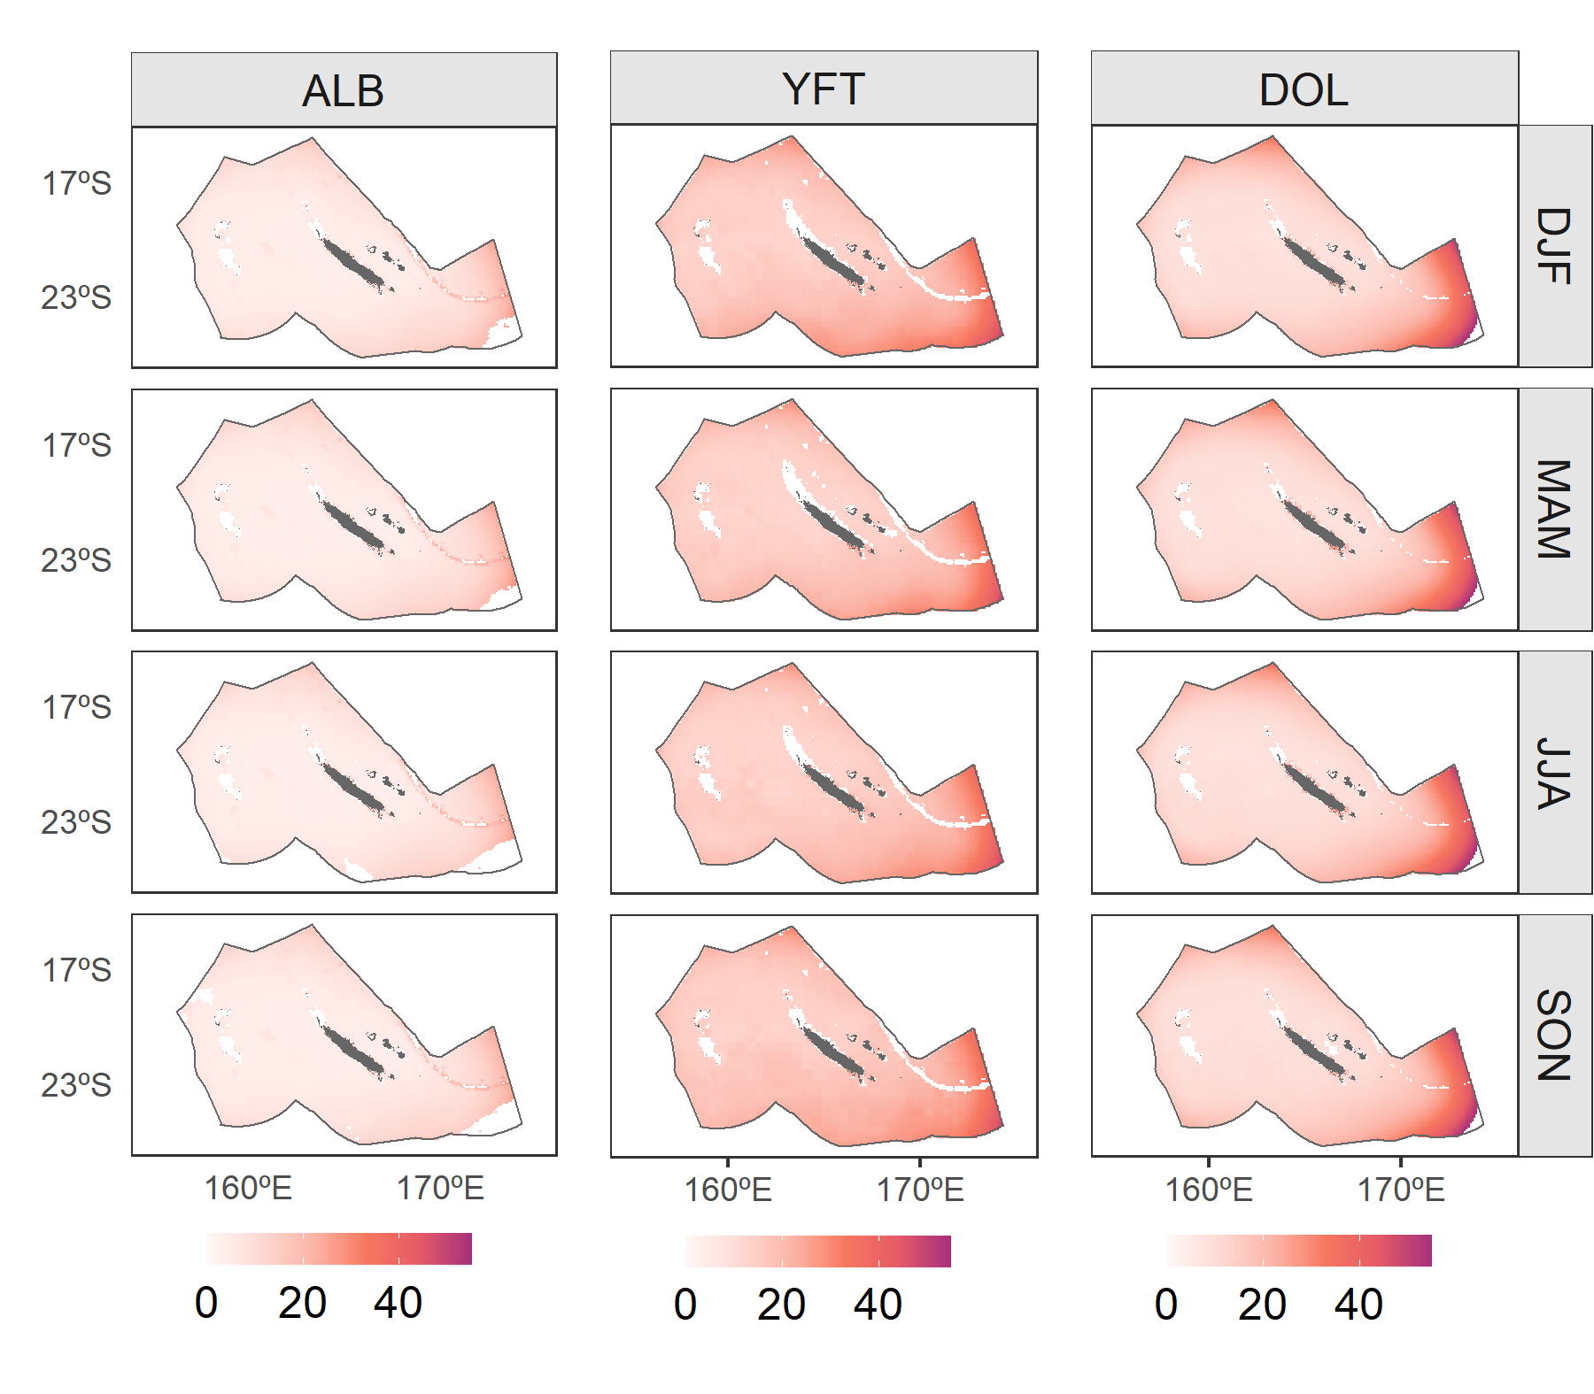
Figure S6: Spatial predictions of standard error (expressed in %) for catch per unit of effort (CPUE; number of fish caught per 100 hooks) of albacore (ALB), yellowfin tuna (YFT) and dolphinfish (DOL), by quarter in the New Caledonian EEZ. DJF: December, January and February; MAM: March, April and May; JJA: June, July and August; SON: September, October and November. Land is represented in grey. Reef and island names are indicated on Figure 1A. Areas in white include areas where no extrapolation was made and waters with bathymetry shallower than 300 m (identified on Figure 1).
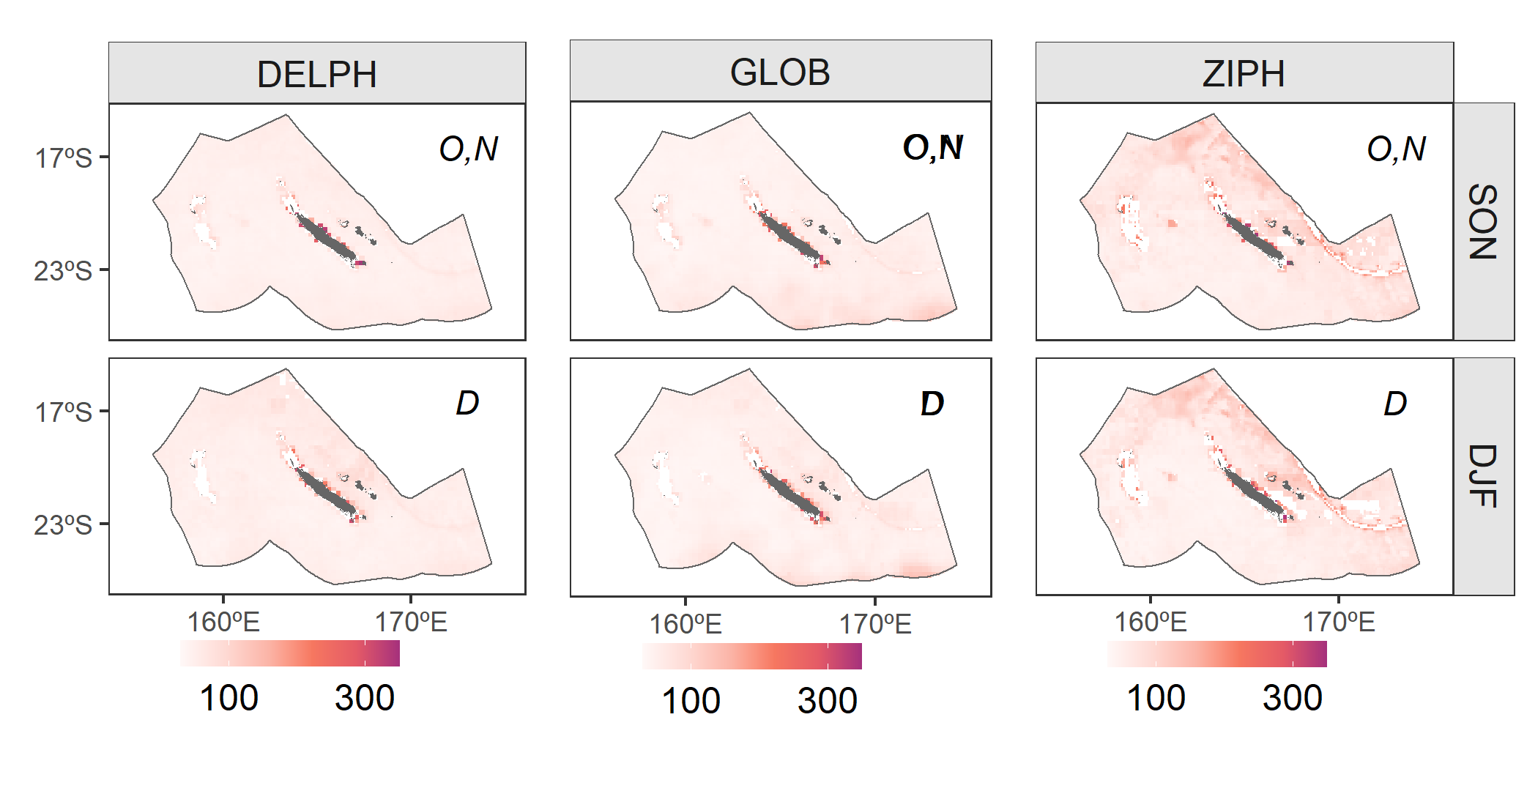
Figure S7: Spatial predictions of standard error (expressed in %) for counts of individuals (of Delphininae (DELPH), Globicephalinae (GLOB) and Ziphiidae (ZIPH), by quarter in the New Caledonian EEZ. DJF: December, January and February; MAM: March, April and May; JJA: June, July and August; SON: September, October and November. Land is represented in grey. Reef and island names are indicated on Figure 1A. Areas in white include areas where no extrapolation was made and waters with bathymetry shallower than 300 m (identified on Figure 1).

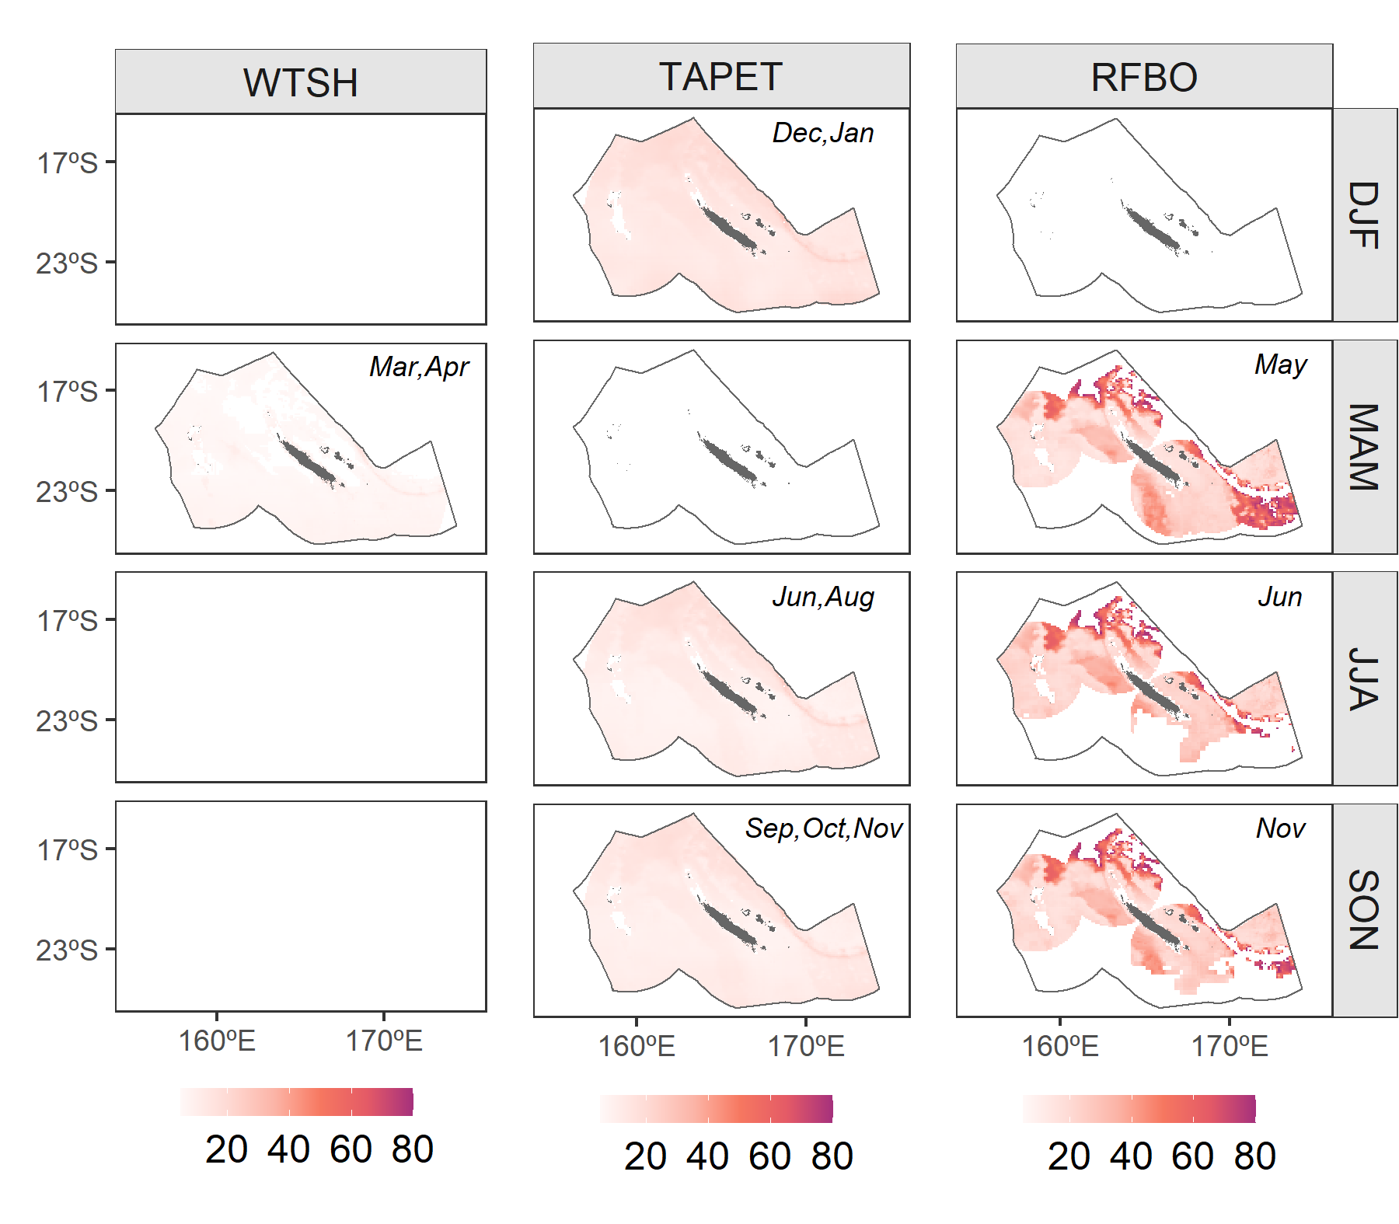
Figure S8:Spatial predictions of standard error (expressed in %) for foraging probability of the wedge-tailed shearwater (WTSH), the Tahiti petrel (TAPET) and the red-footed booby (RFBO), by quarter in the New Caledonian EEZ. DJF: December, January and February; MAM: March, April and May; JJA: June, July and August; SON: September, October and November. Reef and island names are indicated on Figure 1A. Areas in white include areas where no extrapolation was made and waters with bathymetry shallower than 300 m (identified on Figure 1).

