SUPPORTING INFORMATION
Table S1. Descriptions for each of fifteen morphological measurements obtained directly from individual fish observed in Baited Remote Underwater Stereo-Video (Stereo-BRUV) footage or museum specimens. Descriptions are adapted from Appendix A Villeger et al. (2010).

Abbreviation | Description
CFd | Caudal fin depth; the maximum dorso-ventral caudal distance.
CPd | Caudal peduncle depth; the minimum dorso-ventral caudal distance.
Ed | Maximum eye diameter
Eh | Eye height; length between the centre of the eye and the ventral surface of the head.
Hd | Head depth; along the vertical axis of the centre of the eye.
Hl | Head length; length between the most anterior point of the upper jaw (snout) to the posterior edge of the operculum.
Lj | Lower jaw length; measured from the anterior tip of the lower jaw to the corner of the mouth along the dentary section of the mandible.
mBd | Maximum body depth
Ml | Mouth length. Ml is derived from a sequence of three measured 3D points within a single frame, and are obtained internally within EventMeasure software (www.seagis.com.au), using the “Head Morphometrics” feature of EventMeasure version 4.4.
Mo | Mouth open; distance from the top of the mouth to the bottom of the head along the head depth axis.
PFb | Body depth at the insertion of the pectoral fin along the dorso-ventral axis.
PFi | Pectoral fin insertion; distance between the insertion of the pectoral fin to the bottom of the body.
PFl | Pectoral fin length; length between the insertion of the pectoral fin and the posterior end of fin along the medial axis of the body.
TL | Total body length
Uj | Upper jaw length; measured as the distance from the tip of the jaw (premaxilla), to the posterior end of the maxilla.

REFERENCES
Villéger S., Miranda J. R., Hernández D. F. & Mouillot D. (2010) Contrasting changes in taxonomy vs. functional diversity of tropical fish communities after habitat degradation. Appendix A: Functional characterization of fishes. Ecol. Appl. 20, 1512-1522.

Table S2. Museum voucher specimens of 144 New Zealand actinopterygian fish species examined. For each species there were between 1 and 4 individuals measured. See Roberts et al. (2015) for details of classification, nomenclature, distribution, and biology of each species. Specimens are listed in phylogenetic order, followed by unique collection registration number. Prefix: AK and MA –Auckland Museum Tāmaki Paenga Hira, The Domain, Parnell, Auckland; P – National Fish Collection, Museum of New Zealand Te Papa Tongarewa, 169 Tory Street, Wellington.

Order | FAMILY | Genus Species | Reg. no
Notacanthiformes | HALOSAURIDAE | Halosaurus pectoralis | MA4287
 |  | Halosaurus pectoralis | P.047357
 |  | Halosaurus pectoralis | P.047099
 | NOTACANTHIDAE | Notacanthus sexspinis | P.042185
 |  | Notacanthus sexspinis | P.046667
Anguilliformes | CONGRIDAE | Gorgasia japonica | P.035166
 |  | Bassanago bulbiceps | P.044020
 |  | Bassanago bulbiceps | P.044371
 |  | Conger verreauxi | AK135203
 |  | Conger verreauxi | MA045555
 |  | Conger verreauxi | P.045555
 | MURAENIDAE | Gymnothorax berndti | P.034433
 |  | Gymnothorax nubilus | AK655313
 |  | Gymnothorax nubilus | P.037121
 |  | Gymnothorax nubilus | P.052124
 |  | Gymnothorax nubilus | P.044274
 |  | Gymnothorax porphyreus | AK655399
 |  | Gymnothorax porphyreus | P.044115
 |  | Gymnothorax porphyreus | P.044077
 |  | Gymnothorax porphyreus | P.044079
 |  | Gymnothorax prasinus | P.044073
 |  | Gymnothorax prasinus | P.044242
 |  | Gymnothorax prionodon | P.004867
 | OPHICHTHIDAE | Ophisurus serpens | AK118
 |  | Ophisurus serpens | MA046347
 |  | Scolecenchelys castlei | P.044497
 |  | Scolecenchelys castlei | P.044495
 | SYNAPHOBRANCHIDAE | Diastobranchus capensis | P.044025
 |  | Diastobranchus capensis | P.044259
 |  | Simenchelys parasitica | P.044094
 |  | Simenchelys parasitica | MA180057
 |  | Synaphobranchus affinis | P.044083
 |  | Synaphobranchus affinis | P.044016
Argentiniformes | ALEPOCEPHALIDAE | Alepocephalus australis | P.046858
 |  | Alepocephalus australis | P.047640
Stomiiformes | CHAULIODONTIDAE | Chauliodus sloani | P.042448
 |  | Chauliodus sloani | P.023804
Aulopiformes | IPNOPIDAE | Bathypterois longifilis | P.042010
 |  | Bathypterois longifilis | P.054527
 | NOTOSUDIDAE | Scopelosaurus hamiltoni | P.046766
 |  | Scopelosaurus hamiltoni | P.051901
 | PARAULOPIDAE | Paraulopus nigripinnis | P.042473
 |  | Paraulopus nigripinnis | P.047687
 |  | Paraulopus okamurai | P.054938
 |  | Paraulopus okamurai | P.051928
Polymixiiformes | POLYMIXIIDAE | Polymixia cf. busakhini | P.056079
 |  | Polymixia cf. busakhini | P.056136
Ophidiiformes | OPHIDIIDAE | Brotulotaenia nigra | P.045943
 |  | Brotulotaenia nigra | P.046587
 |  | Genypterus blacodes | P.044057
 |  | Genypterus blacodes | P.044035
Gadiformes | BATHYGADIDAE | Bathygadus cottoides | P.054706
 |  | Bathygadus cottoides | P.044249
 |  | Gadomus aoteanus | P.023310
 |  | Gadomus aoteanus | P.047085
 | MACROURIDAE | Coelorinchus acanthiger | P.038935
 |  | Coelorinchus acanthiger | P.046391
 |  | Coelorinchus aspercephalus | P.005256
 |  | Coelorinchus aspercephalus | P.006670
 |  | Coelorinchus biclinozonalis | P.034780
 |  | Coelorinchus biclinozonalis | P.012997
 |  | Coelorinchus bollonsi | P.023348
 |  | Coelorinchus bollonsi | P.046061
 |  | Coelorinchus fasciatus | P.023370
 |  | Coelorinchus fasciatus | P.023372
 |  | Coelorinchus innotabilis | P.023565
 |  | Coelorinchus innotabilis | P.008124
 |  | Coelorinchus kermadecus | P.038988
 |  | Coelorinchus kermadecus | P.034014
 |  | Coelorinchus mycterismus | P.039350
 |  | Coelorinchus mycterismus | P.047507
 |  | Coelorinchus mystax | P.039439
 |  | Coelorinchus mystax | P.056089
 |  | Coelorinchus oliverianus | P.023538
 |  | Coelorinchus oliverianus | P.023539
 |  | Coryphaenoides murrayi | P.046951
 |  | Coryphaenoides murrayi | P.046941
 |  | Coryphaenoides rudis | P.039706
 |  | Coryphaenoides rudis | P.042706
 |  | Coryphaenoides serrulatus | P.037130
 |  | Coryphaenoides serrulatus | P.034596
 |  | Coryphaenoides subserrulatus | P.021692
 |  | Coryphaenoides subserrulatus | P.011309
 |  | Lepidorhynchus denticulatus | P.025859
 |  | Lepidorhynchus denticulatus | P.003549
 |  | Lucigadus nigromaculatus | P.039606
 |  | Lucigadus nigromaculatus | P.044565
 |  | Macrourus carinatus | P.026961
 |  | Macrourus carinatus | P.047145
 |  | Malacocephalus laevis | P.034757
 |  | Malacocephalus laevis | P.039297
 |  | Nezumia nsp | P.034712
 |  | Nezumia nsp | P.058241
 | TRACHYRINCIDAE | Trachyrincus aphyodes | P.049413
 |  | Trachyrincus aphyodes | P.014862
 |  | Trachyrincus longirostris | P.030155
 |  | Trachyrincus longirostris | P.047595
 | MERLUCCIIDAE | Lyconus pinnatus | P.053343
 |  | Lyconus pinnatus | P.045512
 |  | Macruronus novaezelandiae | P.052479
 |  | Macruronus novaezelandiae | P.054712
 | MORIDAE | Antimora rostrata | P.047831
 |  | Antimora rostrata | P.047832
 |  | Laemonema robustum | P.044032
 |  | Laemonema robustum | P.047299
 |  | Lepidion microcephalus | P.047098
 |  | Lepidion microcephalus | P.046760
 |  | Lepidion schmidti | P.042216
 |  | Lepidion schmidti | P.058051
 |  | Mora moro | P.042435
 |  | Mora moro | P.052244
 |  | Notophycis marginata | P.023561
 |  | Notophycis marginata | P.047618
 |  | Pseudophycis bachus | P.049678
 |  | Pseudophycis bachus | P.047709
 |  | Pseudophycis barbata | P.052745
 |  | Pseudophycis barbata | P.052585
 |  | Tripterophycis gilchristi | P.044506
 |  | Tripterophycis gilchristi | P.046600
 | MURAENOLEPIDIDAE | Muraenolepis orangiensis | P.032946
 |  | Muraenolepis orangiensis | P.045213
Beryciformes | BERYCIDAE | Beryx decadactylus | P.033364
 |  | Beryx decadactylus | P.044340
 |  | Beryx splendens | P.054054
 |  | Beryx splendens | P.031766
 |  | Centroberyx affinis | P.050476
 |  | Centroberyx affinis | P.057370
 | TRACHICHTHYIDAE | Hoplostethus atlanticus | P.041334
 |  | Hoplostethus atlanticus | P.030202
 |  | Hoplostethus mediterraneus | P.046055
 |  | Hoplostethus mediterraneus | P.044529
Zeiformes | CYTTIDAE | Cyttus novaezealandiae | P.052391
 |  | Cyttus novaezealandiae | P.034978
 | MACRORAMPHOSIDAE | Centriscops humerosus | P.039438
 |  | Centriscops humerosus | P.051937
 | OREOSOMATIDAE | Allocyttus niger | P.053972
 |  | Allocyttus niger | P.047035
 |  | Oreosoma atlanticum | P.032973
 |  | Oreosoma atlanticum | P.021264
 | ZEIDAE | Zeus faber | P.044254
 |  | Zeus faber | P.058529
 | ZENIONTIDAE | Capromimus abbreviatus | P.042055
 |  | Capromimus abbreviatus | P.032657
 |  | Zenion sp | P.052317
 |  | Zenion sp | P.046323
 |  | Zenion sp | P.045238
Scorpaeniformes | PSYCHROLUTIDAE | Psychrolutes microporos | P.037011
 |  | Psychrolutes microporos | P.044612
 | SCORPAENIDAE | Scorpaena cardinalis | P.037092
 |  | Scorpaena cardinalis | P.050229
 |  | Scorpaena papillosa | P.048324
 |  | Scorpaena papillosa | P.044467
 | SEBASTIDAE | Helicolenus barathri | P.047352
 |  | Helicolenus barathri | P.046482
 |  | Helicolenus percoides | P.047376
 |  | Helicolenus percoides | P.047388
 | TRIGLIDAE | Chelidonichthys kumu | P.046491
 |  | Chelidonichthys kumu | P.002812
 |  | Pterygotrigla andertoni | P.046349
 |  | Pterygotrigla andertoni | P.057368
Perciformes | ARRIPIDAE | Arripis xylabion | P.051988
 |  | Arripis xylabion | P.052233
 | CALLANTHIIDAE | Callanthias australis | P.039226
 |  | Callanthias australis | P.046485
 | CARANGIDAE | Pseudocaranx georgianus | P.045523
 |  | Pseudocaranx georgianus | MA053942
 |  | Seriola lalandi | P.044121
 |  | Seriola lalandi | P.051966
 |  | Seriola rivoliana | P.045522
 |  | Seriola rivoliana | P.038264
 | CENTROLOPHIDAE | Hyperoglyphe antarctica | P.054908
 |  | Hyperoglyphe antarctica | P.037102
 |  | Seriolella brama | P.003996
 |  | Seriolella brama | P.045161
 | CEPOLIDAE | Cepola haastii | P.053890
 |  | Cepola haastii | P.042235
 | CHAETODONTIDAE | Amphichaetodon howensis | P.050218
 |  | Amphichaetodon howensis | P.050513
 | CHEILODACTYLIDAE | Cheilodactylus francisi | P.041671
 |  | Cheilodactylus francisi | P.017846
 |  | Cheilodactylus spectabilis | P.048640
 |  | Cheilodactylus spectabilis | P.057354
 |  | Nemadactylus douglasii | P.046502
 |  | Nemadactylus douglasii | P.044275
 |  | Nemadactylus macropterus | P.037127
 |  | Nemadactylus macropterus | P.044276
 |  | Nemadactylus nsp | P.046489
 |  | Nemadactylus nsp | P.046488
 | ECHENEIDAE | Echeneis naucrates | P.037943
 |  | Echeneis naucrates | P.056993
 | GEMPYLIDAE | Rexea solandri | P.039338
 |  | Rexea solandri | P.037665
 |  | Ruvettus pretiosus | P.024449
 |  | Ruvettus pretiosus | P.005343
 |  | Thyrsites atun | P.046811
 |  | Thyrsites atun | P.048504
 | GIRELLIDAE | Girella cyanea | P.050060
 |  | Girella cyanea | P.056095
 | LABRIDAE | Bodianus flavipinnis | P.054009
 |  | Bodianus flavipinnis | P.042465
 |  | Bodianus unimaculatus | P.052742
 |  | Bodianus unimaculatus | MA31305
 |  | Coris picta | P.004809
 |  | Coris picta | MA6377
 |  | Coris sandeyeri | P.049928
 |  | Coris sandeyeri | MA655759
 |  | Notolabrus cinctus | P.047827
 |  | Notolabrus cinctus | MA7307
 |  | Notolabrus fucicola | P.053862
 |  | Notolabrus fucicola | MA7313
 |  | Notolabrus inscriptus | P.050183
 |  | Notolabrus inscriptus | MA1168
 |  | Pseudolabrus luculentus | P.049891
 |  | Pseudolabrus luculentus | MA211270
 |  | Pseudolabrus miles | P.046497
 |  | Pseudolabrus miles | MA4372
 |  | Suezichthys arquatus | P.050188
 |  | Suezichthys arquatus | MA655308
 |  | Suezichthys aylingi | P.053897
 |  | Suezichthys aylingi | MA655905
 | LATRIDAE | Latridopsis ciliaris | P.032933
 |  | Latridopsis ciliaris | P.032866
 |  | Latridopsis forsteri | P.032932
 |  | Latridopsis forsteri | P.032809
 |  | Latris lineata | P.053323
 |  | Latris lineata | P.053303
 | LUTJANIDAE | Etelis coruscans | P.034455
 |  | Etelis coruscans | P.058272
 | MULLIDAE | Parupeneus spilurus | P.050266
 |  | Parupeneus spilurus | P.041289
 |  | Upeneichthys porosus | P.057407
 |  | Upeneichthys porosus | P.057384
 | NOTOTHENIIDAE | Notothenia angustata | P.053299
 |  | Notothenia angustata | P.053301
 |  | Notothenia microlepidota | P.047327
 |  | Notothenia microlepidota | P.053738
 | PINGUIPEDIDAE | Parapercis binivirgata | P.045603
 |  | Parapercis binivirgata | P.045606
 |  | Parapercis colias | P.046566
 |  | Parapercis colias | P.055213
 |  | Parapercis gilliesii | P.052402
 |  | Parapercis gilliesii | P.045156
 | POLYPRIONIDAE | Polyprion americanus | P.056097
 |  | Polyprion americanus | P.039477
 |  | Polyprion oxygeneios | P.053547
 |  | Polyprion oxygeneios | P.050479
 | POMACENTRIDAE | Chromis abyssicola | P.046274
 |  | Chromis abyssicola | MA180391
 |  | Chromis dispila | P.050125
 |  | Chromis dispila | MA655437
 | GRAMMISTIDAE | Aulacocephalus temminckii | P.050123
 |  | Aulacocephalus temminckii | P.049837
 | SERRANIDAE | Caesioperca lepidoptera | P.048552
 |  | Caesioperca lepidoptera | MA7300
 |  | Caprodon longimanus | P.052743
 |  | Caprodon longimanus | MA774
 |  | Epinephelus daemelii | P.046364
 |  | Epinephelus daemelii | MA1389
 |  | Hypoplectrodes spB | P.052735
 |  | Hypoplectrodes spB | MA655928
 |  | Lepidoperca inornata | P.052506
 |  | Lepidoperca inornata | P.047740
 |  | Lepidoperca inornata | P.049653
 |  | Plectranthias bilaticlavia | P.038143
 |  | Plectranthias bilaticlavia | P.020264
 |  | Plectranthias maculicauda | P.053099
 |  | Plectranthias maculicauda | MA2495
 | SPARIDAE | Chrysophrys auratus | P.048499
 |  | Chrysophrys auratus | P.053537
 | TRICHIURIDAE | Lepidopus caudatus | P.039460
 |  | Lepidopus caudatus | P.060720
 | TRIPTERYGIIDAE | Forsterygion flavonigrum | P.053907
 |  | Forsterygion flavonigrum | P.053709
 |  | Forsterygion maryannae | P.028344
 |  | Forsterygion maryannae | P.055230
 |  | Matanui profundum | P.052462
 |  | Matanui profundum | P.052463
 | ZOARCIDAE | Melanostigma gelatinosum | P.046973
 |  | Melanostigma gelatinosum | P.046779
 | DIODONTIDAE | Allomycterus pilatus | P.039274
 |  | Allomycterus pilatus | P.035109
 | MONACANTHIDAE | Meuschenia scaber | P.054644
 |  | Meuschenia scaber | P.046547
 |  | Thamnaconus analis | P.050301
 |  | Thamnaconus analis | P.049895
 | TETRAODONTIDAE | Canthigaster callisterna | P.040694
 |  | Canthigaster callisterna | P.036663
 |  | Lagocephalus cheesemanii | P.057045
 |  | Lagocephalus cheesemanii | P.026922
 |  | Torquigener altipinnis | P.052229
 |  | Torquigener altipinnis | P.052245

REFERENCES
Roberts C. D., Stewart A. L. & Struthers C. D. (2015) The fishes of New Zealand. Te Papa Press, Wellington, New Zealand.

Table S3. Description of 8 functional traits calculated from raw morphological length measurements of individual fishes (see Table S1).

 | Functional Trait | Calculation | Ecological relevance
Universal trait | Total body length | TL | Proxy for overall body size; indicative of trophic level or relative food-web position
Food acquisition | Eye size† | Ed / Hd | Prey detection
 | Oral gape position† | Mo / Hd | Feeding method in the water column
 | Jaw length‡ | $\frac{1}{2}$ (Uj + Lj) / Hl | Proxy for size of oral gape; indicative of the size of potential prey
Locomotion | Elongation | TL / mBd | Indicative of overall body shape; greater elongation indicates steady swimming ability (Claverie & Wainwright 2014)
 | Eye position† | Eh / Hd | Indicative of vertical position in the water column
 | Caudal peduncle throttling† | CFd / CPd | Indicative of the efficiency of caudal propulsion; reduction of drag
 | Pectoral fin position† | PFi / PFb | Indicative of manoeuvrability using pectoral fins

†Traits adapted from Villéger et al. (2010).
‡Trait described by Myers et al. (2019).

REFERENCES
Claverie T. & Wainwright P. C. (2014) A morphospace for reef fishes: elongation is the dominant axis of body shape evolution. PLoS ONE 9, e112732.
Myers E. M., Anderson M. J., Eme D., Liggins L. & Roberts C. D. (2019) Changes in key traits versus depth and latitude suggest energy‐efficient locomotion, opportunistic feeding and light lead to adaptive morphologies of marine fishes. J. Anim. Ecol. 89, 309-322.
Villéger S., Miranda J. R., Hernández D. F. & Mouillot D. (2010) Contrasting changes in taxonomy vs. functional diversity of tropical fish communities after habitat degradation. Ecol. Appl. 20, 1512-1522.

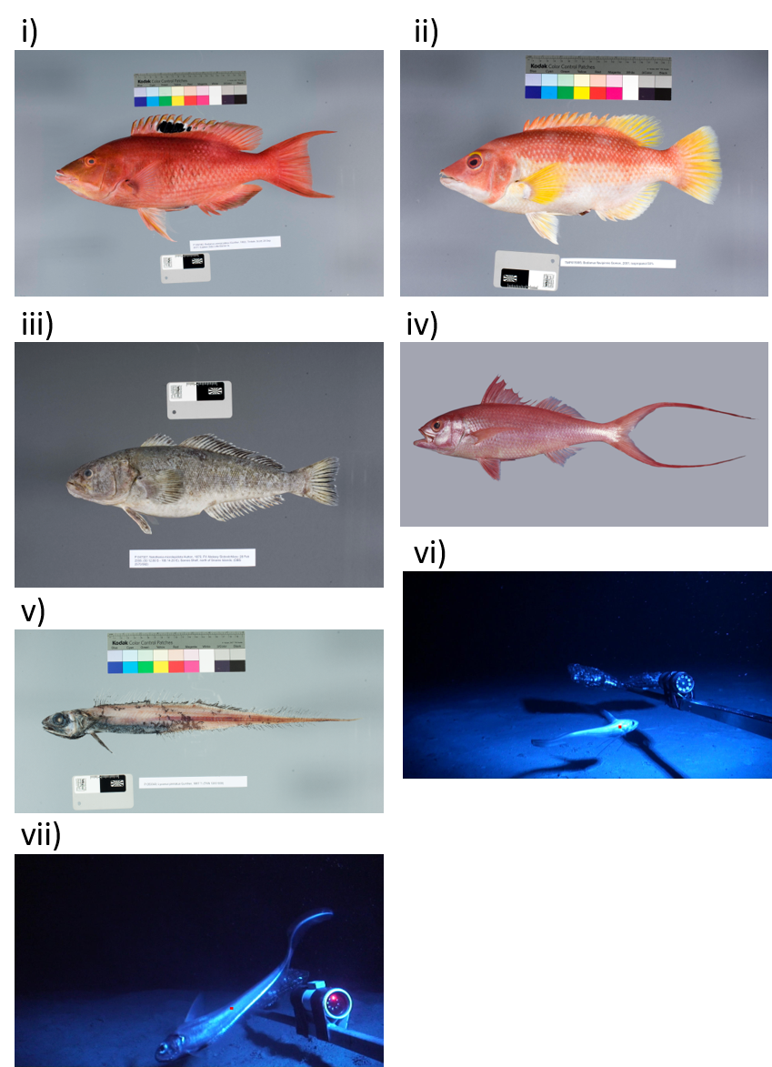

Fig. S1. Photographic images of the species closest to the centroid (in 8-dimensional functional trait-space (i.e., the “typical” species morphology) for each functional bioregion (from Figs. 5 and 6). i) Bodianus unimaculatus, Labridae, ii) Bodianus flavipinnis, Labridae, iii) Notothenia microlepidota, Nototheniidae, iv) Etelis coruscans, Lutjanidae, v) Lyconnus pinnatus, Merluccidae, vi) Coryphaenoides subserrulatus, Macrouridae, vii) Lepidorhynchus denticulatus, Macrouridae.

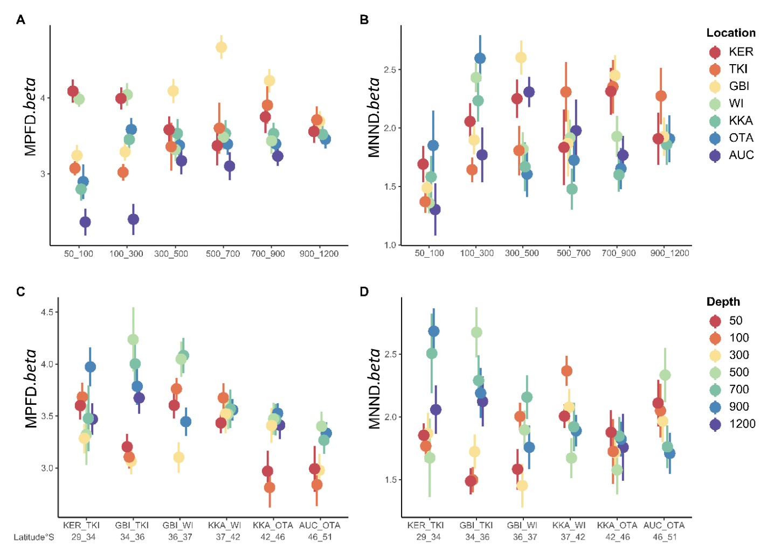

Fig. S5. Functional turnover (measured by MPFD.beta or MNND.beta) between adjacent depth cells at each latitude (A, B; with coloured symbols denoting locations from KER in the north to AUC in the south), and between adjacent latitudinal cells within each depth stratum (C, D; with coloured symbols denoting depth strata from 50 m to 1200 m). The error bars give the standard deviation in MPFD.beta or MNND.beta values calculated across the 100 data tables drawn randomly from the complete dataset.

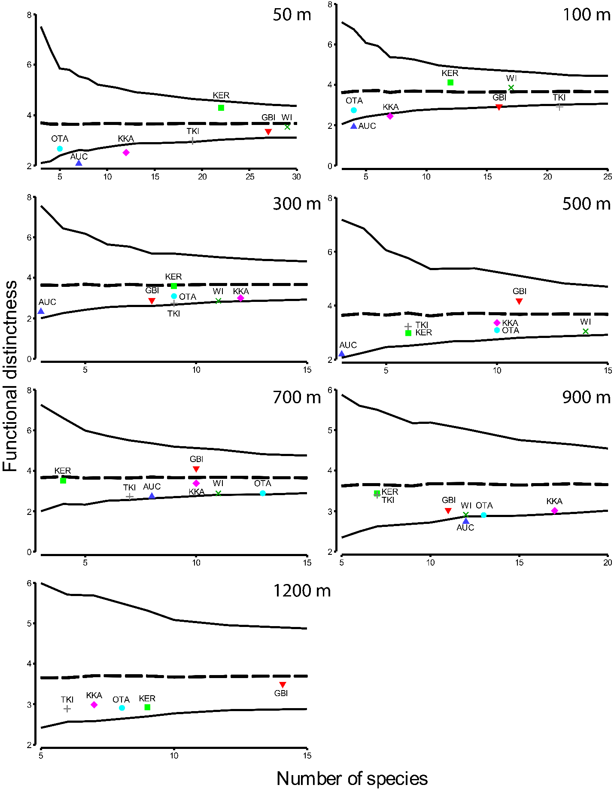

Fig. S2. Funnel plots showing mean (dotted line) and 95% confidence bounds (solid lines) for the expected functional distinctness, given the number of species observed in each cell using random draws from the full list of species seen within each depth stratum. Coloured symbols show the observed functional distinctness values for each depth-by-latitude cell.

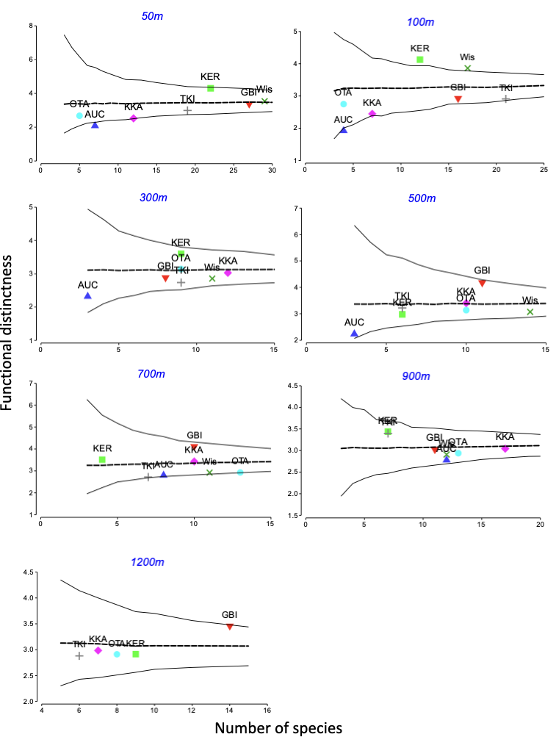
Fig. S3. Funnel plots showing mean (dotted line) and 95% confidence bounds (solid lines) for the expected functional distinctness observed in each cell using random draws from the full list of species seen within each depth stratum, given the frequency of the species within each depth stratum. Coloured symbols show the observed functional distinctness values for each depth-by-latitude cell.
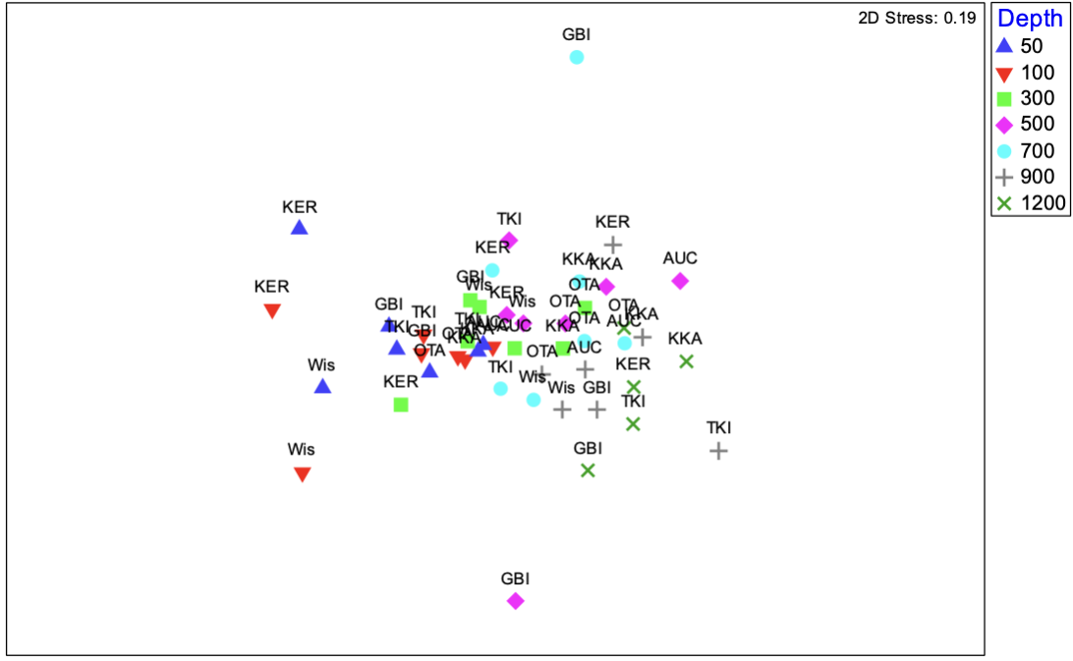
Fig. S4. Non-metric multi-dimensional scaling (nMDS) ordination on the basis of mean pairwise functional distances (MPFD.beta) among depth-by-location cells for p = 8 normalised functional traits, with symbols corresponding to the 7 depth strata.

