Relationships between microscopic charcoal in Iberian margin sediments and fire regimes in southwestern Europe: interpreting marine paleofire records

Authors and affiliations
Marion Genet¹, Anne-Laure Daniau¹, Florent Mouillot², Vincent Hanquiez¹, Sabine Schmidt¹, Valérie David¹, M. Georget¹, Fatima Abrantes^{3,4}, Pierre Anschutz¹, Franck Bassinot⁵, Jérome Bonnin¹, Bernard Dennielou⁶, Frédérique Eynaud¹, David A. Hodell⁷, Thierry Mulder¹, Filipa Naughton^{3,4}, Linda Rossignol¹, Polychronis Tzedakis⁸, Maria Fernanda Sánchez-Goñi^{1,9}

Supplementary Information

Figure S1. West to east scheme of the different water masses from the western Iberian margin (adapted from Villacieros‐Robineau et al. ( 2019)). The surface circulation is dominated by the Iberian Poleward Current (IPP) (black arrow) and by the Eastern Atlantic Central Water (ENACW). The intermediate circulation is dominated by the Mediterranean Outflow Water (MOW). The deep circulation is dominated by the North Atlantic Deep Water (NADW). Close to the coastline, the regional circulation is influenced by season. During the upwelling period (summer), the Inshore Coastal Current (ICC) flows southward (orange arrows) and the Surface Nepheloid Layer (SNL) is well developed (orange area). During the downwelling period (winter), the ICC flows northward (green arrows) promoting a well developed Bottom Nepheloid Layer (BNL) (green area) due to the remobilisation of sediment (black round arrows) in the High Resuspension Inner Shelf Area (HRISA). Mud Patch: brown area
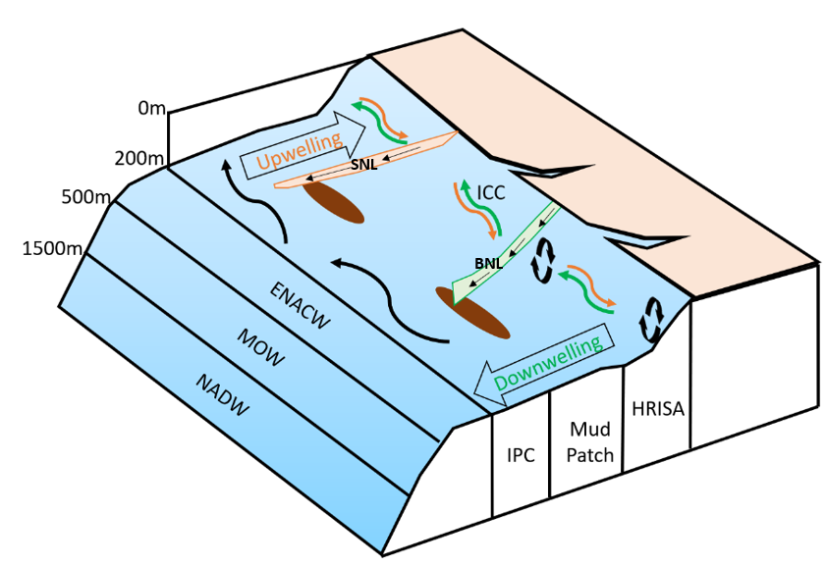

Table S1. Location, geographic and dating information of the 102 marine surface sediment samples analysed in this study (see excel file Table S1).
References regarding dates in the column (21):
Abrantes, F., Lopes, C., Rodrigues, T., Gil, I., Witt, L., Grimalt, J., Harris, I., 2009. Proxy calibration to instrumental data set: Implications for paleoceanographic reconstructions: PROXY CALIBRATION TO INSTRUMENTAL DATA SET. Geochem. Geophys. Geosyst. 10, n/a-n/a. https://doi.org/10.1029/2009GC002604
Chabaud, L., Sánchez Goñi, M.F., Desprat, S., Rossignol, L., 2014. Land–sea climatic variability in the eastern North Atlantic subtropical region over the last 14,200 years: Atmospheric and oceanic processes at different timescales. The Holocene 24, 787–797. https://doi.org/10.1177/0959683614530439
Desprat, S., 2005. Réponses climatiques marines et continentales du Sud-Ouest de l’Europe lors des dernières interglaciaires et des entrées en glaciations (These de doctorat). Bordeaux 1.
Dessandier, P.-A., 2015. Distribution des faunes vivantes, mortes et fossiles de foraminifères benthiques sur la marge portugaise : impact des apports fluviatiles et de la qualité de la matière organique (These de doctorat). Bordeaux.
Dias, Jouanneau, J.M., Gonzalez, R., Araújo, M.F., Drago, T., Garcia, C., Oliveira, A., Rodrigues, A., Vitorino, J., Weber, O., 2002. Present day sedimentary processes on the northern Iberian shelf. Progress in Oceanography, Benthic processes and dynamics at the NW Iberian Margin: resultss of the OMEX II Program 52, 249–259. https://doi.org/10.1016/S0079-6611(02)00009-5
Ducassou, E., Hassan, R., Gonthier, E., Duprat, J., Hanquiez, V., Mulder, T., 2018. Biostratigraphy of the last 50 kyr in the contourite depositional system of the Gulf of Cádiz. Marine Geology 395, 285–300. https://doi.org/10.1016/j.margeo.2017.09.014
Fatela, F.J., Duprat, J., Pujos, A., 1994. How southward migrated the polar front, along the west Iberian Margin, at 17,800 years BP. Gaia 8, 169–173.
Griveaud, C., 2007. Influence des conditions écologiques sur la composition isotopique (δ13C, δ18O) du test de foraminifères benthiques actuels (These de doctorat). Angers.
Hassan, R., 2014. La sédimentation dans le Golfe de Cadix au cours des derniers 50 000 ans (analyses multi-paramètres et multi-échelles). 383.
Ménabréaz, L., Thouveny, N., Bourlès, D.L., Deschamps, P., Hamelin, B., Demory, F., 2011. The Laschamp geomagnetic dipole low expressed as a cosmogenic 10Be atmospheric overproduction at ~41ka. Earth and Planetary Science Letters 312, 305–317. https://doi.org/10.1016/j.epsl.2011.10.037
Mil-Homens, M., Stevens, R.L., Cato, I., Abrantes, F., 2007. Regional geochemical baselines for Portuguese shelf sediments. Environmental Pollution 148, 418–427. https://doi.org/10.1016/j.envpol.2006.12.007
Mouret, A., 2009. BIOGEOCHIMIE BENTHIQUE : PROCESSUS COMMUNS ET DIVERGENCES ENTRE LES SEDIMENTS LITTORAUX ET CEUX DES MARGES CONTINENTALES Comparaison entre le Bassin d’Arcachon et le Golfe de Gascogne 294.
Mulder, T., Lecroart, T.P., Voisset, M., Schönfeld, J., Le Drezen, E., Gonthier, E., Hanquiez, V., Zahn, R., Faugères, J.-C., Hernandez-Molina, F.J., Llave-Barranco, E., Gervais, A., 2002. Past deep-ocean circulation and the paleoclimate record-Gulf of Cadiz. Eos Trans. AGU 83, 481. https://doi.org/10.1029/2002EO000337
Naughton, F., Sanchez Goñi, M.F., Desprat, S., Turon, J.-L., Duprat, J., Malaizé, B., Joli, C., Cortijo, E., Drago, T., Freitas, M.C., 2007. Present-day and past (last 25000 years) marine pollen signal off western Iberia. Marine Micropaleontology 62, 91–114. https://doi.org/10.1016/j.marmicro.2006.07.006
Naughton, F., Sanchez Goñi, M.F., Rodrigues, T., Salgueiro, E., Costas, S., Desprat, S., Duprat, J., Michel, E., Rossignol, L., Zaragosi, S., Voelker, A.H.L., Abrantes, F., 2016. Climate variability across the last deglaciation in NW Iberia and its margin. Quaternary International 414, 9–22. https://doi.org/10.1016/j.quaint.2015.08.073
Voelker, A., Lebreiro, S., Schonfeld, J., Cacho, I., Erlenkeuser, H., Abrantes, F., 2006. Mediterranean outflow strengthening during northern hemisphere coolings: A salt source for the glacial Atlantic? Earth and Planetary Science Letters 245, 39–55. https://doi.org/10.1016/j.epsl.2006.03.014

Table S2. Land cover classification system. The first column corresponds to codes, the second column to LCCS class, the third column corresponds to the conversion into closed vegetation (composed mainly by trees), mixed vegetation (composed of trees, shrubs and grasses) and open vegetation (composed of non-arboreal vegetation). The fourth column corresponds to the conversion of LCCS class into managed grass class of the UNLCCS according to Poulter et al. (2015) in percentages.
LCCS class code | LCCS class | Landscape cover | Managed Grass percentages
60 | Tree cover, broadleaved, deciduous, closed to open (>15%) | Closed | 0
70 | Tree cover, needleleaved, evergreen, closed to open (>15%) | Closed | 0
90 | Tree cover,mixed leaf type (broadleaved and needleleaved) | Closed | 0
100 | Mosaic tree and shrub (>50%) / herbaceous cover (<50%) | Mixed | 0
10 | Cropland, rainfed | Open | 100
11 | Herbaceous cover | Open | 100
12 | Tree or shrub cover | Open | 50
20 | Cropland, irrigated or post‐flooding | Open | 100
30 | Mosaic cropland (>50%) / natural vegetation (tree, shrub, herbaceous cover) (<50%) | Open | 60
40 | Mosaic natural vegetation (tree, shrub, herbaceous cover) (>50%) / cropland (<50%) | Open | 40
110 | Mosaic herbaceous cover (>50%) / tree and shrub (<50%) | Open | 0
120 | Shrubland | Open | 0
122 | Deciduous shrubland | Open | 0
130 | Grassland | Open | 0
150 | Sparse vegetation (tree, shrub, herbaceous cover) (<15%) | Open | 0
153 | Sparse herbaceous cover (<15%) | Open | 0
180 | Shrub or herbaceous cover, flooded, fresh/saline/brakish water | Open | 0

Table S3. Charcoal concentration and elongation values for the 102 samples analysed in this study (see excel file Table S3)

Figure S2. Results of the PCA of the full environmental dataset for each fire location (burnt grass, burnt shrub and burnt tree derived from the FRY database (Laurent et al., 2018). The net primary productivity for all seasons: NPP_winter, NPP_spring, NPP_summer, NPP_autumn. andMean Annual NPP (MANPP). Temperature in summer (Temp_summer), in spring (Temp_spring), in autumn andMean Annual Temperature (MAT). Precipitation in summer (Precip_summer), in spring (Precip_spring), in autumn (Precip_autumn), in winter (Precip_winter) and Mean Annual Precipitation (MAP) derived from the GEFD4s database (Version: GFED4s, raster with spatial resolution: 0,25 degree, period: 1997-2015; (Giglio et al., 2013)). Preferential source areas of microcharcoal: zone 1 (blue circle), zone 2 (yellow circle), zone 3 (grey circle), zone 4 (red circle), zone 5 (blue circle).

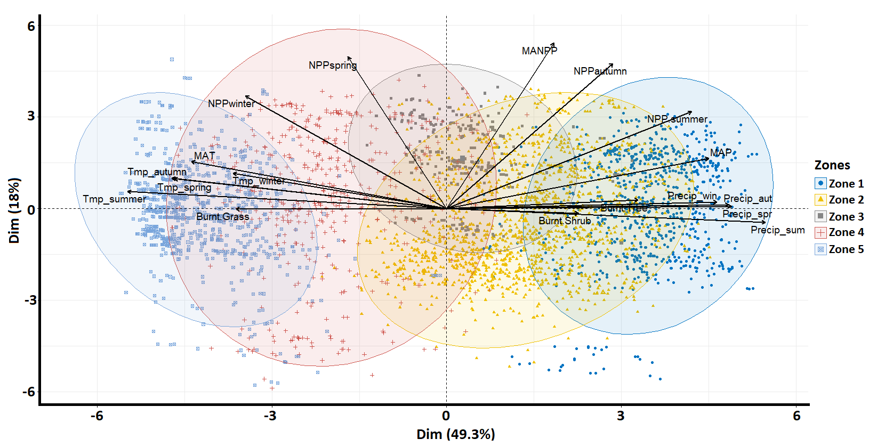

Figure S3. Correlation matrix of the variables (seasonal and mean annual temperature and precipitation; NPP (net primary productivity); burnt trees, shrubs and grasses). Positive correlation in blue and negative correlation in red and their associated r-pearson correlation number.
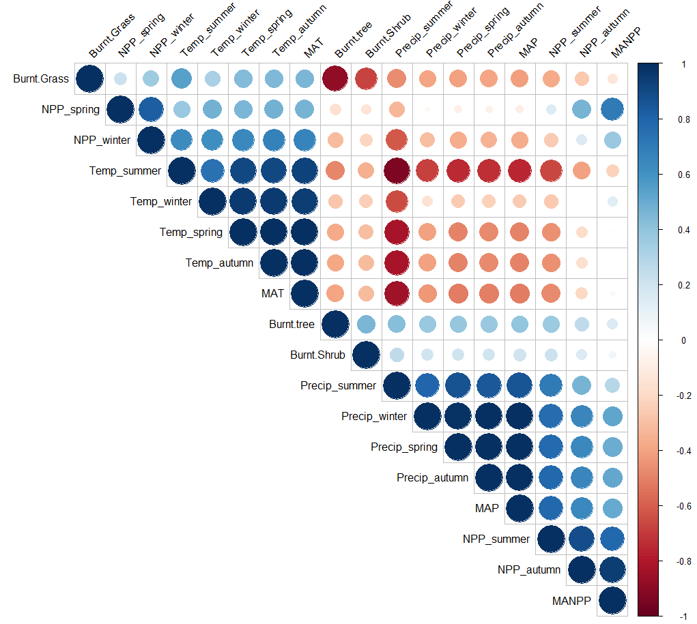

Figure S4. Boxplots representing the distribution of climate and NPP in the five zones from the north (left) to the south (right). (a) Annual temperatures in degree celsius, b: Annual precipitation in millimetres, (c) to (f) NPP in spring, winter, summer and autumn in g.C.m⁻²month⁻¹.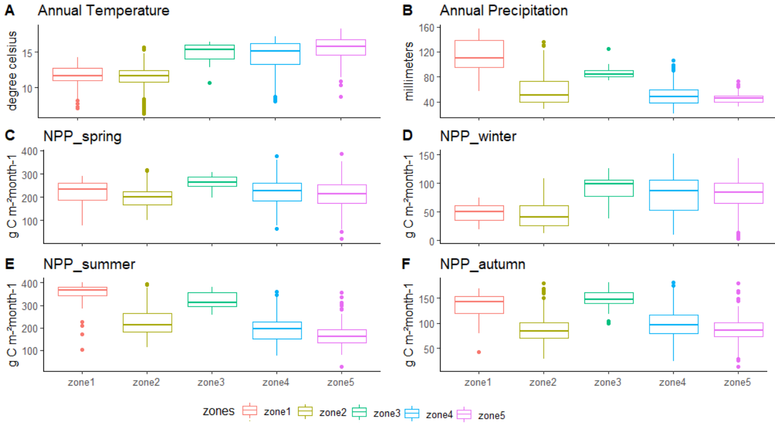

Figure S5. Scatter plot of microcharcoal concentration as the number of particles per gram of dry bulk sediment (CCnb in nb/g) versus the total surface area of microcharcoal (CCsurf in mm²/g) for the 102 studied samples.
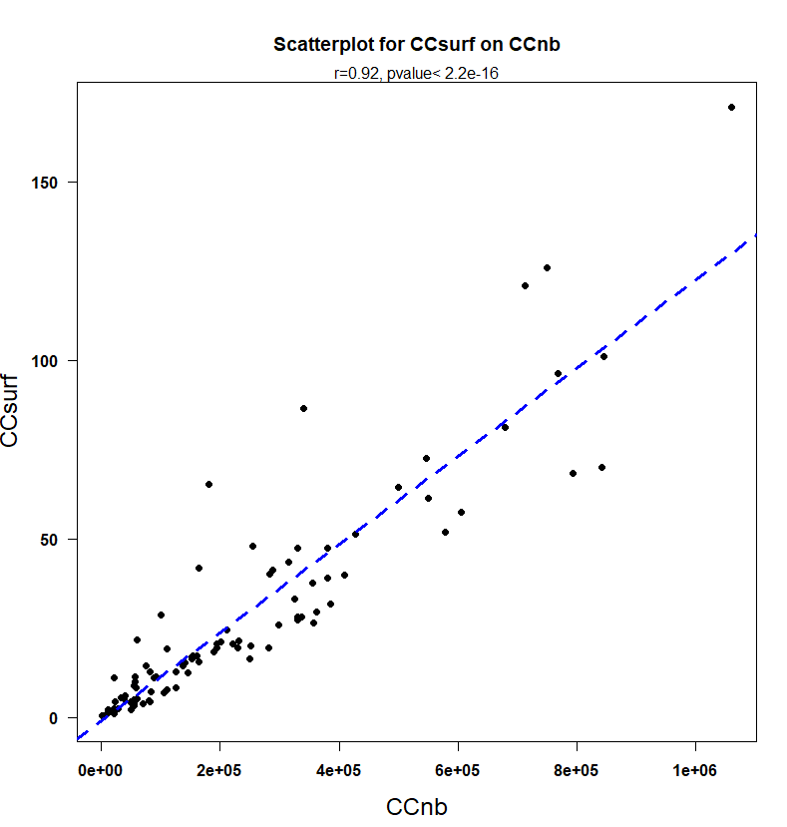

Figure S6. Boxplots representing the distribution of mean microcharcoal concentration in zones 1, 3, 4 and 5. No boxplot was produced for zone 2 because no information regarding dates was available for samples in this zone. a : the CCnb in nb.g⁻¹ and b: the CCnb divided by the estimated age of the samples nb.g⁻¹.yr⁻¹ (each individual CCnb was divided by the estimated sample age, before producing the boxplot).
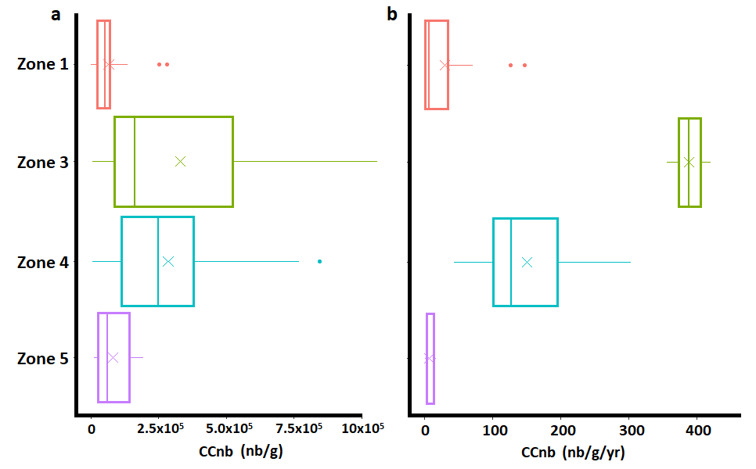

Figure S7. Test of the significance for the microcharcoal concentration and elongation for the five zones considering average (student t-test) and the median (Kruskall-Wallis test) (light grey) and their associated p-values (dark grey). Two zones are different if p<0.05 and similar if p>0.05. 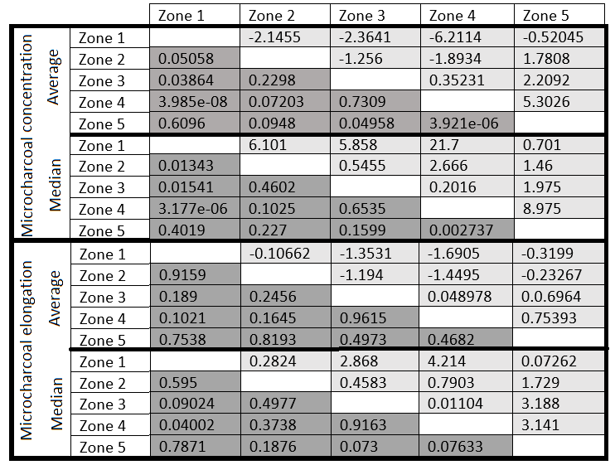
Figure S8. a: Microcharcoal concentrations in the interface coreslocated in the Galician margin. b: Comparison of microcharcoal concentration values (CCnb, nb.g⁻¹) in the interface cores located in the Galician margin with microcharcoal concentration values from marine sediment surface samples of the Iberian margin and the Gulf of Cadiz.
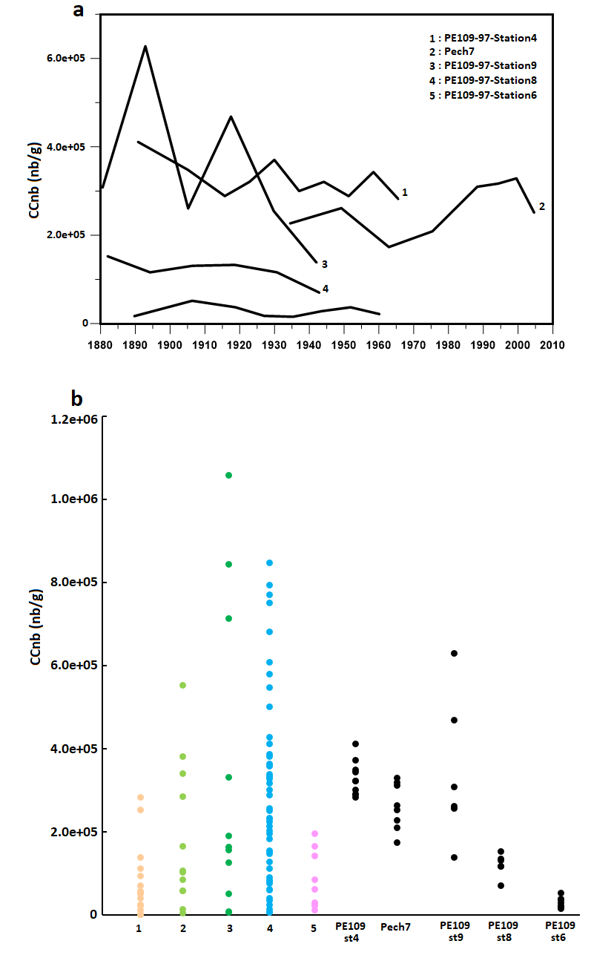

Figure S9. Results of the single linkage (nearest neighbour) algorithm and stratigraphically constrained clustering carried out on (a) microcharcoal concentration and water depth of samples (b) microcharcoal elongation and water depths of samples. Colours correspond to groups defined from the analysis.
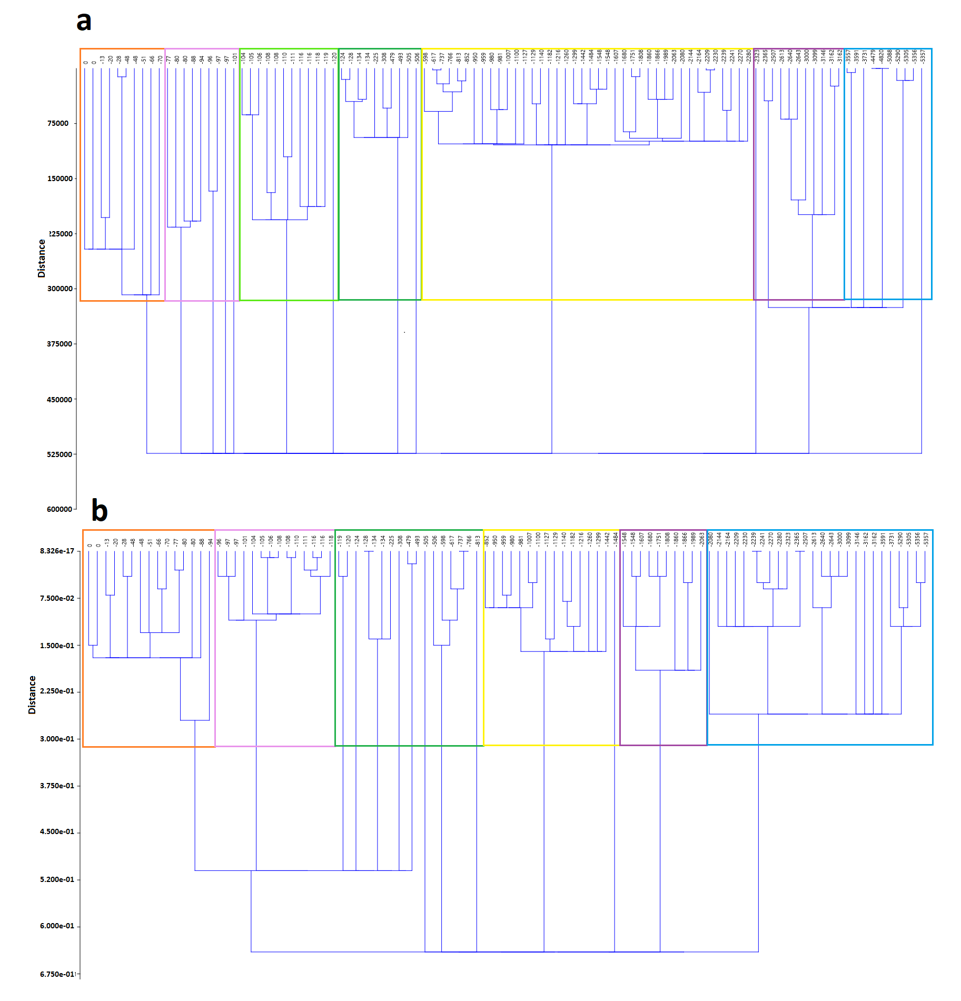

Figure S10. Scatter plot of water depths of samples and distance from the river mouth of samples and associated correlation coefficient.

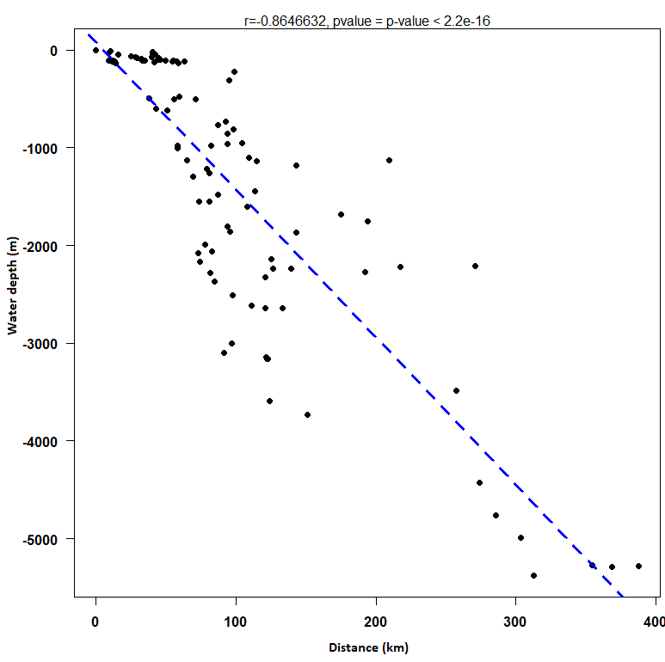

Figure S11. Relationships between microcharcoal elongation and water depths. a) Boxplots representing the variability of microcharcoal elongation in six groups defined by clustering analysis. b) Location of samples according to clusters groups
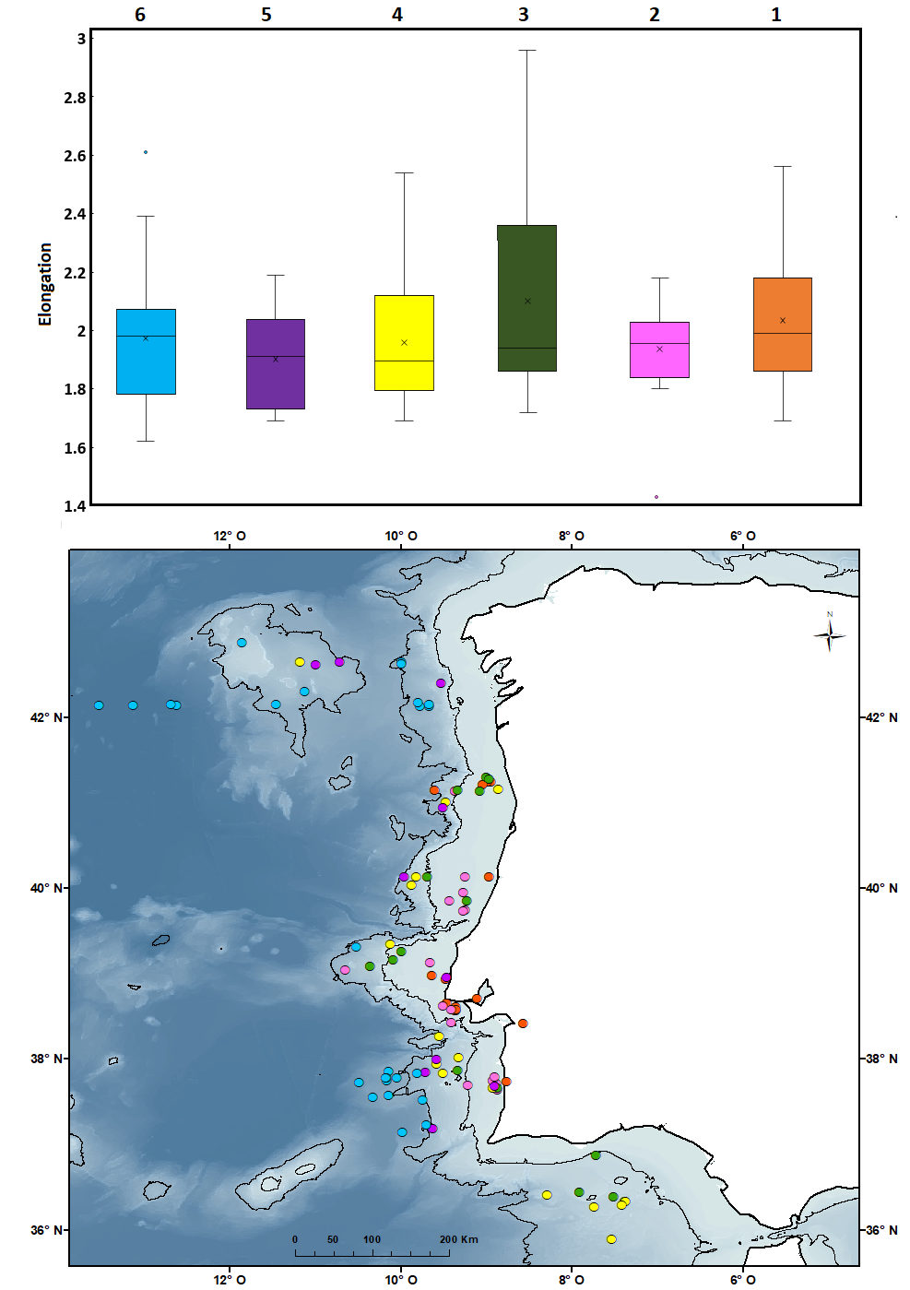

Figure S12. Test of significance of the microcharcoal concentration for the 7 groups (a) and of microcharcoal elongation for the 6 groups (b)following the clustering analysis (Figure S9) considering average (student t-test) and the median (Kruskall-Wallis test) (light grey) and their associated p-values (dark grey). Two groups are different if p<0.05 (bold) and similar if p>0.05.

