Supplementary Information for Disentangling diverse responses to climate change among global marine ecosystem models

S1 Supplementary Tables and Figures

Table S1 $ΔTCB$ with $ΔSST$ for each model, from the Temperature Change experiment (regression equation: $ΔTCB=exp(β_{0}+β_{1}ΔSST)+ε$). R² and predicted response to 1°C warming also reported. Cold waters are all waters <15°C, warm waters are all waters $≥$15°C.
Model | $$β_{0}$$ |  |  | $$β_{1}$$ |  |  | R² (%)
 | All waters | Cold water | Warm water | All water | Cold water | Warm water | All water | Cold water | Warm water
APECOSM** | 4.71 | 4.72 | 4.57 | -0.02 | -0.019 | 0.020 | 8.9 | 8.4 | 6.9
FEISTY** | 4.61 | 4.59 | 4.64 | -0.007 | -0.014 | -0.005 | 1.7 | 11.6 | 0.1
ZooMSS** | 4.61 | 4.62 | 4.61 | -0.01 | -0.006 | -0.013 | 20.4 | 22.0 | 10.1
DBPM** | 4.54 | 4.52 | 4.64 | -0.005 | -0.01 | -0.03 | 0.5 | 3.2 | 5.4
DBEM** | 4.30 | 4.97 | 4.48 | -0.06 | 0.01 | -0.31 | 0.1 | 0.1 | 0.2
EcoTroph** | 4.61 | 4.60 | 4.59 | -0.05 | -0.05 | -0.040 | 90.6 | 97.7 | 54.3
BOATS** | 4.66 | 4.65 | 4.64 | -0.14 | -0.14 | -0.13 | 81.9 | 88.0 | 39.7
Macroecological** | 4.70 | 4.66 | 4.64 | -0.17 | -0.18 | -0.12 | 62.8 | 82.2 | 12.1
** indicates models for which all regression coefficients are statistically significant at the 0.01 level.

Table S2 $ΔTCB$ with $ΔLTL$ for each model, from the Lower Trophic Level (LTL) Change experiment (regression equation: $ΔTCB=β_{0}+β_{1}ΔLTL+ε$). R² and predicted response to a 1% increase in LTL also reported. Cold waters are all waters <15°C, warm waters are all waters $≥$15°C.
Model | $$β_{0}$$ |  |  | $$β_{1}$$ |  |  | R² (%)
 | All water | Cold water | Warm water | All water | Cold water | Warm water | All water | Cold water | Warm water
APECOSM** | 4.12 | 3.64 | 0.80 | 0.92 | 1.00 | 0.61 | 45.7 | 43.8 | 47.1
FEISTY** | -1.29 | -1.36 | 4.14 | 0.68 | 0.65 | 1.09 | 33.5 | 21.5 | 61.4
ZooMSS** | -1.29 | -0.10 | -1.36 | 1.09 | 1.06 | 1.19 | 85.9 | 86.0 | 84.2
DBPM** | 8.73 | 21.20 | 0.02 | 0.64 | 0.40 | 1.01 | 15.5 | 9.3 | 73.4
DBEM** | 1.33 | 6.43 | 0.29 | 0.73 | 0.62 | 0.88 | 51.7 | 33.7 | 94.4
EcoTroph** | -0.36 | -1.47 | 0.04 | 0.99 | 1.02 | 0.97 | 95.4 | 94.0 | 96.6
BOATS** | 12.8 | 25.1 | 1.71 | 1.74 | 1.53 | 1.42 | 75.2 | 62.5 | 92.3
Macroecological** | 0.76 | 0.27 | 0.23 | 1.28 | 1.30 | 1.19 | 93.6 | 91.1 | 96.2
** indicates models for which all regression coefficients are statistically significant at the 0.01 level.

Table S3 Pearson correlation coefficients for change in consumer biomass for each model from the LTL Change experiment, across the four aggregated LTL variables. For each model, the greatest correlation is bolded, and the correlation for the aggregated LTL variable each model uses is highlighted in yellow.
Model | LTL variable
 | Phytoplankton production | Phytoplankton carbon | Zooplankton carbon | Phytoplankton + zooplankton carbon
APECOSM | 0.53 | 0.66 | 0.34 | 0.68
FEISTY | 0.56 | 0.43 | 0.58 | 0.58
ZooMSS | 0.84 | 0.93 | 0.42 | 0.90
DBPM | 0.64 | 0.39 | 0.89 | 0.66
DBEM | 0.72 | 0.64 | 0.57 | 0.69
EcoTroph | 0.98 | 0.82 | 0.62 | 0.90
BOATS | 0.88 | 0.63 | 0.83 | 0.84
Macroecological | 0.97 | 0.82 | 0.63 | 0.90

Table S4 Mean change in total consumer biomass ($Δ$TCB, %) for each model with 1°C warming and a 1% increase in its lower trophic level (LTL) forcings, for all, cold (<15°C) and warm ($≥$15°C) waters in 1950-1960, calculated from fitted regressions in Figure 5 and 6. Summaries of the fitted regressions are in Supplementary Tables 1 and 2.

Model | $$ΔTCB (+1°C;\%)$$ |  |  | $$ΔTCB (+1\% LTL;\%)$$
 | All waters | Cold waters | Warm waters | All waters | Cold waters | Warm waters
APECOSM | -1.98 | -1.98 | 2.02 | 0.92 | 1.00 | 0.61
FEISTY | -0.80 | -1.39 | -0.50 | 0.68 | 0.65 | 1.09
ZooMSS | -0.90 | -0.60 | -1.29 | 1.09 | 1.06 | 1.19
DBPM | -0.50 | -1.00 | -2.86 | 0.64 | 0.40 | 1.01
DBEM | -5.82 | 1.41 | -27.38 | 0.73 | 0.62 | 0.88
EcoTroph | -4.78 | -4.88 | -3.92 | 0.99 | 1.02 | 0.97
BOATS | -13.06 | -13.06 | -12.19 | 1.74 | 1.53 | 1.42
Macroecological | -15.38 | -16.81 | -11.57 | 1.28 | 1.30 | 1.19

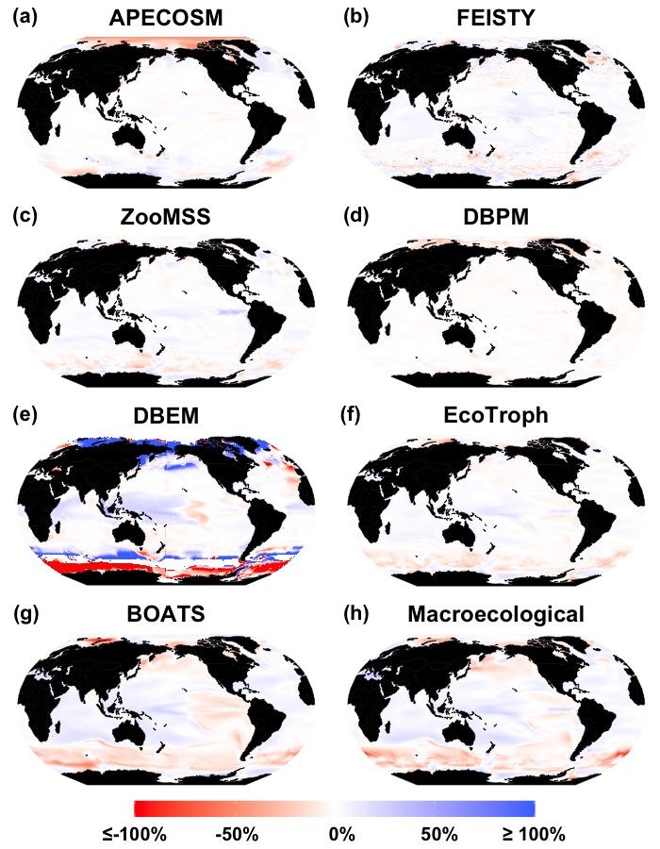
Figure S1 Maps of non-linear climate impacts, showing the change in total consumer biomass from the climate change simulation ($ΔTCB$_{Climate}) minus the sum of changes in total consumer biomass from the LTL and Temperature Change simulations ($ΔTCB$_{LTL +Temp}), compared to the Control simulation in 2090-2100 for a) APECOSM, b) FEISTY, c) ZooMSS, d) DBPM, e) DBEM, f) EcoTroph, g) BOATS and h) Macroecological.

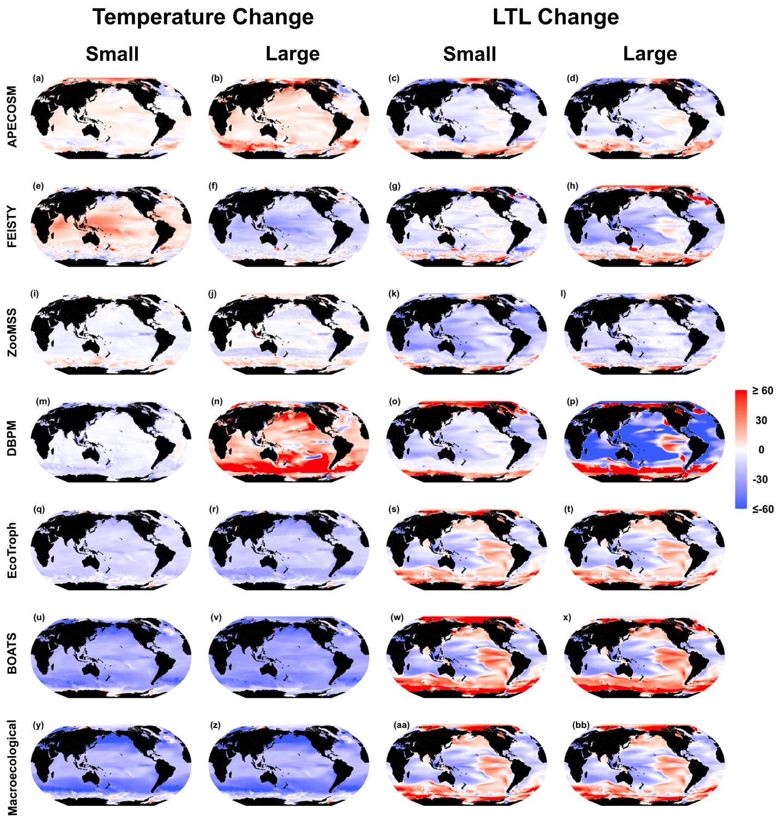
Figure S2 Maps of mean relative small and large consumer biomass averaged over 2090-2100, compared to the Control in 2090-2100, for the Temperature (two left columns) and Lower Trophic Level (LTL; two right columns) experiments for a-d) APECOSM, e-h) FEISTY, i-l) ZooMSS, m-p) DBPM, q-t) EcoTroph, u-x) BOATS, y-bb) Macroecological.

S2 Model Summaries
S2.1 APECOSM
APECOSM is a spatially explicit, 3D, trait-based and size-based model of global marine ecosystems (Maury, 2010; Maury et al. 2007a, 2007b; Maury and Poggiale, 2013). It represents the pelagic ecosystem with three dynamic trait-based size-spectra, representing epipelagic, mesopelagic and migratory mesopelagic animals between 1e-3m (15$μ$g) – 2m (120kg). At the individual level, the uptake and use of energy for growth, maintenance and reproduction is modelled according to the Dynamic Energy Budget theory (Kooijman, 2010). Energy moves from small to large size classes through explicit size-structured predation and growth and mortality includes predatory as well as non-predatory natural mortality sources such as disease and starvation. Small and large phytoplankton and zooplankton biomass, as well as detritus fuel the consumer spectra, providing food for the smallest consumers. Plankton biomass and detritus also affect water clarity and light penetration into water and hence the vertical distribution of organisms. Importantly, areas with the highest consumer biomass are not necessarily regions with the highest primary production, due to active and passive horizontal movements in response to temperature, light, food availability and the strength of currents.

3D temperature affects both energy acquisition through feeding and energy dissipation through metabolism as well as the various non predatory mortality components. These processes scale with ambient temperature $(T; °C)$ using the Arrhenius factor, $A(T)$:

$$A\left(T\right)=exp\left(\frac{5020}{298.15}-\frac{5020}{(T+273.15)}\right),$$

An individual of size $w$’s rate of energy acquisition through feeding $f(w)$ is a function of water temperature $T (°C)$ and total prey $p(w)$, and is represented using a Holling type 2 functional response:

$$f\left(w\right)∝\frac{p(w)}{C(T)+p(w)},$$

where $C\left(T\right)$ controls the saturation of the functional response and $p(w)$ is a function of prey density. Since the reactive distance (the maximal distance at which a prey can be seen by a predator) varies with ambient light and predator swimming speed varies with both ambient temperature and predator size, $C\left(T\right)$ can be expressed as:

$$C\left(T\right)=\frac{c}{A\left(T\right) v\left(PAR\right) w^{0.33} },$$

with$c$ a constant, $PAR$ the Photosynthetically Active Radiation and $v$ a function characterizing the influence of light on the reactive distance.

This formulation means that, in regions with high prey density (generally regions with high plankton concentrations),$f\left(w\right) is dominated by temperature effects$, while in regions with low prey density, $f\left(w\right)$ is driven by food availability .

The mortality exerted by predators on their prey scales with temperature just as the food uptake of predators does. Energy dissipation through maintenance $m(w)$ and energy losses through non predatory mortality, including disease and ageing mortality, all scale with temperature and body size:

$$m\left(w\right)∝A\left(T\right).$$

APECOSM is mass-balanced, so when energy acquisition through feeding is unable to meet maintenance costs, growth and reproduction stop and the energy deficit is drawn from existing biomass. This process is represented as an additional mortality term from starvation. In regions with high food concentrations, increases in mortality and maintenance with temperature are matched by a proportional increase in ingestion. However, in areas with low food concentration, temperature-driven increases in maintenance and non-predation mortality are not matched by a parallel increase in ingestion. This results in reduced growth (smaller individuals) and reproduction as well as increased starvation mortality that may also become an additional source of energy loss from the system.

Warmer temperatures increase predators’ food intake and thus the speed of biomass transfer from small to large size classes through predation. Faster biomass transfers with increasing temperature can adversely affect smaller organisms biomass, compared to larger animals and this can be exacerbated by increased top-down predation. However, increasing temperatures also means increasing productivity (reproduction and growth) so that a lower biomass of small species can support more predation from large organisms with faster energy transfer.

S2.2 BOATS
BOATS is a dynamic size-spectrum model representing all commercial animal biomass from 10g – 100kg (Carozza et al. 2016, 2017). Animals are grouped into three size-spectra, each starting at 10gm, but with differing asymptotic sizes. Animals in each size spectra grow from the smallest size class up to their group’s asymptotic size, reproduce, respire biomass and die through time. In each size class, animal biomass evolves through time as a balance between growth (and recruitment from reproduction in the smallest size class) less mortality losses.

For an animal of size $w$, energy for growth and reproduction is supplied from primary production $(PP;mmol C m^{-2} d^{-1})$ by the transfer of biomass through the food web by predation. Total primary production available for animals of size $w$ ($π(w, PP)$) dependent on$PP$, the average trophic efficiency, predator prey mass ratio and the representative phytoplankton size ($w_{p};g$):

$$π\left(w,PP\right)=\frac{PP}{w_{p}}{\left(\frac{w}{w_{p}}\right)}^{(log⁡(0.16)/log⁡(7609))-1}.$$

$w_{p}$ is calculated as the geometric mean of the mass of a typical large $w_{p_{L}}$, and typical small phytoplankton $w_{p_{L}}$:

$$w_{p}=w_{p_{L}}^{Φ_{L}}w_{p_{S}}^{{1-Φ}_{L}},$$

where $Φ_{L}$ is the fraction of primary production due to large phytoplankton, which depends on PP and temperature ($T; °C)$ averaged over the euphotic layer depth (here 75m), using an empirical equation from Dunne et al., (2005):

$$Φ_{L}=\frac{0.5\left(-1+\sqrt{1+4PP/75/(0.3135×exp⁡(0.0667T)})\right)}{1+0.5\left(-1+\sqrt{1+4PP/75/(0.3135×exp⁡(0.0667T)})\right)}.$$

$π\left(w,PP\right)$ sets the environmental upper bound on the growth and reproduction rate of animals of size $w,$ $f(π\left(w,PP\right))$. However, total growth and reproduction cannot exceed a biologically determined maximum rate $A(w,T$), dependent on $w$ and $T$, no matter the environmental upper bound:

$$A(w,T)∝exp\left(\frac{0.3116}{8.617×{10}^{-5}}\left(\frac{1}{283.15}-\frac{1}{T+273.15}\right)\right)$$

To account for this limitation, total growth and reproduction of animals with body size $w$, $ξ_{T}(w)$, is defined as:

$$ξ_{T}\left(w\right)=min\left[f\left(π\left(w,PP\right)\right), A(w,T)\right].$$

This formulation means that the total maximum growth and reproduction rates is $A(w,T)$ when there is no food limitation, and $f\left(π\left(w,PP\right)\right)$ when animals are food-limited. In areas with no food limitation, excess available food is assumed to support non-commercial animal biomass, which is not resolved by the model. All else being equal, as temperature increases, growth and reproduction of commercial biomass increases in regions where food is non-limiting. In the meantime, mortality increases with warming. This means areas that are cold, with high PP will see biomass variations mostly controlled by temperature. However, areas that are warm will be increasingly limited by PP. If PP decreases in these warm waters, the scope for growth of new biomass will become increasingly limited.

Natural mortality $μ_{T}$in each animal size class represents losses due to predation, as well as other natural causes such as disease or senescence. The mortality formulation scales with temperature $T$:

$$μ_{T}\left(w,T\right)∝exp\left(\frac{0.3756}{8.617×{10}^{-5}}\left(\frac{1}{283.15}-\frac{1}{T+273.15}\right)\right),$$

With this formulation, growth and reproduction are less sensitive to warming compared to mortality (0.3116 < 0.3756). Thus, where food is non-limiting warming reduces the maximum biomass.

S2.3 DBEM
The Dynamic Bioclimate Envelope Model (DBEM) is a dynamic mechanistic species distribution model comprised of two main components (i) species habitat suitability and (ii) population dynamics. While total primary production (NPP) and sea surface temperature (SST) are used in several sub-components of the DBEM (e.g. temperature is a component of the larvae dispersal equation), they play major roles in the following processes (Cheung et al., 2016, 2009, 2010).

Sea Surface Temperature
In DBEM, species habitat suitability in grid cell $i$ ($P_{i}$) is related to sea surface temperature:
$$P_{i}∝P\left(T_{i},TPP, Others\right),$$
where T_{i} is seawater temperature in grid cell i (note that for demersal species T is bottom temperature while for pelagic species is surface temperature), TPP is the species temperature preference profile and Others include environmental conditions such as salinity, physical structure or biogenic habitats that the species are associated with, bathymetry (for demersal species) and sea ice extent (for polar species).. At the species level, DBEM estimates TPP by matching the estimated species distribution with annual seawater temperature by firstly estimating an average relative abundance in annual temperature class i ($R_{i}$) as follows:
$$R_{i}=\frac{Q_{i}}{A_{i}}$$
where $Q_{i}$ and $A_{i}$ are the sum of relative abundance and range area from spatial cells within temperature class i. TPP is then calculated as:
$$TPP_{i}=\frac{R_{i}}{∑R_{i}}$$
In addition to TPP, DBEM incorporates temperature in the population dynamics component to estimate a species’ weight ($W_{t}$), as a modification of the asymptotic weight ($W_{∞}$) of the von Bertalanffy growth function (VBGF). Hence, DBEM considers that the metabolism of an individual is temperature dependent and aerobic scope is dependent on oxygen availability in water and finally maintenance metabolism is affected by physiological stress (e.g., increased acidity). Thus, ($W_{∞}$) is estimated by the balance between anabolism, which depends on oxygen ${[O}_{2}]$, and catabolism, which increases with acidification [$H^{+}$]:
$$W_{∞}=(\frac{g[O_{2}]*e^{-j_{1}/T}}{h[H^{+}]*e^{-j_{2}/T}})$$
where g and h are coefficients for anabolism and catabolism, respectively. j is Ea/R with Ea and R being activation energy and Boltzmann constant, respectively, and T is temperature (K). $j_{1}$ is parameterized so that anabolism has a Q₁₀ of around 1.85, and $j_{2}$ is parameterized so catabolism has a Q₁₀ of around 2.4.
As waters warm in a grid cell, species habitat suitability will change, causing species’ biomass to increase or decrease in that grid cell. At the same time, since anabolism scales slower with temperature than catabolism, warming drives decreases in the asymptotic size of individuals from different species, reducing the maximum biomass they can attain in that grid cell.
Net Primary Production
Primary production is incorporated into the DBEM across the exploitable range of a species and affects the carrying capacity (θ) in each cell i. The initial distribution of the species determines the initial carrying capacity and habitat suitability, and changes carrying capacity between time steps (t), are directly proportional to changes in net primary production (NPP), such that:
$$θ_{i,t+1}=θ_{i,t}\frac{{NPP}_{i,t+1}}{{NPP}_{i,t}}$$

S2.4 DBPM
The Dynamic Benthic-Pelagic Model (DBPM) is a dynamic size-spectrum model that resolves benthic and pelagic animal biomass from 1mg to 1 tonne, as well as the energetic pathways that link benthic and pelagic systems (Blanchard et al., 2012, 2009) . Energy moves from small to large size classes through the size-dependent process of predation-fuelled growth. Energy is lost from the system due to inefficiencies in predators converting prey biomass into new predator biomass, and mortality.

At the base of the food chain, small and large phytoplankton carbon biomass define the producer size-spectrum, which provides food for small benthic and pelagic consumers. Less phytoplankton biomass means less food for small consumers, decreasing their biomass, which in turn decreases the biomass of larger consumers. At the same time, as phytoplankton biomass decreases, the proportion of total producer biomass that is comprised of small phytoplankton increases. As small phytoplankton biomass increases, the average number of trophic steps between a consumer of a given size and producers increases, which equates to more trophic steps between producer and consumer, and thus lower consumer biomass due to trophic inefficiency.

Temperature affects the balance between energy acquisition through feeding, and energy dissipation through mortality. These processes scale with temperature $\left(T;°C\right)$ using an Arrhenius scaling:

$A\left(T\right)=$exp$\left(25.22-\frac{0.63}{8.62×{10}^{-5}\left(273.15+T\right)}\right)$

The growth and egestion rates of pelagic consumers of size $w$ at time $t$ is fuelled by feeding $f(w,t)$ on smaller size classes, which scales with sea-surface temperature $\left(T;°C\right).$

$$f\left(w,t\right)∝A(T),$$

Growth of benthic consumers is fuelled by feeding on an unstructured, shared pool of detritus, not size-based predation. Despite this difference, benthic animal growth rates scales with sea floor temperature in the same way as the pelagic consumer growth rate scales with sea surface temperature.

Since total predation mortality for animal of size $w$ at time $t$, $μ_{p}(w,t)$, is the integral of the feeding rate of all organisms larger than $w$, on size $w,$ therefore predation mortality similarly scales with temperature,:

$$μ_{p}\left(w^{'},t\right)∝A(T).$$

This formulation means that increases in the growth rate with increases in temperature for animals in any size class are matched by increases in predation mortality. However, size-dependent background and senescence mortality are also represented in DBPM, and background mortality scales with temperature in the same way as growth and predation. For an animal of size $w$ at time $t$, background $μ_{B}\left(w\right)$and senescence mortality $μ_{S}\left(w\right)$are given by:

$$μ_{B}\left(w\right)∝A(T)w^{-0.25},$$

$$μ_{S}\left(w\right)∝{\left(\frac{w}{1000}\right)}^{0.3}.$$

With a scaling factor of -0.25 with body size, background mortality affects smaller animals more than larger animals, so an increase in $μ_{B}\left(w\right)$ with increasing temperature will cause smaller animal biomass to decline more than larger animal biomass. However, since growth is driven by predation on smaller organisms, a decline in small animal biomass with increasing temperature will cause lower growth rates and potentially less biomass of larger pelagic organisms.

Finally, the shared pool of detritus that fuels the growth of benthic animals is produced by egestion and dead organic matter from the pelagic size spectrum. The fraction of detritus $D_{f}$ to reach the seafloor from egestion and dead organic matter from the pelagic spectrum scales with temperature and depth ($D, m$):

$$D_{f}∝exp \left(-0.032T\right) ,$$

thus, the fraction of pelagic detritus to reach the seafloor decreases with increasing temperature $T$.

S2.5 ECOTROPH
EcoTroph is an ecosystem modelling approach through which the ecosystem trophic functioning is modelled as a continuous flow of biomass surging up the food web, from lower to higher trophic levels (TLs), through predation and ontogenic processes (Gascuel and Pauly 2009; Gascuel et al. 2011; du Pontavice et al. 2021). EcoTroph is founded on the principle that an ecosystem can be represented by a continuous distribution of the biomass along TLs. The trophic functioning of aquatic ecosystems is viewed as a continuous biomass flow moving from lower to higher TLs. Each organic particle moves up the food web by continuous processes (representing an organisms’ ontogenetic changes in TLs as it grows) and abrupt jumps due to predation events. By combining the flows of all particles in a food web, the aggregated biomass flows can be represented by a continuous function.
The flow of biomass in a biomass spectrum in EcoTroph is represented by the traditional equations of fluid dynamics. Specifically, the continuous biomass flow (Ф, i.e., the quantity of biomass moving up through TL $τ$, at every moment, $t$) is described by:
$Φ\left(τ,t\right)= B\left(τ,t\right)$K($τ,t$)
where $Φ(t,τ)$ is expressed in t.year⁻¹, $B(t,τ)$ the density of biomass at TL = $τ$ expressed in tonnes per TL, and $K(t,τ)$ the flow kinetic expressed in TLs per year⁻¹. The flow kinetic measures the speed of the biomass flow in the food web, from low to high TLs. Under steady-state conditions, the flow equation becomes:
$$B\left(τ\right)= \frac{Φ\left(τ\right)}{K(τ)}$$
Furthermore, the biomass flow $Φ(τ)$ can be expressed as a decreasing function of TL:
$$Φ\left(τ+Δτ,t\right)=Φ\left(τ\right) exp(-μ_{τ} Δτ)$$
Where $Φ(τ)$ is the biomass flow at trophic level $τ$, $μ_{τ}$(expressed in TL⁻¹) represents the mean natural losses. It defines the transfer efficiency, TE, within the trophic class [τ, τ + Δτ] such that TE =exp(-μ_{τ}).

Net primary production (NPP) and sea surface temperature (SST) play major roles in the following processes:
Sea surface temperature
The trophic transfer efficiency of energy through the food web (TE) and the flow kinetic (K) are sensitive to changes in sea surface temperature
The transfer efficiency, TE, is a decreasing function of temperature (du Pontavice et al. 2020, representing the natural losses between each TL through non-predation mortality, excretion, and respiration:
$$TE=1.038 exp(T(a-0.025)+b)$$
where $T$ is sea surface temperature $(°C)$ and $a$ and $b$ depends on ecosystem type (Table 1). The sensitivity of TE to temperature depends on the ecosystem types (polar, temperate, tropical and upwelling) with a strong sensitivity to temperature in polar ecosystems and a lower sensitivity in tropical ecosystems.
Ecosystem type | Transfer efficiency coefficient
 | a | b
Polar | 0 | 0
Temperate | -0.013 | 0.142
Tropical | 0.015 | -0.352
Upwelling | -0.032 | 0.167
The flow kinetic, K, (the biomass turnover rate) is a decreasing function of trophic level and an increasing function of temperature, reflecting the slower metabolic rate and biomass turnover of larger organisms higher in the food chain, as well as faster physiological rates with increasing temperature (Gascuel et al. 2008):
$$K \left(τ\right)={20.19 τ}^{-3.26} exp(0.041 T)$$
where $T$ is sea surface temperature $(°C)$, and$τ$the trophic level.
Net primary production
EcoTroph considers NPP as biomass production at TL=1 i.e., Production at trophic level 1 = NPP. The flows of detritus biomass is not considered in this study.
Assuming NPP stays constant, the changes in ocean temperature drives an overall decrease in biomass across all trophic levels through changes in the low kinetics, but also a change in the trophic structure through declines in the biomass flow induced by decreases in trophic transfer efficiency, which means decreases in biomass are exacerbated for higher trophic level animals.

S2.6 FEISTY
FEISTY is a size- and trait-based model that resolves forage, large pelagic and demersal fish as well as benthic invertebrates, between 1mg and 125kg (Petrik et al. 2019). Instead of a continuous size-distribution, the ecosystem is represented as a system of boxes ordered by size: medium zooplankton (2e-7g-1e-3g; given by small zooplankton from CESM1-BGC in this study), small fish and large zooplankton (1e-3g-0.5g), medium fish (0.5g-250g) and large fish (250g – 125kg).

Energy flow is size-structured, flowing from small to large organisms through size-based predation, with losses at each step due to trophic inefficiency and natural non-predation mortality. Medium zooplankton biomass (g m⁻²) is the sole food source for small fish across all functional types, and large zooplankton biomass (g m⁻²), as well as small fish are food for medium forage and pelagic fish. Thus, areas with lower zooplankton biomass will support lower fish biomass overall, and areas with more small zooplankton biomass will support relatively less medium and large fish biomass, due to an increase in the number of trophic steps between zooplankton and those size classes. The flux of detrital matter (g m⁻² d⁻¹) to the ocean floor is the sole food source for benthic invertebrates, which are food for medium demersal fish who live entirely in the benthos. In areas where the water column is >200m both medium and large demersals are fully benthic, feeding on benthic invertebrates and in the case of large demersals, also feeding on medium demersals. In shallower areas, large demersals feed in both the benthos and pelagic waters, depending on the biomass of prey in those regions.

In FEISTY, ingestion and metabolic rates scale with temperature and body size, but in different ways. The biomass-specific ingestion rate for an animal in size class $i$, $I_{i}$ (d⁻¹), depends on the sum of encounter rates of group$i$ with prey group $j$, $E_{ij}$ (d⁻¹), and the maximum consumption rate of group $i$, $C_{i}$ (d⁻¹), both of which scale with temperature $\left(T;°C\right)$ and body size $w$:

$$E_{ij}∝exp\left(0.063\left(T-10\right)\right) w_{i}^{-0.2},$$
$$C_{i}∝exp\left(0.063\left(T-10\right)\right) w_{i}^{-0.25}.$$

The ingestion rate is calculated using a multi-prey type 2 feeding response:

$$I_{i}=\sum_{j}{\frac{C_{i}E_{ij}}{C_{i}+\sum_{j}{E_{ij}}}}.$$

For a given size class $i$, the total biomass-specific energy available for growth and reproduction, $ν_{i}$ (d⁻¹) is given by:

$$ν_{i}=αI_{i}-M_{i},$$

where $α$ is the food assimilation efficiency and $M_{i}$ is the biomass-specific basal metabolic costs (d⁻¹), which scale with temperature and body size:

$$M_{i}=exp\left(0.0855\left(T-10\right)\right)w_{i}^{-0.175}$$

This parameterisation means that, as temperatures increase, biomass-specific basal metabolic costs will increase faster than ingestion rates, leaving less energy for growth and reproduction. Since natural non-predation mortality does not scale with temperature, animals with less energy for growth and reproduction will see a decline in biomass, as growth and reproduction decrease with increased temperatures relative to natural mortality which does not change with temperature. At the same time, the different scalings of encounter, consumption and basal metabolic costs with body size means that biomass-specific basal metabolic costs decrease with body size slower than encounter and consumption rates. This means that larger organisms are more sensitive to any increase in their metabolic rate from higher temperatures, since their metabolic costs are already high compared to their ingestion rate, relative to smaller organisms. All else being equal, higher temperatures would cause a change in the trophic structure of the foodweb, as smaller size classes are released from predation mortality from larger size classes, which see greater decreases in biomass from higher temperatures.

S2.7 MACROECOLOGICAL
MACROECOLOGICAL represents all heterotrophic animal biomass from 1gm – 1 tonne as a static size-spectrum (Jennings & Collingridge, 2015; Jennings et al., 2008). Total production at any animal body size $w$ is determined by primary production, temperature, the number of trophic levels between the median phytoplankton size and a given animal body size $w$, and trophic transfer efficiency. Total biomass at any given size is determined by total production at that size, divided by the mass-specific production rate (which implicitly includes both somatic growth and respiration), which is a function of temperature and body size.

The median phytoplankton size $M_{P50}$ ($g$) depends on integrated net primary production ($PP;g C m^{-2} d^{-1}$) and sea surface temperature ($T; °C$), using an empirical equation from Barnes et al., (2011):

$$M_{P50}∝{10}^{0.864\log_{10}\left(PP\right)-0.078T }.$$

Primary production at $M_{P50}$ ($P_{50}$) depends on the total size range of the phytoplankton community $M_{P_{10-90}}$, over which total primary production is spread equally. $M_{P_{10-90}}$ increases with temperature, such that $P_{50}$ decreases with temperature:

$$P_{50}=\frac{PP}{M_{P_{10-90}}}∝\frac{PP}{{10}^{0.025T }}$$

$P_{50}$ and $M_{P50}$ are used to calculate the total production of animals at any body size larger than $M_{P50}$, assuming a constant transfer efficiency and predator-prey mass ratio. There are changes in transfer efficiency in first step of food chain to primary consumers, depending on export of primary production, but the impact of these changes are secondary to changes in $M_{P50}$ and $P_{50}$ with $PP$ and $T$ (not shown). Total production at any animal body size class ($P(w)$) is converted to biomass ($B(w)$), using the mass-specific production rate $P{\left(w\right)}^{*}$, which depends on temperature:

$$B\left(w\right)=\frac{P\left(w\right)}{P{\left(w\right)}^{*}}∝ 1/exp⁡\left(25.22-\frac{0.6}{8.62×{10}^{-5}(273.15+T)}\right)$$

$M_{P50}$ determines the number of trophic steps from primary producers to a given animal body size $w$: as $M_{P50}$ decreases with decreasing $PP$ and increasing $T$, the number of trophic steps to a given animal body size $w$ increases, resulting in less production at $w$. At the same time, $P_{50}$ determines the intercept of the animal production spectrum: $P_{50}$ decreases as $PP$ decreases and $T$ increases, resulting in less total production across the entire animal size range, which translates to less biomass. Finally, the mass-specific production rate $P{\left(w\right)}^{*}$ converts total production at size $w$, $P\left(w\right)$, to biomass. As $T$ increases, $P{\left(w\right)}^{*}$ increases, which equates to less biomass at size $w$, $B\left(w\right)$.

S2.8 ZooMSS
The Zooplankton Model of Size Spectrum (ZooMSS) is a dynamic size-spectrum model that represents the marine ecosystem as a static phytoplankton community, nine dynamic zooplankton groups and three fish groups (Heneghan et al., 2020). Energy moves from small to large size classes through the size-dependent process of predation-fuelled growth. Energy is lost from the system due to inefficiencies in predators converting prey biomass into new predator biomass, and mortality.

At the base of the food chain, surface phytoplankton carbon biomass is used to calculate the slope and intercept of the static phytoplankton size spectrum. The phytoplankton spectrum provides food for the smallest consumers. Less phytoplankton biomass means a lower phytoplankton spectrum intercept. This means less food for small consumers, decreasing their biomass, which in turn decreases the biomass of larger consumers. At the same time, as phytoplankton biomass decreases, the phytoplankton spectrum slope gets steeper and proportion of total producer biomass that is comprised of small phytoplankton increases.

Temperature affects the balance between energy acquisition through feeding, and energy dissipation through mortality. These processes scale with temperature $\left(T;°C\right)$ with a Q₁₀ scaling of 2:

$${τ\left(T\right)=2}^{(T-30)/10}$$

The growth and egestion rates of consumers from group $i$, of size $w$ at time $t$ is fuelled by feeding $f(w,t)$ on smaller size classes, which scales with sea-surface temperature $\left(T;°C\right).$

$$f_{i}\left(w,t\right)∝τ(T),$$

Since total predation mortality for an animal from group $i$ of size $w$ at time $t$, $μ_{p}(w,t)$, is the integral of the feeding rate of all organisms larger than $w$, on size $w,$ therefore predation mortality similarly scales with temperature,:

$$μ_{p_{i}}\left(w^{'},t\right)∝τ(T).$$

This formulation means that increases in the growth rate with increases in temperature for animals in any size class are matched by increases in predation mortality. However, size-dependent senescence mortality is also represented in ZooMSS, and senescence mortality scales with temperature in the same way as growth and predation. For an animal from group $i$ of size $w$ at time $t$, senescence mortality $μ_{S}\left(w\right)$ is given by:

$$μ_{S_{i}}\left(w\right)∝{τ(T)\left(\frac{w}{w_{M_{i}}}\right)}^{0.3},$$

where $w_{M_{i}}$ is the maturation size of group $i$. As waters warm, large organisms in each group face increasing senescence mortality, potentially causing their biomass to decline.

References
Blanchard, J. L., Jennings, S., Holmes, R., Harle, J., Merino, G., Allen, J. I., … Barange, M. (2012). Potential consequences of climate change for primary production and fish production in large marine ecosystems. Philosophical Transactions of the Royal Society B: Biological Sciences, 367(1605), 2979–2989. https://doi.org/10.1098/rstb.2012.0231

Blanchard, J. L., Jennings, S., Law, R., Castle, M. D., McCloghrie, P., Rochet, M. J., & Benoît, E. (2009). How does abundance scale with body size in coupled size-structured food webs? Journal of Animal Ecology, 78(1), 270–280. https://doi.org/10.1111/j.1365-2656.2008.01466.x

Carozza, D A, Bianchi, D., & Galbraith, E. D. (2016). The ecological module of BOATS-1.0: a bioenergetically constrained model of marine upper trophic levels suitable for studies of fisheries and ocean biogeochemistry. Geosci. Model Dev., 9(4), 1545–1565. https://doi.org/10.5194/gmd-9-1545-2016

Carozza, David A, Bianchi, D., & Galbraith, E. D. (2017). Formulation , General Features and Global Calibration of a Bioenergetically-Constrained Fishery Model, 1–28. https://doi.org/10.1371/journal.pone.0169763

Cheung, W. W. L., Jones, M. C., Reygondeau, G., Stock, C. A., Lam, V. W. Y., & Frölicher, T. L. (2016). Structural uncertainty in projecting global fisheries catches under climate change. Ecological Modelling, 325, 57–66. https://doi.org/10.1016/j.ecolmodel.2015.12.018

Cheung, W. W. L., Lam, V. W. Y., Sarmiento, J. L., Kearney, K., Watson, R., & Pauly, D. (2009). Projecting global marine biodiversity impacts under climate change scenarios. Fish and Fisheries, 10(3), 235–251. https://doi.org/10.1111/j.1467-2979.2008.00315.x

Cheung, W. W. L., Lam, V. W. Y., Sarmiento, J. L., Kearney, K., Watson, R., Zeller, D., & Pauly, D. (2010). Large-scale redistribution of maximum fisheries catch potential in the global ocean under climate change. Global Change Biology, 16(1), 24–35. https://doi.org/10.1111/j.1365-2486.2009.01995.x

du Pontavice, H., Gascuel, D., Reygondeau, G., Maureaud, A., & Cheung, W. W. L. (2020). Climate change undermines the global functioning of marine food webs. Global Change Biology, 26(3), 1306–1318. https://doi.org/10.1111/gcb.14944

du Pontavice, H., Gascuel, D., Reygondeau, G., Stock, C., & Cheung, W. W. L. (2021). Climate-induced decrease in biomass flow in marine food webs may severely affect predators. Global Change Biology, 27: 2608–2622. https://doi.org/10.1111/gcb.15576

Gascuel, D., Guénette, S., Pauly, D. (2011). The trophic-level based ecosystem modelling approach: Theoretical overview and practical uses. ICES Journal of Marine Sciences, 68: 1403-1416. https://doi.org/10.1093/ icesjms/fsr062

Gascuel, D., Morissette, L., Palomares, D., Christensen, V. (2008). Trophic flow kinetics in marine ecosystems: toward a theoretical approach to ecosystem functioning. Ecological Modelling, 217: 33-47. https://doi.org/10.1016/j.ecolmodel.2008. 05.012.

Gascuel, D., & Pauly, D. (2009). EcoTroph : Modelling marine ecosystem functioning and impact of fishing, 220, 2885–2898. https://doi.org/10.1016/j.ecolmodel.2009.07.031

Heneghan, R. F., Everett, J. D., Sykes, P., Batten, S. D., Edwards, M., Takahashi, K., … Richardson, A. J. (2020). A functional size-spectrum model of the global marine ecosystem that resolves zooplankton composition. Ecological Modelling, 435(August), 109265. https://doi.org/10.1016/j.ecolmodel.2020.109265

Jennings, S., & Collingridge, K. (2015). Predicting consumer biomass, size-structure, production, catch potential, responses to fishing and associated uncertainties in the world’s marine ecosystems. PLoS ONE, 10(7), e0133794. https://doi.org/10.1371/journal.pone.0133794

Jennings, S., Mélin, F., Blanchard, J. L., Forster, R. M., Dulvy, N. K., & Wilson, R. W. (2008). Global-scale predictions of community and ecosystem properties from simple ecological theory. Proceedings of the Royal Society B: Biological Sciences, 275(1641), 1375–1383. https://doi.org/10.1098/rspb.2008.0192
Kooijman, S. (2010). Dynamic Energy Budget theory for metabolic organisation (3rd ed.). Cambridge: Cambridge University Press.
Maury, O. (2010). An overview of APECOSM, a spatialized mass balanced “Apex Predators ECOSystem Model” to study physiologically structured tuna population dynamics in their ecosystem. Progress in Oceanography, 84(1–2), 113–117. https://doi.org/10.1016/j.pocean.2009.09.013

Maury, O., Faugeras, B., Shin, Y. J., Poggiale, J. C., Ari, T. Ben, & Marsac, F. (2007a). Modeling environmental effects on the size-structured energy flow through marine ecosystems. Part 1: The model. Progress in Oceanography, 74(4), 479–499. https://doi.org/10.1016/j.pocean.2007.05.002
Maury O., J.-C. Poggiale, 2013. From individuals to populations to communities: a Dynamic Energy Budget model of marine ecosystem size-spectrum including life history diversity. Journal of Theoretical Biology. 324, 52–71. https://doi.org/10.1016/j.jtbi.2013.01.018
Maury, O., Shin, Y., Faugeras, B., Ari, T. Ben, & Marsac, F. (2007b). Progress in Oceanography Modeling environmental effects on the size-structured energy flow through marine ecosystems . Part 2 : Simulations, 74, 500–514. https://doi.org/10.1016/j.pocean.2007.05.001

Petrik, C. M., Stock, C. A., Andersen, K. H., Denderen, P. D. Van, & Watson, J. R. (2019). Bottom-up drivers of global patterns of demersal , forage , and pelagic fishes. Progress in Oceanography, 176(June), 102124.

