SUPPORTING INFORMATION

Title: Using a robust multi-settings inference framework on published datasets still reveals limited support for the abundant center hypothesis: more testing needed on other datasets

Journal: Global Ecology and Biogeography

Authors: Mathieu Chevalier, Olivier Broennimann and Antoine Guisan

Table of contents:

Supplementary text S1 - Bayesian non-linear mixed-effect model 3
Supplementary Figures and Tables 5
Figure S1. Distance-abundance relationships as predicted from GAMs. 5
Figure S2. Barplots showing the overall proportion of expected and unexpected relationships when the tree dataset is removed. 6
Figure S3. Barplots showing the overall proportion of expected and unexpected relationships when migratory species are removed from the two bird datasets. 7
Figure S4. Distance-abundance relationships as predicted from the Bayesian model for the two bird datasets with migratory species excluded. 8
Figure S5. Species-specific distance-abundance relationships for the mammal dataset. 9
Figure S6. Species-specific distance-abundance relationships for the fish dataset. 10
Figure S7. Species-specific distance-abundance relationships for the eBird dataset. 11
Figure S8. Species-specific distance-abundance relationships for the tree dataset. 12
Figure S9. Species-specific distance-abundance relationships for the BBS dataset. 13
Figure S10. Barplots showing the proportion of species presenting expected and unexpected relationships when the tree dataset is removed. 14
Figure S11. Barplots showing the proportion of species presenting expected and unexpected relationships when migratory species are removed from the two bird datasets. 15
Table S1. Outputs from Bayesian mixed-effect models 16
Table S2. Outputs from Bayesian mixed-effect models for the two bird datasets with migratory species excluded 19
Supplementary references 20

Supplementary text S1 - Bayesian non-linear mixed-effect model
To study the distance-abundance relationship at the group scale under the 12 different settings, we used Bayesian non-linear mixed effect models. Specifically, the log-scaled abundance of population i for species s (denoted Y_{i(s)}) was assumed to follow a normal distribution with mean λ_{i(s)} and standard deviation σ. The mean was modelled as a non-linear (quadratic) function of the distance of the population (denoted Distance_{i(s)}) to either the center (Euclidean or Mahalanobis) or the margins with envelopes delineated with a convex hull (CH) and a kernel density estimator (KDE) in the geographical space or with a CH and a minimum volume ellipsoid (MVE) in the environmental space. The model has the following structure:
$$Y_{i(s)}\sim N(λ_{i(s)}, σ)$$
$$λ_{i(s)}=α_{s}+β_{s}×{Distance}_{i(s)}+ γ_{s}×{Distance}_{i(s)}^{2}$$
$$\left(α_{s},β_{s}\right)\sim MVN\left(μ,Σ\right)$$
$$μ=\left(μ_{α},μ_{β}\right)$$
$$Σ=\left(σ_{α}^{²} σ_{α}×σ_{β}×ρ_{αβ} σ_{α}×σ_{β}×ρ_{αβ} σ_{β}^{²} \right)$$
$$γ_{s}\sim Normal(μ_{γ},σ_{γ})$$
The model includes species-specific (random) effects on intercepts (α_{s}) slopes (β_{s}) and quadratic terms (γ_{s}) and thus explicitly accounts for species-specific differences in the (non-linear) distance-abundance relationship. We included a correlation structure between intercepts and slopes such that the pairs of α_{s} and β_{s} from the same species are assumed to come from a multivariate normal distribution (MVN) with mean vector μ and variance–covariance matrix Σ. The latter is determined by the variances of intercepts ($σ_{α}^{²}$) and slopes ($σ_{β}^{²}$) and the correlation between α_{s} and β_{s} ($ρ_{αβ}$). The mean vector μ is characterized by parameters µ_{α} and µ_{β} representing the intercept and the slope at the group scale. Species-specific quadratic terms (γ_{s}) were assumed to follow a normal distribution with mean µ_{γ} representing the average quadratic effect at the group scale and standard deviation σ_{γ} representing among-species variations in quadratic coefficients. Importantly, because the three sets of species-specific parameters are assumed to come from the same distribution, information about the distance-abundance relationship is shared across species. In this modelling framework, species presenting a large number of populations have more weights in the likelihood and therefore have more influence on the overall distance-abundance relationship (Gelman et al., 2013). The consequence is that parameter estimates for species presenting a low number of population tend to be shrunk toward the value of hyper-parameters (µ_{α,} µ_{β} and µ_{γ}). This shrinkage procedure is recommended to reduce the effect of sampling noise (Gelman et al., 2013; Kruschke, 2014; Harrison et al., 2018).
Parameters were estimated within a Bayesian framework with posterior samples obtained by MCMC sampling using JAGS (Plummer, 2003) run through the R environment (R Core Team, 2019) and the package R2jags (Su & Yajima, 2013). The models were run with three chains with a burn-in of 5,000 and an additional 5,000 iterations with a thinning interval of 10 iterations. For each chain, initial values were selected in different regions of the parameter space.
Regarding priors, we used normal distributions with means zero and large standard deviations (~30) for parameters µ_{α}, µ_{β} and µ_{γ}. For standard deviations associated to process error (σ) and species random effects (σ_{α}, σ_{β} and σ_{γ}), we used half-Cauchy distributions (Gelman, 2006).
All parameters were stored and convergence was assessed using the Gelman and Rubin convergence diagnostic with a threshold fixed to 1.1 (Gelman & Rubin, 1992). The JAGS model code will be made available upon acceptance.

Supplementary Figures and Tables

Figure S1. Distance-abundance relationships as predicted from GAMs.
Overall distance-abundance relationships estimated with generalized additive models fitted to each group under the eight different settings. For further details see Fig. 4 in the main document.

Figure S2. Barplots showing the overall proportion of expected and unexpected relationships when the tree dataset is removed.
For further details see Fig. 3 in the main document. Note that panel E is the same as in Fig. 3 with the exception that the tree dataset is not represented.

Figure S3. Barplots showing the overall proportion of expected and unexpected relationships when migratory species are removed from the two bird datasets.
For further details see Fig. 3 in the main document.

Figure S4. Distance-abundance relationships as predicted from the Bayesian model for the two bird datasets with migratory species excluded.
For further details see Fig. 4 in the main document.

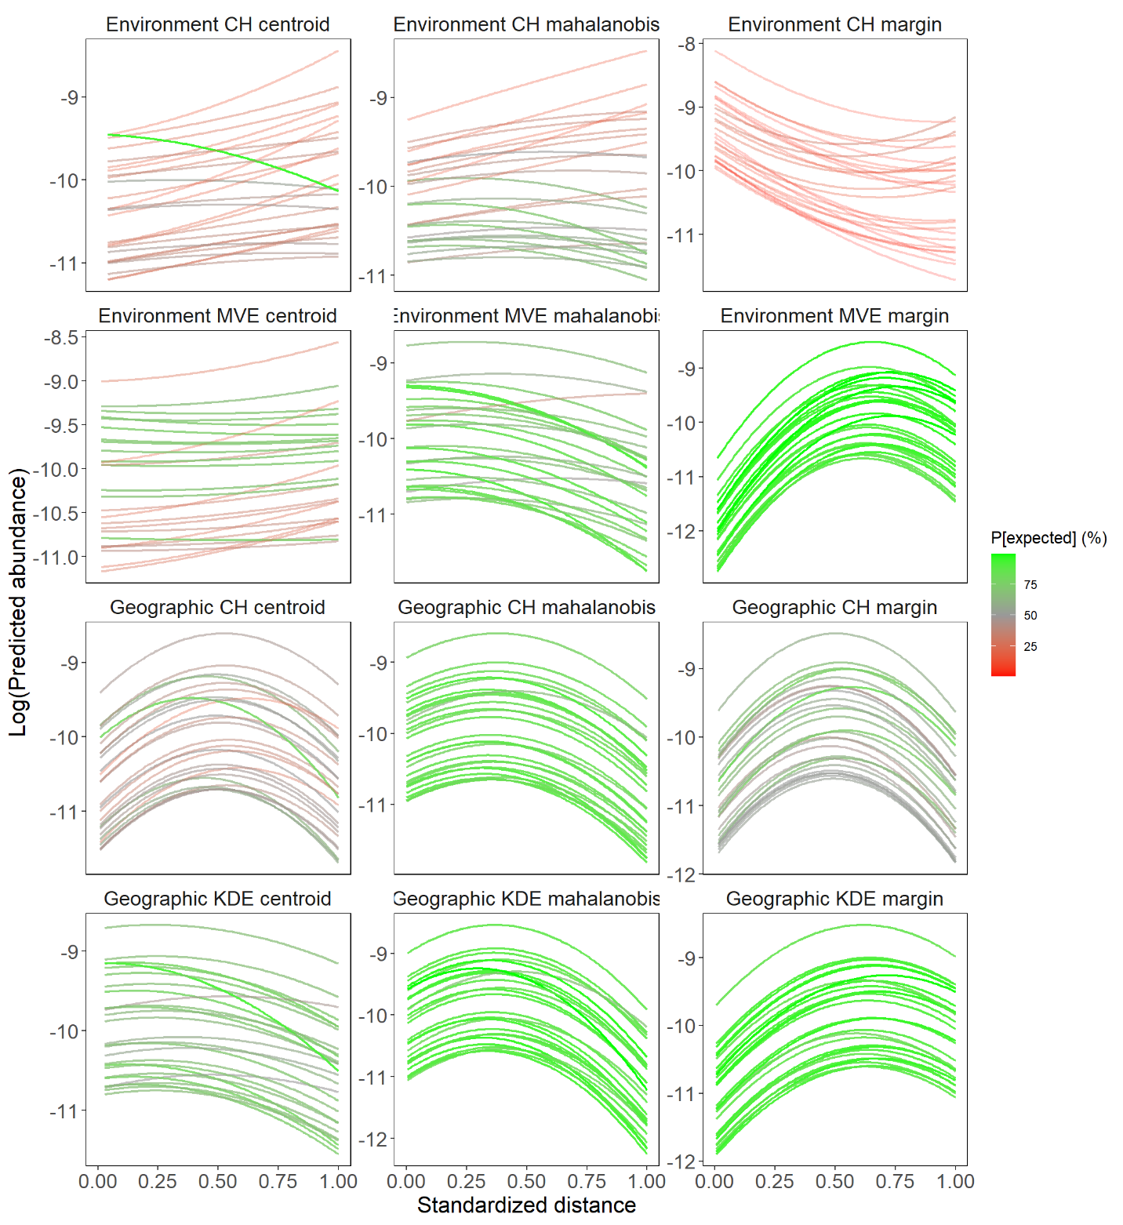

Figure S5. Species-specific distance-abundance relationships for the mammal dataset.
Species-specific distance-abundance relationships estimated from Bayesian non-linear mixed-effect models fitted to the mammal dataset under the 12 different settings. The color scale highlights the posterior probability for the expected relationship with green values representing high probabilities for expected relationships and red values representing high probabilities for unexpected relationships.
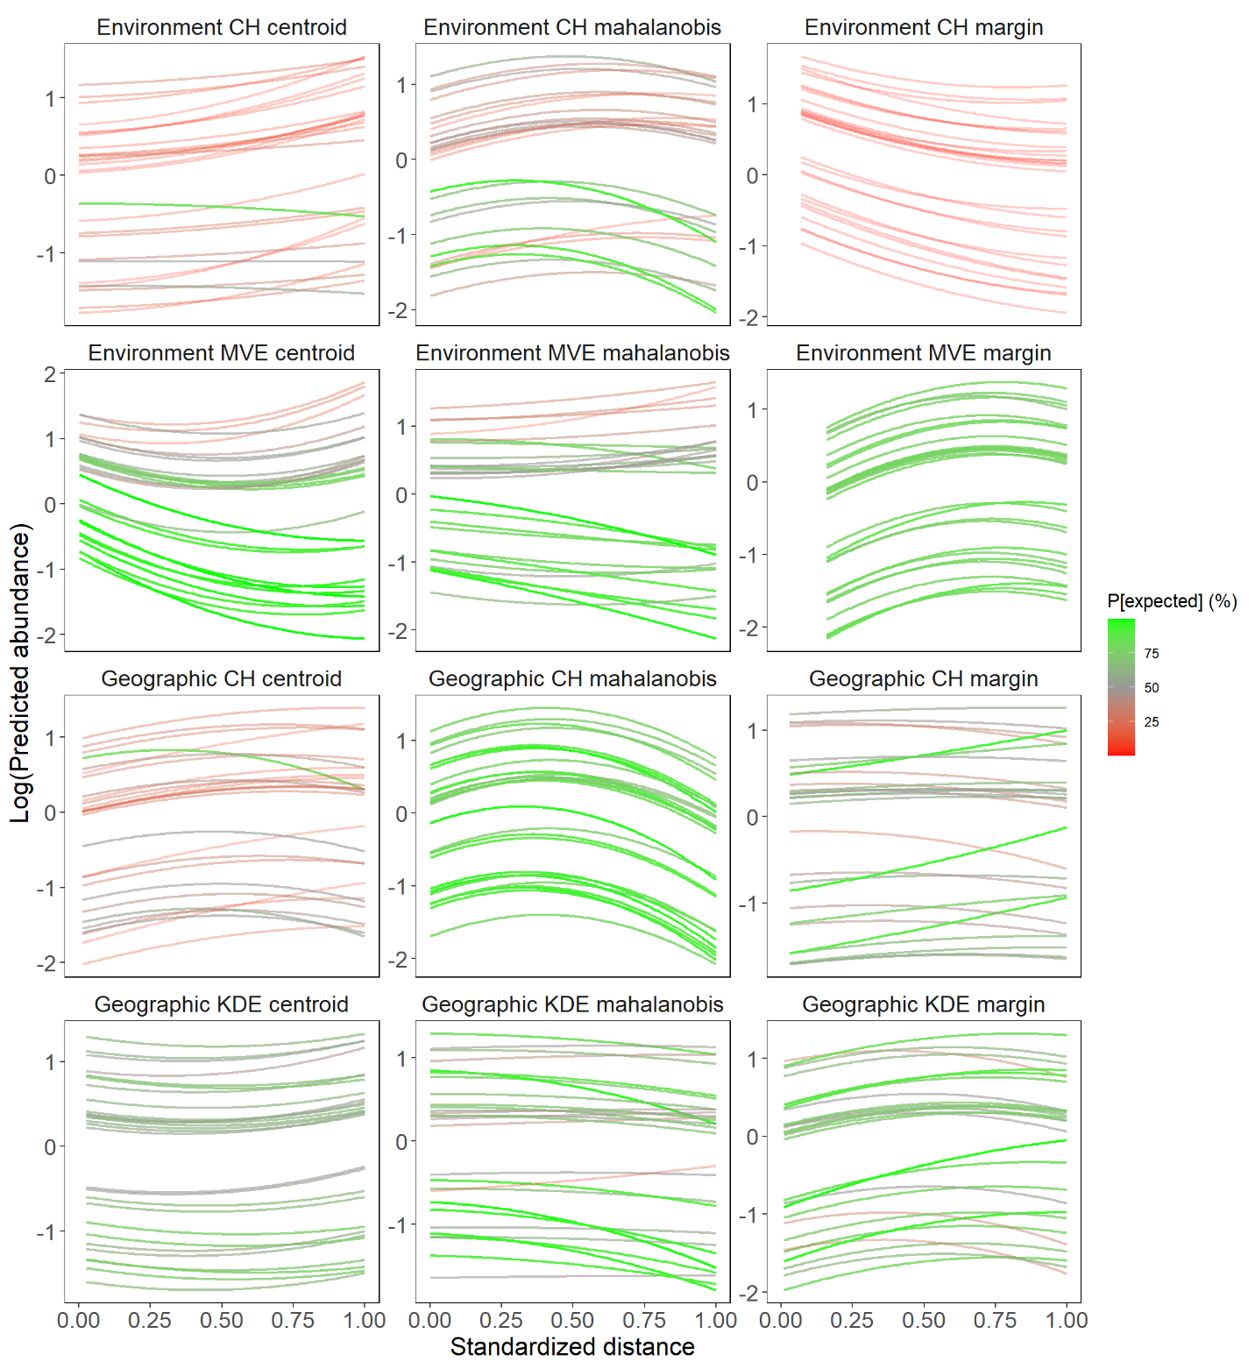

Figure S6. Species-specific distance-abundance relationships for the fish dataset.
Species-specific distance-abundance relationships as estimated from Bayesian non-linear models fitted to the fish dataset under the 12 different settings. For further details see Fig. S1.
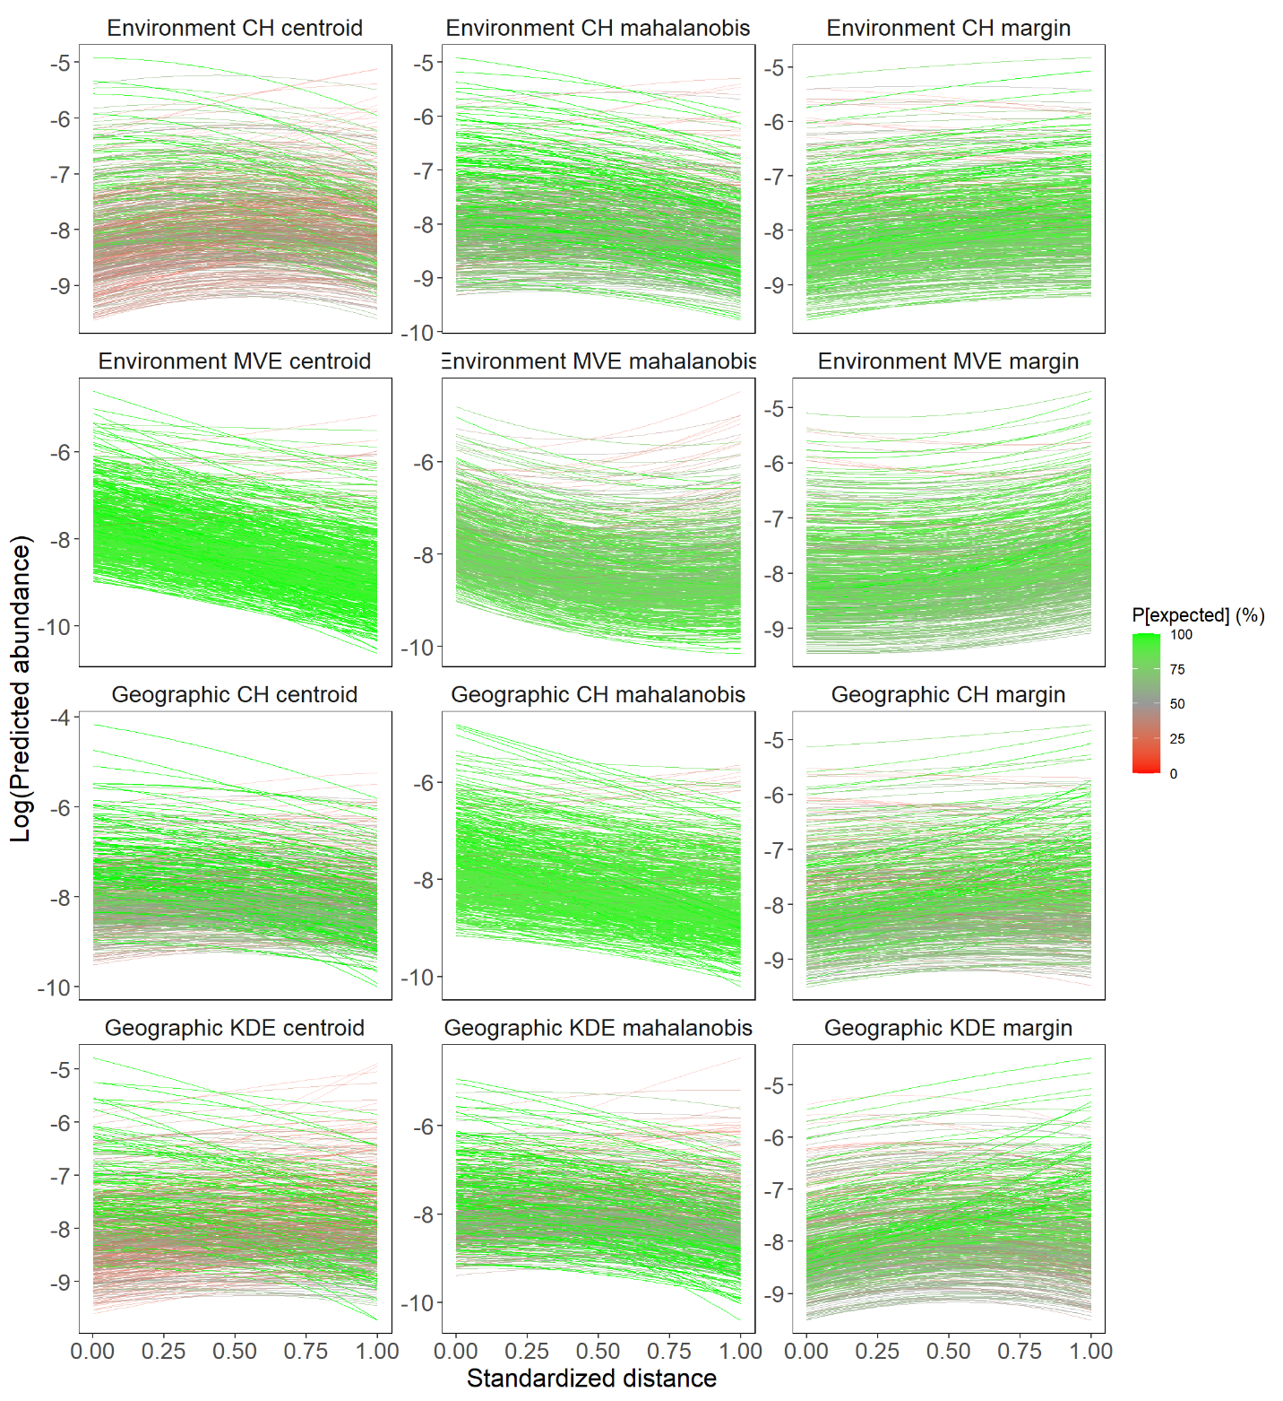

Figure S7. Species-specific distance-abundance relationships for the eBird dataset.
Species-specific distance-abundance relationships as estimated from Bayesian non-linear models fitted to the bird dataset under the 12 different settings. For further details see Fig. S1.

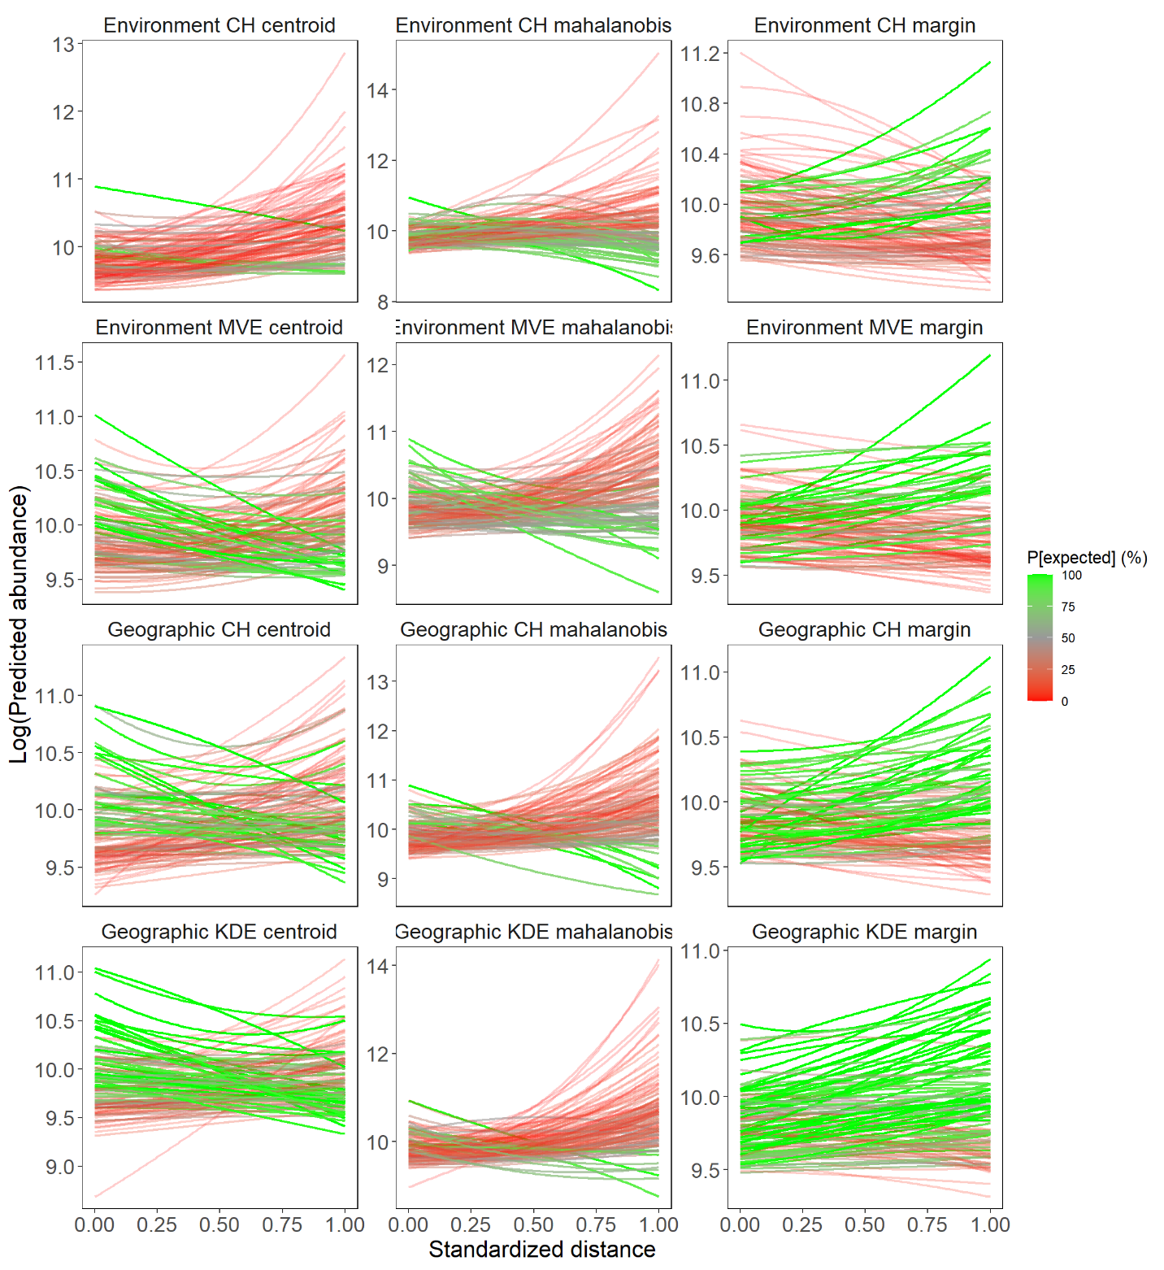

Figure S8. Species-specific distance-abundance relationships for the tree dataset.
Species-specific distance-abundance relationships as estimated from Bayesian non-linear models fitted to the tree dataset under the 12 different settings. For further details see Fig. S1.

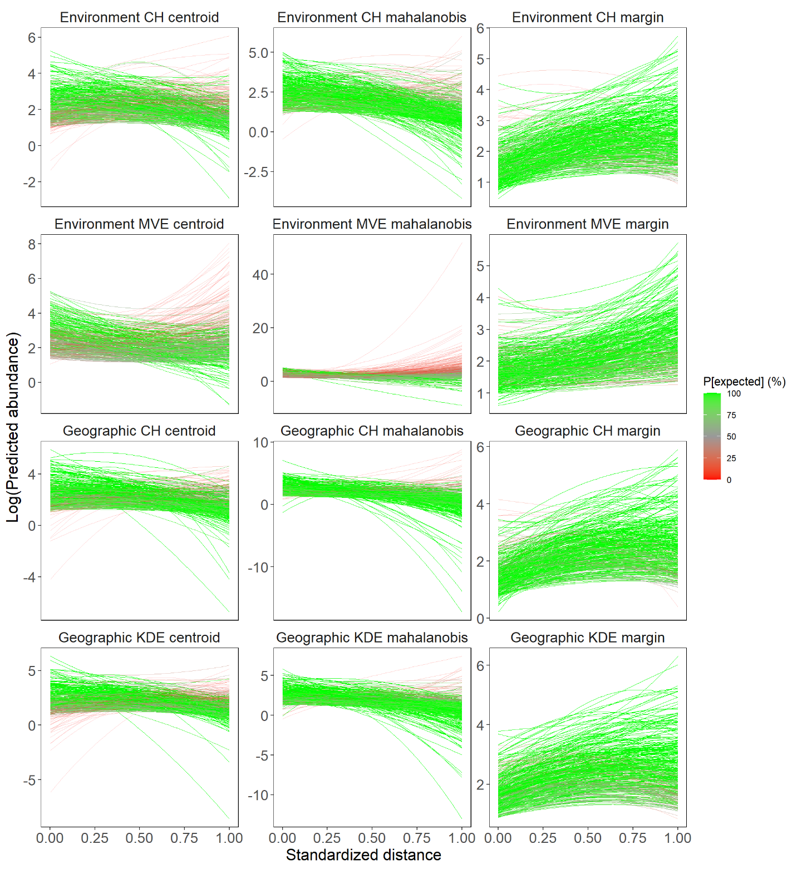

Figure S9. Species-specific distance-abundance relationships for the BBS dataset.
Species-specific distance-abundance relationships as estimated from Bayesian non-linear models fitted to the BBS dataset under the 12 different settings. For further details see Fig. S1.

Figure S10. Barplots showing the proportion of species presenting expected and unexpected relationships when the tree dataset is removed.
For further details see Fig. 5 in the main document. Note that panels A and B are the same as in Fig. 5 with the exception that the tree dataset is not represented.

Figure S11. Barplots showing the proportion of species presenting expected and unexpected relationships when migratory species are removed from the two bird datasets.
For further details see Fig. 5 in the main document.

Table S1. Outputs from Bayesian mixed-effect models
Posterior outputs from Bayesian models fitted to each group of species under 12 different settings differing with respect to the space in which the distance-abundance relationship is evaluated (geographic or environment), how distances are measured (to the center using Euclidean or Mahalanobis distance metrics or to the margins) and how envelopes are delineated (CH or KDE in the geographical space; CH or MVE in the environmental space). For each model and taxonomic group, we report the Bayesian p-value (model fit), the marginal R² (i.e. the proportion of variance explained by fixed effect), the conditional R² (i.e. the proportion of variance explained by both fixed and random effects), the posterior median of slope coefficients (µ_{β}) and quadratic terms (µ_{γ}) and their associated 95% highest posterior density interval, the posterior probability that µ_{β} and µ_{γ} are different from zero (denoted P[µ_{β} ≠ 0] and P[µ_{γ} ≠ 0], respectively) and the posterior probability for the expected relationship (P[expected]; see the text for details on how this is computed).

Group | Space | Envelope | Distance | Bayesian p-value | Marginal R2 | Conditional R2 | Distance effect (µ_{β}) | P[µ_{β} ≠ 0] | Quadratic effect (µ_{γ}) | P[µ_{γ} ≠ 0] | P[expected]
Mammals | Geographic | CH | Center | 0.49 | 3.7E-03 | 0.26 | 1.62[-0.93;4.14] | 94.0 | -1.6[-4;0.31] | 96.4 | 45.2
 |  |  | Margin | 0.50 | 1.1E-02 | 0.22 | 2.36[0.69;4.33] | 100.0 | -2.35[-4.03;-0.75] | 100.0 | 60.2
 |  |  | Mahalanobis | 0.49 | 4.8E-03 | 0.19 | 0.85[-0.66;2.11] | 89.8 | -1.21[-2.53;0.22] | 95.6 | 88.7
 |  | KDE | Center | 0.50 | 2.9E-03 | 0.26 | 0.22[-2.16;2.61] | 57.0 | -0.52[-2.62;1.31] | 67.7 | 72.5
 |  |  | Margin | 0.51 | 7.6E-03 | 0.21 | 2[0.34;3.63] | 99.4 | -1.57[-3;0.01] | 97.1 | 96.3
 |  |  | Mahalanobis | 0.49 | 1.1E-02 | 0.23 | 1.28[-0.28;2.68] | 92.1 | -1.79[-3.12;-0.11] | 98.0 | 95.0
 | Environment | CH | Center | 0.51 | 1.3E-03 | 0.26 | 0.21[-2.9;3.84] | 55.4 | 0.04[-2.96;2.42] | 51.2 | 29.0
 |  |  | Margin | 0.50 | 9.4E-03 | 0.22 | -1.24[-3.24;0.63] | 86.8 | 0.68[-1.19;2.25] | 76.5 | 3.1
 |  |  | Mahalanobis | 0.48 | 2.0E-04 | 0.20 | 0.24[-1.66;1.72] | 58.7 | -0.16[-1.61;1.66] | 56.9 | 43.3
 |  | MVE | Center | 0.48 | 3.0E-04 | 0.25 | 0.02[-1.58;1.65] | 50.7 | 0.1[-1.45;1.63] | 54.2 | 32.2
 |  |  | Margin | 0.50 | 7.8E-03 | 0.24 | 3.5[1.22;5.62] | 100.0 | -2.61[-4.12;-0.77] | 100.0 | 97.2
 |  |  | Mahalanobis | 0.49 | 1.5E-03 | 0.24 | 0.12[-1.75;1.72] | 54.7 | -0.42[-2.27;1.6] | 66.9 | 80.7
eBird | Geographic | CH | Center | 0.50 | 3.0E-04 | 0.47 | 0.15[-0.09;0.44] | 89.5 | -0.28[-0.6;-0.07] | 99.3 | 98.3
 |  |  | Margin | 0.51 | 4.0E-04 | 0.32 | 0.29[0.11;0.5] | 99.8 | -0.17[-0.36;0.02] | 96.0 | 99.7
 |  |  | Mahalanobis | 0.51 | 1.2E-03 | 0.46 | -0.39[-0.69;-0.08] | 98.6 | 0.03[-0.52;0.28] | 55.3 | 100.0
 |  | KDE | Center | 0.51 | 1.0E-04 | 0.48 | 0.22[-0.06;0.63] | 94.1 | -0.17[-0.58;0.09] | 90.3 | 19.2
 |  |  | Margin | 0.50 | 1.0E-03 | 0.30 | 0.59[0.42;0.75] | 100.0 | -0.47[-0.66;-0.3] | 100.0 | 99.3
 |  |  | Mahalanobis | 0.52 | 2.0E-04 | 0.49 | 0.14[-0.15;0.38] | 82.7 | -0.3[-0.57;0.06] | 94.7 | 94.3
 | Environment | CH | Center | 0.50 | 5.0E-04 | 0.38 | 0.55[0.3;0.82] | 100.0 | -0.49[-0.76;-0.23] | 100.0 | 17.5
 |  |  | Margin | 0.50 | 4.0E-04 | 0.34 | 0.29[0.07;0.5] | 99.5 | -0.13[-0.29;0.06] | 88.9 | 100.0
 |  |  | Mahalanobis | 0.52 | 1.0E-04 | 0.41 | 0.12[-0.09;0.38] | 89.1 | -0.28[-0.58;0] | 99.3 | 99.3
 |  | MVE | Center | 0.50 | 1.8E-03 | 0.47 | -0.58[-0.9;-0.33] | 100.0 | 0.02[-0.27;0.46] | 54.7 | 100.0
 |  |  | Margin | 0.50 | 1.3E-03 | 0.31 | -0.11[-0.36;0.09] | 84.0 | 0.32[0.15;0.52] | 100.0 | 99.0
 |  |  | Mahalanobis | 0.51 | 1.7E-03 | 0.45 | -1.05[-1.32;-0.75] | 100.0 | 0.71[0.27;1.1] | 100.0 | 99.6
Fish | Geographic | CH | Center | 0.50 | 4.0E-04 | 0.62 | 0.45[-0.48;1.57] | 83.2 | -0.33[-1.27;0.5] | 78.9 | 24.8
 |  |  | Margin | 0.50 | 1.0E-04 | 0.65 | 0.14[-0.91;1.3] | 59.4 | -0.09[-1.18;0.73] | 57.8 | 60.2
 |  |  | Mahalanobis | 0.51 | 6.3E-03 | 0.58 | 0.75[-0.06;1.43] | 96.2 | -0.99[-1.69;-0.21] | 99.3 | 93.2
 |  | KDE | Center | 0.51 | 5.0E-04 | 0.60 | -0.25[-1.17;0.66] | 69.6 | 0.3[-0.44;1.02] | 76.0 | 63.0
 |  |  | Margin | 0.50 | 5.0E-04 | 0.64 | 0.49[-0.54;1.44] | 83.2 | -0.38[-1.3;0.38] | 79.6 | 77.6
 |  |  | Mahalanobis | 0.50 | 5.0E-04 | 0.60 | 0.01[-0.79;0.74] | 51.2 | -0.11[-0.81;0.67] | 64.0 | 74.0
 | Environment | CH | Center | 0.50 | 2.3E-03 | 0.61 | 0.08[-0.85;0.99] | 55.6 | 0.16[-0.7;1.1] | 63.3 | 6.8
 |  |  | Margin | 0.49 | 3.4E-03 | 0.56 | -0.78[-2.1;0.34] | 89.3 | 0.35[-0.52;1.37] | 76.4 | 0.5
 |  |  | Mahalanobis | 0.51 | 1.3E-03 | 0.59 | 0.56[-0.06;1.25] | 94.2 | -0.54[-1.24;0.23] | 91.5 | 43.8
 |  | MVE | Center | 0.50 | 2.3E-03 | 0.59 | -0.84[-1.74;0.02] | 97.0 | 0.68[-0.14;1.5] | 94.1 | 82.5
 |  |  | Margin | 0.51 | 3.0E-04 | 0.64 | 1.31[-0.94;2.93] | 77.3 | -0.88[-1.93;0.69] | 75.8 | 79.5
 |  |  | Mahalanobis | 0.51 | 2.0E-04 | 0.59 | -0.13[-0.87;0.63] | 63.2 | 0.09[-0.72;0.94] | 58.1 | 71.8
Trees | Geographic | CH | Center | 0.52 | 4.0E-04 | 0.56 | 0.01[-0.13;0.16] | 57.9 | 0.09[-0.05;0.24] | 89.5 | 7.4
 |  |  | Margin | 0.49 | 0.0E+00 | 0.41 | -0.05[-0.16;0.06] | 81.3 | 0.06[-0.03;0.15] | 89.3 | 47.3
 |  |  | Mahalanobis | 0.50 | 5.0E-04 | 0.76 | -0.05[-0.26;0.18] | 67.5 | 0.39[-0.05;0.76] | 96.6 | 9.1
 |  | KDE | Center | 0.48 | 1.0E-04 | 0.51 | -0.05[-0.19;0.08] | 77.1 | 0.09[-0.03;0.22] | 91.5 | 36.9
 |  |  | Margin | 0.52 | 4.0E-04 | 0.27 | 0.07[-0.02;0.15] | 93.6 | -0.01[-0.09;0.07] | 55.2 | 93.8
 |  |  | Mahalanobis | 0.49 | 1.3E-03 | 0.76 | -0.21[-0.43;0] | 96.9 | 0.62[0.23;0.96] | 99.9 | 1.7
 | Environment | CH | Center | 0.48 | 2.9E-03 | 0.59 | 0.01[-0.14;0.15] | 54.6 | 0.28[0.1;0.47] | 99.8 | 0.3
 |  |  | Margin | 0.50 | 3.0E-04 | 0.40 | -0.13[-0.24;-0.02] | 99.2 | 0.07[-0.03;0.17] | 91.6 | 10.3
 |  |  | Mahalanobis | 0.49 | 9.0E-04 | 0.77 | 0.29[0.06;0.49] | 99.5 | -0.06[-0.42;0.32] | 62.1 | 11.6
 |  | MVE | Center | 0.50 | 1.0E-04 | 0.42 | -0.17[-0.28;-0.06] | 100.0 | 0.24[0.09;0.39] | 99.9 | 13.9
 |  |  | Margin | 0.48 | 0.0E+00 | 0.30 | -0.06[-0.18;0.06] | 83.4 | 0.03[-0.05;0.12] | 76.6 | 16.1
 |  |  | Mahalanobis | 0.50 | 1.0E-04 | 0.71 | -0.12[-0.33;0.07] | 90.0 | 0.33[-0.03;0.69] | 96.2 | 12.7
BBSbirds | Geographic | CH | Center | 0.50 | 8.0E-04 | 0.92 | 0.27[-0.09;0.62] | 92.9 | -0.66[-0.99;-0.34] | 100.0 | 97.5
 |  |  | Margin | 0.50 | 2.2E-03 | 0.85 | 1.24[1;1.48] | 100.0 | -0.78[-0.99;-0.57] | 100.0 | 100.0
 |  |  | Mahalanobis | 0.49 | 1.9E-03 | 0.94 | -0.44[-0.83;-0.07] | 98.6 | -0.58[-1.1;-0.11] | 99.0 | 100.0
 |  | KDE | Center | 0.49² | 4.0E-04 | 0.95 | 0.66[0.24;1.06] | 99.9 | -0.93[-1.3;-0.64] | 100.0 | 88.1
 |  |  | Margin | 0.50 | 4.6E-03 | 0.71 | 1.15[1;1.31] | 100.0 | -0.79[-0.95;-0.64] | 100.0 | 100.0
 |  |  | Mahalanobis | 0.47 | 2.2E-03 | 0.94 | -0.24[-0.63;0.15] | 89.3 | -0.69[-1.17;-0.24] | 99.8 | 99.9
 | Environment | CH | Center | 0.49 | 5.0E-04 | 0.90 | 0.61[0.31;0.94] | 100.0 | -0.76[-1.05;-0.5] | 100.0 | 81.6
 |  |  | Margin | 0.49 | 2.5E-03 | 0.78 | 1.05[0.84;1.25] | 100.0 | -0.59[-0.78;-0.41] | 100.0 | 100.0
 |  |  | Mahalanobis | 0.49 | 1.3E-03 | 0.92 | -0.15[-0.47;0.21] | 79.9 | -0.5[-0.89;-0.17] | 99.7 | 100.0
 |  | MVE | Center | 0.49 | 8.0E-04 | 0.84 | -0.95[-1.19;-0.69] | 100.0 | 0.89[0.55;1.22] | 100.0 | 63.7
 |  |  | Margin | 0.49 | 4.2E-03 | 0.69 | 0.21[0.02;0.4] | 98.2 | 0.26[0.11;0.41] | 100.0 | 100.0
 |  |  | Mahalanobis | 0.49 | 9.0E-04 | 0.93 | -1.72[-2.05;-1.32] | 100.00 | 2.21[1.41;2.93] | 100.0 | 10.4

Table S2. Outputs from Bayesian mixed-effect models for the two bird datasets with migratory species excluded
For further details see Table S1.

Group | Space | Envelope | Distance | Bayesian p-value | Marginal R2 | Conditional R2 | Distance effect (µ_{β}) | P[µ_{β} ≠ 0] | Quadratic effect (µ_{γ}) | P[µ_{γ} ≠ 0] | P[expected]
eBird | Geographic | CH | Center | 0.50 | 1.00E-04 | 0.25 | -0.06[-0.11;-0.01] | 99.40 | 0.01[-0.02;0.04] | 74.67 | 98.33
 |  |  | Margin | 0.51 | 0 | 0.24 | 0.06[0.03;0.09] | 100.00 | -0.02[-0.04;0] | 94.53 | 98.77
 |  |  | Mahalanobis | 0.50 | 3.00E-04 | 0.25 | -0.16[-0.21;-0.1] | 100.00 | 0.02[0;0.04] | 95.40 | 100.00
 |  | KDE | Center | 0.50 | 0 | 0.24 | -0.02[-0.07;0.02] | 83.47 | 0.01[-0.02;0.04] | 77.20 | 74.63
 |  |  | Margin | 0.49 | 1.00E-04 | 0.24 | 0.07[0.04;0.1] | 100.00 | -0.02[-0.03;0] | 93.67 | 99.97
 |  |  | Mahalanobis | 0.50 | 2.00E-04 | 0.24 | -0.11[-0.17;-0.05] | 99.97 | 0.03[0;0.05] | 98.40 | 99.87
 | Environment | CH | Center | 0.49 | 0 | 0.24 | 0.05[0.01;0.1] | 98.37 | -0.03[-0.07;0] | 97.03 | 72.97
 |  |  | Margin | 0.49 | 0 | 0.24 | 0.04[0.01;0.06] | 99.77 | -0.03[-0.05;-0.01] | 99.23 | 75.30
 |  |  | Mahalanobis | 0.50 | 0 | 0.23 | -0.01[-0.06;0.03] | 72.67 | -0.01[-0.03;0.01] | 77.40 | 99.47
 |  | MVE | Center | 0.50 | 1.00E-04 | 0.24 | -0.12[-0.16;-0.09] | 100.00 | 0.02[0;0.03] | 99.40 | 100.00
 |  |  | Margin | 0.49 | 1.00E-04 | 0.24 | 0.07[0.05;0.1] | 100.00 | 0[-0.02;0.01] | 54.20 | 100.00
 |  |  | Mahalanobis | 0.51 | 1.00E-04 | 0.23 | -0.14[-0.17;-0.1] | 100.00 | 0.01[0.01;0.02] | 100.00 | 100.00
BBSbirds | Geographic | CH | Center | 0.49 | 3.00E-04 | 0.37 | -0.08[-0.13;-0.03] | 99.83 | -0.01[-0.04;0.01] | 81.93 | 99.90
 |  |  | Margin | 0.50 | 1.00E-04 | 0.35 | 0.09[0.06;0.12] | 100.00 | -0.04[-0.06;-0.02] | 100.00 | 99.87
 |  |  | Mahalanobis | 0.50 | 7.00E-04 | 0.42 | -0.15[-0.23;-0.09] | 100.00 | -0.01[-0.04;0.02] | 76.87 | 100.00
 |  | KDE | Center | 0.50 | 3.00E-04 | 0.37 | -0.07[-0.12;-0.03] | 99.87 | -0.01[-0.03;0.01] | 81.67 | 99.97
 |  |  | Margin | 0.50 | 3.00E-04 | 0.34 | 0.13[0.1;0.16] | 100.00 | -0.06[-0.07;-0.04] | 100.00 | 100.00
 |  |  | Mahalanobis | 0.50 | 0.0012 | 0.45 | -0.19[-0.26;-0.12] | 100.00 | 0.01[-0.03;0.05] | 65.40 | 100.00
 | Environment | CH | Center | 0.51 | 2.00E-04 | 0.37 | -0.01[-0.06;0.04] | 64.63 | -0.05[-0.08;-0.02] | 99.93 | 100.00
 |  |  | Margin | 0.49 | 2.00E-04 | 0.35 | 0.1[0.07;0.13] | 100.00 | -0.03[-0.05;-0.02] | 100.00 | 99.90
 |  |  | Mahalanobis | 0.50 | 3.00E-04 | 0.41 | -0.08[-0.14;-0.03] | 99.70 | -0.02[-0.05;0.01] | 93.27 | 99.97
 |  | MVE | Center | 0.49 | 1.00E-04 | 0.35 | -0.07[-0.11;-0.04] | 100.00 | 0.03[0.01;0.05] | 99.90 | 98.37
 |  |  | Margin | 0.50 | 6.00E-04 | 0.33 | 0.12[0.09;0.15] | 100.00 | 0.01[-0.01;0.02] | 82.43 | 100.00
 |  |  | Mahalanobis | 0.49 | 3.00E-04 | 0.39 | -0.16[-0.2;-0.11] | 100.00 | 0.03[0.02;0.05] | 100.00 | 100.00

Supplementary references
Gelman, A. (2006) Prior distributions for variance parameters in hierarchical models. Bayesian Analysis, 1, 515–534.
Gelman, A., Carlin, J.B., Stern, H.S., Dunson, D.B., Vehtari, A. & Rubin, D.B. (2013) Bayesian data analysis, Chapman and Hall/CRC.
Gelman, A. & Rubin, D. (1992) Inference from iterative simulation using multiple sequences. Statistical science, 7, 457–511.
Harrison, X.A., Donaldson, L., Correa-Cano, M.E., Evans, J., Fisher, D.N., Goodwin, C.E.D., Robinson, B.S., Hodgson, D.J. & Inger, R. (2018) A brief introduction to mixed effects modelling and multi-model inference in ecology. PeerJ, 2018, 1–32.
Kruschke, J. (2014) Doing Bayesian data analysis: A tutorial with R, JAGS, and Stan, Academic Press.
Plummer, M. (2003) JAGS: A program for analysis of Bayesian graphical models using Gibbs sampling. Proceedings of the 3rd International Workshop on Distributed Statistical Computing (DSC 2003) (ed. by K. Hornik), F. Leisch), and A. Zeileis), Vienna, Austria.
R Core Team (2019) R: A Language and Environment for Statistical Computing.
Su, Y.-S. & Yajima, M. (2013) R2jags: A Package for Running jags from R.

