

*Geophysical Research Letters*

Supporting Information for

**Decomposing the Oxygen Signal in the Ocean Interior: Beyond Decomposing Organic Matter**

Nicolas Cassar1,2, David Nicholson3, Samar Khatiwala4, Ellen Cliff4

1 Division of Earth and Climate Sciences, Nicholas School of the Environment, Duke University, Durham, NC 27708, USA

2 CNRS, Université de Brest, IRD, Ifremer, LEMAR, F-29280 Plouzané, France

3 Department of Marine Chemistry and Geochemistry, Woods Hole Oceanographic Institution, Woods Hole, Massachusetts, USA  
4Department of Earth Sciences, University of Oxford, Oxford, UK.

**Contents of this file**

Text S1 to S2

Figures S1 to S6

Text S1.

**Description of model**

The biogeochemical model used in Cliff et al. (2021) is the Model of Ocean Biogeochemistry and Isotopes (MOBI) (Khatiwala et al., 2019; Muglia et al., 2018) coupled to the Transport Matrix Method (TMM) (Khatiwala, 2007; Khatiwala et al., 2005), a computationally efficient scheme for “offline” tracer simulations. MOBI-TMM was driven by physical forcing fields (winds, circulation, temperature, salinity and sea ice) from a preindustrial configuration of the University of Victoria Earth System Climate Model (UVic ESCM v2.9) (Weaver et al., 2001), a 3-D ocean general circulation model of resolution 1.8º x 3.6º x 19 layers that is coupled to atmospheric energy-moisture balance, dynamic-thermodynamic sea ice and land surface components. The model was tuned to a variety of ocean chemical and biogeochemical tracer observations (Muglia & Schmittner, 2015; Muglia et al., 2018). In order to explicitly calculate ${\left[O_{2}\right]}_{Rem}$ (i.e., -TOU) preformed PO4 was simulated (Ito et al., 2004) by propagating the seasonally-varying surface ocean phosphate field into the interior using the TMM. Disequilibrium O2 was diagnosed by simulating preformed O2 and “O2,eq” by similarly propagating the seasonally-varying surface ocean oxygen and equilibrium O2 fields, respectively, into the interior. Lastly, to decompose disequilibrium O2 into physical and biological components, a parallel simulation was carried out with identical physical forcings but with the source/sink terms in the biogeochemical model switched off. To apply the proposed O2/Ar method, we simulated Ar with the TMM as in our previous work (Nicholson et al., 2016) using the same physical forcing fields and gas transfer parameterization as for O2. The Ar saturation concentration was calculated according to Jenkins et al. (2019).

Text S2.

**Derivation of $∆\left({O_{2}}/{Ar}\right)$-estimates of ${\left[O_{2}\right]}_{bio}$**

From main text Equations (1) and (5):

$\left[O_{2}\right]={{(\left[O_{2}\right]}_{sat}+\left[O_{2}\right]}_{phy}+{\left[O_{2}\right]}_{bio})$ (1)

$\frac{{{(\left[O_{2}\right]}_{sat}+\left[O_{2}\right]}_{phy})}{{\left[O_{2}\right]}_{sat}}≈ \frac{{{(\left[Ar\right]}_{sat}+\left[Ar\right]}_{phy})}{{\left[Ar\right]}_{sat}}=\frac{\left[Ar\right]}{{\left[Ar\right]}_{sat}}$ (5)

Replacing ${{(\left[O_{2}\right]}_{sat}+\left[O_{2}\right]}_{phy})$ in Equation (1) with $\left(\frac{\left[Ar\right]}{{\left[Ar\right]}_{sat}}{\left[O_{2}\right]}_{sat}\right)$ from Equation (5) and isolating ${\left[O_{2}\right]}_{bio}$:

$${\left[O_{2}\right]}_{bio} \left[O_{2}\right]-\frac{\left[Ar\right]}{{\left[Ar\right]}_{sat}}{\left[O_{2}\right]}_{sat}$$

Factoring out ${\left[O_{2}\right]}_{sat}$ and $\frac{\left[Ar\right]}{{\left[Ar\right]}_{sat}}$ on right-hand side of equation:

$${\left[O_{2}\right]}_{bio} {\frac{\left[Ar\right]}{{\left[Ar\right]}_{sat}}\left[O_{2}\right]}_{sat}\left(\frac{{\left[Ar\right]}_{sat}\left[O_{2}\right]}{\left[Ar\right]{\left[O_{2}\right]}_{sat}}-1\right)$$

Or,

$${\left[O_{2}\right]}_{bio} {\frac{\left[Ar\right]}{{\left[Ar\right]}_{sat}}\left[O_{2}\right]}_{sat}\left[\frac{\frac{\left[O_{2}\right]}{\left[Ar\right]}}{\frac{{\left[O_{2}\right]}_{sat}}{{\left[Ar\right]}_{sat}}}-1\right]= {\frac{\left[Ar\right]}{{\left[Ar\right]}_{sat}}\left[O_{2}\right]}_{sat}∆\left({O_{2}}/{Ar}\right)$$

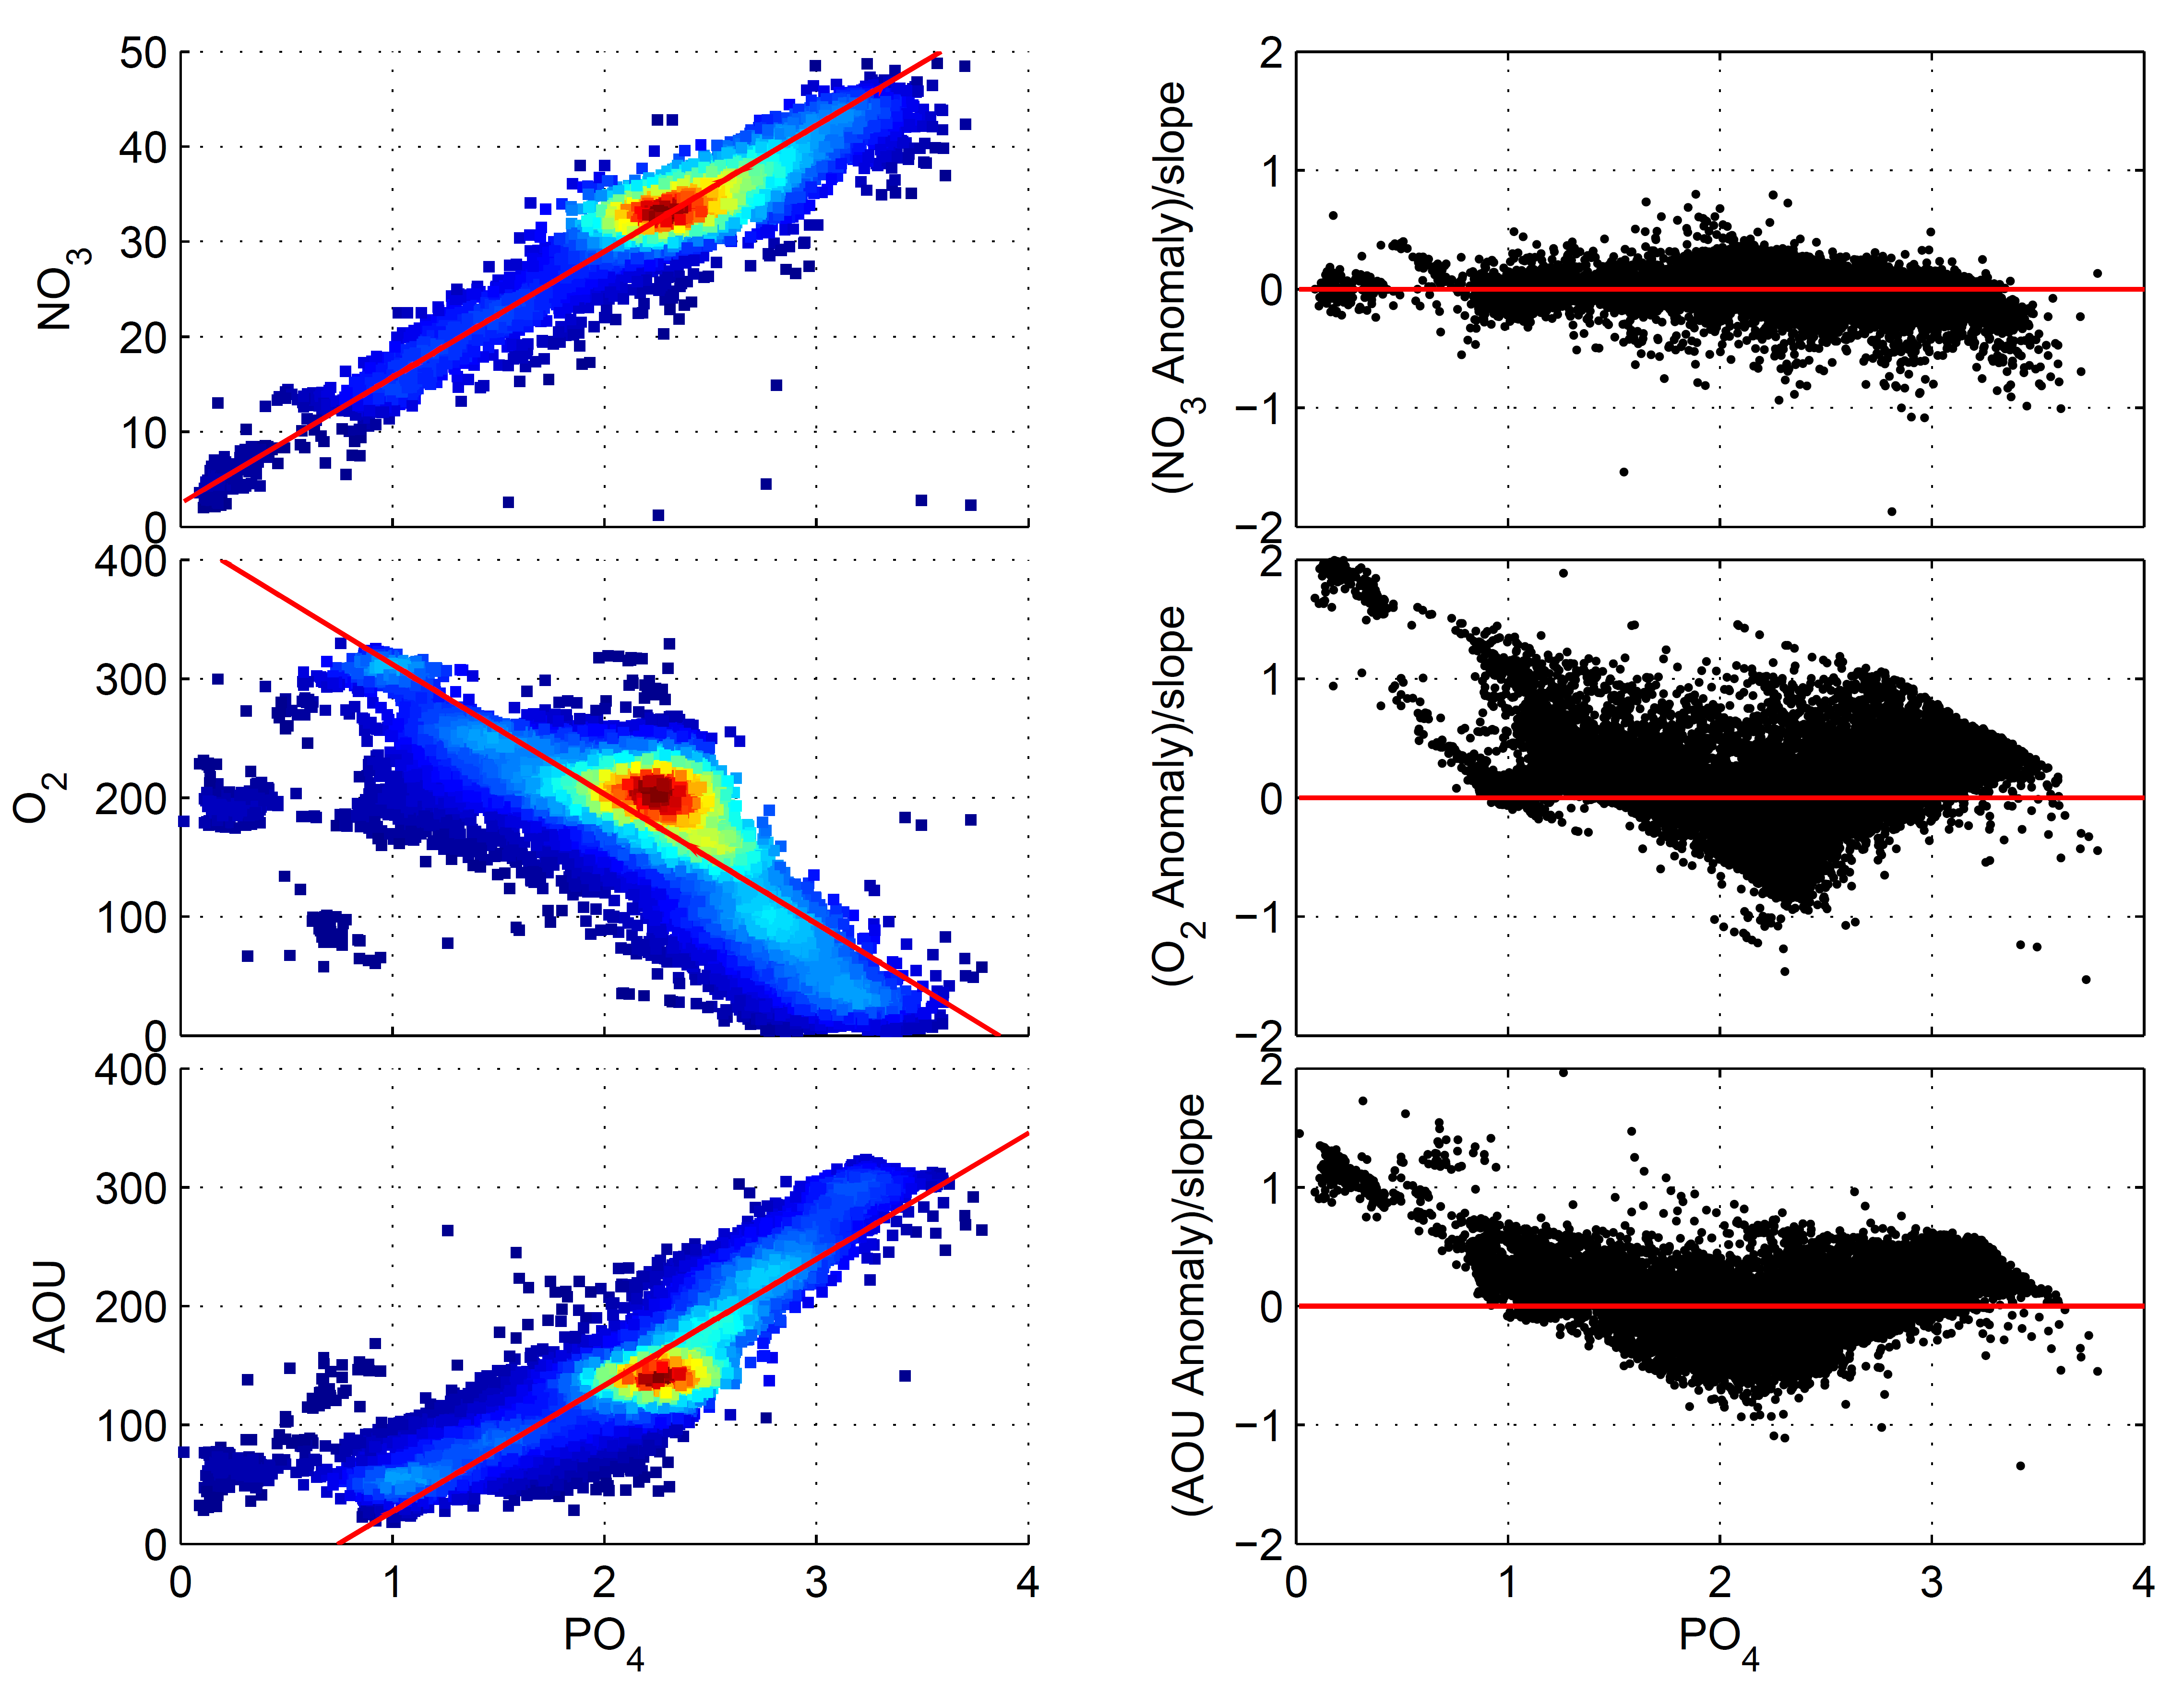

**Figure S1.** Left panels: Relation of nitrate, dissolved oxygen, and AOU to phosphate in the ocean interior (> 600 meters). Red lines represent robust bisquare regressions. Points are color-coded for data density. Right panels: Residuals around the regressions, all in phosphate-equivalent units for comparison purposes by dividing by the respective slopes. All values in M. 5o-resolution data from World Ocean Atlas 2009 (Garcia et al., 2010).

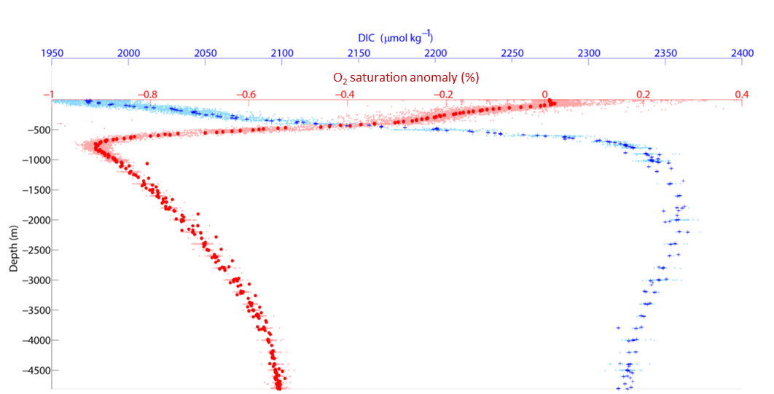

**Figure S2.** Depth-profiles of DIC and O2 saturation anomaly (%) ($100(\frac{\left[O_{2}\right]}{{\left[O_{2}\right]}_{sat}}-1)$ or $100(-\frac{AOU}{{\left[O_{2}\right]}_{sat}}))$ at Station ALOHA (HOT Time-series, data from 1988-2007).



**Figure S3.** Comparison of O2 and Ar gas exchange and solubility properties. Isopleths of constant ratios of (A) gas exchange velocities, (B) Bunsen solubility coefficients. Gas exchange velocities are based on Wanninkhof (1992). O2 and Ar solubilities are based on Garcia and Gordon (1992), and Hamme and Emerson (2004), respectively.

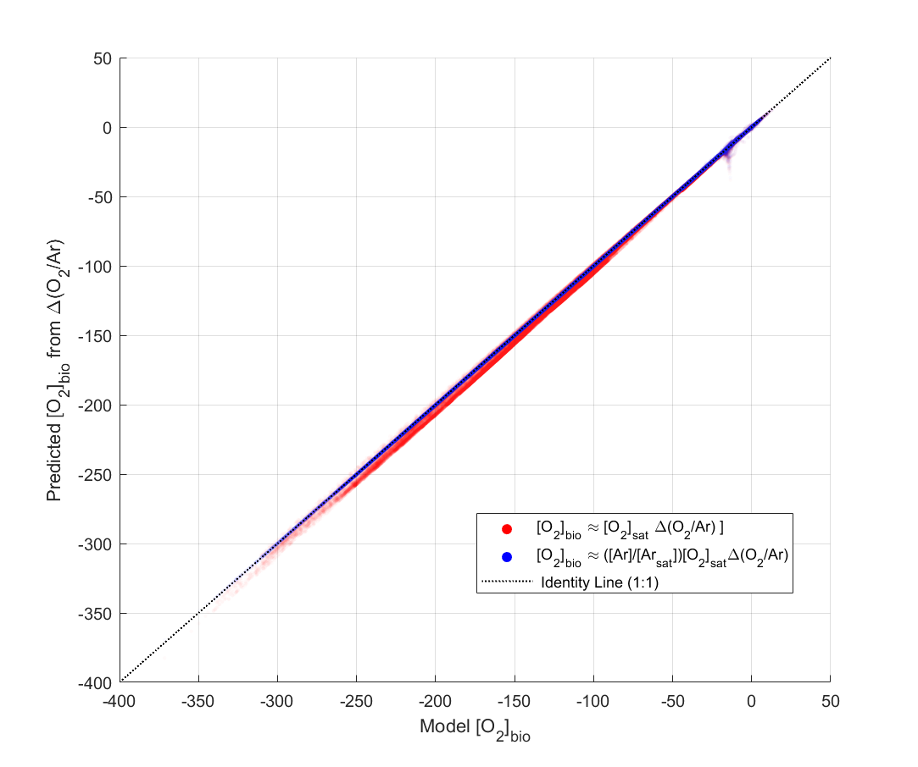

**Figure S4.** Predicted ${\left[O_{2}\right]}_{bio}$ based on $∆\left({O_{2}}/{Ar}\right)$ vs. model ${\left[O_{2}\right]}_{bio}$. Assuming that Ar is at saturation when estimating ${\left[O_{2}\right]}_{bio}$ (red markers) introduces a small error compared to the more exact $∆\left({O_{2}}/{Ar}\right)$ estimates of ${\left[O_{2}\right]}_{bio}$ (blue markers). Concentrations are in mmol m-3.



**Figure S5.** Modeled ocean inventories of O2 components, as defined in the main text.



**Figure S6.** Cumulative frequency of the difference in performance of modeled O2/Ar-derived ${\left[O_{2}\right]}_{bio}$ and $AOU$ in predicting TOU.

**References**

Cliff, E., Khatiwala, S., & Schmittner, A. (2021). Glacial deep ocean deoxygenation driven by biologically mediated air–sea disequilibrium. *Nature Geoscience, 14*(1), 43-50. <https://doi.org/10.1038/s41561-020-00667-z>

Garcia, H. E., & Gordon, L. I. (1992). Oxygen solubility in seawater - better fitting equations. *Limnology and Oceanography, 37*(6), 1307-1312. <Go to ISI>://A1992KR91400015

Garcia, H. E., Locarnini, R. A., Boyer, T. P., Antonov, J. I., Zweng, M. M., Baranova, O. K., & Johnson, D. R. (2010). *World Ocean Atlas 2009, Volume 4: Nutrients (phosphate, nitrate, silicate)*. Retrieved from

Hamme, R. C., & Emerson, S. R. (2004). The solubility of neon, nitrogen and argon in distilled water and seawater. *Deep-Sea Research Part I-Oceanographic Research Papers, 51*(11), 1517-1528. <Go to ISI>://000225123100007

Ito, T., Follows, M. J., & Boyle, E. A. (2004). Is AOU a good measure of respiration in the oceans? *Geophysical Research Letters, 31*(17). <Go to ISI>://000224122700004

Jenkins, W. J., Lott, D. E., & Cahill, K. L. (2019). A determination of atmospheric helium, neon, argon, krypton, and xenon solubility concentrations in water and seawater. *Marine Chemistry, 211*, 94-107. <Go to ISI>://WOS:000467669600008

Khatiwala, S. (2007). A computational framework for simulation of biogeochemical tracers in the ocean. *Global Biogeochemical Cycles, 21*(3). <Go to ISI>://WOS:000247880600001

Khatiwala, S., Schmittner, A., & Muglia, J. (2019). Air-sea disequilibrium enhances ocean carbon storage during glacial periods. *Science Advances, 5*(6). <Go to ISI>://WOS:000473798500080

Khatiwala, S., Visbeck, M., & Cane, M. A. (2005). Accelerated simulation of passive tracers in ocean circulation models. *Ocean Modelling, 9*(1), 51-69. <Go to ISI>://WOS:000226433400004

Muglia, J., & Schmittner, A. (2015). Glacial Atlantic overturning increased by wind stress in climate models. *Geophysical Research Letters, 42*(22), 9862-9869. <Go to ISI>://WOS:000368343200033

Muglia, J., Skinner, L. C., & Schmittner, A. (2018). Weak overturning circulation and high Southern Ocean nutrient utilization maximized glacial ocean carbon. *Earth and Planetary Science Letters, 496*, 47-56. <Go to ISI>://WOS:000438179400006

Nicholson, D. P., Khatiwala, S., & Heimbach, P. (2016). Noble gas tracers of ventilation during deep-water formation in the Weddell Sea. *IOP Conference Series: Earth and Environmental Science, 35*, 012019. <http://dx.doi.org/10.1088/1755-1315/35/1/012019>

Wanninkhof, R. (1992). Relationship between wind-speed and gas-exchange over the ocean. *Journal of Geophysical Research-Oceans, 97*(C5), 7373-7382. <Go to ISI>://A1992HU91100013

Weaver, A. J., Eby, M., Wiebe, E. C., Bitz, C. M., Duffy, P. B., Ewen, T. L., et al. (2001). The UVic Earth System Climate Model: Model description, climatology, and applications to past, present and future climates. *Atmosphere-Ocean, 39*(4), 361-428. <Go to ISI>://WOS:000173445700001