Journal of Geophysical Research: Solid Earth
Supporting Information for
Seismic Velocity Structure Along and Across the Ultraslow-Spreading Southwest Indian Ridge at 64°30'E Showcases Flipping Detachment Faults
A. Corbalán^{1,*}, M.R. Nedimović¹, K.E. Louden², M. Cannat³, I. Grevemeyer⁴, L. Watremez⁵, and S. Leroy⁶
¹Department of Earth and Environmental Sciences, Dalhousie University, Halifax, NS, Canada.
²Department of Oceanography, Dalhousie University, Halifax, NS, Canada.
³Geoscience Marines, Université de Paris, Institut de Physique du Globe de Paris, UMR 7154 CRNS, Paris, France.
⁴GEOMAR Helmholtz Centre for Ocean Research, Kiel, Germany.
⁵﻿Laboratoire d’Océanologie et de Géosciences, ﻿Université Lille, CNRS, ﻿Université Littoral Côte d’Opale, Lille, France.
⁶Sorbonne Université, CNRS-INSU, Institut des Sciences de la Terre de Paris, ISTeP, France.

Contents of this file

Tables S1 to S2
Figures S1 to S9

Introduction
We provide additional details about the data acquisition, data processing prior to first arrival picking, and P-wave tomographic inversion for the velocity models as follows. In the Data Acquisition section, we give information on the conversion from the OBS names used during the MD 199 -SISMO-SMOOTH Cruise 2014 seismic experiment to the sequential numerical values used in the paper for presentation purposes (Table S1). In the Data Processing section, we present the static shifts used for OBS 8, 10 and 12 to achieve acceptable fits during the OBSs relocation process (Table S2). In the Methods and Results section, Figures S1, S2, S3, S4, S5, S6, S7, S8 and S9 are presented to expand on what is shown in the main text body.
Data acquisition

SMOO33 (NS profile) |  | SMOO35 (EW profile)
Original name | Converted name | Original name | Converted name
C37 | Lost | C26 | 17
C36 | 1 | C25 | 18
C35 | 2 | C24 | 19
C34 | 3 | C23 | 20
C33 | Bad data | C22 | 21
I1 | 4 | T1 | 22
T5 | 5 | C21 | 23
I2 | 6 | I6 | 24
T6 | 7 | T2 | 25
I3 | 8 | I2 | 26
T7 | 9 | T3 | 27
I4 | 10 | I7 | 28
T8 | 11 | C27 | 29
I5 | 12 | T4 | 30
T10 | 13 | C28 | 31
T9 | Lost | C29 | Noisy data
C38 | 14 | C30 | 32
C39 | 15
C40 | 16

Table S1. Conversion of the OBS names from the ones used during the seismic experiment (original) to the ones in use in this work (converted). Italic typography indicates the OBSs that were lost or had unusable data.

Data processing

The raw data were downloaded, corrected for clock drift, converted to SEGY format, and stored on hard disks while at sea. The data were first inspected to make sure that the clock drift was correctly implemented, and that the shot positions were accurate in all the OBS records. Because the OBSs recorded continuously, the next step was to cut the raw SEGY data into common receiver gathers with 60-s-long data traces pertinent to the shooting operations for the two orthogonal profiles analyzed in this work (Fig. 1a). The hydrophone or vertical channel data, depending on arrival clarity and signal-to-noise ratio, were then used to pick the water arrival up to offsets of ~8 km. To relocate the OBSs to their true positions on the seafloor, one-way traveltimes of the direct water waves were used as input to a least-square regression to fit the optimal latitude, longitude, and depth locations. For most OBS surveys, including depth as a variable in the regression is not necessary. However, given that the seafloor topography in the study area is very rough with steep gradients present (up to ~35° along the NS Profile around the highest topographic feature), including seafloor depth was quite helpful in determining optimal locations of a number of OBSs. The reduced root-mean square (RMS) misfit of arrival times translate to a horizontal position uncertainty of 11–84 m, with the true OBS seafloor locations differing up to ~300 m from the deployment locations, which is expected considering the great seafloor depth and ocean currents in the study area. The water velocity structure used for OBS relocations was constructed through a combination of: (i) an ARGO Profile located <200 km away from the study area, at longitude 62°42'E and latitude 27°27'S, collected on 03–11–2017 for depths <2.5 km; and (ii) the Echo-sounding Correction Tables (Carter, 1980) for depths >2.5 km. Despite the detailed work on OBS relocations, first arrivals from OBS 8, 10 and 12 of the French contingent needed arbitrary static shifts to achieve acceptable fits, likely due to problems with their internal clocks (Table S2).

OBS name | Static shift (ms)
8 | -186
10 | -150
12 | -229

Table S2. Static shift applied to OBSs 8, 10, and 12 (SMOO33, NS profile).

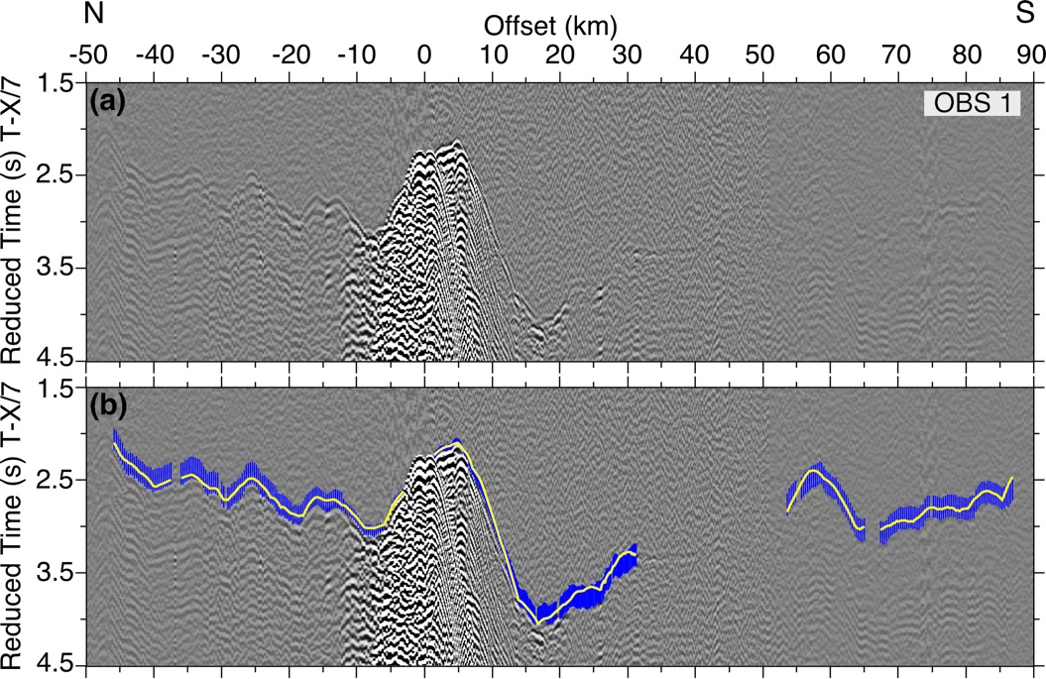

Figure S1. Example OBS 1 gather for the NS profile. (a and b) Vertical geophone data for OBS 5 after application of a reduction velocity of 7 km/s and band-pass filtering (1-5-18-25 Hz). Picked (centers of blue error bars) and modeled (yellow curves) first arrival traveltimes are shown in (b).

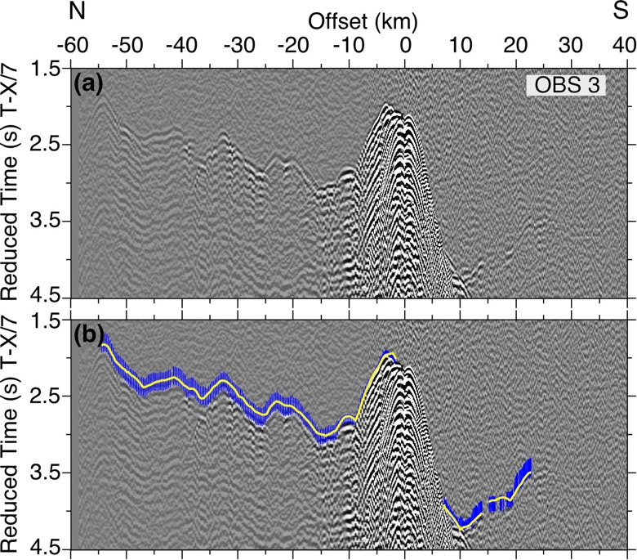

Figure S2. Example OBS 3 gather for the NS profile. (a and b) Vertical geophone data for OBS 5 after application of a reduction velocity of 7 km/s and band-pass filtering (1-5-18-25 Hz). Blue error bars and yellow curves as in Figure S1 caption.

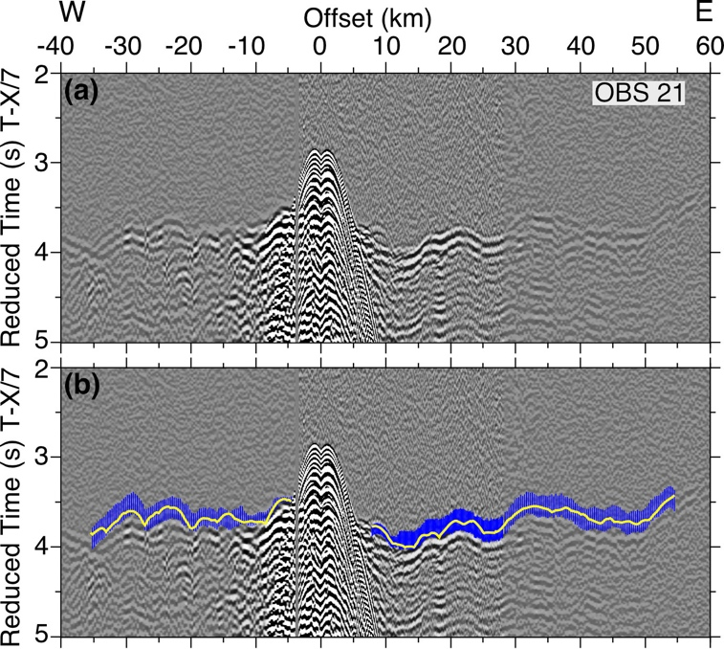

Figure S3. Example OBS 21 gather for the EW profile. (a and b) Vertical geophone data for OBS 5 after application of a reduction velocity of 7 km/s and band-pass filtering (1-5-18-25 Hz). Blue error bars and yellow curves as in Figure S1 caption.

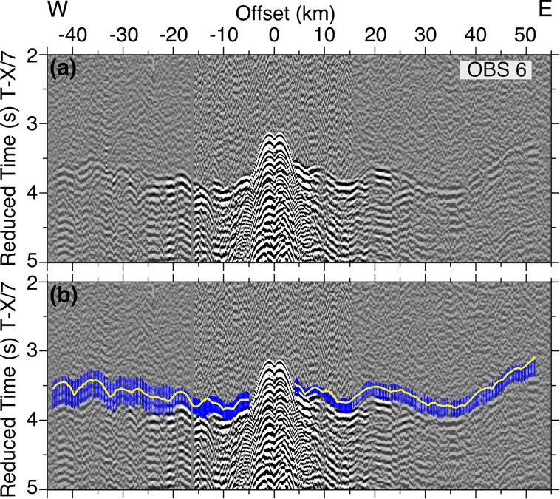

Figure S4. Example OBS 6 gather for the EW profile. (a and b) Vertical geophone data for OBS 5 after application of a reduction velocity of 7 km/s and band-pass filtering (1-5-18-25 Hz). Blue error bars and yellow curves as in Figure S1 caption.

Methods and results

The traveltime tomography method we use, TOMO2D, applies first a hybrid-approach for the forward modeling that combines the graph method with a local ray-bending refinement (Korenaga et al., 2000; Moser, 1991; Moser et al., 1992; Van Avendonk et al., 1998) to find the shortest raypath from the shot to the receiver for each arrival. We use a tenth-order forward star for the horizontal direction and a fifteenth-order for the vertical direction for the graph method (Zhang & Toksöz, 1998), and a minimum segment length of 1 km with 8 interpolation points per segment for the bending method (Papazachos & Nolet, 1997). Tolerances for the conjugate gradient and Brent minimization are 1x10⁻⁴ and 1x10⁻⁵, respectively. The second TOMO2D step is a least-squares regularized inversion, in which the starting velocity model is perturbed and updated until the targeted chi-squared (χ²) or the set number of maximum iterations is reached (Korenaga et al., 2000). We set our inversion to run 5 iterations and set the least-squares tolerance to 1 x 10⁻³. Figure S2 shows χ² as a function of iteration. We tested different values of smoothing and damping to detect the values that result in the best trade-off between data fitting and model smoothness, i.e. a low fitting error concurrent with a low horizontal and vertical roughness. The damping and smoothing weighting factors used are 30 and 60, respectively. We use a horizontal correlation length that linearly increases from 2 km at the top of the model, at the seafloor, to 6 km at the bottom of the model. Likewise, the vertical correlation length increases from 2 km at the top to 5 km at the bottom of the model

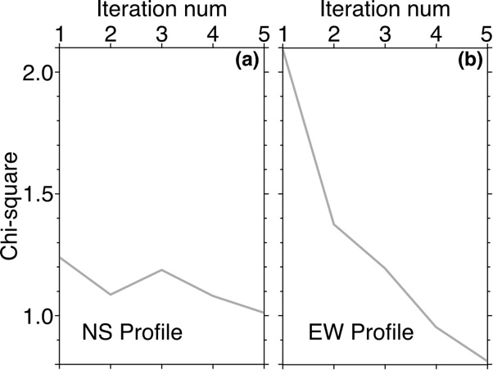

Figure S5. Scatter plot showing the $χ^{2}$values for each of the 5 iterations during the inversion process.
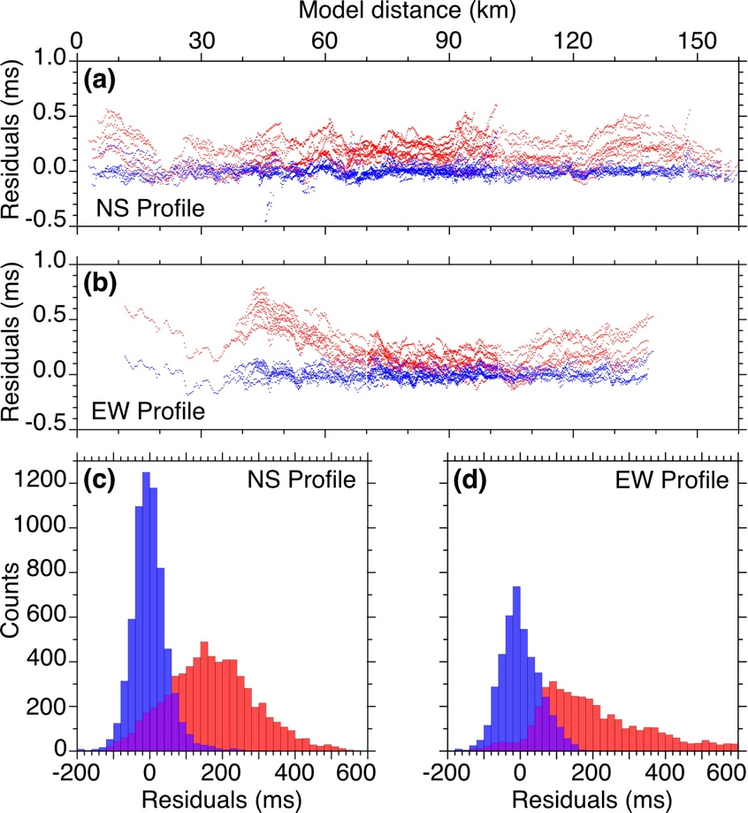

Figure S6. Traveltime residuals for the starting (red) and final (blue) tomographic velocity models versus model distance for the NS (a) and EW (b) profiles. Histograms of the traveltime residual distributions for the NS (c) and EW (d) profiles. Bins are 20 ms wide.

Figures S6a and S6b show that the travel times are fitted at all distances for the NS and EW profiles. The histograms in Figures S6c and S6d show that the traveltime residuals for the starting velocity models are shifted toward positive numbers and centered around zero for the final velocity models, which indicates that the starting velocity models are overall slower than the final velocity models.

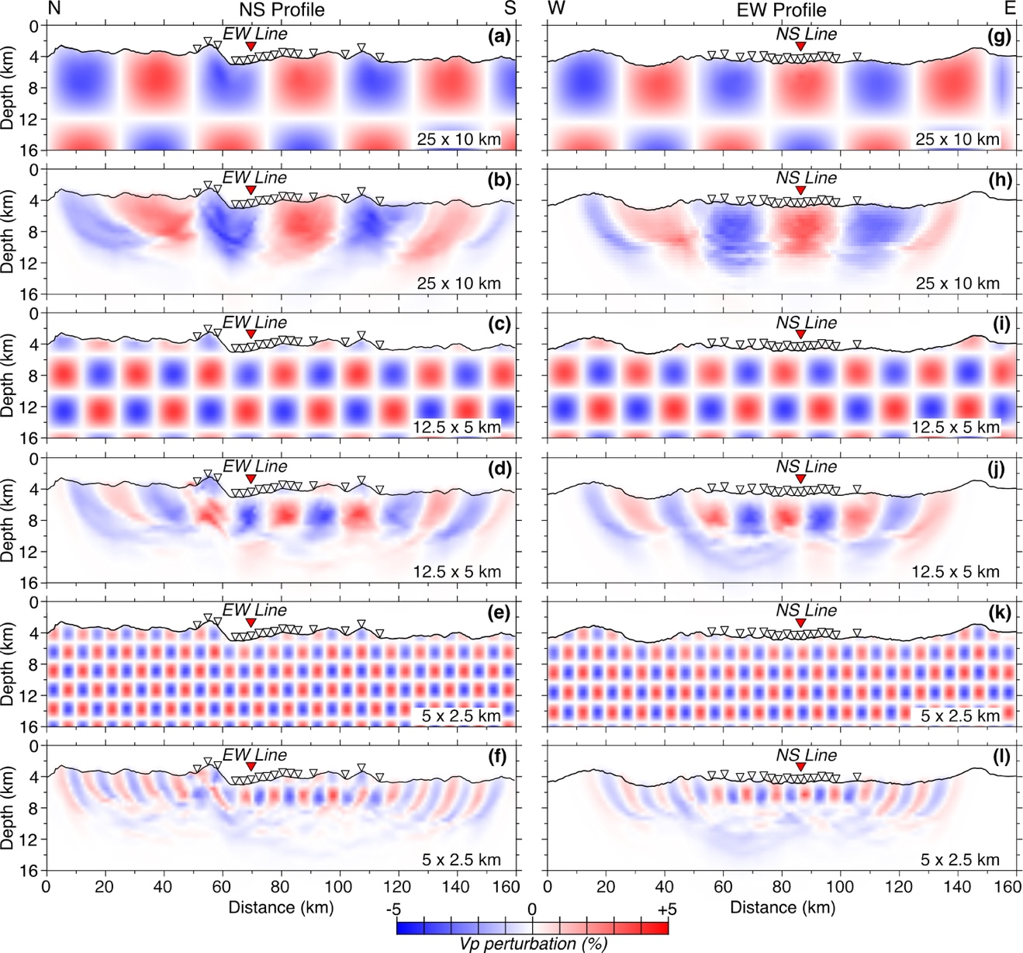

Figure S7. Full-size checkerboard resolution tests for the NS (left column) and EW (right column) profiles for perturbation cells: 25 km wide x 10 km high (a and d), 12.5 km wide x 5 km high (b and e), 5 km wide x 2.5 km high (c and f). The input perturbed model is shown in the bottom left inset and the recovered perturbed model is the full-size figure. White inverted triangles show the positions of the OBSs on the seafloor. Red triangles show the location at which the profiles cross each other.

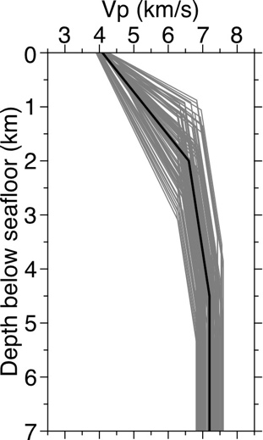

Figure S8. Starting 1D velocity model (thick black line) hung off the seafloor in Figures 3a and 3d is shown together with 100 of its randomizations (thin grey lines) used for the Monte Carlo analysis.

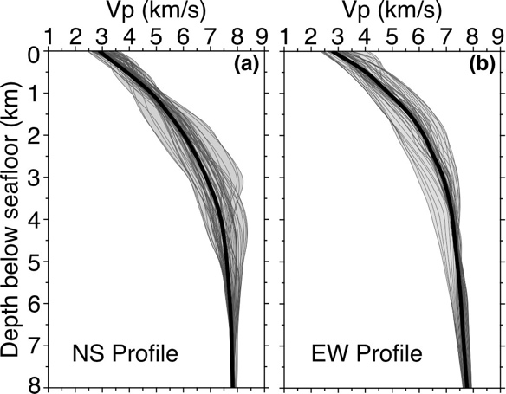
Figure S9. 1D velocity-depth profiles (dark grey) sampled every 1 km in the section of the NS (a) and EW (b) averaged velocity models within the best resolved areas (Figs. 5a,b): (a) 51 km to 114 km and (b) 55 km to 106 km. Average 1D velocity-depth profiles are shown with thick black lines and the velocity envelope in light grey.

