Supplementary Material for Vendettuoli et al. “Daily bathymetric surveys document how stratigraphy is built and its extreme incompleteness: One summer offshore Squamish Delta, British Columbia”
The supplementary material is provided as follows:

- Table S1: Summary of previous repeat bathymetric mapping in areas of active submarine landslides and turbidity currents. References cited in Table S1 are included at the end of this document.
- Figure S1: Seafloor elevation changes through time, taken at 100 m intervals along each of the channel axes at the Squamish prodelta
- Figures S2-7: Across channel profiles illustrating the stratigraphic evolution for across channel profiles B-C-D-E-G and H at the Squamish prodelta
- Figure S8: Evolution of stratigraphic completeness over time along the three channels at the Squamish prodelta
- Ascii data for cumulative aggradation map (“cum_aggrad.txt”) and stratigraphic completeness map (for all areas where stratigraphic completeness <0 “strat_compl_zero.txt” and where stratigraphic completeness >0 “strat_compl_positive.txt”).

Animated videos are also presented in the online material as follows:

- Movie S1_NorthernChannel.avi – Time-lapse animation of stratigraphic evolution of the Northern Channel
- Movie S2_NorthChannelProximal.avi – Time-lapse animation of stratigraphic evolution of proximal to medial parts of Northern Channel
- Movie S3_NorthChannelDistal.avi – Time-lapse animation of stratigraphic evolution of medial to distal parts of Northern Channel
- Movie S4_CentralChannel.avi – Time-lapse animation of stratigraphic evolution of the Central Channel
- Movie S5_CentralChannelProximal.avi – Time-lapse animation of stratigraphic evolution of proximal to medial parts of Central Channel
- Movie S6_CentralChannelDistal.avi – Time-lapse animation of stratigraphic evolution of medial to distal parts of Central Channel
- Movie S7_SouthChannel.avi – Time-lapse animation of stratigraphic evolution of the Southern Channel
- Movie S8_SouthChannelProximal.avi – Time-lapse animation of stratigraphic evolution of proximal to medial parts of Southern Channel
- Movie S9_SouthChannel_LTZ.avi – Time-lapse animation of stratigraphic evolution of the channel lobe transition zone of Southern Channel
- Movie S10_SouthChannel_LTZ_Zoom - Time-lapse animation of stratigraphic evolution of the channel lobe transition zone of Southern Channel – zoom in
- Movie S11_A.avi- Time-lapse animation of stratigraphic evolution of across-profile A
- Movie S12_B.avi- Time-lapse animation of stratigraphic evolution of across-profile B
- Movie S13_C.avi- Time-lapse animation of stratigraphic evolution of across-profile C
- Movie S14_D.avi- Time-lapse animation of stratigraphic evolution of across-profile D
- Movie S15_E.avi- Time-lapse animation of stratigraphic evolution of across-profile E
- Movie S16_F.avi- Time-lapse animation of stratigraphic evolution of across-profile F
- Movie S17_G.avi- Time-lapse animation of stratigraphic evolution of across-profile G
- Movie S18_H.avi- Time-lapse animation of stratigraphic evolution of across-profile H

Repeated bathymetric surveys | Location and water depth [m] | Frequency of flows/landslide  [if known] | Processed observed | Reference
5 x annual surveys (2008-2004)  1 x annual survey (2009) | Oguue’ River submarine delta, Gabon  [55 m] | 10s/year | Submarine landslide | Biscara et al. (2012)
2 x annual survey (in 2009 and 2004) | Begawan Solo submarine delta, East Java  [30 m] | - | Turbidity currents | Syahnur and Java (2016)
Survey every 6-24 months (from 2004 to 2009); survey every week day (during Spring and Summer 2011 and 2012); single survey for 6 days (June 2013); 1 x annual survey (2015)  *5 x surveys a day for 6 days (2015) | Squamish submarine delta, British Columbia, Canada  [<200m]  *Central Channel at Squamish Delta  [60 m] | 10s ÷ 100s/year | Delta-lip collapses, turbidity currents and bedforms migration | Hughes Clarke et al. (2012, 2014), Clare et al. (2016), Hughes Clarke (2016), Hizzett et al. (2018), Hage et al. (2018), this work;
Repeat surveys every 15 minutes for 10 days | Westerschelde Estuary, the Netherlands  [20 m] | 10s ÷ 100s/year | Dredging-induced slope failure, bedform migration | Mastbergen et al. (2016)
6 x annual surveys (1967, 1974, 1991, 1999, 2006 and 2011) | Offshore Nice, France1  [300 m] | 10s ÷ 100s/year | Submarine landslide | Kelner et al. (2016)
2 x annual surveys (September 2002 and February 2005); 2 x surveys (March 25, 2003 and March 26, 2006); 1 x annual survey (September 2003); 2 x surveys (September 2004 and November 2004); | Monterey Canyon, California, USA  [300 m] | 10s ÷ 100s/year | Submarine landslide, bedforms migration | Smith et al. (2007); Xu et al. (2008); Paull et al. (2010)
1 x annual surveys (1891); 1 x annual survey (between December 2012 and November 2013); 4 x surveys (1986, 2000, 2008, 2012) | Lake Geneva, Western Europe  [<300 m] | ~10s ÷ 100s/flows | Turbidity currents, mass transport events | Silva et al. (2018); Corella et al. (2016)
1 x annual survey (2007); 1 x annual survey (2012) | Lower St. Lawrence Estuary, Eastern Canada [350 m] |  | Turbidity currents, bedform migration | Normandeau et al. (2014)
2 x annual surveys (2005 and 2008); 1 x annual survey (2010) | Knight, Bute and Toba Inlets, British Columbia, Canada  [up to 400 m] | 10s/year | Slope failure, turbidity currents | Conway et al. (2012);
2 x annual surveys (between 2005 and 2007) | Fiumara Mounths, Western Messina Strait, Italy  [up to 2000 m] | ~100s/year | Hyperpycnal flows, landslides | Casalbore et al. (2011)
2 x surveys (2016) | Kaikoura Canyon, New Zealand  [2000 m] | ~100s/year | Canyon flashing | Mountjoy et al. (2018)
1 x annual survey (1994, 2001, 2003, 2005); 2 x surveys (May 2006 and September 2006) | Fraser River Delta, Western Canada  [up to 110 m] | ~ 10s/year | Turbidity currents, slope failure | Hill et al. (2008); Lintern et al. (2018)

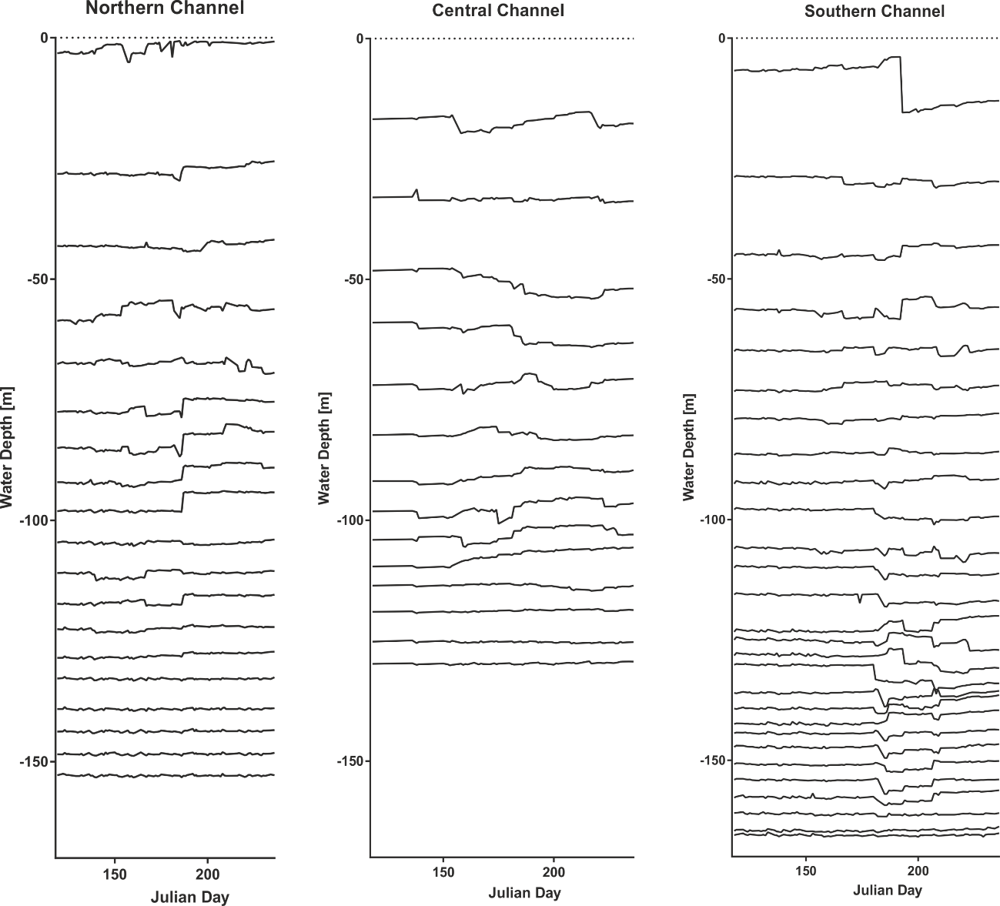

Figure S1: Seafloor elevation changes through time, taken at 100 m interval along single points of the thalweg for each of the three channels at the Squamish prodelta

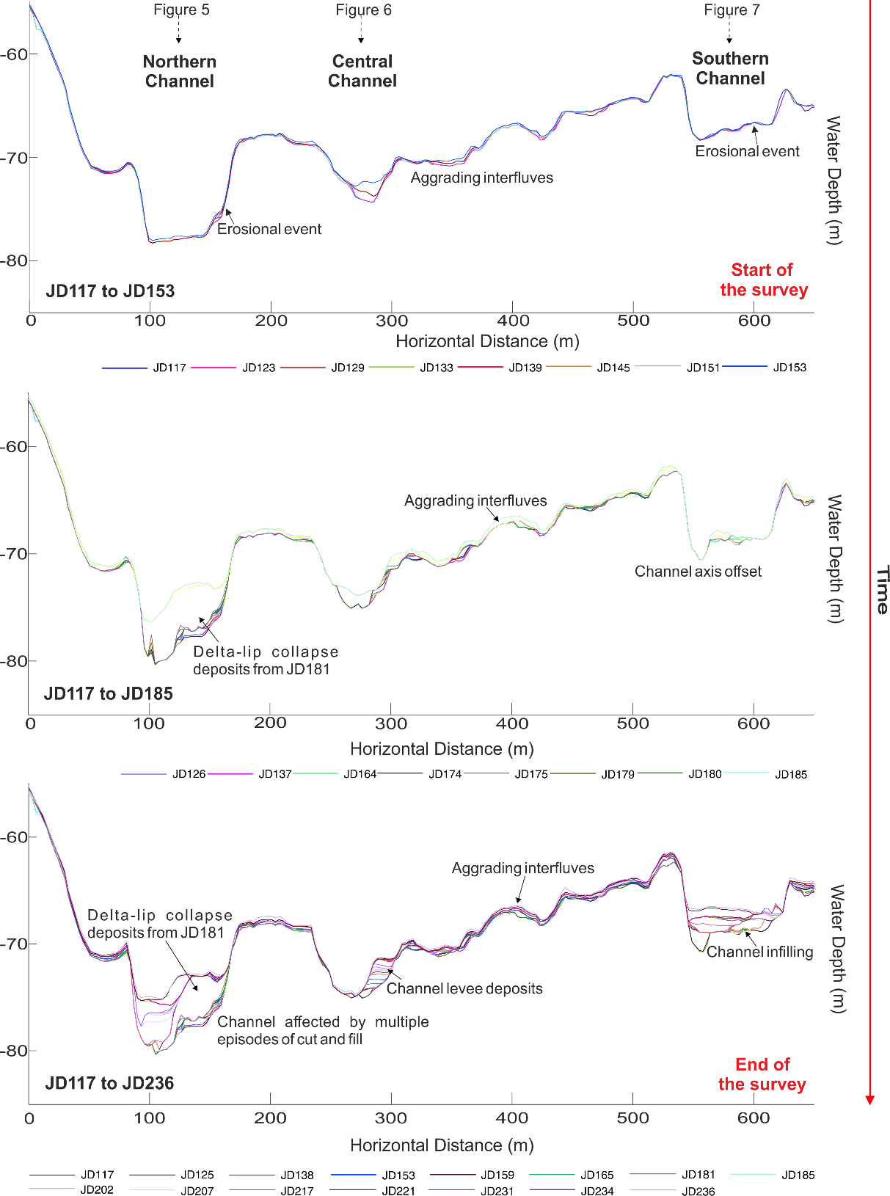

Figure S2: Across channel profile B (see Figure 2B in the main text for the location of the profile; vertical exaggeration: 9x)

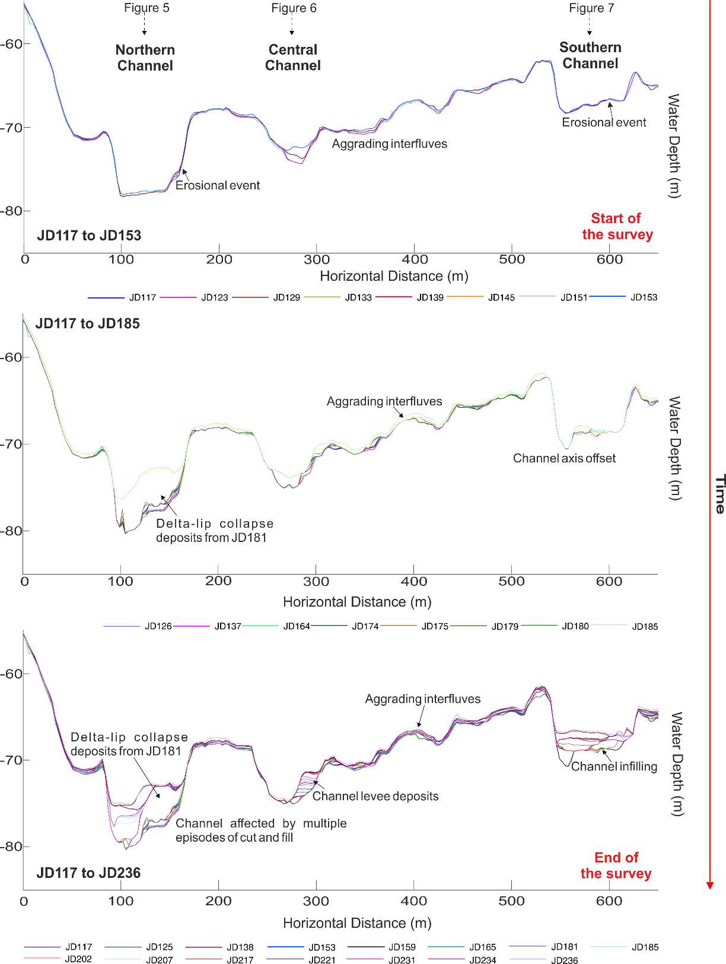

Figure S3: Across channel profile C (see Figure 2B in the main text for the location of the profile; vertical exaggeration: 9x)

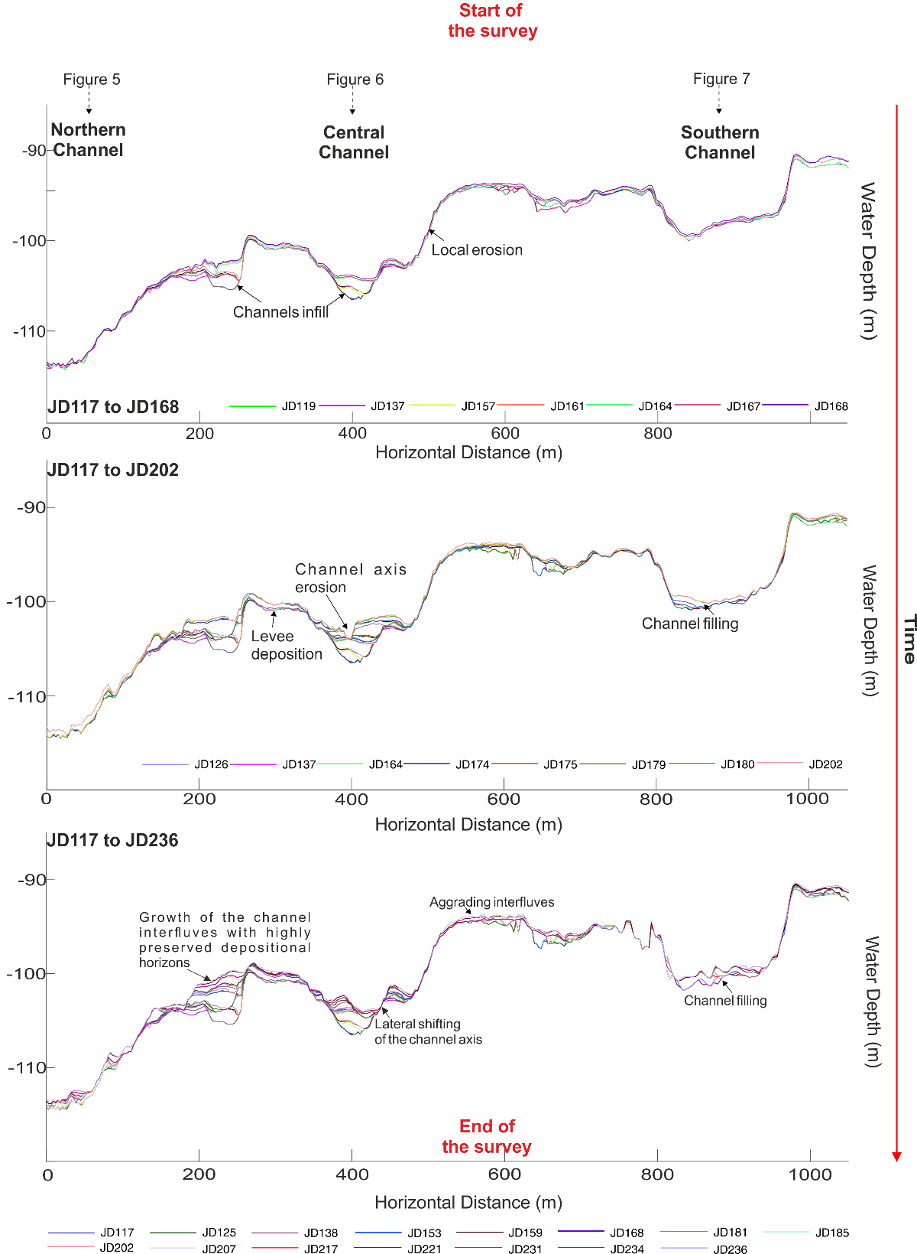

Figure S4: Across channel profile D (see Figure 2B in the main text for the location of the profile; vertical exaggeration: 12x)

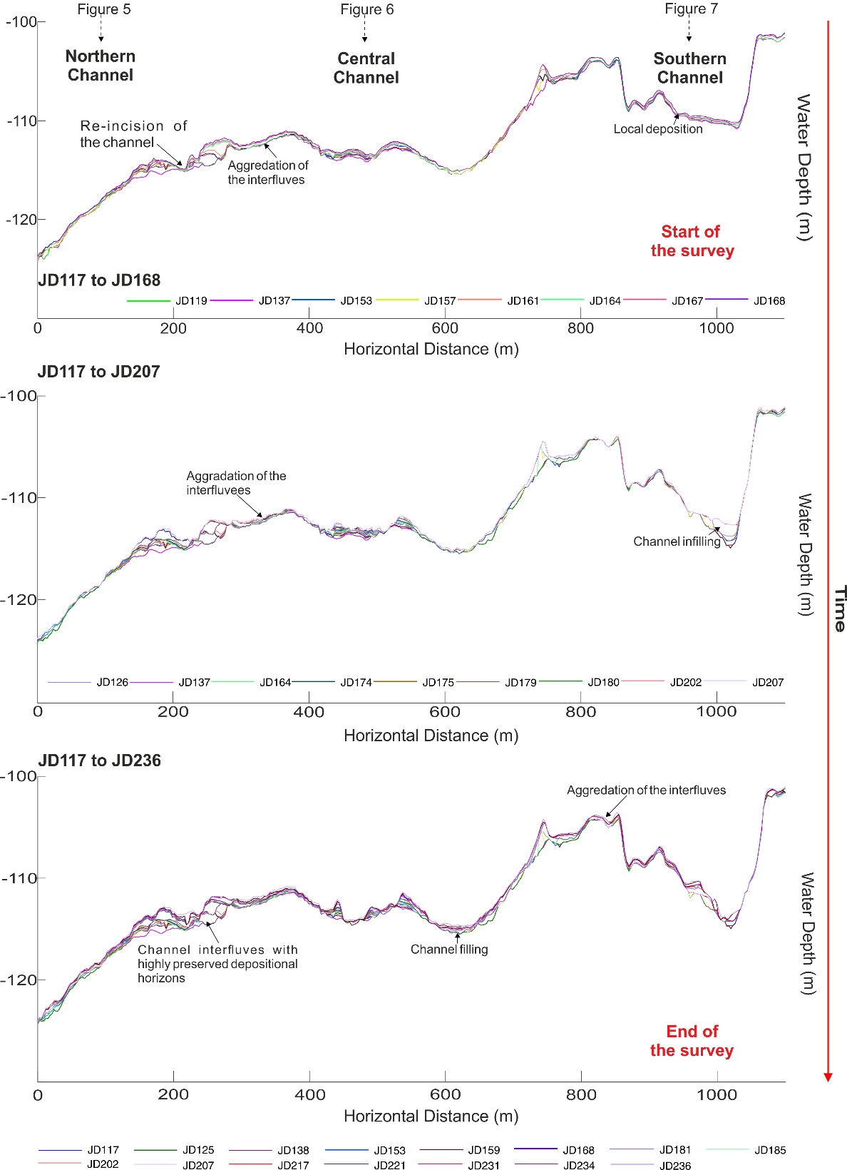

Figure S5: Across channel profile E (see Figure 2B in the main text for the location of the profile; vertical exaggeration: 14.5x)

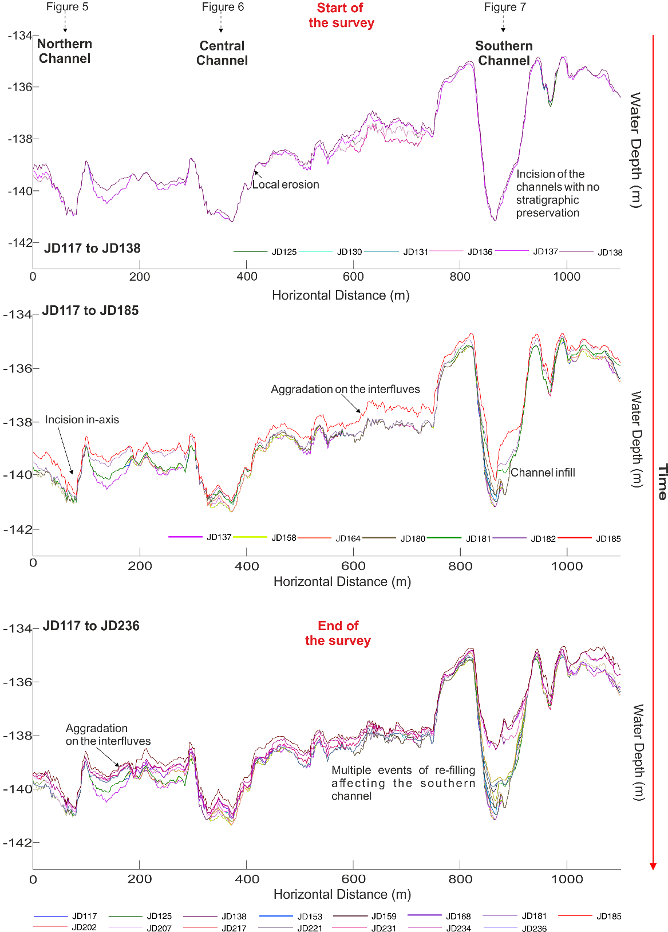

Figure S6: Across channel profile G (see Figure 2B in the main text for the location of the profile; vertical exaggeration: 48x)

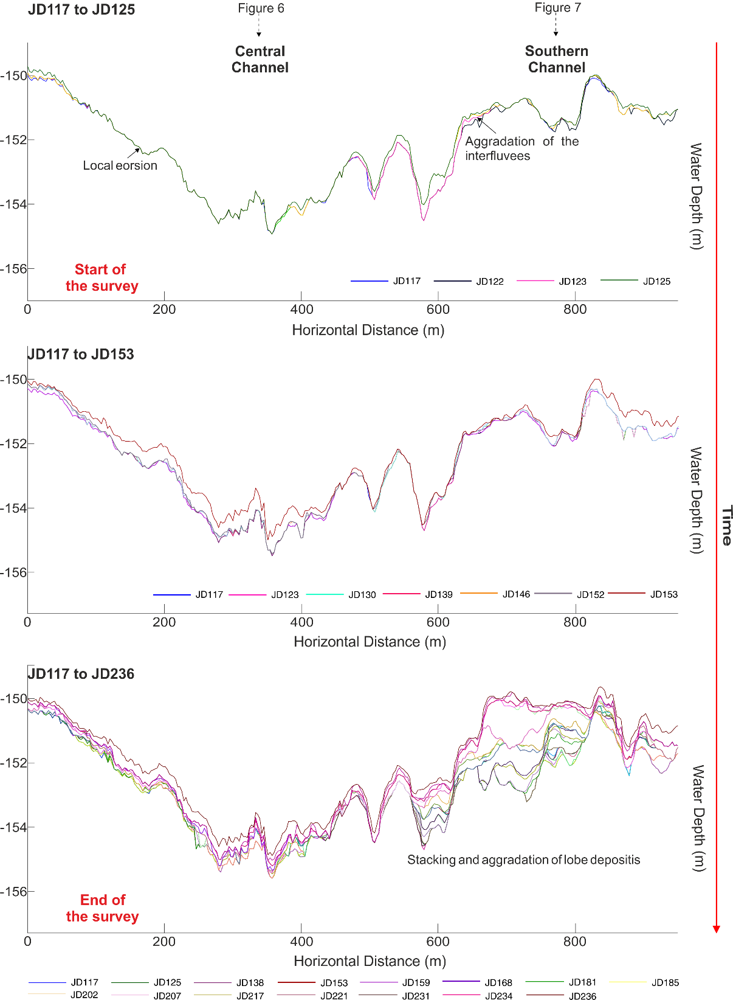

Figure S7: Across channel profile H (see Figure 2B in the main text for the location of the profile; vertical exaggeration: 47.5x)

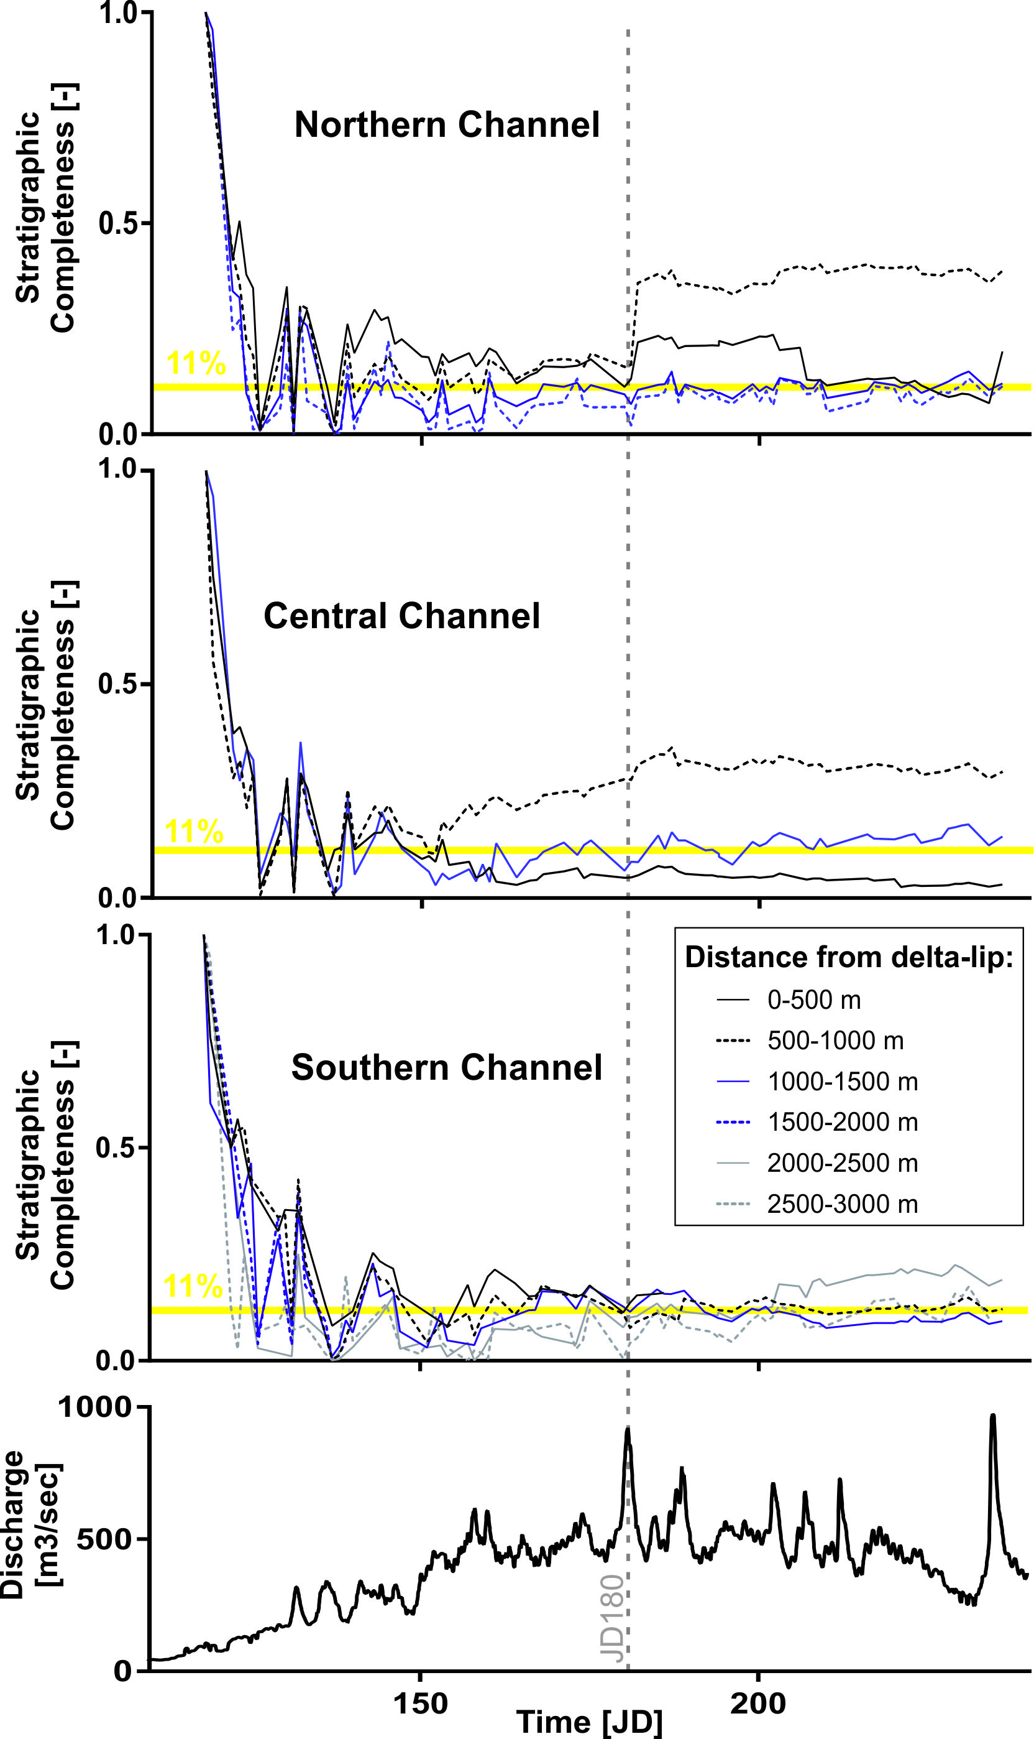
Figure S8: River discharge rata and evolution of stratigraphic completeness over time along the three channel at the Squamish prodelta

- Biscara, L., Hanquiez, V., Leynaud, D., Marieu, V., Mulder, T., Gallissaires, J. M. and Garlan, T. (2012). Submarine slide initiation and evolution offshore Pointe Odden, Gabon—Analysis from annual bathymetric data (2004–2009). Marine Geology, 299, 43-50.

- Syahnur, Y. and Jaya, K.A. (2016). Geomatics best practices in Saka Indonesia Pangkah Limited (Case Study: Ujung Pangkah Pipeline Integrity). 2015 Indonesian Petroleum Association Convention.

- Hughes Clarke, J.E., Brucker, S., Muggah, J., Hamilton, T., Cartwright, D., Church, I. and Kuus, P. (2012). Temporal progression and spatial extent of mass wasting events on the Squamish prodelta slope. In Landslides and engineered slopes: protecting society through improved understanding (pp. 1091-1096). Taylor and Francis Group London.

- Hughes Clarke, J. E., Vidiera Marques, C. R. and Pratomo, D. (2014) in Submarine mass movements and their consequences (eds Krastel, et al.) vol. 37, 249–260 (Advances in Natural and Technological Hazards Research, Springer).

- Clare, M. A., Clarke, J. H., Talling, P. J., Cartigny, M. J. B. and Pratomo, D. G. (2016). Preconditioning and triggering of offshore slope failures and turbidity currents revealed by most detailed monitoring yet at a fjord-head delta. Earth and Planetary Science Letters, 450, 208-220.

- Hughes Clarke, J. E. (2016). First wide-angle view of channelized turbidity currents links migrating cyclic steps to flow characteristics. Nature communications, 7, 11896.

- Hizzett, J. L., Hughes Clarke, J. E., Sumner, E. J., Cartigny, M. J. B., Talling, P. J. and Clare, M.
  - (2018). Which Triggers Produce the Most Erosive, Frequent, and Longest Runout Turbidity Currents on Deltas? Geophysical Research Letters, 45(2), 855-863.

- Hage, S., Cartigny, M.J.B., Clare, M.A., Sumner, E.J., Vendettuoli, D., Hughes Clarke, J.E, Hubbard, S.M., Talling, P.J., Lintern, D.G., Stacey, C.D., Englert, R.G., Vardy, M.E., Hunt, J.E., Yokokawa, M., Parsons, D.R., Hizzett, J.L., Azpiroz-Zabala, M. and Vellinga, A.J. (2018). How to recognize crescentic bedforms formed by supercritical turbidity currents in the geologic record: insights from active submarine channels, Geology.

- Mastbergen, D., van den Ham, G., Cartigny, M., Koelewijn, A., de Kleine M. and Clare M. (2016). Multiple flow slide experiment in the Westerschelde Estuary, The Netherlands. In: Submarine Mass Movements and Their Consequences, pp. 241–249. Springer International Publishing.

- Kelner, M., Migeon, S., Tric, E., Couboulex, F., Dano, A. and Lebourg, T. (2016). Frequency and triggering of small-scale submarine landslides on decadal timescales: analysis of 4D bathymetric data from the continental slope offshore Nice (France). Marine Geology 379, 281–297.

- Smith, D.P., Kvitek, R., Iampietro, P.J. and Wong K. (2007). Twenty-nine months of geomorphic change in upper Monterey Canyon (2002–2005). Marine Geology 236(1), 79–94.
- Xu, J.P., Wong, F.L., Kvitek, R., Smith, D.P. and Paull, C.K. (2008), Sandwave migration in Monterey Submarine Canyon, Central California. Marine Geology 248, 193–212.

- Paull, C.K., Ussler, III W., Caress, D.W., Lundsten, E., Covault, J.A. and Maier, K.L. (2010a). Origins of large crescent-shaped bedforms within the axial channel of Monterey Canyon, offshore California. Geosphere 6(6), 755–774.

- Silva, T.A., Girardclos, S., Stutenbecker, L., Bakker, M., Costa, A., Schlunegger, F., Lane, S.N., Molnar, P. and Loizeau, J-L (2018). The sediment budget and dynamics of a delta‐canyon‐lobe system over the Anthropocene timescale: The Rhone River Delta, Lake Geneva (Switzerland/France). Sedimentology. https://doi.org/10.1111/sed.12519.

- Corella, J.P., Loizeau, J-L., Kremer, K., Hilbe, M., Gerard, J., le Dantec, N., Stark, N., Gonzalez- Quijano, M. and Girardclos, S. (2016). The role of mass-transport deposits and turbidites in shaping modern lacustrine deepwater channels. Marine and Petroleum Geology, 77, 515-525.

- Normandeau, A., Lajeunesse, P., St-Onge, G., Bourgault, D., St-Onge Drouin, S., Senneville, S. and Bélanger, S. (2014). Morphodynamics in sediment-starved inner-shelf submarine canyons (Lower St. Lawrence Estuary, Eastern Canada). Marine Geology, 357, 243–255.

- Conway, K.W., Vaughn Barrie, J., Picard, K. and Bornhold, B.D. (2012). Submarine channel evolution: active channels in fjords, British Columbia, Canada. Geo-Mar Lett, 32, 301–312.

- Casalbore, D., Chiocci, F.L., Scarascia Mugnozza, G., Tommasi, T., Sposato, A. (2011). Flash- flood hyperpycnal flows generating shallow-water landslides at Fiumara mouths in Western Messina Strait (Italy). Marine Geophysics Research, 27, 32:257.

- Mountjoy, J.J., Howarth, J.D., Orpin,A.R., Barnes, P.M., Bowden, D.A., Rowden, A.A., Schimel, A.C.G., Holden, C., Horgan, H.J., Nodder, S.D., Patton, J.R., Lamarche, G., Gerstenberger, M., Micallef, A., Pallentin, A. and Kane, T. (2018). Earthquakes drive large-scale submarine canyon development and sediment supply to deep-ocean basins. Science Advance, 4, eaar3748.

- Hill, P.R., Conway, K., Lintern, D.G., Meulé, S., Picarda, K. and Barriea, J.V. (2008). Sedimentary processes and sediment dispersal in the southern Strait of Georgia, BC, Canada. Marine Environmental Research, Volume 66, Supplement, S39-S48.

- Lintern, D.G., Hill, P.R., and Stacey, C. (2016). Powerful unconfined turbidity current captured by cabled observatory on the Fraser River delta slope, British Columbia, Canada. Sedimentology, 63 (5), 1041-1064. Chicago.

