Supplementary material:
A lot of validation work were already done by several authors (see part 3.1). A further validation is carried out. The model outputs are compared with 5 ADCP and the tide gauge of the Brest harbour (appendix 1). It concerns a case with a spatialized roughness length (appendix 2) and a uniform roughness length equal to 3.5mm (appendix 3).

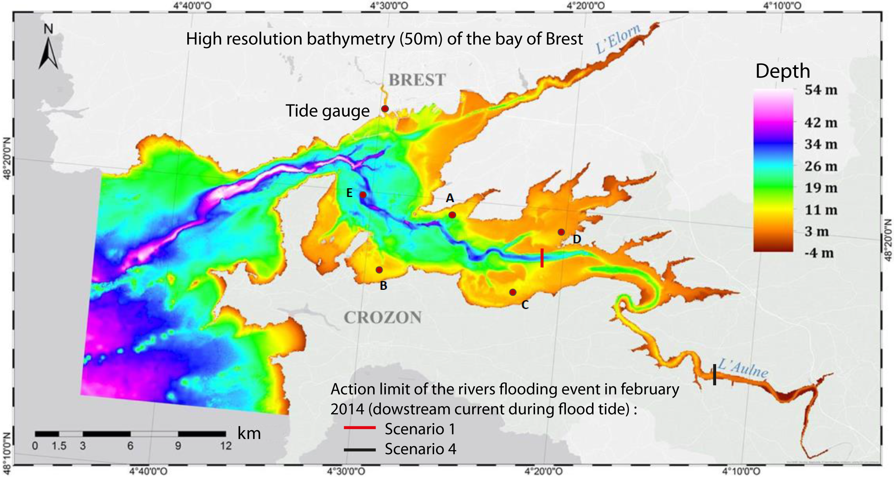
Appendix. 1: High resolution bathymetry, with the position of all ADCP and the tidal gauge of Brest harbour. A, B, C, D recorded during 1 month (October 2014, Petton et al., 2016), E during 24 days (16 of July, ENSTA) and the tidal gauge during the entire year 2014. The action limit of one rivers flooding event during a flood of neap tide (February 2014, described in section 4.1) corresponds to black and red line.

Appendix 2: Validation of simulated currents with a spatialized Z0
Localisation | Variable | Percentage correlation (%) | RMSE | Willmott index
Tidal gauge | free surface | 99 | 0,27m | 0,93
ADCP A | U barotrope | 70,3 | 0,1 | 0.47
 | V barotrope | -11,2 | 0,06 | 0,37
ADCP B | U barotrope | 61,7 | 0,04 | 0,57
 | V barotrope | 82,6 | 0,03 | 0,64
ADCP C | U barotrope | 96,4 | 0,04 | 0,87
 | V barotrope | 75,9 | 0,02 | 0,62
ADCP D | U barotrope | 96,6 | 0,05 | 0,82
 | V barotrope | 95,4 | 0,05 | 0,78
ADCP E | U barotrope | 89,6 | 0,14 | 0,65
 | V barotrope | 97,5 | 0,16 | 0,74

Appendix 3: Validation of simulated currents with a uniform Z0 (3.5mm)
Localisation | Variable | Percentage correlation (%) | RMSE | Willmott index
ADCP D | U barotrope | 95.9 | 0.05 | 0.81
 | V barotrope | 95.1 | 0.05 | 0.78
ADCP E | U barotrope | 85.7 | 0.16 | 0.62
 | V barotrope | 94.4 | 0.23 | 0.67

The compared points reveal very slightly better values for the configuration with a spatialized roughness length. This justifies the simplification of the approach and the use of a uniform roughness length to facilitate comparison with past stages.

M2 and S2 ellipses:

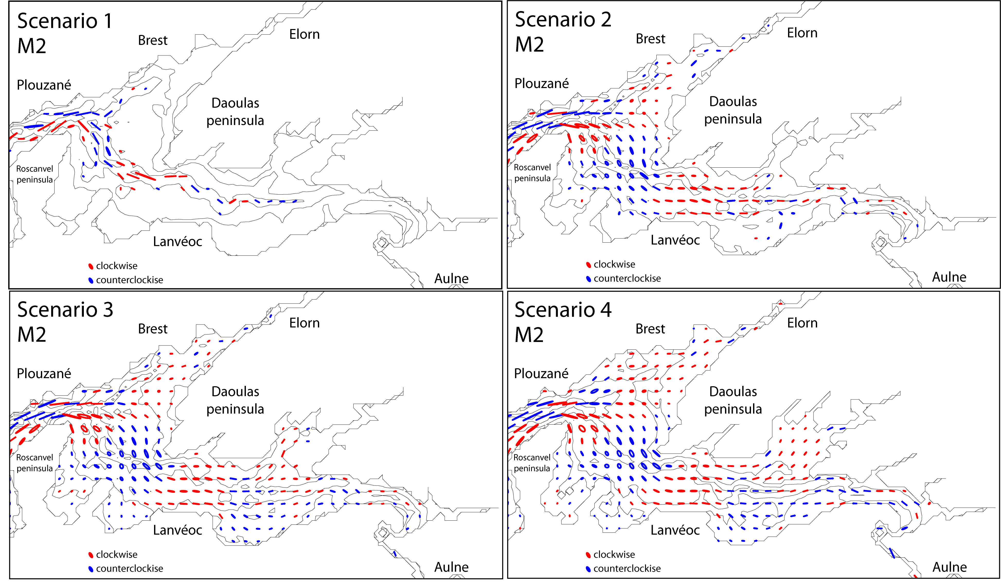
M2 component ellipses for each scenario, calculated from the barotropic currents U and V.

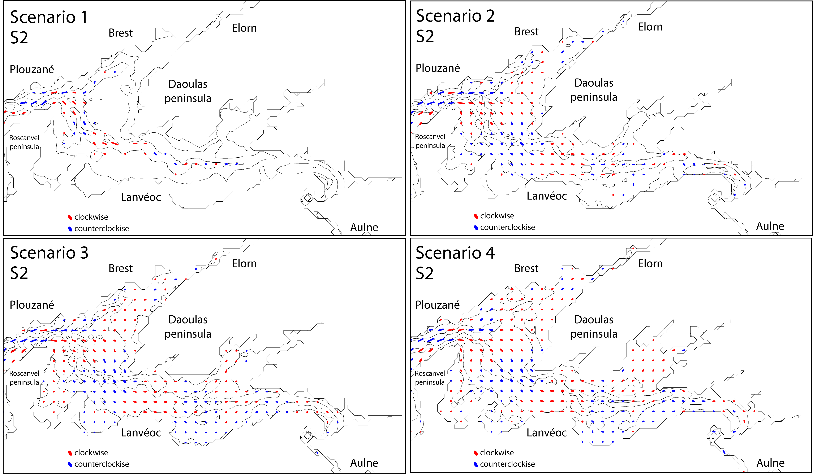
S2 component ellipses for each scenario, calculated from the barotropic currents U and V.

