Journal of Geophysical Research: Oceans
Supporting Information for
Satellite-based Sea Surface Salinity designed for Ocean and Climate Studies
J. Boutin¹, N. Reul², J. Koehler³, A. Martin⁴, R. Catany⁵, S. Guimbard⁶, F. Rouffi⁷, J.L. Vergely⁷, M. Arias⁵, M. Chakroun⁷, G. Corato⁸, V. Estella-Perez^{1,*}, A. Hasson^{1,†}, S. Josey⁴, D. Khvorostyanov¹, N. Kolodziejczyk², J. Mignot¹, L. Olivier¹, G. Reverdin¹, D. Stammer³, A. Supply^{1,2}, C. Thouvenin-Masson¹, A. Turiel⁹, J. Vialard¹, P. Cipollini^{10, ‡}, C. Donlon^{10, ‡}, R. Sabia¹¹, S. Mecklenburg¹⁰
¹Sorbonne University, LOCEAN/IPSL Laboratory, CNRS–IRD–MNHN, Paris, France.
²University of Brest, LOPS Laboratory, IUEM, UBO–CNRS–IRD–Ifremer, Plouzané, France.
³Institut für Meereskunde, Centrum für Erdsystemwissenschaften und Nachhaltigkeit, Universität Hamburg, Germany.
⁴National Oceanography Centre, Southampton, UK.
⁵ARGANS Ltd, UK.
⁶Ocean Scope, France.
⁷ACRI-st, France.
⁸Adwaiseo, Luxemburg.
⁹Barcelona Expert Center (BEC) and Institute of Marine Sciences (ICM), CSIC, Spain.
¹⁰European Space Agency, ECSAT, Harwell, United Kingdom.
¹¹Telespazio-UK for ESA, ESRIN, Frascati, Italy.

Corresponding author: Jacqueline Boutin (jb@locean.ipsl.fr)
*Now at UL Services Spain SL
†Now at Mercator Ocean International, France
‡Now at European Space Agency, ESTEC, Noordwijk, the Netherlands.

Contents of this file

Figures S4, S5, S7 and S8

Introduction
This supporting information illustrates maps of climatology of SSS variability taken as input in the OI , Aquarius representativity uncertainties and SSS anomalies computed with ISAS SSS fields.
All the material presented here is not essential to the comprehension of the article but provides more detailed information to the reader.

- Climatology of monthly SSS variability relative to the whole period SSS mean

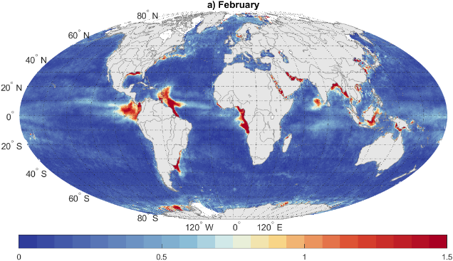 | 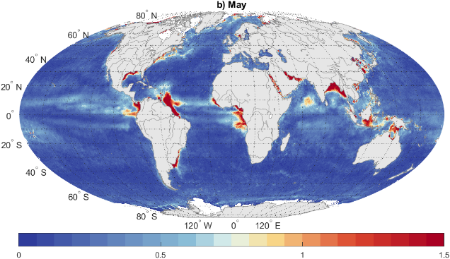
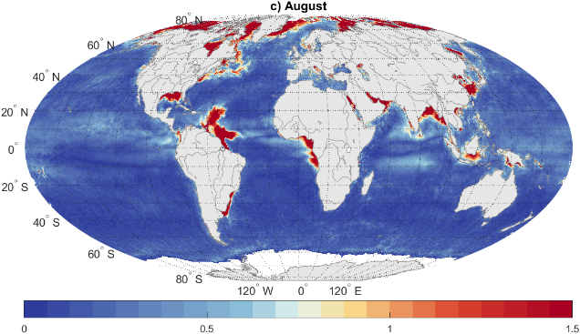 | 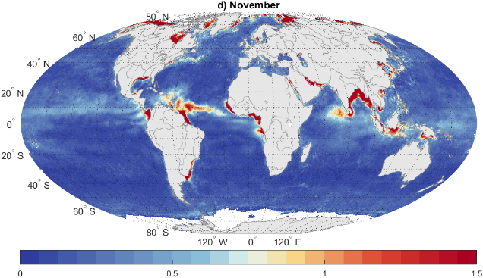
Figure S4. Examples of climatological maps of monthly SSS variability relative to the whole period SSS mean. a) February; b) May; c) August; d) November.

- Climatology of weekly SSS variability relative to monthly mean:
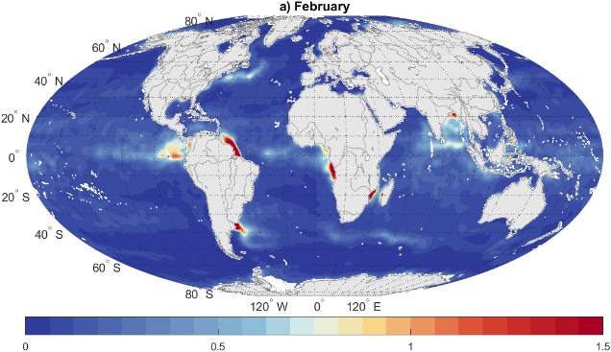 | 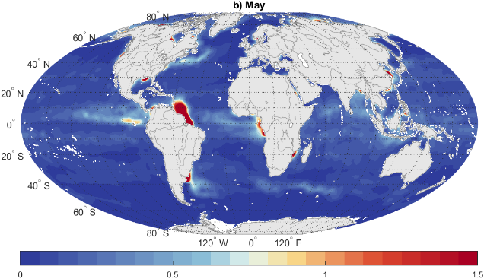
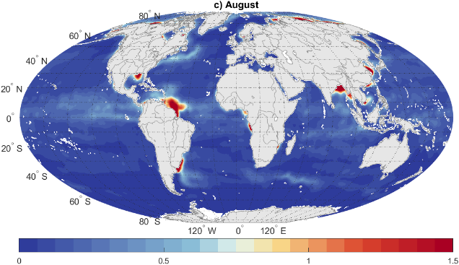 | 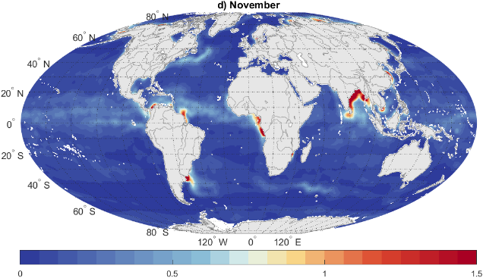
Figure S5. Examples of variability of weekly SSS relative to monthly mean SSS taken as input information in weekly OI , from GLORYS reanalysis. A) February; b) May; c) August; d) November.

- Aquarius representativity uncertainties

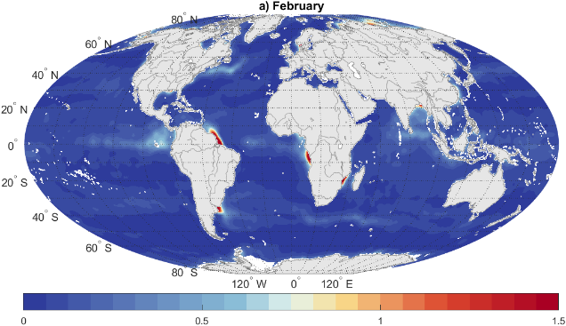 | 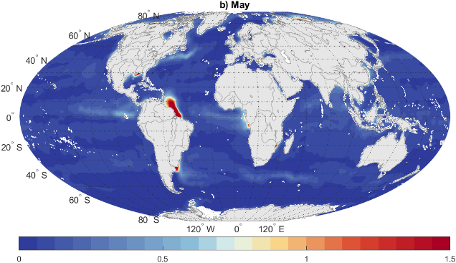
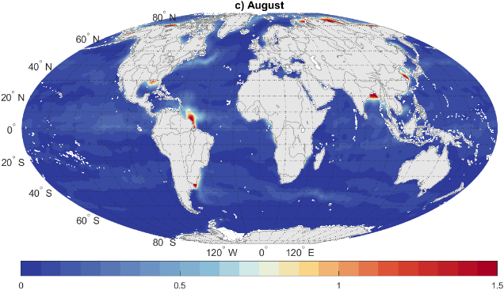 | 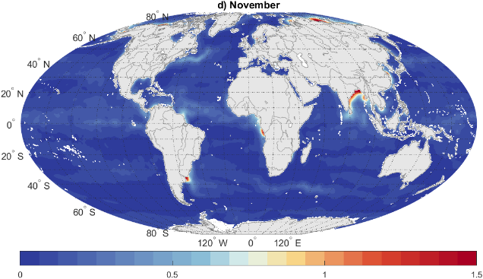

Figure S7. Examples of representativity uncertainties between Aquarius and SMOS/SMAP (150km/7day Aquarius, 50km/30days), from GLORYS simulations. A) February; b) May; c) August; d) November.

- Maps of SSS anomalies derived from ISAS SSS
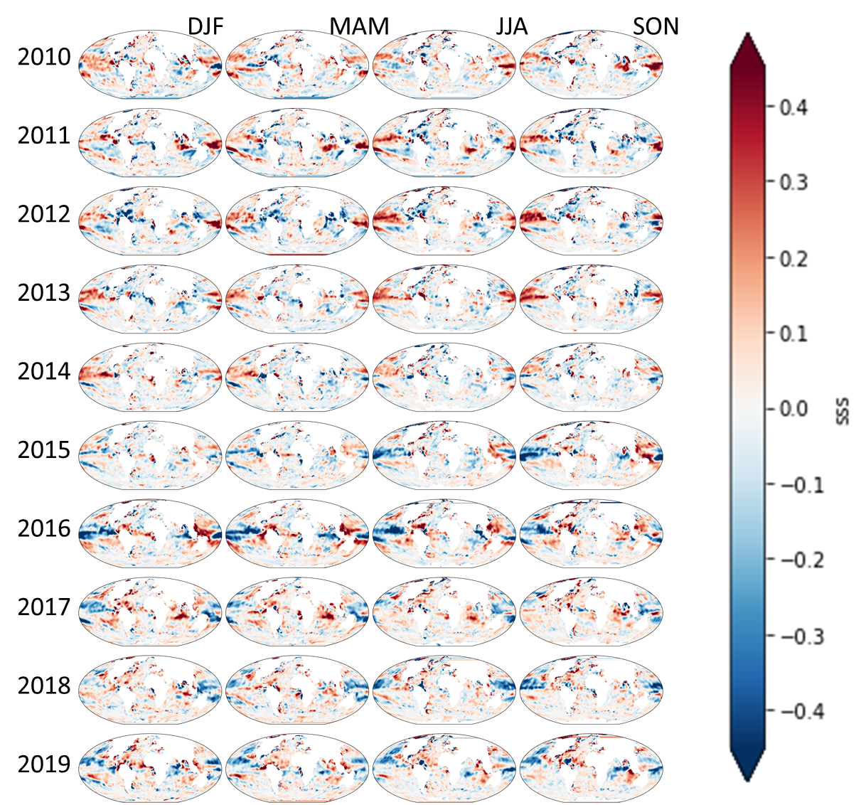
Figure S8. Quarterly SSS anomalies derived from ISAS SSS (only grid points with PCTVAR<95% have been retained to avoid grid points very far from in situ measurements and almost only affected by climatological values).

