Journal of Geophysical Research: Oceans
Supporting Information for
Satellite-based Sea Surface Salinity designed for Ocean and Climate Studies
J. Boutin¹, N. Reul², J. Koehler³, A. Martin⁴, R. Catany⁵, S. Guimbard⁶, F. Rouffi⁷, J.L. Vergely⁷, M. Arias⁵, M. Chakroun⁷, G. Corato⁸, V. Estella-Perez^{1,*}, A. Hasson^{1,†}, S. Josey⁴, D. Khvorostyanov¹, N. Kolodziejczyk², J. Mignot¹, L. Olivier¹, G. Reverdin¹, D. Stammer³, A. Supply^{1,2}, C. Thouvenin-Masson¹, A. Turiel⁹, J. Vialard¹, P. Cipollini^{10, ‡}, C. Donlon^{10, ‡}, R. Sabia¹¹, S. Mecklenburg¹⁰
¹Sorbonne University, LOCEAN/IPSL Laboratory, CNRS–IRD–MNHN, Paris, France.
²University of Brest, LOPS Laboratory, IUEM, UBO–CNRS–IRD–Ifremer, Plouzané, France.
³Institut für Meereskunde, Centrum für Erdsystemwissenschaften und Nachhaltigkeit, Universität Hamburg, Germany.
⁴National Oceanography Centre, Southampton, UK.
⁵ARGANS Ltd, UK.
⁶Ocean Scope, France.
⁷ACRI-st, France.
⁸Adwaiseo, Luxemburg.
⁹Barcelona Expert Center (BEC) and Institute of Marine Sciences (ICM), CSIC, Spain.
¹⁰European Space Agency, ECSAT, Harwell, United Kingdom.
¹¹Telespazio-UK for ESA, ESRIN, Frascati, Italy.

Corresponding author: Jacqueline Boutin (jb@locean.ipsl.fr)
*Now at UL Services Spain SL
†Now at Mercator Ocean International, France
‡Now at European Space Agency, ESTEC, Noordwijk, the Netherlands.

Contents of this file
Tables S9.1 to S9.4 and S10.1 to S10.2
Introduction
This supporting information gives details about PIMEP validation statistics obtained for weekly SSS CCI fields over the global ocean and for monthly fields in the Southern Ocean.
All the material presented here is not essential to the comprehension of the article but provides more detailed information to the reader.

- Statistics of weekly satellite SSS comparisons with in situ SSS
Table S9.1. Statistics of weekly satellite SSS comparisons with Argo SSS (All matchups)
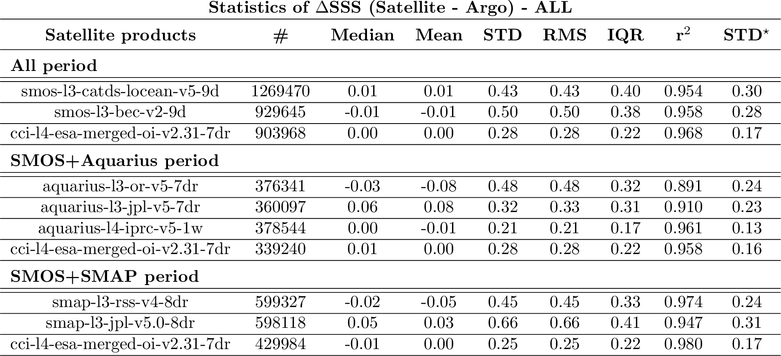

Table S9.2. Statistics of weekly satellite SSS comparisons with Argo SSS (only match-up pairs where RR=0 mm/h, 3<U10 <12 m/s, SST>5°C, distance to coast > 800 km)
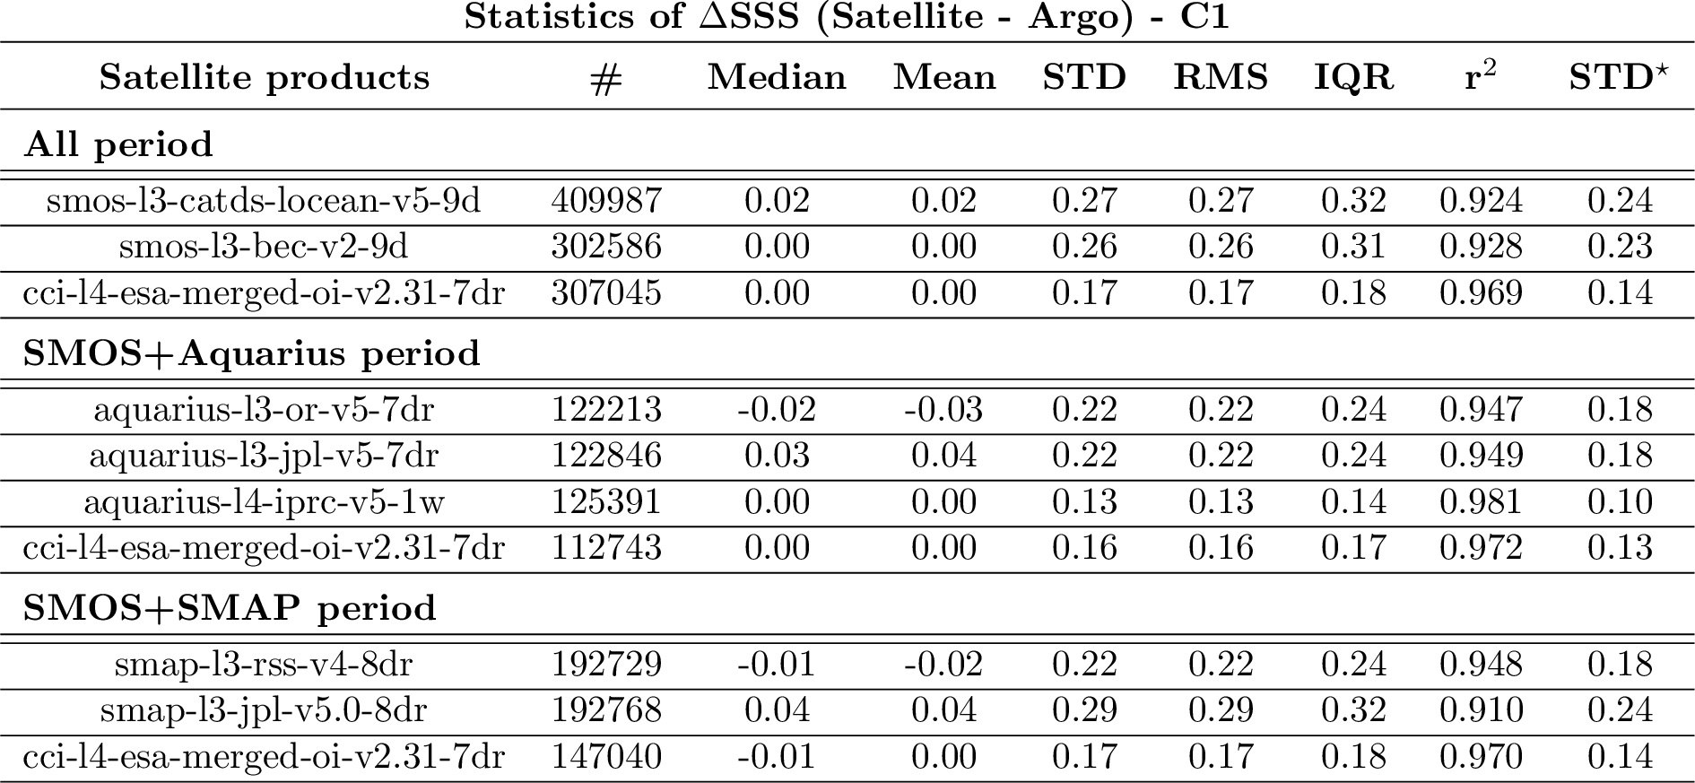

Table S9.3. Statistics of weekly satellite SSS comparisons with VOS LEGOS DM TSG and GOSUD RV TSG SSS (All matchups)
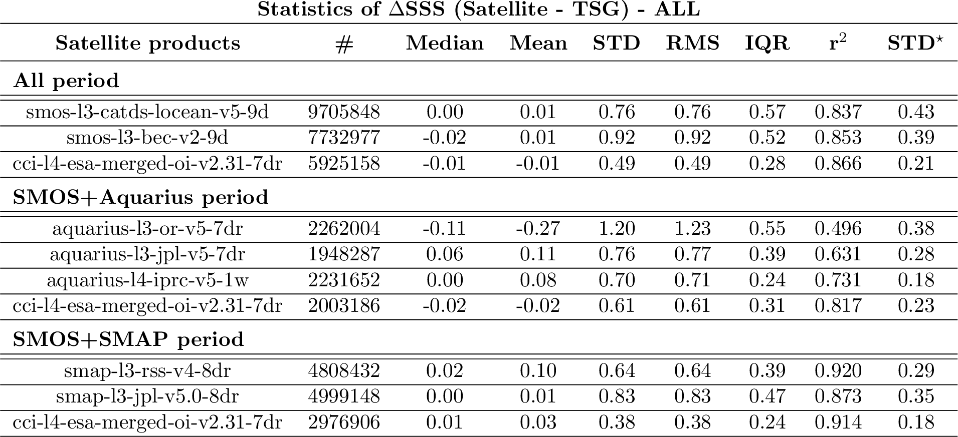

Table S9.4. Statistics of weekly satellite SSS comparisons with VOS LEGOS DM TSG and GOSUD RV TSG SSS (only match-up pairs where RR=0 mm/h, 3<U10 <12 m/s, SST>5°C, distance to coast > 800 km)
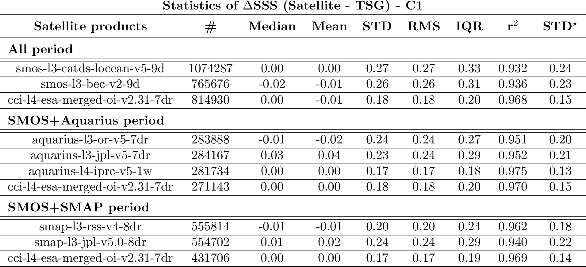

- Statistics of monthly satellite SSS comparisons with in situ SSS in the Southen Ocean (south of 50°S)
Table S10.1. Statistics of monthly satellite SSS comparisons with Argo SSS (All matchups)
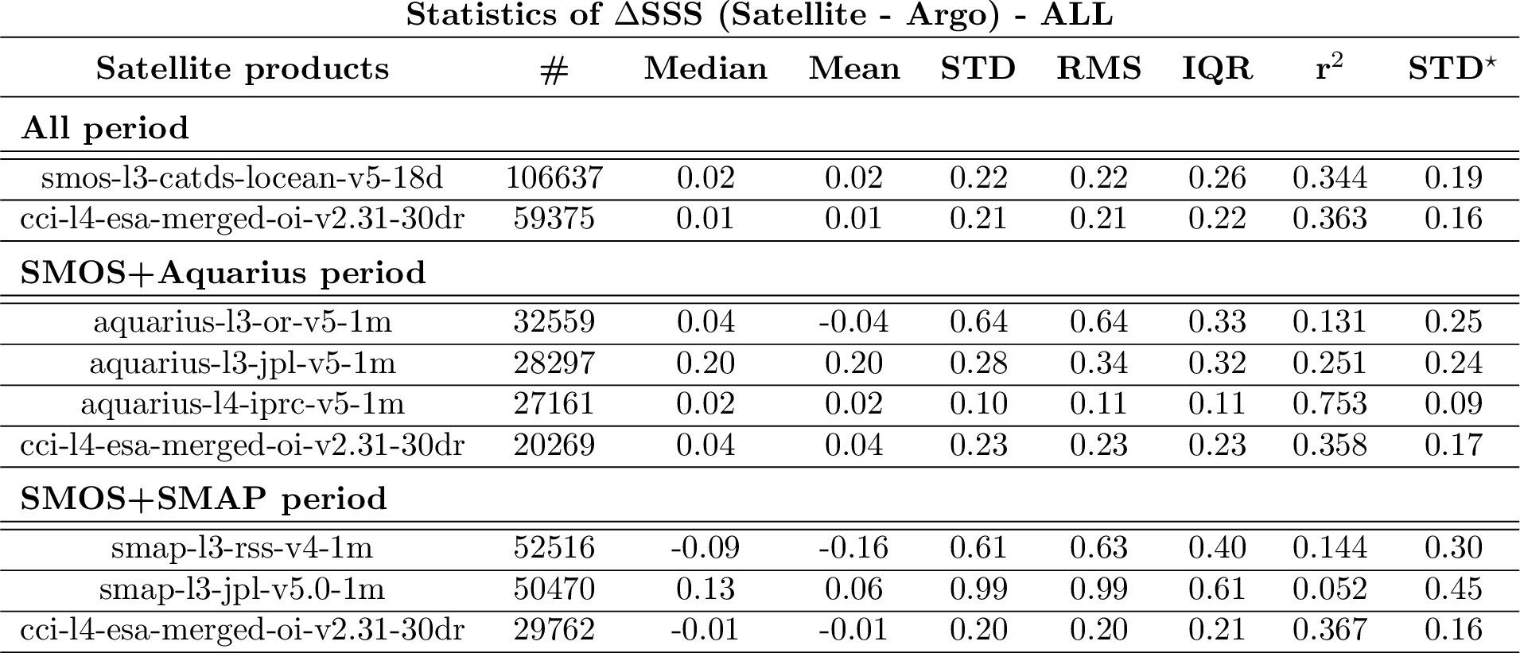

Table S10.2. Statistics of monthly satellite SSS comparisons with sea mammals SSS (All matchups; see a description of the dataset on https://www.salinity-pimep.org)
