SUPPLEMENT TO
Sea Level controls on Agulhas Leakage Salinity and the Atlantic Overturning Circulation

Sophie Nuber* (1, 2, 3), James W. B. Rae (2), Morten B. Andersen (1), Xu Zhang (4), Bas de Boer (5), Matthew D. Dumont (2), Yuchen Sun (6), Huw T. Mithan (3), Ian R. Hall (1), Stephen Barker (1).
(1) Cardiff University, (2) University of St. Andrews, (3) National Taiwan University, (4) Institute of Tibet Plateau Research, Chinese Academy of Science, (5) Vrije Universiteit Amsterdam, (6) Alfred Wegener Institute

METHODS
- SST and relative salinity reconstruction using Mg/Ca and δ¹⁸O_{sw}
Globigerinoides ruber (G. ruber) samples were picked from U1476, then crushed and homogenised. An aliquot of 5 foraminifera was analysed for δ¹⁸O on a MAT253 with a Kiel IV preparation device at Cardiff University. The remaining samples were cleaned and dissolved in a fume hood equipped with HEPA filters under clean laboratory conditions according to Barker et al. (2003). Analysis of Mg/Ca was conducted partially on a Thermo Element XR at Cardiff University, partially on an Agilent Triple Quadrupole at the University of St. Andrews. The instruments were cross-calibrated using the same in-house standard. In both institutions, long term reproducibility of in-house standards yielded RSDs of 1-3%.
SST were calculated from G. ruber Mg/Ca using the transfer function and R-script from Gray & Evans (2019)
$$\frac{Mg}{Ca}= e^{0.060\left(±0.008\right)xT+0.033\left(±0.022\right)xS-0.83\left(±0.73\right)x\left(pH-8\right)-1.07(±0.80)}$$
where T is sea surface temperature, S is salinity, and pH is the negative decadic logarithm of H⁺ ions. SST uncertainties were processed using Monte Carlo propagation analysis.
Ice volume-corrected seawater δ¹⁸O (δ¹⁸O_{sw-ivc}) has been previously used as a proxy for changes in relative seawater salinity in the surface Indian Ocean (e.g. Kiefer et al., 2006). We therefore correct our δ¹⁸O_{carbonate} according to
δ¹⁸O_{sw-ivc} = δ¹⁸O_{carbonate} – δ¹⁸O_{temperature} – δ¹⁸O_{ice volume}
to reflect local δ¹⁸O_{sw} and interpret the results as changes in relative salinity. δ¹⁸O_{temperature} was calculated from Mg/Ca-based temperatures and δ¹⁸O_{G. ruber} using the transfer function of Bouvier-Soumagnac & Duplessy (1985) for Indian Ocean planktonic foraminifera with a correction factor of +0.20 (Pearson, 2012). To determine the best correction curve for δ¹⁸O_{ice volume} across the last 1.2Ma, we tested the sensitivity of 4 different sea level reconstructions on the resulting δ¹⁸O_{sw-ivc} (Figure S6). Reconstructions of δ¹⁸O_{ice volume} from de Boer et al. (2014b) based on the LR04 stack gave representative results over the last ~500 kyr where different sea level reconstructions can be readily compared and also extends for the ~1.2 Myr duration of our record, and was therefore used to determine δ¹⁸O_{sw-ivc}.
The resulting δ¹⁸O_{sw-ivc} was detrended per glacial cycle using the respective glacial cycle’s mid-termination δ¹⁸O_{sw-ivc}. We identified the mid-point of each termination as the middle between the maximum and minimum δ¹⁸O_{benthic} value using the δ¹⁸O_{benthic} data from van der Lubbe et al. (2021). Then, we defined the half-point of each glaciation as the middle between minimum δ¹⁸O_{benthic} and the following maximum. We finally collected the δ¹⁸O_{sw-ivc} value during each termination mid-point and subtracted it from all δ¹⁸O_{sw-ivc} values within that glacial cycle. A glacial cycle was defined from one glacial half-point to the next, with the respective termination mid-point in the centre.
The lead-time of δ¹⁸O_{sw-ivc} to δ¹⁸O_{benthic} was calculated by subtracting the “termination” midpoint-time of δ¹⁸O_{sw-ivc} from the termination midpoint-time of δ¹⁸O_{benthic}. Using this method, we receive an average lead time of δ¹⁸O_{sw-ivc} to δ¹⁸O_{benthic} of 15kyr. For comparison, we also performed a cross spectral analysis between δ¹⁸O_{sw-ivc} and δ¹⁸O_{benthic}. Both records were first clipped to 1350kyr, then subsampled to 1kyr. The resulting cross spectral analysis calculated an average lead time of 18kyr in the δ¹⁸O_{sw-ivc} to δ¹⁸O_{benthic} at the 95% confidence interval.
- SST and δ¹⁸O_{sw} stack formation
The data for the SST, δ¹⁸O_{sw-ivc}, and δ¹⁸O_{benthic} stacks was taken from 8 cores within the Indian Ocean. These include the Agulhas Bank Slice (Martinez-Mendez et al., 2010), MD96-2048 (Caley et al., 2012), U1476 SST, δ¹⁸O_{sw-ivc} (this study) and U1476 δ¹⁸O_{benthic} (van der Lubbe et al., 2021), WIND 28K (Kiefer et al., 2006), TY93-929/P (Barker et al., 2003), MD90-0963 (Rostek et al., 1997; Bassinot et al., 1994), GeoB10038-4 (Mothadi et al., 2010), and MD01-2378 (Xu et al., 2006; Zuraida et al., 2009). The SST, δ¹⁸O_{sw-ivc,} and respective δ¹⁸O_{benthic} stacks were created by first mitigating sampling bias through resampling each of the records at high frequency (10yrs) by linear interpolation. All the resampled records were then combined and a gaussian function (sigma = 8/5kyr) was used to smooth the combined data into a single continuous record with a sampling frequency of 100yrs. The δ¹⁸O_{benthic} stacks were created to allow lead-lag analysis between the SST and δ¹⁸O_{sw-ivc} stacks and their respective δ¹⁸O_{benthic} data. By making an Indian Ocean-specific δ¹⁸O_{benthic} stack, age-model errors are equal between surface and benthic stacks, which makes lead-lag analyses possible.
- Indian Ocean source water analysis
To test whether the salinification process is also evident in Indian Ocean source waters, we additionally analysed SST core data from the western Pacific warm pool (ODP806) (de Gardiel-Thoron et al., 2005) and the South China Sea (ODP1146) (Herbert et al., 2010) for lead-lag against their respective δ¹⁸O_{benthic} using cross spectral analysis. For the analysis, SST and δ¹⁸O_{benthic} data from the cores was clipped to 6-1168kyr, then subsampled at 1kyr. The cross spectral analysis was conducted between the SST data and their respective δ¹⁸O_{benthic} from the same core using the resampled data. Neither core ODP806 or ODP1146 showed a significant SST lead at the 95% confidence interval.
- Age model
The age model for U1476 was taken from van der Lubbe et al. (2021) who aligned U1476 δ¹⁸O_{benthic} to the δ¹⁸O_{benthic} probability stack (Ahn et al., 2017).
- ANICE-SELEN sea level-topography model
To gain understanding of the land surfacing and flooding rates around the Indonesian archipelago, we ran a time-transient simulation of RSL calculated in the ice-sheet model ANICE (de Boer et al., 2013), which was then fed into the topography model SELEN (de Boer et al., 2014a). ANICE uses an inverse forward modelling approach where δ¹⁸O_{benthic} is split into ice volume and bottom water temperature components through global ice mass conservation calculations. The approach assumes that changes in NH mid latitude-to-subpolar surface-air temperatures (ΔT_{NH}) are strongly related to changes in ice volume and deep-water formation. Changes in ΔT_{NH} are derived from the difference between modelled δ¹⁸O at time t, and foraminiferal δ¹⁸O_{benthic} at time t+100 years. The changes in ΔT_{NH} are subsequently fed into a 3D ice sheet and deep-water temperature model whose outputs influence the determination of modelled δ¹⁸O. Relative sea level is calculated in parallel from changes in the resulting ice volume component of δ¹⁸O. The sea level height information was then fed into SELEN which calculates above-sea level topography using ice sheet chronology and a solid Earth rheology model accounting for changes in RSL as well as gravitational changes linked to water and ice load, influences of earth’s rotation, glacial isostatic adjustment of the solid earth, and migration of coastlines across the globe. Model coupling is complete, such that SELEN informs the ANICE model about basal topography prior to the next timestep. To increase model-run efficiency, the fully coupled version was run for 599 kyr with a map every 1 kyr, producing 598 global topography maps (see supplementary Figure S7). The spatial resolution per map is 1 pixel per ⁓5000 km². To cover a greater number of glacial cycles in 600kyr of model run time, we chose to run 10 glacial cycles between 651kyr and 1250ky assuming that changes in the outline of continents and islands stay constant across the last 1.2Ma. Therefore, any correlations between changes in the land-ocean ratio and RSL should also be valid for younger glacial cycles.
To calculate changes in above-sea level topography, all maps were processed in Python and cut to the same size, zooming in on the Indonesian archipelago (Figure S4a). Each pixel was given a value of 0, 1, or NaN for ocean, land, or unidentifiable, respectively. Then, land-to-ocean ratios were calculated for each map as
$$R_{land-ocean}= \frac{\sum{{Pixel}_{land}}}{\sum{{Pixel}_{ocean}}}$$
Changes in the ratio land-to-ocean ratio with respect to sea level stand [m] were calculated as
$$∆R_{land-ocean}= \frac{R_{land-ocean}\left(RSL\left(t+1\right)\right)-R_{land-ocean}(RSL\left(t\right))}{RSL\left(t+1\right)-RSL(t)}$$
To identify trends linked to rising and falling sea level, the data was grouped into ratios at times of rising, and ratios at times of falling sea level, respectively.
- Salinity influence on AMOC in comprehensive climate model COSMOS
Ocean circulation experiments were conducted in COSMOS (Zhang et al., 2013). For glacial state control settings see Zhang et al. (2013). Based on the equilibrium state of the Last Glacial Maximum, we disturbed the glacial ocean circulation by imposing a constant 0.15Sv freshwater perturbation over the ice-rafted debris belt in the North Atlantic for 500 years (LGM015) (see also Zhang et al., 2013). This weakened AMOC state serves as a climate background comparable to early deglacial Heinrich stadial. We then investigated effects of additional salinity perturbations on the Agulhas plateau by removing freshwater from the region through enhanced evaporation. Two salt-water perturbation experiments with strengths of 0.05Sv (LGM015 SA_005) and 0.1Sv (LGM015 SA_01) were integrated for 800 years based on LGM015 (i.e. under the background climate of persistent freshwater input in the North Atlantic). In addition, LGM015 is continued for additional 800 years to provide a direct reference for AMOC changes in LGM015 SA_005 and LGM015 SA_01.

SUPPLEMENTARY FIGURES

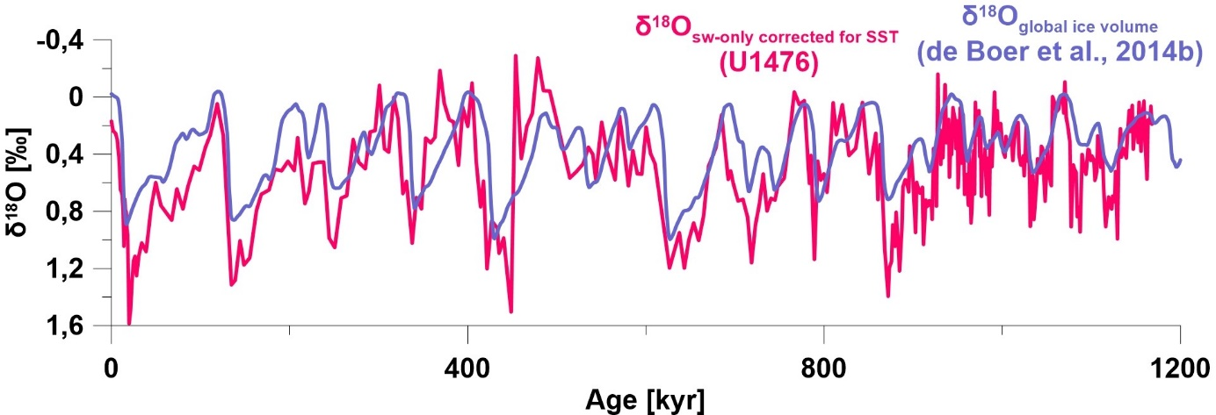
Figure S1. Reconstructed δ¹⁸O_{sw-SST} (SST corrected only) from U1476 (pink) and δ¹⁸O from global ice volume changes (de Boer et al., 2014). In each glacial cycle, the change in surface water δ¹⁸O_{sw-SST} at U1476 exceeds global changes during peak glacial conditions. The average glacial-interglacial difference across all glacial cycles is roughly 50% lower in the δ¹⁸O_{global ice volume} than in the δ¹⁸O_{sw-SST}.

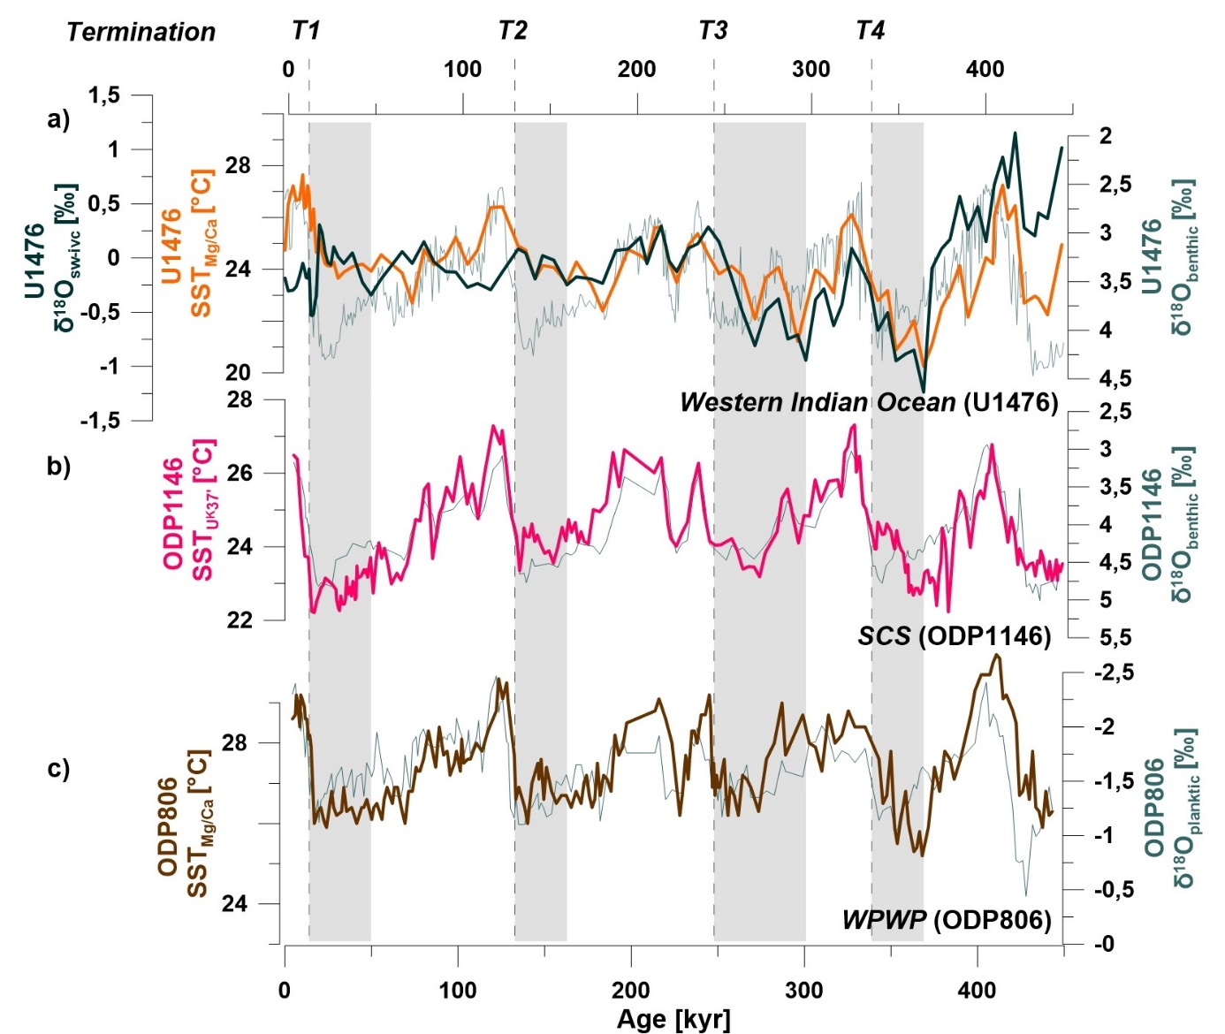
Figure S2. Surface hydrography in the source regions of the ITF and the Indian Ocean. (a) U1476 δ¹⁸O_{sw-ivc} (dark green), U1476 Mg/Ca-derived sea surface temperatures (orange), and U1476 δ¹⁸O_{benthic} (thin blue line) (van der Lubbe et al., 2021) from the western Indian Ocean. (b) Alkenone-derived sea surface temperatures (light pink) and δ¹⁸O_{benthic} (thin blue line) from the South China Sea (Herbert et al., 2010). (c) Mg/Ca-derived sea surface temperatures (brown) and δ¹⁸O_{benthic} (thin blue line) from the western Pacific warm pool (de Gardiel-Thoron et al., 2012). Onset of U1476 glacial salinification highlighted in grey bars. Note that both South China Sea, and western Pacific warm pool records do not show a similarly consistent lead-lag pattern between their respective SST and δ¹⁸O_{benthic} data.

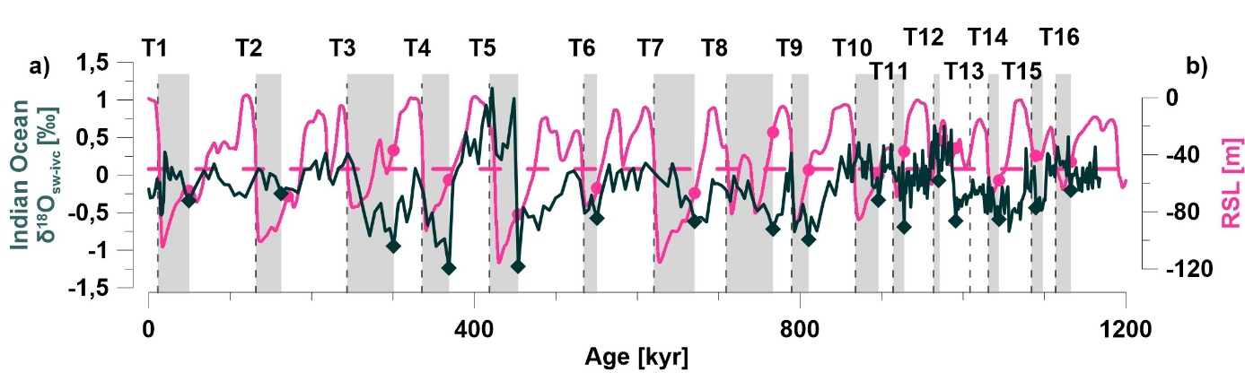
Figure S3. (a) U1476 ice volume-corrected δ¹⁸O_{sw} (green line) for the surface Ocean, with the onset of δ¹⁸O_{sw-ivc} increases indicated by green diamonds. (b) Relative sea level (de Boer et al., 2014) (pink line), with pink dots indicating the RSL-stands at times of onset of δ¹⁸O_{sw-ivc} increases (e.g. pink dots mark RSL at the time of the green diamonds in δ¹⁸O_{sw-ivc}). The average RSL-stand corresponding to increased δ¹⁸O_{sw-ivc} is indicated with a horizontal dashed pink line. This yields very similar results to the analysis of the whole Indian Ocean stack shown in Figure 3.

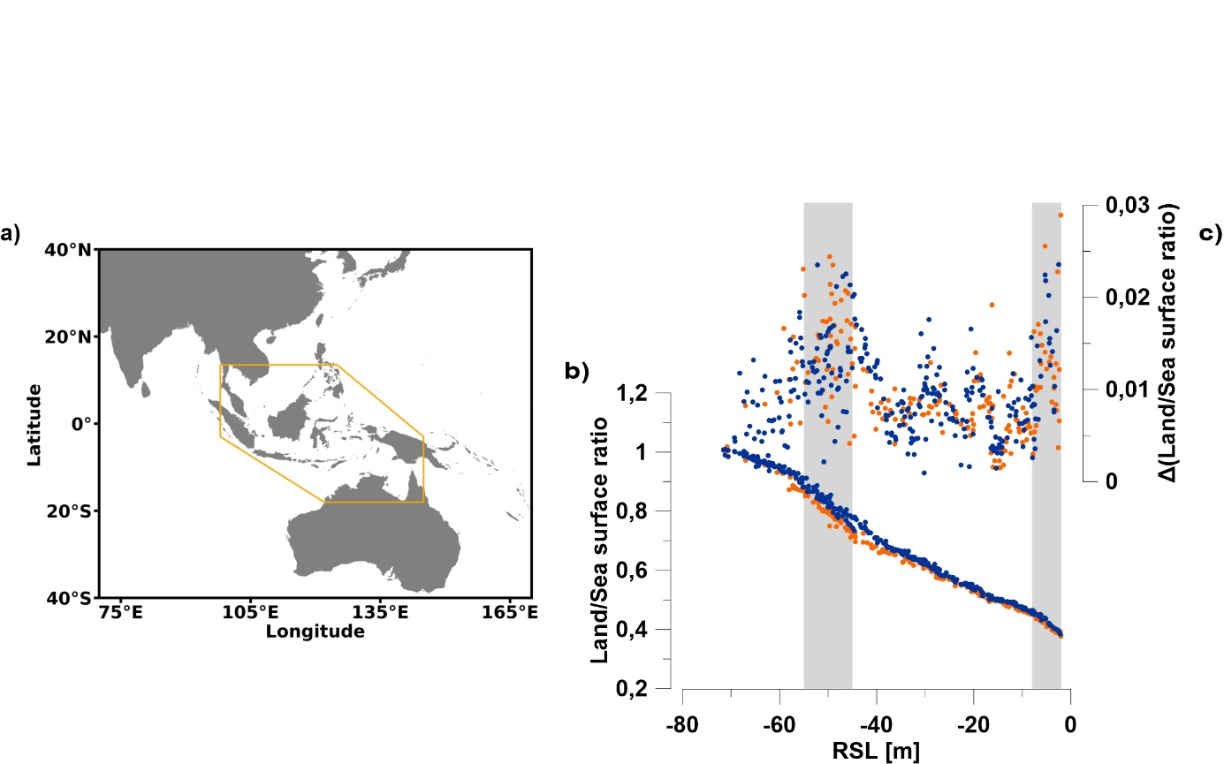
Figure S4. Changes in land surfacing in the Indonesian Archipelago as a function of changes in sea level. (a) The pixels occurring within the orange polygon were used to calculate the land/sea ratio in each time-slice map created by the ANICE-SELEN model. (b) Change in land to sea surface ratio in the Indonesian archipelago as modelled by the coupled ice sheet-topography model ANICE-SELEN for a subset of 9 glacial-interglacial cycles in respect to relative sea level. Changes occurring from falling and rising sea level are plotted in blue and orange respectively. (c) Slope of the land/sea surface ratio as a function of RSL to highlight specific sea levels at which the rate of land exposure during sea level fall, or land flooding during sea level rise, is particularly fast. This occurs at around 0-8m and 45-50m (highlighted with vertical grey shaded bars).

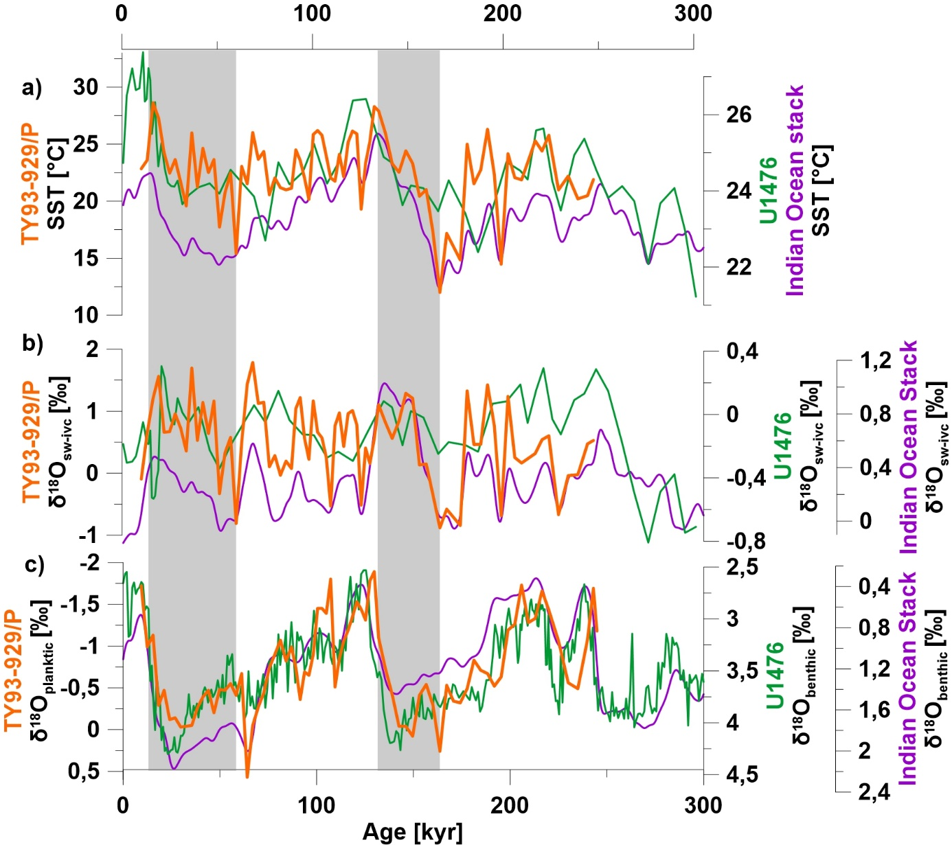
Figure S5. Consistent evolution of SST (a) and δ¹⁸O_{sw-ivc} (b) from the western Indian Ocean (U1476, green line) (this study), Arabian Sea (TY93-929/P, orange line) (Barker et al., 2003), and the whole Indian Ocean SST and δ¹⁸O_{sw-ivc} stacks (purple line) (this study). Raw benthic and planktic δ¹⁸O data are also shown (c) as a measure of chronological consistency. Grey bars highlight the early increase in SST and δ¹⁸O_{sw-ivc} prior to terminations as seen in δ¹⁸O_{benthic}.

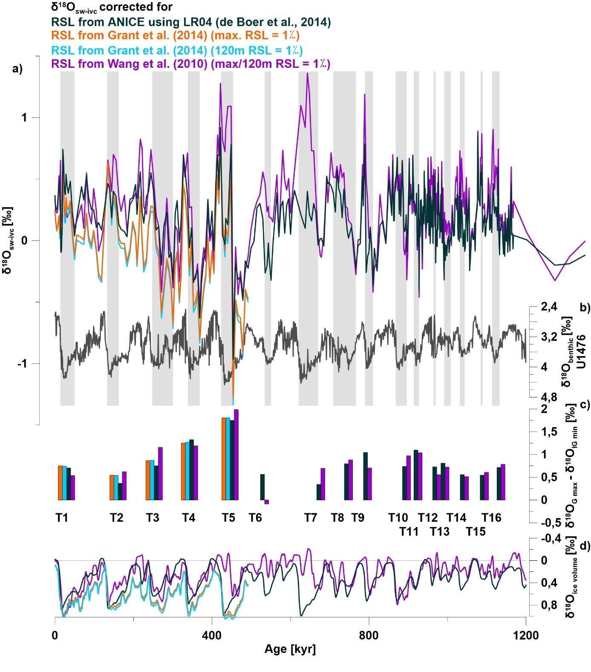
Figure S6. (a) Resulting δ¹⁸O_{sw-ivc} records using 4 different RSL reconstructions for the ice volume correction. U1476 δ¹⁸O_{benthic} (van der Lubbe et al., 2021) is plotted in b) for lead-lag comparison. Grey bars highlight the early increase in δ¹⁸O_{sw-ivc} prior to terminations. The de Boer et al. (2014) ice volume correction allowed modelled ice volume δ¹⁸O to be used (dark green). For other RSL reconstructions, a change of 1% in δ¹⁸O_{benthic} per 120m RSL was assumed. The colour of each δ¹⁸O_{sw-ivc} record corresponds with the referenced scenario below. (c) Absolute δ¹⁸O_{sw-ivc} amplitude of the glacial δ¹⁸O_{sw-ivc} maxima compared to the preceding minima for all 4 δ¹⁸O_{sw-ivc} scenarios. The colours of the bars correspond to the referenced scenarios in (a). Note that differences between different scenarios are small. (d) Corresponding ice volume δ¹⁸O curves for the 4 RSL reconstructions. The colours of each line correspond with the referenced scenario in (a).

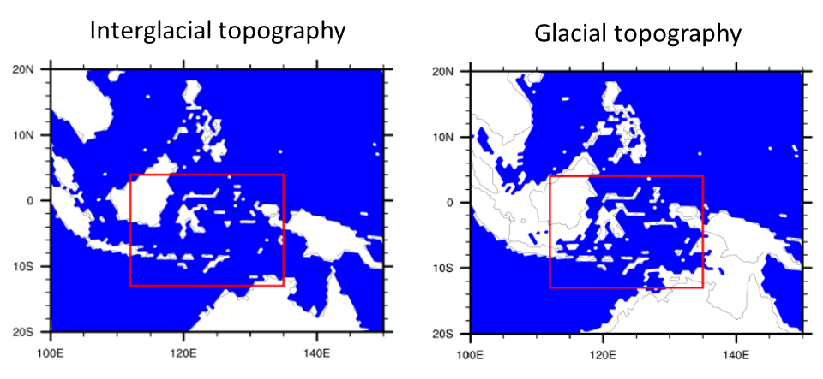
Figure S7. Example output maps from ANICE-SELEN coupled ice-sheet topography model showing coastline topography in the Indonesian archipelago during a representative interglacial (1067kyr) and representative glacial (873kyr).

ADDITIONAL REFERENCES
- Lauvset, S. K., Lange, N., Tanhua, T., Bittig, H. C., Olsen, A. C., Kozyr, A., Àlvarez, M., Becker, S., Brown, P. J., Carter, B. R., Cotrim da Cunha, L., Feely, R. A., van Heuven, S., Hoppema, M., Ishii, M., Jeansson, E., Jutterström, S., Jones, S. D., Karlsen, M. K., Lo Monaco, C., Michaelis, P., Murata, A., Pérez, F. F., Pfeil, B., Schirnick, C., Steinfeldt, R., Suzuki, T., Tilbrook, B., Velo, A., Wanninkhof, R., Woosley, R. J., and Key, R. M. (2021). An updated version of the global interior ocean biogeochemical data product, GLODAPv2.2021. Earth System Sciences Data Discussion, 1-32. doi:10.5194/essd-2021-234.
- Pierre, C., Saliège, J. F., Urrutiaguer, M. J., & Giraudeau, J. (2001). Stable isotope record of benthic and planktonic foraminifera from ODP Site 175-1087 in the southern Cape Basin, Atlantic Ocean. PANGAEA. https://doi.org/10.1594/PANGAEA.701338
- Martinez-Mendez, G., Zahn, R., Hall, I. R., Peeters, F. J. C., Pena, L. D., Cacho, I., & Negre, C. (2010). Contrasting multiproxy reconstructions of surface ocean hydrography in the Agulhas Corridor and implications for the Agulhas Leakage during the last 345,000 years. Paleoceanography, 25(4). https://doi.org/10.1029/2009PA001879
- Kiefer, T., McCave, I. N., & Elderfield, H. (2006). Antarctic control on tropical Indian Ocean sea surface temperature and hydrography. Geophysical Research Letters, 33(24), L24612. https://doi.org/10.1029/2006GL027097
- Rostek, F., Bard, E., Beaufort, L., Sonzogni, C., & Ganssen, G. (1997). Sea surface temperature and productivity records for the last 240 kyr on the Arabian Sea. Deep-Sea Research Part II: Topical Studies in Oceanography, 44(6–7), 1461–1480. https://doi.org/10.1016/S0967-0645(97)00008-8
- Bassinot, F. C., Beaufort, L., Vincent, E., Labeyrie, L. D., Rostek, F., Müller, P. J., Quidelleur, X., & Lancelot, Y. (1994). Coarse fraction fluctuations in pelagic carbonate sediments from the tropical Indian Ocean: A 1500-kyr record of carbonate dissolution. Paleoceanography, 9(4), 579–600. https://doi.org/10.1029/94PA00860
- Mohtadi, M., Lückge, A., Steinke, S., Groeneveld, J., Hebbeln, D., & Westphal, N. (2010). Late Pleistocene surface and thermocline conditions of the eastern tropical Indian Ocean. Quaternary Science Reviews, 29(7), 887–896. https://doi.org/https://doi.org/10.1016/j.quascirev.2009.12.006
- Xu, J., Holbourn, A., Kuhnt, W., Jian, Z., & Kawamura, H. (2008). Changes in the thermocline structure of the Indonesian outflow during Terminations I and II. Earth and Planetary Science Letters, 273(1–2), 152–162. https://doi.org/10.1016/j.epsl.2008.06.029
- Zuraida, R., Holbourn, A., Nürnberg, D., Kuhnt, W., Dürkop, A., & Erichsen, A. (2009). Evidence for Indonesian Throughflow slowdown during Heinrich events 3 to 5. Paleoceanography, 24(2), n/a-n/a. https://doi.org/10.1029/2008PA001653
- Herbert, T. D., Peterson, L. C., Lawrence, K. T., & Liu, Z. (2010). Tropical ocean temperatures over the past 3.5 million years. Science, 328(5985), 1530–1534. https://doi.org/10.1126/science.1185435
- De Garidel-Thoron, T., Rosenthal, Y., Bassinot, F., & Beaufort, L. (2005). Stable sea surface temperatures in the western Pacific warm pool over the past 1.75 million years. Nature, 433(7023), 294–298. https://doi.org/10.1038/nature03189
- de Boer, B., Lourens, L. J., & Van De Wal, R. S. W. (2014b). Persistent 400,000-year variability of antarctic ice volume and the carbon cycle is revealed throughout the plio-pleistocene. Nature Communications, 5. https://doi.org/10.1038/ncomms3999
- Gray, W. R., & Evans, D. (2019). Nonthermal Influences on Mg/Ca in Planktonic Foraminifera: A Review of Culture Studies and Application to the Last Glacial Maximum. Paleoceanography and Paleoclimatology, 34(3), 306–315. https://doi.org/10.1029/2018PA003517
- Bouvier-Soumagnac, Y., & Duplessy, J.-C. (1985). Carbon and oxygen isotopic composition of planktonic foraminifera from laboratory culture, plankton tows and Recent sediment; implications for the reconstruction of paleoclimatic conditions and of the global carbon cycle. Journal of Foraminiferal Research, 15(4), 302–320. http://dx.doi.org/10.2113/gsjfr.15.4
- Pearson, P. N. (2012). Oxygen Isotopes in Foraminifera: Overview and Historical Review. The Paleontological Society Papers, 18, 1–38. https://doi.org/10.1017/s1089332600002539
- Ahn, S., Khider, D., Lisiecki, L. E., & Lawrence, C. E. (2017). A probabilistic Pliocene–Pleistocene stack of benthic δ18O using a profile hidden Markov model. Dynamics and Statistics of the Climate System, 2(1). https://doi.org/10.1093/climsys/dzx002
- de Boer, B., van de Wal, R. S. W., Lourens, L. J., Bintanja, R., & Reerink, T. J. (2013). A continuous simulation of global ice volume over the past 1 million years with 3-D ice-sheet models. Climate Dynamics, 41(5), 1365–1384. https://doi.org/10.1007/s00382-012-1562-2

