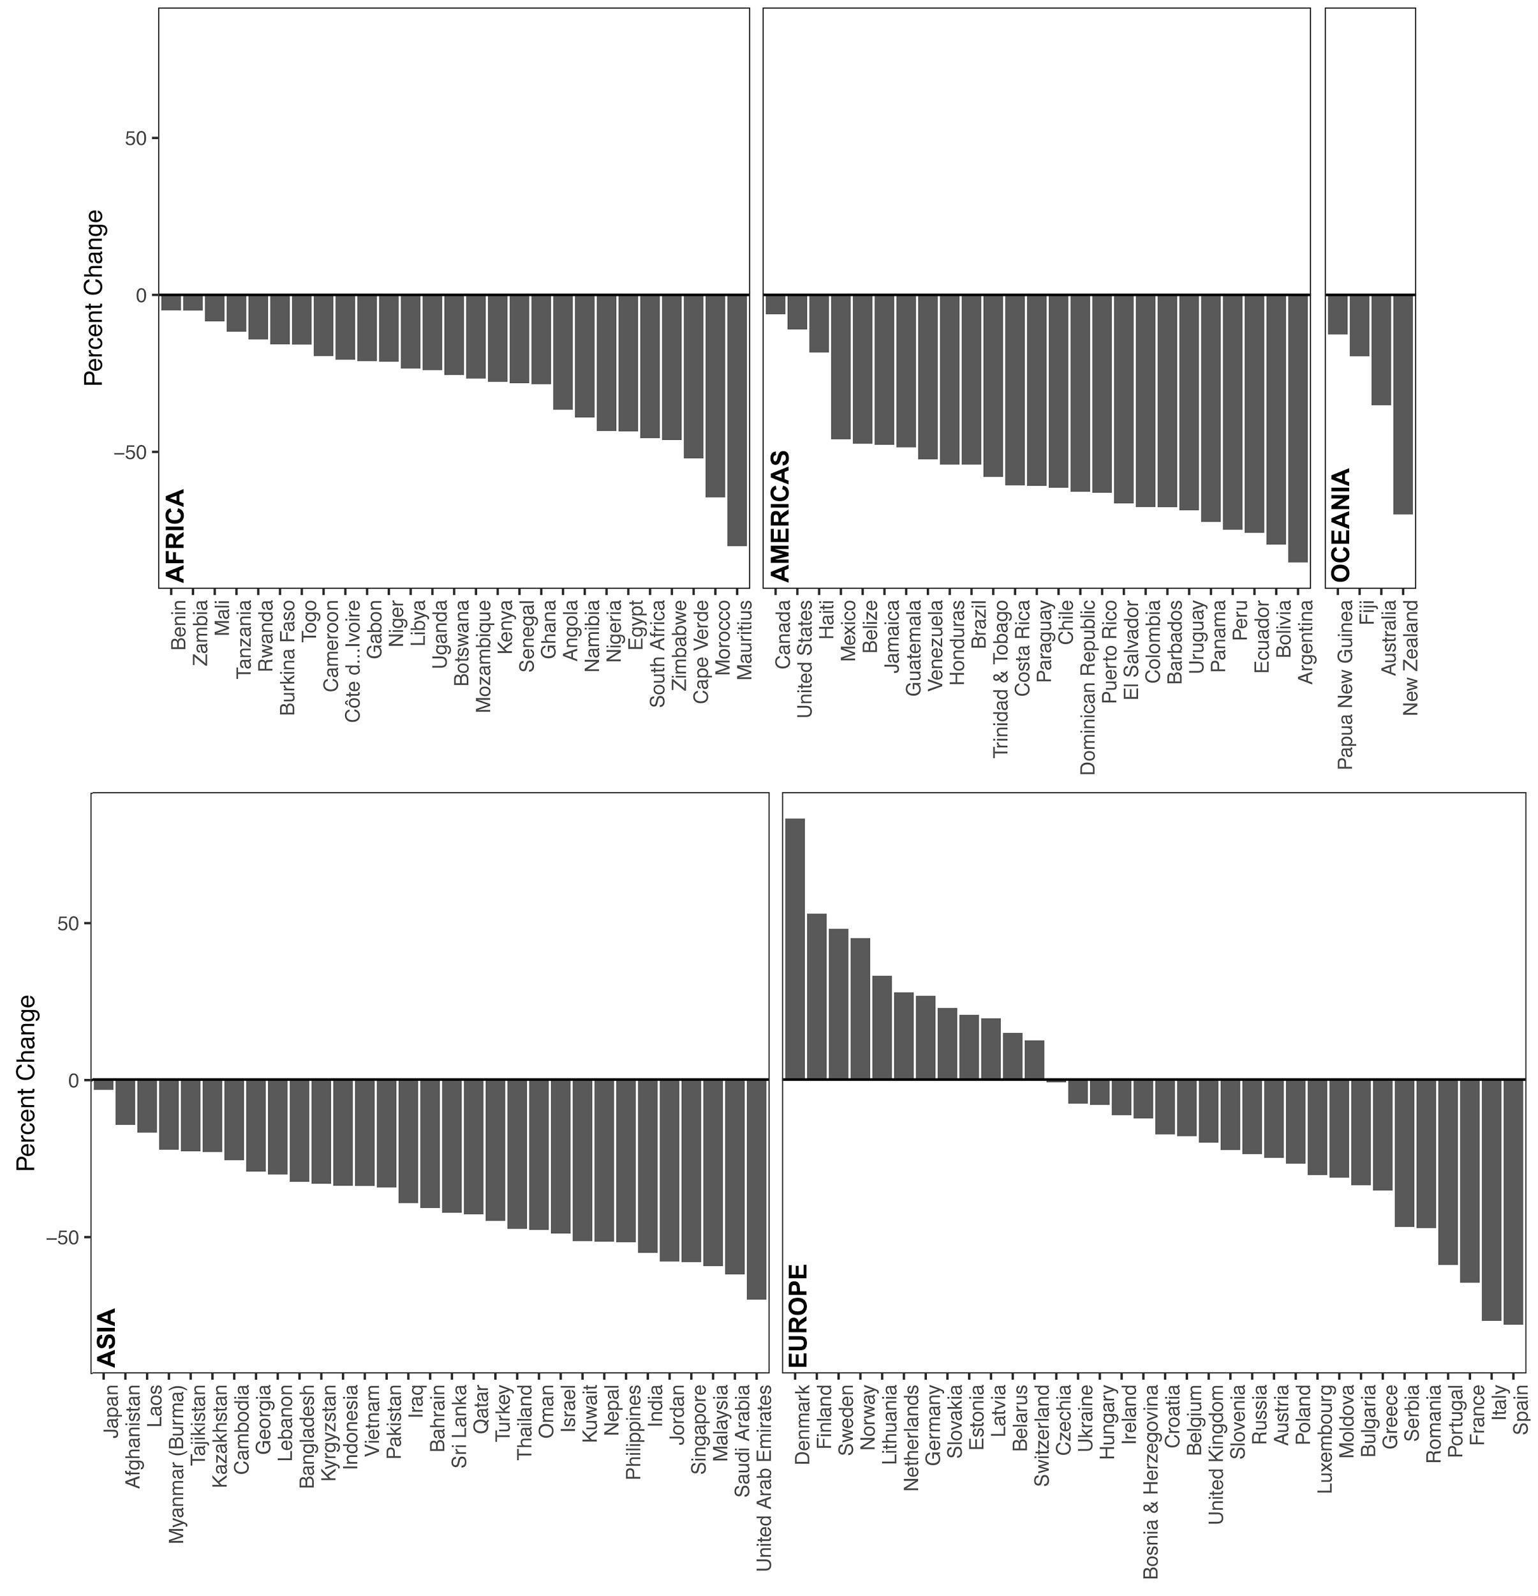
Fig. A1. Change in time spent visiting nature. Percent change in time spent visiting parks and beaches following implementation of confinement measures in each country.
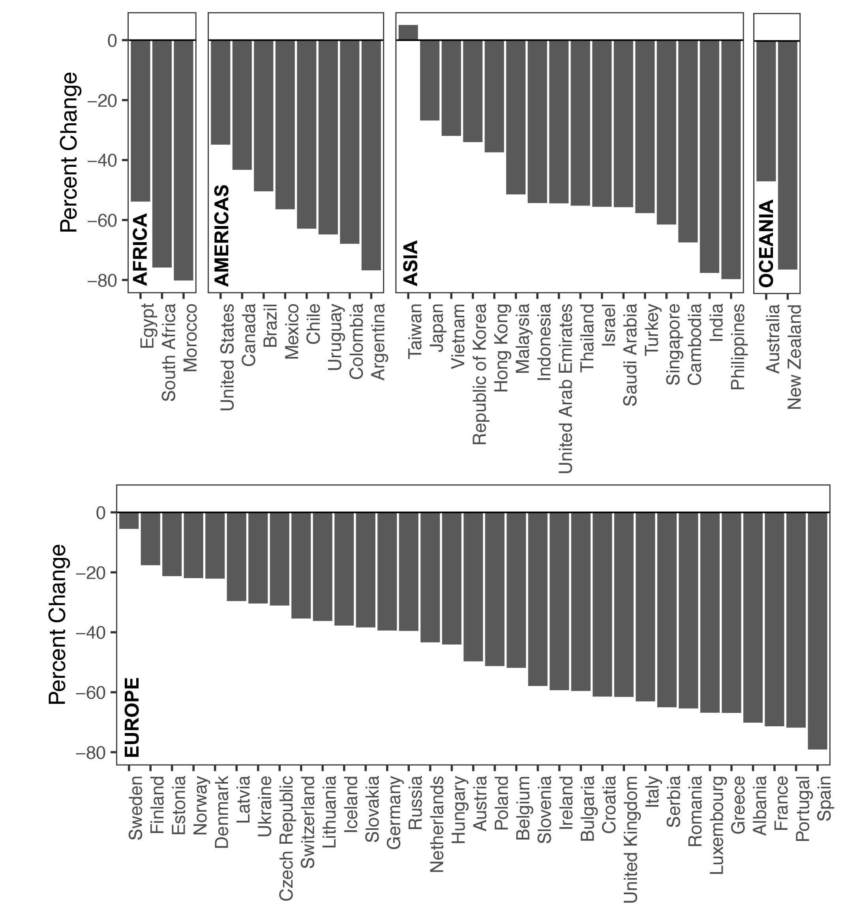
Fig. A2. Change in time spent driving. Percent change in time spent driving following implementation of confinement measures in each country.
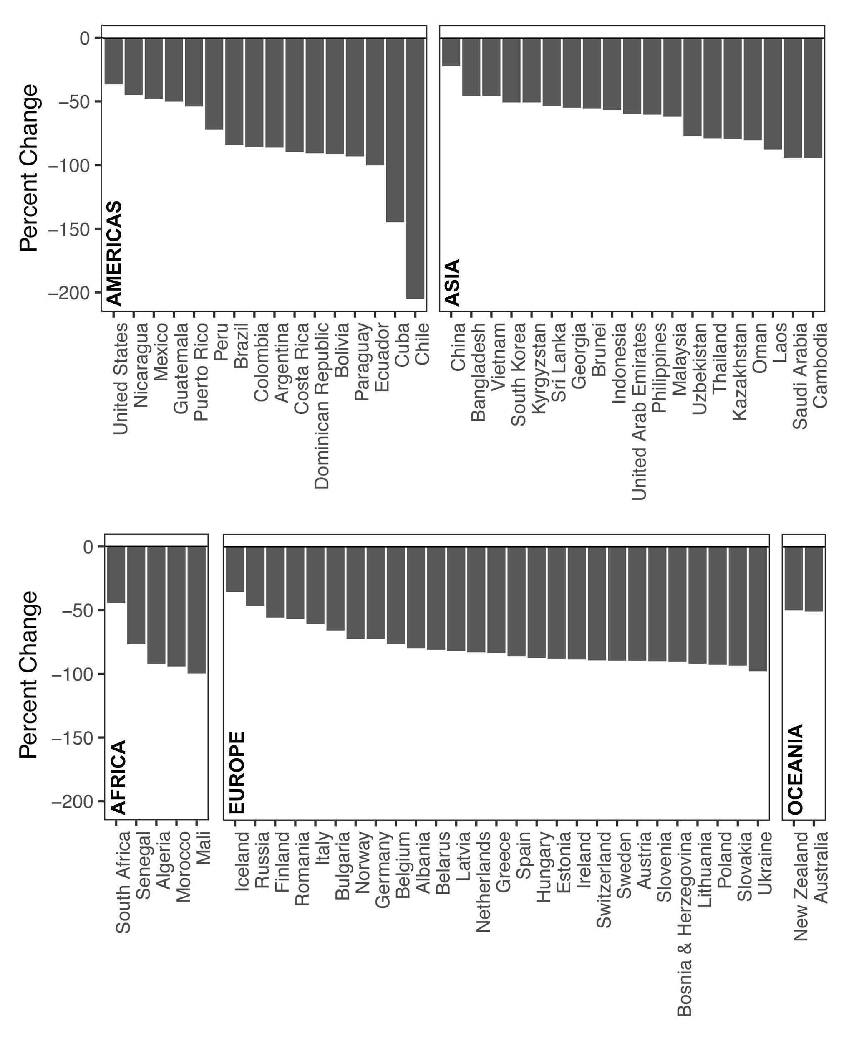
Fig. A3. Change in air traffic based on flight schedules. Percent change in flight schedules (air traffic) following implementation of confinement measures in each country.
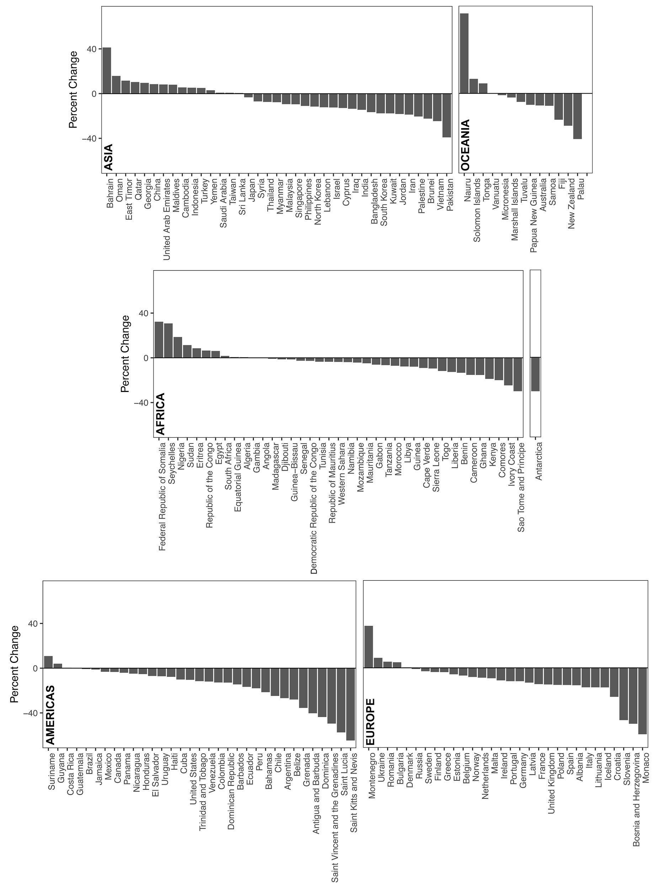
Fig. A4. Change in marine traffic based on automatic information system (AIS) by country economic exclusive zone (EEZ). Percent change in marine traffic density based on global AIS following implementation of confinement measures in each country’s EEZ.

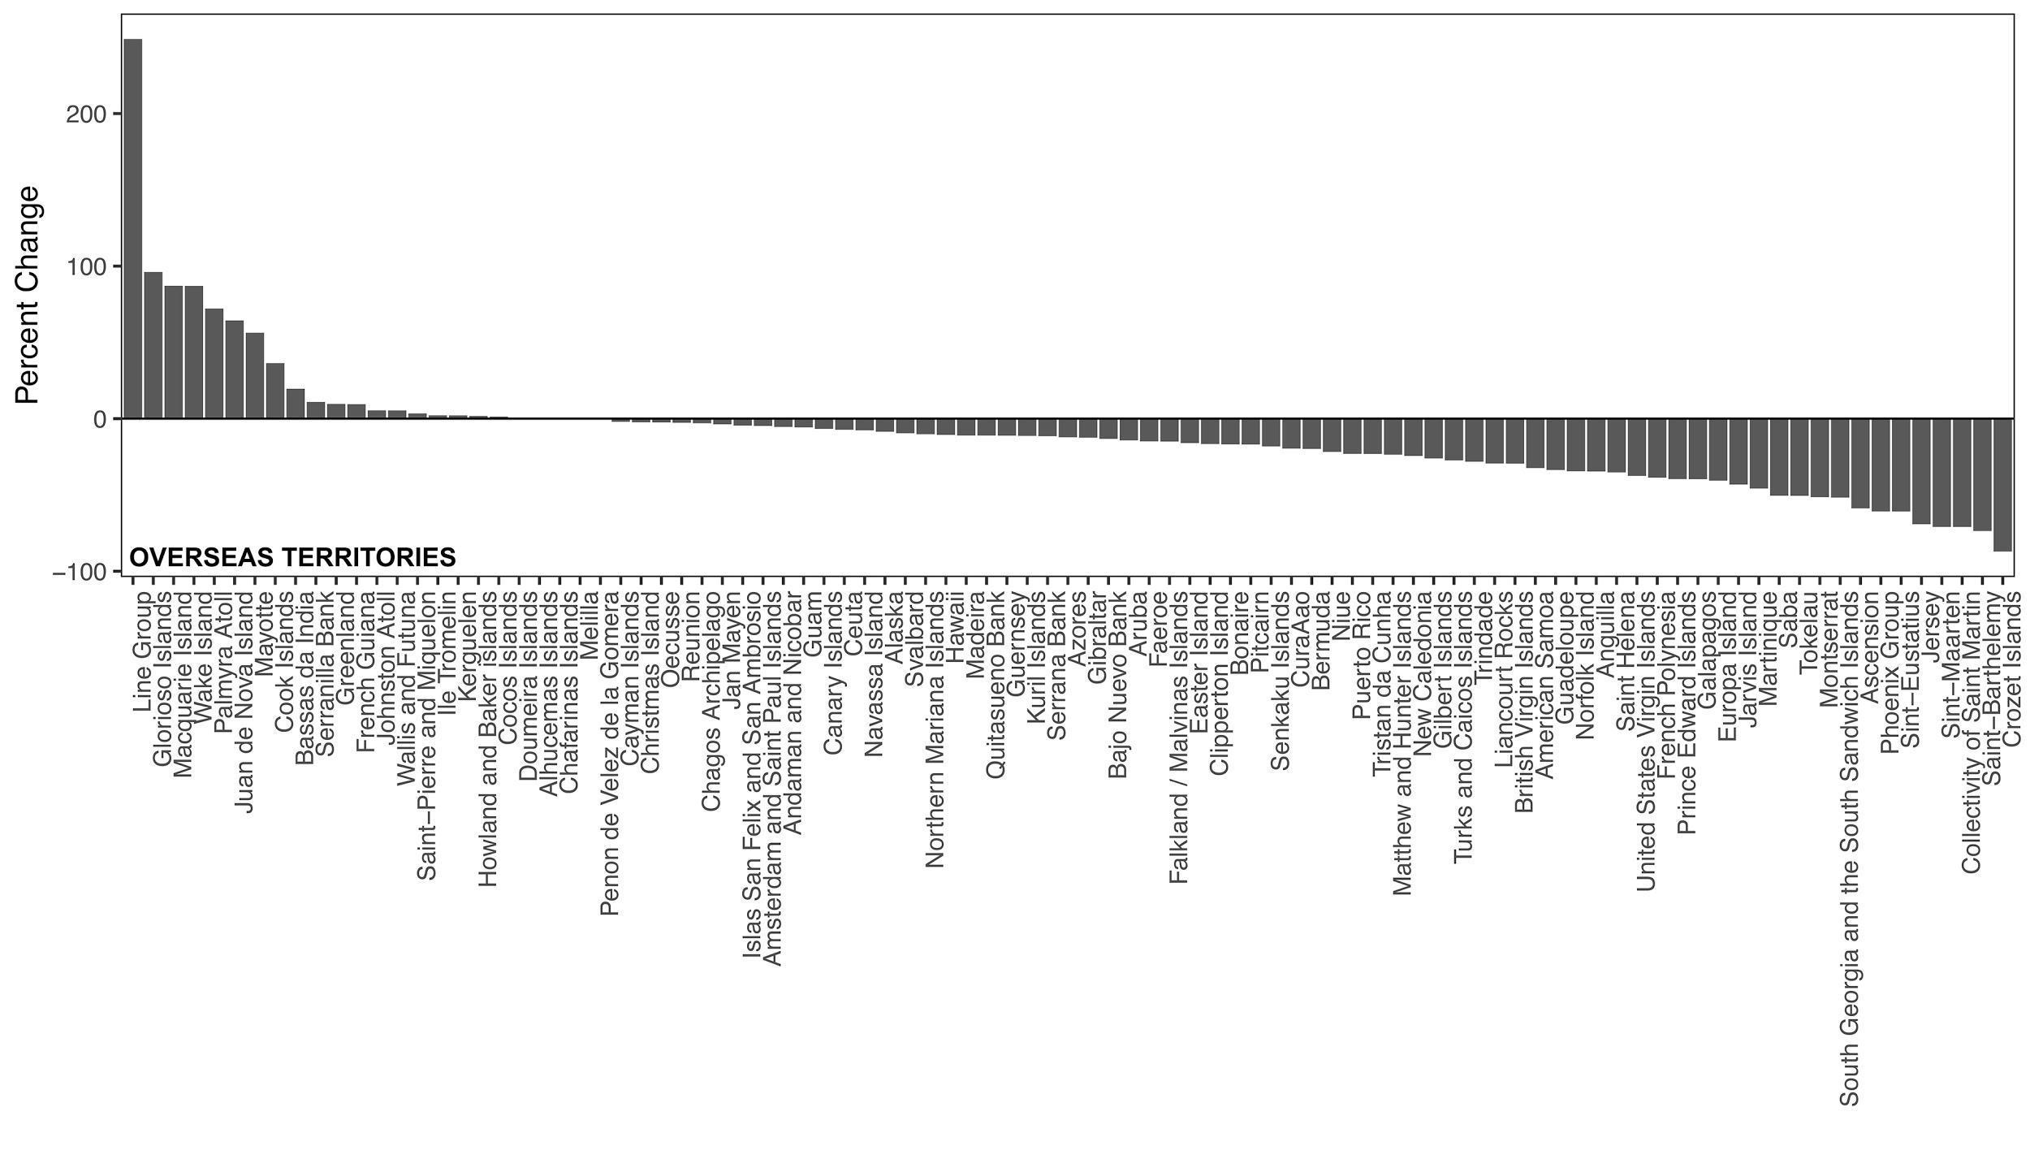Fig. A5. Change in marine traffic based on automatic information system (AIS) by Overseas Territory exclusive economic zone (EEZ). Percent change in time marine vessels were active (marine traffic) based on global ship tracking intelligence (AIS) following implementation of confinement measures in each EEZ.

Table A1. Categories describing the type of effect related to human activities, biodiversity threats, biodiversity and social systems.

Group | Category | Response
Human Mobility & Activities | Transportation corridor | Air traffic
Human Mobility & Activities | Transportation corridor | Boat traffic
Human Mobility & Activities | Transportation corridor | Road traffic
Human Mobility & Activities | Transportation corridor | Shipping traffic
Human Mobility & Activities | Mobility | Time at home
Human Mobility & Activities | Recreation | Human presence
Biodiversity Threats | Human-wildlife interaction | Aggression
Biodiversity Threats | Human-wildlife interaction | Disease transmission
Biodiversity Threats | Human-wildlife interaction | Habituation
Biodiversity Threats | Environmental damage | Habitat change
Biodiversity Threats | Environmental damage | Environmental pollution
Biodiversity Threats | Environmental damage | Noise
Biodiversity Threats | Environmental damage | Waste production
Biodiversity Threats | Biological resource use | Animal exploitation
Biodiversity Threats | Biological resource use | Hunting & fishing
Biodiversity Threats | Biological resource use | Illegal hunting
Biodiversity Threats | Biological resource use | Wildlife trade
Biodiversity Threats | Biological resource use | Mining
Biodiversity Threats | Traffic | Animal strike
Wildlife Responses | Habitat use | Abundance¹
Wildlife Responses | Habitat use | Distribution²
Wildlife Responses | Habitat use | Diversity
Wildlife Responses | Habitat use | Foraging
Wildlife Responses | Performance | Behavior
Wildlife Responses | Performance | Health
Wildlife Responses | Performance | Reproduction
Wildlife Responses | Performance | Survival
Wildlife Responses | Species interaction | Competition & predation
Social Systems & Structures | Communication | Nature sentiment
Social Systems & Structures | Conservation | Monitoring
Social Systems & Structures | Conservation | Pest management
Social Systems & Structures | Conservation | Species protection
Social Systems & Structures | Economy | Income
Social Systems & Structures | Policy | Enforcement
Social Systems & Structures | Science | Monitoring
Social Systems & Structures | Science | Field research

- Abundance: if there is a report of more individuals of a species in their usual location, or recovery in population numbers, or increase in frequency of sightings for usual (rather than unusual) locations.
- Distribution: if there is a report of one or more individuals of a species in a different location than usual (in essence, when the species expands its range).

Table A2. Effect scoring scheme applied to qualitative observations.

Direction Effect | Score | Description
None | 0 | Effect is unknown or minimal
Positive | 1 | Effect is positive in relation to response observed
Negative | -1 | Effect is negative in relation to response observed
Spatial  Index | Score | Description
Local | 1 | Small-scale: town/ city / community
Regional | 2 | Medium-scale: larger than city or more than one city
Global | 3 | Large-scale: continental to global
Temporal Index | Score | Description
Short-term | 1 | Instantaneous - observation occurred once
Medium-term | 2 | Ephemeral – occurred over weeks to months
Magnitude Effect Score | Score | Description
Unknown | 0 | No known impact
Low | 1 | Low social, environmental and/or economic impact
Moderate | 2 | Moderate social, environmental and/or economic impact
High | 3 | High social, environmental and/or economic impact
Extreme | 4 | Extreme social, environmental and/or economic impact

