**SUPPLEMENTARY INFORMATION**

**APPENDIX**

**Appendix 1: Investigating methylation shifts on candidate genes**

Previous studies on birds (particularly great tits) in urban or non-urban context highlighted several genes involved in phenotypic shifts associated with urbanization:

* DRD4 and SERT: involved in novelty seeking, risk taking and exploratory behaviour (Mueller, Partecke, Hatchwell, Gaston, & Evans, 2013; Riyahi, Sánchez-Delgado, Calafell, Monk, & Senar, 2015)
* CLOCK: involved in circadian behaviour (e.g. Steinmeyer, Mueller, & Kempenaers, 2009)
* COL4A5: involved in bill morphology (Bosse et al., 2017)
* EGR1: involved in learning and memory (Laine et al., 2016)
* FOXP2: involved in song learning (Laine et al., 2016)
* GP2: involved in modulating immune response (Lindner et al., 2021)
* NR5A1: involved in regulating female reproduction, in particular ovarian functioning (Lindner et al., 2021)

We explored patterns of methylation associated with these gene and provide methylation plots that could be used in future studies focusing on these genes. Note that among this list of genes, only DRD4, CLOCK, COL4A5, EGRI and FOXP2 were sequenced with enough quality in our dataset and were hence plotted in Figure S7 to S11. We do not detect any clear pattern of methylation shifts between urban and forest birds on any of these genes. These results suggest that if a difference in expression of these genes is responsible for the phenotypic shifts observed in the urban habitat, such difference in expression is probably not due to a difference in methylation in blood tissues.

**SUPPLEMENTARY TABLES**

**Table S1:** RRBS reads filtering and mapping success reports per sample.

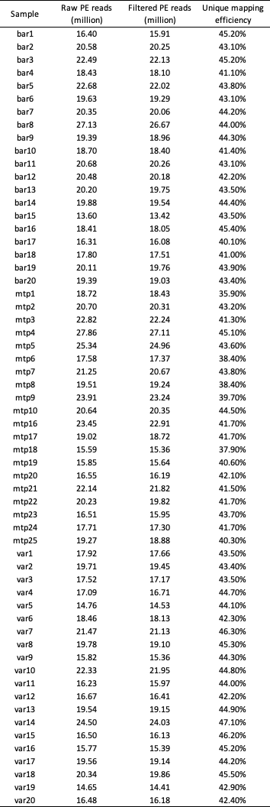

**Table S2:** Redundancy analysis (RDA) performed on the genetic data including the Z chromosome.



**Table S3:** Redundancy analysis (RDA) performed on the genetic data without Z chromosome.



**Table S4:** Fst estimation averaged on autosomes between pairs of subpopulations. 95% confidence computed intervals in brackets were computed using StAMPP package with 1000 bootstrap.

**Table S4:** Fst estimation averaged on Z chromosome between pairs of subpopulations. 95% confidence computed intervals in parenthesis were computed using StAMPP package with 1000 bootstrap.

**Table S6:**  Redundancy analysis (RDA) performed on the methylation data including the Z chromosome.



**Table S7:**  Redundancy analysis (RDA) performed on the methylation data without Z chromosome.



**Table S8:** Results of Type I ANOVA performed on mean methylation level of cytosines in a CpG context per individual, including: habitat (rural vs urban), city (Barcelona, Montpellier and Warsaw) and sex as explanatory variables. The first part of the table shows results of the analysis on autosomes and the second part shows results of the analysis on the Z chromosome only.



**Table S9:** Significantly enriched GO associated with genes overlapping 5kb windows around genomic outliers between forest and urban habitats.

**SUPPLEMENTARY FIGURES**

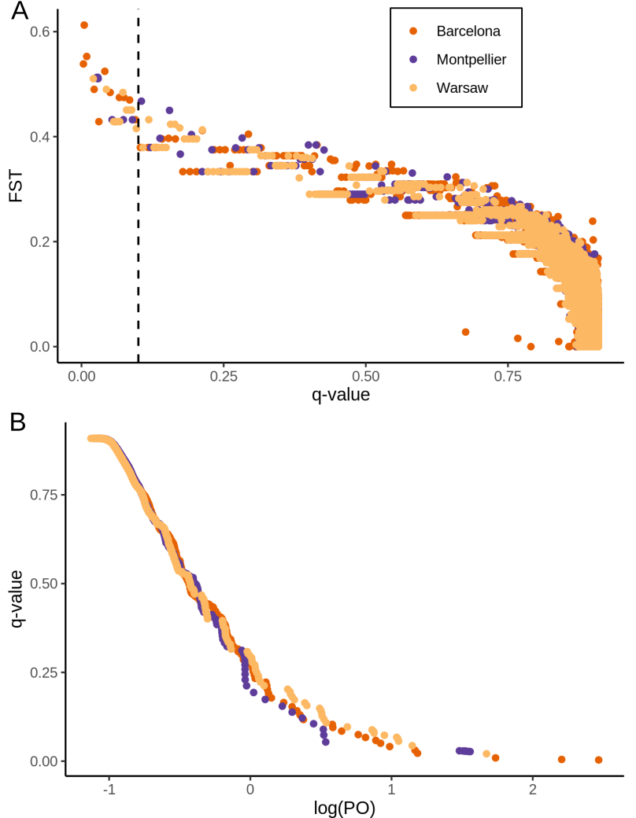

**Figure S1:** Results of the Bayescan tests between forest and urban great tits, for each of the three urban-forest pairs. (A) Distribution of FST values per position in function of q-value. (B) Distribution of q-value in function of log(PO).

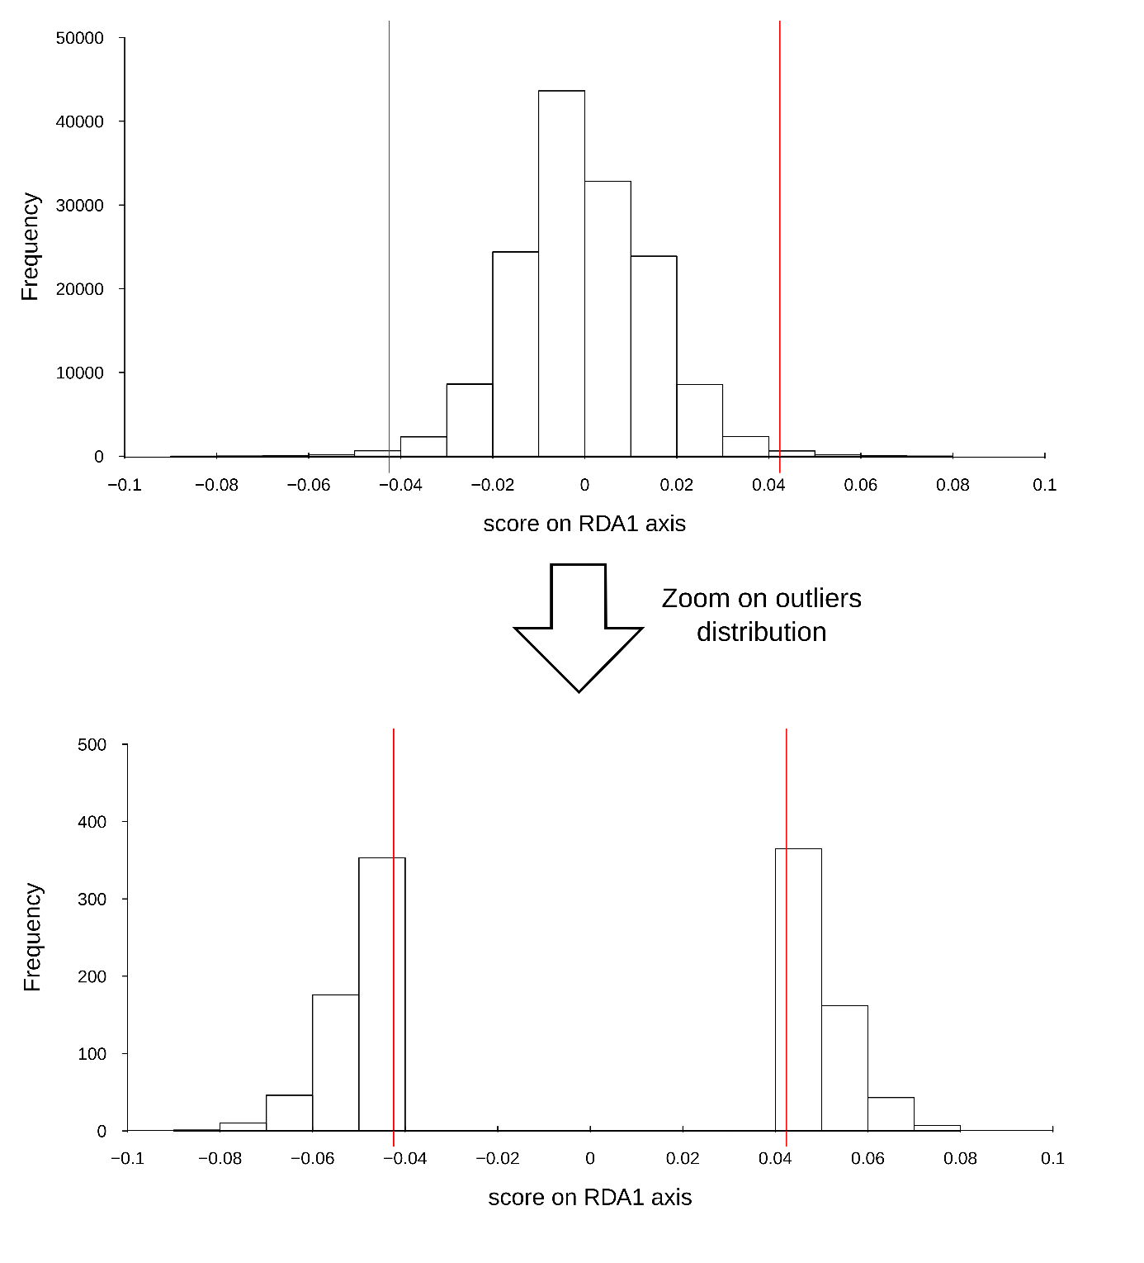

**Figure S2:** Distribution of genomic RDA loadings of each locus (above), and outliers (below). Vertical red lines represent the thresholds used to select outliers (please see methods for more details).

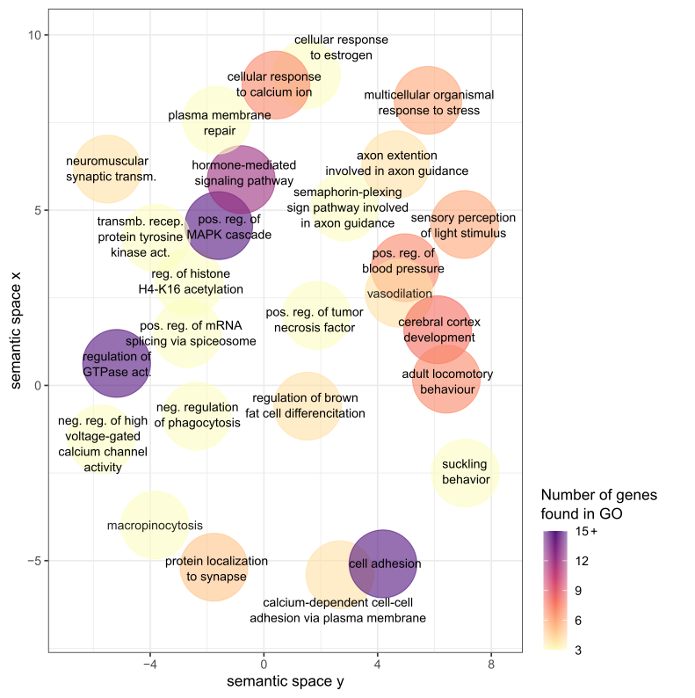

**Figure S3:** Semantic space representation for enriched GO terms from genes associated with genetic outlier (the outliers of the RDA analyses). Semantic space coordinates have been calculated based on similarity of GO term word composition using REVIGO. The color gradient indicates the number of genes involved in each GO term.

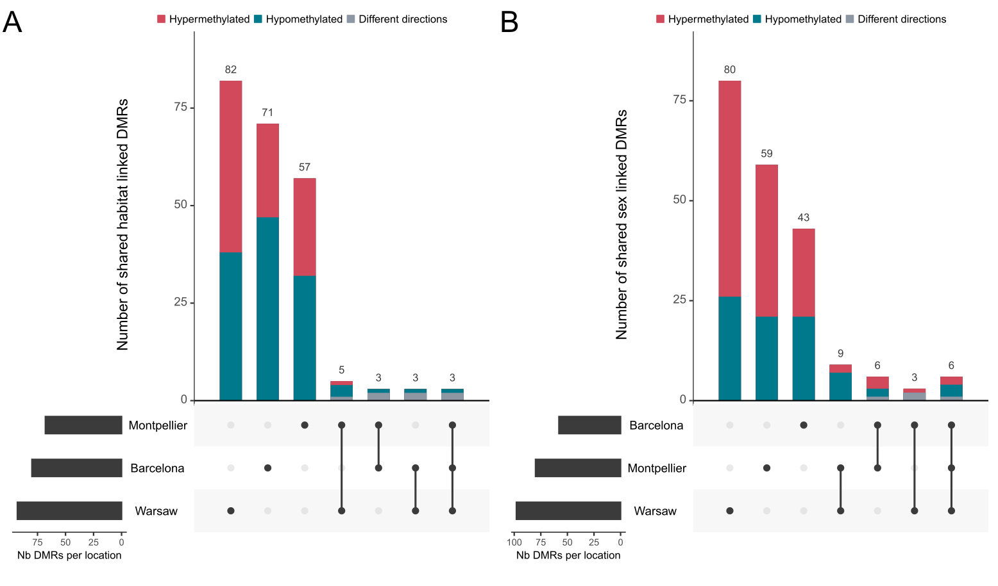**Figure S4:** Sharing among each location of the significant DMRs found between A) forest and urban habitats, and B) females and males great tits. Hypermethylated DMRs ( A) in urban, B) in males) are shown in red, hypomethylated in blue and for shared DMRs, grey represent cases where a DMRs was found in multiple locations but for which the direction of methylation was opposite.

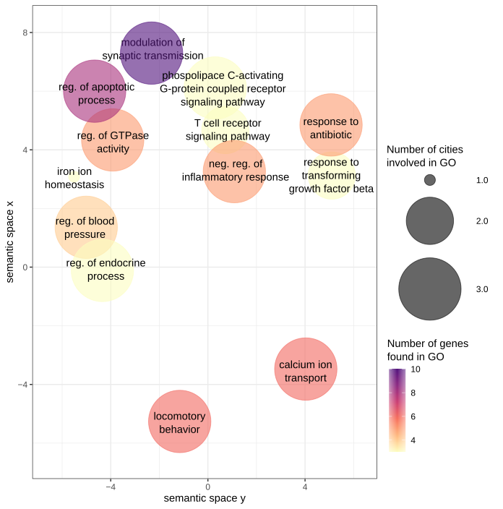

**Figure S5:** Semantic space of enriched GO terms from genes associated with urbanization-linked DMRs. Semantic space coordinates have been calculated based on similarity of GO term word composition using REVIGO. The color gradient indicates the number of genes involved in each GO term and circle size indicates the number of city contributing to each category.

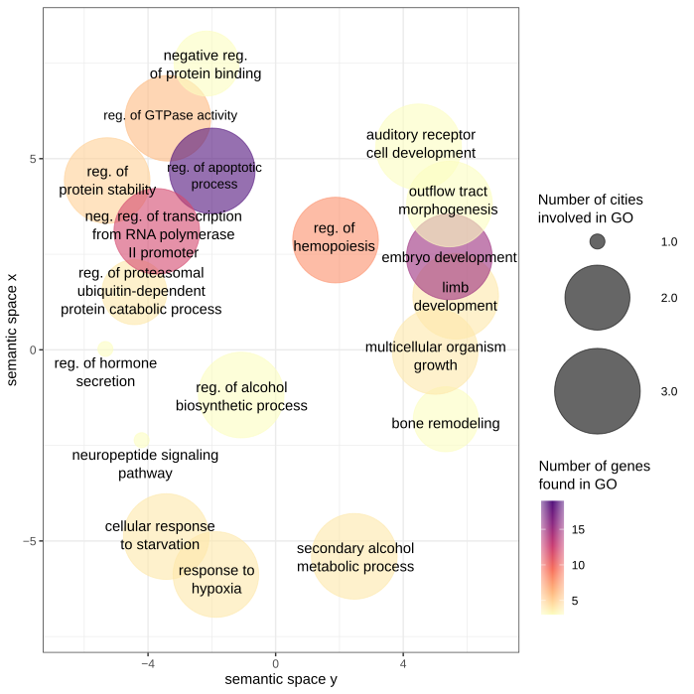

**Figure S6:** Semantic space of enriched GO terms from genes associated with sex-linked DMRs. Semantic space coordinates are calculated based on similarity of GO term word composition using REVIGO. The color gradient indicates the number of genes involved in each GO term and circle size indicates the number of city contributing to each category.

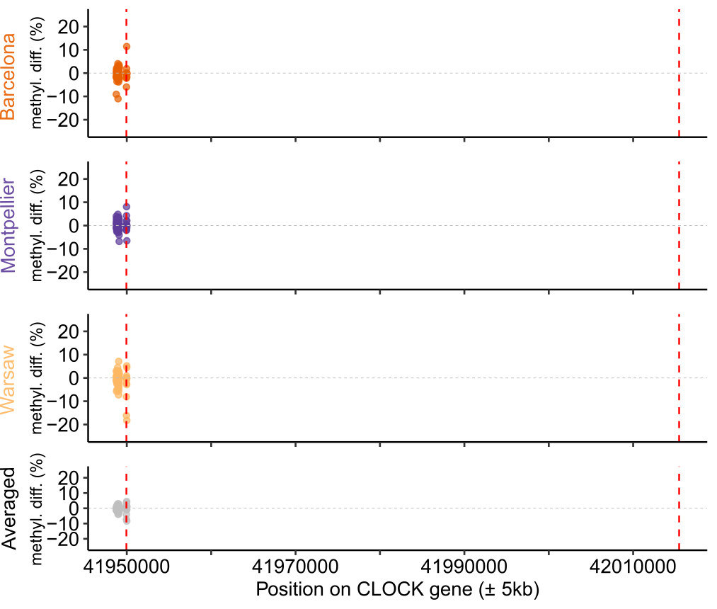

**Figure S7:** Mean methylation difference per base along the CLOCK gene. Vertical dashed lines materialised start and end of the gene.

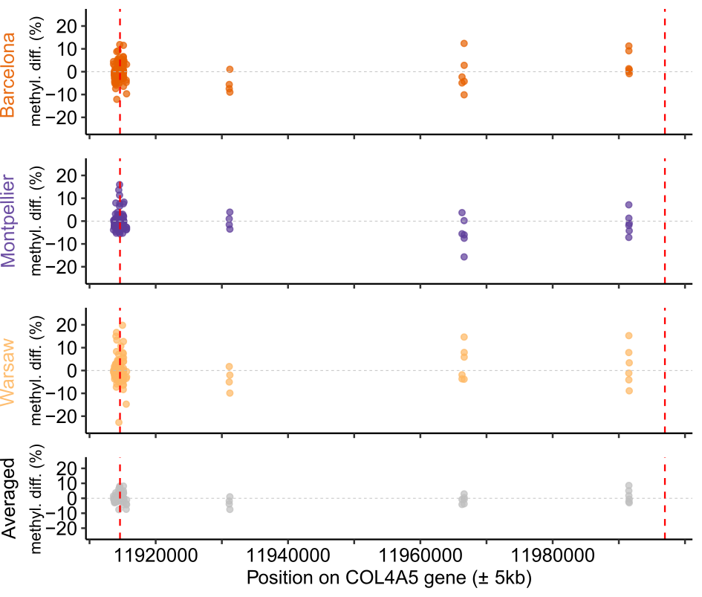

**Figure S8:** Mean methylation difference per base along the COL4A5 gene. Vertical dashed lines materialised start and end of the gene.

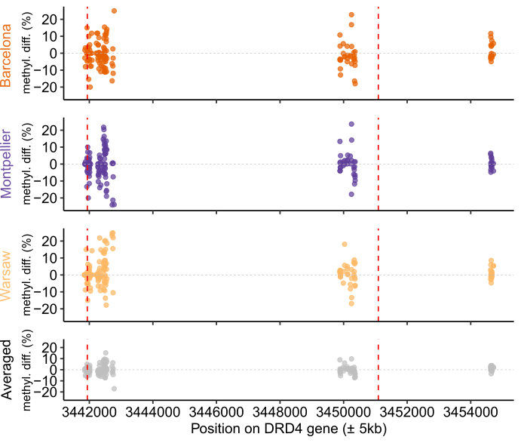

**Figure S9:** Mean methylation difference per base along the DRD4 gene. Vertical dashed lines materialised start and end of the gene.

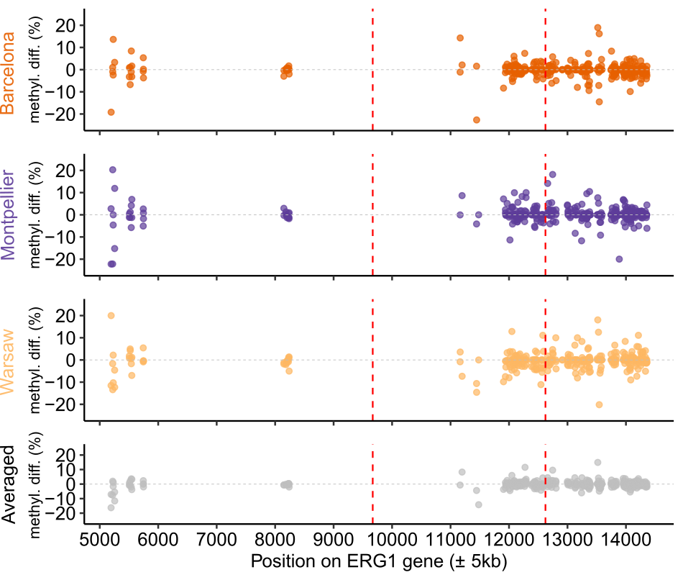

**Figure S10:** Mean methylation difference per base along the EGR1 gene. Vertical dashed lines materialised start and end of the gene.

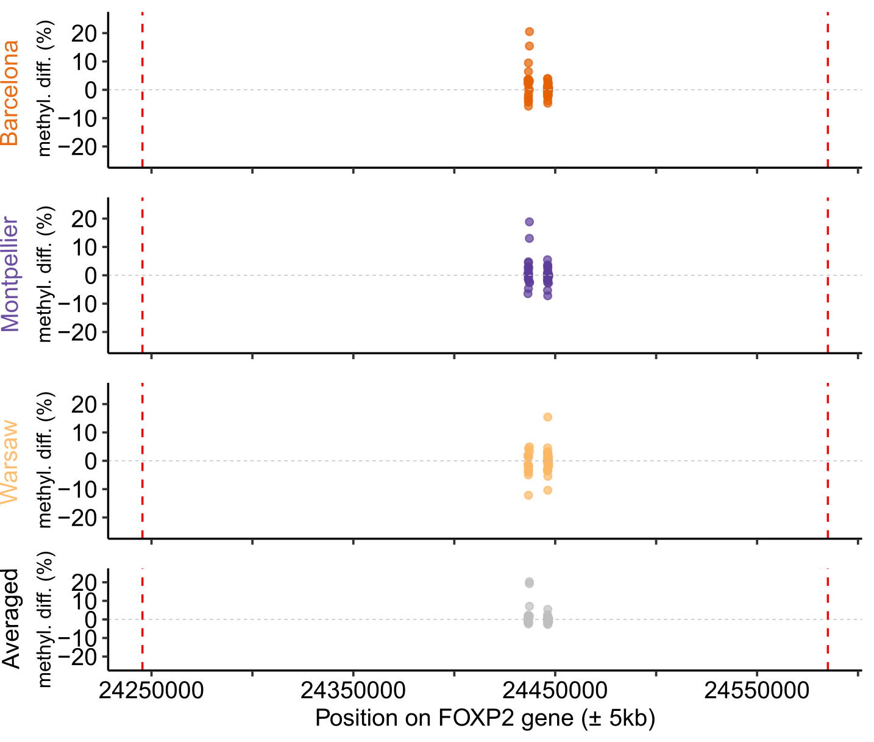

**Figure S11:** Mean methylation difference per base along the FOXP2 gene. Vertical dashed lines materialised start and end of the gene.

**SUPPLEMENTARY BIBLIOGRAPHY**

Bosse, M., Spurgin, L. G., Laine, V. N., Cole, E. F., Firth, J. A., Gienapp, P., … Slate, J. (2017). Recent natural selection causes adaptive evolution of an avian polygenic trait. *Science*, *358*(6361), 365–368. https://doi.org/10.1126/SCIENCE.AAL3298/SUPPL_FILE/AAL3298_BOSSE_DATABASE-S1.XLSX

Laine, V. N., Gossmann, T. I., Schachtschneider, K. M., Garroway, C. J., Madsen, O., Verhoeven, K. J. F., … Groenen, M. A. M. (2016). Evolutionary signals of selection on cognition from the great tit genome and methylome. *Nature Communications*, *7*, 10474. https://doi.org/10.1038/ncomms10474

Lindner, M., Laine, V. N., Verhagen, I., Viitaniemi, H. M., Visser, M. E., van Oers, K., & Husby, A. (2021). Rapid changes in DNA methylation associated with the initiation of reproduction in a small songbird. *Molecular Ecology*, mec.15803. https://doi.org/10.1111/mec.15803

Mueller, J. C., Partecke, J., Hatchwell, B. J., Gaston, K. J., & Evans, K. L. (2013). Candidate gene polymorphisms for behavioural adaptations during urbanization in blackbirds. *Molecular Ecology*, *22*(13), 3629–3637. https://doi.org/10.1111/mec.12288

Riyahi, S., Sánchez-Delgado, M., Calafell, F., Monk, D., & Senar, J. C. (2015). Combined epigenetic and intraspecific variation of the *DRD4* and *SERT* genes influence novelty seeking behavior in great tit *Parus major*. *Epigenetics*, *10*(6), 516–525. https://doi.org/10.1080/15592294.2015.1046027

Steinmeyer, C., Mueller, J. C., & Kempenaers, B. (2009). Search for informative polymorphisms in candidate genes: Clock genes and circadian behaviour in blue tits. *Genetica*, *136*(1), 109–117. https://doi.org/10.1007/S10709-008-9318-Y/TABLES/4