Supplementary Material

1 Supplementary Tables
Supplementary Table 1. Overview of the seabird census result from the two cruises headed in March and September 2017 on Huon and Surprise islets.

 |  | Huon |  | Surprise
Total count |  | March | September | March | September
Anous | minutus |  |  | 569 | 9492
Anous | stolidus | 2820 | 1674 | 26 | 104
Fregata | sp |  | 3 | 390 | 4759
Gygis | alba |  |  |  | 1
Onychoprion | fuscatus |  | 3 |  | 4
Phaeton | lepturus |  |  |  | 2
Phaeton | rubicauda |  | 3
Sterna | bergii |  | 16 |  | 12
Sterna | sumatrana |  | 56 |  | 90
Sternula | nereis |  |  |  | 1
Sula | dactylara | 704 | 557 | 84 | 15
Sula | leucogaster | 84 | 2270 | 215 | 55
Sula | sula |  |  | 4498 | 14095
 | Total | 3608 | 4582 | 5782 | 28630

Supplementary Table 2. Mean δ¹⁵N (‰) values ± s.d, mean δ¹³C (‰) values ± s.d, and number of sample (N) of dried guano samples per species and sites.

Site | Species |  | δ¹⁵N_{guano} ± s.d | N
Surprise
 | black noddy | Anous minutus | 8.19 ± 1.04 | 6
 | brown noddy | Anous stolidus | 6.81 ± 1.33 | 6
 | frigatebird | Fregata sp. | 8.52 ± 0.85 | 5
 | masked booby | Sula dactylatra | 7.95 ± 1.31 | 5
 | red-footed booby | Sula sula | 7.61 ± 1.32 | 5
Huon
 | brown noddy | Anous stolidus | 9.17 ± 0.48 | 4
 | masked booby | Sula dactylatra | 8.03 ± 1.49 | 5
 | brown booby | Sula leucogaster | 7.91 ± 1.57 | 5

Supplementary Table 3. Mean NOx concentrations (µM) values ± s.d and number of sample (N) for each site and seasons, and at each transect locations.
 |  | Mean [Nox] (µM) ± s.d. (N)
 |  | 25m | 50m | 100m | 400m | Control
Huon
 | March | 1.7 ± 0.05 (2) | 1.4 ± 0.07 (2) | 1.0 ± 0.05 (2) | 0.2 ± 0.11 (2) | 0.4 ± 0.02 (2)
 | September | 7.3 ± 0.35 (3) | 1.7 ± 0.03 (3) | 1.2 ± 0.07 (3) | 0.1 ± 0.03 (3) | 0.2 ± 0.03 (3)
Surprise
 | March | 0.7 ± 0.02 (2) | 0.5 ± 0.03 (2) | 0.3 ± 0.01 (2) | 0.1 ± 0.02 (2) | 0.5 ± 0.12 (2)
 | September | 1.4 ± 0.02 (3) | 0.5 ± 0.02 (3) | 0.5 ± 0.01 (3) | 0.3 ± 0.03 (3) | 0.1 ± 0.03 (3)

Supplementary Table 4. Results of model selections as ANOVA tables and validation metrics corresponding to isotope values of coral tissues and zooxanthellae, macroalgae and POM samples.
 | δ¹⁵N Tissues |  |  |  | δ¹⁵N Zoox. |  |  |  | δ¹⁵N Macroalgae |  |  |  | δ¹⁵N POM |  |  |  | [] NOx
Models slected structure | df | Sum. Sq. | F | p_value | df | Sum. Sq. | F | p_value | df | Sum. Sq. | F | p_value | df | Sum. Sq. | F | p_value | df | Sum. Sq. | F | p_value
Transect | 4 | 2.27 | 134.4 | <0.001 | 4 | 132.34 | 96.87 | <0.001 | 4 | 13.168 | 234.19 | <0.001 | 4 | 33.80 | 11.65 | <0.001 | 4 | 54.89 | 1393.7 | <0.001
Site | 1 | 0.03 | 7.85 | 0.007 | 1 | 12.85 | 37.63 | <0.001 | 1 | 0.08 | 42.98 | 0.03 | 1 | 3.96 | 5.45 | 0.04 | 1 | 5.39 | 547.6 | <0.001
Season | 1 | 0.06 | 14.22 | <0.001 | 1 | 26.90 | 78.78 | <0.001 | 1 | 0.625 | 5.32 | <0.001 | - | - | - | - | 1 | 15.98 | 1623.2 | <0.001
Transect:Season | 4 | 0.13 | 7.55 | <0.001 | 4 | 3.23 | 2.37 | 0.06 | 4 | 0.59 | 10.12 | <0.001 | - | - | - | - | 4 | 18.84 | 478.2 | <0.001
Transect:Site | 2 | 0.12 | 13.84 | <0.001 | 2 | 2.46 | 3.598 | 0.03 | 4 | 4.58 | 78.71 | <0.001 | - | - | - | - | 4 | 26.57 | 674.7 | <0.001
Site:Season | 1 | 0.02 | 3.64 | 0.06 | - | - | - | - | 1 | 0.00 | 0.02 | 0.89 | - | - | - | - | 1 | 3.26 | 331.1 | <0.001
Transect:Site:Season | - | - | - | - | - | - | - | - | 4 | 0.76 | 13.08 | <0.001 | - | - | - | - | 4 | 11.14 | 283.0 | <0.001
Residuals | 67 | 0.28 |  |  | 68 | 23.22 |  |  | 37 | 0.54 |  |  | 10 | 7.26 | - | - | 30 | 0.30
Models Validation Metrics | Test Statistic |  |  | p_value | Test Statistic |  |  | p_value | Test Statistic |  |  | p_value | Test Statistic |  |  | p_value | Test Statistic |  |  | p_value
Durbin-Watson (D-W) | 2.41 |  |  | 0.52 | 2.54 |  |  | 0.28 | 2.29 |  |  | 0.634 | 1.58 |  |  | 0.13 | 3.02 |  |  | 0.218
ShapiroWilk (W) | 0.99 |  |  | 0.71 | 0.99 |  |  | 0.74 | 0.95 |  |  | 0.01 | 0.96 |  |  | 0.68 | 0.96 |  |  | 0.12
Bartlett (K2) or Levene (F) | 7.94 |  |  | 0.54 | 19.94 |  |  | 0.17 | 1.28 |  |  | 0.25 | 1.47 |  |  | 0.83 | 29.00 |  |  | 0.07
Adjusted R² | 0.91 |  |  |  | 0.88 |  |  |  | 0.96 |  |  |  | 0.76 |  |  |  | 0.99

Supplementary Table 5. Mean δ¹⁵N (‰) values ± s.d and number of sample (N) for each site and seasons, and at each transect locations.
 |  |  | Mean δ¹⁵N (‰) ± s.d. (N)
 |  |  | 25m | 50m | 100m | 400m | Reference
Huon
 | Macroalgae
 |  | March | 6.2 ± 0.2 (5) | 5.2 ± 0.3 (5) | 3.8 ± 0.2 (5) | 2.1 ± 0.4 (5) | 2.1 ± 0.2 (5)
 |  | September | 8.2 (1) | 8.3 (1) | 6.0 (1) | 3.2 (1) | 3.0 (1)
 | POM
 |  | March | 5.4 (1) | 5.4 (1) | 3.8 (1) | 1.9 ± 1 | 4.3 (1)
 | Coral tissues
 |  | March |  | 6.5 ± 0.3 (5) | 6.1 ± 0.3 (5) | 5.4 ± 0.8 (5) | 4.4 ± 0.2 (5)
 |  | September |  | 6.4 ± 0.2 (5) | 6.2 ± 0.4 (5) | 4.8 ± 0.1 (6) | 4.8 ± 0.3 (5)
 | Coral symbionts
 |  | March |  | 4.8 ± 0.8 (5) | 3.9 ± 0.6 (5) | 3.1 ± 0.7 (5) | 1.9 ± 0.6 (5)
 |  | September |  | 6.1 ± 0.8 (5) | 4.4 ± 0.5 (5) | 3.8 ± 0.6 (6) | 3.2 ± 0.5 (5)
Surprise
 | Macroalgae
 |  | March | 10.5 ± 2.2 (5) | 10.4 ± 2.4 (5) | -0.3 ± 1 (5) | 1.7 ± 0.4 (5) | 2.1 ± 0.6 (5)
 |  | September | 10.0 (1) | 11.4 (1) | 4.3 (1) | 0.8 (1) | 3.2 (1)
 | POM
 |  | March | 6.6 ± 0.7 (2) | 7.2 (1) | 4.1 (1) | 3.5 ± 0.9 (3) | 3.7 ± 0.5 (2)
 | Coral tissues
 |  | March | 7.4 ± 0.5 (5) | 6.6 ± 0.6 (5) | 5.6 ± 0.2 (5) |  | 5 ± 0.5 (5)
 |  | September | 8.9 ± 0.7 (5) | 7.3 ± 0.3 (5) | 5.8 ± 0.3 (5) |  | 5.6 ± 0.4 (5)
 | Coral symbionts
 |  | March | 6.1 ± 0.8 (5) | 5.4 ± 0.6 (5) | 4.3 ± 0.2 (5) |  | 3.3 ± 0.5 (5)
 |  | September | 7.9 ± 0.2 (5) | 6.7 ± 0.7 (5) | 5.3 ± 0.6 (5) |  | 4.8 ± 0.5 (5)

Supplementary Table 6. Mean δ¹³C (‰) values ± s.d number of sample (N) for each site and seasons, and at each transect locations.
 |  |  | Mean δ¹³C (‰) ± s.d (N)
 |  |  | 25m | 50m | 100m | 400m | Reference
Huon
 | Macroalgae
 |  | March
 |  | September
 | POM
 |  | March | -6.5 (1) | -5.6 (1) | -12.1 (1) | -20.3 ± 0.5 (3) | -14.7 (1)
 | Coral tissues
 |  | March |  | -12.9 ± 0.5 (5) | -13.8 ± 0.6 (5) | -14.5 ± 0.3 (5) | -15.6 ± 1.2 (5)
 |  | September |  | -13.1 ± 1.0 (5) | -16.9 ± 4.9 (5) | -15.6 ± 2.5 (6) | -15.1 ± 1.3 (5)
 | Coral symbionts
 |  | March |  | -12.6 ± 1.0 (5) | -14.0 ± 0.5 (5) | -14.5 ± 0.2 (5) | -15.4 ± 1.4 (5)
 |  | September |  | -10.9 ± 2.6 (5) | -13.1 ± 1.4 (5) | -14.2 ± 1.5 (6) | -13.1 ± 1.8 (5)
Surprise
 | Macroalgae
 |  | March | -10.6 ± 1.9 (5) | -10.6 ± 2.1 (5) | -9.8 ± 0.8 (5) | -7.0 ± 1.4 (5) | -4.5 ± 1.6 (5)
 |  | September
 | POM
 |  | March | -8.0 ± 4.0 (2) | -16.4 (1) | -17.1 (1) | -16.9 ± 4.8 (3) | -15.2 ± 4.3 (2)
 | Coral tissues
 |  | March | -14.1 ± 0.4 (5) | -14.4 ± 0.5 (5) | -13.7 ± 0.4 (5) |  | -15.2 ± 1.0 (5)
 |  | September | -14.3 ± 2.3 (2) | -14.0 ± 2.4 (5) | -12.6 ± 0.5 (4) |  | -14.6 ± 0.9 (4)
 | Coral symbionts
 |  | March | -14.0 ± 0.5 (5) | -14.4 ± 0.4 (5) | -13.6 ± 0.5 (5) |  | -15.0 ± 1.3 (5)
 |  | September | -13.9 ± 0.6 (5) | -12.8 ± 1.5 (5) | -13.1 ± 0.7 (5) |  | -14.5 ± 1.0 (5)

2 Supplementary figures
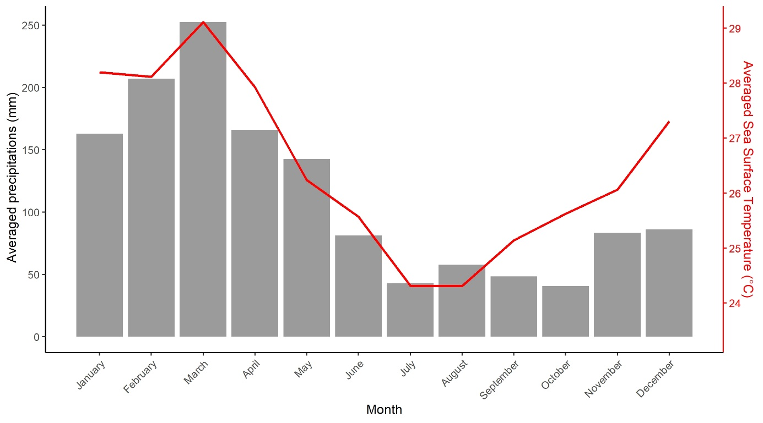Supplementary Figure 1. Mean monthly precipitation from the Global Precipitation Climatology Center and monthly averaged sea surface temperature (SST) calculated from the data collected by the Aqua-MODIS instrument, for one station located in the d’Entrecasteaux reefs during the year 2017 (Brown and Minnett 1999, Schneider et al., 2020).

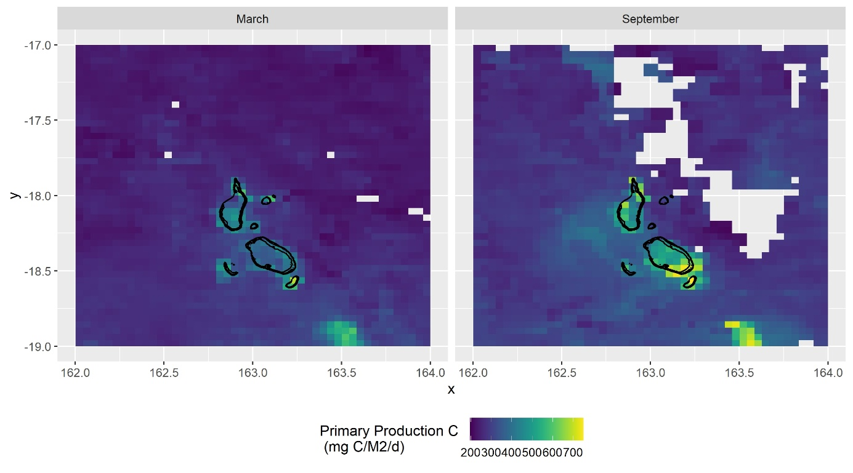
Supplementary Figure 2. Monthly averaged primary production in the d’Entrecasteaux reefs in March and September 2017 (Aqua-Modis, Chu et al., 2018).

