Supplementary Material

Supplementary Material S1
Supplementary Table 1: Meaning of concepts used in the FCMs
Categories | Variables | Meaning
Ecosystem denomination | Mangrove | Two types are identified : estuarine and coastal
Biological compartments | Biodiversity | Rarely defined explicitly, and viewed differently according to actors. Generally perceived as an indicator of the richness of the mangrove ecosystem in terms of species abundance and diversity.
 | Mudflat/Mud bank | Formed by sediment inputs to the intertidal zone, mudflats are mobile over time
Ecosystem services and human well-being | Climate regulation | Influence on climate generally considered at the global rather than local scale
 | Water purification | Greenery treatment of urban waters in response to failing water sewage networks
 | Storm/coastal protection | Protection from coastal risk, erosion by sea rise
 | Provisioning of habitat | Serves important ecological functions : hosting of species, support to early life stages, food tank. Turbidity of water in the mangrove has a protective role.
 | Education and knowledge systems
 | Landscape aesthetic values | Participates in spiritual values, social relations, well-being. Essentially mentioned w.r.t the shoreline
 | Heritage values | Mangrove inspires local cultural life and participates to local communities identity
 | Recreational activities | Leisure activities practiced either by tourism or local inhabitants : Kayaking, bird watching, hunting (mangrove deer, birds), hinking.
 | Fishery resources | Provisioning service of wild food
 | Public health | Mentioned as threatened with respect to insects and to bacteriology on beaches  owing to lake of water sanitation
Ecosystem disutilities | Insects | Essentially ash butterfly, a moth that scatters stinging darts causing rashes
 | Accessibility issues | Refers to access limitations to the coast line caused by mangrove forest and mudbanks : problematic for certain activities/communities.
Anthropic activities | Tourism | Meant as the range of economic activities directly or indirectly supported by tourism (hotel, transport, restaurants, outdoor activities, etc.). Sector providing jobs and contributing to national income.
 | Aquaculture | Production in French Guiana is not very developed at this stage, and concerns mainly freshwater and brackish water aquaculture
 | Recreational and professional fishing | Crabe picking within the mangrove is reported as a typical recreational practice, along with finfish fishing. Amerindian populations also rest up on fishing. Professional fishing is a heterogeneous category with different forms of dependence/relation to mangrove. Target species reported : white fish, snapper, shrimp.
 | Local development | Understood as local economic dynamism (development of new economic activities, expansion of existing sectors, demographic growth)
 | Beekeeping | Small scale economic activity : production of mangrove honey in Sinnamary and Macouria
 | Estuary dredging | Aims at removing sediment accumulation to maintain passage depth for shipping
 | Transport and security | Circumstances of port activities
 | Territory planning | Emergence of constructions and development projects in support to local economy and in relation to the living environment of the population
 | Agricultural activities (affecting mangrove) | Essentially rice field in the Mana area, limited in scope
 | Legislation | Refers either to existing legislation in favor of mangrove conservation, or need of legislation to supervise territorial development
Impact factors | Pollution | Mentioned in relation to water pollution from urbanization, industries, agriculture, residential areas
 | Artificialization | Land conversion for human settlements
 | Deforestation | Cut down of mangrove forest
 | Climate change | Thought through sea level rise, ocean acidification, biodiversity decline. Evidences of local consequences not fully/clearly established
 | Sargassum | Raised as a concern rather than a local reality

Supplementary Material S2

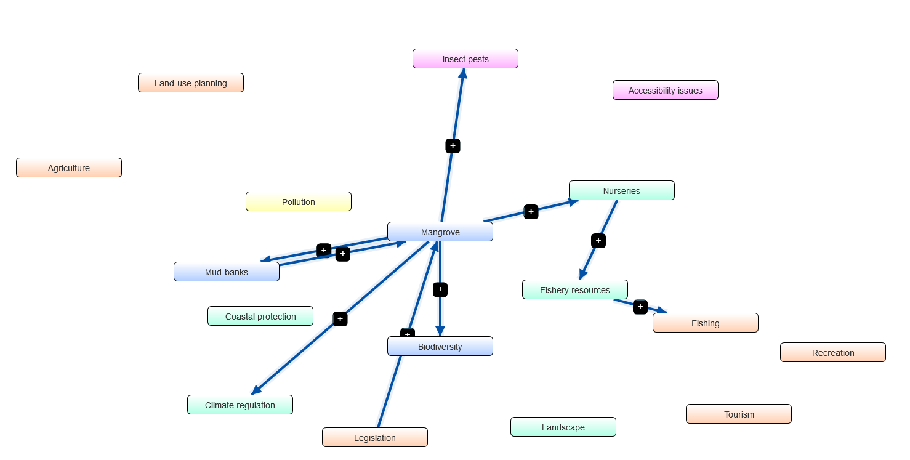
Supplementary Figure 1 - Community map after workshops with only variables and links mentioned by all stakeholder’s groups (Blue arrows (with a ‘+’ sign) indicate a positive relationship, while orange (with a ‘-’ sign) indicate a negative relationship. Thickness of the arrow reflects the strength of the relationship from |1| (when reported by every group) to |0,25| (when reported by only one group). Box colors are selected to assist the reading of the FCM: Blue boxes for biological compartments, green boxes for ecosystem services, pink boxes for disservices, orange boxes for anthropic activities and yellow boxes for pressure vectors).

