AN EARLY 3D-MAP OF A TERRITORY? THE BRONZE AGE CARVED SLAB FROM SAINT-BÉLEC, LEUHAN (BRITTANY, FRANCE)

Clément Nicolas, Yvan Pailler, Pierre Stéphan, Julie Pierson, Laurent Aubry, Bernard Le Gall, Vincent Lacombe, Joël Rolet

SUPPORTING INFORMATION

SI1– METHODS 2

SI2– NETWORK AND SHAPE ANALYSES AND GEOREFERENCING OF THE SLAB 7

SI3- THE EARLY BRONZE AGE IN ARMORICA 9

REFERENCES 16

SUPPLEMENTARY FIGURES 21

SI1– METHODS

The study of the slab was conducted using several 3D survey methods to record the surface topography of the slab at different scales and to analyse the morphology, technology, and chronology of the engravings.

Photography

Following the methodology developed by Cassen and Robin (2010) to study megalithic art, many photographs were taken from fixed stations with several oblique lights in order to highlight the outlines of the engravings and superimpose their drawing. The storage conditions (dark cellar with low ceiling, lying slab), quite similar to those of caves or megalithic graves, hindered good quality vertical shots of the whole object. We therefore favoured close-up shots, divided into eight distinct zones, using a Canon EF-S camera (18-55 mm f/3.5-5.6 IS) mounted on a tripod. Up to 98 shots were taken for each of the eight zones. As most patterns are deeply interrelated, the optical distortions between these sets of photographs proved too important to assemble the eight zones and draw the outlines of the engravings. However, all these photographic documents have proved essential for analysing the state of the surfaces or the details of the engravings.

Photogrammetry

Photogrammetry was used for the whole slab and was quick to implement, something which was especially helpful when working on the back face of the slab as for this the whole piece had to be lifted.

In order to create a 3D-model by photogrammetry it is necessary to photograph the object of study from different perspectives with large overlapping areas between shots. The photogrammetry software used the similarities between the images to reconstruct the three-dimensional geometry of the object. For the Saint-Bélec slab, accessibility to the slab was the main difficulty. It was necessary to make the engraved face accessible to photogrammetry shots.

As the slab weighs approximately two tonnes the first mosaic of images was made on the rear face when it was lifted. Coverage of the engraved face was carried out when the slab was placed horizontally on pallets.

The photographic mosaic was made with two digital cameras (Canon EOS 70D at 20 Mpixels and a Nikon P520 at 18 Mpixels for vertical shots). The light was best controlled by diffused white light illumination via four light boxes. Finally, on a more experimental basis, three series of photographs were taken using three orientations of oblique lighting in order to exaggerate the relief of the engravings and to verify the impact of light oriented towards photogrammetric analysis (Fig. S1).

Photogrammetry consists in developing a 3D-model from photographic pictures. Thus, the model obtained reflects the geometry of the photographed object and not its dimensions. In order to overcome this problem, photogrammetric targets have been placed near the slab and allow the sizing of the generated models as well as measurements during the operation. During this phase, different data sets with 40–220 photographs each were acquired (Table S1).

Dataset | Camera | Number of photographs | Slab position | Face | Lighting
D2V | Canon EOS 70D | 146 | Vertical | Rear | Diffuse
D2R | Canon EOS 70D | 220 | Horizontal | Front | Diffuse
D2R | Coolpix p520 | 40 | Horizontal | Front | Diffuse
D2R_ER1 | Canon EOS 70D | 67 | Horizontal | Front | Oblique
D2R_ER2 | Canon EOS 70D | 84 | Horizontal | Front | Oblique
D2R_ER3 | Canon EOS 70D | 141 | Horizontal | Front | Oblique
Table S1. List of the photogrammetric dataset of the Saint-Bélec slab.

The data were processed using Photoscan Pro software (Agisoft) at the UMR 8215 (Nanterre, France) photogrammetric computing stations into as many models as data sets. The models have a dimensioning accuracy ranging from 30mm (for the less precise) down to a few mm (for the more precise). The model of the carved front face was obtained with the dataset acquired with Canon EOS 70D under diffuse lightning conditions. The photogrammetric model was calculated from the 220 photos of the dataset and is composed of almost 6 million faces for 3 million vertexes.

General 3D-scanning

To complement the photogrammetry, the research laboratory Trajectoires (CNRS, UMR 8215) used a 3D-scan device EVA from ARTEC, owned by the Labex Dynamite. This portable scanner has structured light projection to predefine patterns on the object with a white flash light. With two cameras, the device measures the deformation of light produced by the shape of the object and models it. In contrast to the photogrammetry process, this device sizes the object of study directly, so a topographical protocol is not necessary to avoid errors. Furthermore, this device has its own source light so there is no need of external light to obtain the texture of the object.

In the 3D data recording of the Saint-Bélec slab, the operator manually passes the device across the surface at a distance of about 0.5m. The device acquires data at 16 frames per second and the operator verifies on the control screen the scanned zone to minimize the blind areas. Regarding the dimensions of the slab and the movement constraints, ten datasets were acquired to achieve a global registration without blank areas.

Post-processing consists mainly in erasing outlier points and noise from the datasets and combining all of them by semi-automatic shape recognition process to produce the final model. In this case the model produced has a resolution of 0.5mm with given precision of 0.1mm (about 4pts/mm²).

High definition 3D-scanning

A second and much finer 3D-scanning process was carried out by one of the author (V.L., DIGISCAN3D) using 3D Metrologic Industrial measuring equipment such as GOM ATOS Compact Scan 5M (shape recording) to provide the best results currently available on the 3D measurement and control market (Fig. S2).

Based on stereographic images and phase-shift analysis, this device allows the accurate full-field, high-density, recording and measurement of all the points that make up the surface of a given structure. The ATOS Compact Scan scanner allows all the surfaces of an intricate 3D-structure to be measured in the field without any contact. By simply changing the measurement volume, the sensor can measure surface differences up to 0.05mm. Depending on the chosen measurement volume, this sensor allows the acquisition of clouds of dense points (5pts/mm²) to very dense points (3400pts/mm²). This level of detail allows most planar structures (including schistosity fabrics) to be recorded, while morphological features as well as the chronology of the engravings are also accurately depicted (Fig. S2b–d).

In order to ensure the quality of the measurements, a calibration of the instruments was carried out at each step of the process, determining the intrinsic and extrinsic geometric characteristics of the devices and ensuring that deviations are known, constrained and minimal. Calibration of measuring systems, which is monitored in real time, allows accurate, precise and exhaustive measurements. The quality of the data is known during the acquisition operations, as well as the overall measurement uncertainty.

In the course of 3D-scanning, the device was calibrated in c.0.3×0.3m measuring volume, which allows a 75pts/mm² density (up to 8 million points have been recorded). The system was then faced to the surface to measure and was moved as many times as necessary to scan the whole slab (Fig. S2a). Each acquisition required to have a sufficient overlap surface with the previous position. So, it can be realigned within the global 3D bundle thanks to the homologous surfaces recognition algorithm of the system measurement, while the software, GOM ATOS Professional, instantly generates a 3D preview mesh.

Unfortunately, some parts of the slab could not be integrated into the 3D-model as they were too flat (weathered or broken surfaces) and didn’t provide sufficient information, like engravings or bumps, for analysing overlaps and recognising homologous surfaces. Thus, all the engravings have been 3D-scanned but some peripheral areas (upper break, right bottom corner) were not. A larger measuring volume would have provided more space for recognising homologous surfaces and scanning the whole slab. However, the 3D-model would have lost in resolution and point density and, therefore, hindered the study of engravings.

Digital Elevation Map and visualization techniques

Point cloud produced from high definition 3D-scanning (in *.xyz format) totalize a number of 35.106 points corresponding to a mean spatial density of 13.9pts/mm² homogenously distributed over the slab. In order to optimize the processing time, the data volume and the use of visualization tools, the point cloud was integrated into a single spatial model by rasterizing the (x, y, z) data. Surfer 9.0 software was used to import and process the (x, y, z) data. The generation of a 3D Digital Elevation Map (DEM) was the basis for subsequent interpretation and analysis. The kriging interpolation method was used to generate a regular 0.5×0.5mm grid. The grid resolution was adapted to the density of the point cloud to avoid aggregation (or upscaling) and/or disaggregation (downscaling) of the micro-topographical information (Hengl 2006). The pixel size is considered as suitable enough to capture the micromorphological details by the output DEM.

Five visualization techniques based on DEM manipulation methods were used from RVT Software (Kokalj et al. 2011; Zakšek et al. 2011) to ensure the detection of the overall engravings on the slab:

1. Slope gradient image was calculated from the DEM and represents the maximum rate of change between each cell and its neighbours (Kokalj et al. 2011; Zakšek et al. 2011). Cell values are expressed in percentage of slope (from 0 to 1). The representation of the relief is given by applying an inverted greyscale scheme (steep slopes are darker). Additional information is generally needed to distinguish between convex (e.g. bumps) and concave (e.g. engravings) features. Consequently, slope gradient was combined with the other images by applying a transparency degree (Fig. S3a).

2. Multi-hillshading (MHS) image was based on a relief shading method emphasizing features that are obliquely illuminated in several directions. The multi-hillshading method was preferred to the single hillshading method which tends to hide features that are illuminated along the perpendicular axis. The MHS image used in this study combines a set of 16 images produced from 16 different directions of the illumination source (from 0° to 360°). The sun elevation angle used is 35° (Fig. S3b).

3. Principal Components Analysis Hillshading (PCA-HS) image statistically summarizes the information of 16 relief images, shaded with evenly distributed illumination sources which are correlated between them using a PCA. The sun elevation angle used is 35°. A false colour composite image in RGB is produced from the first three components of the PCA analysis (first component in the red band-R, second component in the green band-G, third component in the blue band-B). This shading method simplifies the interpretation of multiple shading data (Devereux et al. 2008; Fig. S3c).

4. Anisotropic Sky-View Factor (SVF-A) image corresponds to a supplementary analytical hill-shading method used to address the shortcomings of relief shading (directional illumination source) by diffuse illumination relief shading models (Zakšek et al. 2011). Sky-View Factor is a measure for the portion of the sky visible from a certain point. The portion of the visible sky limited by the relief horizon corresponds to the relief illumination (e.g. a bump is more illuminated than the bottom of a steep engraving). Anisotropic Sky-View Factor assumes that the sky is brighter in some directions than in others. Three parameters need to be set (Kokalj et al. 2011; Zakšek et al. 2011): the azimuth of the highest weight, the exponent defining the gradient from maximal to minimal weight (level of anisotropy), and the minimal possible weight. The weights are based on the cosine function of half angle (Zakšek et al. 2011). The SVF-A image produced in this study used a low anisotropy level with a minimal weight of 0.4 and an exponent of 4. For each cell of the raster image, the Anisotropic Sky-View Factor was calculated using a search radius of 10 pixels and a number of search directions of 16. The main direction of anisotropy was 315°N. Cell values of the SVF-A image ranges from 0 to 1. Values close to 1 mean that almost the entire hemisphere is visible, which is the case in exposed features (planes and peaks), while values close to 0 present lower parts of deep engravings from where almost no sky is visible (Fig. S3d).

5. Simple Local Relief Model (SLRM) images (also called ‘deviation map’; Cassen et al. 2014) were produced by a trend removal procedure that separates local small-scale topographic features from large-scale forms. The procedure first calculates a trend DEM (also called ‘smoothed elevation model’) by resampling to a lower resolution and then subtracts it from the original DEM, producing a local relief model (LRM). The process of DEM generalization used by the RVT Software is based on a low pass convolution filter calculating the mean (z) value within a pre-defined radius (Kokalj et al. 2011; Zakšek et al. 2011). Authors recommend adapting the calculation radius according to the size of the small-scale features to be detected (Hesse 2010). In this study, we tested 6 different calculation radius (5, 10, 15, 17.5, 20, 22.5mm) because of the various sizes of engravings and bumps on the slab. Finally, we used the SLRM image produced with a radius value of 20mm because it proposes the best fitting with the microtopographical features of the slab (Fig. S3e).

Drawings of the engravings

To facilitate the analysis of the engravings, their outlines were traced using vector drawing software (Adobe Illustrator). Thanks to the DEM and relative relief processing, we have obtained different depictions of the 3D acquisition (MHS, PCA-HS, SVF-A, SLRM) to highlight the various features of the engravings (outlines, morphology, technological traces and overlapping). Due to the cleaved structure of the rock, directional flaking related to the engravings tend to create multiple outlines, especially in cases where they are shallow or intertwined. In such cases, we have retained the steepest delineations, created by a repeated gesture of pecking or incising. This drawing process was controlled cross-checking the various relative relief depictions, as well as going back and forth to the detailed photographs with oblique lighting, relief profiles generated from the DEM and direct observations. The early 20th century photographs have been distorted as much as possible in order to fit with the elaborated DEM and to complete the lost fragments.

SI2– NETWORK AND SHAPE ANALYSES AND GEOREFERENCING OF THE SLAB

In order to test the degree of similarity between the engravings of the Saint-Bélec slab and the corresponding landscape elements (relief and river network), shape and network analyses were performed using QGIS software and the Python language (network module).

The network analysis first required the creation of two graphs representing the engravings of the slab and the corresponding landscape elements, respectively. These graphs are composed of nodes connected by edges whose length was measured. Two metrics were then computed in order to evaluate the degree of concordance between the graphs, by comparing the edges by Jaccard's distance (Jaccard 1901) and by a comparison of the distance matrices of the two networks via Mantel's test (Mantel 1967).

The Jaccard distance provides a percentage of similarity between the two graphs. This distance does not take into account the distance between the nodes but only the connection (or not) of these nodes to each other: it simply compares the edges, each edge being of the form (x, y) where x and y are the identifiers of the two nodes of the edge. In our case, we obtain a Jaccard distance of 0.8, which means that our two graphs are 80% similar (Fig. S4a). This result is based on the assumption that the three meandering signs (L1/L3, L11/L13 and L73/L74) were indeed connected. If this assumption is removed from the analysis (excluding nodes 25 and 26), Jaccard's distance is found to be slightly lower (0.7).

The Mantel test (Mantel 1967) is a statistical test commonly used to compare two by two matrices of distances whose units are not necessarily identical. It is often used in population genetics studies to compare genetic and geographic distances. However, this test is calculated from a graph whose nodes must be connected to each other. Therefore, the test is limited to the subgraph of the upper left quarter of the slab, for which we obtain a correlation coefficient of 0.81, i.e. a strong correlation between the two subgraphs. The associated p-value is 0.001, indicating that the relationship is not random (Fig. S4b). The Mantel test excluding nodes 25 and 26 was not conducted because it only allows the comparison of distance matrices of the same dimensions, thus networks with the same number of nodes.

The shape analysis was conducted using two methods to obtain comparative metrics. First, the Pompeiu-Hausdorff distance (Rockafellar and Wets 2004, 117), which corresponds to the maximum distance between two superimposed line forms, was calculated to compare the triangular line formed by the bas-relief B1 and the staked line L17 with the ridge line of the Montagnes noires and the course of the Odet River. These two landscape elements represent a linear distance of more than 42 km. After an affine transformation of this line on the slab to best match the corresponding line on the map, the Hausdorff distance was estimated to be only 713 m in this area (Fig. S4c). Comparison of the B4/L15 pattern with the Landudal massif (10.2 km perimeter) yielded a higher Hausdorff distance (843 m).

The second shape analysis employed was based on a method of standardizing the lines to avoid scale, rotation and translation effects. Then, the Wilcoxon statistical test was performed on the standardized lines to estimate their degree of similarity using the Line Similarity experimental extension of the QGIS software. This non-parametric test allows for the comparison of datasets, based on the comparison of ranks. Because this test works only on unbranched lines, we chose to compare the lines formed by the Odet Valley and the contours of the Landudal massif to the corresponding engravings. The results give p-values close to 1, which means that the hypothesis of similarity cannot be rejected (Fig. S4d).

Finally, a network analysis was also performed on two mind maps drawn by the Tuareg (Fig. S5a–b) and the Yupno (Fig. S6a–b) in order to compare the results obtained on the Saint-Bélec slab with those of other proven cartographic representations. A pairwise comparison of nodes by Jaccard distance yields a similarity of 0.75 for the Yupno map and 0.625 for the Tuareg map (Fig. S5c and Fig. S6c). These values are equivalent and even lower than those we obtained for the engravings analyzed on the Saint-Bélec slab and support our hypothesis that the latter is a cartographic representation of a river network.

Based on these statistical results, a georeferencing of the Saint-Bélec slab was carried out from ArcGIS software using about twenty control points. These points correspond to the sources of the rivers, the hydrographic confluences and, in the case of the Aulne River, the main inflections of the meanders (Fig. S7). Georeferencing is a procedure classically used in geomatics to align and geometrically rectify raster data (maps and aerial photographs) that present limited deformations. Here, the engravings may represent objects distributed in space, but their layout and overall distribution do not respect current cartographic conventions (respect of scales, distances and orientation, etc.). Some of the landscape elements represented were oversized, while their respective positions are not proportional to the distance separating them from each other on the ground. Therefore, we only used a georeferencing approach to roughly define the boundaries of the represented space. A linear transformation was employed to perform the displacement, scaling and rotation of the slab. The residual error measured at each of the control points is particularly large, up to 4.7 km. The sum of the root mean square errors of all residuals is 2.9 km. The georeferencing procedure indicates that the area presented by the slab is about 30 km long and 21 km wide, oriented along an ENE-WSW axis corresponding to the course of the Odet River.

SI3- THE EARLY BRONZE AGE IN ARMORICA

The Early Bronze Age in northwestern France was recognized initially through the excavation of burial mounds. Indeed, these barrows, several thousand of which are known in Brittany and to a lesser extent in Normandy, were for the most part well preserved in the 19th century (Fig. S8). Like many regions in Europe, these monuments, which are easily identifiable in the landscape, were the subject of numerous excavations, often connected with the rise of learned societies and their desire for fieldwork in the second half of the 19th century.

History of the research

With the exception of ancient casual finds, the first real excavation took place in 1843 when Arthur Boutarel explored the Lothéa Barrow in Quimperlé (Finistère), a large mound perfectly preserved in the Carnoët forest. The exceptional results from this excavation in the form of a richly furnished grave including arsenical copper daggers and gold and silver ornaments encouraged others to tackle similar sites (Nicolas et al. 2013).

It is undeniable that Paul du Chatellier, from the 1870s onwards, worked hardest on this vast endeavour effort, leading or funding the exploration of several hundred barrows and cists. Nevertheless, this research has been carefully documented and regularly published in accordance with the standards of the time, notably in his book Les Époques préhistoriques et gauloises dans le Finistère (Chatellier 1907). Thus, by the turn of the 20th century, the main characteristics of funerary practices of the Early Bronze Age were perfectly known. The abundance of grave goods (metal, ceramics, stone) made it possible to identify specific cultures, and elites in western Brittany, who were distinguished by the quality and quantity of crafted goods (bronze weapons, goldwork, flint arrowheads, leather objects; Chatellier 1907; Aveneau de la Grancière 1899; Martin 1900).

Between the two World Wars, the scale of excavation declined sharply except in the Morbihan with the work of Zacharie Le Rouzic (1934). At that time, Stuart Piggott brought this Armorican Tumulus Culture closer to that of Wessex in southern England on the basis of objects that were found in elite graves on both sides of the Channel (Piggot 1938). It is also worth noting the 1939 excavation of A.E. van Giffen at La Motta (Lannion, Côtes-d'Armor) using trenches and stratigraphic surveys that served as models for the ensuing decades (Butler & Waterbolk 1974).

At the end of the Second World War, typological analysis drew upon the large funerary assemblage to define and illustrate many types of objects (Briard & Giot 1956). A typology of grave goods was also established, distinguishing between the richly equipped, supposedly earlier, graves with arrowheads and the presumed later tombs characterized by their pottery (Giot & Cogné 1951). At the same time, the development of industrial-scale agriculture in Brittany with the regrouping of fields and arrival of tractors proved tragic for Bronze Age monuments. The mechanization of ploughing and the levelling of the field banks led to the flattening of many burial mounds and the removal of many capstones from stone-cists. This destruction triggered numerous rescue excavations by the Laboratoire d’Anthropologie of the University of Rennes, main directed by Jacques Briard (1984). These excavations, often carried out using trenches, made it possible to record the graves and to document the structure and form of barrow construction.

By the turn of the 21st century, excavations at Early Bronze Age sites were very rare, in part due to the death of Jacques Briard (1933-2002). However, the rise of development-led archaeology has since led to a new approach to excavations. Thanks to extensive open-area stripping, discoveries of settlements and fieldsystems have multiplied, and new classes of monuments such as pit graves have been recognised. Research excavations have also contributed to the renewal of knowledge (Pailler & Nicolas 2019). Regions that were little known in earlier centuries because of the ancient levelling of barrows, such as Lower Normandy, have upon detailed investigation proved to be very dense in remains of the Early Bronze Age (Marcigny 2016). In parallel, several collective research programmes and academic works have made it possible to synthesize the results of these new excavations (Pailler & Nicolas 2019; Blanchet et al. 2019). It is within the framework of the collective research programme ‘Éléments pour une nouvelle approche de l’âge du Bronze en Bretagne’ (dir. S. Blanchet) that the Saint-Bélec slab was rediscovered. Incidentally, typochronology and the increased availability of radiocarbon dates on short-lived samples have made it possible to revise and refine the relevant chronological framework (Needham 2000; Marcigny 2016; Nicolas 2016; Pailler & Nicolas 2019). In consequence, these advances have made it possible to propose an analysis of the social and territorial structures of Early Bronze Age communities in northwestern France that is now underway (Brun 1998; Needham 2000; Marcigny 2016; Nicolas 2016).

Graves

A recent inventory compiled by two of the authors (C.N., Y.P.) and Muriel Fily (Centre départemental d'Archéologie du Finistère) based on previous work and aerial photographs has doubled the number of known graves in Finistère. And it is anticipated that western Brittany has at least 3 000 recorded graves.

These graves are of various sizes, from simple pit to large stone-cists measuring more than 4m in length and 2m in height. The combination of wooden, dry-stone walling and slab architecture shows a great diversity, likely reflecting chronological and territorial disparities. The graves can be grouped into small cemeteries of about ten stone-cists or pits. Nevertheless, most burial sites include one or more burial mounds covering a central grave and one or more satellite graves. The barrows variously comprise a stone cairn, and several levels of piled-up earth. They generally measure 10 to 30m in diameter but the most monumental ones reach 60m in diameter and 5 to 6m in height (Briard 1984). These imposing structures, which sometimes cover perfectly enclosed cists, include a wide range of grave goods. The presence of copper oxides from the corrosion of bronze weapons have often favoured the conservation of organic remains, such as floors, coffins, leaf beds, or boxes containing funerary deposits. These stone cists and barrows are found in western Brittany, northern Cotentin and the Channel Islands (Patton 1995; Delrieu 2012; Fig. S8). In eastern Brittany and in the Caen plain, the graves are generally in pits and can be surrounded by a circular ditch that once circumscribed mounds (Le Maire 2014; Marcigny 2016). Moreover, not all individuals were buried within a pit or a stone-cist because human remains might be found in domestic middens (Pailler & Nicolas 2019).

Funeral practices in the Early Bronze Age favour individual burial, although multiple burials are known along with rare cremations (Briard 1984; Blanchet et al. 2019). Skeletons are mostly found in a crouched position (left-sided or right-sided) but sometimes laying on the back. They are mainly deposited along an E-W or NW/SE axis, with the head to the east or west (Tonnerre 2015). In the previous period (Bell Beaker culture), this dichotomy in body orientation corresponds to a gendered division between males and females (Turek & Černý 2001; Salanova 2011). However, with the acidic soils of Armorica, large numbers of well-preserved skeletons are still lacking to affirm that this Early Bronze Age dichotomy results from a gender division.

The majority of graves do not deliver any grave goods that have survived. In Brittany, the most common grave goods consist of pottery. These ceramics, often handled vessels, sometimes with incised decoration, characterize the ‘Armorican’ products of the Early Bronze Age, and have been found both in funeral and domestic contexts. These rather diverse ceramics undoubtedly express territorial identities in their form and decoration (Stévenin & Nicolas 2019; Blanchet et al. 2019).

Rather distinctive are the so-called ‘Armorican’ copper-alloy daggers, triangular or with curved edges, decorated with grooved lines to the edges and riveted (Briard 1984). These can be of varying sizes from about ten centimetres to half a metre in length. In some contexts, the good preservation of organic remains in contact with the blade shows that the hilt was made of wood and that the sheaths were made of a triple thickness of skin (inside), bark (middle) and decorated leather (outside). The assembly of the parts of the sheaths is done by means of edge-to-edge sewing with intricate stitches less than one millimetre wide, indicating a high level of skill. A luxurious version of these daggers exists with the addition of tiny gold nails (1–3 mm in length) on the wooden handle. Other items include ‘Armorican’ low-flanged axeheads, and gold or silver (ornaments and cups; Needham et al. 2006; Nicolas 2016).

A few graves yield dozens of flint arrowheads. These finely-shaped arrowheads are specific to northwestern France. Knapped from imported flint (Tours area), they have been produced by craftsmen. Although they show signs of hafting, they show no signs of use and seem to have been reserved for display before being placed in wooden boxes in the graves. Some larger stone tools are also occasionally present, including querns or whetstones (Nicolas 2016).

The vast majority of ornaments appear to be imported, mainly from the Great Britain, whether produced there or transited there. These include British faience beads, Baltic amber, Whitby jet from northern England or Iberian spiral chains in gold or silver (Gardin 1996; Sheridan & Shortland 2004; Nicolas et al. 2013; Nicolas 2016). An Armorican speciality is the production of bracer ornaments in precious metal (gold) or exotic stone (amber, jet), reminiscent in miniature form of the Bell Beaker models (Nicolas 2019).

Finally, rare remains attest to the presence of shells or fabrics in the graves, but their poor state of preservation prevents any detailed reconstruction (Briard 1984).

Settlements

For a while, settlements were only known through archaeological remains found within the barrow mounds, the result of stripping land near the settlements to build the mounds (Briard 1984). It is only recently, thanks to development-led excavations and extensive topsoil stripping that the first settlement structures have been recognized.

The few houses recognized are oval or rectangular in plan and measure 7–21m in length and 3–6m in width (Nicolas 2011; Roy 2014; Pailler 2019; Pailler & Nicolas 2019). They were built of timber posts or, in island contexts, in dry-stone walling as in Molène, Finistère (Pailler & Nicolas 2019). In two sites, there is a partial superposition of two houses, which indicates a certain durability of the settlements (Pailler & Nicolas 2019; Roy 2014). However, these houses generally appear isolated. Occupation layers and floors of these houses are very rarely preserved, limiting functional interpretation; Molène where the site was quickly buried under the dune is an exception (Pailler & Nicolas 2019).

In addition to these open settlements, there are curvilinear enclosures in both Brittany and Normandy. They range from 1 500m², as in Colombelles, Calvados, to nearly four hectares in Lannion, Côtes-d'Armor (Escats 2013; Nicolas 2021; Fig. 11b). The enclosure ditches can be quite massive, reaching 4.5m wide and 2m deep. Unfortunately, the levelling of these structures does not allow the recognition of buildings inside or an understanding of how these enclosures work. Only waste materials incorporated into ditch fills allow the function of these sites to be considered. The remains, particularly ceramics and lithic tools (querns in particular), testifies at least to a domestic function.

Economy

Like most pre-industrial societies, the economy of Early Bronze Age Armorican communities is mainly based on the exploitation of agro-pastoral resources. Concerning agriculture, four cereals were cultivated (hulled barley/Hordeum vulgare, naked barley/Hordeum vulgare var. nudum, emmer/Triticum dicoccum, and common wheat/Triticum aestivum) as well as two legumes (broad bean/Vicia faba var. minuta, and pea/Pisum sativum). Stock rearing is based on the domestic triad (beef/Bos taurus, sheep-goat/Ovis aries-Capra hircus, and pork/Sus scrofa domesticus), although in varying proportions. The diet was supplemented by the collection of fruits (hazelnut/Corylus avellana, hawthorn/Crataegus monogyna, and dogwood/Cornus sanguinea) and, to a small extent, hunting (deer/Cervus elaphus, hare/Lepus, wild boar/Sus scrofa, and birds). Along the coastlands, there was intensive exploitation of the foreshore for shellfish collection or fish-capture using stone or wooden fish weirs (Billard & Bernard 2016; Marcigny 2016; Pailler & Nicolas 2019).

Although this subsistence economy does not seem to differ in appearance from that of the preceding Neolithic period, profound changes can be observed with the development of fieldsystems from the early 2nd millennium BC onwards (Marcigny 2016; Blanchet et al. 2019). These ditch-defined systems appear as islands with the unenclosed landscape and that can extend over several tens of hectares (Fig. 11d). On coastlands, these field boundaries can be reinforced with megalithic slabs, joined or associated with dry-stone walling (Lecerf 1985; Pailler & Nicolas 2019). Domestic and funeral structures can also be integrated into these fieldsystems, similar to what is known in England (Fleming 2008). However, most of the time, the enclosures seem to be outside the fieldsystems. Although these ditch/bank systems may have had practical advantages (drainage, wind and pest protection), their creation probably reflects a new land tenure system (Marcigny 2016).

For the Early Bronze Age, various manufactured products are known, both household and specialized. Although craft productions were known in previous periods, such as the Late Neolithic Grand-Pressigny flint daggers (Pelegrin 2002), a greater specialization of manufacturing activities can be observed at the beginning of the Bronze Age.

The most emblematic production is that of copper-alloy objects, mainly weapons (daggers, axes) and to a lesser extent ornaments. The metal objects found in the graves of northwestern France (c.250 daggers and 50 axes; Briard 1984) constitute one of the largest corpuses of Early Bronze Age material in western Europe. Despite this abundance, no early copper mining is known so far, although Armorican rocks do contain some copper ores; too weak or formerly exhausted, they have not been the subject of modern exploitation (Guénin 1911; Kerforne 1918), although the latter have often helped to identify prehistoric mines (O’Brien 2014). In parallel, some deposits of copper ingots imported from Ireland are known for the period (Gandois et al. 2019). If the existence of these imports is secure, could they have been enough to support the development of a flourishing bronze production in Armorica? On the other hand, the region has abundant tin resources a material essential for the production of bronze (Guigues 1970; Chauris 1989). Cassiterite is found in magmatic rocks (granites), in related veins, and especially in alluvial deposits where it is found in the form of small prismatic crystals or rounded grains, which can be sorted and accumulated by rivers. The extraction of these alluvial deposits proves to be easier than mining but is also a vanishing tradition. Nevertheless, work carried out by the Bureau des Recherches Géologiques et Minières on a stanniferous flat in northwestern Brittany has led to the discovery of several traces of ancient exploitation, one of which is radiocarbon dated to the Middle/Late Bronze Age (Giot & Lulzac 1998). The care given to dagger production, particularly the gold nail decorations, attests to an undeniable mastery of metallurgy by craftsmen. Productions seem to take place on a small scale in dedicated places outside the settlements, as suggested by the recent discovery of a bronze workshop in Kersulec, Plonéour-Lanvern, Finistère (Pailler 2016). Armorican dagger production is found all-over northwestern France but seems to have been exported or imitated far beyond in France, in England and western Germany (Needham 2000; Nicolas 2016). Although these bronze products characterized the period, they were confined during the Early Bronze Age to social display items (weapons, ornaments). They were certainly recycled and systematically recast but marginal in everyday life, which still seemed largely dominated by stone tools (Nicolas et al. 2015a).

Beside bronze items, there is a wide range of socially valued objects in flint (arrowheads), leather (sheaths), precious materials (gold, silver) or exotic materials (amber, jet, faience). The production of these luxury goods requires the existence of specialized craftsmen. Nevertheless, their rarity and limited distribution shows that these prestigious objects were intended for a few, probably the same people that controlled production (Nicolas 2016; Nicolas et al. 2015b).

Finally, there is a whole range of products that are not especially specialized. Ceramics show a wide range of qualities, from coarse and irregular pottery to thin-walled and carefully decorated pots (Stévenin & Nicolas 2019). There are few evidences of textile production (Pénisson 2019). The flint tools were still widely used on coastlands where the raw material is abundant and show poorly standardized manufacturing (Rousseau 2015). Nevertheless, this lithic industry, sometimes discovered in the form of waste heaps, could be involved in specific activities (Rousseau et al. 2014). The same is true for macrolithic tools, many of which show a greater functional specialization, especially for metalworking (Nicolas et al. 2015a).

The various evidences of specialization that can be perceived through craft production, and new land tenure, or the exploitation of certain coastal resources could testify to a search for a surplus in order to supply exchange networks. Prestigious objects have undeniably circulated long distances on both sides of the Channel and, to a lesser extent, around the Bay of Biscay (Needham 2009; Nicolas 2016). Nevertheless, one may wonder about the significance of these flows of precious goods, which probably correspond to non-market reciprocal exchanges, in order to form alliances between elites (Godelier 1999). Thus, following the example of the Kula exchange in Melanesia (Malinowski 1922), it is likely that these circulating prestigious items are the visible part of exchanges of other, more common, products. Thus, since copper and tin, essential for casting bronze, are unequally distributed in Europe, it is reasonable to believe that this trade may have encouraged the development of wider trade networks. Other products may have been traded, like textiles, as suggested by recent isotopic analyses of Bronze Age wool in Denmark (Frei et al. 2015).

Social and Territorial organisation

Grave goods and funerary architectures show highly hierarchical societies during the Early Bronze Age in Armorica. At least three or four social classes can be recognized: the largest number of people were buried, whether under a barrow or not, without preserved grave goods or with one ceramic vessel (‘commoners’); a few people were buried along with a bronze dagger, a distinctive object at this time of early metallurgy, and frequently buried under large barrows (‘nobles’); a limited number of individuals (about 40 graves all-over Armorica) were over-equipped with specific grave goods (gold ornamented bronze daggers, bronze axes, flint arrowheads, precious or exotic finery) and are usually found under the largest barrows suggesting they were the ruling elite (Nicolas 2016; Fig. S9). Such items of power, exclusively intended for the chiefs, could be considered as ‘sacred objects’, as defined by M. Godelier(1999), which are for the elite real means of reproducing life and interceding with the gods. Finally, we cannot rule out the possibility of needy people or slaves at the very bottom of the social scale to whom formal burial was refused. The settlement patterns seem to be congruent with this social hierarchy, with buildings that could house a family unit and related to cemeteries of flat graves, like at Ergué-Gabéric (Pailler 2019), stone-cists or small barrows like at Molène (Pailler & Nicolas 2019) and enclosures linked to elite burials like at Lannion and Colombelles (Escats 2013; Nicolas 2021; Fig. 11b).

This strong hierarchy is well supported by the spatial distribution of the grave goods. While pottery is found regularly, daggers are unevenly distributed with higher concentration around elite barrows. Furthermore, some daggers found within child burials might suggest a hereditary status (Briard 1984). This pattern suggests control by the elite of the metal producers. Except British faience beads, all precious or exotic goods are found in elite burials suggesting the existence of objects of power intended for the chiefs and a control by the latter over these specialized crafts and exchange networks (Nicolas 2016). Furthermore, these elite barrows are frequently located at key places, along such so-called ‘Roman’ roads that could be dated back to the Early Bronze Age, or above upper estuaries at the point where tidal movement ends, suggesting a control of trade flows (Nicolas et al. 2013).

The link between barrows and ‘Roman’ roads is well supported by recent excavations at Piré-sur-Seiche (Ille-et-Vilaine), where an Early Bronze Age grave has been found close to a road whose foundation dates back to the same period (Leroux 2015). Thus, Early Bronze Age graves seem to be located in relation to a road network, perhaps already existing but which is accompanied by the creation of new pathways. Controlling the road network through settlements located on crossroads or ‘hubs’, between terrestrial and maritime routes, seem to play a key role in the organization of Early Bronze Age territories.

Elite barrows are regularly distributed in western Brittany, as well as in Lower Normandy. They can be found alone or in small clusters which are separated by a few or several tens of kilometres (Fig. S8). The association of large enclosures with elite barrows, like at Lannion (Fig. 11b), makes likely that such structures acted as the central places within territories. These theoretical territories can be drawn from Thiessen Polygons (Fig. S8) and show quite coherent patterns congruent with geographical (rivers, mountains) and historical boundaries (Brun 1998; Nicolas 2016). Such territories measure between 160 and 1 600km² in size. Furthermore, elite burials are found more frequently on the most fertile land, in particular the northern coastlands of Brittany, so they were perhaps primarily related to the control of agricultural products (Nicolas 2016). And this makes sense with the development of the fieldsystems, which could be interpreted as a new way for controlling land ownership.

To sum up, Early Bronze Age societies in Armorica attest a stratified organization likely to be hereditary. They are settled in defined political entities and ruled by a distinctive elite. The power of these elites seems to be based on the control of land, agricultural and craft productions and long-distance exchange networks. Such societies are conventionally classified as ‘chiefdoms’, as defined by E.R. Sevice (1962) and later by A.W. Johnson and T.K. Earle (1987), although their socio-economic organization may share some common features with the first agrarian States; in particular while considering the possibility of land ownership by the elites, as may be suggested by the development of the fields and the Saint-Bélec slab. Indeed, such land ownership would lay the foundations of the state according to A. Testart (2005). Such questions deserve close attention, bringing together archaeological facts and ethnographic data (Jeunesse 2019).

REFERENCES

AVENEAU DE LA GRANCIÈRE, P. 1899: Le Bronze en Bretagne-Armorique: de quelques sépultures de l'époque du Bronze en Armorique occidentale. Bulletin Archéologique de l'Association Bretonne 17, 202–217.

BILLARD, C. & BERNARD, V. 2016. Pêcheries de Normandie: Archéologie et histoire des pêcheries littorales du département de la Manche (Rennes).

BLANCHET, S., FAVREL, Q., FILY, M., NICOLAS, C., NICOLAS, T., PAILLER, Y. and RIPOCHE, J. 2019: Le Campaniforme et la genèse de l'âge du Bronze ancien en Bretagne : vers une nouvelle donne. In MONTOYA, C., FAGNART, J.-P. and LOCHT J.-L. (eds.), Préhistoire de l'Europe du Nord-Ouest : mobilité, climats et identités culturelles, volume 3, Néolithique – âge du Bronze (Paris), 269–288.

Briard, J. 1984: Les Tumulus d’Armorique (Paris, L’âge du Bronze en France 3).

BRIARD, J. and GIOT, P.-R. 1956: Typologie et chronologie du Bronze ancien et du premier Bronze moyen en Bretagne. Bulletin de la Société Préhistorique Française 53(7–8), 363–373.

BRUN, P. 1998: Le complexe culturel atlantique: entre le cristal et la fumée. In JORGE, S. (ed.), Existe uma idade do Bronze atlântico? (Lisboa, Trabalhos de Arqueologia 10), 40–51.

BUTLER, J.J. and WATERBOLK, H. 1974: La fouille de A.-E. Van Giffen à la Motta, un tumulus de l’âge du Bronze ancien à Lannion (Bretagne). Palaeohistoria 16, 107–167.

CASSEN, S., LESCOP, L., GRIMAUD, V. and ROBIN, G. 2014: Complementarity of acquisition techniques for the documentation of Neolithic engravings: lasergrammetric and photographic recording in Gavrinis passage tomb (Brittany, France). Journal of Archaeological Science 45, 126–140.

CASSEN, S. and ROBIN, G. 2010: Recording Art on Neolithic Stelae and Passage Tombs from Digital Photographs. Journal of Archaeological Method and Theory 17, 1–14.

CHAURIS, L. 1989: Les exploitations minières dans le Massif Armoricain. Déclin ou progrès. Norois 141, 5–32.

DELRIEU, F. 2012: Entre terre et Mer : tumulus et paysages funéraires à l'âge du Bronze dans la pesqu'île de la Hague (France, Manche). In BÉRENGER, D. BOURGEOIS, J. TALON, M. and WIRTH, S. (eds.), Gräberlandschaften der Bronzezeit – Paysages funéraires de l'âge du Bronze (Darmstadt, Bodenaltertümer Westfalens 51), 205–217

DEVEREUX, B.J., AMABLE, G.S. and Crow, P. 2008: Visualisation of LiDAR terrain models for archaeological feature detection. Antiquity 82(316), 470–479.

DU CHATELLIER, P. 1907: Les époques préhistoriques et gauloises dans le Finistère (Rennes).

DU GARDIN, C. 1996. L'ambre en France au Bronze ancien: données nouvelles. In Mordant, C. and Gaiffe, O. (eds.), Cultures et sociétés du Bronze ancien en Europe (Paris), 189–195

ESCATS, Y. ed. 2013: Une vaste enceinte et deux tumulus de l'âge du Bronze, Z.A. de Bel Air, Lannion, (Côtes d'Armor). Unpublished report, Inrap Grand Ouest (Cesson-Sévigné).

FLEMING, A. 2008: The Dartmoor Reaves: Investigating Prehistoric Land Divisions (Oxford).

FREI, K.M., MANNERING, U., KRISTIANSEN, K., ALLENTOFT M.E., WILSON, A.S., SKALS, I., TRIDICO, S., NOSCH, M.L., WILLERSLEV, E., CLARKE, L. and FREI, R. 2015: Tracing the dynamic life story of a Bronze Age Female. Nature Scientific Reports 5, 10431.

GANDOIS, H., BURLOT, A., MILLE, B. and LE CARLIER DE VESLUD, C. 2019: Early Bronze Age axe-ingots from Brittany: evidence for connections with South-West Ireland? Proceedings of the Royal Irish Academy: Archaeology, Culture, History, Literature 119C, 1–36.

GIOT, P.-R. and COGNÉ, J. 1951: J. L'âge du Bronze ancien en Bretagne. L'Anthropologie 55, 424–444.

GIOT, P.-R. & LULZAC, Y. 1998: Datation à l'âge du Bronze d'une exploitation de cassitérite dans le Finistère. Bulletin de la Société Préhistorique Française 95(4), 598–600.

GODELIER, M. 1999: The Enigma of the Gift (Chicago).

GUÉNIN, G. 1911: Le Cuivre en Bretagne. Bulletin de la Société Préhistorique Française 8(3), 187–189.

GUIGES, J. 1970: Les minéraux alluvionnaires de Basse-Bretagne. Pen ar Bed 7(60), 239–248.

HENGL, T. 2006: Finding the right pixel size. Computers & Geosciences 32, 1283-1298.

HESSE, R. 2010: LiDAR-Derived Local Relief Models - a New Tool for Archaeological Prospection. Archaeological Prospection 17(2), 67–72.

JACCARD, P. 1901: Distribution de la flore alpine dans le bassin des Dranses et dans quelques régions voisines. Bulletin de la Société Vaudoise des Sciences naturelles 37, 241–272.

JEUNESSE, C. 2019. Dualist socio-political systems in South East Asia and the interpretation of late prehistoric European societies. In KADROW, S. & MÜLLER, J. (eds.) Habitus? The Social Dimension of Technology and Transformation (Leiden), 181–213.

JOHNSON, A.W. and EARLE, T.K. 1987: The evolution of human societies (Stanford).

KERFORNE, F. 1918: Les ressources du sous-sol armoricain (Rennes).

KOKALJ, Ž., ZAKŠEK, K. and OŠTIR, K. 2011: Application of Sky-View Factor for the Visualization of Historic Landscape Features in Lidar-Derived Relief Models. Antiquity 85(327), 263–273.

LE MAIRE, M. 2014: Les enclos circulaires protohistoriques en Bretagne. Unpublished Master 1 dissertation (Université de Rennes 2 Haute-Bretagne).

LE ROUZIC, Z. 1934: Le mobilier des sépultures préhistoriques du Morbihan. L’Anthropologie 44, 485–524.

LECERF, Y. 1985: L’allée couverte de Kernic à Plouescat (Finistère). Bulletin de la Société Archéologique du Finistère 114, 17–34.

LEROUX, G., ed. 2015: Piré-sur-Seiche, Ille-et-Vilaine, ZAC de Bellevue, secteur est. Un itinéraire routier de l’âge du Bronze au Moyen Âge. Unpublished report, Inrap Grand Ouest (Cesson-Sévigné).

MALINOWSKI, B. 1922: Argonauts of the Western Pacific (London).

MANTEL, N. 1967. The detection of disease clustering and a generalized regression approach. Cancer Research 27(2), 209–220.

MARCIGNY, C. 2016: Peuplement et échanges culturels sur les rivages de la Manche à l’âge du Bronze: l’exemple normand. Unpublished PhD dissertation (Paris, École des Hautes Études en Sciences Sociales).

MARTIN, A. 1900: Les sépultures à belles pointes de flèches en silex. L'Anthropologie 11, 159–178.

NEEDHAM, S. 2000: Power pulses across a cultural divide: cosmologically driven acquisition between Armorica and Wessex. Proceedings of the Prehistoric Society 66, 151–207.

NEEDHAM, S. 2009: Encompassing the Sea: ‘Maritories’ and Bronze Age maritime interactions. In CLARK, P. (ed.), Bronze Age Connections: cultural contact in prehistoric Europe (Oxford), 12–37.

NEEDHAM, S., PARFITT, K. and VARNDELL, G. 2006: The Ringlemere cup: precious cups and the beginning of the Channel Bronze Age (London).

NICOLAS, C. 2016: Flèches de pouvoir à l’aube de la métallurgie de la Bretagne au Danemark (2500-1700 av. n. è.) (Leiden).

NICOLAS, C. 2019: The production and use of archery-related items as a reflection of social changes during the Late Neolithic and the Early Bronze Age in Europe. In KADROW, S. and MÜLLER, J. (eds.) Habitus? The Social Dimension of Technology and Transformation (Leiden), 115–139.

NICOLAS, C., ed. 2021: Colombelles « ZAC Lazzaro 3 »: occupations néolithiques, enclos protohistoriques et antiques à la croisée des chemins. Unpublished report, Inrap Grand Ouest (Bourguébus).

NICOLAS, C., PAILLER, Y., STÉPHAN, P. and GANDOIS, H. 2013. Les reliques de Lothéa (Quimperlé, Finistère): une tombe aux connexions atlantiques entre Campaniforme et âge du Bronze ancien. Gallia Préhistoire 53,181–227.

NICOLAS, C., ROUSSEAU, L. and DONNART, K. 2015a: La pierre à l'aube de la métallurgie, de la sphère domestique au monde funéraire : l'exemple du grand nord-ouest de la France. In NORDEZ, M., ROUSSEAU, L. and CERVEL, M. (eds.), Recherches sur l’âge du Bronze: Nouvelles recherches et perspectives (Dijon), 103–137.

NICOLAS, C., STÉVENIN, C. and STÉPHAN, P. 2015b: L’artisanat à l’âge du Bronze ancien en Bretagne. In BOULUD-GAZO, S. and NICOLAS, T. (eds.), Artisanats et productions à l’âge du Bronze (Paris, Séances de la Société Préhistorique Française 4), 123–153.

NICOLAS, É., ed. 2011: Nord du bourg, Plédéliac, Côtes d’Armor: deux bâtiments de l’âge du Bronze. Unpublished report, Inrap Grand Ouest (Cesson-Sévigné).

O’BRIEN, W. 2014: Prehistoric copper mining in Europe: 5500-500 BC (Oxford).

PAILLER, Y. and NICOLAS, C., eds. 2019: Une maison sous les dunes : Beg ar Loued, Île Molène, Finistère. Identité et adaptation des groupes humains en mer d’Iroise entre les IIIe et IIe millénaires avant notre ère (Leiden).

PAILLER, Y., ed. 2016: Plonéour-Lanvern (Finistère), Kersulec: Un dépôt en fosse du Néolithique moyen 2 & une occupation de l’âge du Bronze ancien. Unpublished report, Inrap Grand Ouest (Cesson-Sévigné).

PAILLER, Y., ed. 2019: Finistère, Ergué-Gabéric, Park al Lann: 10 000 ans d’occupations humaines en discontinu. Unpublished report, Inrap Grand Ouest (Cesson-Sévigné).

PATTON, M.A. 1995: Neolithic Communities of the Channel Island (Oxford).

PELEGRIN, J. 2002: La production des grandes lames de silex du Grand-Pressigny. In GUILAINE, J. (ed.) Matériaux, productions, circulations du Néolithique à l'âge du Bronze (Paris, Séminaire du Collège de France), 131–148.

PÉNISSON, R. 2019: Outils de tisserand et production textile à l’âge du Bronze: Étude et inventaire du mobilier de tisserand pour le territoire breton. Bulletin de l’Association pour la Promotion des Recherches sur l'Âge du Bronze 17, 125–133.

PIGGOT, S. 1938: The Early Bronze Age in Wessex. Proceedings of the Prehistoric Society 4, 52–106.

ROCKAFELLAR, R.T., and WETS, J.-B. 2004: Variational Analysis (Berlin, Grundlehren der mathematischen Wissenschaften 317).

ROUSSEAU, L. 2015: Des dernières sociétés néolithiques aux premières sociétés métallurgiques: Productions lithiques du quart nord-ouest de la France (IIIe-IIe millénaires av. notre ère). Unpublished PhD dissertation (Université de Nantes).

ROUSSEAU, L., BILLARD, C., CHARRAUD, F., LAISNÉ, G. and VILGRAIN-BAZIN, G. 2014: Le site Bronze ancien de La Caillouerie à Saint-Lô d’Ourville (50), un site spécialisé en contexte littoral ? Revue Archéologique de l’Ouest 31, 37–55.

ROY, E. 2014: Belle-Isle-en-Terre (22), Le Dossen: découverte de vestiges de l'âge du bronze ancien et gallo-romains. Unpublished report, Inrap Grand Ouest (Cesson-Sévigné).

SALANOVA, L. 2011: Chronologie et facteurs d’évolution des sépultures individuelles campaniformes dans le nord de la France. In SALANOVA, L. and TCHÉRÉMISSINOFF, Y. (eds.), Les sépultures individuelles campaniformes en France (Paris, Gallia Préhistoire supplément 41), 125–142.

SEVICE, E.R. 1962: Primitive social organization: an evolutionary perspective (New York).

SHERIDAN, A. and SHORTLAND, A. 2004: ‘…Beads which have given rise to so much dogmatism, controversy and rash speculation’: faience in Early Bronze Age Britain and Ireland. In SHEPHERD, I.A.G. and BARCLAY, G.J. (eds.), Scotland in ancient Europe: the Neolithic and Early Bronze Age of Scotland in their European context (Edinburgh), 263–179.

STÉVENIN, C. and NICOLAS, C. 2019: Les vases céramiques en contexte funéraire aux débuts de l’âge du Bronze en Bretagne. In PAILLER, Y. and NICOLAS, C. (eds.), Une maison sous les dunes : Beg ar Loued, Île Molène, Finistère. Identité et adaptation des groupes humains en mer d’Iroise a la transition IIIe – IIe millénaires avant notre ère (Leiden), 667–714.

TESTART, A. 2005: Éléments de classification des sociétés (Paris).

TONNERRE, L. 2015: Étude archéo-anthropologique des squelettes de l’âge du Bronze en Bretagne. Unpublished Master 2 dissertation (Université de Rennes 2 Haute-Bretagne).

TUREK, J. and ČERNÝ, V. 2011: Society, gender and sexual dimorphism of the Corded Ware and Bell Beaker populations. In NICOLIS, F. (ed.), Bell Beakers today: pottery, people, culture, symbols in prehistoric Europe (Trento), 601–612.

ZAKŠEK, K., OŠTIR, K. and KOKALJ, Ž. 2011: Sky-View Factor as a Relief Visualization Technique. Remote Sensing 3, 398–415.

SUPPLEMENTARY FIGURES

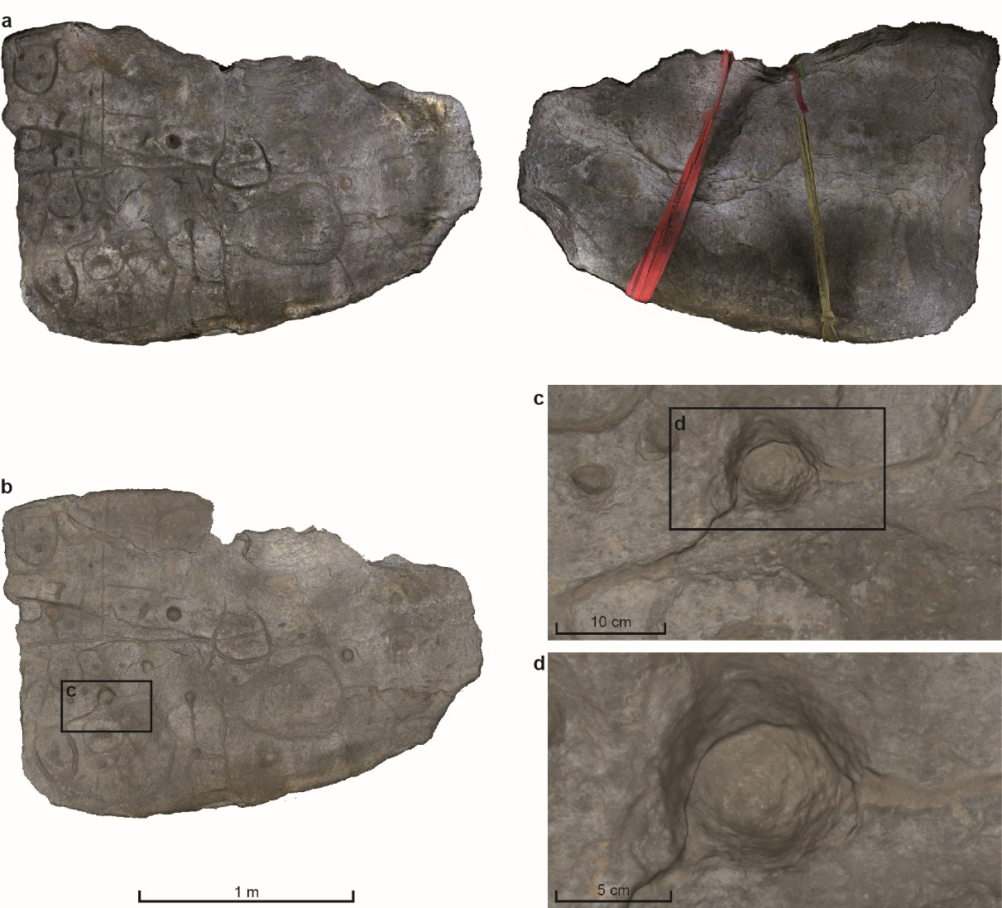
FIGURE S1
Photogrammetry and general scanning of the Saint-Bélec slab. (a) Photogrammetric 3D-models of the front face (left) and the rear face while lifting (right). (b) General 3D-model acquired by ARTEC EVA device. (c-d) Details of the general 3D-model (L. Aubry).

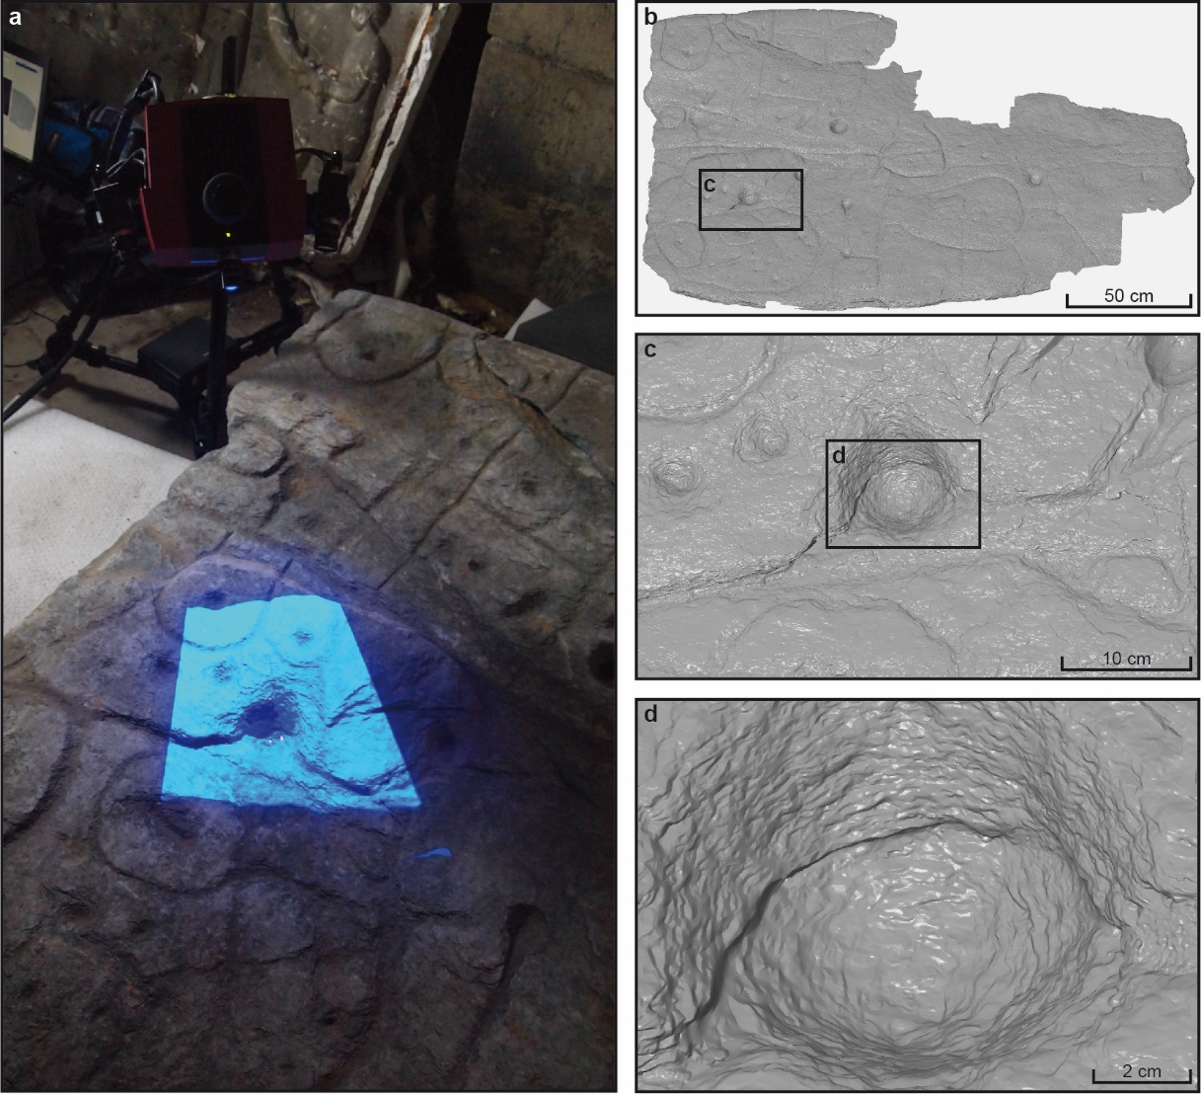
FIGURE S2
3D-scanning of the Saint-Bélec slab with ATOS Compact Scan. (a) 3D-scanning of an area of c. 30×30 cm in process. (b–d) The 3D-model and zoomed views of the same area, showing the planar schistosity fabric (a, P. Stéphan; b–d V. Lacombe).

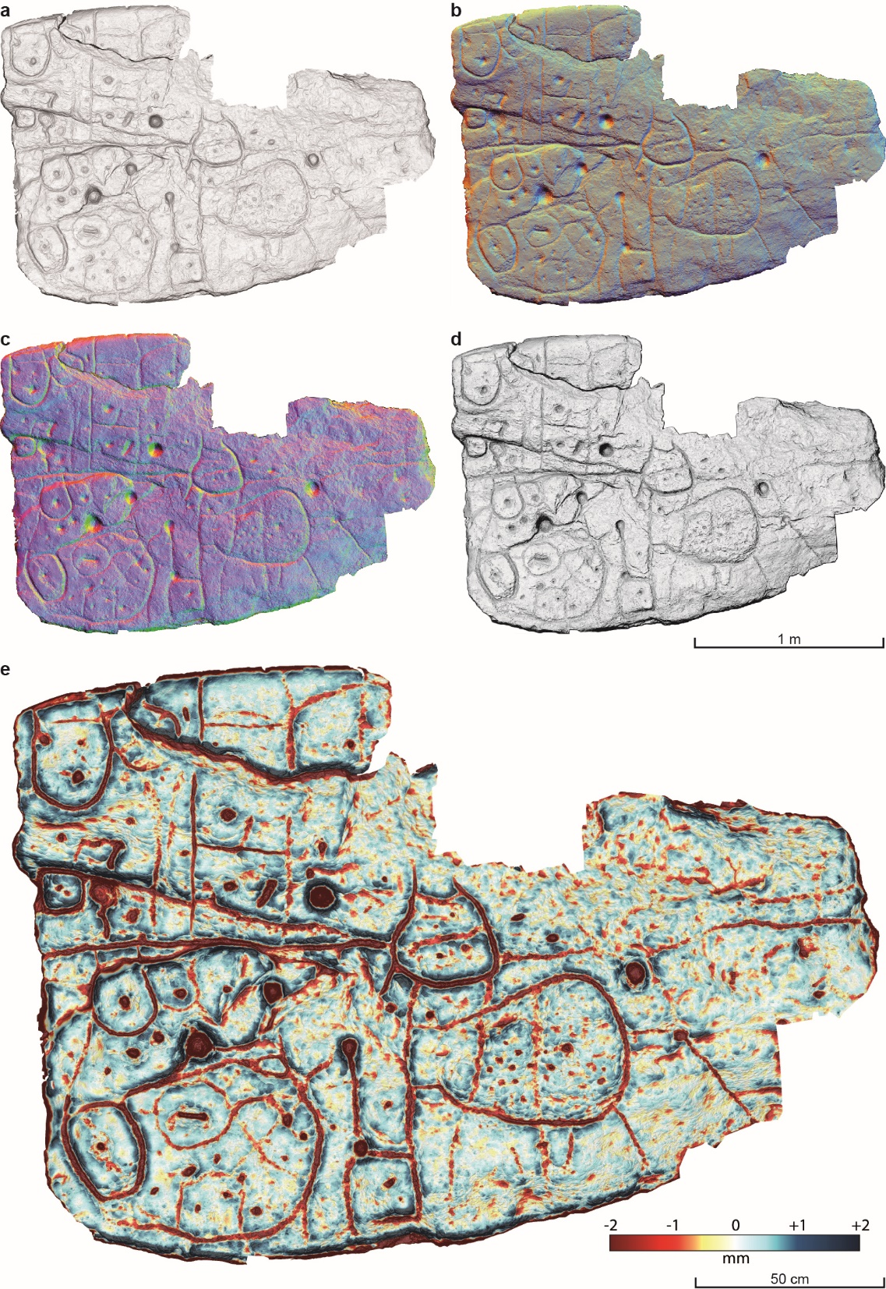
FIGURE S3
Various visualizations of the Saint-Bélec slab obtained by relative relief processing of the Digital Elevation Model. (a) Slope gradient image. (b) Multi-hillshading (MHS). (c), PCA Hillshading (PCA-HS). (d) Anisotropic Sky-View Factor (SVF-A). (e) 5. Simple Local Relief Model (SLRM) with 20 mm radius superimposed with Slope gradient image (P. Stéphan).
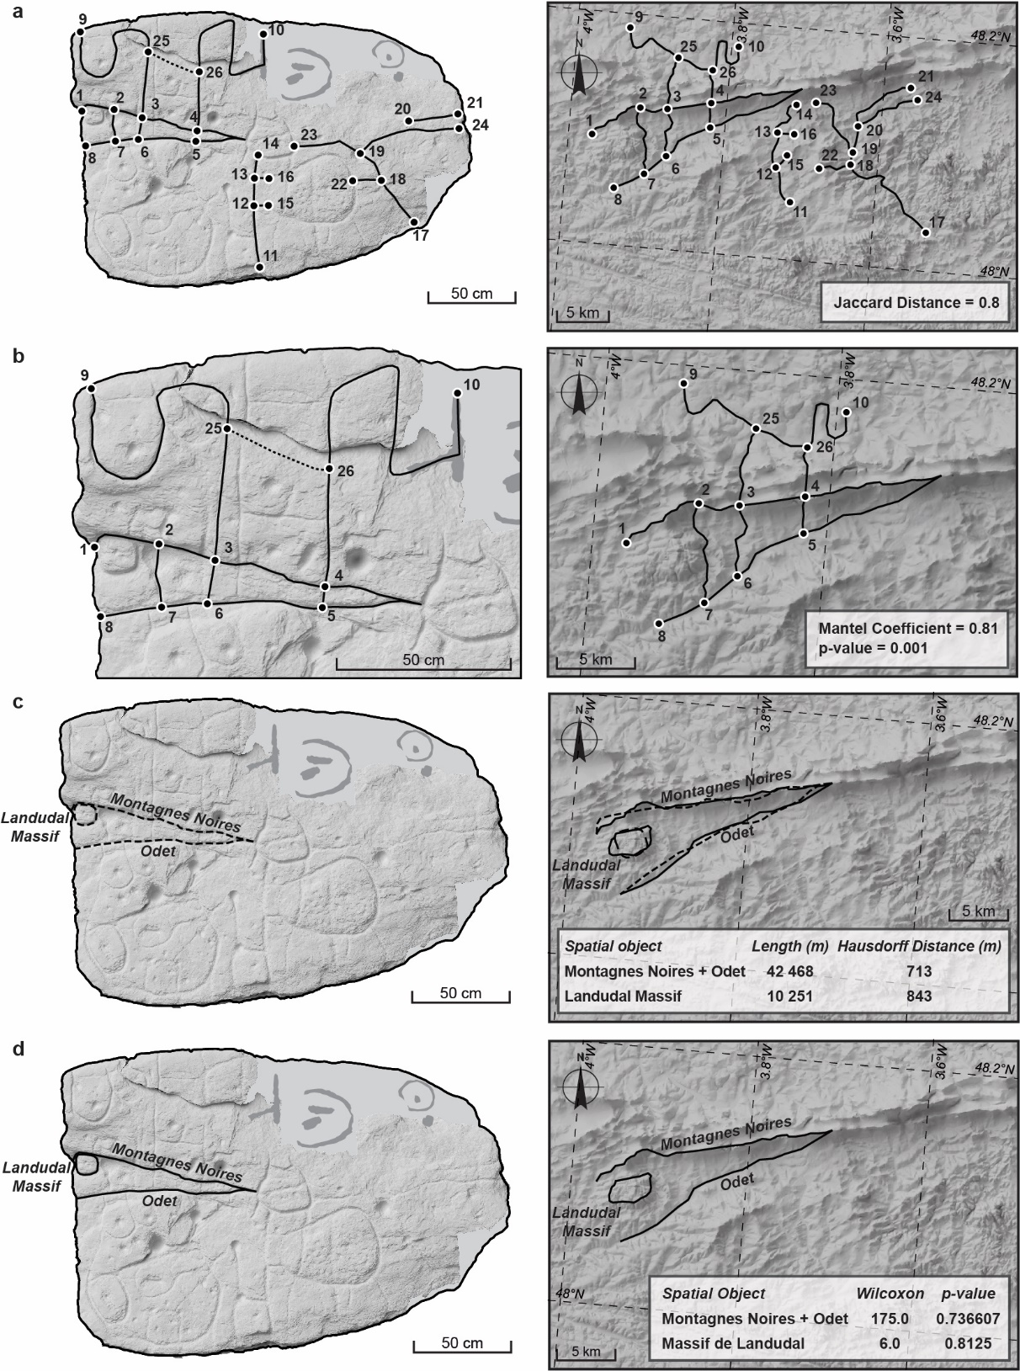
FIGURE S4
Network and shape analyses comparing the relief and the river network depicted on the Saint-Bélec to those of the montagnes Noires area. (a) Jaccard distance, (b) Mantel test, (c) Pompeiu-Hausdorff distance, (d) Wilcoxon test (Slab DEM: V. Lacombe and P. Stéphan; background maps: IGN; CAD: J. Pierson).
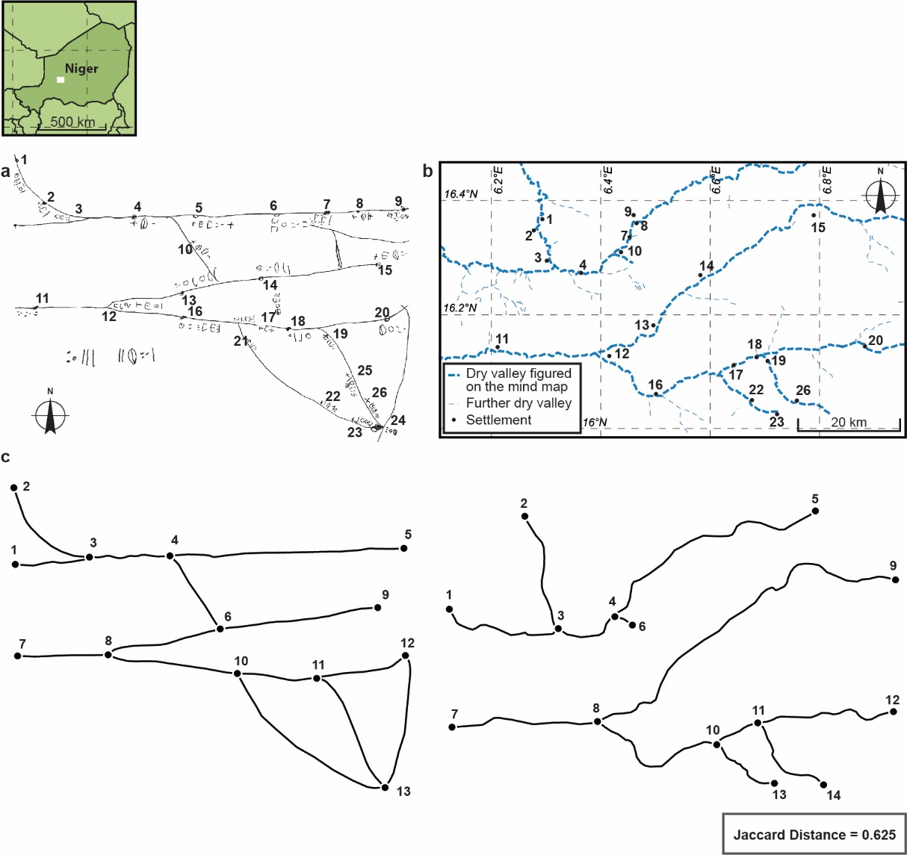
FIGURE S5
From solicited mind map to network analysis: a Tuareg case. (a) Reproduction of a map drawn by Kili ag Najim, Illabakan chief’s son, Niger, 1960s, (b) map of the corresponding river network, (c) network analysis (Jaccard distance) comparing the river network of the ethnographic solicited map to the local topography (a, after Bernus 1974 ; b, CAD C. Nicolas after OpenStreetMap and Bernus 1974; c, CAD J. Pierson).

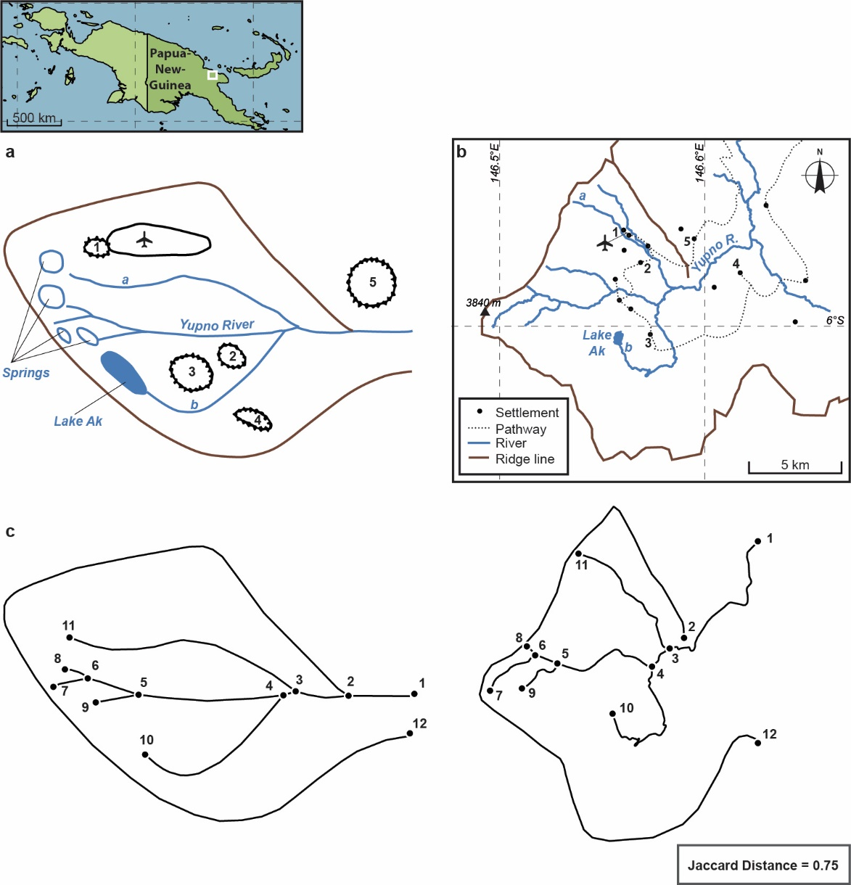
FIGURE S6
From solicited mind map to network analysis: a Papuan case. (a) Reproduction of a map drawn by an elder Yupno, Papua New Guinea, 1990s, (b) map of the corresponding relief and river network, (c) network analysis (Jaccard distance) comparing the relief and river network of the ethnographic solicited map to the local topography (a–b, after Wassmann 1993; c, CAD J. Pierson).

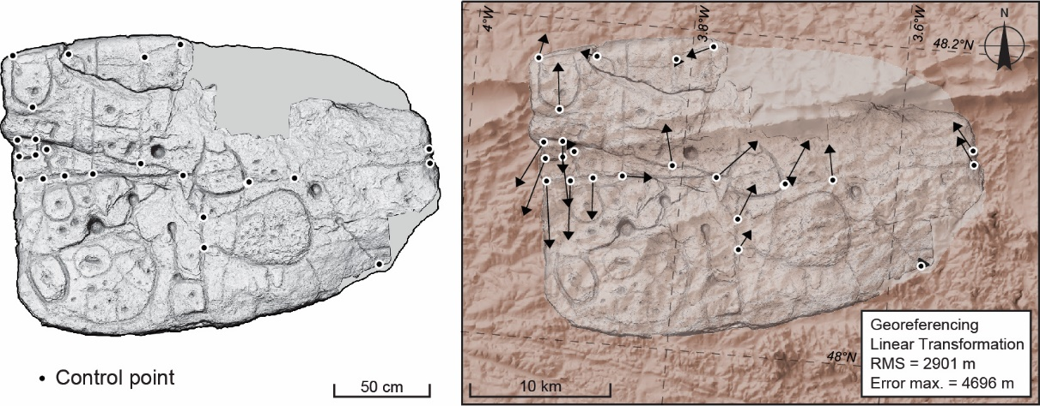
FIGURE S7
Control points and georeferencing of the Saint-Bélec slab (DEM: V. Lacombe and P. Stéphan; background map, Institut Géographique National).

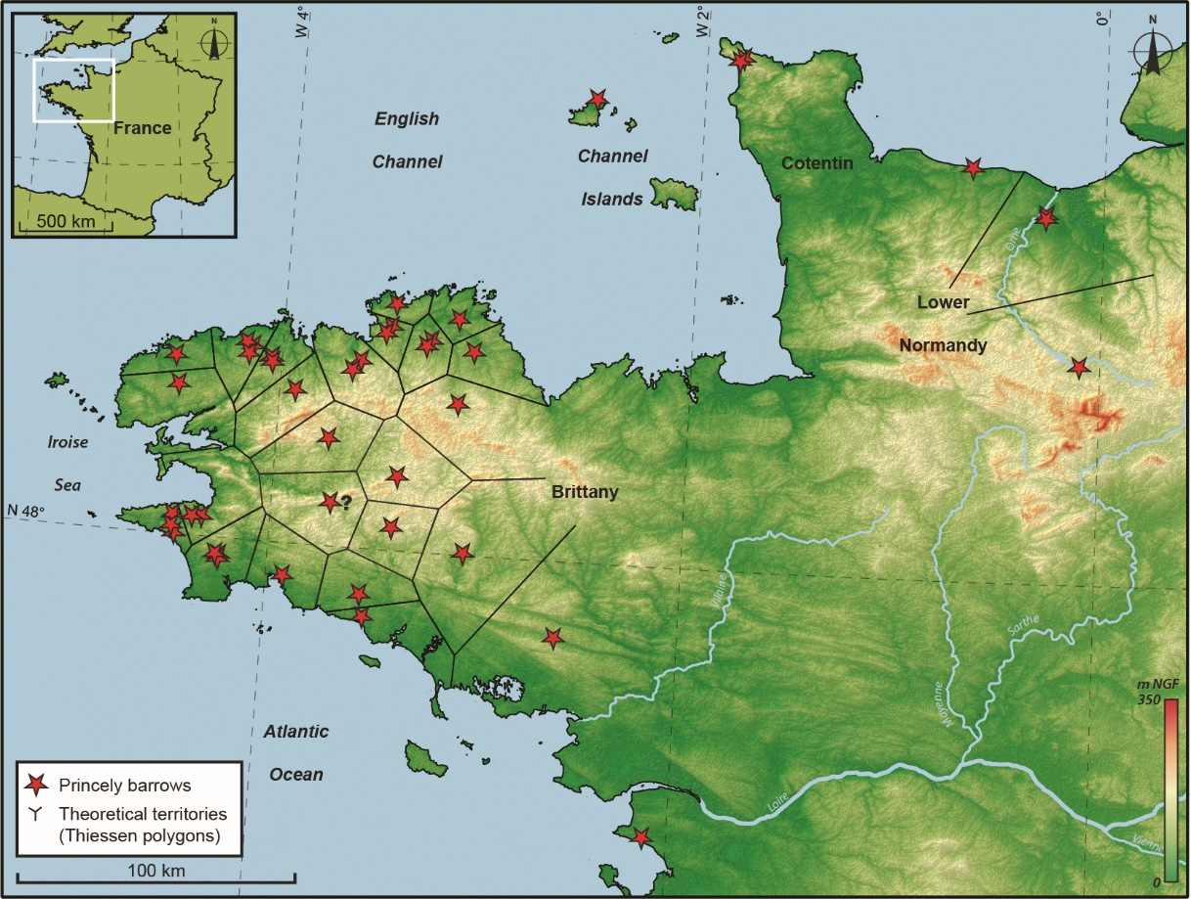
FIGURE S8
Early Bronze Age chief’s graves and theoretical territories in northwestern France and Channel Islands (background map, Institut Géographique National).

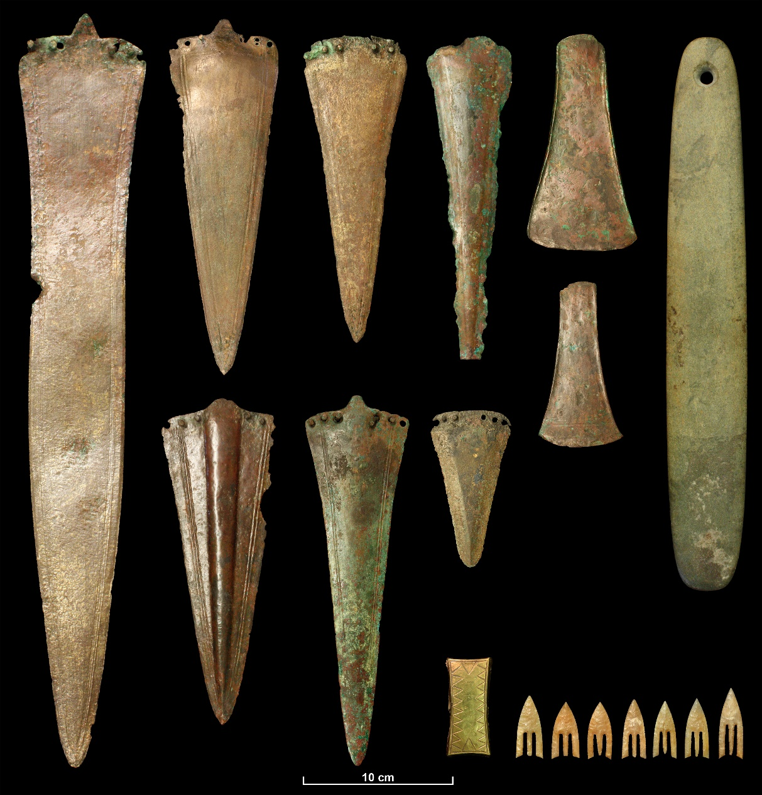
FIGURE S9
The grave goods of the La Motta Barrow (Lannion, Brittany), including bronze daggers and axes, a large whetstone or touchstone, a gold-sheet bracer and finely shaped ‘Armorican’ flint arrowheads. This is a good example of a richly furnished elite burial in northwestern France. Musée d’Archéologie Nationale, Saint-Germain-en-Laye. © C. Nicolas.

