Supporting Information for

Amorphous-to-crystal transition in the layer-by-layer growth
of bivalve shell prisms

Julien Duboisset, Patrick Ferrand, Arthur Baroni, Tilman A. Grünewald, Hamadou Dicko, Olivier Grauby, Jeremie Vidal-Dupiol, Denis Saulnier, Gilles Le Moullac, Martin Rosenthal, Manfred Burghammer, Julius Nouet, Corinne Chevallard, Alain Baronnet, Virginie Chamard*

This PDF file includes:

Fig. S1 Description of the Pinctada margaritifera sample

Fig. S2 Description of the Pinna nobilis sample

Fig. S3 Coherent Raman microscopy principles

Fig. S4 Coherent Raman images acquired at the P. margaritifera shell growth edge.

Fig. S5 External side of early-mineralized units after a light etching treatment

Fig. S6 Symmetric difference map principles, based on simulations.

Fig. S7 Coherent Raman microscopy images performed at the CC and ACC vibration modes of a P. margaritifera growing shell edge

Fig. S8 Correlation coefficient analysis on P. margaritifera and P. nobilis coherent Raman data

Fig. S9 Classical Raman microscopy on a P. margaritifera shell.

Fig. S10 Principles of birefringence measurements for a uniaxial optical material

Fig. S11 Optical vectorial ptychography characterization of a Pinna nobilis shell growth edge.

Fig. S12 X-ray nanoprobe Bragg diffraction of disc and prism of a P. margaritifera shell.

Fig. S13 Transmission electron microscopy of a Pinctada margaritifera prism.

Fig. S14 Transmission electron microscopy (TEM) of an axial section of a P. margaritifera prism.

Fig. S15 TEM images of the external sub-surface of a prism

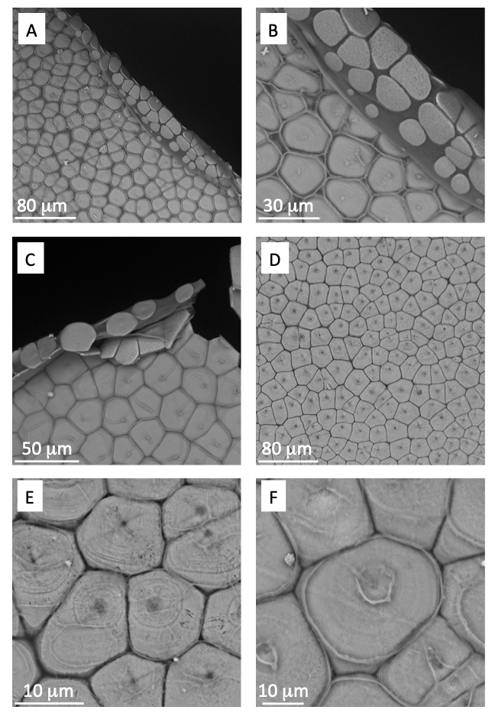
Fig. S1. Description of the Pinctada margaritifera sample. Scanning electron microscopy images produced on the outer side of the shell, in the vicinity of the growth edge. (A, B) The growth edge: note the difference between mature juxtaposed prismatic units and disc-like rather isolated early-mineralized units at the very border. Also note the different aspect of the external side of the shell (visible organics walls around the prisms, presence of a spotty feature at the centre of the units) and the internal side (homogeneously rough surface). (C) Another shell showing similar structural features. Note the presence of some faint ring-like patterns. (D) Mature part of the shell, showing a central depression visible in each prism. (E) Zoom-in view, allowing one to observe the central depression and the ring like pattern. (F) Zoom-in view showing a break of the periostracum above each central depression.
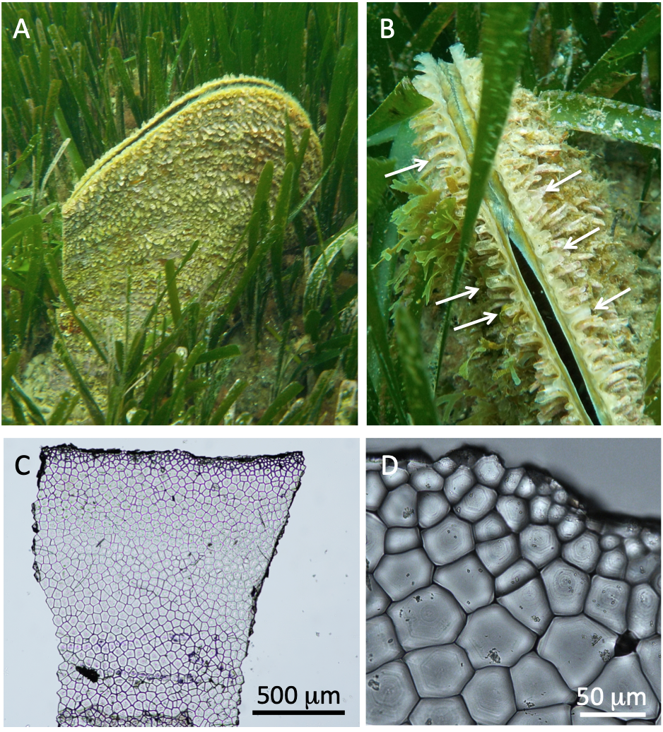
Fig. S2. Description of the Pinna nobilis sample. (A), (B) Pictures of the P. nobilis living shell in the Mediterranean Sea. Some spines are highlighted in (B) with arrows. (C) White light microscopy of a typical shell spine, as the one used for the present study. (D) Zoom-in view evidencing the prism shape and size and some annular features centered within the prismatic units.

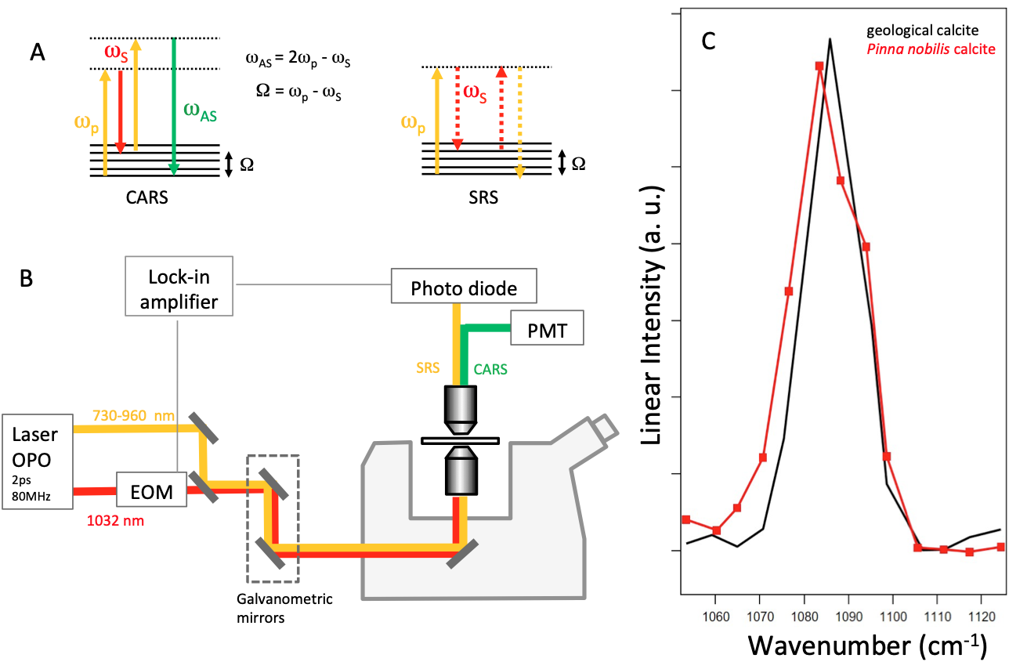
Fig. S3. Coherent Raman microscopy (chemical sensitive microscopy). (A) CARS and SRS energetic diagram. Ω is the energy of the vibrational bond, ω_{p} is the energy of the pump laser photons and ω_{S} the energy of the Stokes laser photons (note that, following the common practice in Raman spectroscopy, energies are expressed as wavenumbers 1/λ (in cm⁻¹), with λ the corresponding wavelength in vaccuum. The pump wavelength is tuned in order to fulfil the condition Ω = ω_{p} - ω_{S}. (B) CARS/SRS microscopy. For both CARS and SRS modalities, a mode-locked laser (optical parametric oscillator (OPO)) delivers synchronous pulses at two different wavelengths, the Stokes one at 1032 nm and the pump one, a tuneable pulse within a range of 730-960 nm. The two beams overlap in time and space and are focused using a water immersion objective. The image acquisition is performed using galvanometric scanning mirrors. The forward emitted light is collected in transmission using a long working distance air objective and focused on a channel photomultiplier tube (PMT). In the SRS mode, the experimental scheme is slightly modified. Electro optic modulator (EOM) modulates the intensity of the Stokes beam at 20 MHz. The forward signal is focused on the photodiode and a lock-in amplifier. (C) SRS spectrum obtained in the vicinity of the calcite symmetric C-O stretch ν₁ mode for a reference calcite crystal (black) and a biogenic calcite from a Pinna nobilis shell (red).
Note that, in general, the coherent Raman spectrum may be influenced by the polarization of the laser. However, our experimental approach allows avoiding this situation. (i) The same ν1 carbonate mode is investigated (we do not compare different vibrational peaks); (ii) the crystalline orientation within a prism or a disc is known to be rather homogeneous, in comparison with the mis-orientation that would be needed to modify the peak intensity); (iii) All emitted photons are collected whatever their polarization state is, which reduces the influence of the birefringence; (iv) An important effect could be a chromatic birefringence (the birefringence at lambda pump different from the birefringence at lambda stokes), which could affect differently the linear polarization of the pump and Stokes beam. However, the chromatic birefringence in the close infrared range is very low, and furthermore the thickness crossed by the light is sufficiently small to not affect differently the pump and the Stokes beam. Therefore, we are confident that the dependence of the Raman spectrum with respect to the laser polarization is not at the origin of the observed structural features.
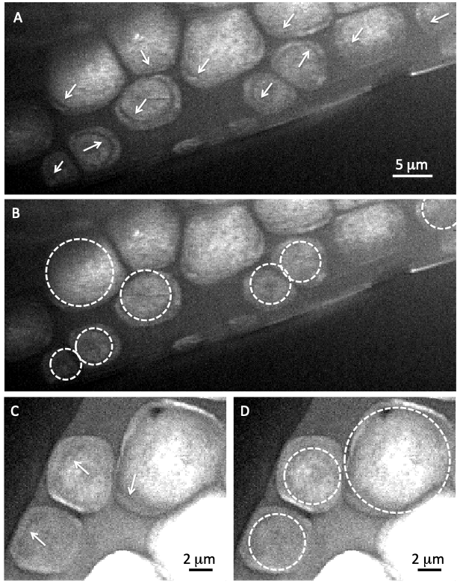

Fig. S4. Coherent anti-Stokes Raman scattering (CARS) images acquired in the vicinity of the Pinctada margaritifera shell growth edge (chemical sensitive microscopy). (A)-(D) Intensity distribution of the CARS signal obtained for the symmetric stretch C-O (ν₁) mode (calcite). (A), (C) Same images as in Figs. 1(B) and 2(A) (main text), respectively. The black rings are clearly visible (arrows). In (B) and (D) the same images are reproduced and white circles have been added as guides to the eye to highlight the strong deformation of the annular behaviour, in the vicinity of some of the disc/disc or disc/prism interface.

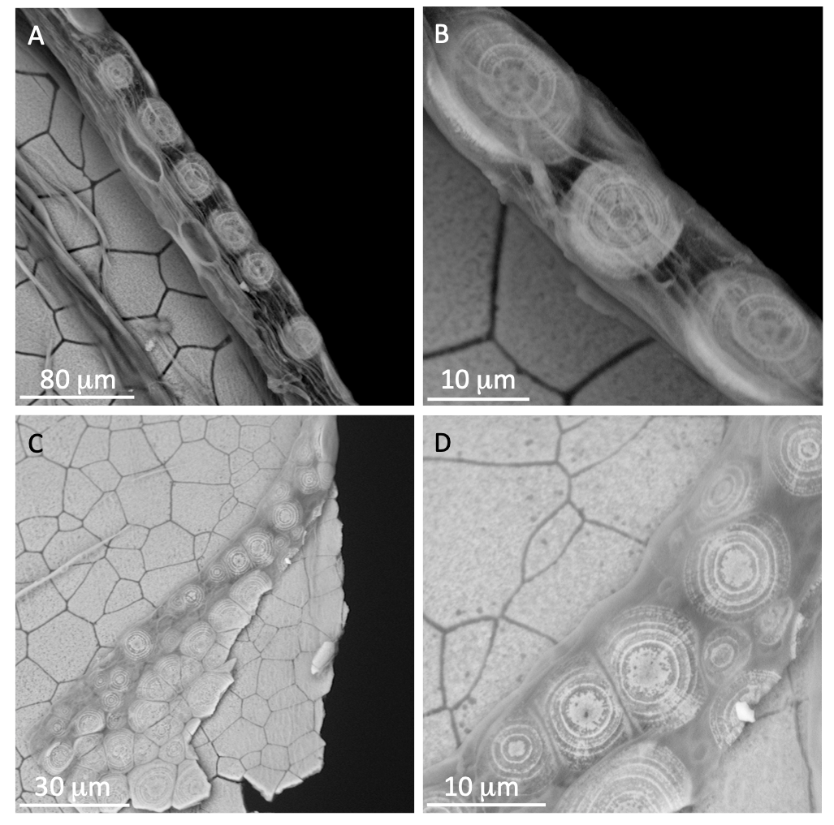
Fig. S5. External side of early-mineralized units after a light etching treatment. Pinctada margaritifera juvenile shells were etched for a couple of minutes in phenoxyethanol (A, B) 1ml/l or (C, D) 3ml/l. The external side of the shell growth edge was further investigated with scanning electron microscopy. It reveals a series of concentric rings within each unit, only visible on the external side. (A) Large overview, showing the internal side of the shell, on the left, and the external side of the early mineralized units on the right-hand of the shell. (B) Zoom-in view, evidencing ring-like features. (C) Large overview of a broken shell, showing its internal side. The broken part of the shell corresponds to the growth edge external side (with early-mineralized units) lying on the top. Note that the rings are only visible on the external side of the units. (D) Zoom-in view, showing the fine details of the ring-like pattern.

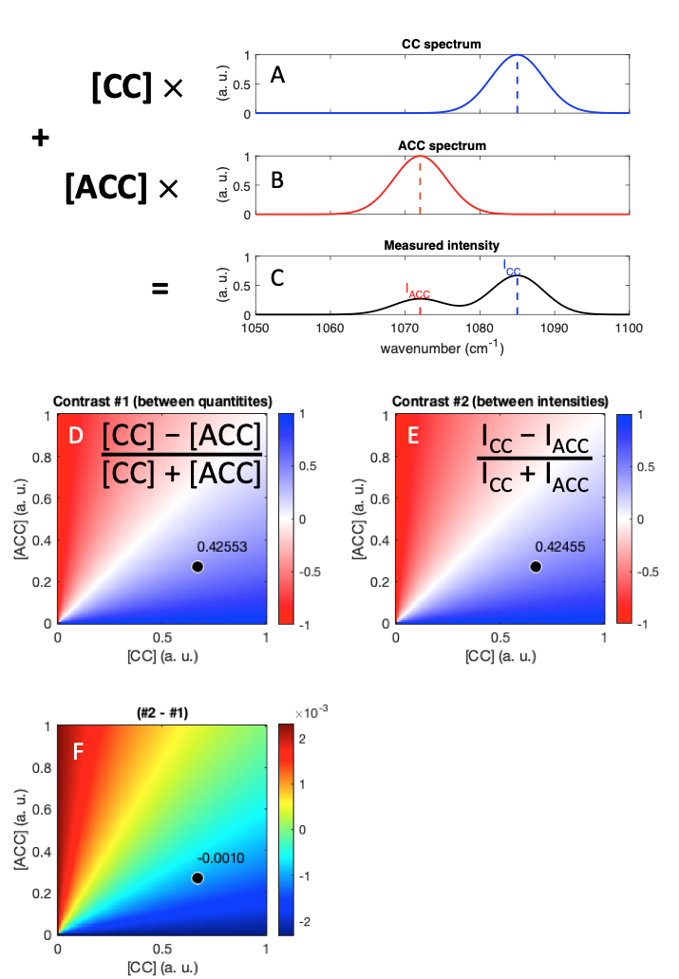
Fig. S6. Symmetric difference map principles, based on simulations. (A) Simulated Raman spectrum of the ν₁ CC resonance, assumed to be centred at a wavenumber of 1085 cm⁻¹, with a peak width of 10 cm⁻¹. (B) Simulated spectrum of the ACC resonance, centred at 1072 cm⁻¹, with a peak width of 10 cm⁻¹. (C) Simulated spectrum in presence of both CC and ACC phases, in respective quantities [CC] and [ACC]. ICC and IACC refer to the simulated measured intensities, extracted at the nominal CC and ACC wavenumbers, respectively. (D) Map of Contrast #1, a quantity defined as the ratio ([CC]-[ACC])/([CC]+[ACC]), for various combinations ([CC], [ACC]). A value of Contrast #1 = +1 (resp., -1), indicates the exclusive presence of CC (resp., ACC), while a 0 value means that [CC]=[ACC]. The location of the black spot indicates the values of [CC] and [ACC] that were used to plot the examples in (A)-(C). (E) Contrast #2 is the ratio (ICC-IACC)/(IACC+ICC), and shows a similar behaviour as Contrast #1. (F) Difference between Contrast #1 and Contrast #2, showing some negligible discrepancies when CC or ACC is close to 0.
Note that if a non-resonant (constant) background is added to the spectrum, the whole Contrast #2 amplitude is reduced. In addition, if the peak widths are different for CC and ACC, the whole Contrast #2 is shifted. It can be easily accounted for in the expression of Contrast #2. In the absence of detailed knowledge of the respective peak widths, we note however that the whole Contrast #2 behaviour follows the behaviour of Contrast #1 and is therefore suitable to monitor local variations in the balance of [CC] vs. [ACC] in a specimen.

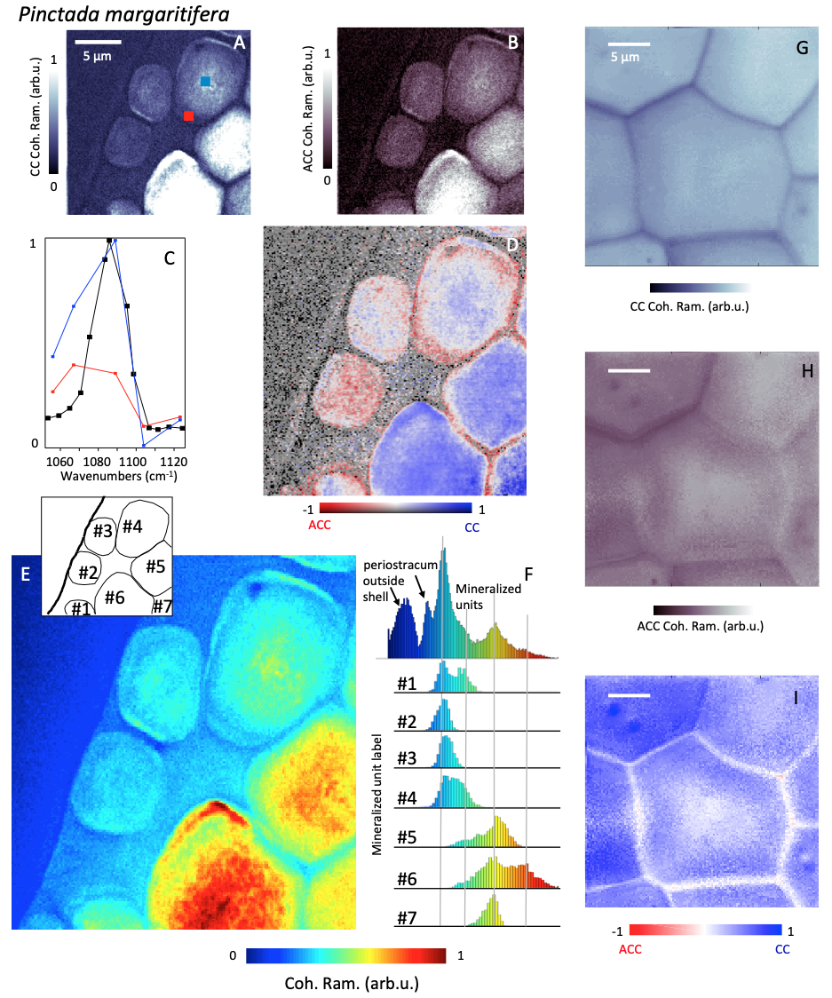
Fig. S7. Coherent Raman microscopy images performed at the CC and ACC vibration modes of a Pinctada margaritifera growing shell edge (Chemical sensitive microscopy). (A) CARS intensity image obtained at the symmetric stretch C-O (ν1) vibration (calcite). (B) Spectra obtained for two regions of the shell, marked as blue and red rectangles in (A). The reference spectrum (black) has been obtained on geological calcite. (C) The normalized intensity difference (symmetric difference, see Fig. S6) calculated from images obtained near 1085 and 1070 cm⁻¹. The hue values encode the amount of CC material versus ACC, while the brightness corresponds to the CC intensity signal. (E, F) Histogram analysis (F) of the coherent Raman intensity signal shown in (E). The histograms refer to individual prisms identified in the inset of (E). The intensity color scale, similar to (E) and (B), is indicated on the plot. (G, H) Similar as (A, B) for a mature prism located at about 50 μm from the shell growth edge. (I) Similar as (D) for the data acquired on the mature prism, shown in (G) and (H). The hue values encode the amount of CC material versus ACC.
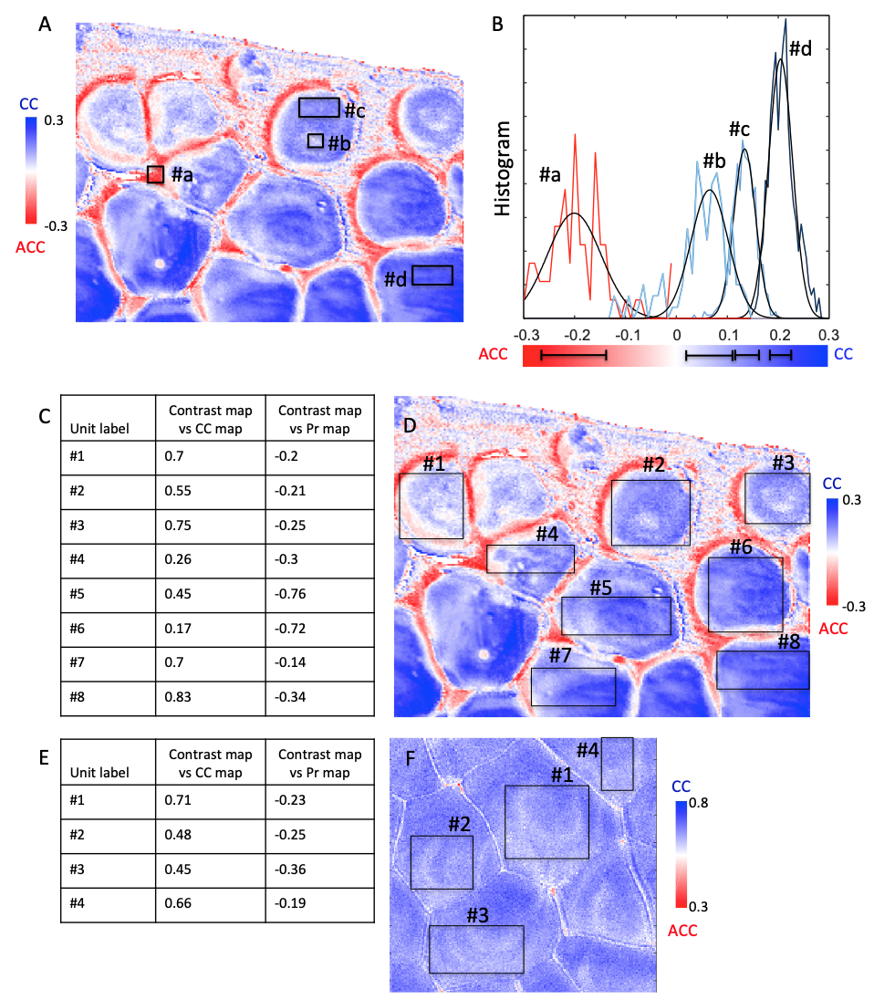
Fig. S8. Noise analysis and correlation coefficient analysis from coherent Raman data (chemical sensitive microscopy). (A) CC/ACC contrast map obtained from a Pinctada margaritifera shell allowing to define several regions for noise analysis: ACC-rich interprismatic region (#a), CC-rich (#b) and slightly ACC-rich (#c) region in a young disc, and CC-rich (#d) region in a more mature prism. (B) Histogram distributions for these four regions, showing that the noise fluctuation is sufficiently limited to show significant differences in the contrast level. A Gaussian fit was performed to estimate the mean value and dispersion of each region. The dispersion of each histogram is reported (black lines) on the colour bar. They are small with respect to the shifts observed between the different regions. In as second step, the correlation coefficients have been calculated between the CC/ACC symmetric difference (contrast) map and (i) the CC map or (ii) the Pr map for a series of sub-regions within discs and prisms. (C) Correlation coefficients for the Pinctada margaritifera shell, in regions defined in the CC/ACC contrast map (D). (E) Same as (C) for the Pinna nobilis shell, in regions defined in the CC/ACC contrast map (F). Note that, all coefficients are clearly different from 0. They are positive when the contrast map is compared to the CC distribution map and negative when the contrast map is compared to the Pr distribution. Note that the border of the individual prisms being strongly contrasted in all these chemical sensitive maps, the correlation coefficient - calculated to investigate the likelihood between the structural features observed within the prisms - can only be evaluated in regions which avoid the prism borders. For the same reason, some prisms could not be analysed because their shape was not compatible with the rectangular window used to extract the local correlation coefficients.

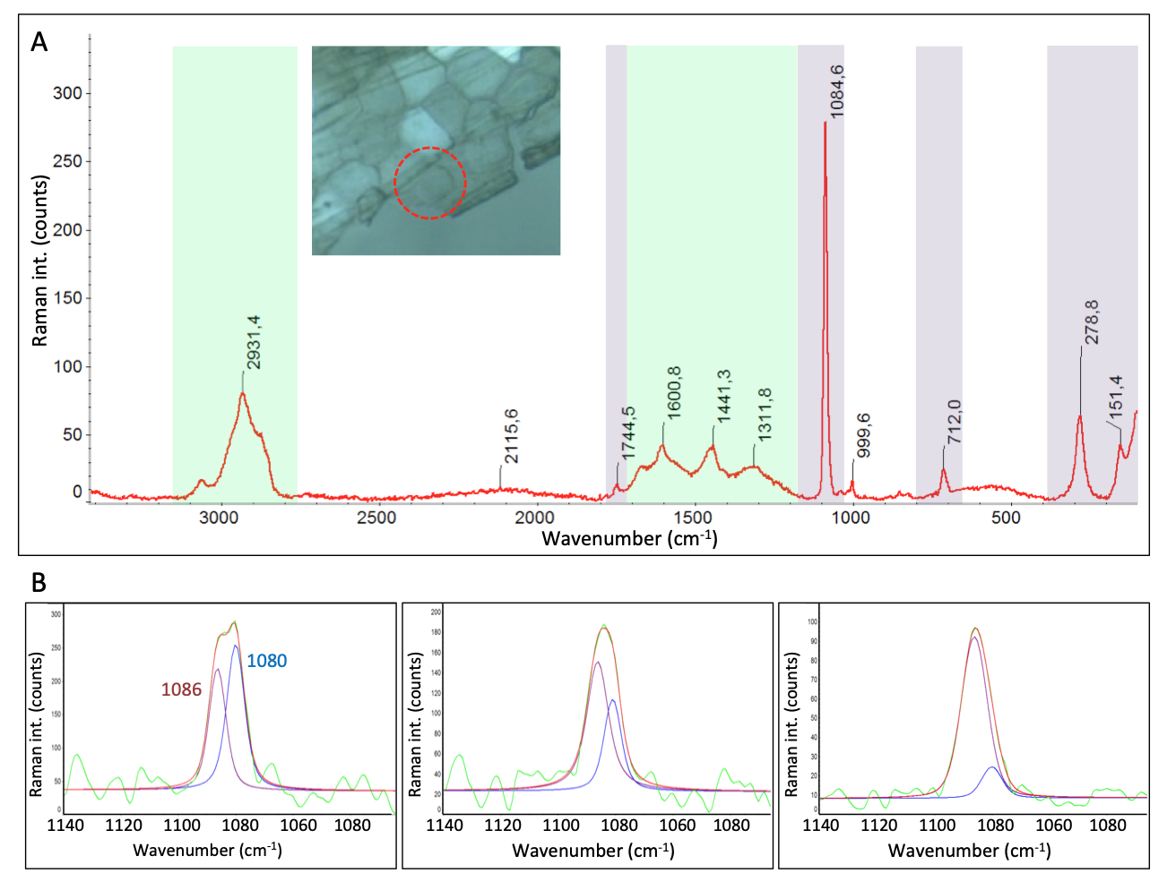

Fig. S9. Classical Raman microscopy performed on the growth edge of the P. margaritifera shell (chemical sensitive approach). (A) Raman spectrum obtained on a disc located at the shell border (similar to the one highlighted by a red circle on the inserted polarized optical microscopy picture), showing vibration bands of the organic (in green) and mineral (lavender) components of the shell. Internal carbonate vibration peaks (at 1748, 1085 and 713 cm⁻¹) as well as lattice peaks (at 281 and 153 cm⁻¹) typical for calcite polymorph are present. The organic content of the shell is revealed by CH2/CH3 peaks in the 2800-3100 cm⁻¹ range, as well as amide I/amide II peaks in the 1300-1700 cm⁻¹ region. (B) Result of the de-convolution of the carbonate peak around 1085 cm⁻¹ for three different locations at the shell border. This vibration band appears to always correspond to a double contribution, one coming from the carbonate vibration related to calcite polymorph, at 1085 cm⁻¹, the other one being located at 1080 cm⁻¹ and likely arising from the amorphous mineral contribution.
Methods: Raman experiments were performed on a Raman Thermo Scientific DXR spectrometer available at SOLEIL synchrotron (SMIS beamline). The sample was illuminated using a 532 nm laser with a power of 7mW, and the scattered light was collected with a x50 objective resulting in a spatial resolution of 0.7 µm. An exposure time of 10s and a repetition number between 20 and 30 were used to achieve an acceptable signal-to-noise ratio without inducing a noticeable degradation of the sample. Higher values of exposure time induced dramatic damage on the sample, as detected by the appearance of characteristic carbon vibration bands in the 1350-1600 cm⁻¹ range. The auto-fluorescence of the shell organic content results in initially high levels of background signal, which slowly decreases, under illumination, owing to photo-bleaching effects.

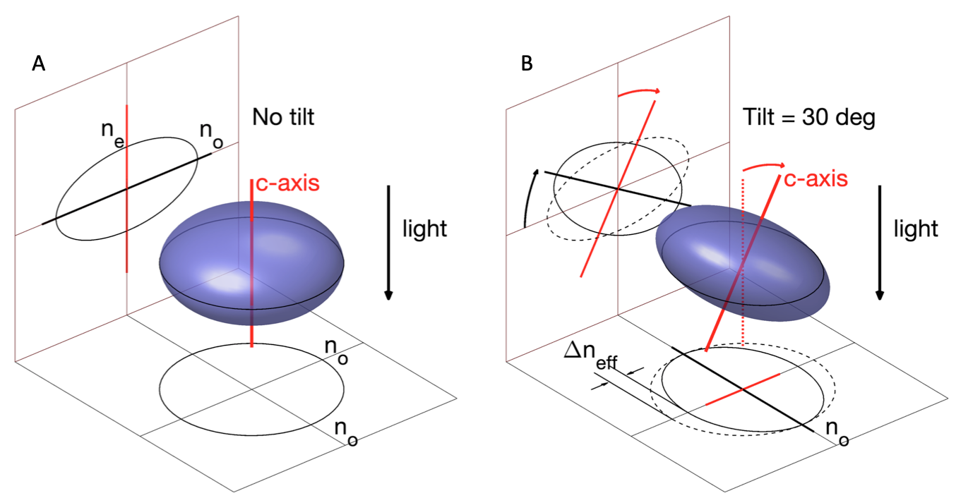
Fig. S10. Principles of birefringence measurements for a uniaxial optical material: Impact of the c-axis tilt on the observed birefringence (crystalline sensitive approach). The optical properties of calcite, known to be a negative uniaxial crystal, can be understood by considering its refractive index ellipsoid, which is slightly shrunk along the direction of the crystal c-axis, where the extraordinary index n_{e} is smaller than the ordinary one n_{o}. (A) When light propagates vertically along the direction of the c-axis, the transverse electric field vibrations take place in the horizontal plane, which intercepts the ellipsoid in its equator. This intercept is circular (see projection at the bottom), indicating that light travels in an apparently isotropic material of index n_{o}. (B) When the c-axis is tilted, the horizontal intercept becomes elliptical, so that light gets sensitive to the anisotropic nature of the material, with an effective birefringence Δn_{eff} and a corresponding retardance R = Δn_{eff} × t (where t is the thickness of the crystal). Note that indices differences have been exaggerated here for a better visualization. For pure calcite, n_{o} = 1.65 and n_{e} = 1.48.

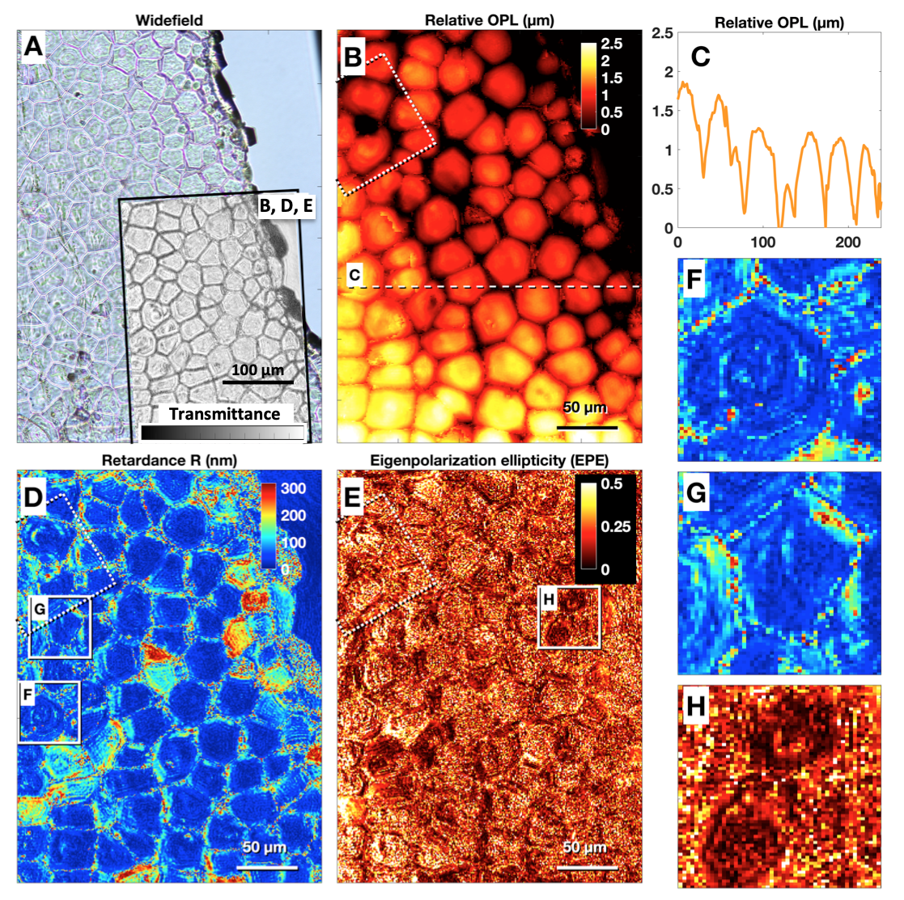

Fig. S11. Optical vectorial ptychography characterization of a Pinna nobilis shell growth edge (crystalline sensitive approach). (A) Widefield optical microscopy image (white light) of the investigated spine piece. The investigated sample piece was taken in the vicinity of the shell growth edge, as illustrated in Fig. S2. The black rectangle highlights the region investigated with optical vectorial ptychography. It exhibits the retrieved transmittance plotted on a linear scale in arbitrary units. (B) Optical path length (OPL) map obtained over a large field of view. (C) Cross-section of the OPL map, along the white dashed line shown in (B). (D) Retardance (R) map over the same region. Note that, some prisms exhibit high retardance values, likely corresponding to a tilt of the c-axis with respect to the beam direction [1]. (E) Eigenpolarization ellipticity (EPE) map over the same region. Note that, the EPE reduces to noise when the retardance is close to 0. The respective colour scales are indicated on the figures, in m, nm and unit-less for OPL, R and EPE respectively. (F, G) Zoom-in views of the R map, corresponding to the white square regions in (D). (H) Zoom-in view of the EPE map, corresponding to the white square regions in (E). The dashed white square corresponds to the region shown in Fig. 3 (main text).

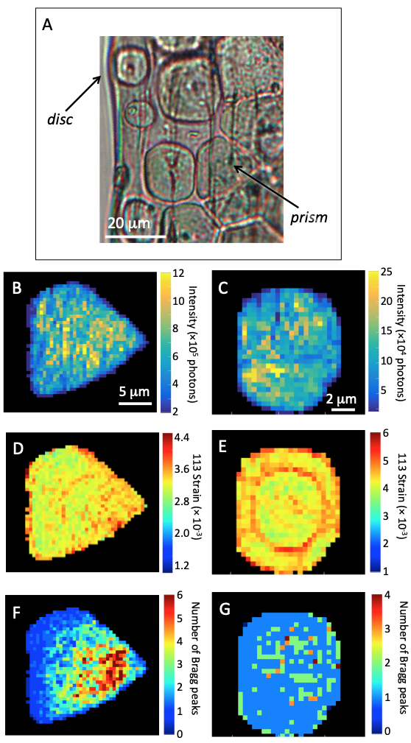

Fig. S12. X-ray nanoprobe Bragg diffraction investigation of a disc and prism from a Pinctada margaritifera shell (crystalline sensitive approach). (A) White light optical microscopy view of the investigated area, showing the disc and prism and their orientation with respect to the growth shell direction (the limit of the native shell border is visible on the left). In the following plots, this orientation is preserved. (B, C) Integrated Bragg diffraction intensity from the 113, 125 and 204 reflection for the prism and 113 reflection for the disc, respectively. (D, E) Strain (or lattice distortion) extracted from the 113 intensity distribution for the prism and disc, respectively. (F, G) Number of peaks (or components) in the Bragg reflection intensity distribution: for the prism (F), the shown numbers correspond to the average value obtained on the 113, 125 and 204 reflection maps, while the result shown for the disc (G) has been obtained for the only measured 113 reflection. Note that (B)-(F) are the same as Fig. 6B, F, C G and D, respectively.
Transmission Electron microscopy approach (crystalline sensitive approach).

TEM Methods, used to produce Figs. S12-15
Two different ion-milling techniques and processes were used, depending on the investigated regions in the prism, to produce electron-transparent thin foils of the P. margaritifera prismatic layer. For the outer sub-surface region sample, the convex side of a tiny valve was glued under binocular with an ultra thin layer of epoxy resin to cover a 1 mm single hole of a Cu slot. Then only the inner side of the shell was eroded (back-thinning) by Ar+ ion-milling with the precision ion polishing system (PIPS) Gatan, up to hole formation. The thin wedge around the hole was suitable for TEM observation. An acceleration voltage of 5.2 kV of Ar+ ions was first applied to the single gun, operating at 4° grazing incidence to the shell surface. The finish was performed with an acceleration of 2.8 kV during 15-30 min to minimize the thickness of the beam-induced amorphous layer. Eventually, a 10-20 nm-thick C coating layer was evaporated on the backside of the eroded layer to ensure electric conduction of the sample. The above procedure favoured the observation of the preserved outer surface of the prismatic layer and of the material underneath. This preparation was used for the specimen shown in Supporting Fig. S15.
Another specimen preparation was made to investigate the axial sections of the prisms. For that purpose, an electron-transparent 10 × 5-8 × 0.00-0.15 µm³ (length x depth x thickness) thin foil was cut with a Ga⁺ focussed ion beam (FIB), FEI model 200 TEM FIB, housed at CP2M, Aix-Marseille University. Issued from carefully scanning the prism surface with the Ga⁺ beam, a secondary electron image allowed localizing precisely the foil cut normal to it. The foil included a (calcification centre) nodule as well as the organic wall separating the prisms. Prior to ion digging of the foil, a thin C-coating and then a thick Pt-layer were deposited onto the outer surface for ion conduction and foil edge protection, respectively. The ion milling itself is made under a 20 nA Ga⁺ beam current accelerated at 30 kV. The FIB lift-out method was used as described by Heaney et al. [2]. The excavated foil was eventually transferred onto a C-film sustained on a TEM mesh Cu-grid, and observed without metallisation. This preparation was used for the specimen shown in Supporting Fig. S13 and S14.
A transmission electron microscope JEOL 2000fx (200 kV), hosted at CINaM, and equipped with a LaB6 electron source, was used with a double-tilt specimen holder. The JEOL 2000fx working at 200 kV provided contrasted, fixed beam, bright-field and dark-field images under low beam exposure and at moderate magnifications to minimize beam damages. Working in scanning transmission electron microscope mode, it allowed energy dispersive spectroscopy (EDS) for chemical element mapping when coupled with a TRACOR-Northern X-ray Si (Li) detector fitted with an ultra thin window. A LHESA analog low-light camera allowed a low-dose illumination during tuning of the objective focus and astigmatism correction made beside of the target of interest to avoid beam damage. The SAED patterns were recorded, selecting specimen areas equal to, or smaller than, shell units to be characterized. Further precautions have been also taken to distinguish possible amorphized matter from the pristine amorphous matter of the shell [3].

An axial section, cutting the prism in the vicinity of the centre of the rings (as those observed in Supplemental Fig. 1) was prepared (see Methods in the main text). The corresponding images are plotted below as Figs. S13-15. On the external prism surface (Fig. S13), TEM revealed the presence of a nodule, further characterized with qualitative energy dispersive X-ray spectroscopy showing that it lacks calcium signal and is also poor in oxygen (Fig. S14). The close-up view beneath the nodule indicates that a layered, rather irregular, organisation of the mineral material took place along the prism depth. Such layers are about 150 to 300 nm in thickness and the first deposited layers present an arcuate shape following the inner side of the nodule (dashed light pink lines). Strong elastic strain contrasts delineate the boundaries between the layers (green arrows). It was verified that this contrast is not stemming from dislocation lines but rather from point-like defects: neither dislocation line segments were observed during tilt nor systematic extinction of the diffraction contrasts, which would have pointed towards dislocation lines or Burgers vectors, respectively [3]. Selected area electron diffraction (SAED) patterns proved the amorphous (i.e., no crystalline order) nature of the nodule. The further series of SAED patterns made along the prism axis below the nodule, with a selected area smaller than the layer thickness, displays a calcite single-crystal diffraction pattern, stemming only from a single crystalline orientation, which does not significantly tilt along the prism length. This evidences locally the undistorted crystalline behaviour of the prism, already present in the first mineralized parts of the prism. Faint diffuse electron scattering in the background of the spotty SAED patterns may point towards an additional presence of amorphous (organic and/or mineral) components (a share of the contribution could come also from inelastic scattering through the rather thick FIB lamellae).
Additional investigations performed on the external sub-surface of a prism are shown in Fig. S15, together with a series of close-up views of the granule structure, along the prism radius up to the prism edge. It exhibits a crystalline to amorphous transition towards the prism edge.

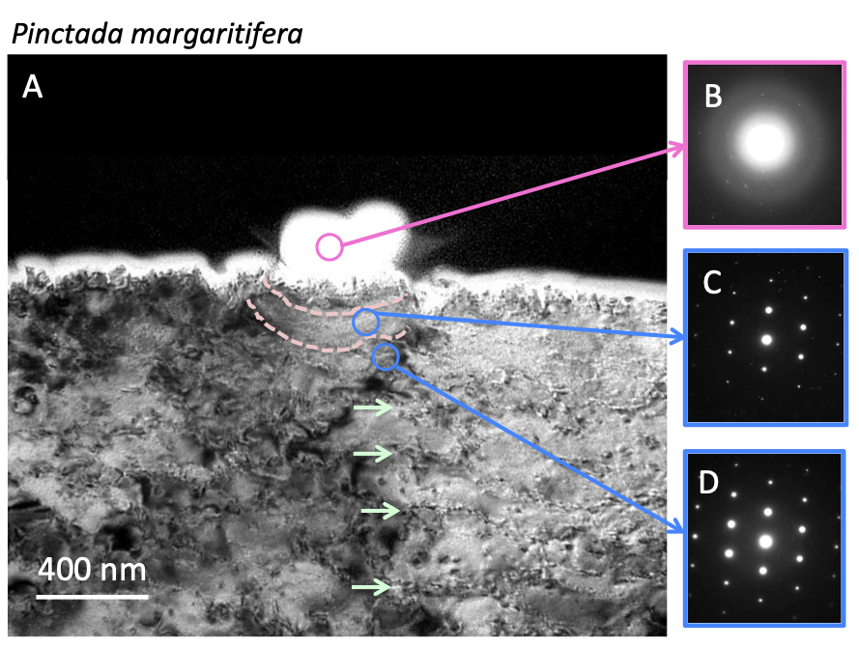

Fig. S13. Transmission electron microscopy of a Pinctada margaritifera prism. (A) Bright-field TEM image of an axial section of a prism in the vicinity of the ring centre, at the external sub-surface. Zones in exact Bragg diffraction conditions appear in black. The white envelope on the top surface corresponds to the strongly conductive C layer (preparation process). Underneath a (white) nodule, an arcuate layering is marked by lines of dotted contrasts (light pink lines superimposed on some dotted contrasts and green arrows pointing to dotted contrasts have been added as guides to the eye). (B)-(D) Series of SAED patterns recorded from the encircled area in (a); Pink: halos of diffuse scattering from the nodule indicating an amorphous material (note the presence of a few diffraction spots, arising from the tail of the electron beam impinging on the crystal below); Blue: spotty calcite single-crystal patterns in the subsequent layers.
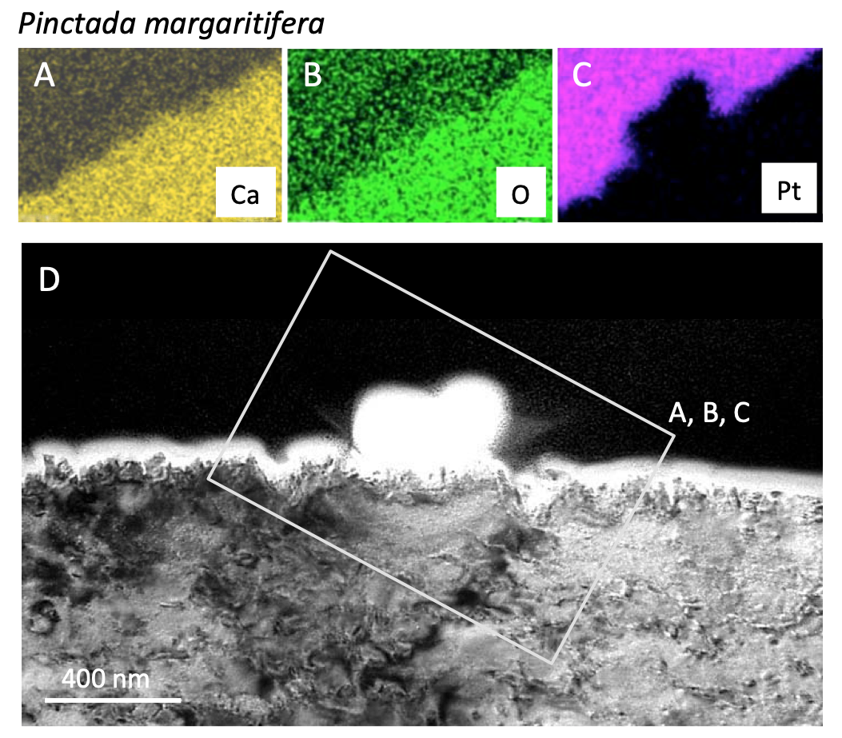
Fig. S14. Transmission electron microscopy (TEM) of an axial section of a Pinctada margaritifera prism. (A) Calcium, (B) oxygen and (C) platinum (cover layer form the preparation process) maps obtained by energy dispersive X-ray spectrometry, in the white rectangle area shown in (D). (D) Bright-field TEM image performed in the vicinity of the ring centre, at the external sub-surface of the prism (same as Fig. 4(A), main text).

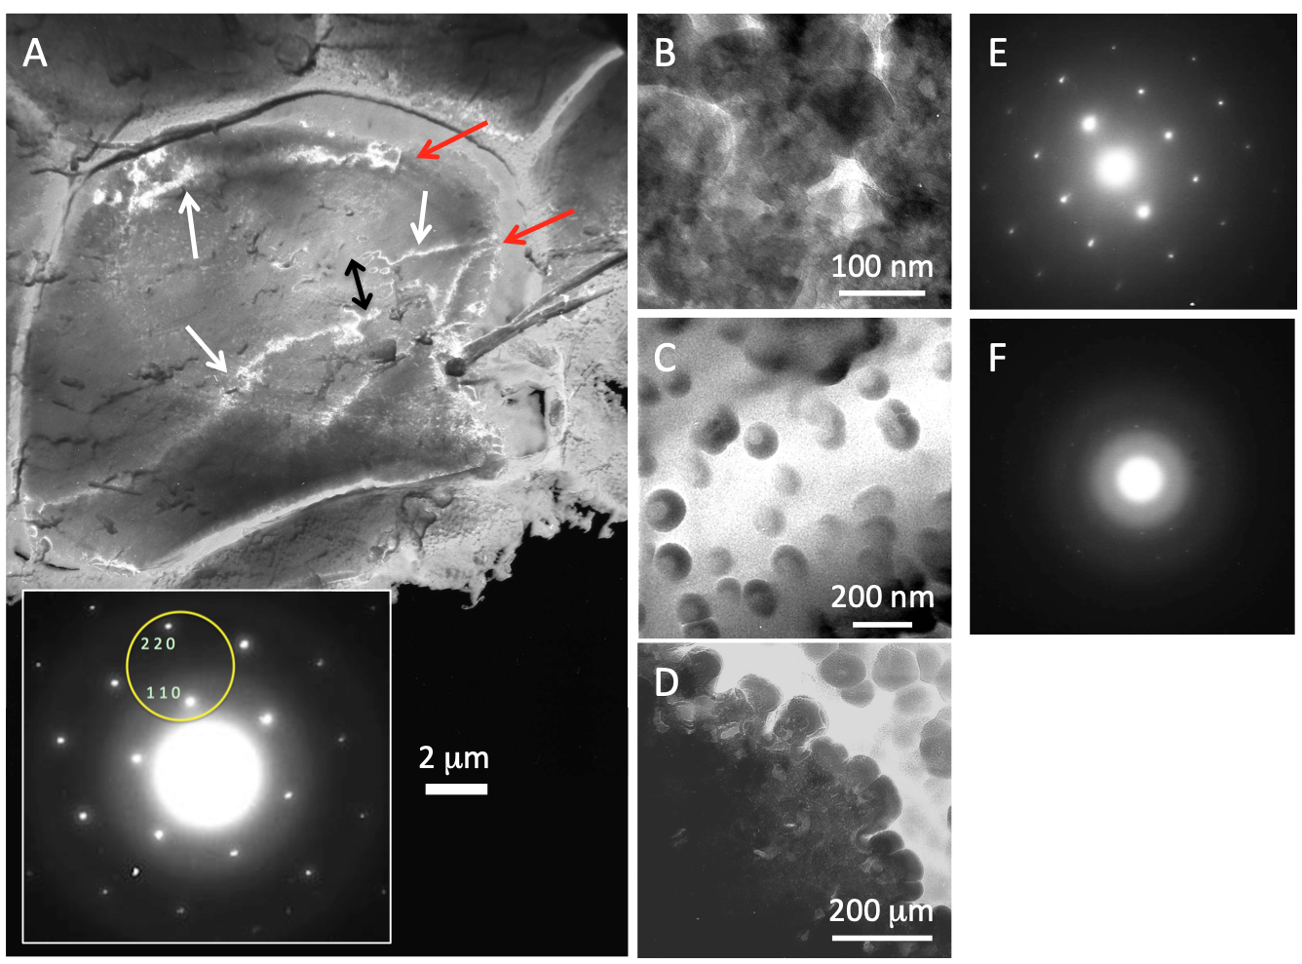
Fig. S15. TEM images of the external sub-surface of a prism (Pinctada margaritifera juvenile shell). (A) Low-magnification dark-field TEM image. Inset: 110 and 220 reflections selected from the <001> zone axis diffraction pattern for the presented double-beam dark-field image. Bright lines (white arrows) running across the prism are bend contours (BC) related to these reflections. BC crossing the whole prism is interpreted as the "single-crystalline" nature of the prism. However, the distorted, mottled and disrupted BC trajectories highlight crystalline mosaicity and/or strain at nanoscale. In the middle-right side of the image, the sharp BC offset (black arrow) indicates a sudden, although small, crystallographic orientational change. Light spotty shades of grey, on the left side, track increased inter-granular nano-porosity along growth banding. Top- and right-hand side: BC stops abruptly against the uniform contrast of prism rims and inter-prismatic boundaries (red arrows). These features are illuminated by diffuse electron scattering alone in dark-field mode and are therefore indicative of amorphous matter. (B)-(D) Close-up bright-field TEM images of the core-rim boundary, investigating the sub-micrometric granules, similarly to previous observations³. These higher porosity regions were chosen to avoid full overlap of granules, in depth of the sample. (B) Bragg fringes and other diffraction contrasts move continuously across the interconnected network of granules when tilting the sample, indicating that the whole granule network behaves as a single crystal. (C) In the vicinity of the prism edge, the granule contrast is homogenous and not orientation-dependent, as verified by tilting the sample: it results from absorption, indicating likely their amorphous nature. A unique bubble-like feature may be observed in many granules. As not growing under the electron illumination, such bubbles are likely due to earlier degassing of the granule content. Such in situ degassing might have taken place inside a watertight organic envelope. (D) An arrested crystallization front between a highly porous calcite single crystal (left) and fused amorphous granules (right), observed in the vicinity of the prism edge. (E, F) <122> SAED patterns acquired normal to the prism growth surface, in regions similar to (C) and (B), respectively.
References
[1] Y. Dauphin, E. Zolotoyabko, A. Berner, E. Lakin, C. Rollion-Bard, J.P. Cuif, P. Fratzl, Breaking the long-standing morphological paradigm: Individual prisms in the pearl oyster shell grow perpendicular to the c-axis of calcite, J. Struct. Biol. 205 (2019) 121–132.

[2] P. J. Heaney, E. P. Vicenzi, L. A. Giannuzzi, K. J. T. Livi, Focused ion beam milling: A method of site-specific sample extraction for microanalysis of Earth and planetary materials American Mineralogist. 86, 1094–1099 (2001).

[3] A. Baronnet, J. P. Cuif, Y. Dauphin, B. Farre, J. Nouet, Crystallization of biogenic Ca carbonate within organo-mineral micro-domains. Structure of the calcite prisms of the Pelecypod Pinctada margaritifera (Mollusca) at the submicron to nanometre ranges. Mineralog Mag. 72, 617–626 (2008).

