Supplementary Information for

**Plant community impact on productivity: trait diversity or key(stone) species effects?**

by

Philipp Brun, Cyrille Violle, David Mouillot, Nicolas Mouquet, Brian J. Enquist, François Munoz, Tamara Münkemüller, Annette Ostling, Niklaus E. Zimmermann, Wilfried Thuiller

# Text

## Methods

### Preprocessing and filtering community data

We filtered and regularized the community data according to the following steps: first, we harmonized the taxonomic backbones of the two datasets and aggregated subspecies information to the species level. Second, we removed all community plots (a) containing any trees, large shrubs, or aquatic plants as defined by Flora Indicativa (Landolt et al., 2010); (b) containing less than five species recorded or incomplete inventories, and (c) having a standard error of geo-positioning of more than 10 m. Third, we translated cover-abundance class information of the species into cover percentages using the conversion suggested by Münkemüller *et al.* (2014). This conversion allowed summed cover estimates to exceed 100% when vegetation structure was vertically layered. We then removed all community plots with total cover estimates of less than 30% or more than 300% to avoid distortions of remotely-sensed productivity estimates due to rocks/bare soil and to filter out a few observations with unrealistically high cover values (Brun et al., 2019). A minority of taxa contained in this set of community observations were genus-level classifications, non-angiosperm taxa, and full parasites. We did not consider these taxa as key(stone) species candidates nor did we match them with trait information, however, we left them in the analysis and considered their cover abundance to calculate the fraction of community cover abundance for which we had trait information (see below).

### Environmental data

#### Soil adjusted vegetation index data

We used the remotely-sensed Soil Adjusted Vegetation Index (SAVI) as a proxy for productivity. Geo-corrected SAVI data were obtained from the Landsat project (landsat.gsfc.nasa.gov) at a horizontal resolution of 30 m. We downloaded SAVI estimates for all 14 scenes (images) of the Landsat 7 satellite covering the study area (row-path combinations 27-193, 28-193, 27-194, 28-194, 27-195, 28-195, 29-195, 30-195, 27-196, 28-196, 29-196, 30-196, 28-197, and 29-197) from July 1999 to October 2017 and extracted SAVI values at the locations of community plots (Fig. S2). We removed extracted values that contained water, clouds, and cloud shadow, and those with invalid SAVI scores. Observations with snow coverage were replaced at each location by the lowest, snow-free SAVI measurement in the time series. On average, we obtained 271 SAVI estimates per community plot (ranging from 20 to 633). For each pixel, we first calculated monthly averages of SAVI observations, from which we then derived annual means (see Fig. S2 for an overview over the raw data and a graphical illustration of how annual means were derived).

#### Climate data

Climate data included annual mean temperature and humidity, and was obtained from CHELSA v1.2 (Karger et al., 2017). For annual mean temperature we used a custom version for the European Alps that was estimated by mechanistically interpolating ERA-interim weather reconstructions to 100 m resolution using CHELSA methodology (Karger et al., 2017). We define humidity as the extent to which the climate is humid, i.e., as the difference between annual precipitation and potential evapotranspiration (Henry, 2005). Humidity was estimated at 1000 m resolution based on the corresponding CHELSA layers. All climate data are representative for the period 1979-2013.

#### Soil and topography data

Soil and topography variables included soil moisture, soil fertility, terrain wetness, and exposition. Indices for soil moisture and fertility were derived from interpolated averages of indicator values of plant communities at 100 m resolution (Descombes et al., 2020). While these estimates are proxies for soil conditions, they benefit from the high density of plant observations available across the European Alps. Only sites with at least 10 species were considered to derive estimates of soil moisture and fertility from averaged indicator values. Given that hundreds of species were considered for the estimates across all sites, the impact of any single species was negligible. On average, the Spearman correlation coefficient was >0.999 between averaged proxies of soil conditions estimated from the full data set, and proxies estimated from data sets with one species iteratively being removed (Descombes et al., 2020). Moreover, the proxies derived this way were correlated reasonably to measured soil properties (Descombes et al., 2020). It is important to note that while reliable maps of directly-measured soil properties may be preferable, mapped soil properties often lack accuracy, even in data-rich countries like Switzerland: indicator value-based estimates of soil conditions outperformed interpolations of direct measurements as predictors for plant distributions more than indicator value-based estimates of any other predictor group (Scherrer & Guisan, 2019).

Topography predictors originated from the EU-DEM digital elevation model provided by the European Environment Agency at 25 m spatial resolution. From these data, we deduced the terrain wetness index (TWI), by applying the SAGA wetness index function in SAGA GIS (Conrad et al., 2015), and the north/south component of exposition, using the geospatial data abstraction library (GDAL, https://gdal.org).

#### Land cover data

We used land cover data to identify sparsely vegetated sites. Potential productivity expected from climate and soil/topography conditions is not realized when vegetation is missing. We therefore identified sparsely vegetated sites based on data from the CORINE Land Cover 2018 map (https://land.copernicus.eu/), with 100 m resolution. We aggregated the 44 original land cover classes to a binary layer in which 1 represented the five classes of the category ‘Open spaces with little or no vegetation’ (beaches, dunes, sands; bare rocks; sparsely vegetated areas; burnt areas; glaciers and perpetual snow) to represent sparse vegetation.

### Classifying partial response curves

We used goodness-of-fit and shape criteria to separate five classes of responses of SAVI to community-level functional predictors, following the approach of Brun et al. (2019). Goodness of fit was determined based on explained deviance added. Partial response curves of model fits with explained deviance added <1% were classified as non-significant (ns). Three conditions had to be fulfilled for a curve to be considered ‘concave-‘ (unimodal). Its minimum had to be at one edge of the prediction range, its maximum had to be somewhere within the prediction range, and the edge of the prediction range that was not associated with the minimum had to be at least 10% of the response range below the response maximum. For a curve to be classified ‘concave+‘ inverse criteria applied, except, that the edge of the prediction range that was not associated with the response maximum had to be at least 25% of the response range above the response minimum. This more constrained definition of ‘concave+’ curves was chosen, because in many cases the relatively inflexible GAM fits increased somewhat towards the minimum of the prediction range, when they otherwise showed an exponentially increasing response, and since there was no theoretical reason to expect ‘concave+’ relationships. If response curves did not fall into any of the above classes, and their value at the minimum of the prediction range was lower than the value at the maximum, responses were classified as ‘increasing’; else they were classified as ‘decreasing’.

## Results

### Environmental clusters

To group community surveys by similar environment, we defined two key environmental dimensions which turned out to be closely linked SAVI. We conducted a PCA on the scaled and centered values of temperature, humidity, and soil fertility associated with community observations and used the first two axes, which explained 92.6% of the variance, to define environmental similarity. For these principal components, the loadings of temperature and soil fertility aligned fairly well, and they were more or less orthogonal to the loadings of humidity, thus defining a quasi-two-dimensional space of major environmental gradients. For intuitive presentation, we rotated these first two principal components to align the loading of increasing temperature with the X-axis, and only display the loadings in the graphics. In this environmental space, high SAVI was linked to intermediate to high values in all three environmental factors, low SAVI linked to cold conditions/low soil fertility, and intermediate SAVI was linked to cool temperatures/intermediate soil fertility, and/or low humidity. The habitats resulting from partitioning around medoids clustering within this space are shown in Fig. S3.

# Tables & Figures

**Table S1 | List of sources of trait data**

|  |  |  |
| --- | --- | --- |
| **Trait** | **Databases** | **References** |
| SLA | TRY, ORIGIN ALPS | Adler et al. 2014, Brun et al. 2019, Ciccarelli 2015, Cornelissen 1996, Cornelissen et al. 2004, Dalke et al. 2018, de Vries et al. 2016, Diaz et al. 2004, Giarrizzo et al. 2017, Gos et al. 2016, Kattge et al. 2009, Kichenin et al. 2013, Kleyer et al. 2008, Lhotsky et al. 2016, Maire et al. 2015, Milla and Reich 2011, Ordoñez et al. 2010, Peco et al. 2005, Sandel et al. 2011, Schroeder-Georgi et al. 2016, Shipley 2002, Takkis 2014, Thuiller et al. 2014, Vergutz et al. 2012, Vile 2005 |
| LNC | TRY, ORIGIN ALPS | Adler et al. 2014, Atkin et al. 2015, Belluau and Shipley 2018, Brun et al. 2019, Campbell et al. 2007, Campetella et al. 2011, Cornelissen 1996, Cornelissen et al. 2004, Craine et al. 2005, Craine et al. 2009, Craine et al. 2012, Dalke et al. 2018, de Vries et al. 2016, Fitter and Peat 1994, Freschet et al. 2010, Han et al. 2012, Herz et al. 2017, Kattge et al. 2009, Kazakou et al. 2006, Kerkhoff et al. 2006, Kichenin et al. 2013, Laughlin et al. 2010, Li and Shipley 2018, Louault et al. 2005, Loveys et al. 2003, Maire et al. 2015, Milla and Reich 2011, Onoda et al. 2017, Ordonez et al. 2010, Prentice et al. 2011, Quested et al. 2003, Schroeder-Georgi et al. 2016, Shipley et al. 2000, Smith et al. 2014, Spasojevic and Suding 2012, Thuiller et al. 2014, Tribouillois et a. 2015, Vergutz et al. 2012, Wang et al. 2017, Wright et al. 2004 |
| HGT | TRY, ORIGIN ALPS | Brun et al. 2019, Gos et al. 2016, Kleyer et al. 2008, Thuiller et al. 2014 |
| Life form | ORIGIN ALPS | Brun et al. 2019, Thuiller et al. 2014 |

**Table S2 | Number of observations and number of species available for analysis within the different environmental clusters considered**. Q25 represents the first quartile; Q50 represents median; and Q75 represents the third quartile.

|  |  |  |  |  |  |  |  |  |  |  |  |
| --- | --- | --- | --- | --- | --- | --- | --- | --- | --- | --- | --- |
|  |  | **Number of observations** | | | | | **Number of species with trait data\*** | | | | |
|  | nclust | Min | Q25 | Q50 | Q75 | Max | Min | Q25 | Q50 | Q75 | Max |
| **Community-level** | 1 |  |  | 17764 |  |  |  |  | 412 |  |  |
| 5 | 2215 | 3632 | 3755 | 4051 | 4111 | 311 | 375 | 376 | 393 | 396 |
| 25 | 99 | 540 | 786 | 861 | 1133 | 175 | 276 | 300 | 350 | 3777 |
| 50 | 59 | 267 | 388 | 454 | 545 | 145 | 241 | 282 | 320 | 359 |
| **Key(stone) species** | 1 |  |  | 29091 |  |  |  |  | 412 |  |  |
| 5 | 5297 | 5592 | 5599 | 5726 | 6877 | 253 | 269 | 304 | 333 | 354 |
| 25 | 626 | 1041 | 1162 | 1355 | 1725 | 136 | 193 | 211 | 238 | 272 |
| 50 | 218 | 492 | 603 | 668 | 916 | 95 | 152 | 188 | 205 | 230 |

* Note that number of species in key(stone) species datasets are lower than in community-level datasets despite the higher number observations because we filtered for species with at least 1% prevalence per habitat for individual-species analyses, but not for community-level analyses.

**Table S3 | Key(stone) species identified across the full dataset**. Listed are all key species (38 species) with the subset of keystone species (11 species) highlighted in bold. Explained deviance refers to full model with productivity (soil adjusted vegetation index) as response and environmental conditions (smooth terms) and cover values of the species (linear coefficient) as predictors. Delta explained deviance refers to model improvement after adding the species coefficient.

|  |  |  |  |  |  |  |  |
| --- | --- | --- | --- | --- | --- | --- | --- |
| **Species** | **Plant type** | **Explained deviance** | **Delta exp. Dev.** | **Linear coefficient** | **Trait data** | **Seed mixture species\*** | **Listed in GISD\*\*** |
| *Trifolium pratense* | Legumes | 68.87 | 0.75 | 18.66 | Yes | Yes | No |
| *Holcus lanatus* | Grasses | 68.86 | 0.75 | 22.54 | Yes | No | Yes |
| ***Ranunculus acris*** | **Forbs** | **68.66** | **0.54** | **30.15** | **Yes** | **No** | **No** |
| *Anthoxanthum odoratum* | Grasses | 68.59 | 0.47 | 12.87 | Yes | Yes | No |
| *Poa trivialis* | Grasses | 68.57 | 0.45 | 21.34 | Yes | No | No |
| ***Rumex acetosa*** | **Forbs** | **68.57** | **0.45** | **48.07** | **Yes** | **No** | **No** |
| *Festuca pratensis* | Grasses | 68.56 | 0.44 | 23.62 | Yes | Yes | No |
| *Dactylis glomerata* | Grasses | 68.55 | 0.43 | 16.26 | Yes | No | Yes |
| *Trisetum flavescens* | Grasses | 68.53 | 0.41 | 16.70 | Yes | Yes | No |
| *Arrhenatherum elatius* | Grasses | 68.53 | 0.41 | 12.18 | Yes | No | No |
| ***Plantago lanceolata*** | **Forbs** | **68.53** | **0.41** | **24.16** | **Yes** | **Yes** | **No** |
| *Trifolium repens* | Legumes | 68.42 | 0.30 | 22.81 | Yes | Yes | Yes |
| *Avenula pubescens* | Grasses | 68.40 | 0.29 | 17.22 | Yes | No | No |
| ***Tragopogon pratensis*** | **Forbs** | **68.39** | **0.27** | **57.97** | **Yes** | **No** | **No** |
| *Lolium perenne* | Grasses | 68.39 | 0.27 | 21.63 | Yes | Yes | No |
| ***Lathyrus pratensis*** | **Legumes** | **68.38** | **0.26** | **25.23** | **Yes** | **Yes** | **No** |
| *Festuca arundinacea* | Grasses | 68.37 | 0.25 | 16.22 | Yes | Yes | No |
| *Cynosurus cristatus* | Grasses | 68.36 | 0.25 | 19.67 | Yes | Yes | No |
| *Carex montana* | Sedges | 68.36 | 0.24 | 8.12 | Yes | No | No |
| *Sanguisorba minor* | Forbs | 68.35 | 0.23 | 15.11 | Yes | Yes | No |
| ***Taraxacum officinale*** | **Forbs** | **68.35** | **0.23** | **26.09** | **Yes** | **No** | **Yes** |
| *Poa pratensis* | Grasses | 68.34 | 0.22 | 16.75 | Yes | Yes | Yes |
| *Rhinanthus alectorolophus* | Forbs | 68.33 | 0.21 | 11.30 | Yes | No | No |
| *Festuca rubra* | Grasses | 68.32 | 0.20 | 8.77 | Yes | Yes | No |
| ***Achillea roseo-alba*** | **Forbs** | **68.31** | **0.19** | **55.98** | **No** | **No** | **No** |
| *Leucanthemum vulgare* | Forbs | 68.30 | 0.18 | 19.89 | Yes | Yes | No |
| *Ranunculus repens* | Forbs | 68.30 | 0.18 | 20.73 | Yes | No | No |
| ***Knautia arvensis*** | **Forbs** | **68.30** | **0.18** | **26.70** | **Yes** | **Yes** | **No** |
| *Ranunculus bulbosus* | Forbs | 68.30 | 0.18 | 19.04 | Yes | No | No |
| ***Veronica chamaedrys*** | **Forbs** | **68.30** | **0.18** | **35.65** | **Yes** | **No** | **No** |
| ***Vicia cracca*** | **Legumes** | **68.28** | **0.16** | **29.75** | **Yes** | **Yes** | **No** |
| *Leontodon hispidus* | Forbs | 68.27 | 0.16 | 10.46 | Yes | Yes | No |
| *Salvia pratensis* | Forbs | 68.26 | 0.15 | 11.49 | Yes | Yes | No |
| *Agrostis capillaris* | Grasses | 68.26 | 0.14 | 10.13 | Yes | Yes | Yes |
| *Bromus erectus* | Grasses | 68.25 | 0.13 | 3.11 | Yes | No | No |
| *Centaurea jacea* | Forbs | 68.25 | 0.13 | 16.79 | Yes | Yes | No |
| *Geum montanum* | Forbs | 68.24 | 0.12 | 15.26 | Yes | No | No |
| ***Colchicum autumnale*** | **Forbs** | **68.23** | **0.11** | **26.11** | **Yes** | **No** | **No** |

* as defined in Lehmann et al. (2000); ** GISD represents Global Invasive Species Database (http://www.iucngisd.org/)

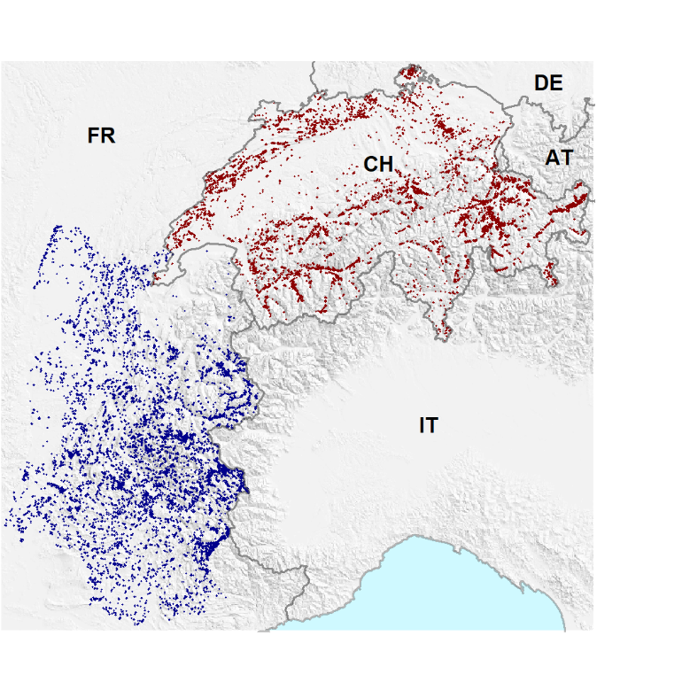

**Fig. S1 | Distribution of community plots in the French alps and Switzerland**. Observations from the French National Alpine Botanical Conservatory are shown in blue; observations from the dry meadows and pastures initiative are shown in red.

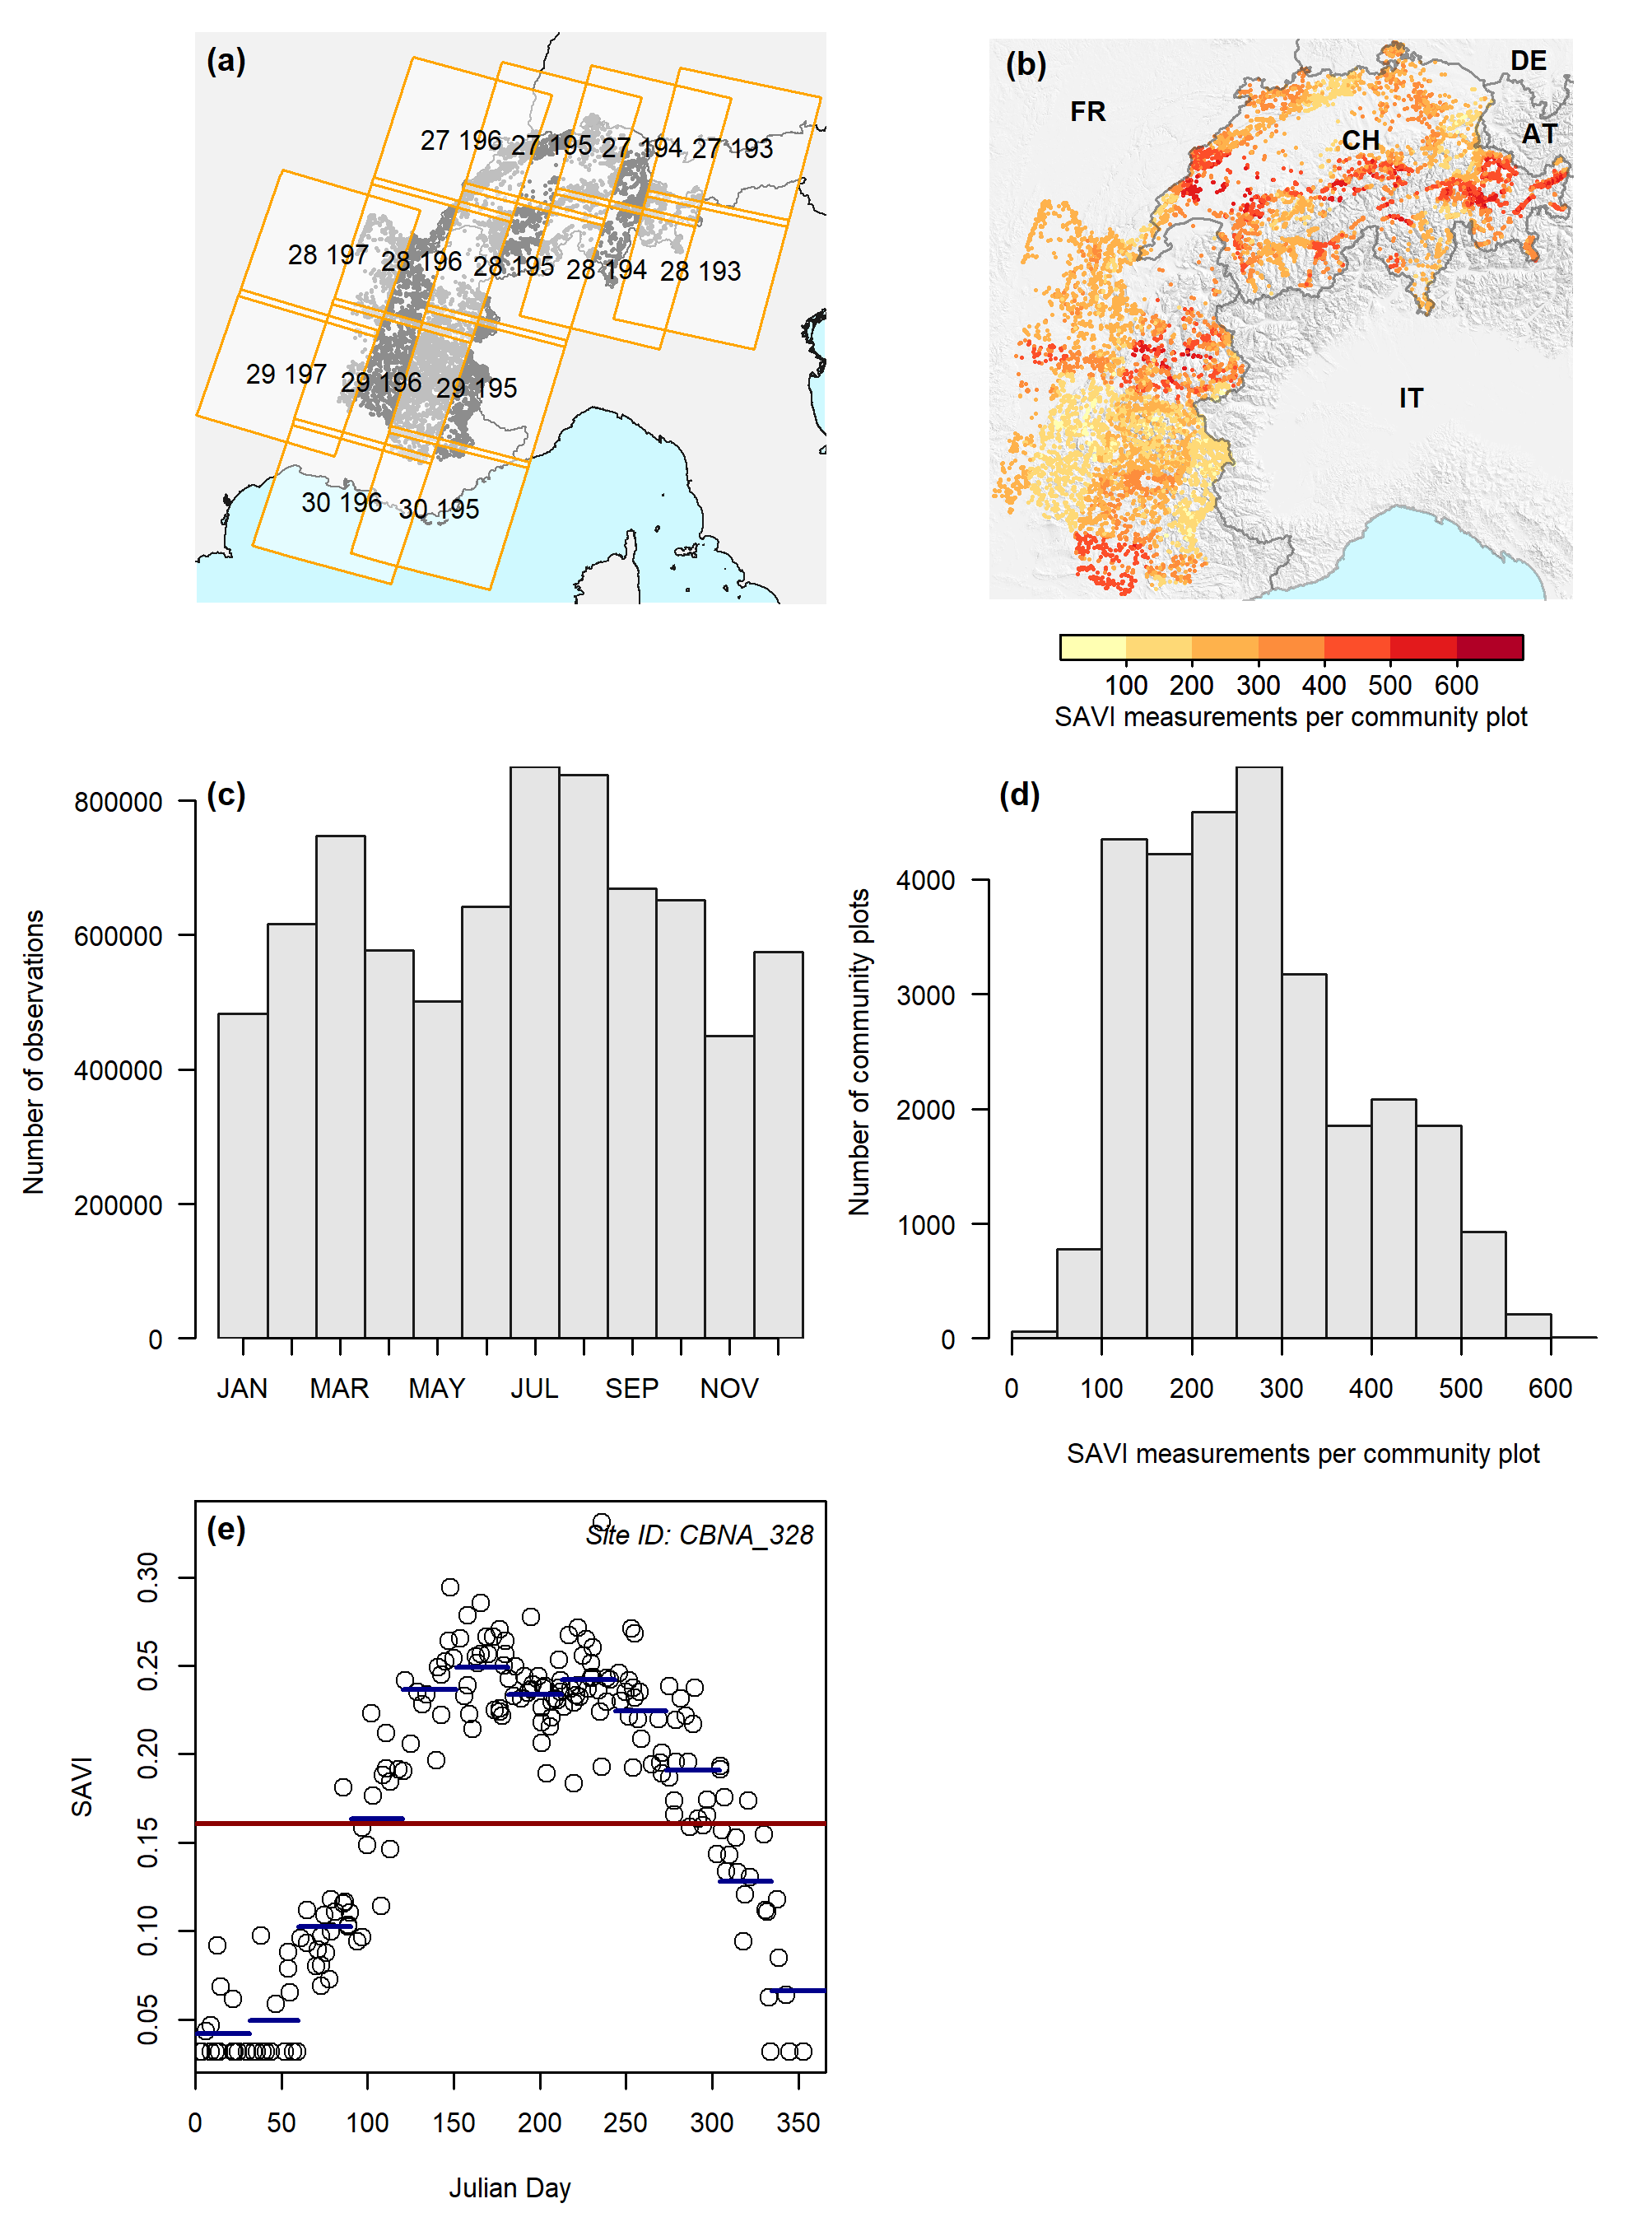

**Fig. S2 | SAVI data and computation of annual means**. **a**, Landsat 7 tiles considered; **b**, spatial distribution of number of SAVI observations per community plot; **c**, frequency distribution of SAVI observations across the season; **d**, frequency distribution of number of SAVI observations per community plot; **e**, estimation of annual averages per site at the example of site “CBNA_328” (202 observations): first monthly averages are calculated (dark blue lines), then the annual mean (dark red line) is calculated from the monthly averages. The increased number of points at SAVI≈0.04 results from substituting all observations with snow cover with the lowest value observed at the site.

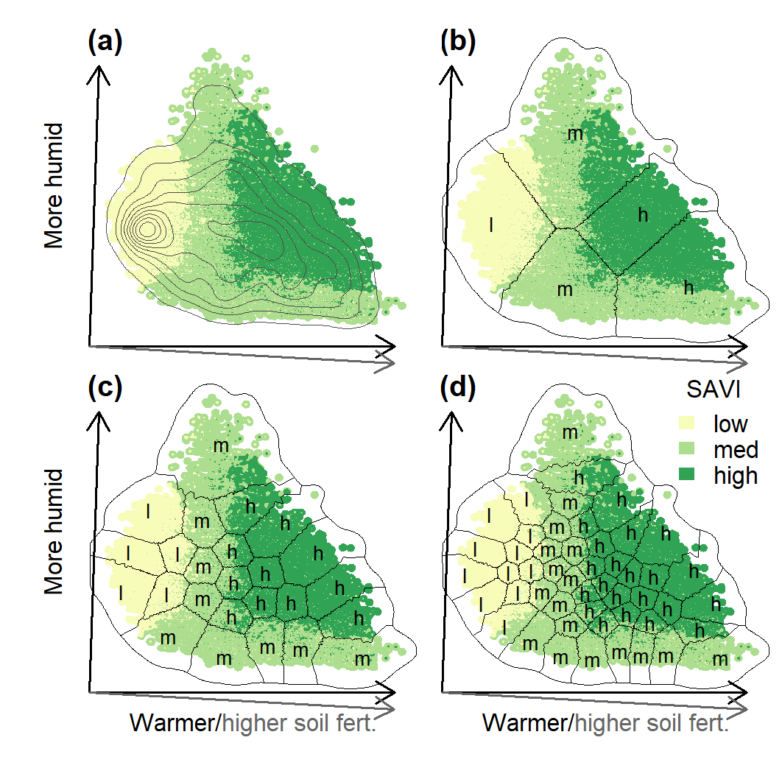

**Fig. S3 | Environmental space and habitats considered in this study**. **a**, density distribution of observations across environmental space; **b**, separation of environmental space into five habitats; **c**, separation of environmental space into 25 habitats; **d**, separation of environmental space into 50 habitats. Classification of productivity (soil adjusted vegetation index, SAVI) levels is indicated by letters representing low (l), intermediate (m), and high (h). Axes are rotated principal components of environmental space (see Methods) with arrows representing loadings for increasing temperature, soil fertility, and humidity. Surface depicts inverse-squared-distance interpolation of productivity levels and superimposed isolines represent the density of observations.

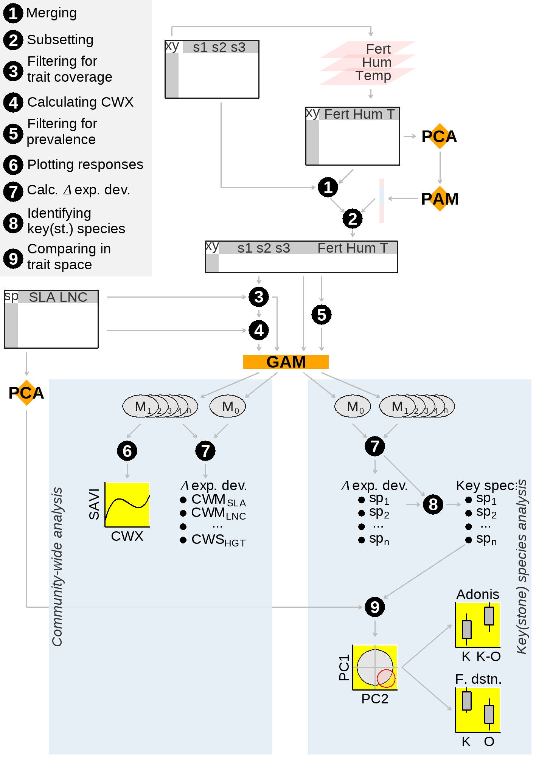

**Fig. S4 | Schematic illustration of the analyses conducted in this study**. Black circles indicate data transformations; arrows indicate flow of information; results are highlighted in yellow. PCA represents principal component analysis; PAM indicates partitioning around medoid clustering; and GAM stands for generalized additive modeling.

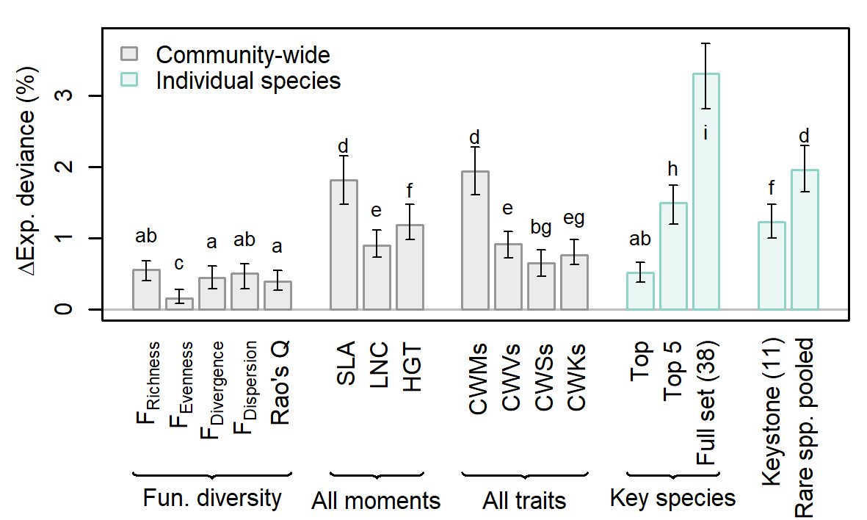

**Fig. S5 | Explained deviance added by additional community-wide and individual-species predictors**. Shown are contributions of functional diversity metrics, combinations of all community-weighted moments per trait, combinations of all traits per community-weighted moment, key-species cover, keystone-species cover, and rare-species cover to explained deviance of model fits explaining productivity (soil adjusted vegetation index) with environmental conditions. Functional diversity metrics include functional richness (FRichness), i.e., the volume of functional space occupied by the community; functional evenness (FEvenness), i.e., the regularity of the distribution of cover abundance in this volume; functional divergence (FDivergence), i.e., the divergence of the distribution of cover abundance in this volume; functional dispersion (FDispersion), i.e., the mean distance between species and the community centroid in trait space; and functional diversity measured by Rao’s quadratic entropy (Rao’s Q) (Botta‐Dukát, 2005; Villéger et al., 2008; Laliberté & Legendre, 2010). Functional diversity metrics were calculated using the R package FD (Laliberté et al., 2014) considering SLA, LNC, and HGT and their effect was represented with smooth terms of three degrees of freedom. Linear coefficients were used to model the effect of the cover values of key(stone) species. ‘Rare spp. pooled’ is the summed cover abundance of species with <1% occurrence frequency represented as a smooth term with three degrees of freedom. The groups “All moments” and “All traits” include the smooth terms of all community-weighted moments per trait and the smooth terms of all traits per community-weighted moment, respectively. Bars represent medians and error bars are interquartile ranges of 100 models fitted on resampled data. Letters on top of bars indicate groups according to a Tukey HSD test: if two bars share any letter, they are not significantly different from each other.

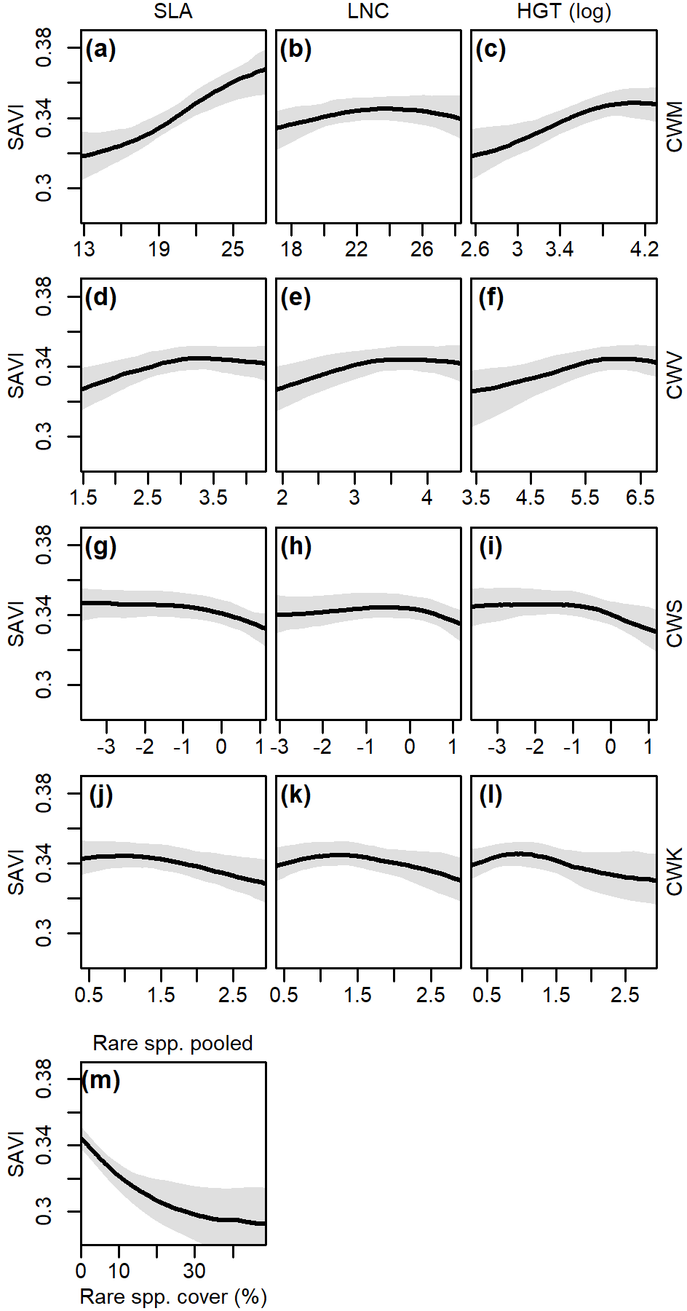

**Fig. S6 | Partial responses of productivity to community-weighted moments and rare species cover abundance**. Partial responses of productivity (soil adjusted vegetation index, SAVI) to community-weighted means (**a**-**c**), variances (**d**-**f**), skewness (**g**-**i**), and kurtosis (**j**-**l**) of SLA (**a**, **d**, **g**, **j**), LNC (**b**, **e**, **h**, **k**), and HGT (**c**, **f**, **i**, **l**) and to rare species cover abundance (**m**). Rare species cover abundance is the summed cover abundance of species with <1% occurrence frequency. Lines represent medians and polygons are 95%-confidence intervals of 100 models fitted on resampled data. CWV, CWS, and CWK of all traits and CWM of HGT were log-transformed.

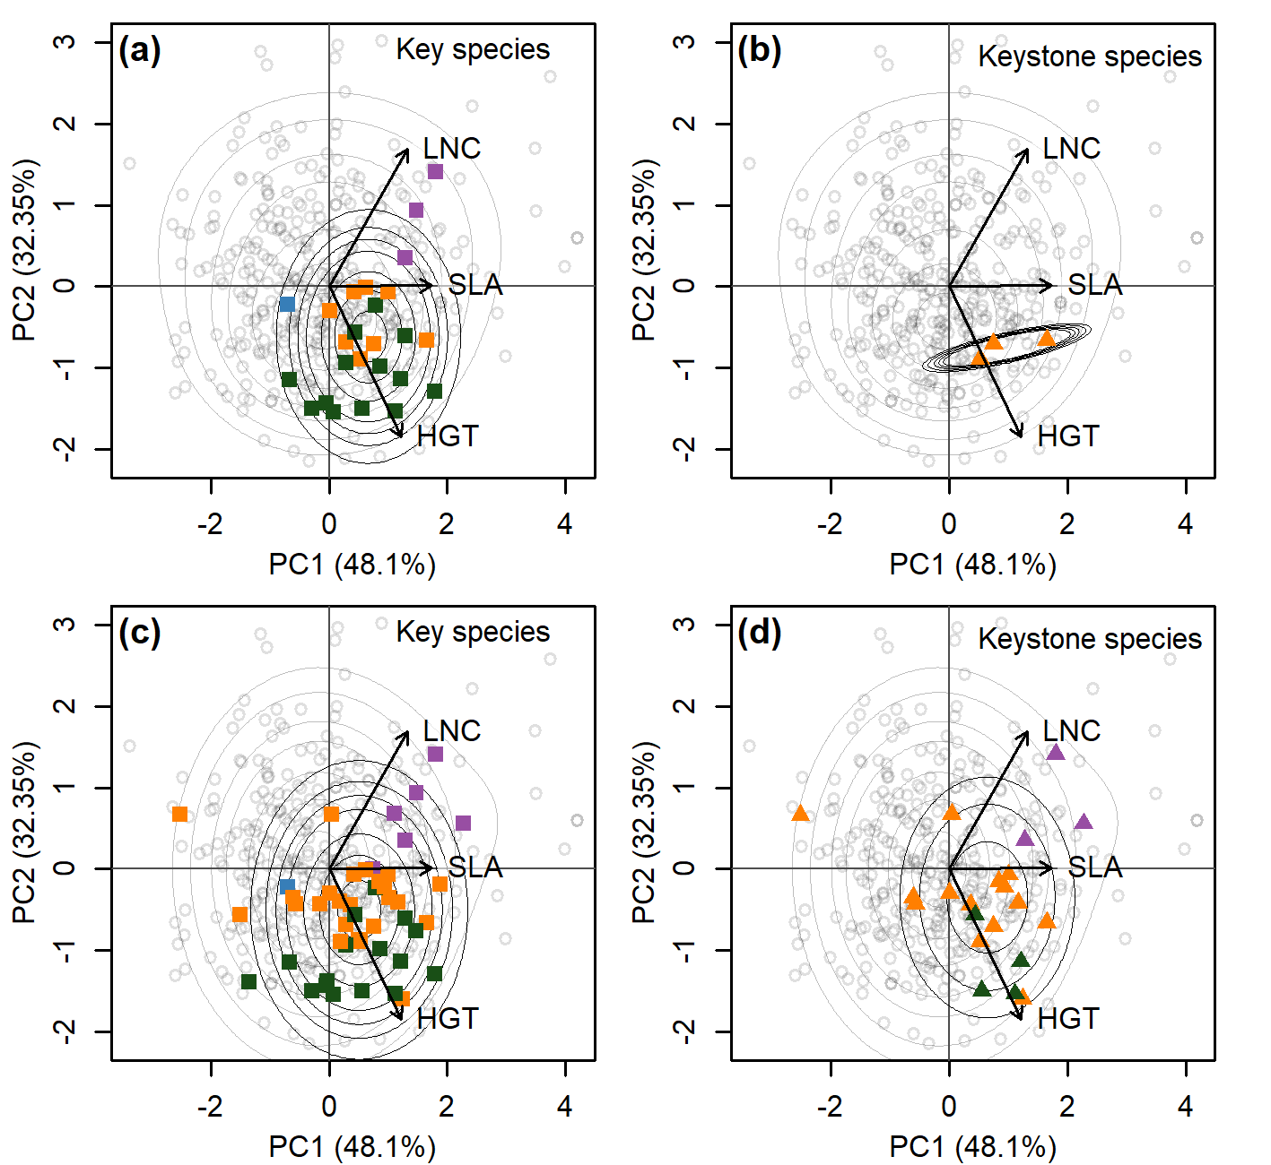

**Fig. S7 | Traits of different definitions of key(stone) species.** Ordinary species and key (**a**, **c**) and keystone species (**b**, **d**), are shown in a two-dimensional representation of trait space (PCA axes with explained variance in brackets, see Methods). Top and bottom row represent definitions of key(stone) species based on the 95th and the 90th percentiles of overall contribution and effect size, respectively. Key species are shown as squares, keystone species as triangles. Colors encode plant type: dark green represents grasses; orange represents forbs; blue represents sedges; and purple represents legumes. Remaining, ordinary species are shown as grey circles. Isolines are Gaussian mixture density functions of the distributions of key(stone) species (black) and ordinary species (grey), respectively.

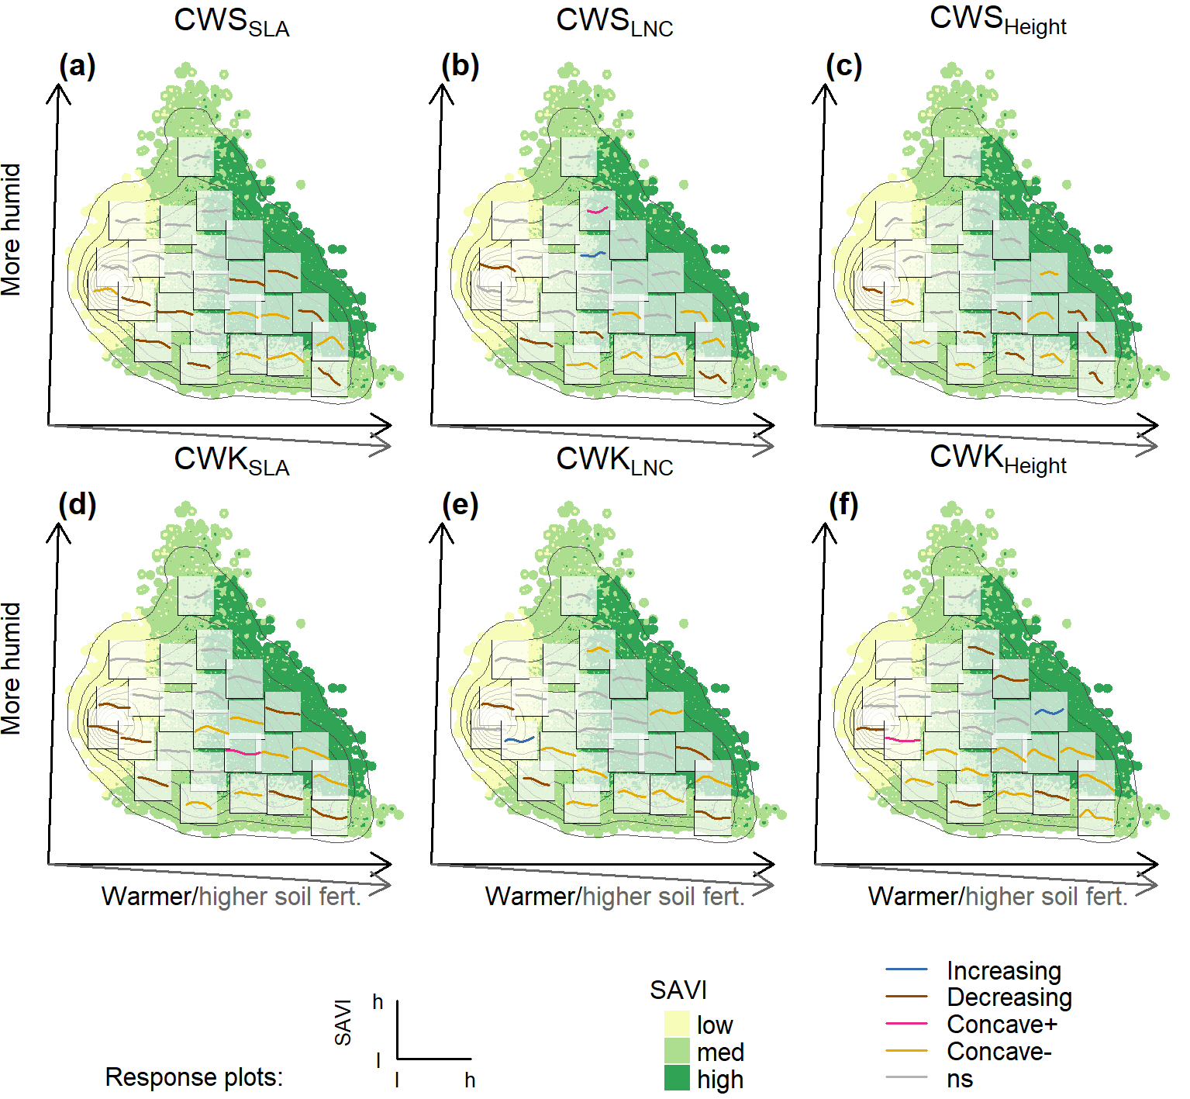

**Fig. S8 | Partial responses of productivity to community-weighted skewness and kurtosis across 25 habitats.** Partial responses of productivity (soil adjusted vegetation index, SAVI) to community-weighted means (**a**-**c**) and community-weighted variances (**d**-**f**) of SLA (**a**, **d**), LNC (**b**, **e**), and HGT (**c**, **f**) across 25 subsampled datasets from similar environments. Curve types are classified as increasing (blue), decreasing (dark red), concave positive (pink), unimodal (yellow), and non-significant (grey, see Methods). Axes are a rotation of the first two principal components of environmental space with arrows representing loadings for increasing temperature, soil fertility, and humidity. Surface depicts inverse-squared-distance interpolation of productivity levels and superimposed isolines represent the density of observations.

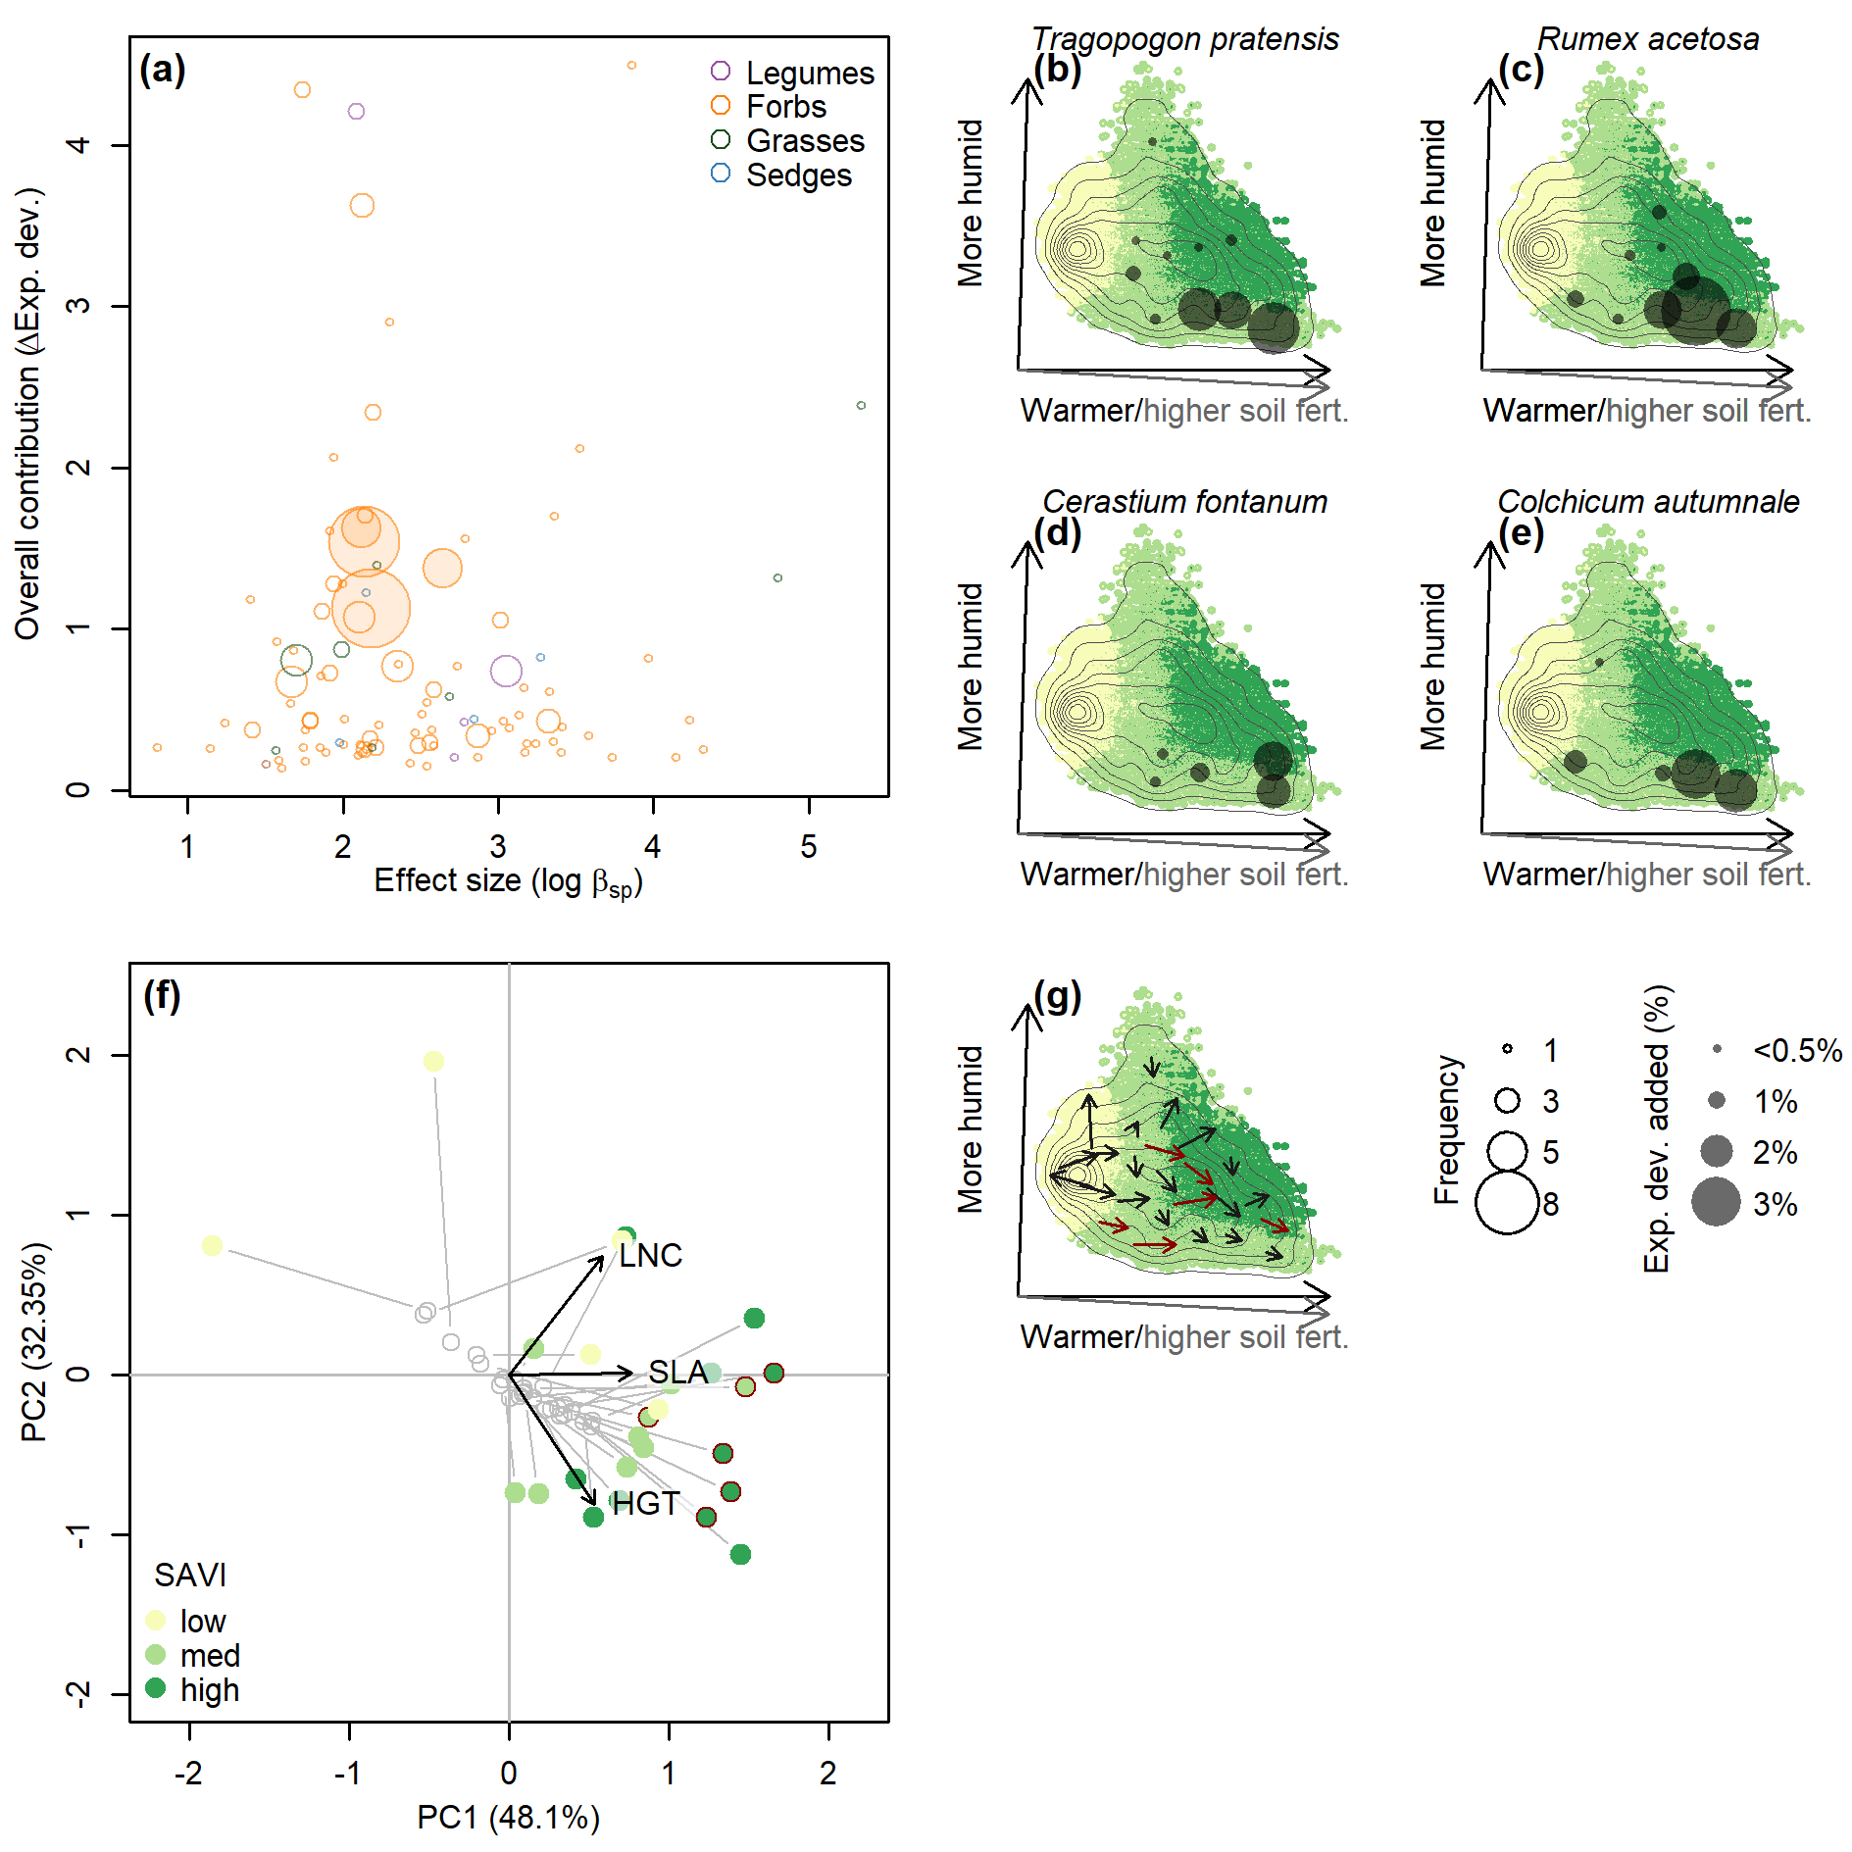

**Fig. S9 | Importance and traits of keystone species across 25 habitats**. **a**, increase in productivity per percent cover (effect size), and explained deviance added to the reference model (overall contribution) of keystone species of all habitats. Keystone species are colored according to plant type (see legend); ring size represents the number of habitats in which a species belongs to the keystone-species set; the four most global keystone species are highlighted with semi-transparent filling. **b**-**e**, added explained deviance across environmental space for the four most global keystone species. Circles are only shown for habitats where the species are in the set of keystone species. **f**, centroids of keystone-species sets (colored circles) and ordinary-species sets (grey rings) from each habitat in a two-dimensional representation of trait space (PCA axes with explained variance in brackets, see Methods). Point pairs are connected by grey lines. **g**, magnitude and direction of shifts between the centroids of keystone and ordinary species, with directions corresponding to the axes in panel **f**. Axes in panels **b**-**e** and **g** are a rotation of the first two principal components of environmental space with arrows representing loadings for increasing temperature, soil fertility, and humidity. Surface depicts inverse-squared-distance interpolation of productivity levels and superimposed isolines represent the density of observations.

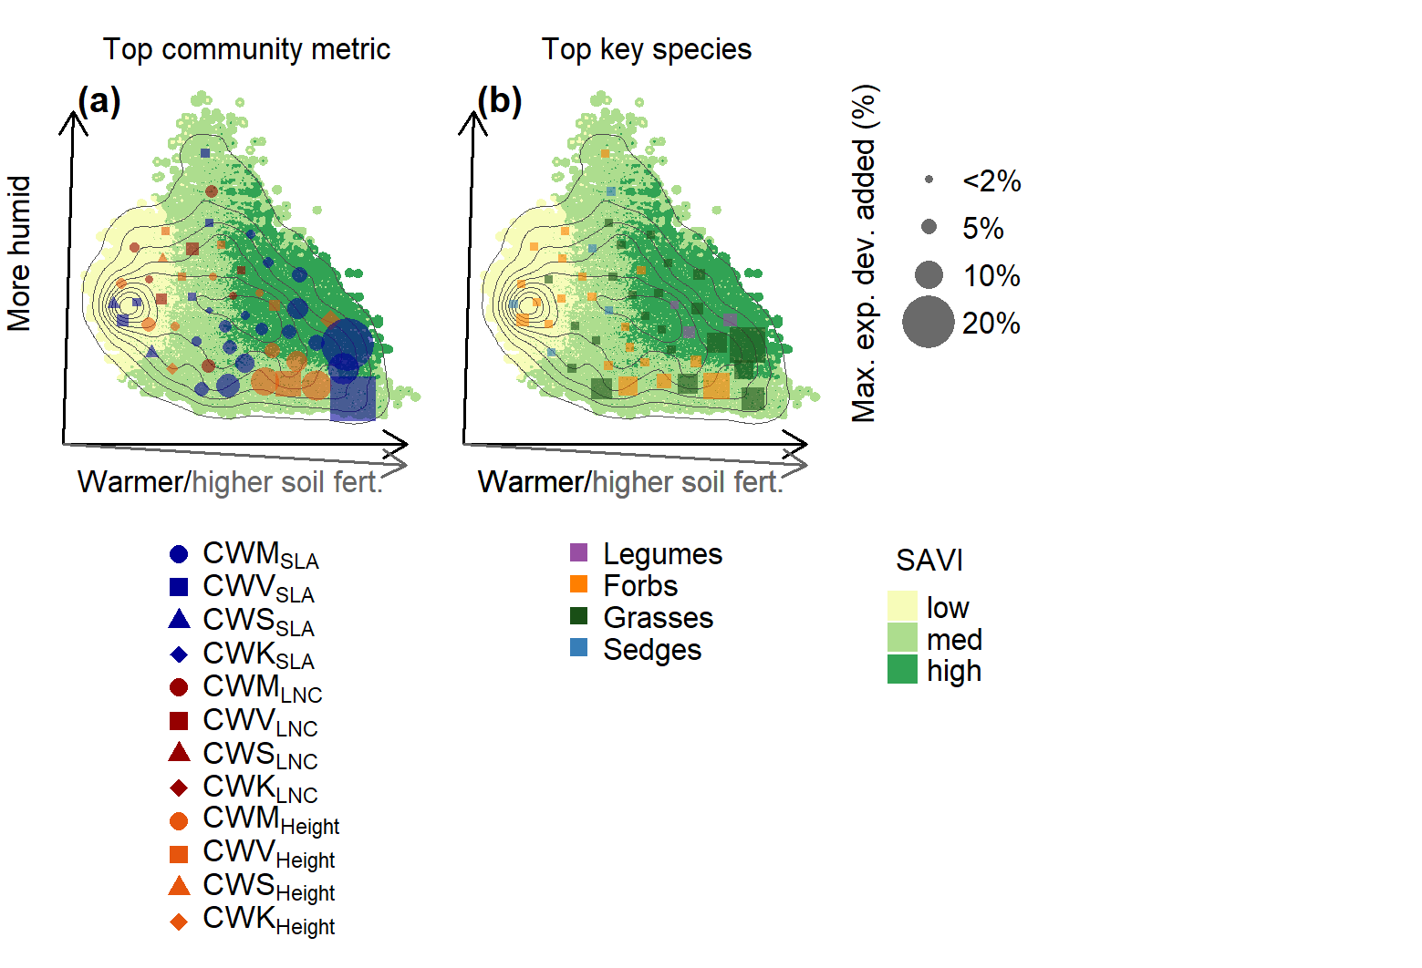

**Fig. S10 | Explained deviance added by community-level predictors and key-species cover across 50 habitats**. **a**, identity and added explained deviance of smooth terms of best-performing community-level predictors. **b**, plant type and explained deviance of best-performing key species. Axes are a rotation of the first two principal components of environmental space (see Methods) with arrows representing loadings for increasing temperature, soil fertility, and humidity. Surface depicts inverse-squared-distance interpolation of productivity (soil adjusted vegetation index, SAVI) levels and superimposed isolines represent the density of observations.

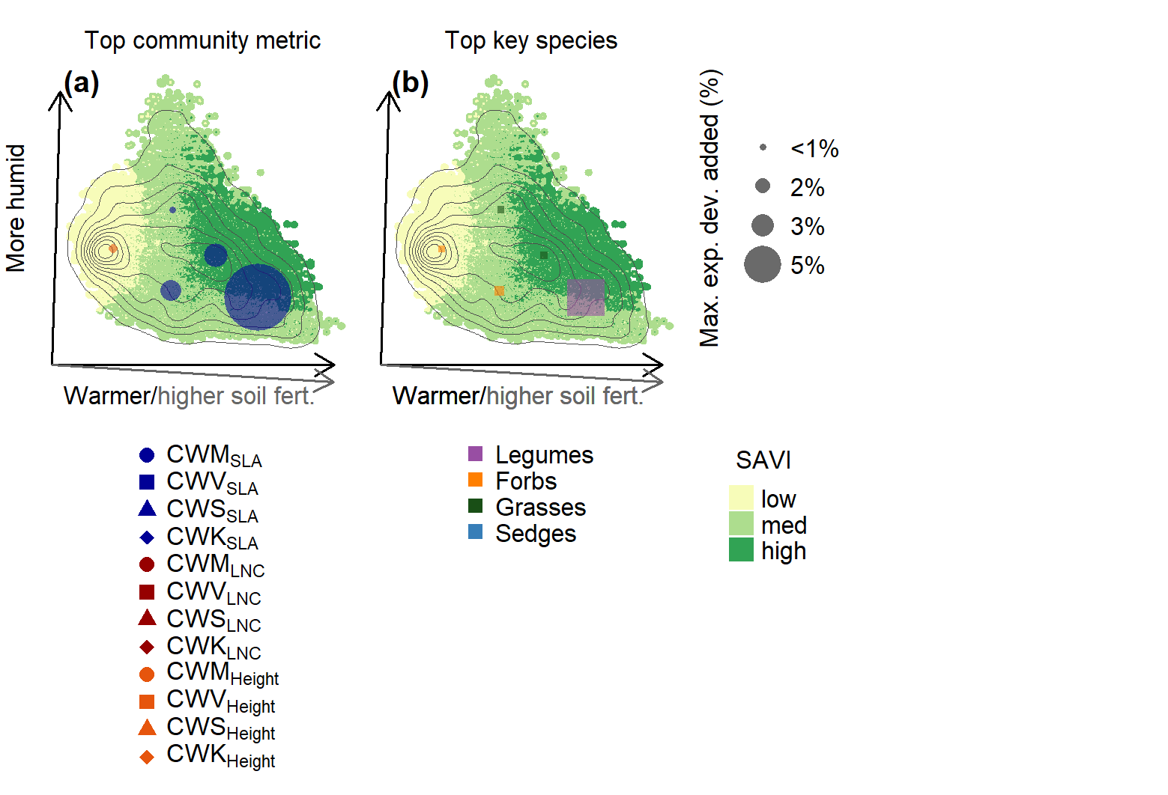

**Fig. S11 | Explained deviance added by community-level predictors and key-species cover across five habitats**. **a**, identity and added explained deviance of smooth terms of best-performing community-level predictors. **b**, plant type and explained deviance of best-performing key species. Axes are a rotation of the first two principal components of environmental space (see Methods) with arrows representing loadings for increasing temperature, soil fertility, and humidity. Surface depicts inverse-squared-distance interpolation of productivity (soil adjusted vegetation index, SAVI) levels and superimposed isolines represent the density of observations.

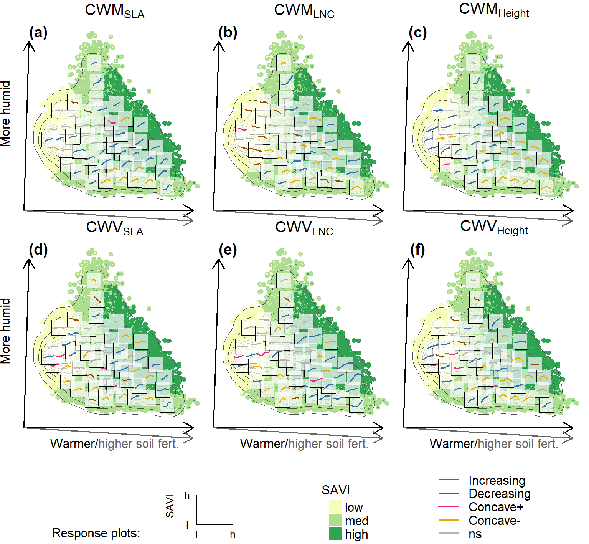

**Fig. S12 | Partial responses of productivity to community-weighted means and variances across 50 habitats.** Partial responses of productivity (soil adjusted vegetation index, SAVI) to community-weighted means (**a**-**c**) and community-weighted variances (**d**-**f**) of SLA (**a**, **d**), LNC (**b**, **e**), and HGT (**c**, **f**) across 50 subsampled datasets from similar environments. Curve types are classified as increasing (blue), decreasing (dark red), concave positive (pink), unimodal (yellow), and non-significant (grey, see Methods). Axes are a rotation of the first two principal components of environmental space with arrows representing loadings for increasing temperature, soil fertility, and humidity. Surface depicts inverse-squared-distance interpolation of productivity levels and superimposed isolines represent the density of observations.

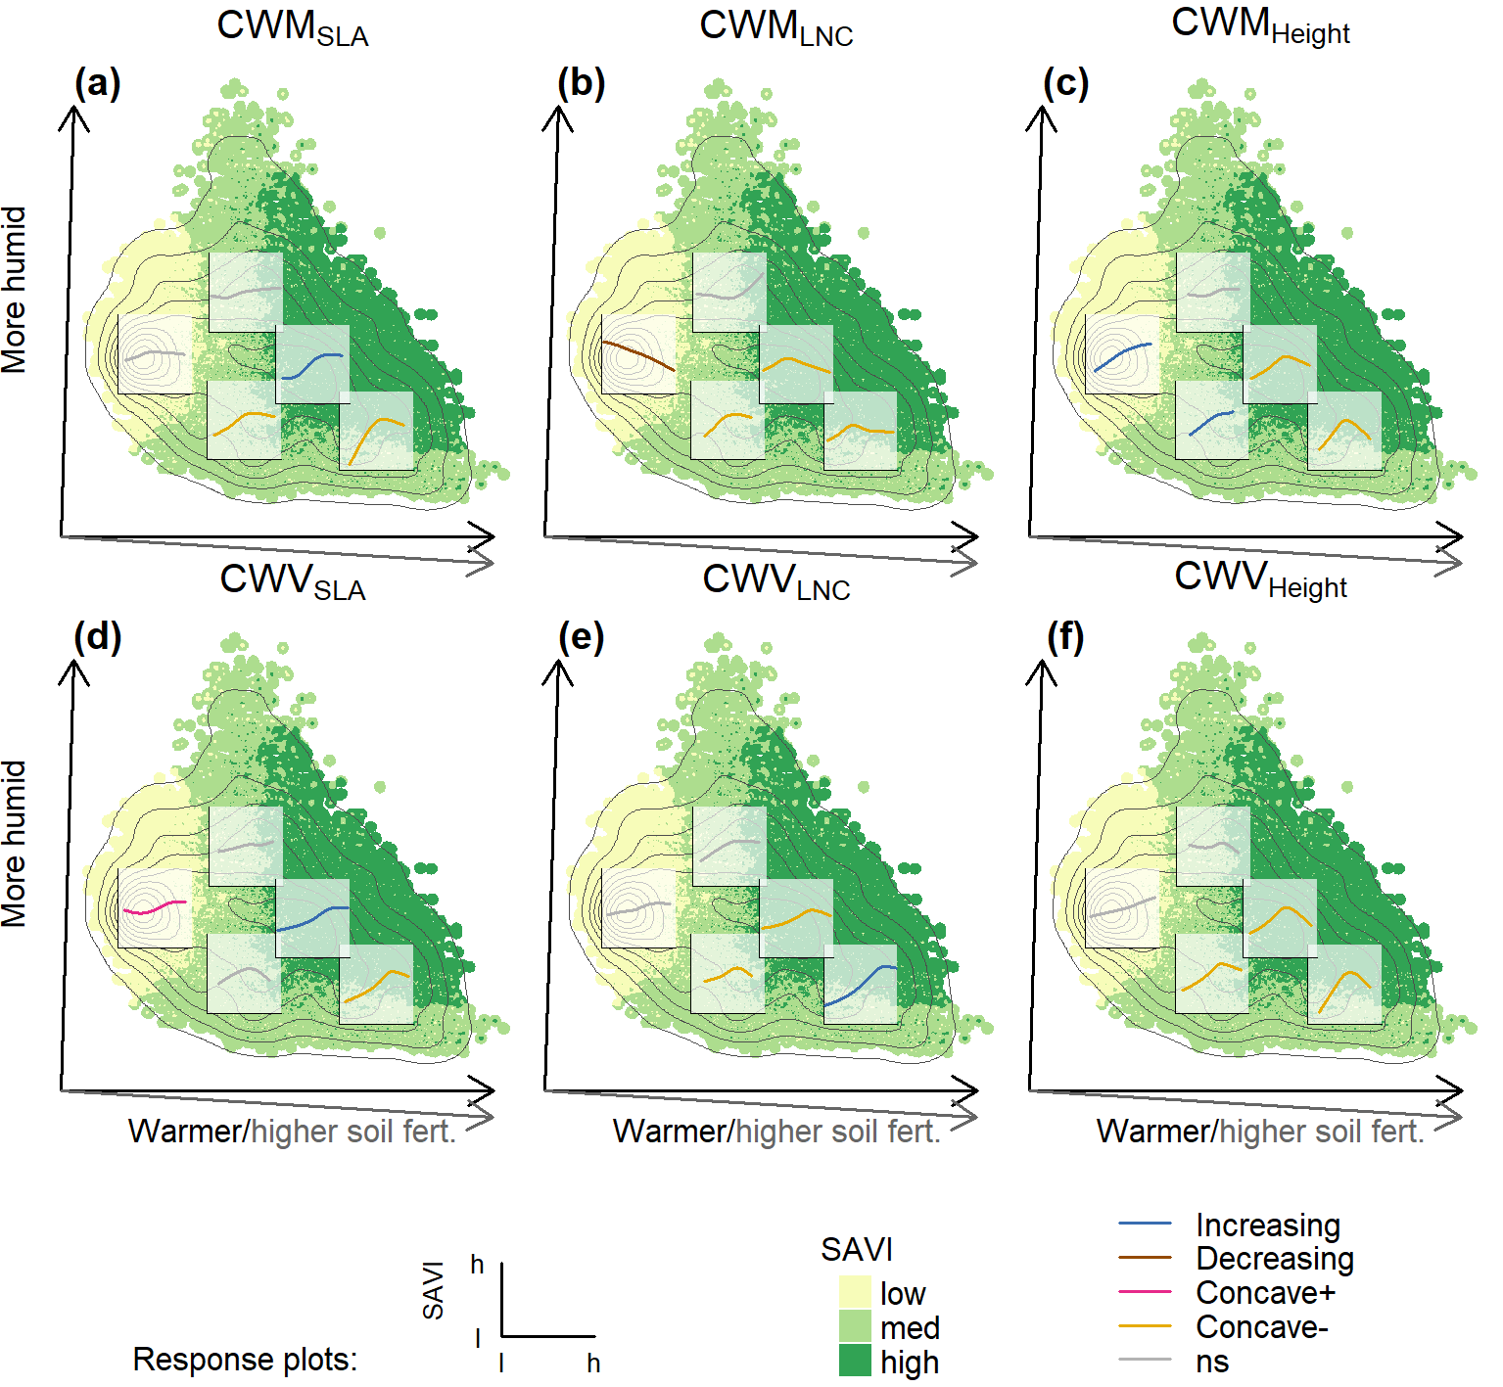

**Fig. S13 | Partial responses of productivity to community-weighted means and variances across five habitats.** Partial responses of productivity (soil adjusted vegetation index, SAVI) to community-weighted means (**a**-**c**) and community-weighted variances (**d**-**f**) of SLA (**a**, **d**), LNC (**b**, **e**), and HGT (**c**, **f**) across five subsampled datasets from similar environments. Curve types are classified as increasing (blue), decreasing (dark red), concave positive (pink), unimodal (yellow), and non-significant (grey, see Methods). Axes are a rotation of the first two principal components of environmental space with arrows representing loadings for increasing temperature, soil fertility, and humidity. Surface depicts inverse-squared-distance interpolation of productivity levels and superimposed isolines represent the density of observations.

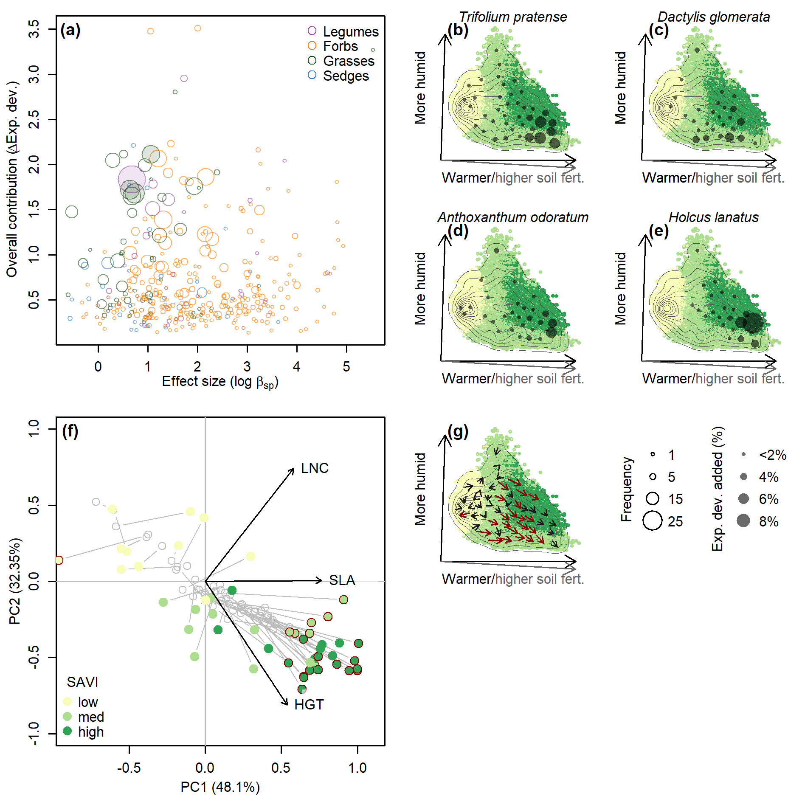

**Fig. S14 | Importance and traits of key species across 50 habitats. a**, increase in productivity per percent cover (effect size), and explained deviance added to the reference model (overall contribution) of key species of all habitats. Key species are colored according to plant type (see legend); ring size represents the number of habitats in which a species belongs to the key-species set; the four most global key species are highlighted with semi-transparent filling. **b**-**e**, added explained deviance across environmental space for the four most global key species. Circles are only shown for habitats where the species are in the set of key species. **f**, centroids of key-species sets (colored circles) and ordinary-species sets (grey rings) from each habitat in a two-dimensional representation of trait space (PCA axes with explained variance in brackets, see Methods). Point pairs are connected by grey lines. **g**, magnitude and direction of shifts between the centroids of keystone and ordinary species, with directions corresponding to the axes in panel **f**. Axes in panels **b**-**e** and **g** are a rotation of the first two principal components of environmental space with arrows representing loadings for increasing temperature, soil fertility, and humidity. Surface depicts inverse-squared-distance interpolation of productivity levels and superimposed isolines represent the density of observations.

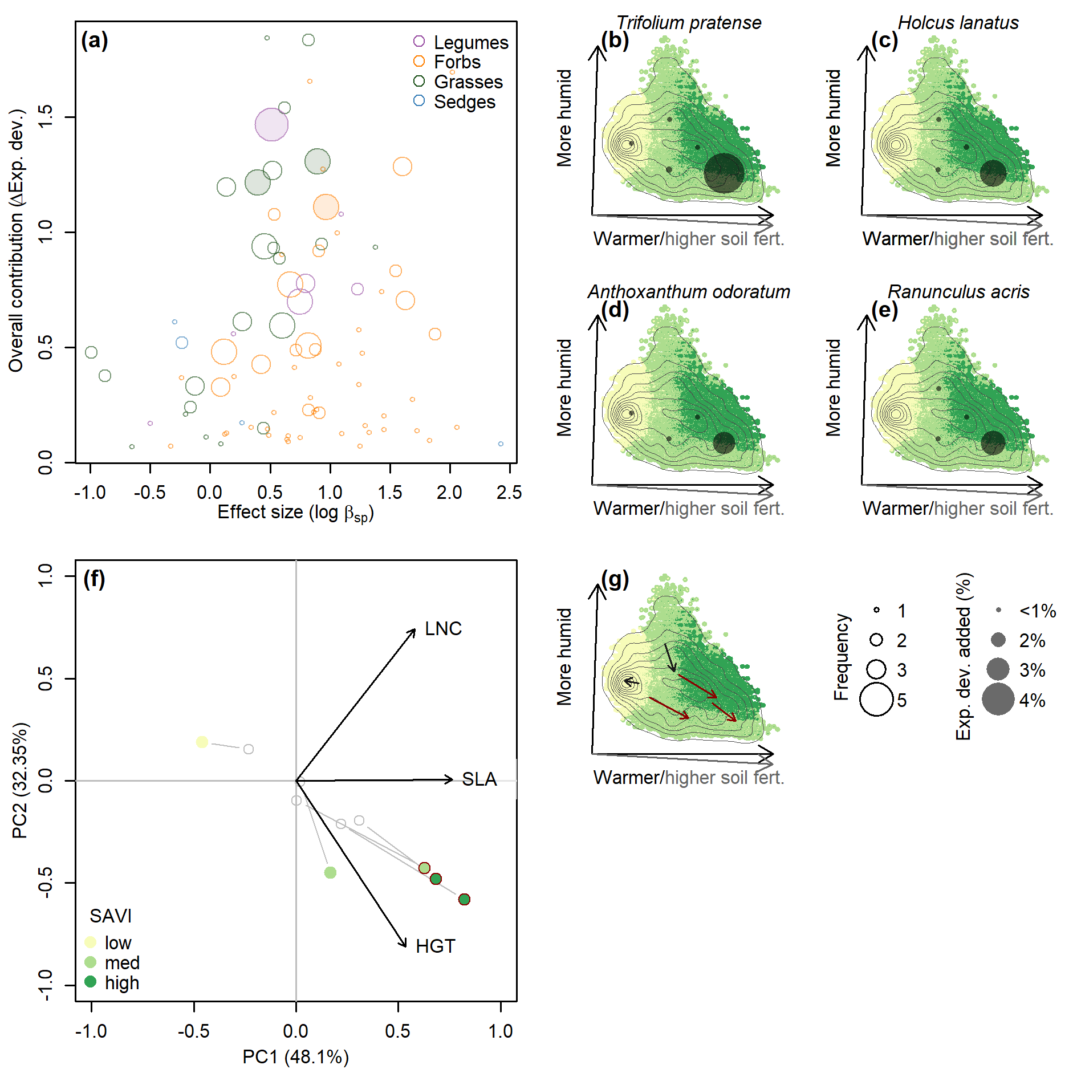

**Fig. S15 | Importance and traits of key species across five habitats. a**, increase in productivity per percent cover (effect size), and explained deviance added to the reference model (overall contribution) of key species of all habitats. Key species are colored according to plant type (see legend); ring size represents the number of habitats in which a species belongs to the key-species set; the four most global key species are highlighted with semi-transparent filling. **b**-**e**, added explained deviance across environmental space for the four most global key species. Circles are only shown for habitats where the species are in the set of key species. **f**, centroids of key-species sets (colored circles) and ordinary-species sets (grey rings) from each habitat in a two-dimensional representation of trait space (PCA axes with explained variance in brackets, see Methods). Point pairs are connected by grey lines. **g**, magnitude and direction of shifts between the centroids of keystone and ordinary species, with directions corresponding to the axes in panel **f**. Axes in panels **b**-**e** and **g** are a rotation of the first two principal components of environmental space with arrows representing loadings for increasing temperature, soil fertility, and humidity. Surface depicts inverse-squared-distance interpolation of productivity levels and superimposed isolines represent the density of observations.

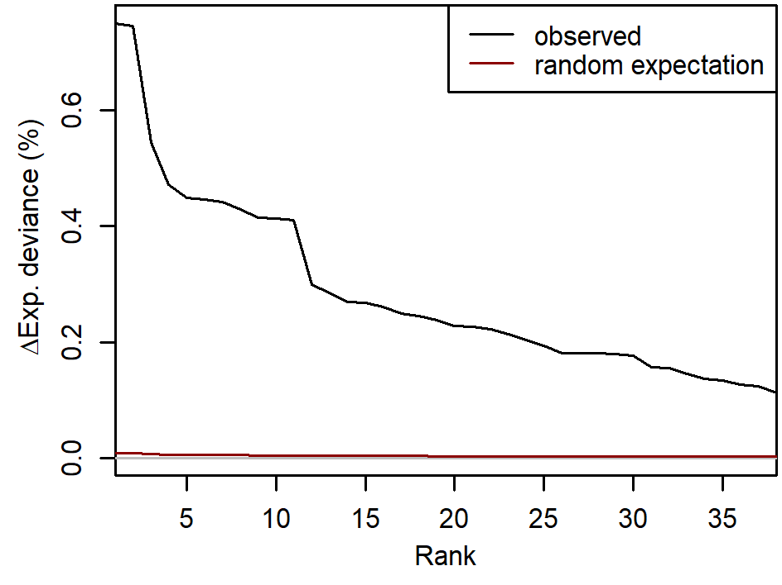

**Fig. S16 | Added explained deviance by key species versus random expectation**. Black line illustrates added explained deviance of the 38 key species identified in the full data set (see also Table S3). Dark red line shows top 38 simulated species that were generated by randomly permuting the cover values of each of our 500 candidate species and repeating key-species identification analysis. This randomization procedure allows assessing random expectation of added explained deviance by simply adding more predictors for our data and set up.

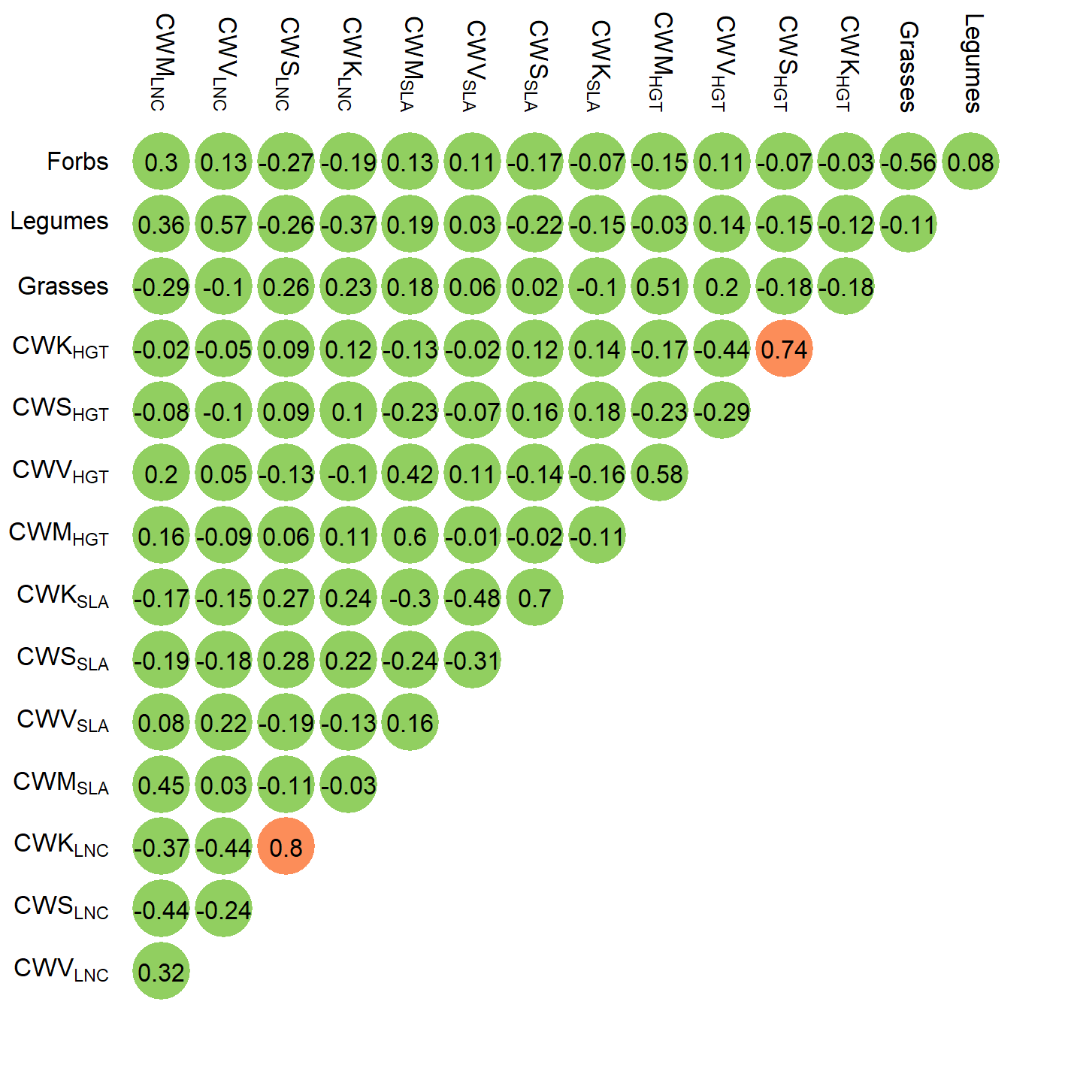

**Fig. S17 | Spearman correlation coefficients between community-weighted moments, and cover values of grasses, forbs, and legumes.** Green circles represent absolute Spearman correlation coefficients below 0.7; orange circles represent absolute Spearman correlation coefficients between 0.7 and 0.9. CWM, CWV, CWS, and CWK represent community-weighted mean, variance, skewness, and kurtosis, respectively and HGT, SLA, and LNC represent reproductive height, specific leaf area, and leaf nitrogen content, respectively.

# References

Adler, P.B., Salguero-Gomez, R., Compagnoni, A., Hsu, J.S., Ray-Mukherjee, J., Mbeau-Ache, C., & Franco, M. (2014) Functional traits explain variation in plant life history strategies. *Proceedings of the National Academy of Sciences*, **111**, 740–745.

Atkin, O.K., Bloomfield, K.J., Reich, P.B., et al. (2015) Global variability in leaf respiration in relation to climate, plant functional types and leaf traits. *New Phytologist*, **206**, 614–636.

Belluau, M. & Shipley, B. (2018) Linking hard and soft traits: Physiology, morphology and anatomy interact to determine habitat affinities to soil water availability in herbaceous dicots. *PLOS ONE*, **13**, e0193130.

Botta‐Dukát, Z. (2005) Rao’s quadratic entropy as a measure of functional diversity based on multiple traits. *Journal of Vegetation Science*, **16**, 533–540.

Brun, P., Zimmermann, N.E., Graham, C.H., Lavergne, S., Pellissier, L., Münkemüller, T., & Thuiller, W. (2019) The productivity-biodiversity relationship varies across diversity dimensions. *Nature Communications*, **10**, 5691.

Campbell, C., Atkinson, L., Zaragoza-Castells, J., Lundmark, M., Atkin, O., & Hurry, V. (2007) Acclimation of photosynthesis and respiration is asynchronous in response to changes in temperature regardless of plant functional group. *New Phytologist*, **176**, 375–389.

Campetella, G., Botta-Dukát, Z., Wellstein, C., Canullo, R., Gatto, S., Chelli, S., Mucina, L., & Bartha, S. (2011) Patterns of plant trait–environment relationships along a forest succession chronosequence. *Agriculture, Ecosystems & Environment*, **145**, 38–48.

Ciccarelli, D. (2015) Mediterranean coastal dune vegetation: Are disturbance and stress the key selective forces that drive the psammophilous succession? *Estuarine, Coastal and Shelf Science*, **165**, 247–253.

Conrad, O., Bechtel, B., Bock, M., Dietrich, H., Fischer, E., Gerlitz, L., Wehberg, J., Wichmann, V., & Böhner, J. (2015) System for Automated Geoscientific Analyses (SAGA) v. 2.1.4. *Geoscientific Model Development*, **8**, 1991–2007.

Cornelissen, J.H.C. (1996) An Experimental Comparison of Leaf Decomposition Rates in a Wide Range of Temperate Plant Species and Types. *The Journal of Ecology*, **84**, 573.

CORNELISSEN, J.H.C., QUESTED, H.M., GWYNN-JONES, D., VAN LOGTESTIJN, R.S.P., DE BEUS, M.A.H., KONDRATCHUK, A., CALLAGHAN, T. V., & AERTS, R. (2004) Leaf digestibility and litter decomposability are related in a wide range of subarctic plant species and types. *Functional Ecology*, **18**, 779–786.

Craine, J.M., Elmore, A.J., Aidar, M.P.M., Bustamante, M., Dawson, T.E., Hobbie, E.A., Kahmen, A., Mack, M.C., McLauchlan, K.K., Michelsen, A., Nardoto, G.B., Pardo, L.H., Peñuelas, J., Reich, P.B., Schuur, E.A.G., Stock, W.D., Templer, P.H., Virginia, R.A., Welker, J.M., & Wright, I.J. (2009) Global patterns of foliar nitrogen isotopes and their relationships with climate, mycorrhizal fungi, foliar nutrient concentrations, and nitrogen availability. *New Phytologist*, **183**, 980–992.

Craine, J.M., Lee, W.G., Bond, W.J., Williams, R.J., & Johnson, L.C. (2005) ENVIRONMENTAL CONSTRAINTS ON A GLOBAL RELATIONSHIP AMONG LEAF AND ROOT TRAITS OF GRASSES. *Ecology*, **86**, 12–19.

Craine, J.M., Towne, E.G., Ocheltree, T.W., & Nippert, J.B. (2012) Community traitscape of foliar nitrogen isotopes reveals N availability patterns in a tallgrass prairie. *Plant and Soil*, **356**, 395–403.

Dalke, I. V., Novakovskiy, A.B., Maslova, S.P., & Dubrovskiy, Y.A. (2018) Morphological and functional traits of herbaceous plants with different functional types in the European Northeast. *Plant Ecology*, **219**, 1295–1305.

Descombes, P., Walthert, L., Baltensweiler, A., Meuli, R.G., Karger, D.N., Ginzler, C., Zurell, D., & Zimmermann, N.E. (2020) Spatial modelling of ecological indicator values improves predictions of plant distributions in complex landscape. *Ecography*, .

Diaz, S., Hodgson, J.G., Thompson, K., et al. (2004) The plant traits that drive ecosystems: Evidence from three continents. *Journal of Vegetation Science*, **15**, 295–304.

Fitter, A.H. & Peat, H.J. (1994) The Ecological Flora Database. *The Journal of Ecology*, **82**, 415.

Freschet, G.T., Cornelissen, J.H.C., van Logtestijn, R.S.P., & Aerts, R. (2010) Evidence of the ‘plant economics spectrum’ in a subarctic flora. *Journal of Ecology*, **98**, 362–373.

Giarrizzo, E., Burrascano, S., Chiti, T., de Bello, F., Lepš, J., Zavattero, L., & Blasi, C. (2017) Re-visiting historical semi-natural grasslands in the Apennines to assess patterns of changes in species composition and functional traits. *Applied Vegetation Science*, **20**, 247–258.

Gos, P., Loucougaray, G., Colace, M.-P., Arnoldi, C., Gaucherand, S., Dumazel, D., Girard, L., Delorme, S., & Lavorel, S. (2016) Relative contribution of soil, management and traits to co-variations of multiple ecosystem properties in grasslands. *Oecologia*, **180**, 1001–1013.

Han, W., Chen, Y., Zhao, F.-J., Tang, L., Jiang, R., & Zhang, F. (2012) Floral, climatic and soil pH controls on leaf ash content in China’s terrestrial plants. *Global Ecology and Biogeography*, **21**, 376–382.

Henry, J.A. (2005) Humid Climates. *Encyclopedia of World Climatology* (ed. by J.E. Oliver), pp. 412–413. Springer Netherlands,

Herz, K., Dietz, S., Haider, S., Jandt, U., Scheel, D., & Bruelheide, H. (2017) Predicting individual plant performance in grasslands. *Ecology and Evolution*, **7**, 8958–8965.

Karger, D.N., Conrad, O., Böhner, J., Kawohl, T., Kreft, H., Soria-Auza, R.W., Zimmermann, N.E., Linder, H.P., & Kessler, M. (2017) Climatologies at high resolution for the earth’s land surface areas. *Scientific Data*, **4**, 170122.

Kattge, J., Knorr, W., Raddatz, T., & Wirth, C. (2009) Quantifying photosynthetic capacity and its relationship to leaf nitrogen content for global-scale terrestrial biosphere models. *Global Change Biology*, **15**, 976–991.

KAZAKOU, E., VILE, D., SHIPLEY, B., GALLET, C., & GARNIER, E. (2006) Co-variations in litter decomposition, leaf traits and plant growth in species from a Mediterranean old-field succession. *Functional Ecology*, **20**, 21–30.

Kerkhoff, A.J., Fagan, W.F., Elser, J.J., & Enquist, B.J. (2006) Phylogenetic and Growth Form Variation in the Scaling of Nitrogen and Phosphorus in the Seed Plants. *The American Naturalist*, **168**, E103–E122.

Kichenin, E., Wardle, D.A., Peltzer, D.A., Morse, C.W., & Freschet, G.T. (2013) Contrasting effects of plant inter- and intraspecific variation on community-level trait measures along an environmental gradient. *Functional Ecology*, **27**, 1254–1261.

Kleyer, M., Bekker, R.M., Knevel, I.C., et al. (2008) The LEDA Traitbase: a database of life-history traits of the Northwest European flora. *Journal of Ecology*, **96**, 1266–1274.

Laliberté, E. & Legendre, P. (2010) A distance-based framework for measuring functional diversity from multiple traits. *Ecology*, **91**, 299–305.

Laliberté, E., Legendre, P., & Shipley, B. (2014) FD: measuring functional diversity from multiple traits, and other tools for functional ecology. .

Landolt, E., Bäumler, B., Erhardt, A., Hegg, O., Klötzli, F., Lämmler, W., Nobis, M., Rudmann-Maurer, K., Schweingruber, F.H., Theurillat, J.-P., Urmi, E., Vust, M., & Wohlgemuth, T. (2010) *Flora indicativa.* Haupt Verlag, Berne CH.

Laughlin, D.C., Leppert, J.J., Moore, M.M., & Sieg, C.H. (2010) A multi-trait test of the leaf-height-seed plant strategy scheme with 133 species from a pine forest flora. *Functional Ecology*, **24**, 493–501.

Lehmann, J., Rosenberg, E., & Mosimann, E. (2000) Standardmischungen für den Futterbau. *AGRARForschung*, **7**, 1–12.

Lhotsky, B., Csecserits, A., Kovács, B., & Botta-Dukát, Z. (2016) New plant trait records of the Hungarian flora. *Acta Botanica Hungarica*, **58**, 397–400.

Li, Y. & Shipley, B. (2018) Community divergence and convergence along experimental gradients of stress and disturbance. *Ecology*, **99**, 775–781.

Louault, F., Pillar, V.D., Aufrère, J., Garnier, E., & Soussana, J. ‐F. (2005) Plant traits and functional types in response to reduced disturbance in a semi‐natural grassland. *Journal of Vegetation Science*, **16**, 151–160.

LOVEYS, B.R., ATKINSON, L.J., SHERLOCK, D.J., ROBERTS, R.L., FITTER, A.H., & ATKIN, O.K. (2003) Thermal acclimation of leaf and root respiration: an investigation comparing inherently fast- and slow-growing plant species. *Global Change Biology*, **9**, 895–910.

Maire, V., Wright, I.J., Prentice, I.C., Batjes, N.H., Bhaskar, R., van Bodegom, P.M., Cornwell, W.K., Ellsworth, D., Niinemets, Ü., Ordonez, A., Reich, P.B., & Santiago, L.S. (2015) Global effects of soil and climate on leaf photosynthetic traits and rates. *Global Ecology and Biogeography*, **24**, 706–717.

Milla, R. & Reich, P.B. (2011) Multi-trait interactions, not phylogeny, fine-tune leaf size reduction with increasing altitude. *Annals of Botany*, **107**, 455–465.

Münkemüller, T., Gallien, L., Lavergne, S., Renaud, J., Roquet, C., Abdulhak, S., Dullinger, S., Garraud, L., Guisan, A., Lenoir, J., Svenning, J.-C., Van Es, J., Vittoz, P., Willner, W., Wohlgemuth, T., Zimmermann, N.E., & Thuiller, W. (2014) Scale decisions can reverse conclusions on community assembly processes. *Global Ecology and Biogeography*, **23**, 620–632.

Onoda, Y., Wright, I.J., Evans, J.R., Hikosaka, K., Kitajima, K., Niinemets, Ü., Poorter, H., Tosens, T., & Westoby, M. (2017) Physiological and structural tradeoffs underlying the leaf economics spectrum. *New Phytologist*, **214**, 1447–1463.

Ordoñez, J.C., van Bodegom, P.M., Witte, J.M., Bartholomeus, R.P., van Hal, J.R., & Aerts, R. (2010) Plant Strategies in Relation to Resource Supply in Mesic to Wet Environments: Does Theory Mirror Nature? *The American Naturalist*, **175**, 225–239.

Peco, B., de Pablos, I., Traba, J., & Levassor, C. (2005) The effect of grazing abandonment on species composition and functional traits: the case of dehesa grasslands. *Basic and Applied Ecology*, **6**, 175–183.

Prentice, I.C., Meng, T., Wang, H., Harrison, S.P., Ni, J., & Wang, G. (2011) Evidence of a universal scaling relationship for leaf CO2 drawdown along an aridity gradient. *New Phytologist*, **190**, 169–180.

Quested, H.M., Cornelissen, J.H.C., Press, M.C., Callaghan, T. V., Aerts, R., Trosien, F., Riemann, P., Gwynn-Jones, D., Kondratchuk, A., & Jonasson, S.E. (2003) DECOMPOSITION OF SUB-ARCTIC PLANTS WITH DIFFERING NITROGEN ECONOMIES: A FUNCTIONAL ROLE FOR HEMIPARASITES. *Ecology*, **84**, 3209–3221.

Sandel, B., Corbin, J.D., & Krupa, M. (2011) Using plant functional traits to guide restoration: A case study in California coastal grassland. *Ecosphere*, **2**, art23.

Scherrer, D. & Guisan, A. (2019) Ecological indicator values reveal missing predictors of species distributions. *Scientific Reports*, **9**, 3061.

Schroeder-Georgi, T., Wirth, C., Nadrowski, K., Meyer, S.T., Mommer, L., & Weigelt, A. (2016) From pots to plots: hierarchical trait-based prediction of plant performance in a mesic grassland. *Journal of Ecology*, **104**, 206–218.

Shipley, B. (2002) Trade-offs between net assimilation rate and specific leaf area in determining relative growth rate: relationship with daily irradiance. *Functional Ecology*, **16**, 682–689.

Shipley, B. & Lechowicz, M.J. (2000) The functional co-ordination of leaf morphology, nitrogen concentration, and gas exchange in40 wetland species. *Écoscience*, **7**, 183–194.

Smith, S.W., Woodin, S.J., Pakeman, R.J., Johnson, D., & van der Wal, R. (2014) Root traits predict decomposition across a landscape-scale grazing experiment. *New Phytologist*, **203**, 851–862.

Spasojevic, M.J. & Suding, K.N. (2012) Inferring community assembly mechanisms from functional diversity patterns: the importance of multiple assembly processes. *Journal of Ecology*, **100**, 652–661.

Takkis, K. (2014) *Changes in plant species richness and population performance in response to habitat loss and fragmentation.* University of Tartu,

Thuiller, W., Guéguen, M., Georges, D., Bonet, R., Chalmandrier, L., Garraud, L., Renaud, J., Roquet, C., Van Es, J., Zimmermann, N.E., & Lavergne, S. (2014) Are different facets of plant diversity well protected against climate and land cover changes? A test study in the French Alps. *Ecography*, **37**, 1254–1266.

Tribouillois, H., Fort, F., Cruz, P., Charles, R., Flores, O., Garnier, E., & Justes, E. (2015) A Functional Characterisation of a Wide Range of Cover Crop Species: Growth and Nitrogen Acquisition Rates, Leaf Traits and Ecological Strategies. *PLOS ONE*, **10**, e0122156.

Vergutz, L., Manzoni, S., Porporato, A., Novais, R.F., & Jackson, R.B. (2012) A Global Database of Carbon and Nutrient Concentrations of Green and Senesced Leaves. .

Vile, D. (2005) *Significations fonctionnelle et ecologique des traits des especes vegetales: exemple dans une succession post-cultural mediterraneenne et generalisations.*

Villéger, S., Mason, N.W.H., & Mouillot, D. (2008) NEW MULTIDIMENSIONAL FUNCTIONAL DIVERSITY INDICES FOR A MULTIFACETED FRAMEWORK IN FUNCTIONAL ECOLOGY. *Ecology*, **89**, 2290–2301.

de Vries, F.T. & Bardgett, R.D. (2016) Plant community controls on short-term ecosystem nitrogen retention. *New Phytologist*, **210**, 861–874.

Wang, H., Harrison, S.P., Prentice, I.C., Yang, Y., Bei, F., Furstenau Togashi, H., Wang, M., Zhou, S., & Ni, J. (2017) The China Plant Trait Database. .

Wright, I.J., Reich, P.B., Westoby, M., et al. (2004) The worldwide leaf economics spectrum. *Nature*, **428**, 821–827.