Supplementary figures and tables.
Figure S1: Sample distribution map within the time periods (1935–1969, 1969–1985, and 1985–2014).

Figure S2: Number of samples grouped by cohort and size of scale growth increment.
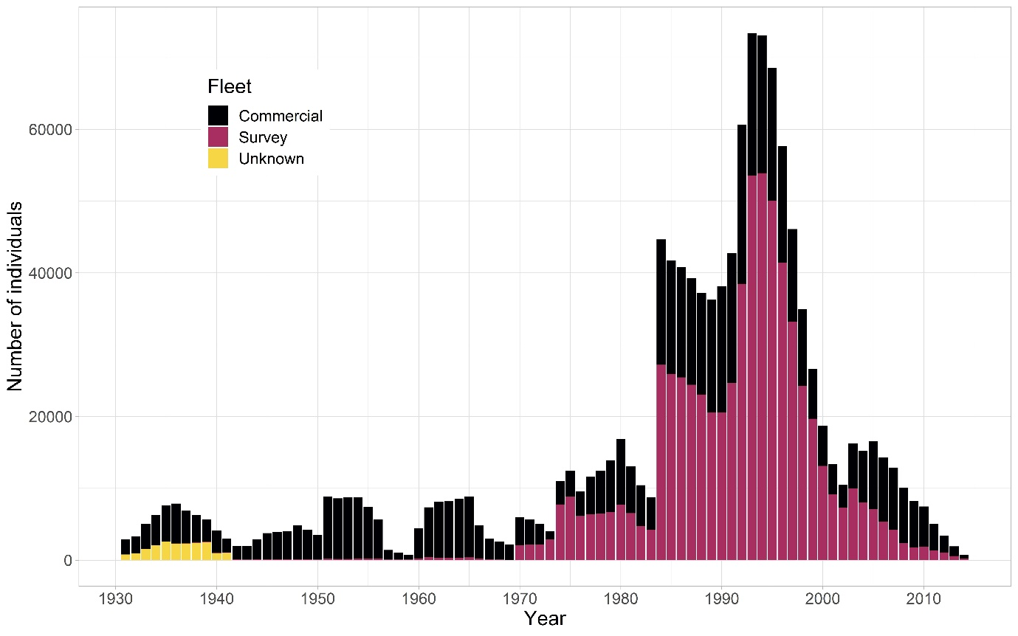
Figure S3: Data sources: Commercial catches, scientific surveys, or unknown source (most likely catch with unknown gear).

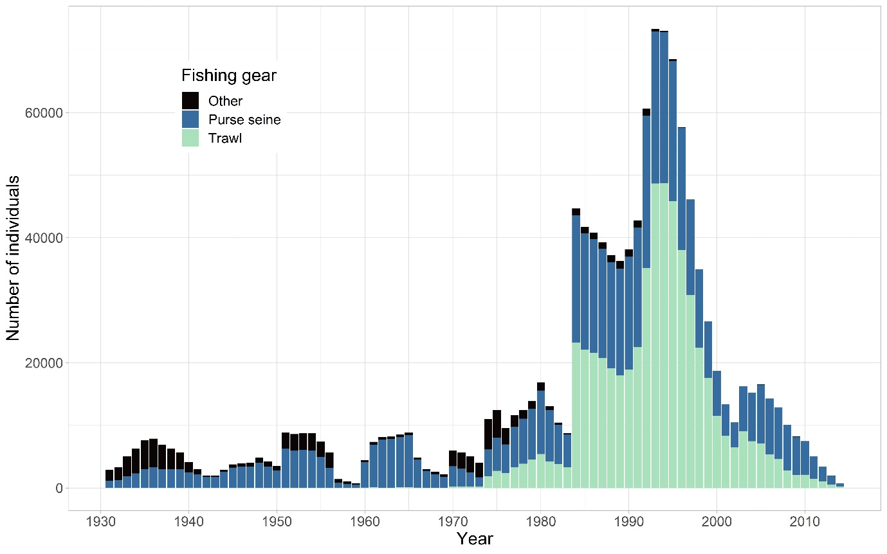
Figure S4: Data sources by main gear type.

Table S1: Selection of random effect
Random effect | Degrees of freedom | AICc | Delta_AICc | AICcWt | Res.LL
1|IndNum + Age|Year | 10 | 342852 | 0 | 1 | -171416
1|IndNum + 1|Year + 1|Cohort | 9 | 371387 | 28535 | 0 | -185684
1|IndNum + Age|Cohort | 10 | 419574 | 76722 | 0 | -209777
1|IndNum + 1|Cohort | 8 | 434288 | 91436 | 0 | -217136
Age|IndNum | 9
1|IndNum + 1|Year | 8 | 562736 | 219883 | 0 | -281360
1|IndNum | 7 | 578887 | 236034 | 0 | -289426
1|IndNum + Age|Year + 1|Cohort | Not converging
1|IndNum + Age|Cohort + 1|Year | Not converging
1|IndNum + Age|Cohort + Age|Year | Not converging

Table S2: Conditional and marginal R-square of the model for different time-series length
Time series | Marginal R-squared | Conditional R-squared
1935 - 2014 | 0.81 | 0.86
1950 - 2014 | 0.81 | 0.86
1960 - 2014 | 0.82 | 0.87
1980 - 2014 | 0.82 | 0.88
1990 - 2014 | 0.78 | 0.86

