Supplementary Material

# Supplementary Tables



**Supplementary Table S1.** Temperature, salinity, dissolved cations (DCa, DK, DMg, DNa) and dissolved anions (DCl, DBr, DSO4) concentrations at six CTD casts from the MoMARsat’19 cruise.



**Supplementary Table S2.** End-members chemical compositions of Lucky strike hydrothermal fluids (Charlou et al., 2000; Chavagnac et al., 2018; Leleu, 2017; Pester et al., 2012; Von Damm et al., 1998) and seawater (El Meknassi et al., 2018; El Meknassi et al., 2020; Leleu, 2017; Millero et al., 2008).



**Supplementary Table S3.** Current speed direction (u, v) and intensities, acquired via ADCP, at the six CTD casts.

# Supplementary Figures

# Supplementary Figure S1. Scatter plot of the DLi vs DSr values for the six CTD casts. The linear regression line (black line) as well as the data uncertainties are displayed.

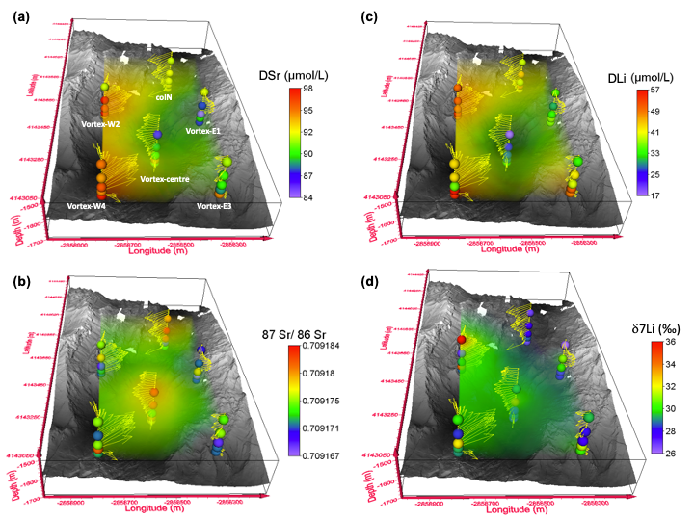

**Supplementary Figure S2.** Profiles of current speed intensities and direction at the six CTD casts reported with the dissolved Sr and Li concentrations (a, c) and their isotopic compositions (b, d) on top of the LSHF bathymetric map.