SUPPORTING INFORMATION 1. Video footage of burrows being filled during a flood tide and floating platform

Article title: The effect of crab burrows on soil-water dynamics in mangroves
Authors: Marie Arnaud, Andy J. Baird, Paul J. Morris, Adam Taylor, Huyen Dang, Hanh Tran Hong, Thoai Dinh Quang, Tai Tue Nguyen, Pierre Polsenaere

S1.1 Crab burrows filling with tidal water from their base
The video can be found here: https://youtu.be/HzMimf8oY9I

S1.2 Description of the video
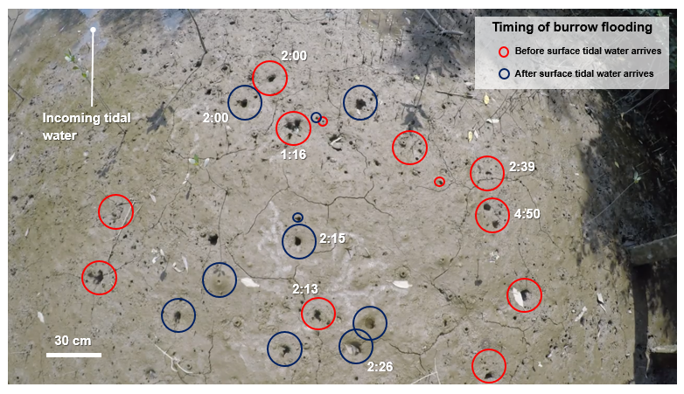
Figure S1.1 Burrow openings from the video S1, which are filled before (circled in red) or during (circled in blue) the arrival of the tidal water. Timestamps indicate the first appearance of water in the burrows. Our characterisation of the burrow filling and timestamps is not exhaustive. The video was taken in Can Gio, Vietnam.

S1.3 Floating platform to take the measurement
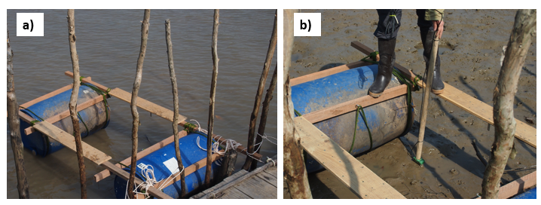
Figure S1.2. Floating platform used to measure the volumetric water content of the sediment matrix in Can Gio. (a) Floating platform with tidal water underneath, (b) grounded floating platform with the operator taking the volumetric water content measurements.

