Supplementary materials
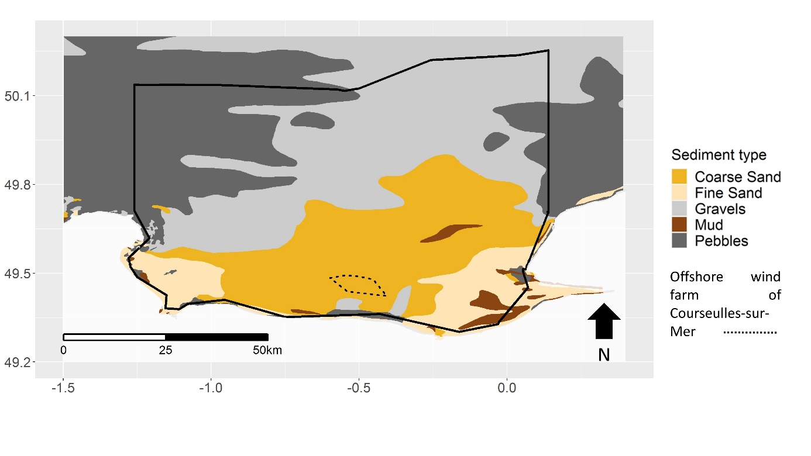
Figure S - 1 Sediment type in the eBoS.

Table S - 1 Absolute fishing landings of the eBoS model (t/km²/year).
Group name | Nets targeting demersal fish | Trawls targeting small pelagic fish | Trawls targeting demersal fish and cephalopods | Trawls targeting demersal fish | Other fishing gears | Dredge
Phytoplankton | 0 | 0 | 0 | 0 | 0 | 0
Bacteria | 0 | 0 | 0 | 0 | 0 | 0
Microzooplankton | 0 | 0 | 0 | 0 | 0 | 0
Mesozooplankton and macrozooplankton | 0 | 0 | 0 | 0 | 0 | 0
Meiofauna | 0 | 0 | 0 | 0 | 0 | 0
Suprabenthos | 0 | 0 | 0 | 0 | 0 | 0
Benthic inv. deposit feeders (Surface) | 0 | 0 | 0 | 0 | 0 | 0
Benthic inv. deposit feeders (Subsurface) | 0 | 0 | 0 | 0 | 0 | 0
King scallop | 0.00037018 | 0 | 0.00082957 | 5.2⁰E-05 | 0 | 0.3274384
Benthic inv. bivalves filter feeders | 0 | 0 | 0 | 0 | 0 | 0
Benthic inv. filter feeders | 0 | 0 | 0 | 0 | 0 | 0
Benthic inv. predators | 0 | 0 | 0 | 0 | 0 | 0
Fish limande | 0.00136914 | 8.2⁰E-05 | 0.01360997 | 0.00010713 | 0.00083433 | 0
Fish flounder | 0.00050364 | 1.8³E-06 | 0.00117131 | 3.8⁸E-06 | 9.6⁹E-05 | 0
Fish European plaice | 0.01160844 | 0.00063378 | 0.08738263 | 0.00046639 | 0.01348183 | 0
Fish sole | 0.01994157 | 3.6⁸E-05 | 0.02212876 | 6.8⁴E-05 | 0.00728431 | 0
Fish sea bream | 0.00010689 | 0.00089551 | 0.02305006 | 0.02742326 | 0.00043187 | 0
Fish benthos feeders | 0.00216087 | 0.00035717 | 0.04413093 | 0.00041176 | 0.00157334 | 0
Fish planktivorous | 0.00011777 | 0.05040085 | 0.00054509 | 3.6⁵E-06 | 0.00105402 | 0
Fish piscivorous | 0.00076925 | 0.00013645 | 0.01595292 | 0.00301107 | 0.00243441 | 0
Fish European sprat | 0 | 0 | 0 | 0 | 0 | 0
Fish European pilchard | 7.6⁷E-06 | 0.3987412 | 0.00307695 | 0.00016376 | 6.1¹E-06 | 0
Fish poor cod | 0 | 0 | 0 | 0 | 0 | 0
Fish pouting | 0.00084178 | 0.00064293 | 0.079098 | 0.0030563 | 0.00331092 | 0
Fish gurnard | 7.0⁶E-05 | 0.00018195 | 0.02772665 | 0.00029845 | 0.00074049 | 0
Fish Atlantic horse mackerel | 8.7⁸E-05 | 0.02122579 | 0.00367715 | 0.00285164 | 0.00012468 | 0
Fish whiting | 0.0002305 | 0.00101399 | 0.05385439 | 0.00033177 | 0.00144541 | 0
Fish Atlantic cod | 0.01055186 | 0.00042124 | 0.03720592 | 0.00115248 | 0.00224472 | 0
Fish sharks | 0.00890666 | 0.00078704 | 0.07944336 | 0.0044787 | 0.01426314 | 0
Fish rays | 1.7⁶E-05 | 3.1¹E-05 | 0.00204594 | 0.00026423 | 6.9⁸E-05 | 0
Fish European seabass | 0.00203618 | 0.00020811 | 0.01350535 | 0.00582477 | 0.00452945 | 0
Fish mackerel | 0.00014466 | 0.05903089 | 0.03021581 | 0.00781924 | 0.00069502 | 0
Benthic cephalopods | 9.7⁵E-05 | 0 | 0.00060458 | 0 | 0.02756191 | 0
Benthopelagic cephalopods | 8.9⁷E-06 | 0.00034458 | 0.04951037 | 0.00069978 | 0.00103215 | 0
Surface feeders seabirds | 0 | 0 | 0 | 0 | 0 | 0
Plunge and pursuit divers seabirds | 0 | 0 | 0 | 0 | 0 | 0
Benthic feeders seabirds | 0 | 0 | 0 | 0 | 0 | 0
Phocidae | 0 | 0 | 0 | 0 | 0 | 0
Harbor porpoises | 0 | 0 | 0 | 0 | 0 | 0
Bottlenose dolphins | 0 | 0 | 0 | 0 | 0 | 0

Table S - 2 Ecospace groups
Functional group id | Functional group | Ecology | Organism
1 | Phytoplankton
2 | Bacteria
3 | Microzooplankton
4 | Mesozooplankton and macrozooplankton
5 | Meiofauna
6 | Suprabenthos |  | Invertebrate
7 | Benthic inv. deposit feeders (surface) |  | Invertebrate
8 | Benthic inv. deposit feeders (subsurface) |  | Invertebrate
9 | King scallop | Benthic | Invertebrate
10 | Benthic inv. bivalves filter feeders |  | Invertebrate
11 | Benthic inv. filter feeders |  | Invertebrate
12 | Benthic inv. predators |  | Invertebrate
13 | Fish dab | Benthic | Fish
14 | Fish flounder | Benthic | Fish
15 | Fish European plaice | Benthic | Fish
16 | Fish sole | Benthic | Fish
17 | Fish sea bream | Demersal | Fish
18 | Fish benthos feeders | Benthic | Fish
19 | Fish planktivorous | Pelagic | Fish
20 | Fish piscivorous | Benthopelagic | Fish
21 | Fish European sprat | Pelagic | Fish
22 | Fish European pilchard | Pelagic | Fish
23 | Fish poor cod | Benthic | Fish
24 | Fish pouting | Benthic | Fish
25 | Fish gurnard | Benthic | Fish
26 | Fish Atlantic horse mackerel | Benthopelagic | Fish
27 | Fish whiting | Benthopelagic | Fish
28 | Fish Atlantic cod | Demersal | Fish
29 | Fish sharks | Demersal | Fish
30 | Fish rays | Demersal | Fish
31 | Fish European seabass | Demersal | Fish
32 | Fish mackerel | Pelagic | Fish
33 | Benthic cephalopods | Demersal | Invertebrate
34 | Benthopelagic cephalopods | Benthopelagic | Invertebrate
35 | Surface feeders seabirds
36 | Plunge and pursuit diverse seabirds
37 | Benthic feeders seabirds
38 | Phocidae
39 | Harbor porpoises
40 | Bottlenose dolphins
41 | Discards
42 | Detritus

Table S - 3 Ecospace environmental drivers
Group name | Environmental driver
Phytoplankton | Primary production map
Bacteria | Everywhere
Microzooplankton | Everywhere
Mesozooplankton and macrozooplankton | Everywhere
Meiofauna | Everywhere
Suprabenthos | Everywhere
Benthic inv. deposit feeders (Surface) | Suitability index map
Benthic inv. deposit feeders (Subsurface) | Suitability index map
King scallop | Suitability index map
Benthic inv.ivalviaa filter feeders | Suitability index map
Benthic inv. filter feeders | Suitability index map
Benthic inv. predators | Suitability index map
Fish dab | Suitability index map
Fish flounder | Suitability index map
Fish European plaice | Suitability index map
Fish sole | Suitability index map
Fish sea bream | Suitability index map
Fish benthos feeders | Suitability index map
Fish planktivorous | Suitability index map
Fish piscivorous | Suitability index map
Fish European sprat | Suitability index map
Fish European pilchard | Suitability index map
Fish poor cod | Suitability index map
Fish pouting | Suitability index map
Fish gurnard | Suitability index map
Fish Atlantic horse mackerel | Suitability index map
Fish whiting | Suitability index map
Fish Atlantic cod | Suitability index map
Fish sharks | Suitability index map
Fish rays | Suitability index map
Fish European seabass | Suitability index map
Fish mackerel | Suitability index map
Benthic cephalopods | Suitability index map
Benthopelagic cephalopods | Suitability index map
Surface feeders seabirds | Everywhere
Plunge and pursuit diverse seabirds | Everywhere
Benthic feeders seabirds | Depth dependent
Phocidae | Depth dependent
Harbor porpoises | Depth dependent
Bottlenose dolphins | Depth dependent
Discards | Everywhere
Detritus | Everywhere
Table S - 4 Fitted climatic species distribution models used to compute environmental driver maps for each trophic group of the eBoS Ecospace model. Models include: multiple regressions (Generalized Linear Model, Generalized Additive Model, Multiple Adaptive Regression Splines), regression trees (Boosted Regression Tree from GBM, Random Forest, Classification Tree Analysis), discriminant analysis (Flexible Discriminant Analysis) and learning techniques (Artificial Neural Network).
 |  |  | climatic
Ecopath trophic group | Latin name | Proportion  in the group | MARS | ANN | CTA | FDA | GAM | GBM | GLM | RF
Benthic cephalopods | Sepia officinalis | 1.00 | 1 |  | 1 |  | 1 | 1 | 1 | 1
Benthic inv. deposit feeders (Subsurface) | Echinocardium cordatum | 0.66 | 1 |  | 1 | 1 | 1 | 1 | 1 | 1
Benthic inv. deposit feeders (Surface) | Ophiothrix fragilis | 0.45 | 1 |  | 1 | 1 |  | 1 | 1 | 1
Benthic inv. deposit feeders (Surface) | Pectinaria koreni | 0.15 | 1 |  |  | 1 |  |  | 1
Benthic inv. filter feeders | Psammechinus miliaris | 0.15 | 1 |  | 1 |  |  | 1 |  | 1
Benthic inv. predators | Asterias rubens | 0.03 | 1 | 1 |  | 1 | 1 |  | 1 | 1
Benthic inv. predators | Buccinum undatum | 0.11 |  |  |  |  |  |  | 1
Benthic inv. predators | Owenia fusiformis | 0.66
Benthic inv. predators | Sagartia troglodytes | 0.09 |  |  |  |  | 1
Benthopelagic cephalopods | Alloteuthis subulata | 0.09 |  |  | 1 | 1 |  |  | 1
Benthopelagic cephalopods | Loligo vulgaris | 0.91 | 1 |  |  |  | 1 | 1 | 1 | 1
Benthic inv. bivalvia filter feeders | Aequipecten opercularis | 0.02 | 1 |  |  | 1 | 1 | 1 | 1 | 1
Benthic inv. bivalvia filter feeders | Ensis directus | 0.00 | 1 |  | 1 | 1 | 1 | 1 | 1 | 1
Benthic inv. bivalvia filter feeders | Glycymeris glycymeris | 0.61 |  |  | 1 | 1 |  |  | 1 | 1
Benthic inv. bivalvia filter feeders | Lanice conchilega | 0.01 | 1 | 1 | 1 | 1 | 1 | 1 | 1 | 1
Fish Atlantic cod | Gadus morhua | 1.00 | 1 | 1 |  | 1 | 1 | 1 | 1 | 1
Fish dab | Limanda limanda | 1.00 | 1 |  |  | 1 | 1 | 1 | 1 | 1
Fish benthos feeders | Callionymus lyra | 0.48 | 1 |  |  | 1 | 1 | 1 | 1 | 1
Fish benthos feeders | Labrus bergylta | 0.07 | 1 |  | 1 | 1 | 1 | 1 | 1 | 1
Fish benthos feeders | Mullus surmuletus | 0.27 |  |  |  | 1 |  | 1 | 1 | 1
Fish benthos feeders | Zeus faber | 0.18 | 1 |  | 1 | 1 | 1 | 1 | 1
Fish piscivorous | Pollachius pollachius | 1.00 | 1 |  | 1 | 1 | 1 | 1 | 1 | 1
Fish planktivorous | Clupea harengus | 0.91 | 1 |  | 1 | 1 | 1 | 1 | 1 | 1
Fish planktivorous | Engraulis encrasicolus | 0.09 | 1 | 1 | 1 |  | 1 | 1 | 1 | 1
Fish flounder | Platichthys flesus | 1.00 | 1 |  | 1 | 1 | 1 |  | 1 | 1
Fish gurnard | Chelidonichthys lastoviza | 0.30 | 1 |  | 1 | 1 | 1 | 1 | 1 | 1
Fish gurnard | Chelidonichthys lucerna | 0.70 | 1 |  |  | 1 | 1 |  | 1 | 1
Fish Atlantic horse mackerel | Trachurus trachurus | 1.00 | 1 |  | 1 | 1 | 1 | 1 | 1 | 1
King scallop | Pecten maximus | 1.00 | 1 |  |  | 1 |  |  | 1
Fish mackerel | Scomber scombrus | 1.00 | 1 |  |  |  | 1 |  | 1 | 1
Fish pilchard | Sardina pilchardus | 1.00 | 1 |  | 1 |  | 1 |  | 1 | 1
Fish plaice | Pleuronectes platessa | 1.00 | 1 |  |  | 1 | 1 |  | 1 | 1
Fish poor cod | Trisopterus minutus | 1.00 | 1 |  |  | 1 | 1 |  | 1
Fish pouting | Trisopterus luscus | 1.00 | 1 |  | 1 | 1 | 1 | 1 | 1 | 1
Fish rays | Raja clavata | 0.86 | 1 |  |  |  | 1 | 1 | 1 | 1
Fish rays | Raja montagui | 0.14 | 1 |  | 1 | 1 | 1 | 1 | 1 | 1
Fish sea bream | Spondyliosoma cantharus | 1.00 |  |  |  | 1 | 1 | 1 | 1 | 1
Fish seabass | Dicentrarchus labrax | 1.00
Fish sharks | Mustelus mustelus | 0.37 | 1 | 1 |  | 1 | 1 | 1 | 1 | 1
Fish sharks | Scyliorhinus canicula | 0.46 | 1 | 1 | 1 |  | 1 |  | 1 | 1
Fish sharks | Scyliorhinus stellaris | 0.17 | 1 |  | 1 | 1 | 1 |  | 1 | 1
Fish sole | Solea solea | 1.00 | 1 |  |  | 1 | 1 |  | 1 | 1
Fish sprat | Sprattus sprattus | 1.00 | 1 | 1 | 1 |  | 1 |  | 1 | 1
Fish whiting | Merlangius merlangus | 1.00 | 1 |  | 1 | 1 | 1 |  | 1

Table S - 5 Fitted habitat species distribution models used to compute environmental driver maps for each trophic group of the eBoS Ecospace model. Models include: multiple regressions (Generalized Linear Model, Generalized Additive Model, Multiple Adaptive Regression Splines), regression trees (Boosted Regression Tree from GBM, Random Forest, Classification Tree Analysis), discriminant analysis (Flexible Discriminant Analysis) and learning techniques (Artificial Neural Network).
 |  |  | habitat
Ecopath trophic group | Latin name | Proportion  in the group | MARS | ANN | CTA | FDA | GAM | GBM | GLM | RF
Benthic cephalopods | Sepia officinalis | 1.00 | 1 | 1 | 1 | 1 | 1 | 1 | 1 | 1
Benthic inv. deposit feeders (Subsurface) | Echinocardium cordatum | 0.66 |  |  | 1 |  |  | 1 | 1 | 1
Benthic inv. deposit feeders (Surface) | Ophiothrix fragilis | 0.45 | 1 | 1 | 1 | 1 | 1 | 1 | 1 | 1
Benthic inv. deposit feeders (Surface) | Pectinaria koreni | 0.15 | 1 |  | 1 |  |  |  | 1 | 1
Benthic inv. filter feeders | Psammechinus miliaris | 0.15 | 1 | 1 | 1 |  | 1 | 1 | 1 | 1
Benthic inv. predators | Asterias rubens | 0.03 | 1 | 1 | 1 |  | 1 | 1 | 1
Benthic inv. predators | Buccinum undatum | 0.11 | 1 | 1 | 1 |  | 1 | 1 | 1 | 1
Benthic inv. predators | Owenia fusiformis | 0.66 | 1 |  | 1 |  |  | 1 | 1 | 1
Benthic inv. predators | Sagartia troglodytes | 0.09 |  |  |  |  |  |  |  | 1
Benthopelagic cephalopods | Alloteuthis subulata | 0.09
Benthopelagic cephalopods | Loligo vulgaris | 0.91
Bivalvia inv. filter feeders | Aequipecten opercularis | 0.02 | 1 |  |  | 1 | 1
Bivalvia inv. filter feeders | Ensis directus | 0.00 |  |  | 1 | 1 |  | 1 | 1 | 1
Bivalvia inv. filter feeders | Glycymeris glycymeris | 0.61 |  |  | 1
Bivalvia inv. filter feeders | Lanice conchilega | 0.01 | 1 |  | 1 | 1 |  | 1 | 1 | 1
Fish Atlantic cod | Gadus morhua | 1.00
Fish dab | Limanda limanda | 1.00 | 1 | 1 | 1 | 1 | 1 | 1 | 1 | 1
Fish benthos feeders | Callionymus lyra | 0.48 |  |  | 1
Fish benthos feeders | Labrus bergylta | 0.07 | 1 | 1 | 1 | 1 | 1 | 1 | 1
Fish benthos feeders | Mullus surmuletus | 0.27
Fish benthos feeders | Zeus faber | 0.18
Fish piscivorous | Pollachius pollachius | 1.00
Fish planktivorous | Clupea harengus | 0.91
Fish planktivorous | Engraulis encrasicolus | 0.09
Fish flounder | Platichthys flesus | 1.00 | 1 | 1 | 1 |  | 1 | 1 | 1 | 1
Fish gurnard | Chelidonichthys lastoviza | 0.30 | 1 | 1 | 1 | 1 | 1 | 1 | 1 | 1
Fish gurnard | Chelidonichthys lucerna | 0.70 |  |  | 1
Fish Atlantic horse mackerel | Trachurus trachurus | 1.00
King scallop | Pecten maximus | 1.00 | 1 | 1 | 1 | 1 | 1 | 1 | 1 | 1
Fish mackerel | Scomber scombrus | 1.00
Fish pilchard | Sardina pilchardus | 1.00
Fish plaice | Pleuronectes platessa | 1.00 | 1 | 1 |  | 1 | 1 | 1 | 1 | 1
Fish poor cod | Trisopterus minutus | 1.00
Fish pouting | Trisopterus luscus | 1.00
Fish rays | Raja clavata | 0.86 |  |  | 1
Fish rays | Raja montagui | 0.14 | 1 | 1 |  | 1 | 1 | 1 | 1 | 1
Fish sea bream | Spondyliosoma cantharus | 1.00
Fish seabass | Dicentrarchus labrax | 1.00 |  |  | 1
Fish sharks | Mustelus mustelus | 0.37 | 1 | 1 | 1 |  | 1 | 1 | 1 | 1
Fish sharks | Scyliorhinus canicula | 0.46 |  |  | 1
Fish sharks | Scyliorhinus stellaris | 0.17 | 1 | 1 | 1 |  | 1 | 1 | 1 | 1
Fish sole | Solea solea | 1.00
Fish sprat | Sprattus sprattus | 1.00
Fish whiting | Merlangius merlangus | 1.00

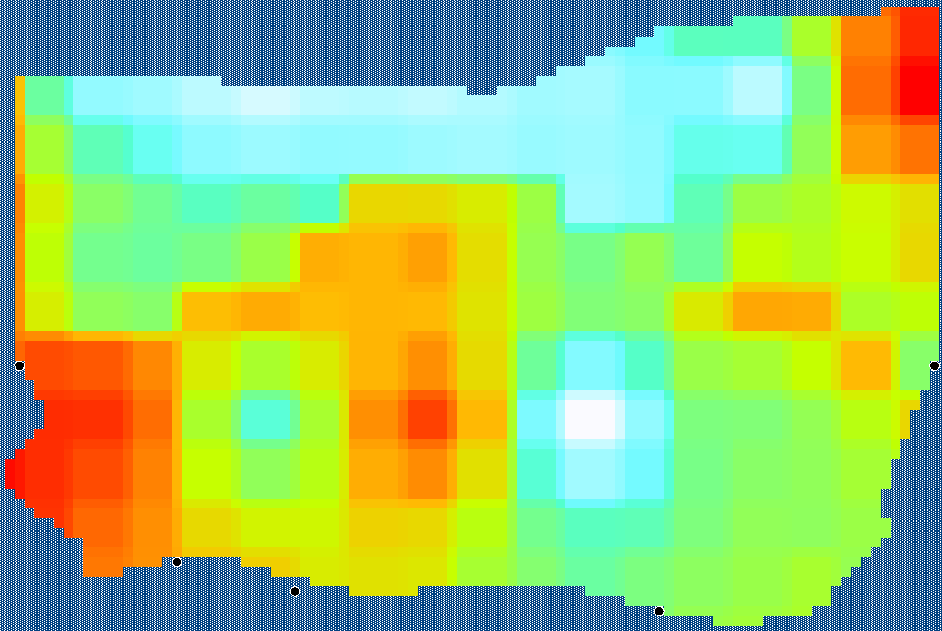
Figure S - 2 Environmental driver map for the Fish Atlantic cod group.
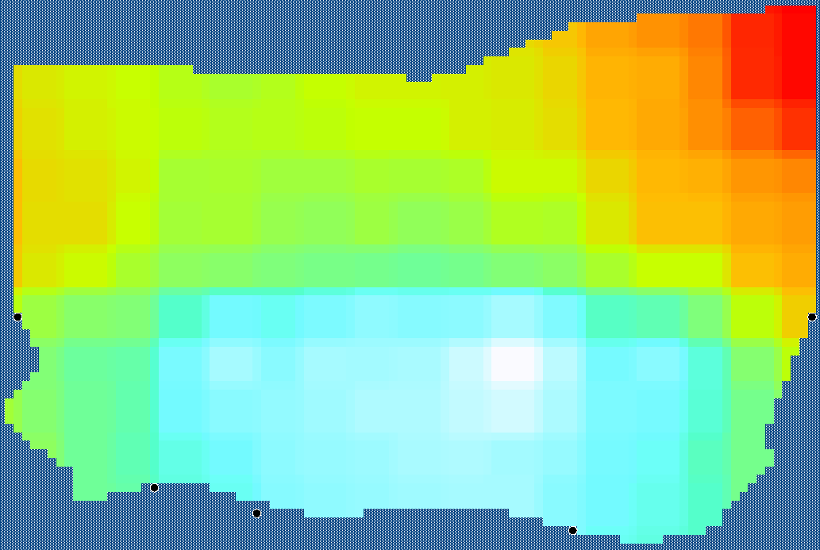
Figure S - 3 Environmental driver map for the Fish Atlantic horse mackerel group.
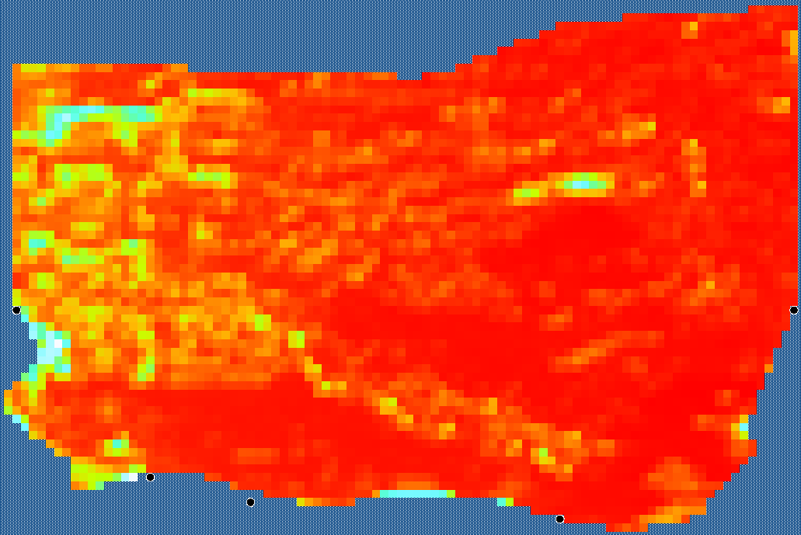
Figure S - 4 Environmental driver map for the Benthic cephalopods group.
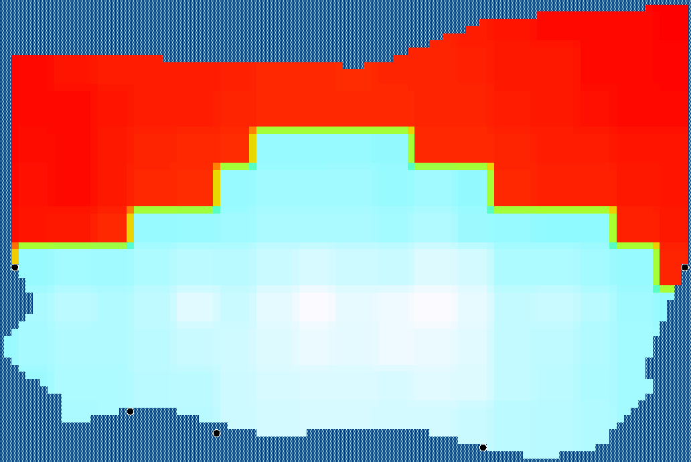
Figure S - 5 Environmental driver map for the Benthopelagic cephalopods group.
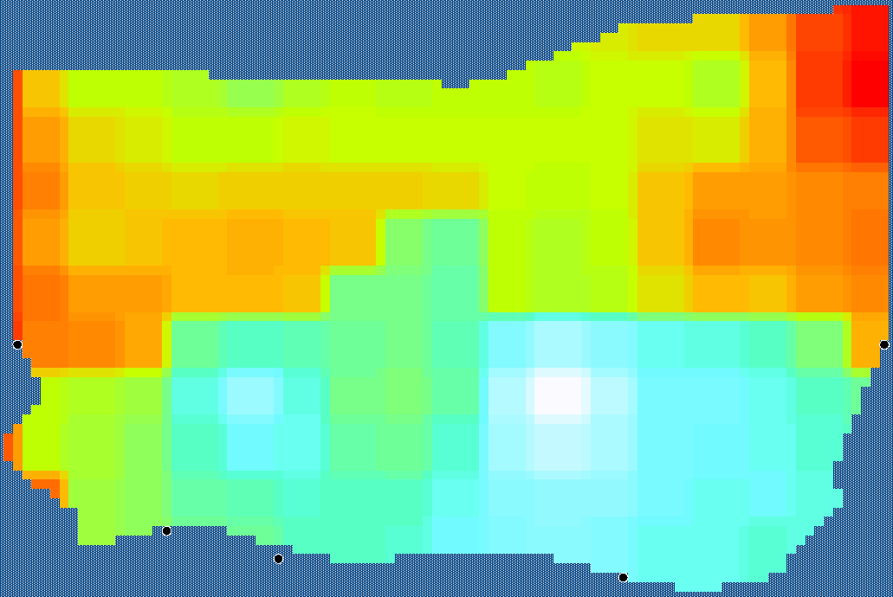
Figure S - 6 Environmental driver map for the Fish benthos feeders group.
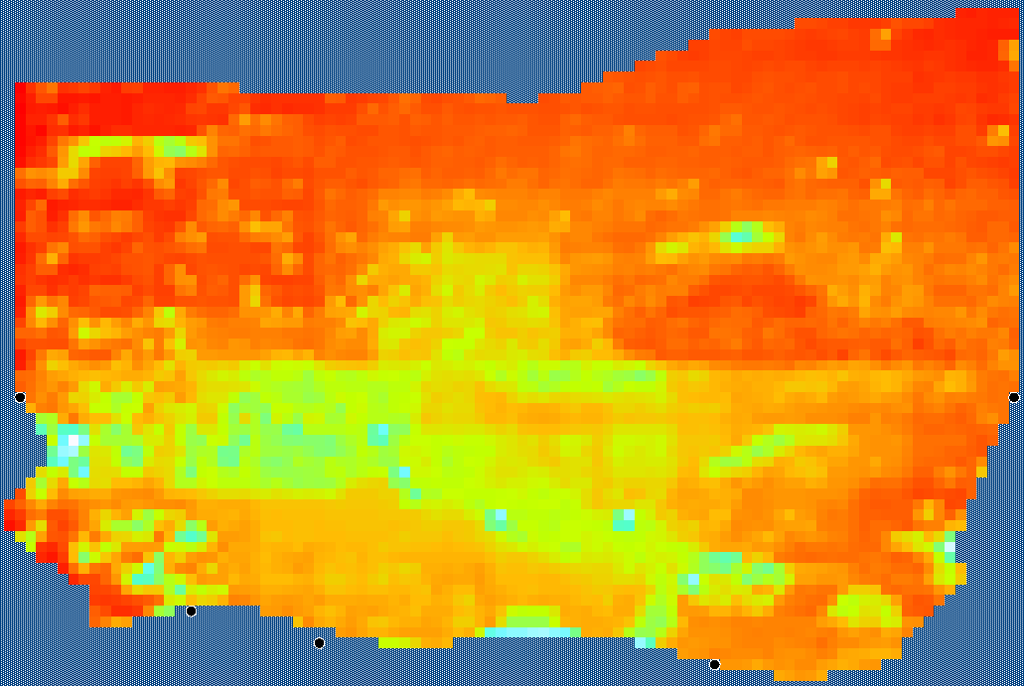
Figure S - 7 Environmental driver map for the Benthic inv. bivalvia filter feeders group.
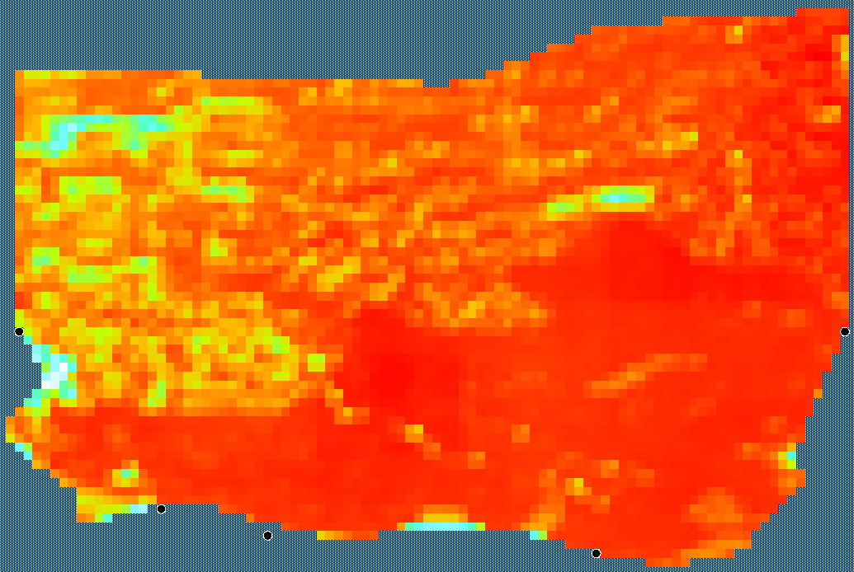
Figure S - 8 Environmental driver map for the Fish European plaice group.
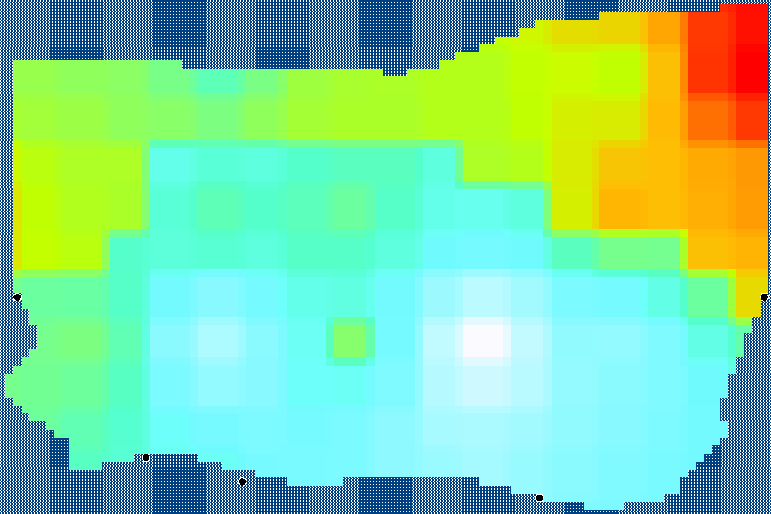
Figure S - 9 Environmental driver map for the Fish European sprat group.
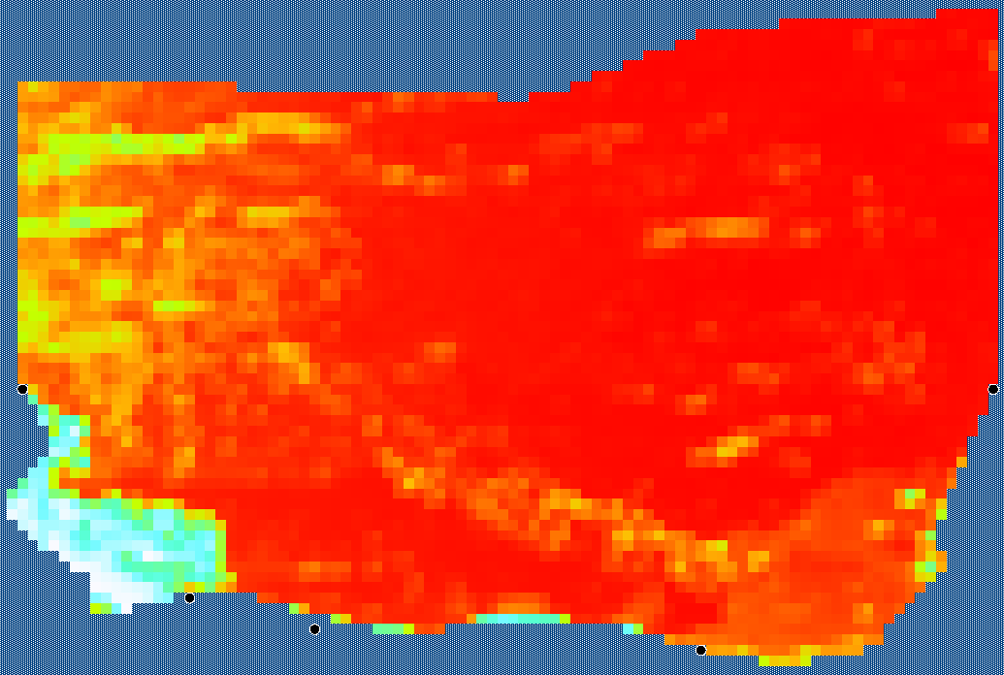
Figure S - 10 Environmental driver map for the Benthic inv. filter feeders group.
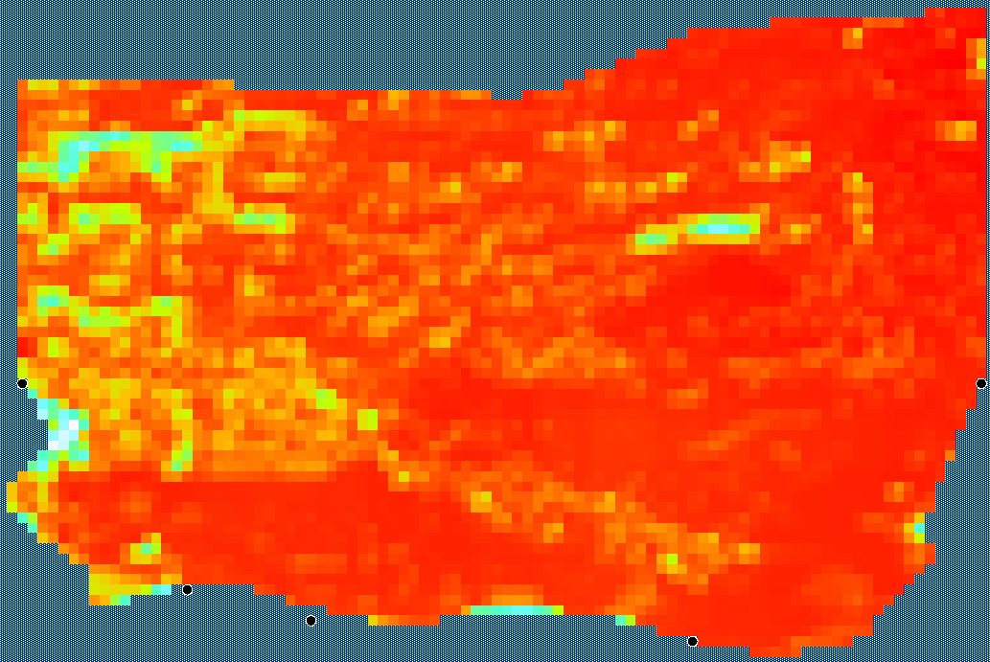
Figure S - 11 Environmental driver map for the Fish flounder group.
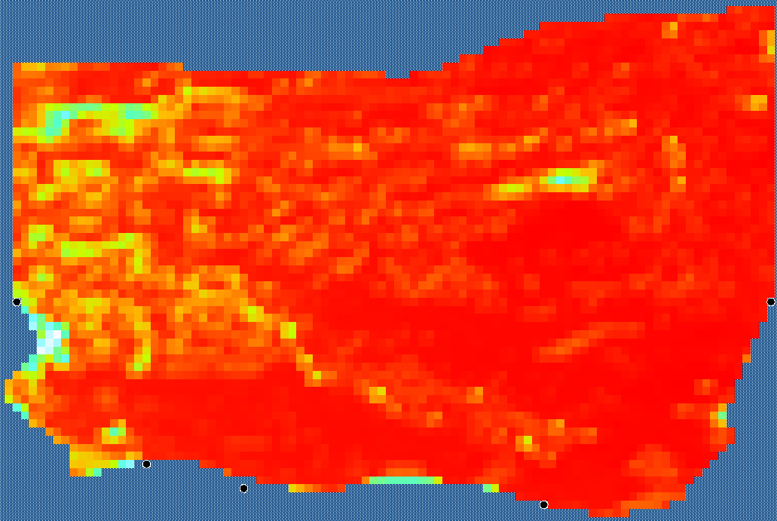
Figure S - 12 Environmental driver map for the Fish gurnard group.
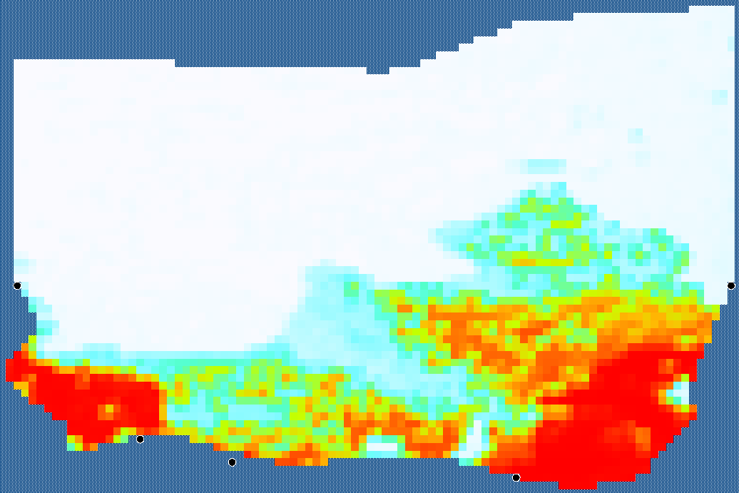
Figure S - 13 Environmental driver map for the Benthic inv. deposit feeders (subsurface) group.
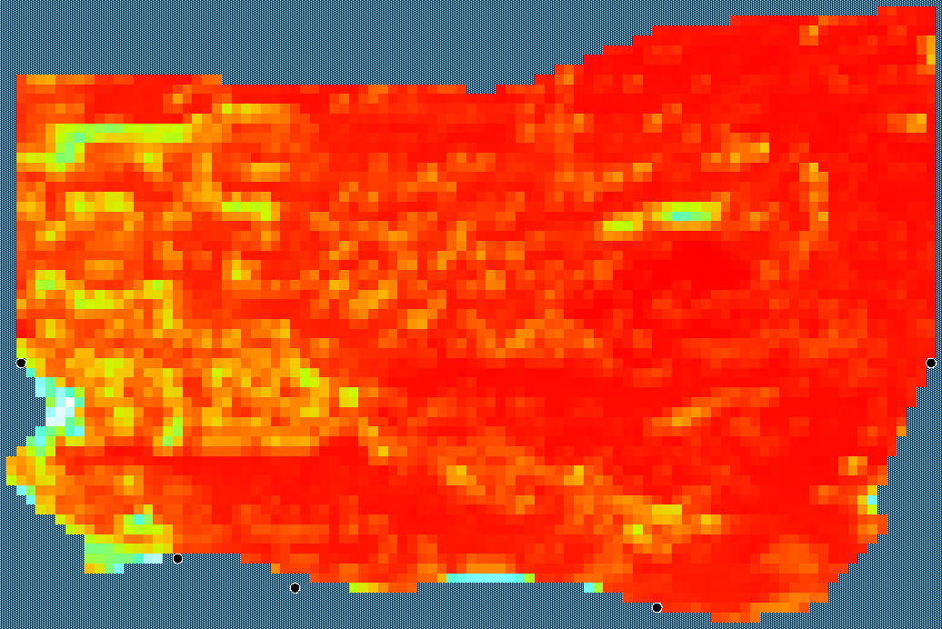
Figure S - 14 Environmental driver map for the Benthic inv. deposit feeders (surface) group.
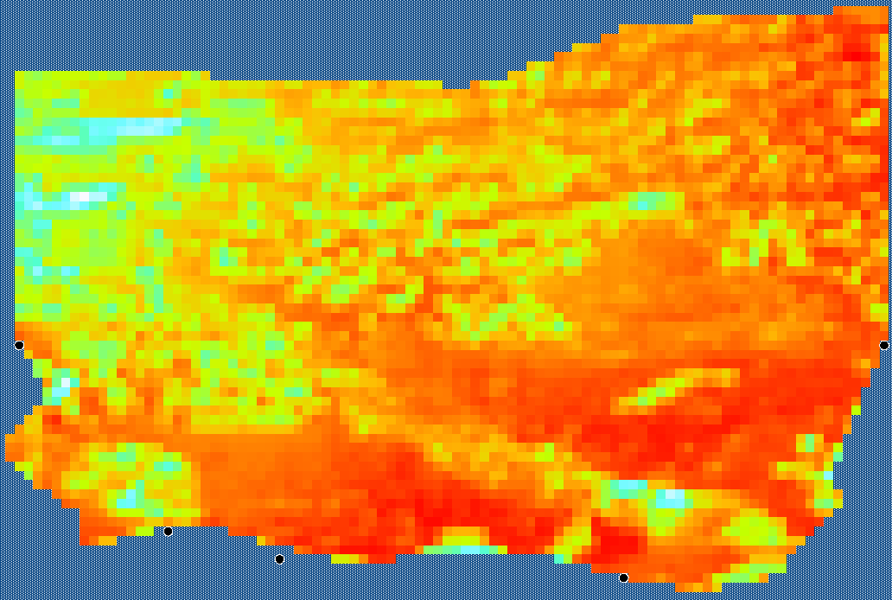
Figure S - 15 Environmental driver map for the Benthic inv. predators group.
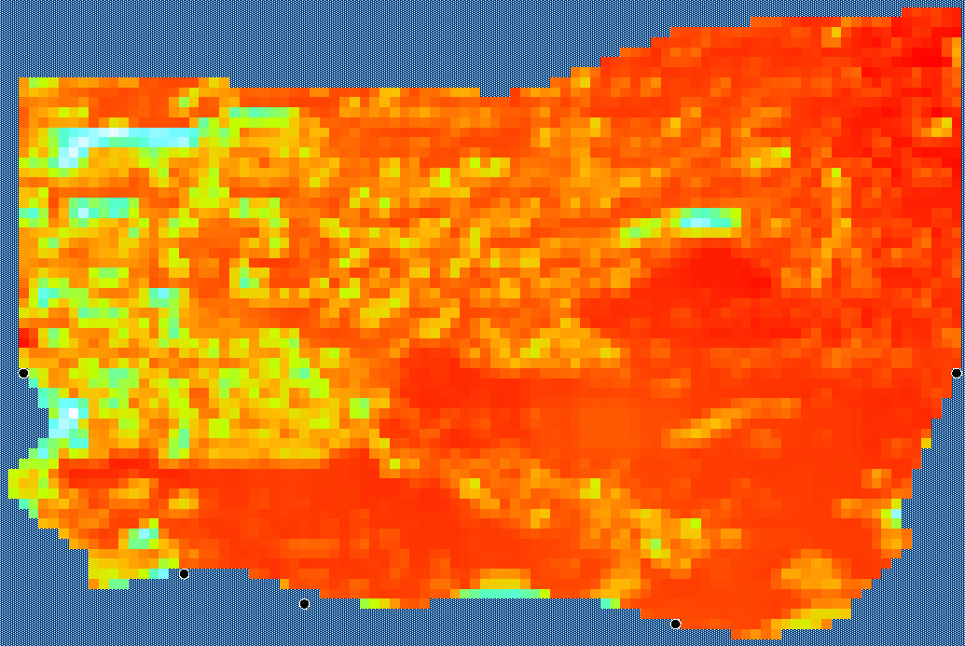
Figure S - 16 Environmental driver map for the King scallop group.
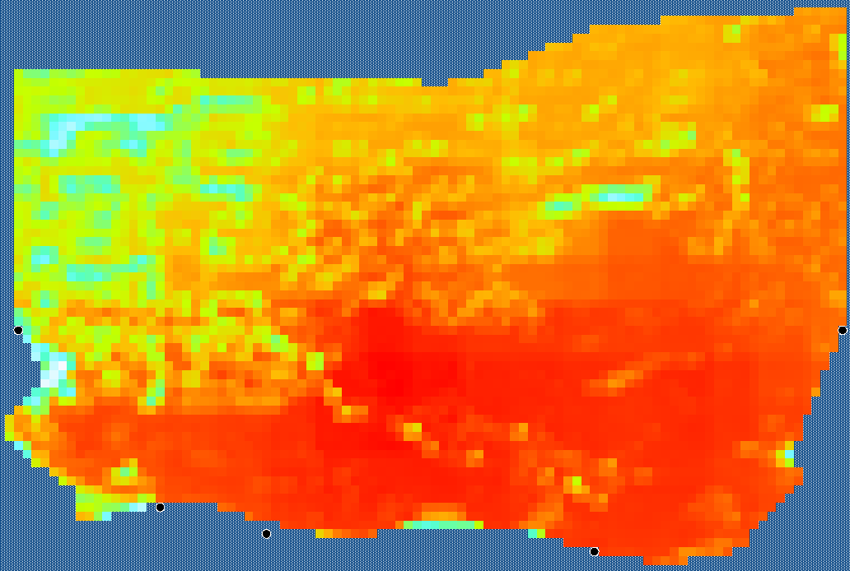
Figure S - 17 Environmental driver map for the Fish limande group.
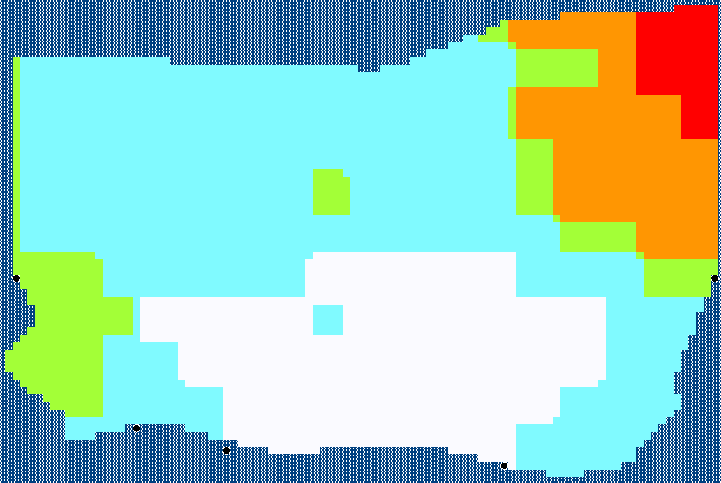
Figure S - 18 Environmental driver map for the Fish mackerel group.
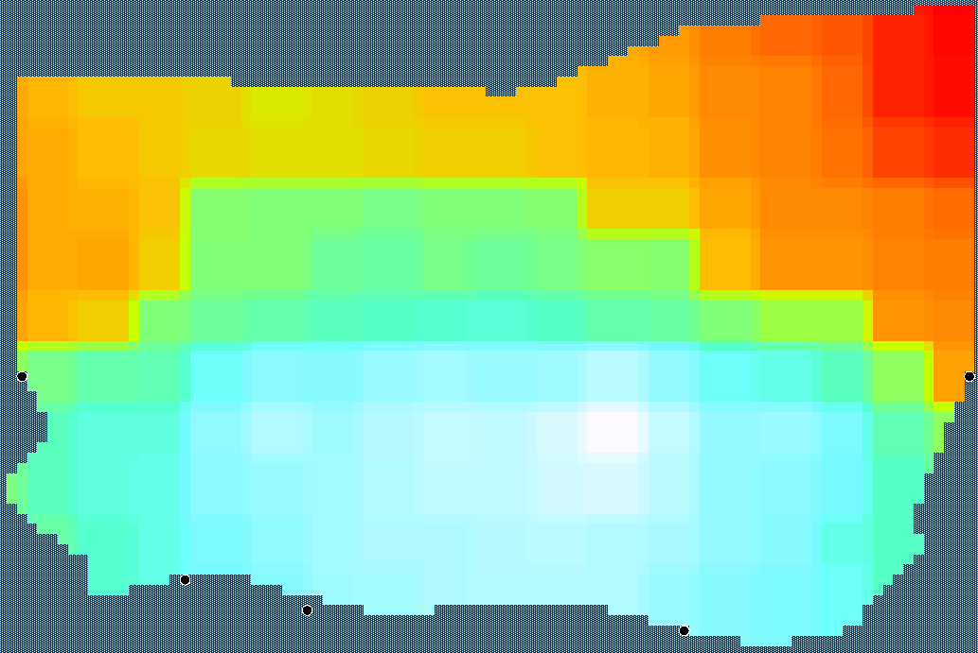
Figure S - 19 Environmental driver map for the Fish pilchard group.
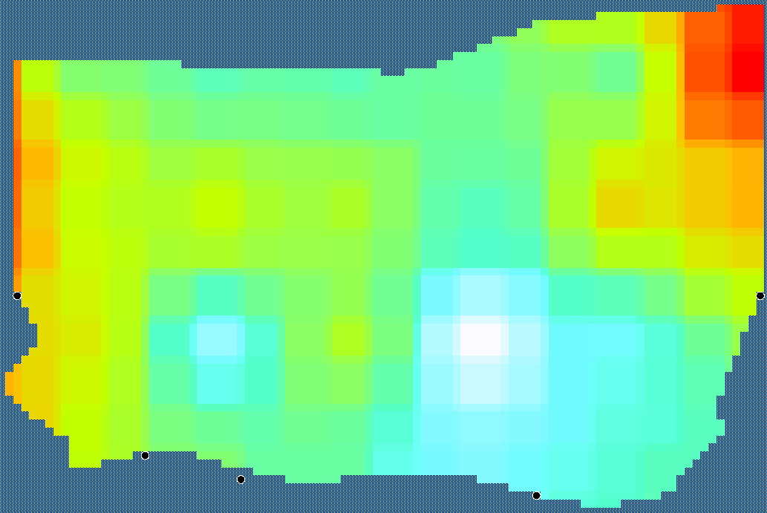
Figure S - 20 Environmental driver map for the Fish piscivorous group.
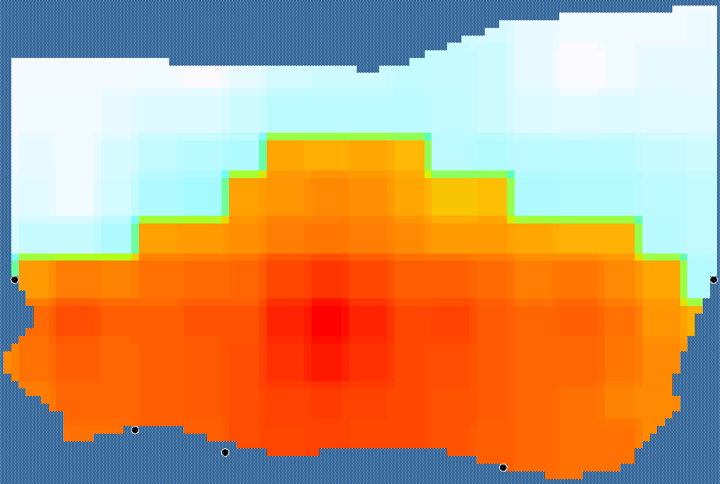
Figure S - 21 Environmental driver map for the Fish planctivorous group.

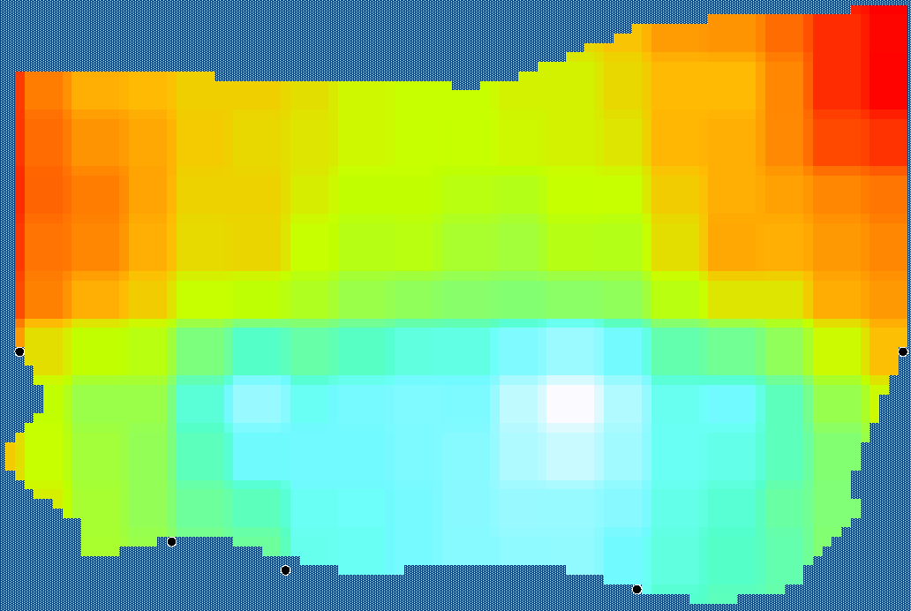
Figure S - 22 Environmental driver map for the Fish poor cod group.
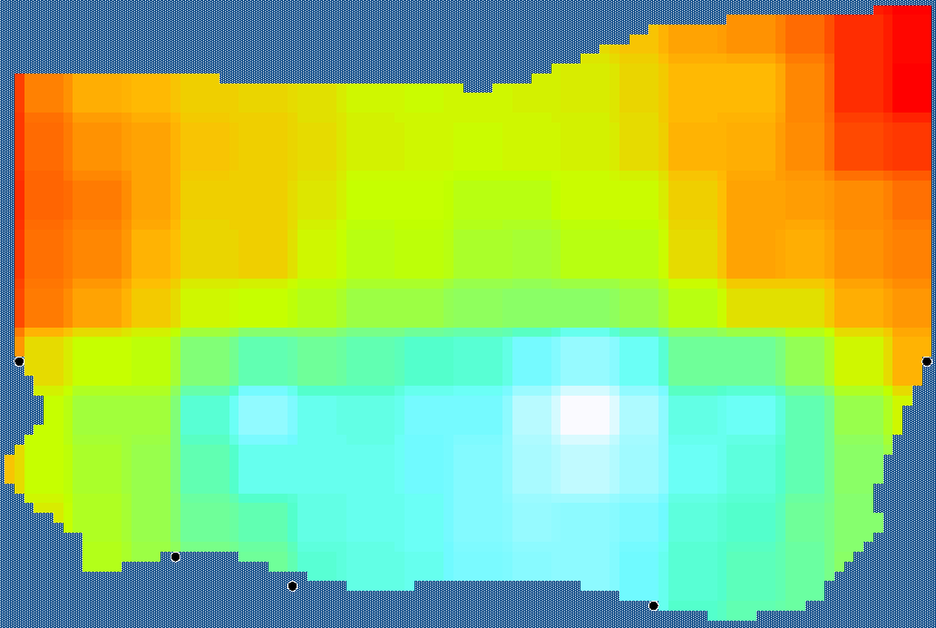
Figure S - 23 Environmental driver map for the Fish pouting group.
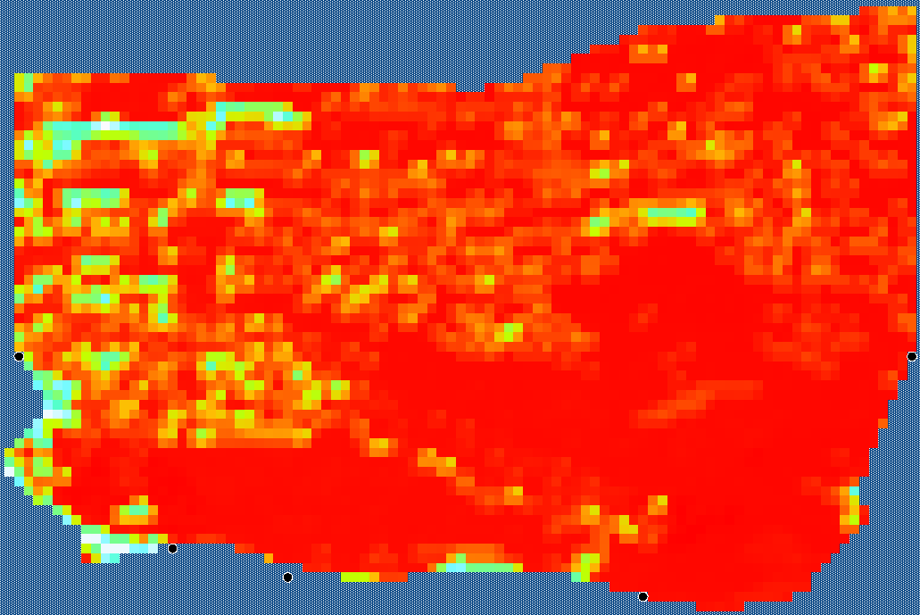
Figure S - 24 Environmental driver map for the Fish rays group.
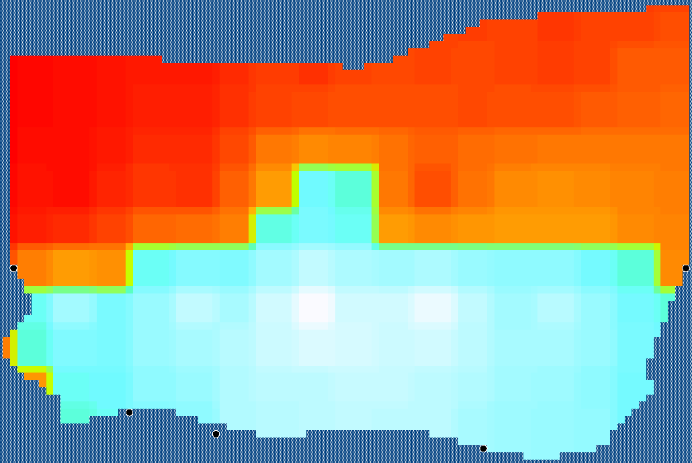
Figure S - 25 Environmental driver map for the Fish sea bream group.
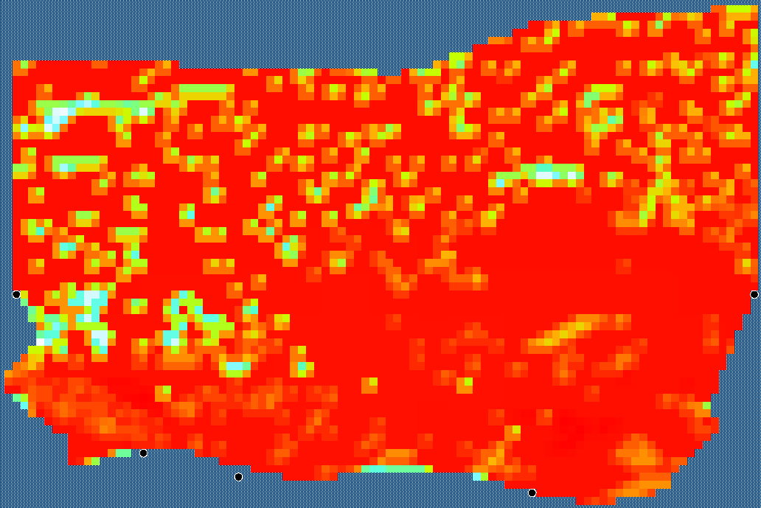
Figure S - 26 Environmental driver map for the Fish sharks group.
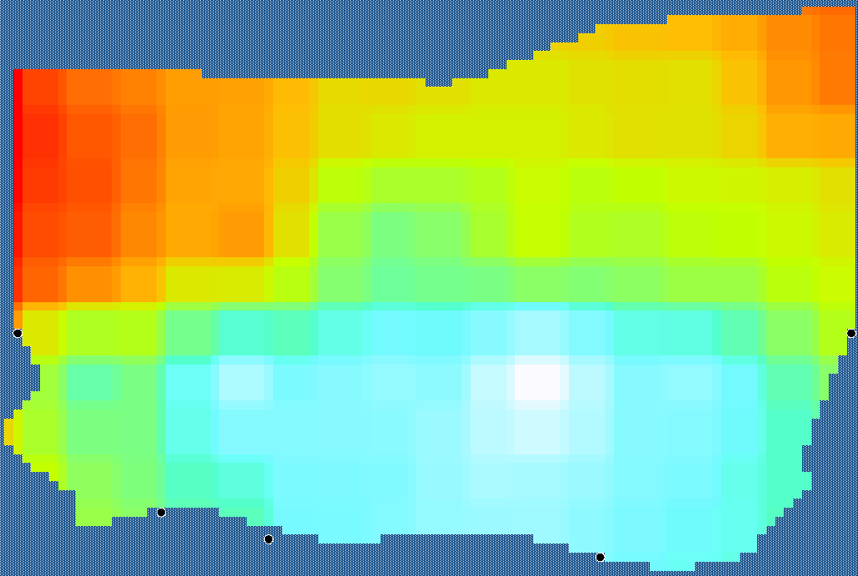
Figure S - 27 Environmental driver map for the Fish sole group.
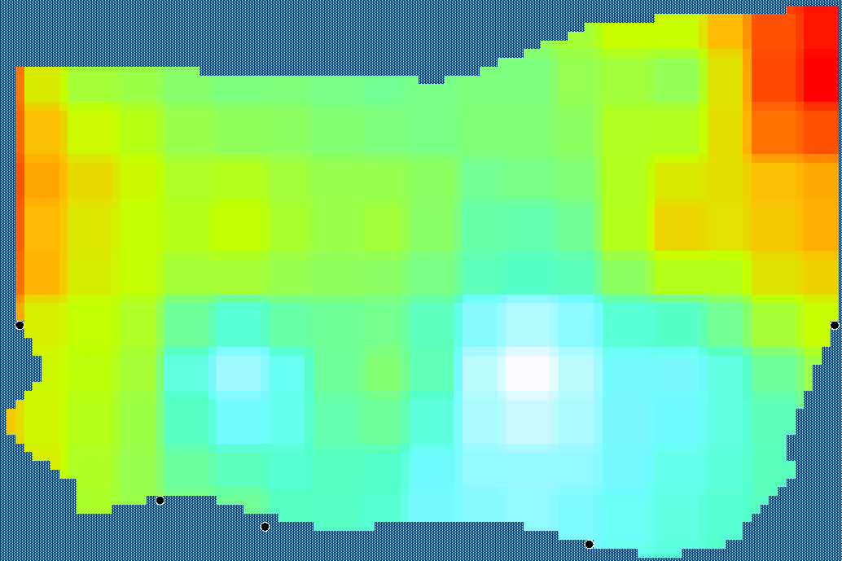
Figure S - 28 Environmental driver map for the Fish whiting group.

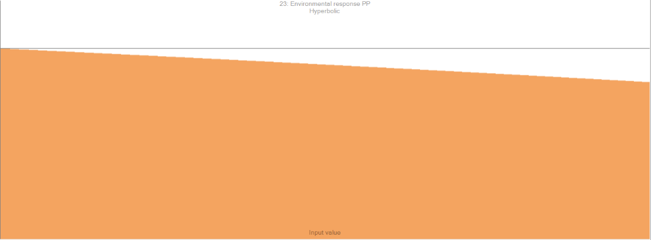
Figure S - 29 Response curve for phytoplankton driven by depth.


Figure S - 30 Response curve for species with undefined habitats driven by depth.

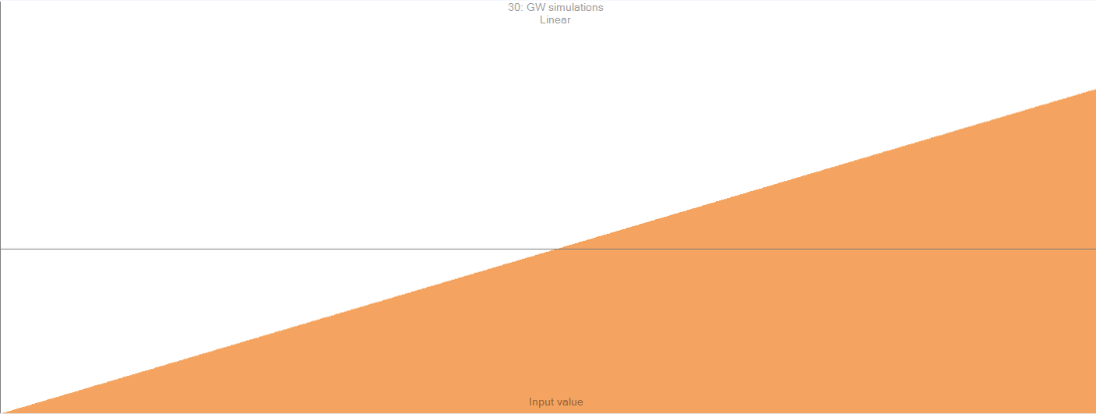
Figure S - 31 Response curve for species driven by the suitability index map.

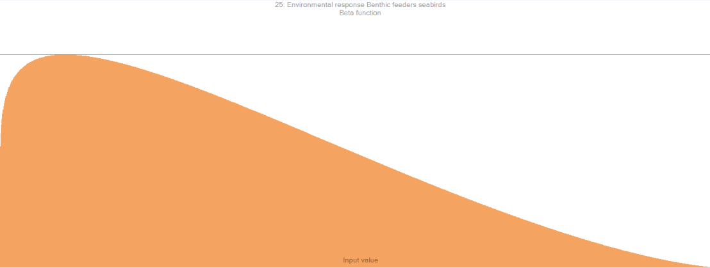
Figure S - 32 Response curve for benthic feeding seabirds driven by depth.


Figure S - 33 Response curve for bottlenose dolphins driven by depth.

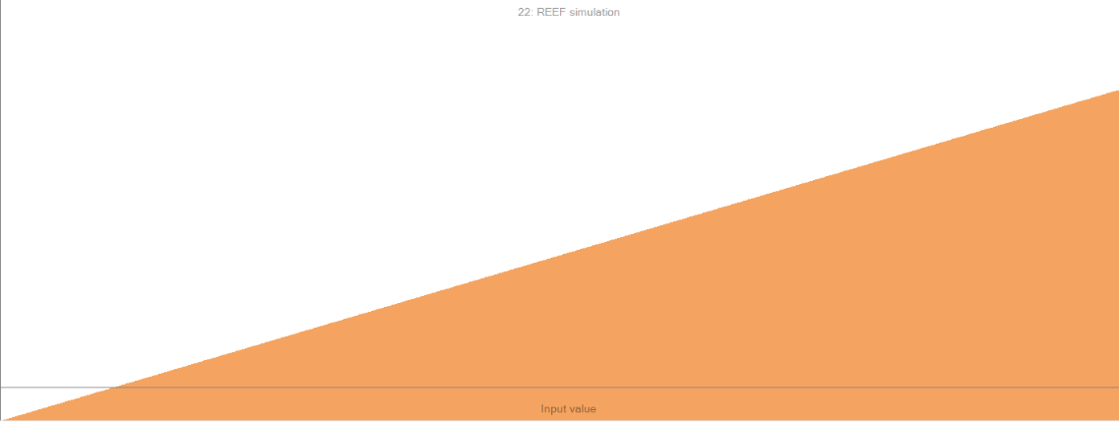
Figure S - 34 Response curve for species impacted by the reef effect driven by the Ecospace reef factor.

Table S - 6 Current fishing effort grid used in the reference scenario to set the value of the fishing effort.
Name | Nets targeting demersals and crustaceans | Pelagic and bottom trawls targeting small pelagic fish | Bottom trawls targeting demersals and cephalopods | Pelagic trawls targeting demersals | Other fishing gears | Dredge
2000 | 1.08 | 0.78 | 1.12 | 0.51 | 1.24 | 1.60
2001 | 1.08 | 0.78 | 1.12 | 0.51 | 1.24 | 1.60
[…] | 1.08 | 0.78 | 1.12 | 0.51 | 1.24 | 1.60
 | 1.08 | 0.78 | 1.12 | 0.51 | 1.24 | 1.60
2075 | 1.08 | 0.78 | 1.12 | 0.51 | 1.24 | 1.60

Table S - 7 Brexit-linked decreased fishing effort grid used in the F_dec scenario to set fishing.
Name | Nets targeting demersals and crustaceans | Pelagic and bottom trawls targeting small pelagic fish | Bottom trawls targeting demersals and cephalopods | Pelagic trawls targeting demersals | Other fishing gears | Dredge
2000 | 1.08 | 0.63 | 0.90 | 0.41 | 1.18 | 1.28
2001 | 1.08 | 0.63 | 0.90 | 0.41 | 1.18 | 1.28
[…] | 1.08 | 0.63 | 0.90 | 0.41 | 1.18 | 1.28
 | 1.08 | 0.63 | 0.90 | 0.41 | 1.18 | 1.28
2075 | 1.08 | 0.63 | 0.90 | 0.41 | 1.18 | 1.28

Table S - 8 Brexit-linked increased fishing effort grid used in the F_inc scenario to set fishing.
Name | Nets targeting demersals and crustaceans | Pelagic and bottom trawls targeting small pelagic fish | Bottom trawls targeting demersals and cephalopods | Pelagic trawls targeting demersals | Other fishing gears | Dredge
2000 | 1.08 | 0.94 | 1.35 | 0.61 | 1.30 | 1.36
2001 | 1.08 | 0.94 | 1.35 | 0.61 | 1.30 | 1.36
[…] | 1.08 | 0.94 | 1.35 | 0.61 | 1.30 | 1.36
 | 1.08 | 0.94 | 1.35 | 0.61 | 1.30 | 1.36
2075 | 1.08 | 0.94 | 1.35 | 0.61 | 1.30 | 1.36

Table S - 9 Environmental drivers inside the OWF area for each specified group calculated according to Raoux et al. (2017) to model the reef effect inside the OWF of Courseulles-sur-Mer. The environmental driver value was set to 1 outside the OWF.
Raoux et al. (2017) groups | eBoS groups | Ecospace environmental driver inside the OWF
Surface feeders seabirds | Surface feeders seabirds | 6.11
Fish Atlantic cod | Fish Atlantic cod | 3.49
Fish whiting | Fish whiting | 4.18
Fish pouting | Fish pouting | 2.32
Fish benthos feeders | Fish benthos feeders | 2.07
Fish sole | Fish sole | 1.93
Other Flatfish | Fish flounder | 4.37
 | Fish dab | 4.37
Benthic inv. predators | Benthic inv. predators | 1.02
Benthic inv. filter feeders | Benthic inv. filter feeders | 1.53
Benthic inv. bivalves | Benthic inv. bivalves | 2.2

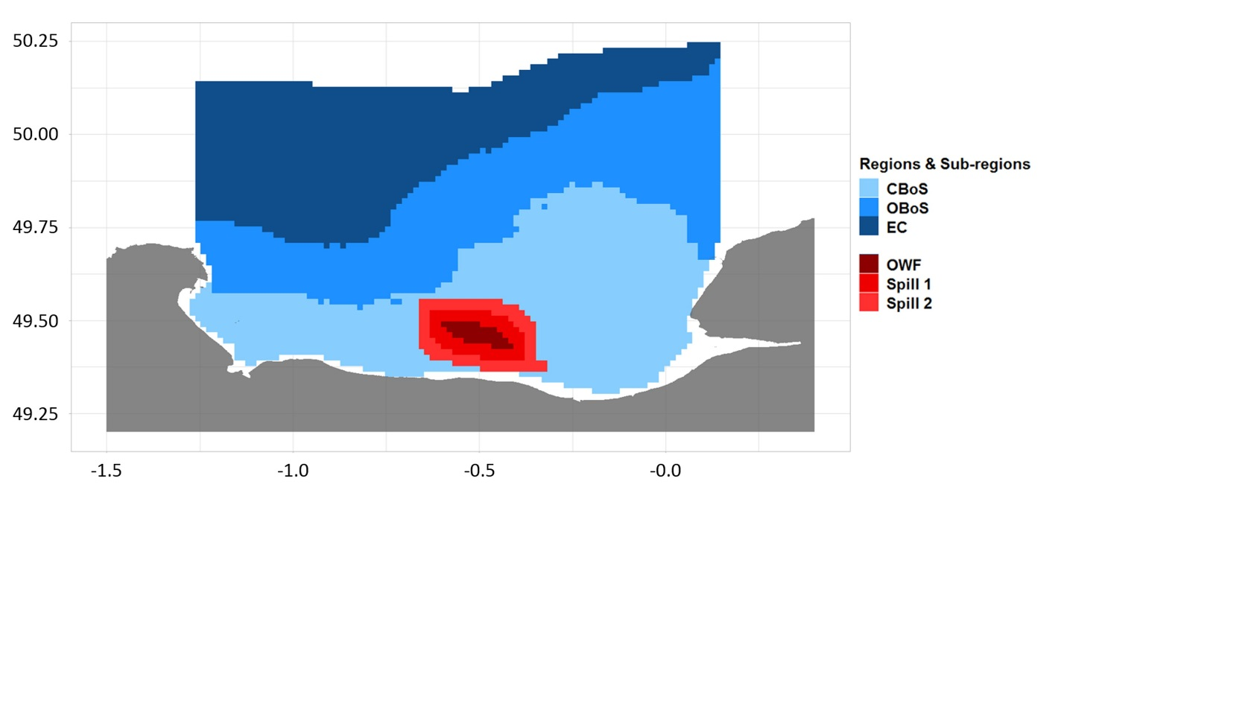
Figure S - 35 All the regions and sub-regions of the extended Bay of Seine.

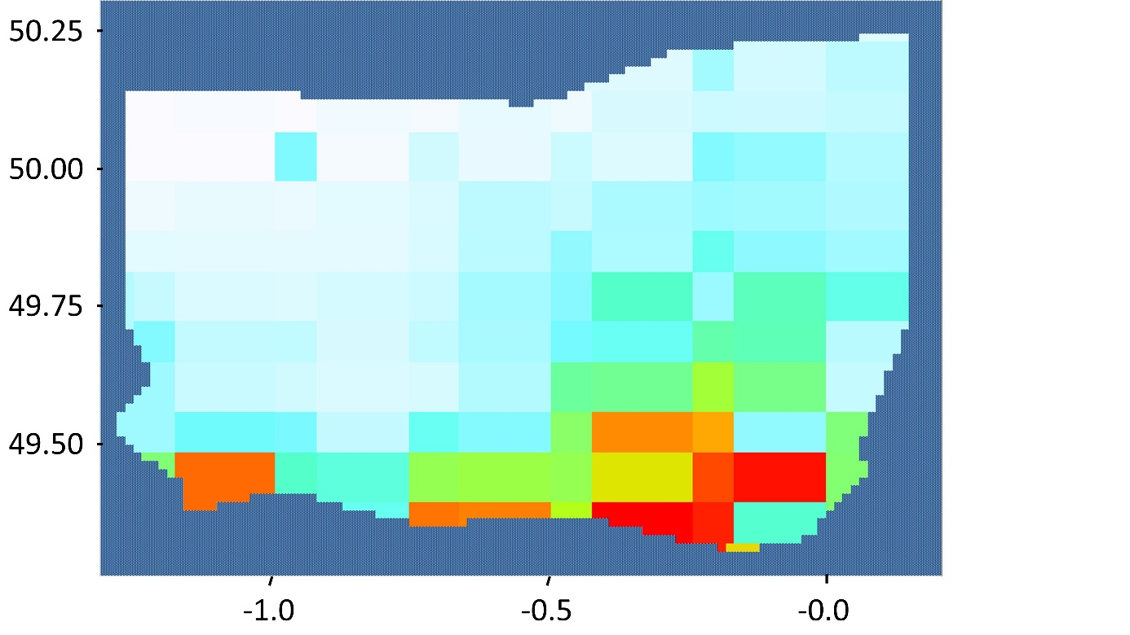
Figure S - 36 Primary production map.
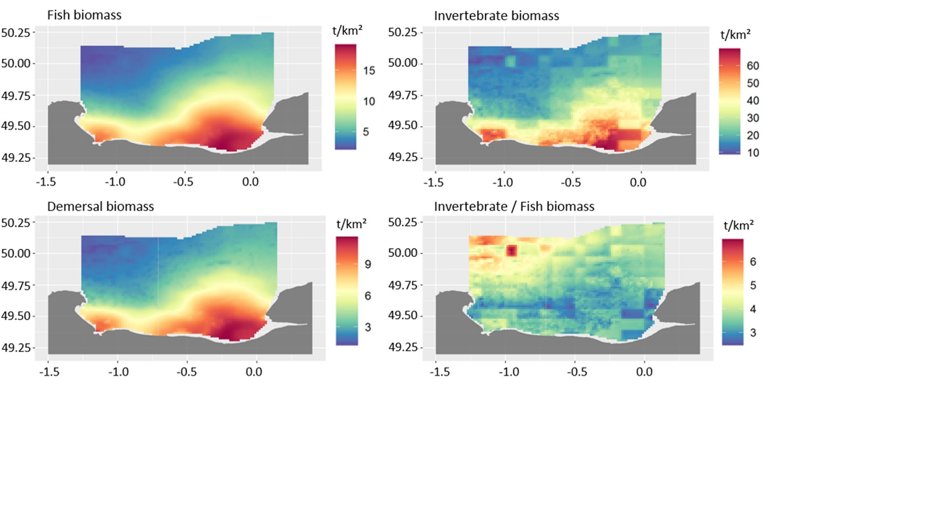
Figure S - 37 Biomass of ecological groups in the reference scenario (wet weight).

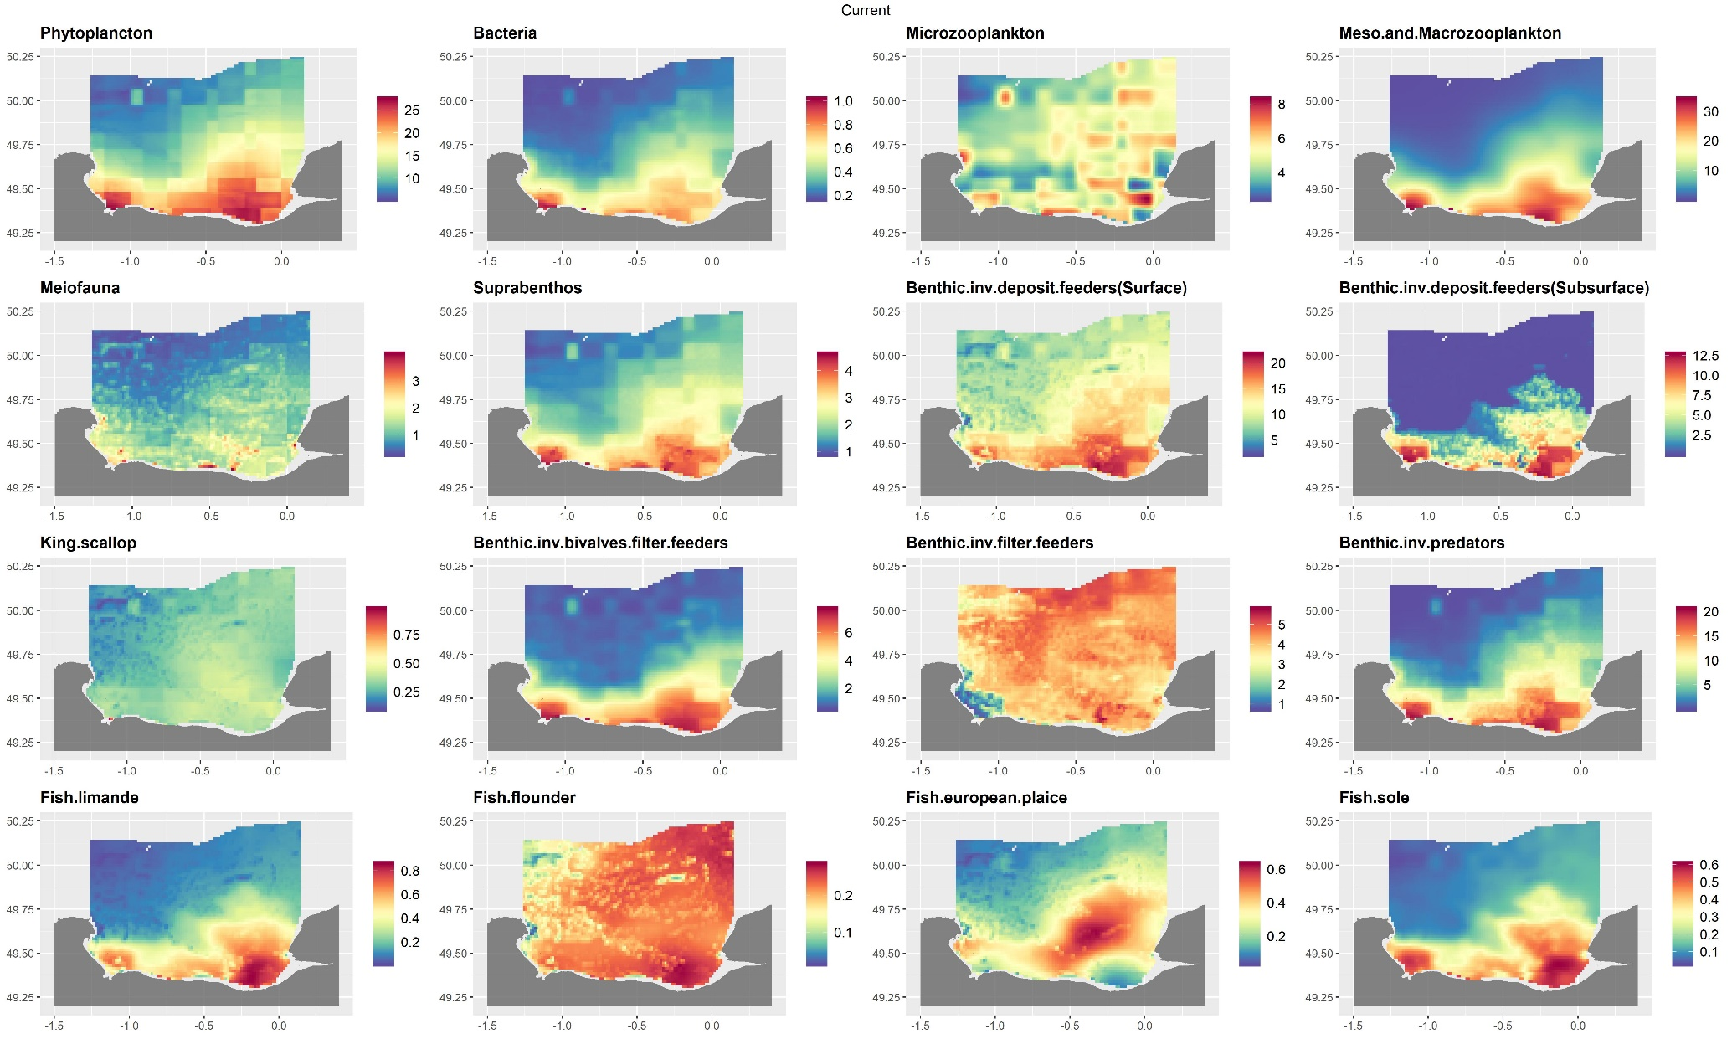
Figure S - 38 Biomass of the groups in the reference scenario (part 1)
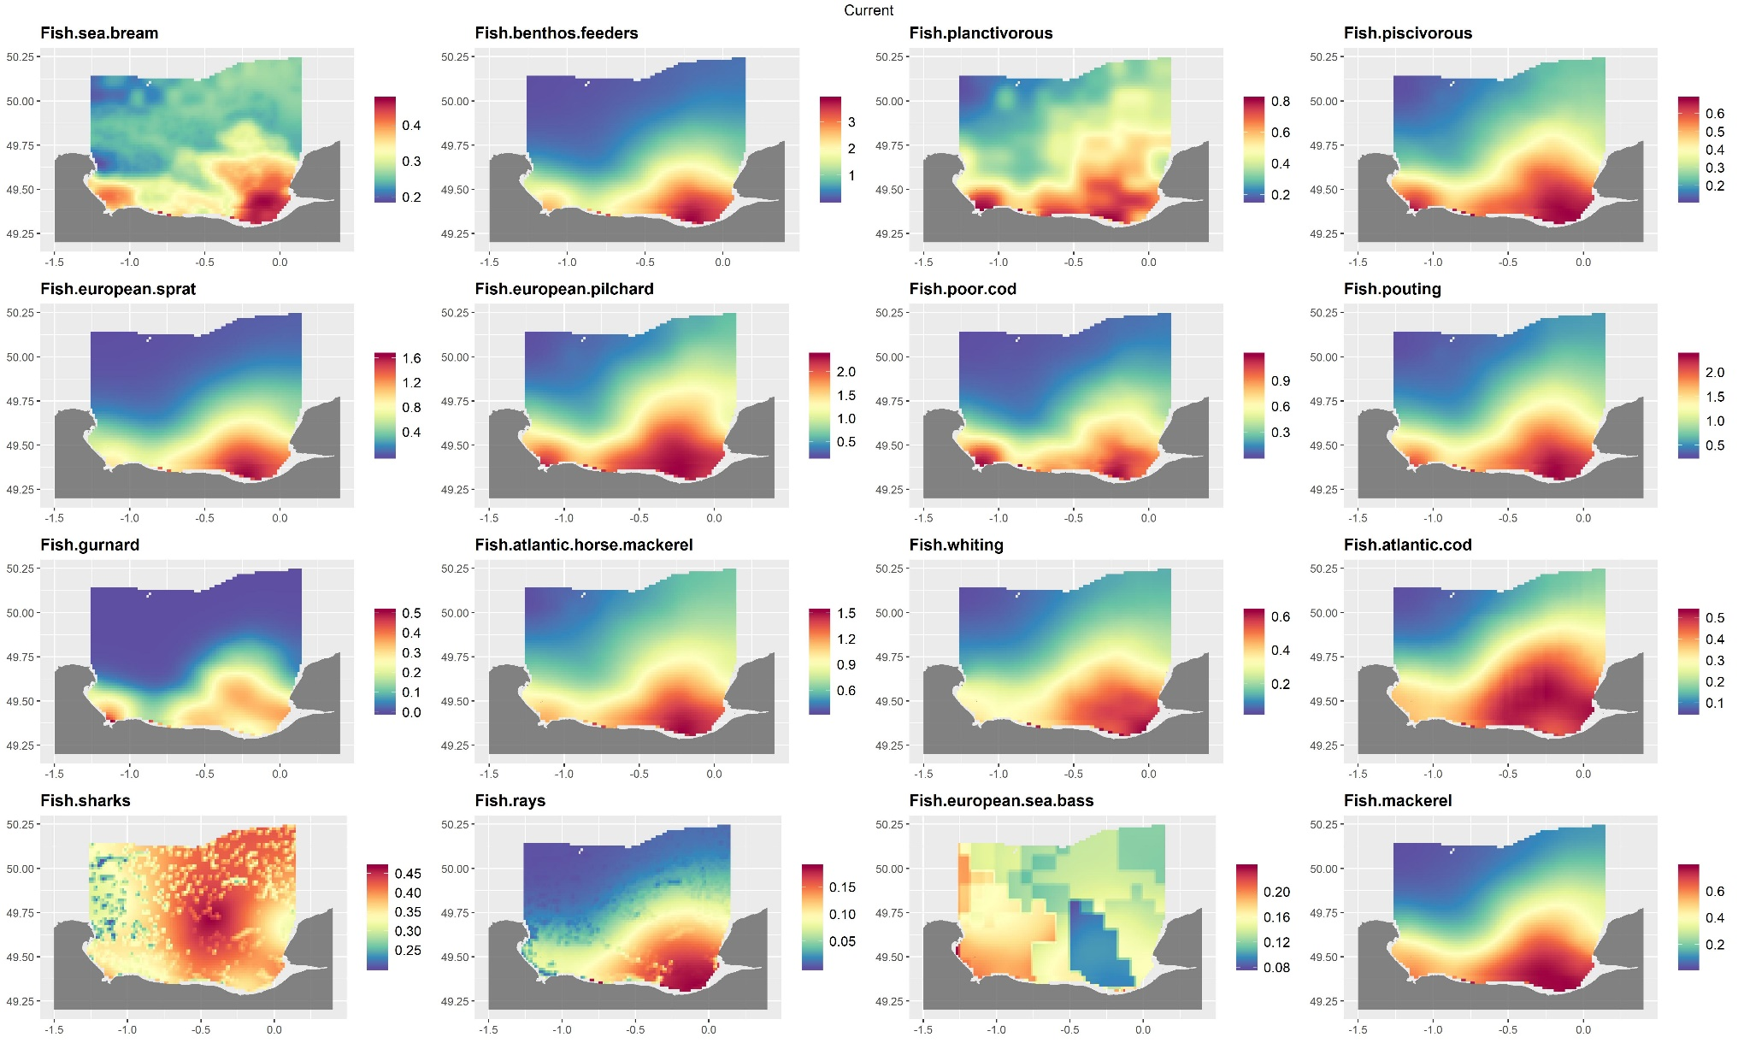
Figure S - 39 Biomass of the groups in the reference scenario (part 2)
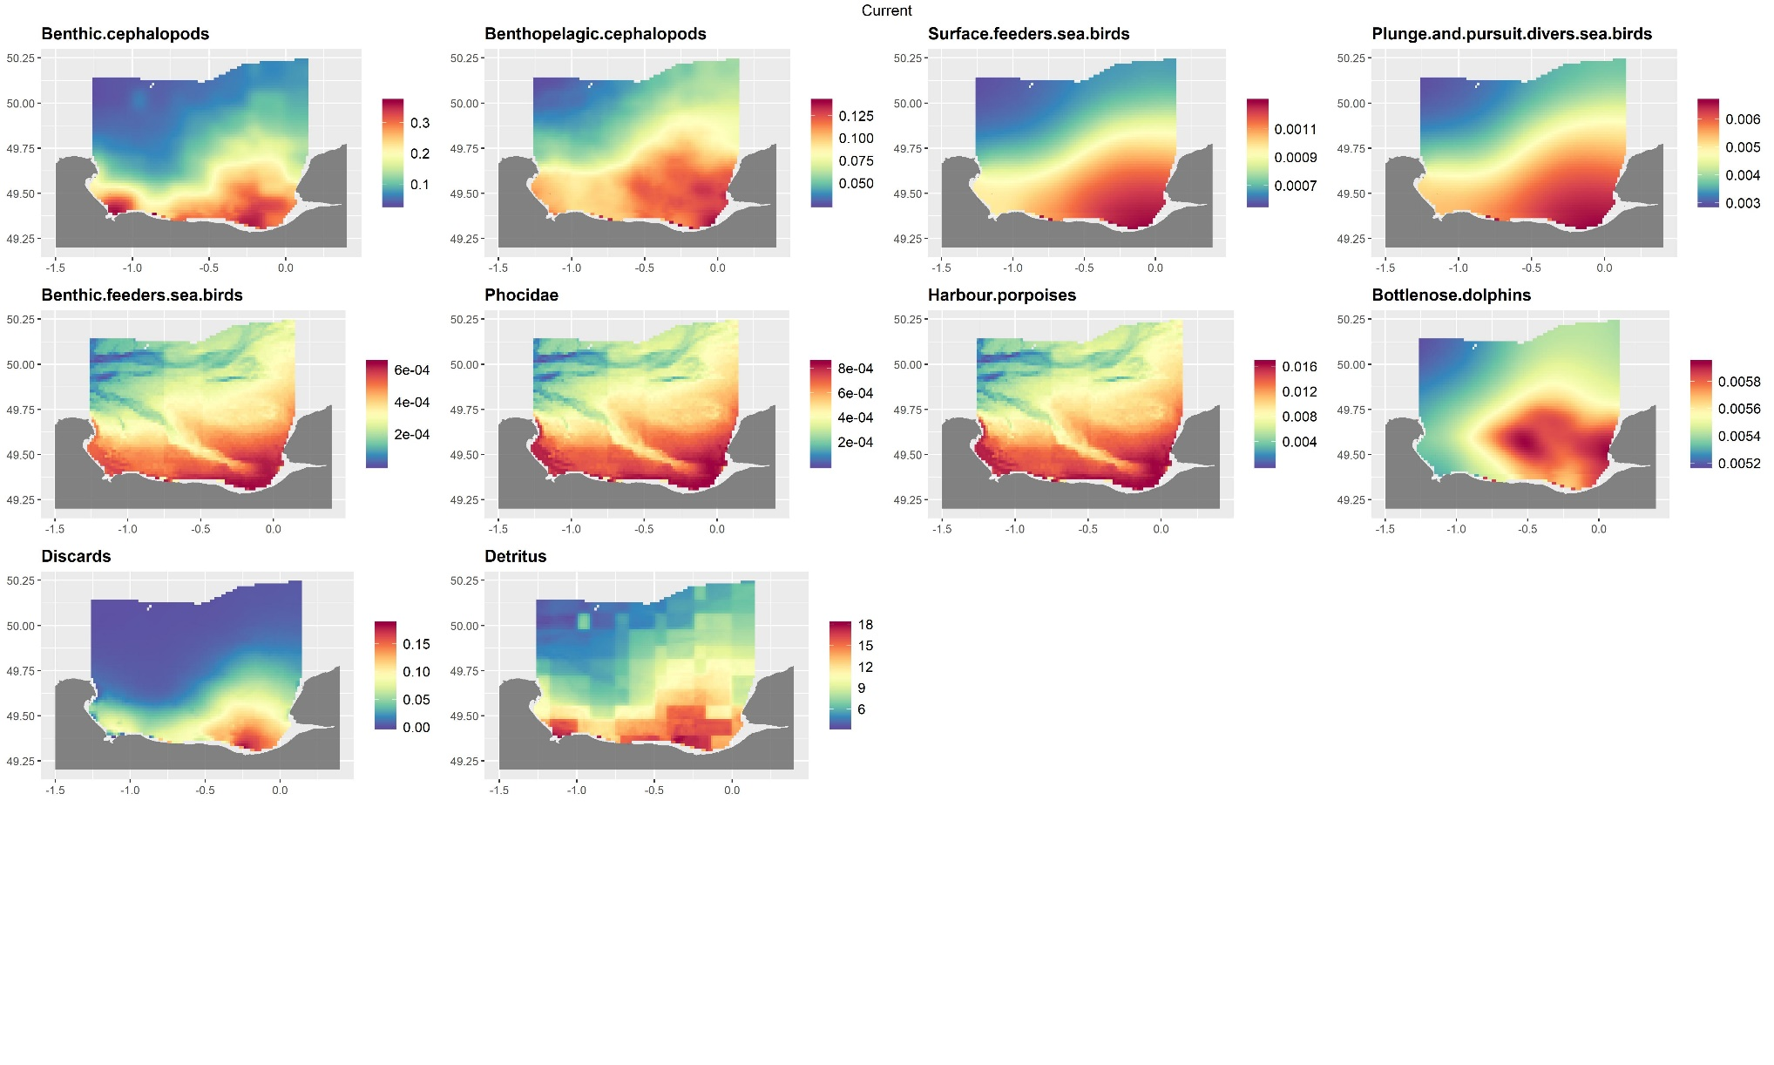
Figure S - 40 Biomass of the groups in the reference scenario (part 3)

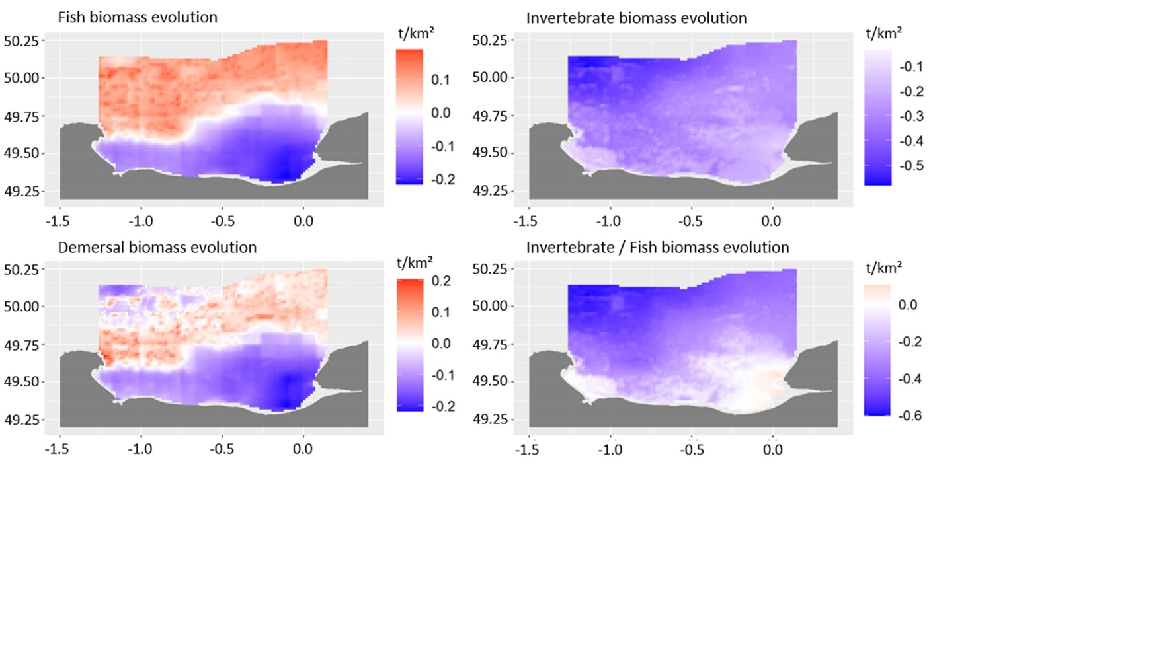
Figure S - 41 Variation of ecological group rates between the reference and the 2100 climate change scenarios (wet weight).

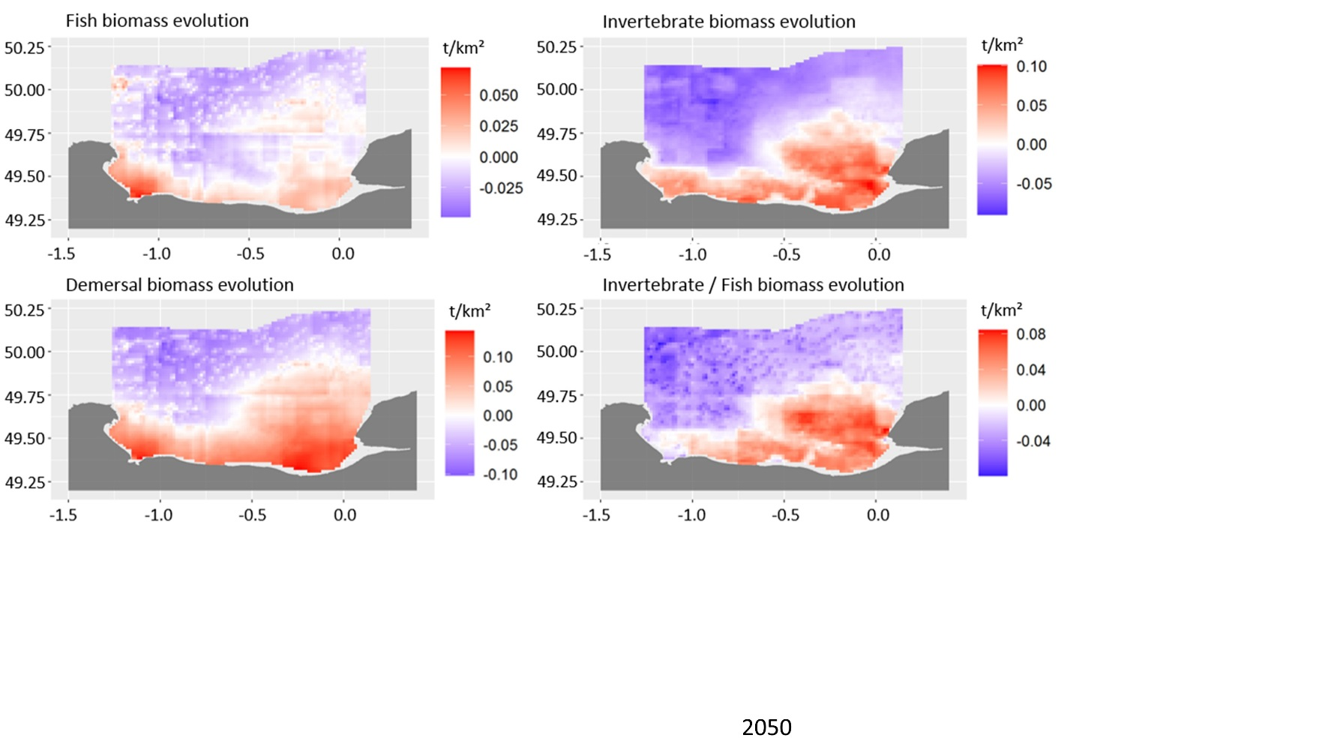
Figure S - 42 Variation of ecological groups between the reference and the 2050 climate change scenarios (wet weight).

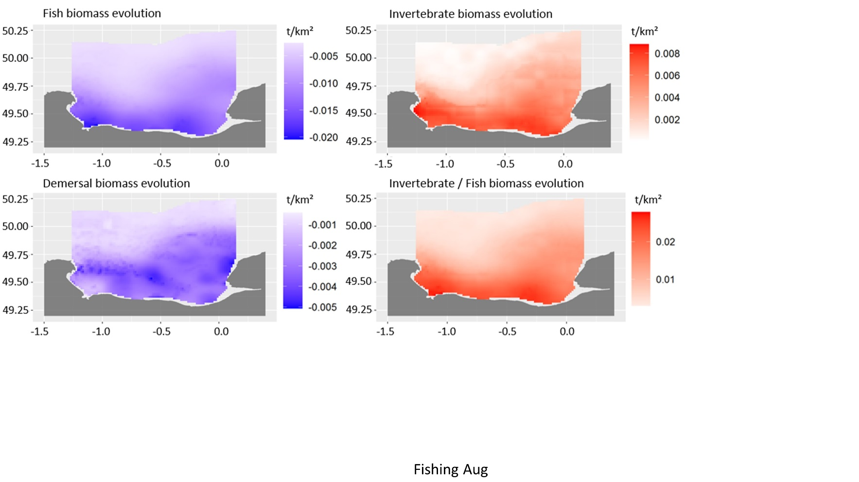
Figure S - 43 Variation of ecological groups between the reference and the Fishing_inc brexit scenarios (wet weight).

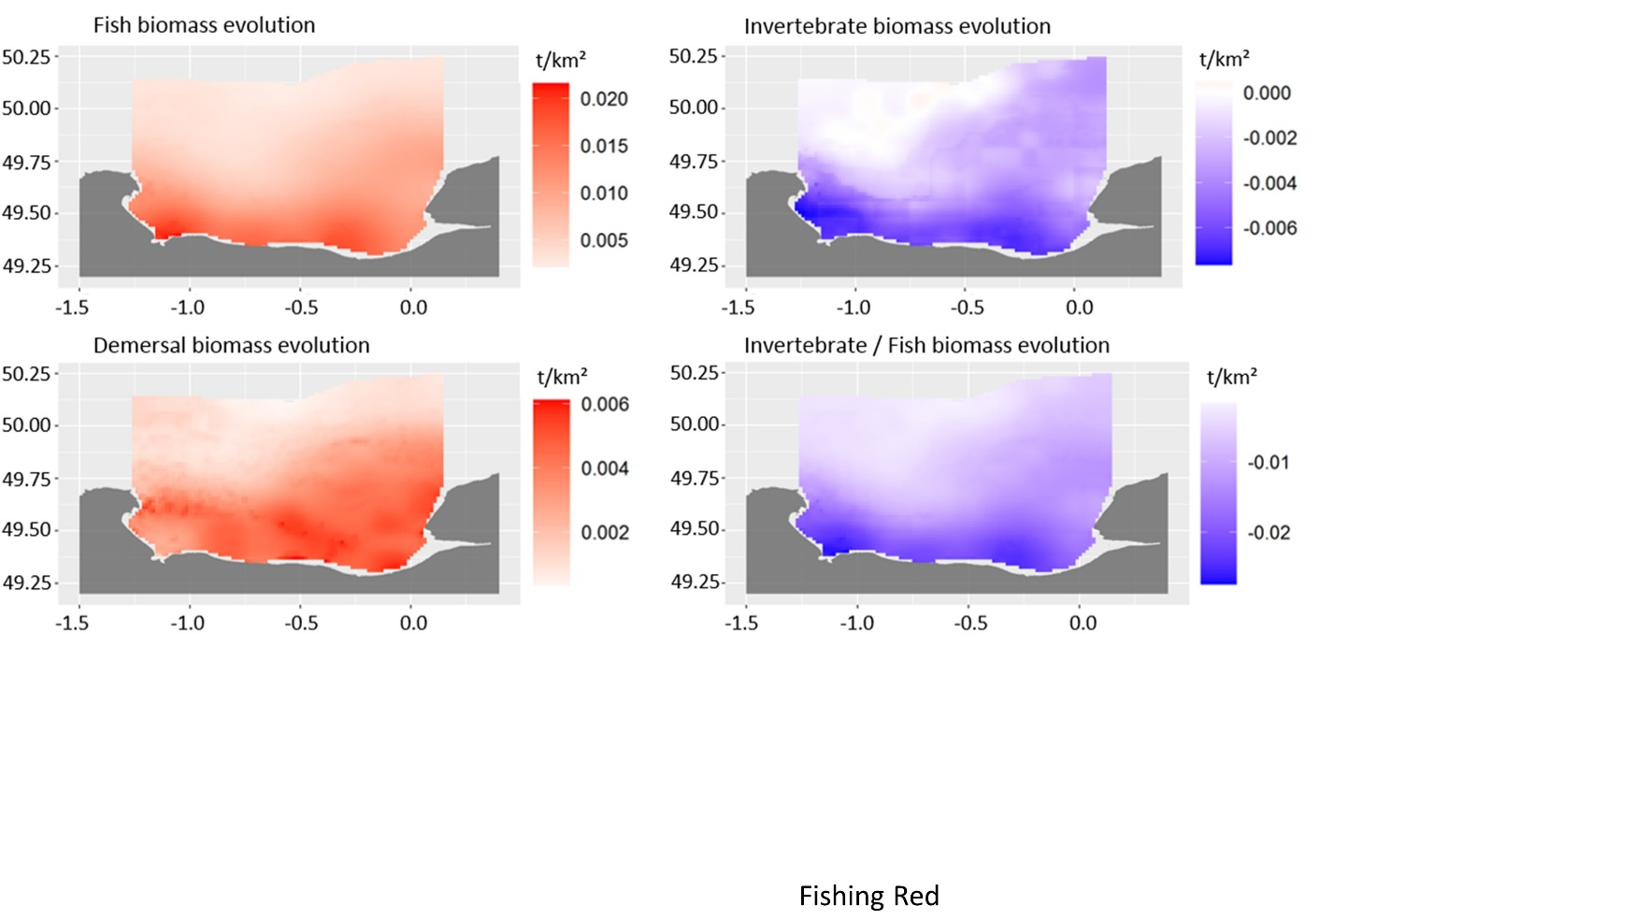
Figure S - 44 Variation of ecological groups between the reference and the Fishing_red brexit scenarios (wet weight).

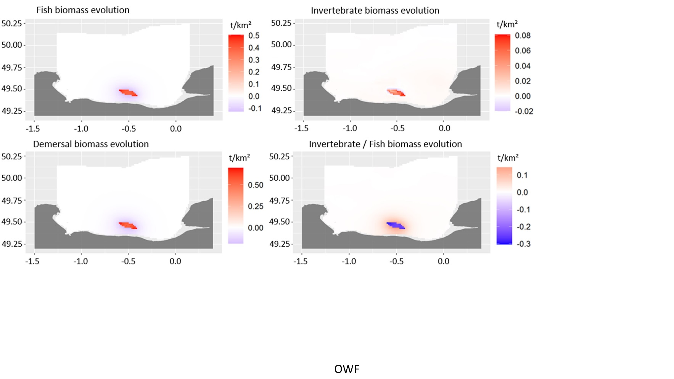
Figure S - 45 Variation of ecological groups between the reference and the OWF scenarios (wet weight).

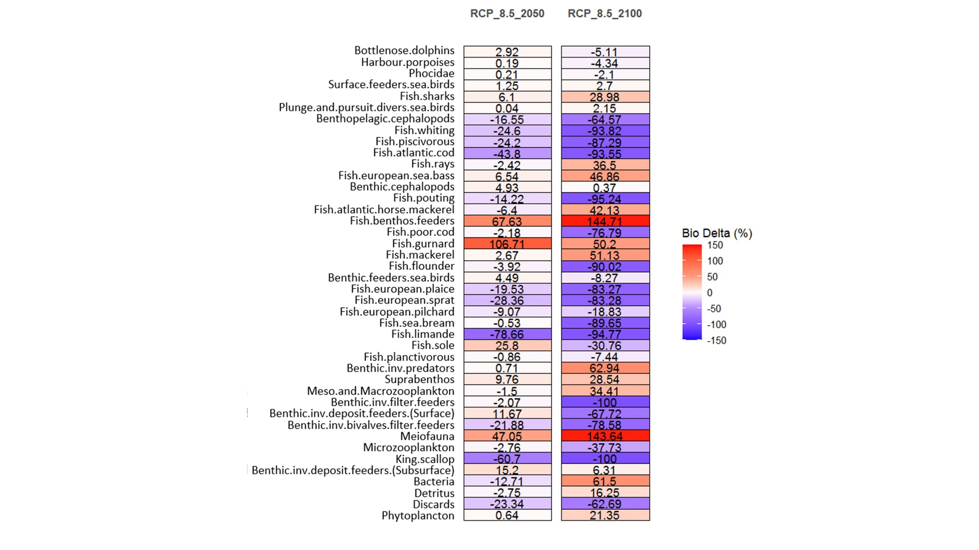
Figure S - 46 Variations in trophic group biomass (in percent) between the reference scenario and both climate change scenarios (2050 & 2100)in the coastal Bay of Seine region.
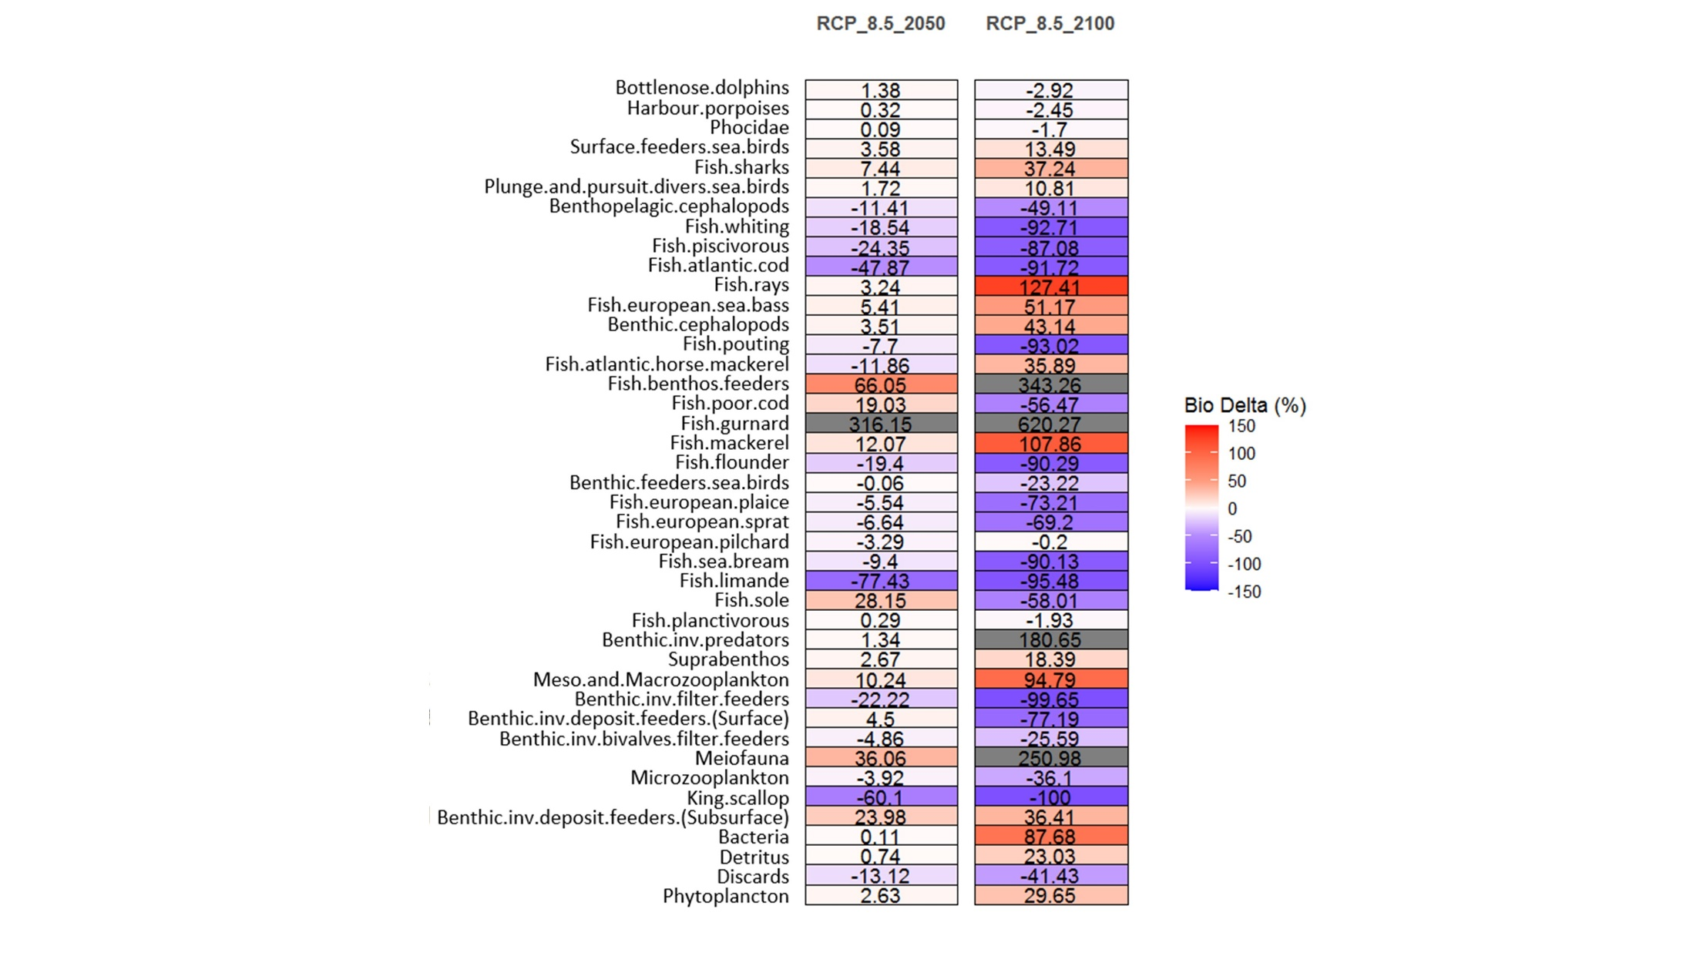
Figure S - 47 Variations in trophic group biomass (in percent) between the reference scenario and both climate change scenarios (2050 & 2100) in the offshore Bay of Seine region.

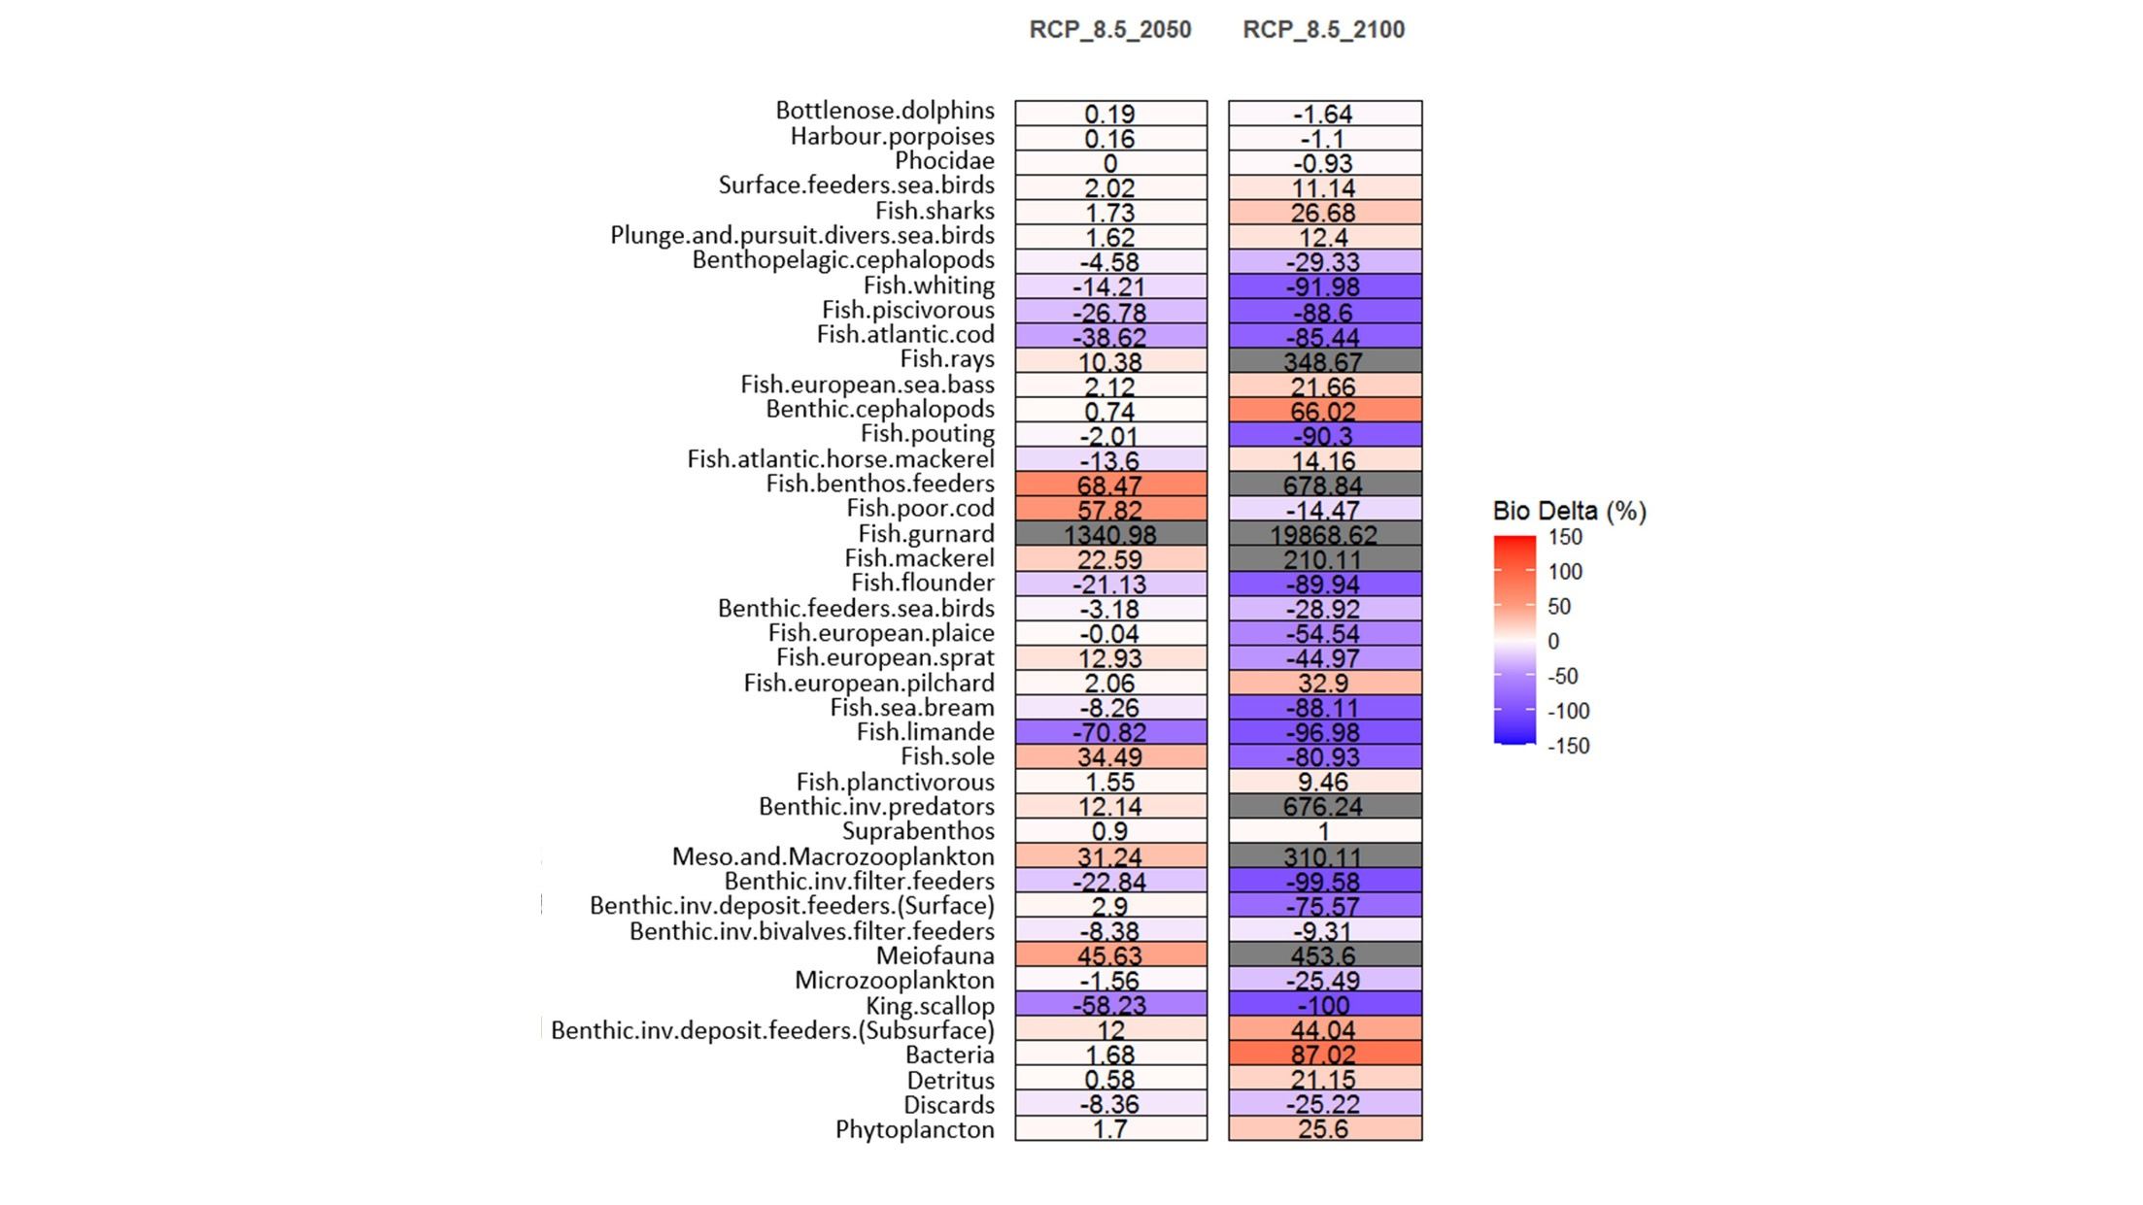
Figure S - 48 Variations in trophic group biomass (in percent) between the reference scenario and both climate change scenarios (2050 & 2100) in the central English Channel region.

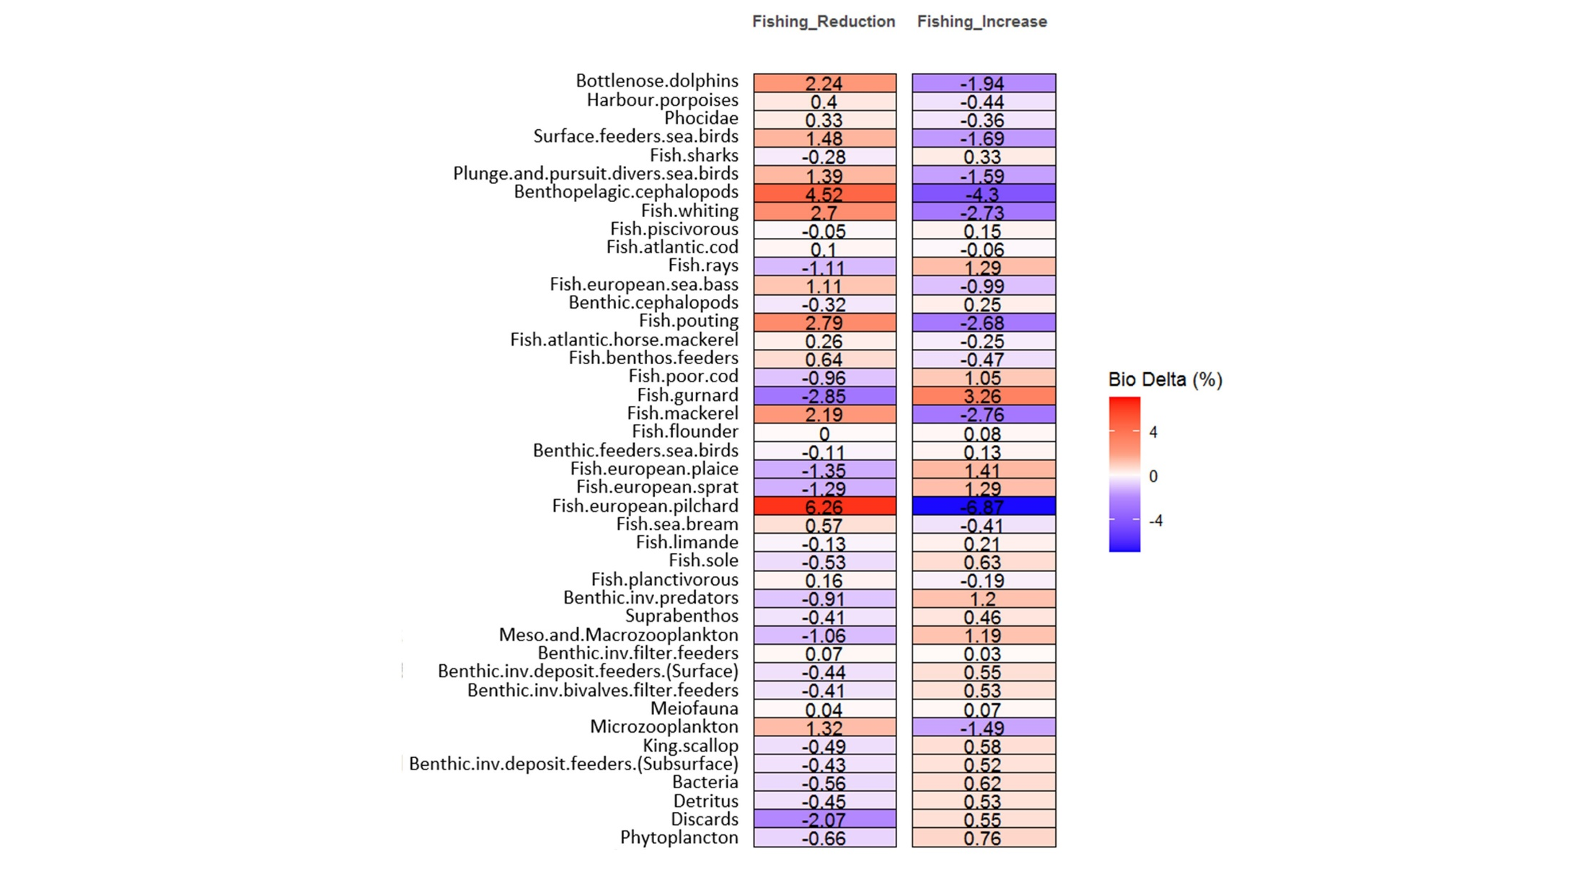
Figure S - 49 Variations in trophic group biomass (in percent) between the reference scenario and both fishing scenarios in the coastal Bay of Seine region.

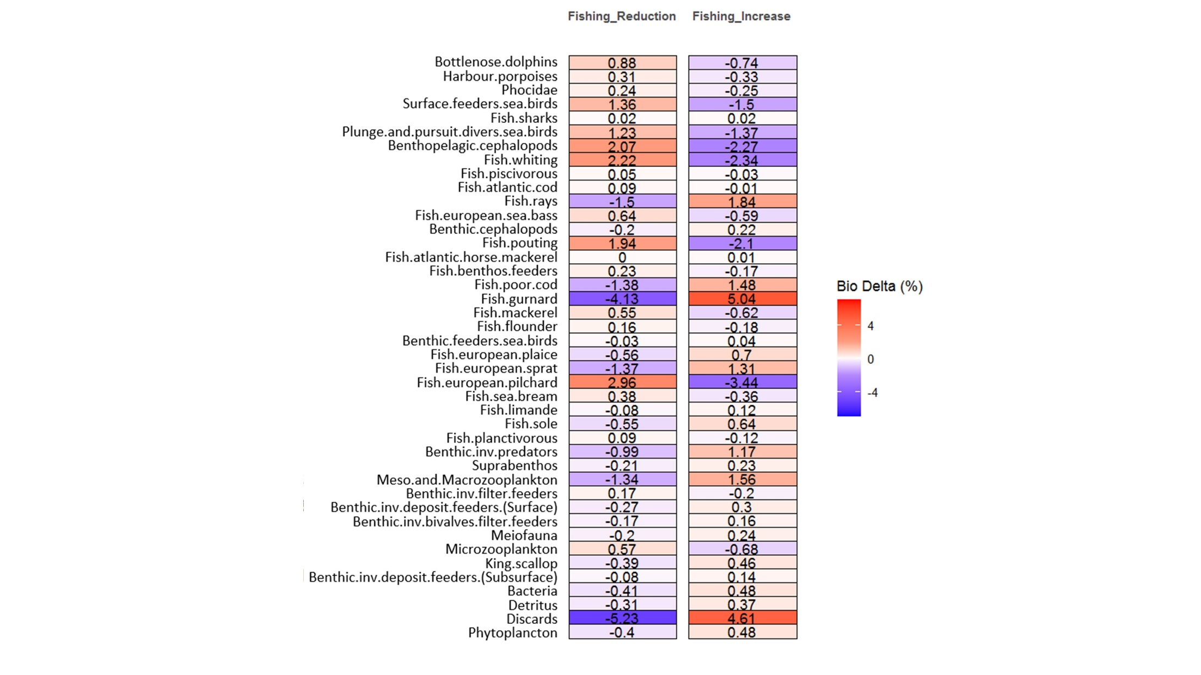
Figure S - 50 Variations in trophic group biomass (in percent) between the reference scenario and both fishing scenarios in the offshore Bay of Seine region.

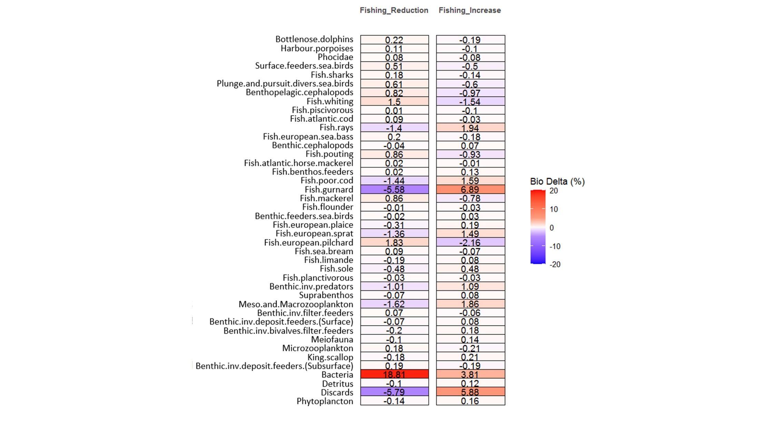
Figure S - 51 Variations in trophic group biomass (in percent) between the reference scenario and both fishing scenarios in the central English Channel region.

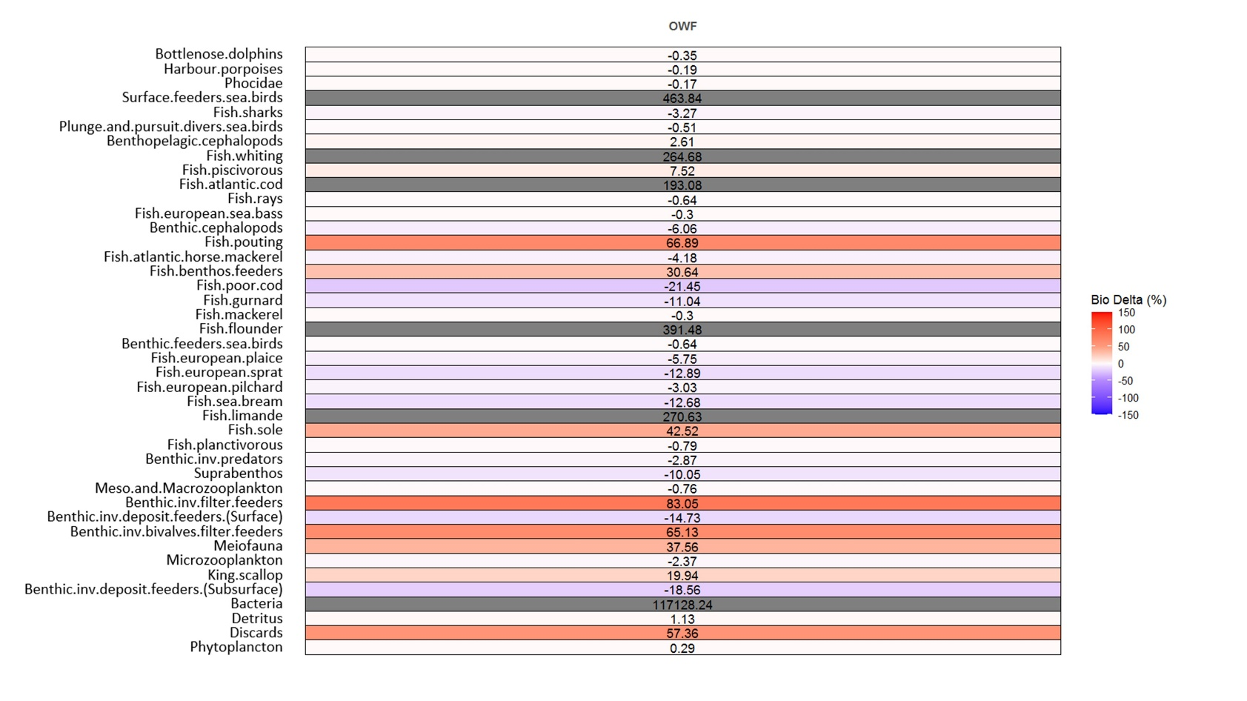
Figure S - 52 Variations in trophic group biomass (in percent) between the reference scenario and the offshore wind farm scenario inside the farm.

Table S - 10 Omnivory index of the trophic groups in the reference scenario in each functional region of the extended Bay of Seine (eBoS). The standard deviation was computed for the entire eBoS and the color gradient displays the most omnivorous groups per region in red.
Trophic groups | cBoS | oBoS | EC | SD total
Phytoplancton | 0.00 | 0.00 | 0.00 | 0.00
Bacteria | 0.00 | 0.00 | 0.00 | 0.00
Microzooplankton | 0.05 | 0.07 | 0.09 | 0.02
Meso.and.Macrozooplankton | 0.28 | 0.23 | 0.20 | 0.04
Meiofauna | 0.11 | 0.10 | 0.09 | 0.01
Suprabenthos | 0.39 | 0.37 | 0.35 | 0.02
Benthic.inv.deposit.feeders(Surface) | 0.19 | 0.18 | 0.17 | 0.01
Benthic.inv.deposit.feeders(Subsurface) | 0.00 | 0.00 | 0.00 | 0.00
King.scallop | 0.00 | 0.00 | 0.00 | 0.00
Benthic.inv.bivalves.filter.feeders | 0.13 | 0.11 | 0.10 | 0.01
Benthic.inv.filter.feeders | 0.34 | 0.31 | 0.29 | 0.02
Benthic.inv.predators | 0.21 | 0.19 | 0.17 | 0.02
Fish.limande | 0.17 | 0.12 | 0.08 | 0.05
Fish.flounder | 0.03 | 0.01 | 0.01 | 0.01
Fish.european.plaice | 0.12 | 0.11 | 0.09 | 0.02
Fish.sole | 0.12 | 0.07 | 0.05 | 0.03
Fish.sea.bream | 0.23 | 0.22 | 0.19 | 0.02
Fish.benthos.feeders | 0.25 | 0.22 | 0.19 | 0.03
Fish.planctivorous | 0.05 | 0.05 | 0.05 | 0.00
Fish.piscivorous | 0.33 | 0.32 | 0.32 | 0.00
Fish.european.sprat | 0.04 | 0.06 | 0.07 | 0.01
Fish.european.pilchard | 0.04 | 0.06 | 0.07 | 0.01
Fish.poor.cod | 0.22 | 0.18 | 0.15 | 0.04
Fish.pouting | 0.20 | 0.17 | 0.15 | 0.02
Fish.gurnard | 0.25 | 0.20 | 0.17 | 0.04
Fish.atlantic.horse.mackerel | 0.17 | 0.15 | 0.14 | 0.01
Fish.whiting | 0.34 | 0.31 | 0.28 | 0.03
Fish.atlantic.cod | 0.34 | 0.34 | 0.33 | 0.00
Fish.sharks | 0.22 | 0.27 | 0.30 | 0.04
Fish.rays | 0.12 | 0.17 | 0.20 | 0.04
Fish.european.sea.bass | 0.24 | 0.26 | 0.27 | 0.02
Fish.mackerel | 0.10 | 0.14 | 0.16 | 0.03
Benthic.cephalopods | 0.32 | 0.33 | 0.32 | 0.00
Benthopelagic.cephalopods | 0.36 | 0.36 | 0.35 | 0.00
Surface.feeders.sea.birds | 0.57 | 0.31 | 0.18 | 0.20
Plunge.and.pursuit.divers.sea.birds | 0.49 | 0.25 | 0.14 | 0.18
Benthic.feeders.sea.birds | 0.11 | 0.07 | 0.04 | 0.03
Phocidae | 0.11 | 0.10 | 0.09 | 0.01
Harbour.porpoises | 0.09 | 0.09 | 0.09 | 0.00
Bottlenose.dolphins | 0.05 | 0.05 | 0.04 | 0.01

Table S - 11 Omnivory index of the trophic groups in the climate change 2100 scenario in each functional region of the extended Bay of Seine (eBoS). The standard deviation was computed for the entire eBoS and the color gradient displays the most omnivorous groups per region in red.
Trophic groups | cBoS | oBoS | EC | SD total
Phytoplancton | 0.00 | 0.00 | 0.00 | 0.00
Bacteria | 0.00 | 0.00 | 0.00 | 0.00
Microzooplankton | 0.02 | 0.04 | 0.05 | 0.01
Meso.and.Macrozooplankton | 0.30 | 0.28 | 0.25 | 0.03
Meiofauna | 0.12 | 0.12 | 0.12 | 0.00
Suprabenthos | 0.35 | 0.38 | 0.38 | 0.02
Benthic.inv.deposit.feeders(Surface) | 0.22 | 0.26 | 0.28 | 0.03
Benthic.inv.deposit.feeders(Subsurface) | 0.00 | 0.00 | 0.00 | 0.00
King.scallop | 0.00 | 0.00 | 0.00 | 0.00
Benthic.inv.bivalves.filter.feeders | 0.11 | 0.12 | 0.11 | 0.00
Benthic.inv.filter.feeders | 0.05 | 0.22 | 0.29 | 0.12
Benthic.inv.predators | 0.16 | 0.11 | 0.09 | 0.04
Fish.limande | 0.41 | 0.38 | 0.34 | 0.03
Fish.flounder | 0.03 | 0.02 | 0.01 | 0.01
Fish.european.plaice | 0.23 | 0.22 | 0.20 | 0.01
Fish.sole | 0.19 | 0.18 | 0.16 | 0.02
Fish.sea.bream | 0.24 | 0.38 | 0.33 | 0.07
Fish.benthos.feeders | 0.32 | 0.30 | 0.28 | 0.02
Fish.planctivorous | 0.02 | 0.04 | 0.06 | 0.02
Fish.piscivorous | 0.20 | 0.18 | 0.18 | 0.01
Fish.european.sprat | 0.01 | 0.03 | 0.06 | 0.03
Fish.european.pilchard | 0.01 | 0.03 | 0.06 | 0.03
Fish.poor.cod | 0.20 | 0.16 | 0.17 | 0.02
Fish.pouting | 0.15 | 0.13 | 0.13 | 0.01
Fish.gurnard | 0.33 | 0.28 | 0.24 | 0.05
Fish.atlantic.horse.mackerel | 0.12 | 0.13 | 0.13 | 0.01
Fish.whiting | 0.31 | 0.24 | 0.19 | 0.06
Fish.atlantic.cod | 0.20 | 0.16 | 0.14 | 0.03
Fish.sharks | 0.14 | 0.14 | 0.14 | 0.00
Fish.rays | 0.06 | 0.05 | 0.05 | 0.01
Fish.european.sea.bass | 0.17 | 0.21 | 0.24 | 0.04
Fish.mackerel | 0.10 | 0.12 | 0.13 | 0.01
Benthic.cephalopods | 0.22 | 0.25 | 0.28 | 0.03
Benthopelagic.cephalopods | 0.30 | 0.42 | 0.46 | 0.08
Surface.feeders.sea.birds | 0.41 | 0.25 | 0.18 | 0.12
Plunge.and.pursuit.divers.sea.birds | 0.26 | 0.14 | 0.10 | 0.08
Benthic.feeders.sea.birds | 0.12 | 0.11 | 0.10 | 0.01
Phocidae | 0.07 | 0.08 | 0.08 | 0.01
Harbour.porpoises | 0.14 | 0.13 | 0.12 | 0.01
Bottlenose.dolphins | 0.09 | 0.07 | 0.05 | 0.02

