

*[Journal of Geophysical Research: Solid Earth]*

**Supporting Information for**

**Evolution of the Crustal and upper Mantle seismic structure from 0 – 27 Ma in the equatorial Atlantic ocean at 2º 43´S**

**V. A. Vaddineni1, S. C. Singh1, I. Grevemeyer2, P. Audhkhasi1 and C. Papenberg2**

1Université de Paris, Institut de Physique du Globe de Paris, CNRS, Paris, France

2GEOMAR Helmholtz Centre of Ocean Research Kiel, RD4—Marine Geodynamics, Kiel, Germany

**Corresponding Author:** [**vaddineni@ipgp.fr**](mailto:vaddineni@ipgp.fr)

**Contents of this file:**

Figures S1 to S5

**Introduction:**

This file contains initial and final residual statistics, uncertainty analysis for the tomographic velocity model with depth kernel weighting tests, starting models in the Monte-Carlo analysis and checkerboard tests to estimate the resolvability of the inversion. An updated reference plate cooling model is shown to support the temperature estimation beneath the ridge-axis. Calculation of porosity and melt fraction using differential effective medium theory is presented.

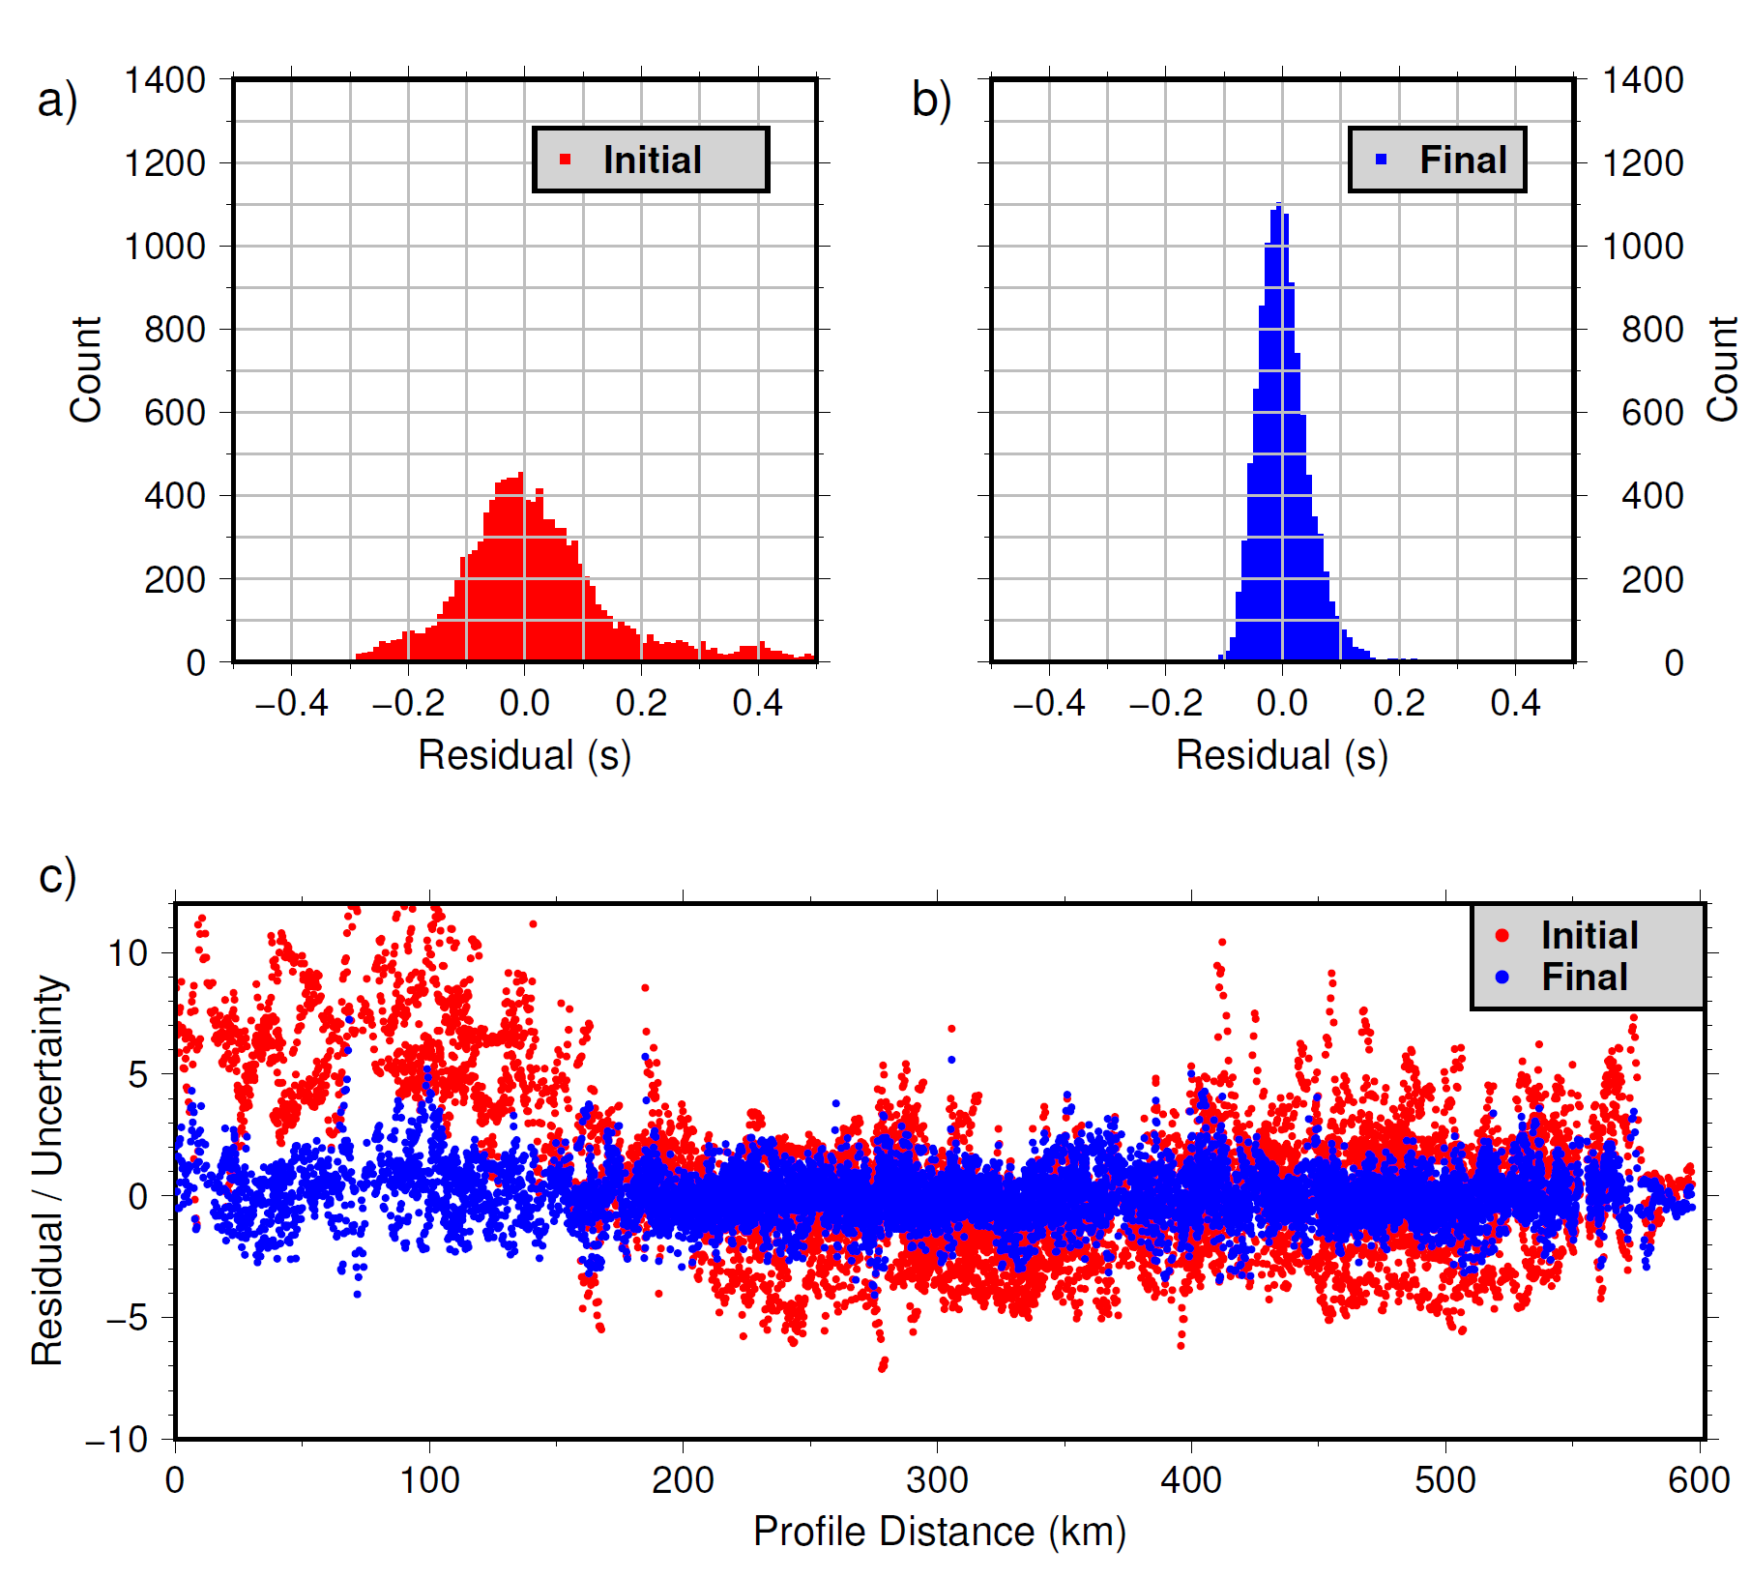

**Figure S1**: (a) Histogram of the initial residual values for all Pg, PmP and Pn traveltime picks. (b) Histogram of the final residual values for all traveltime picks. (c) Normalized residuals versus source-receiver offset in the starting model (red) and the final inverted model (blue).

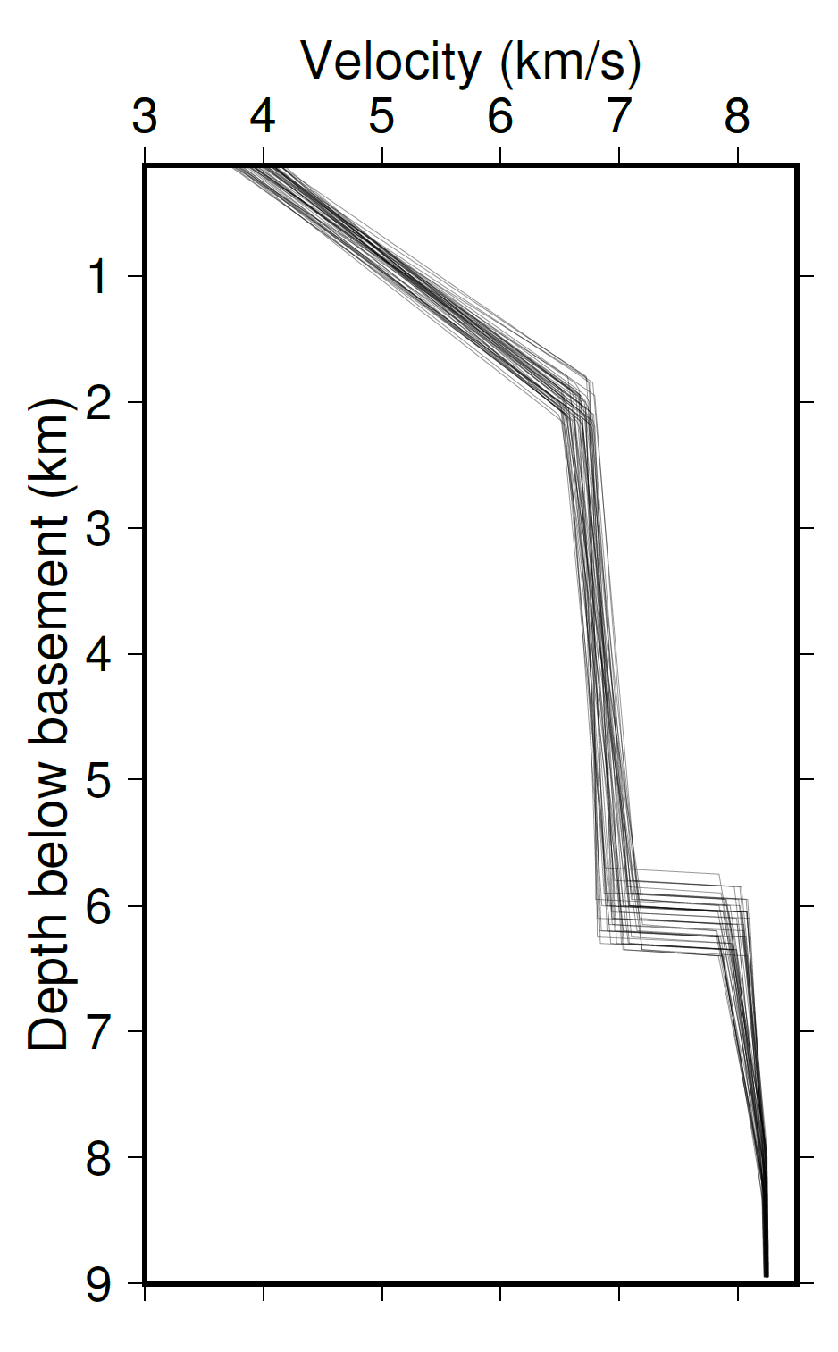

**Figure S2: Monte-Carlo uncertainty analysis:** 1D velocity profiles of the 50 different starting models used to estimate the dependence of the inversion on the starting model. The final velocity model is shown in Figure 3a and the variance in Figure 3c.

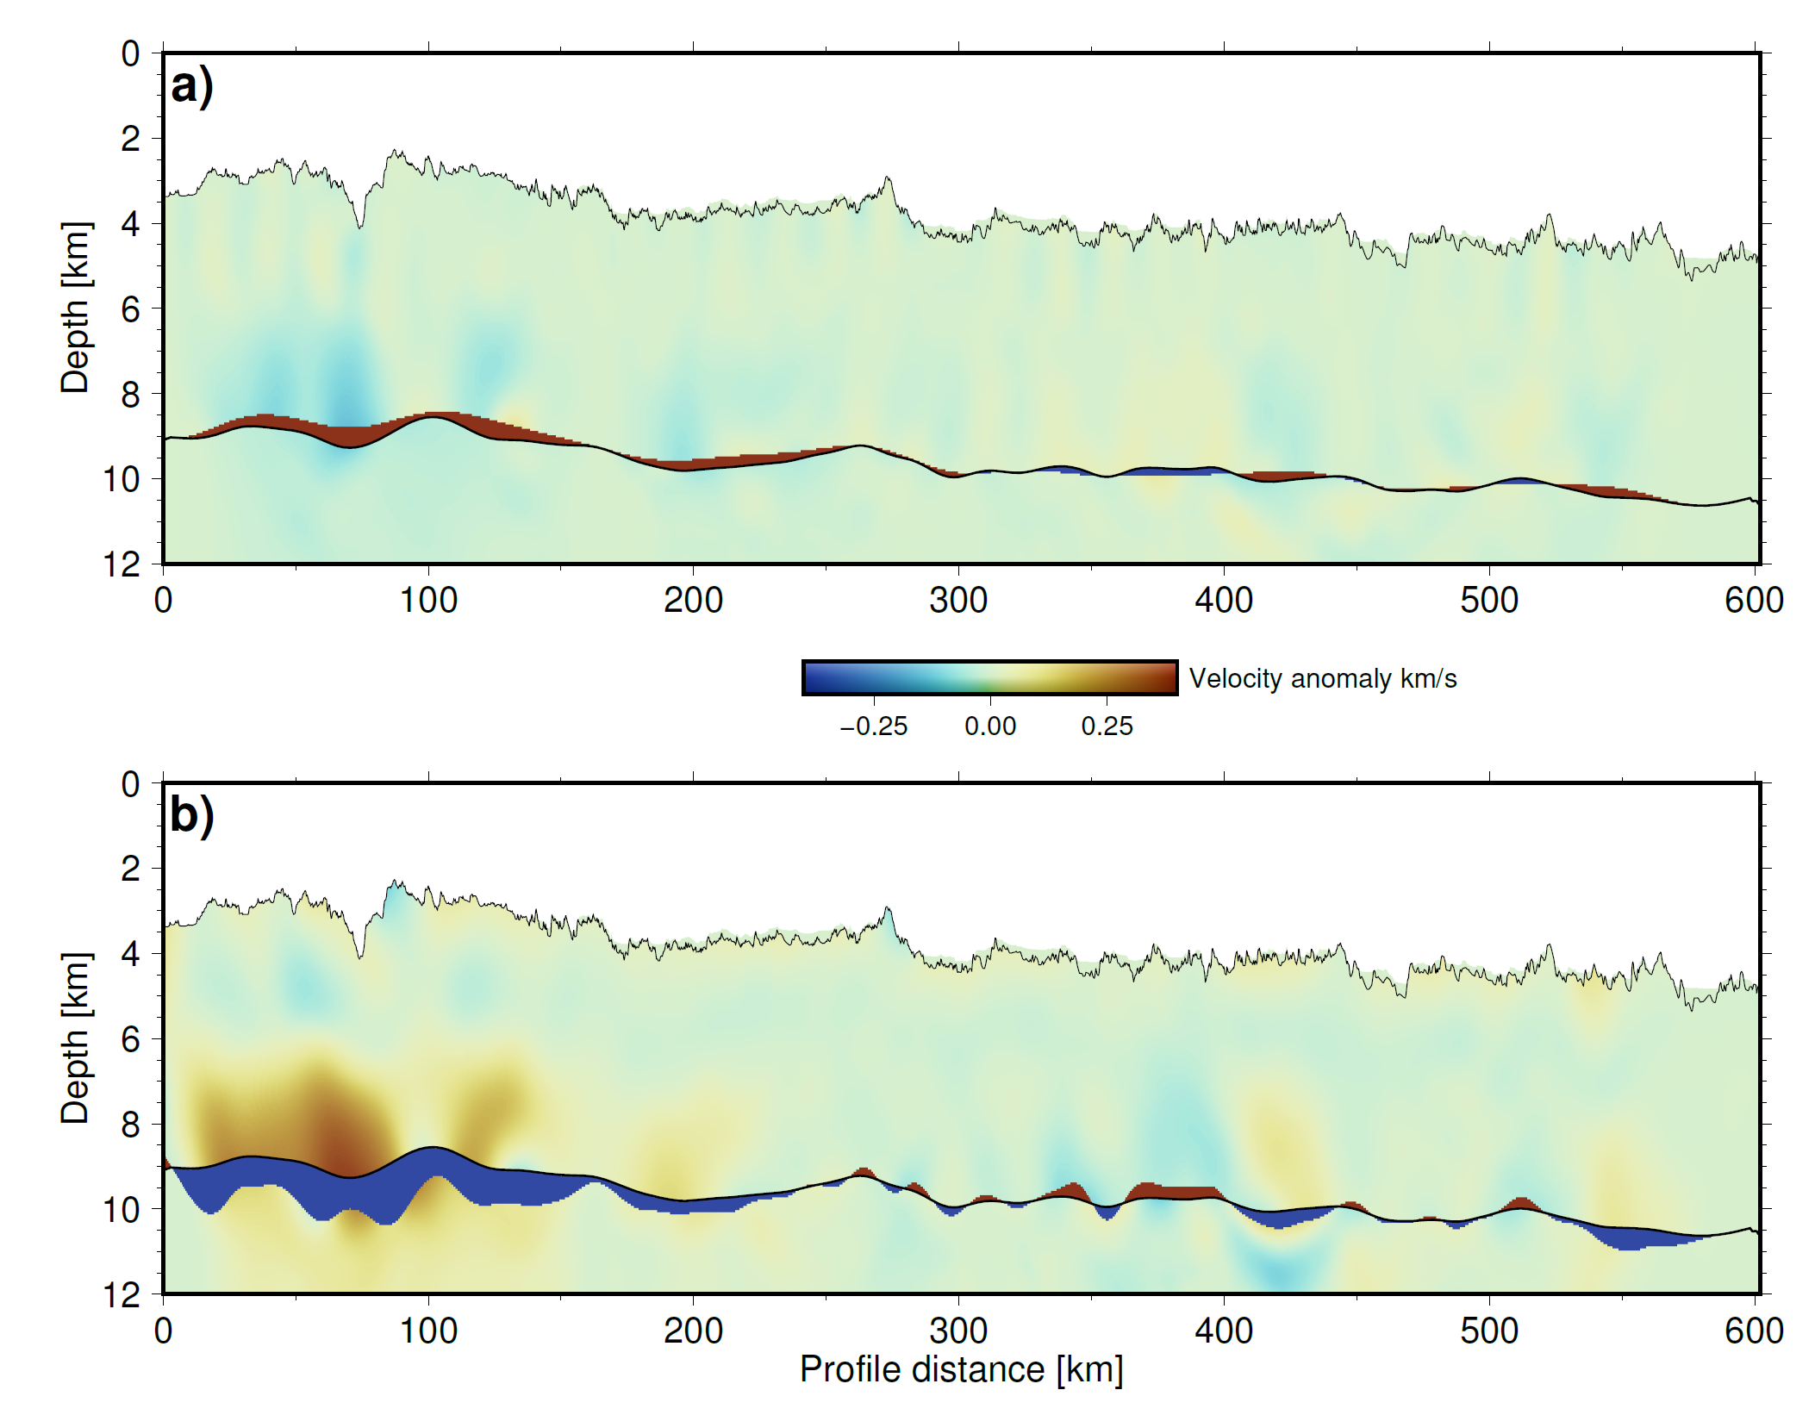

**Figure S3: Depth kernel weighting tests:** Velocity anomaly between the standard model and (a) the velocity model obtained by giving more weight to velocity i.e., most of the residual is mapped on to velocity parameters, and (b) the velocity model obtained by giving more weight to Moho depth structure. In both the models, the maximum anomaly is less than 0.3 km/s near the ridge-axis and less than 0.1 km/s elsewhere in the model. The high anomaly near the ridge-axis is partly due to less ray coverage and partly due to the fact that the starting model is too far from the true model during inversion.

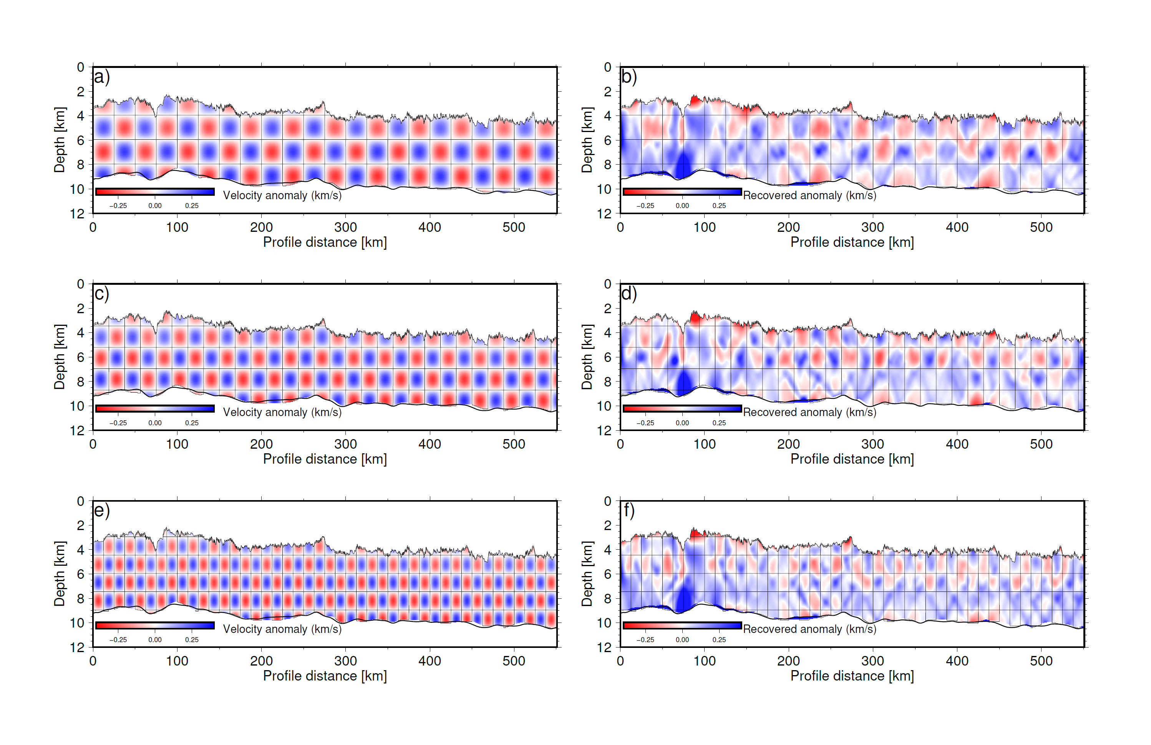

**Figure S4: Checkerboard tests:** (a) Sinusoidal anomaly pattern with a size of 25 km x 2 km is added to the standard model. (b) Recovered pattern after performing the inversion using the same regularization constraints as in the standard model. (c) & (d) True and recovered anomaly pattern size of 19 km x 1.8 km. (e) & (f)True and recovered anomaly pattern size of 12.5 km x 1.5 km.

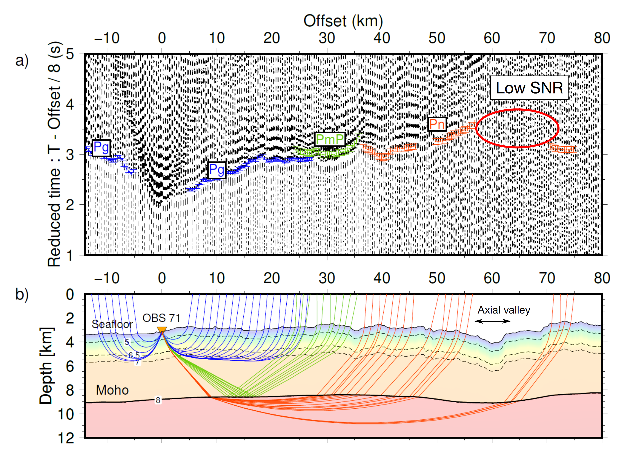

**Figure S5:** (a) Seismic data recorded by OBS 71. (b) Ray diagram for OBS 71 showing the shadow zone generated by the low-velocity zone (60 -70 km offset range).

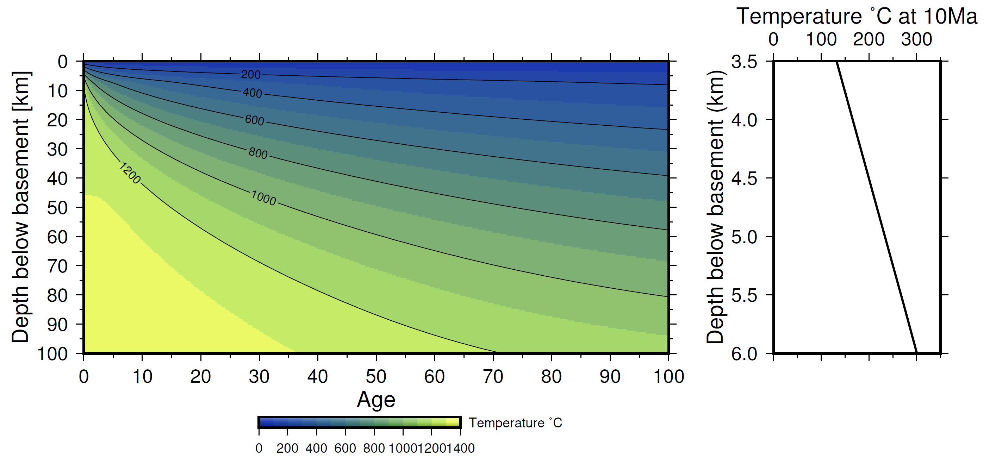**Figure S6:** Updated plate cooling model from Richards et al., 2018. A 1-D temperature profile is extracted at 10 Ma between 3.5 – 6 km depth and is used as a reference profile to estimate the temperature beneath the ridge axis shown in Figure 8c.

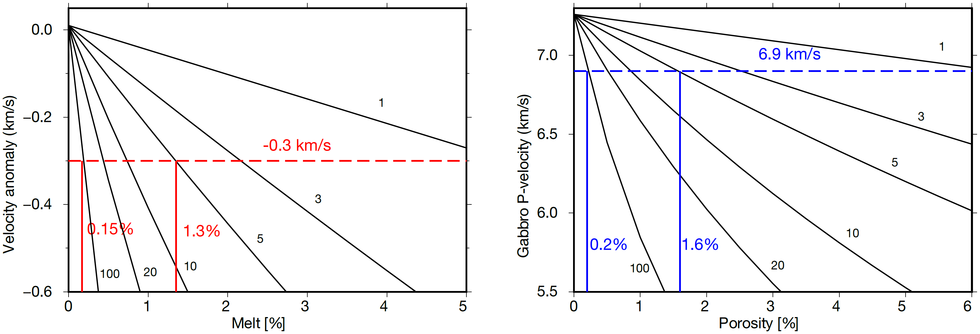

**Figure S7.** Variation of seismic P-velocity of gabbro with melt and increased sea water saturated porosity calculated by using the differential effective medium (DEM) theory (Taylor and Singh, 2002) (black curves). The various curves depict the variation using different aspect ratios for cracks/pore spaces. Left: Estimation of the melt fraction. The dashed red line indicates the negative velocity anomaly of -0.3 km/s observed beneath the ridge axis. The solid red lines indicate 0.15% and 1.3% melt melt-fraction for the aspect ratio of 100 and 5, respectively. Right: Estimation of porosity where pores are filled with a sea water where the P-wave velocity is 1.5 km/s. Blue dashed line indicates the lower crustal velocity decrease to ~6.9 km/s in the LVZs. Vertical dashed blue lines indicate 0.2% and 1.6% of porosity for aspect ratios of between 100 and 5.

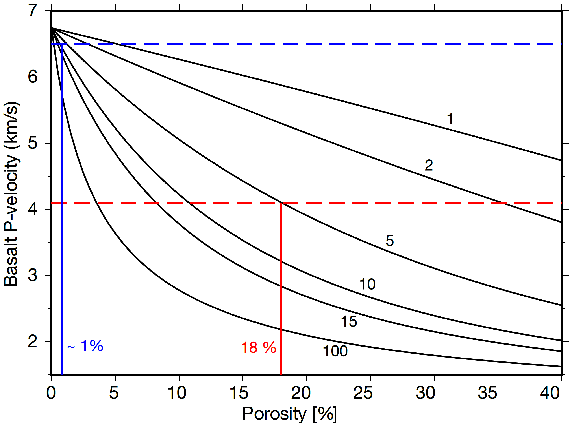**]Figure S8.** Variation of seismic P-velocity of basalt with increased sea water saturated porosity. The P-velocity of basalt at zero porosity is taken to be 6.74 km/s, S-velocity as 3.89 km/s and density as 2.93 kg/m3 (Carlson, 2014). The blue and red dashed horizontal lines indicate the upper crustal velocity of 6.5 km/s (at older ages) and 4.1 km/s (below the ridge axis). The vertical solid blue and red lines mark the porosities of 1% (at older ages) and 18% (at ridge axis) for the crack aspect ratio of 5.