Geophysical Research letters
Supporting Information for
Observed Regional Fluxes to Constrain Modeled Estimates of the Ocean Carbon Sink
A. R. Fay¹, G. A. McKinley¹
1 Columbia University and Lamont Doherty Earth Observatory, Palisades NY, USA

Contents of this file

Text S1
Figures S1 to S3
Tables S1 to S7

Text S1.
Globally and in the equatorial and subtropical regions, the ensemble of the observation-based products and the ensemble of models are in good agreement with regard to the phasing of interannual variability, both prior to and after selection (Figure S3). The high latitudes show limited agreement in either case. Selection does not significantly change interannual correlations (Supplementary Table 7).

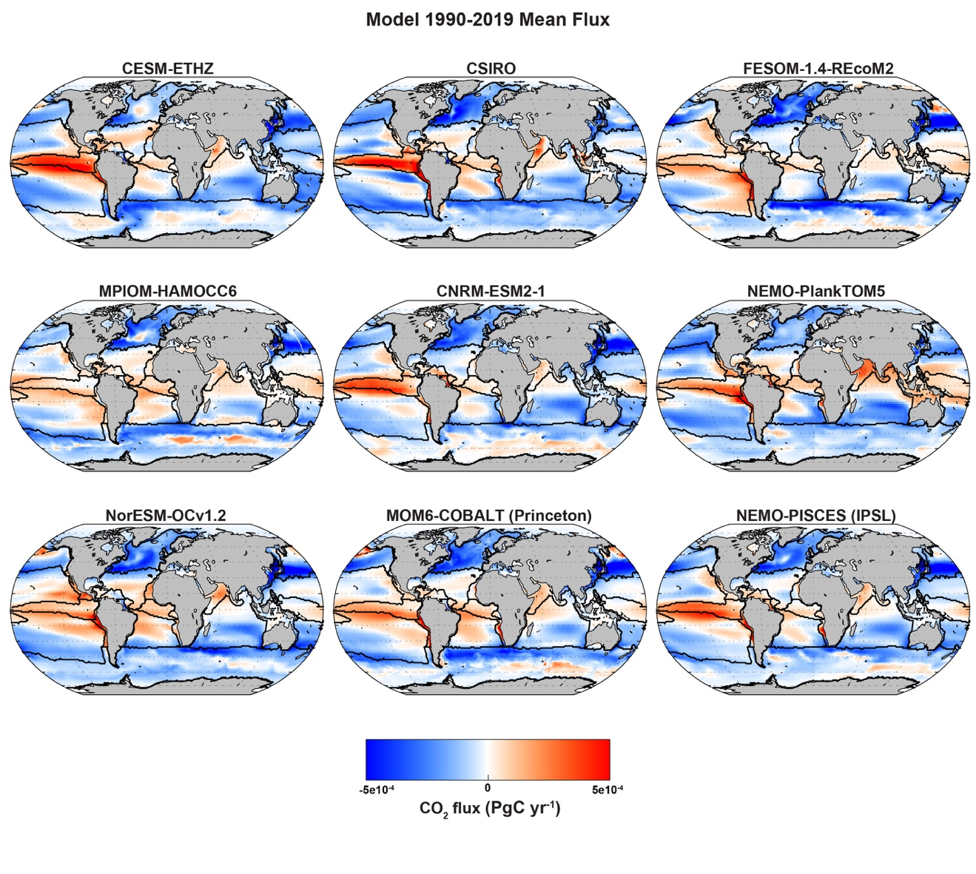

Figure S1. Maps showing mean 1990-2018 air-sea CO₂ flux (PgC/yr) for each model. Black lines show boundaries for regional analysis (as in Figure 1).

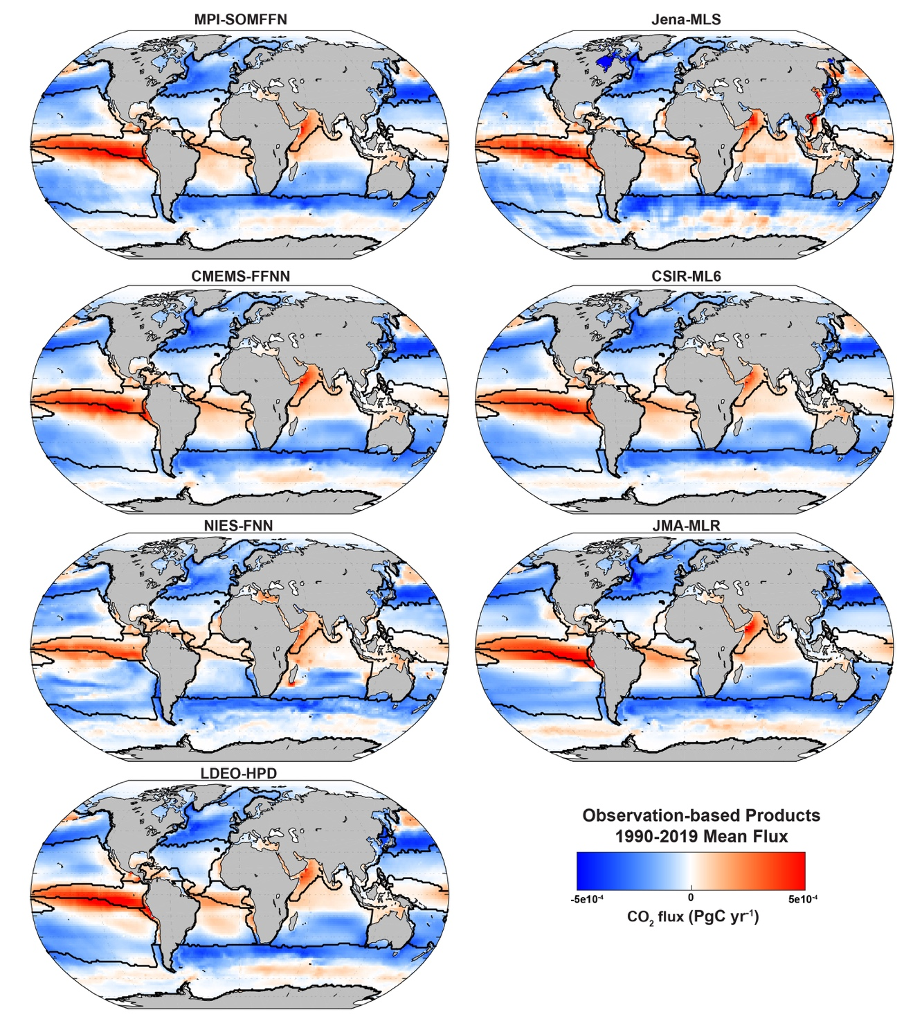

Figure S2. Maps showing mean 1990-2018 air-sea CO₂ flux (PgC/yr) for each observation-based product. Black lines show boundaries for regional analysis (as in Figure 1).

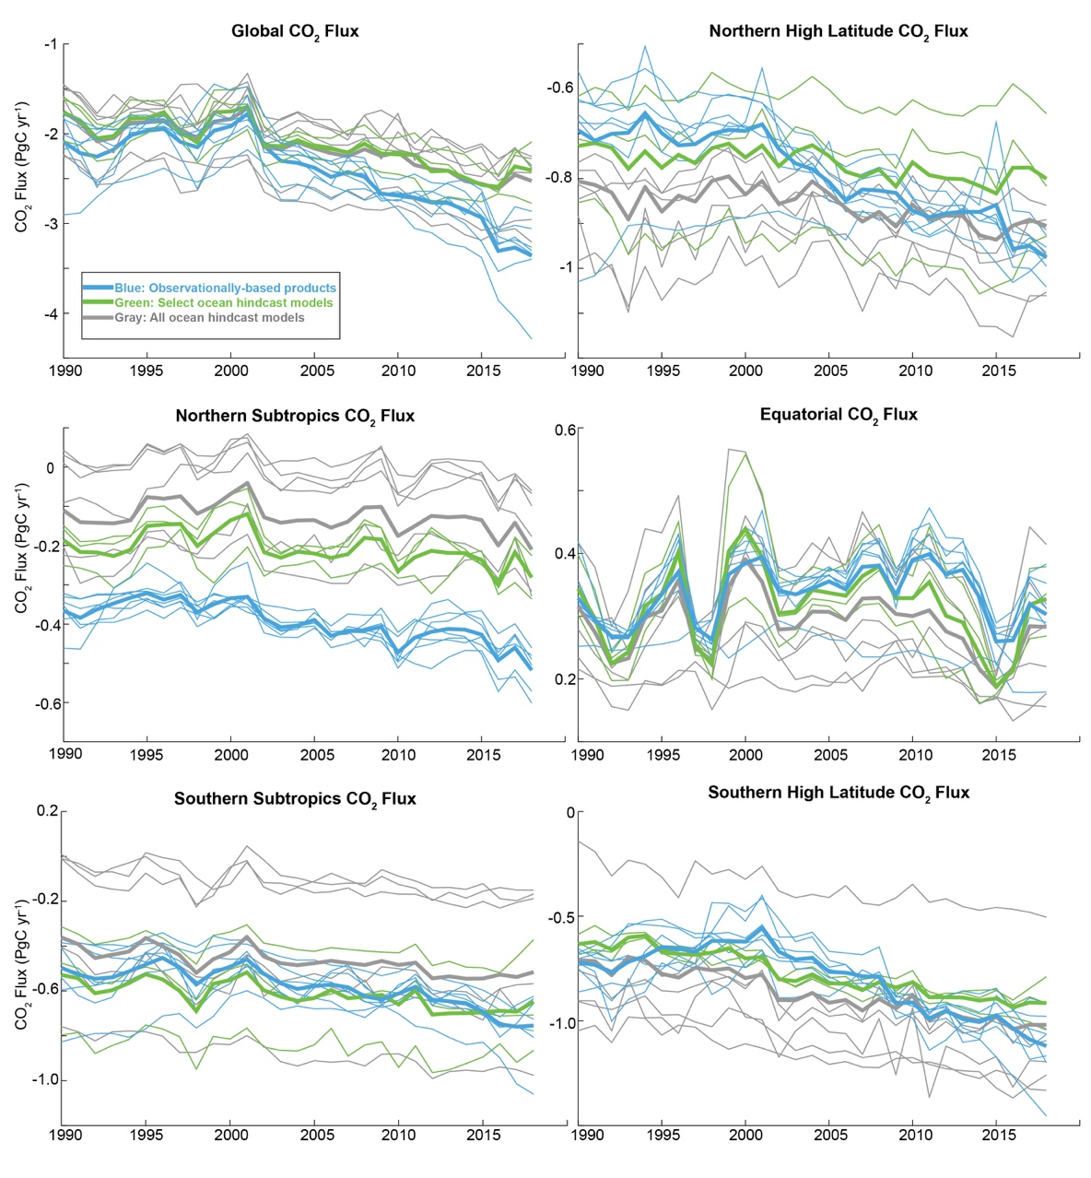

Figure S3. Time series for global and regionally-integrated air-sea CO2 fluxes (PgC/yr) from an ensemble of observation-based products (blue) and hindcast ocean models (gray and green), years 1990-2018. Thin lines are individual ensemble members while bold lines show mean for the products (blue), the full ensemble of models (gray) and the selected models (green).

Table S1. Observation-based pCO2 products and Hindcast Ocean Model names and references

Observation-based pCO₂ products
Name | Reference
CMEMS-FFNN | Denvil-Sommer et al. 2019 Chau et al. 2020
CSIR-ML6 | Gregor et al. 2019
Jena-MLS | Rödenbeck et al. 2013
JMA-MLR | Iida et al. 2020
LDEO-HPD | Gloege et al. 2021
MPI-SOMFFN | Landschützer et al. 2014 Landschützer et al. 2020a
NIES-FNN | Zeng et al. 2014

Hindcast Ocean Models
Name | Reference | Selected
CESM-ETHZ | Doney et al. 2009 | Yes
CNRM-ESM2-1 | Berthet et al. 2019 | No
CSIRO | Law et al. 2017 | No
FESOM-1.4-REcoM2 | Hauck et al. 2020 | No
MOM6-COBALT (Princeton) | Liao et al. 2020 | No
MPIOM-HAMOCC6 | Paulsen et al. 2017 | No
NEMO-PISCES (IPSL) | Aumont et al. 2015 | Yes
NEMO-PlankTOM5 | Buitenhuis et al. 2010 | Yes
NorESM-OCv1.2 | Schwinger et al. 2016 | No

Table S2. River adjustment from Lacroix et al. (2020)
Region | Percent of river efflux | River flux adjustment (% * 0.49PgC/yr)
Northern High Latitudes | 10.3% | 0.051 PgC yr⁻¹
Northern Subtropics | 27.2% | 0.133 PgC yr⁻¹
Equatorial | 3.7% | 0.018 PgC yr⁻¹
Southern Subtropics | 35% | 0.172 PgC yr⁻¹
Southern High Latitudes | 6.2% | 0.030 PgC yr⁻¹

Table S3. River adjustment from Lacroix et al. (2020) for latitude bounds as defined by Aumont et al. (2001).
Region | Lacroix % of river efflux | Aumont % of river efflux
90N-20N | 34% | 26%
20N-20S | 45% | 25%
20S-90S | 21% | 49%

Table S4 Global and regionally integrated air-sea CO₂ flux in PgC/yr for 7 observation-based products, products with river carbon efflux adjustment, all nine models, and select three models. Uncertainty (±) represents 2σ spread. Middle column shows the 3σ bounds on the product ensemble; this is used for the model selection criteria.
 | Products | Products natural outgassing due to rivers | 3σ Product spread | Models | Select Models
Global | -1.94 ± 0.32 | -2.43 ± 0.62 | -3.36; -1.50 | -2.15 ± 0.64 | -2.11 ± 0.42
N High Latitudes | -0.74 ± 0.13 | -0.79 ± 0.14 | -1.01; -0.58 | -0.86 ± 0.25 | -0.77 ± 0.34
N Subtropics | -0.26 ± 0.04 | -0.40 ± 0.15 | -0.62; -0.17 | -0.13 ± 0.22 | -0.21 ± 0.09
Equatorial | 0.35 ± 0.08 | 0.33 ± 0.08 | 0.21; 0.46 | 0.29 ± 0.14 | 0.32 ± 0.10
S Subtropics | -0.41 ± 0.16 | -0.58 ± 0.25 | -0.95; -0.21 | -0.47 ± 0.60 | -0.62 ± 0.45
S High Latitudes | -0.77 ± 0.10 | -0.80 ± 0.10 | -0.95; -0.65 | -0.87 ± 0.48 | -0.77 ± 0.07

Table S5 Coefficient of Variability (CoV) for global and regionally integrated air-sea CO₂ fluxes.
 | Observation-based Products | Products with natural outgassing due to rivers | Hindcast Models | Select Models
Global | 8% | 13% | 15% | 10%
NH High Latitudes | 9% | 9% | 15% | 22%
NH Subtropics | 8% | 19% | 88% | 23%
Equatorial | 12% | 13% | 24% | 15%
SH Subtropics | 20% | 21% | 65% | 36%
SH High Latitudes | 6% | 6% | 28% | 5%

Table S6 Seasonal RMSE mean between ensemble of products and models or select models over five regions.
 | Models | Select Models
Northern High Latitudes | 0.47 | 0.37
Northern Subtropics | 0.12 | 0.09
Equatorial | 0.04 | 0.04
Southern Subtropics | 0.29 | 0.22
Southern High Latitudes | 0.79 | 0.51

Table S7 Correlations for detrended CO₂ flux time series, between the product ensemble mean and that from all models and only select models. Values in bold are significant at the 95% confidence level (student t-test with p<0.05).

 | Products: Models | Products: Select Models
Global | 0.71 | 0.64
N High Latitudes | 0.25 | 0.06
N Subtropics | 0.86 | 0.82
Equatorial | 0.85 | 0.86
S Subtropics | 0.50 | 0.53
S High Latitudes | 0.22 | 0.11

