Supplementary information

Influence of strong iron-binding ligands on cloud water oxidant capacity

Aridane G. González1,2*, Angelica Bianco3, Julia Boutorh2, Marie Cheize2, Gilles Mailhot4, Anne-Marie Delort4, Hélène Planquette2, Nadine Chaumerliac3, Laurent Deguillaume3,5, Geraldine Sarthou2

1 Instituto de Oceanografía y Cambio Global, IOCAG, Universidad de Las Palmas de Gran Canaria, ULPGC.

2 CNRS, Univ Brest, IRD, Ifremer, LEMAR, F-29280 Plouzane, France

3 Laboratoire de Météorologie Physique, UMR 6016, CNRS, Université Clermont Auvergne, 63178 Aubière, France

4 CNRS, SIGMA Clermont, Institut de Chimie de Clermont-Ferrand, Université Clermont Auvergne, F-63000 Clermont-Ferrand, France

5 Observatoire de Physique du Globe de Clermont-Ferrand, UAR 833, CNRS, Université Clermont Auvergne, 63178 Aubière, France

*Correspondence to*: Aridane G. González (aridane.gonzalez@ulpgc.es), Angelica Bianco (angelica.bianco@uca.fr)

**Material and methods**

**SI-S1 Location and sampling description**

The puy de Dôme station (PUY) belongs to the atmospheric survey networks EMEP (the European Monitoring and Evaluation Program), GAW (Global Atmosphere Watch), and ACTRIS (Aerosols, Clouds, and Trace gases Research Infrastructure).

Cloud water sampling was performed by using a dynamic one-stage cloud water impactor (cut off diameter of approximately 7 µm1). The aluminium impactor was cleaned and sterilized by autoclaving before and after each cloud collection. The dataset is composed of 6 cloud events collected between 2013 and 2016 (Table 1). In addition, procedural blank samples were collected by rinsing the cloud collector with Milli-Q water (3 times with 15 mL) just prior to collection. Samples were collected in sterilized bottles and cloud water was filtered using a 0.20 µm nylon filter within 10 minutes after sampling to eliminate microorganisms and particles. Physicochemical and microbiological parameters were measured on each sample.

**SI-S2 Physico-chemical analysis**

At the PUY station, gas and aerosol phase parameters as well as cloud water microphysical parameters like liquid water content (LWC) and droplet radius are measured continuously. Different physico-chemical parameters were determined on cloud water samples. pH was measured by a Hanna multiparameter instrument. The TOC concentration is determined with a TOC analyzer (Shimadzu TOCVCPH/CPN).2 Hydrogen peroxide concentration is estimated using p-hydroxyphenilacetic acid (purity > 98%) and horseradish peroxidase (solid containing 150-200 units per mg), according to the spectrofluorimetric quantification method adapted by Wirgot et al.3 Ion chromatography (IC) analysis is performed employing a DIONEX DX-320 equipped with an IonPac AG11 (guard-column 4×50 mm) and an IonPac AS11 (analytical column 5×250 mm) for anions and a DIONEX ICS-1500 equipped with an IonPac CG16 (guard-column 4×50 mm) and an IonPac CS16 (analytical column 5×250 mm) for cations.

**SI-S3 Chemicals**

The artificial ligand used in this study was 1-Nitroso-2-Naphtol (NN), prepared in Methanol (>99.8% GC, Fluka analytical) at final concentration in each vial of 20 µM. The buffer 2-(N-morpholino)-ethanesulfonic acid (1M MES, 99.5% titration Sigma) was prepared in ammonia (NH4OH, suprapur, Merck; 0.5 M). The pH was adjusted by adding aliquots of HCl (Suprapur, Merck). The final concentration of buffer solution was 10 mM. The samples were treated with H2O2 (30% Suprapur*®*, Merck) as primary oxidant, at a final concentration of 10 µM. In addition, KBrO3 (99.8%, Sigma-Aldrich) was used as auxiliary oxidant with a final concentration of 40 mM.4,5 NaCl (Sigma-Aldrich; 5 M) was added to cloud waters to control the ionic strength of cloud water samples with a final concentration of 50 mM that corresponded to a salinity of 2.9.5,6 The last two solutions were also buffered with MES at pH 6.0 (final concentration of 10 mM). Buffer solutions and NaCl were purified three times passing through 8-hydroxyquinoline resin immobilized on TSK-Gel-AF-Epoxy-650M resin.5 Resin was cleaned with 500 mL of 0.5 M HCl (Suprapure, Merck) and, in a second round, with 100 mL of Milli-Q water. All chemicals were stored at the fridge (4°C and darkness). H2O2 and KBrO3 were daily prepared. Fe standard solutions were prepared from commercial solution of Fe atomic absorption spectroscopy (VWR) at 1 M in acidified Milli-Q water with HCl (1‰ v/v).

**SI-S4 Total dissolvable Fe and Fe-binding ligands concentrations**

Fe-binding ligand samples were frozen at -20°C immediately after collection and then measured in a clean laboratory (class 10000) at the LEMAR laboratory (Brest, France). All the material was cleaned following the GEOTRACES protocol).7,8

Total dissolved Fe (TdFe) concentrations were measured on unfiltered samples by high resolution, magnetic sector field inductively coupled plasma mass spectrometry (SF-ICP-MS; Element 2, Thermo-Fisher). Samples were heated to 150 °C and taken to near-dryness. After evaporation, the samples were re-dissolved in 15 mL of 0.4 M HNO3 (Ultrapur, Merck) containing 1 ppb indium (In) as an internal standard for drift correction. For analysis by SF-ICP-MS, 2 mL of this solution was further diluted in acid-washed, rounded bottom, polypropylene centrifuge tubes (VWR) by addition of 2 mL of the same batch of 0.4 M HNO3 containing 1 ppb In. Samples were introduced to a PFA-ST nebulizer (Elemental Scientific Incorporated) via a modified SC-Fast introduction system consisting of an SC-2 autosampler, a six-port valve and a vacuum rinsing pump. The blank values varied from 1.9±0.8 nM to 12±2 nM, representing less 15% of the TdFe signal.

Fe-organic ligands (L) were measured using an Autolab Type III Model 663 VA Stand (Metrohm). Electrode system was composed by a static mercury drop electrode, a double-injection saturated AgCl reference electrode with a salt bridge filled with 3M KCl, and a glass carbon rod as a counter electrode. The system contained an automatic teflon stirrer (1500 rpm). Titrations were carried out following the method previously developed by Cheize et al.5for rainwater samples. Briefly, cloud water samples were diluted in Milli-Q water to work with a final concentration close to 1 nM. MES, NaCl and H2O2 were added to the diluted sample. The solution was distributed among twelve Teflon® vials and 0–20 nM of Fe was spiked. The natural ligands and added Fe were left to equilibrate for 12 h in the dark. Then, the artificial competitive ligand NN was added and allowed to equilibrate overnight. Bromate was added less than 1 min before measurement. Oxygen was removed by purging with dry nitrogen gas (Alphagaz 2 nitrogen, Air Liquide). A deposition of -0.1 V was set of static mercury drop electrode (SDME). Deposition time was stablished at 3 min. The reduction peak intensity was recorded from −0.20 V to −0.65 V and its height manually determined with the GPES (General Purpose Electrochemical System) software.

Fe-binding ligands have been computed here from TdFe. According to the Fe speciation in natural waters it should not have any impact in the L concentration in clouds due to the low inert Fe species (Fe fraction bounded to non-labile and not exchangeable with the artificial ligand9).

Titration parameters were computed with ProMCC software 10 for ligand concentrations and conditional stability constants. The theory of complexation for Fe-NN complexes and rainwater has been previously described by Cheize et al.5 The blank values ranged from 8±2 nM to 13±4 nM, being always less than 3% of the Fe-organic ligand concentrations.

**SI-S5 Modelling**

**Description of the model**

A modelling study on iron complexation and reactivity has been conducted using the detailed aqueous phase mechanism named the Cloud Explicit Physico-chemical Scheme (CLEPS 1.1).11,12 This mechanism is implemented in a cloud chemistry box model based on the Dynamically Simple Model for Atmospheric Chemical Complexity (DSMACC)13 using the Kinetic Pre Processor (KPP)14. This model allows to take into account the gaseous and aqueous phase reactivity and the mass transfer of soluble chemicals between gas and aqueous phases following the parameterization of Schwartz et al.15 and the estimation of Henry’s law constants by the GROMHE (GROupcontribution Method for Henry’s law Estimate) structure activity relationships.16 In addition, it is off-line coupled with a warm microphysical module simulating the activation of aerosol particles into cloud droplets. This allows the prediction of the aqueous-phase concentrations of chemical compounds originating from particle scavenging. The TUV 4.5 radiative transfer model17 initially set up in DSMACC and dedicated to the calculation of photolysis rates in the gas phase was adapted to include aqueous-phase photolysis reactions.

**Set-up of the simulations**

A gas phase chemistry spin-up simulation is performed to reach a photochemical equilibrium and to initialize the environment with realistic gas phase concentrations before the cloud forms. The chemical conditions are representative of low-NOx condition (in adequation with remote site like the PUY station) and are reported in Table S3. The gas-phase simulation lasts 7.5 days at RH (relative humidity) of 20%, following similar procedure than Rose et al.11 At noon of the seventh day, the cloud simulation is started.

The concentrations of the main inorganic and organic ions as well as the organic ligands (LFe and oxalate) and Fe are initialized in the aqueous phase by their dissolution from the aerosol distribution after activation. Those compounds dissolve in the cloud water droplets in the first minute of the simulation; this leads to initial aqueous phase concentrations reported in Table S4.

To accurately reproduce contrasted environmental conditions, two different scenarios are evaluated: one representative of marine conditions and one of continental conditions, both encountered for the samples presented in this work. The same gas phase spin-up simulation is used for both marine and continental scenarios, while the concentration of ions in the aqueous phase changes, as reported in Table S4.

The simulation of cloud lasts 2h (from 12 PM to 2 PM) and the physical and microphysical conditions are kept constant for the different scenarios to facilitate the comparison of chemical processing. The cloud droplet radius (Re) is set at 10 µm and the liquid water content (LWC) at 0.3 g (of water)/m3 (of air); those parameters are representative of microphysical properties of clouds (marine and continental) sampled at PUY (Deguillaume et al., 2014). Temperature is fixed at 5°C, RH at 100% and pressure at 849 hPa (i.e., PUY altitude). The pH is set at 5.8 for the marine scenario and at 5.0 for the continental scenario; these values are kept constants for all the simulations. All those physical and chemical parameters are set to be representative of the conditions encountered during the studied cloud events.

Summertime conditions are chosen to simulate the reactivity in the case of a higher actinic flux, as described in Mouchel-Vallon et al.12 and Rose et al.11 The coordinates used to calculate actinic fluxes are 45.77° N, 2.96° E, corresponding to the PUY summit. The concentrations of inorganic and organic ions are initialized, as reported in Table S4, based on the experimental values measured at PUY for continental and marine clouds over 18 years (2000-2018). The classification was determined using the principal component analysis as described in Deguillaume et al. (2014) (samples collected between 2001 and 2011) and implementing the samples collected in the period 2012-2018. These concentrations are similar to the ones reported by Renard et al.18 and considering cloud samples collected between 2001 and 2019. Continental clouds are characterized by a lower pH and higher ions concentrations, while marine clouds show slightly higher pH and lower ions concentrations.

**Consideration of Fe complexation in the CLEPS mechanism**

As mentioned previously, Fe dissolves into the aqueous phase by dissolution of the particulate phase at the earlier stage of the simulation time.

The aqueous chemical mechanism already considers Fe(II) and Fe(III) as aqua-complexes as well as the complexation of Fe(III) with oxalate and the photolysis of the Fe(III) complexes (Table S2). The formation and depletion of the complex Fe-L is implemented in the mechanism as reported in Reaction 1:

$L + {Fe}^{3+}⇆Fe-L k_{1}=3.02×{10}^{11} \left(L {mol}^{-1}s^{-1}\right); k_{-1}=1.91×{10}^{-11}(s^{-1})$ (1)

In cloud droplets, the complex Fe-L is likely to absorb light. Passananti et al. 19 investigated the photoreactivity of the complex Fe(III)-pyoverdin, where pyoverdin is an organic macromolecule belonging to siderophores produced by cloud microbiota.20 The photoreactivity of the complex has been investigated at pH 4.0 and 6.0 under simulated solar irradiation. The complex Fe(III)−pyoverdin undergoes a ligand-to-metal-charge-transfer (LMCT) leading to the formation of Fe(II) and organic ligand radicals. The evaluated quantum yields are 1.9 × 10−4 and 5.5 × 10−5, respectively for pH 4.0 and 6.0. The same authors determined also the formation rate of Fe(II) for the irradiated complex at pH 4.0 and 6.0, finding values of the order of 10–9 M s–1. There are two orders of magnitude lower than the ones observed for the complex Fe-oxalate, confirming a stronger interaction between Fe and the organic ligand, pyoverdin in this case, in the complex. A sensitivity test was performed implementing the quantum yield of photolysis of the complex (5.5 × 10−5) for the continental and marine scenarios; however, the difference in iron speciation was negligible (below 0.01%) and no impact has been observed in the cloud water oxidant capacity.

This difference may also explain the overestimation of iron reactivity in cloud chemistry models. Actually, Fe is generally considered as Fe-oxalate or Fe-aqua-complexes, while complexes with high molecular weight organic ligands are not taken into account.

**Table S1: Additional parameters to Table 1: concentrations of other ions, microphysical parameters: LWC: mean Liquid Water Content; Re: mean effective diameter and T:temperature. Time in UTC+1.**

|  |  |  |  |  |  |  |
| --- | --- | --- | --- | --- | --- | --- |
|  | **Cloud water samples** | | | | | |
| Samples | CW1 | CW2 | CW3 | CW4 | CW5 | CW6 |
| Date | 22/05/2013 | 12/11/2014 | 16/06/2015 | 14/01/2016 | 03/05/2016 | 04/06/2016 |
| Sampling time | 9:40-12:55 | 17:15-21:35 | 01:12-05:32 | 10:52-14:30 | 8:55-12:40 | 20:45-23:45 |
| Cl- (µM) | 9.6 | 78.8 | 4.6 | 3.9 | 12.2 | 5.3 |
| Na+ (µM) | 6.0 | 83.5 | 8.0 | 6.7 | 15.1 | 9.3 |
| NO3- (µM) | 43.2 | 24.7 | 128.5 | 3.6 | 37.6 | 47.8 |
| SO42- (µM) | 43.4 | 38.3 | 48.8 | 1.9 | 26.3 | 23 |
| NH4+ (µM) | 90.8 | 15.1 | 240.2 | 12.5 | 158.8 | 78.0 |
| C2O42- (µM) | 3.2 | 8.2 | 2.2 | 0.4 | 2.6 | 1.9 |
| DOC (mg/L) | NM | 4.0 | 3.6 | 5.1 | 3.5 | 4.3 |
| H2O2 (µM) | 30.8 | 7.9 | 25.7 | 0.6 | 29.7 | 41.9 |
| Cells/mL×103 | 12.4 | NM | 23.4 | 15.6 | 68.3 | 316.4 |
| K+ (µM) | 2.4 | 2.0 | 1.9 | 1.1 | 1.8 | 4.3 |
| Ca2+ (µM) | 14.1 | --- | 22.0 | 9.5 | 10.2 | 25.4 |
| Mg2+ (µM) | 5.2 | --- | 4.4 | 1.7 | 1.9 | 3.0 |
| Acetate (µM) | 11.9 | 11.9 | 6.6 | 1.0 | 7.4 | 4.4 |
| Formate (µM) | 14.9 | 5.7 | 20.7 | 1.2 | 9.5 | 17.2 |
| T (°C) | 2 | 2 | 8.5 | -1 | 3 | 7 |
| LWC (g m-3) | - | 0.4 | 0.4 | 0.3 | 0.3 | 0.3 |
| Re (µm) | - | 9 | 7 | 13 | 7 | 7 |

**Table S2. HxOy and Fe chemistry considered in CLEPS V1.1**

| Reactions |  | k298  (M-n+1 s-1) | Ea/R  (K) |
| --- | --- | --- | --- |
| HxOy chemistry |  |  |  |
| O3 + hν → H2O2 + O2 - H2O |  | Calculated |  |
| H2O2 + hν → 2 HO• |  | Calculated |  |
| HO• + HO• → H2O2 |  | 3.6 109 | 930 |
| HO• + HO2• → O2 + H2O |  | 2.8 1010 | 0 |
| HO• + O2•- → O2 + OH- |  | 3.5 1010 | 720 |
| HO• + O3 → HO2• + O2 |  | 1.0 108 |  |
| H2O2 + HO• → HO2• + H2O |  | 3.2 107 | 1700 |
| HO2• + HO2• → H2O2 + O2 |  | 8.3 105 | 2700 |
| HO2• + O2•- → H2O2 + O2 + OH- - H2O |  | 9.6 107 | 910 |
| O3 + HO2• → HO• + 2 O2 |  | 1.0 104 |  |
| O3 + O2•- → HO• + 2 O2 + OH- - H2O |  | 1.5 109 | 2200 |
| HSO3- + HO• → SO3•- + H2O |  | 2.7 109 |  |
| SO32- + HO• → SO3•- + OH- |  | 4.6 109 |  |
| Fe chemistry |  |  |  |
| Fe3+ + hν → Fe2+ + HO• + H+ - H2O |  | Calculated |  |
| [Fe(OH)]2+ + hν → Fe2+ + HO• |  | Calculated |  |
| [Fe(OH)2]+ + hν → Fe2+ + HO• + OH- |  | Calculated |  |
| [Fe(SO4)]+ + hν → Fe2+ + SO4•- |  | Calculated |  |
| H2O2 + Fe2+ → Fe3+ + HO• + OH- |  | 5.2 101 | 5050 |
| H2O2 + FeO2+ → Fe3+ + HO2• + OH- |  | 9.5 103 | 2800 |
| O2•- + Fe2+ → Fe3+ + H2O2 - 2 H+ |  | 1.0 107 |  |
| O2•- + Fe3+ → Fe2+ + O2 |  | 1.5 108 |  |
| O2•- + [Fe(OH)]2+ → Fe2+ + O2 + OH- |  | 1.5 108 |  |
| O2•- + [Fe(OH)2]+ → Fe2+ + O2 + 2 OH- |  | 1.5 108 |  |
| HO2• + Fe2+ → Fe3+ + H2O2 - H+ |  | 1.2 106 | 5050 |
| HO2• + FeO2+ → Fe3+ + O2 + OH- |  | 2.0 106 |  |
| HO• + Fe2+ → [Fe(OH)]2+ |  | 4.6 108 | 1100 |
| HO• + FeO2+ → Fe3+ + H2O2 - H+ |  | 1.0 107 |  |
| O3 + Fe2+ → FeO2+ + O2 |  | 8.2 105 |  |
| FeO2+ → Fe3+ + HO• + OH- - H2O |  | 1.3 10-2 | 4100 |
| FeO2+ + Fe2+ → 2 Fe3+ + 2 OH- - H2O |  | 7.2 104 | 840 |
| FeO2+ + Fe2+ → Fe(OH)2Fe4+ - H2O |  | 1.8 104 | 5050 |
| Fe(OH)2Fe4+ → 2 Fe3+ + 2 OH- |  | 4.9 10-1 | 8800 |
| Fe(OH)2Fe4+ + H+ → 2 Fe3+ + 2 H2O - H+ |  | 2.0 | 5650 |
| Cl2•- + Fe2+ → Fe3+ + 2 Cl- |  | 1.0 107 | 3060 |
| Cl2•- + Fe2+ → [FeCl]2+ + Cl- |  | 4.0 106 | 3700 |
| Cl- + Fe(O)2+ → Fe3+ + ClOH- - H+ |  | 1.0 102 |  |
| NO3• + Fe2+ → Fe3+ + NO3- |  | 8.0 106 |  |
| NO2 + Fe2+ → Fe3+ + NO2- |  | 3.1 104 |  |
| HNO2 + FeO2+ → Fe3+ + NO2 + OH- |  | 1.1 104 | 4150 |
| NO2- + FeO2+ → Fe3+ + NO2 + OH- - H+ |  | <1.0 105 |  |
| HSO3- + [Fe(OH)]2+ → Fe2+ + SO3•- - H2O |  | 3.0 101 |  |
| SO5•- + Fe2+ → [Fe(OH)]2+ + HSO5- - H2O |  | 2.6 107 |  |
| HSO5- + Fe2+ → [Fe(OH)]2+ + SO4•- |  | 3.0 104 |  |
| SO4•- + Fe2+ → Fe3+ + SO42- |  | 4.1 109 | -2165 |
| O2•- + [Fe(SO4)]+ → Fe2+ + SO42- + O2 |  | 1.5 108 |  |
| S2O82- + Fe2+ → Fe3+ + SO4•- + SO42- |  | 1.7 101 |  |
| HSO3- + FeO2+ → Fe3+ + SO3•- + OH- |  | 2.5 105 |  |
| Fe3+ + SO42- → [Fe(SO4)]+ |  | 3.2 103 |  |
| [Fe(SO4)]+ → Fe3+ + SO42- |  | 2.7 101 |  |
| Fe3+ + Cl- → [FeCl]2+ |  | 4.8 |  |
| [FeCl]2+ → Fe3+ + Cl- |  | 9.2 10-1 |  |
| Fe chemistry – with organics |  |  |  |
| *HMHP chemistry (HydroxyMethyl HydroPeroxide)* |  |  |  |
| CH2(OOH)(OH) + Fe2+ → Fe3+ + CHO(OH) + HO2• + OH- - O2 |  | 1.6 101 |  |
| CH2(OH)(OO•) + Fe2+ → [FeOHCH2O2]2+ |  | 5.9 105 |  |
| [FeOHCH2O2]2+ → CH2(OH)(OO•) + Fe2+ |  | 1.3 103 |  |
| [FeOHCH2O2]2+ → Fe3+ + CH2(OOH)(OH) + OH- - H2O |  | 1.0 102 |  |
| [FeOHCH2O2]2+ + H+ → Fe3+ + CH2(OOH)(OH) |  | 3.0 104 |  |
| *MHP chemistry (Methyl HydroPeroxide)* |  |  |  |
| CH3(OOH) + Fe2+ → Fe3+ + CH2(OH)(OO•) + OH- - O2 |  | 1.6 101 |  |
| CH3(OO•) + Fe2+ → [FeCH3O2]2+ |  | 8.6 105 |  |
| [FeCH3O2]2+ → CH3(OO•) + Fe2+ |  | 1.3 103 |  |
| [FeCH3O2]2+→ Fe3+ + CH3(OOH) + OH- - H2O |  | 1.0 102 |  |
| [FeCH3O2]2+ + H+→ Fe3+ + CH3(OOH) |  | 3.0 104 |  |
| *Formaldehyde chemistry* |  |  |  |
| CH2(OH)(OH) + FeO2+ → CHO(OH) + Fe3+ + HO2• + OH- - O2 |  | 4.0 102 | 5350 |
| *Formic acid chemistry* |  |  |  |
| CHO(OH) + FeO2+ → CO(OH)(OO•) + Fe3+ + H2O- H+ -O2 |  | 1.6 102 | 2680 |
| CHO(O-) + FeO2+ → CO(O-)(OO•) + Fe3+ + H2O - H+ - O2 |  | 3.0 105 |  |
| *Ethanol chemistry* |  |  |  |
| CH3CH2(OH) + FeO2+ → 0.90 CH3CH(OH)(OO•) + 0.10 CH2(OH)CH2(OO•) + Fe3+ + OH- - O2 |  | 2.5∙103 |  |
| *EHP chemistry (Ethyl hydroperoxide)* |  |  |  |
| CH3CH2(OOH) + Fe2+ → CH3CH(OH)(OO•) + Fe3+ + OH- - O2 |  | 2.4 101 |  |
| *Oxalic acid chemistry* |  |  |  |
| CO(O-)CO(O-) + Fe3+ → [Fe(C2O4)]+ |  | 7.5 106 |  |
| [Fe(C2O4)]+ → CO(O-)CO(O-) + Fe3+ |  | 3.0 10-3 |  |
| CO(O-)CO(O-) + [Fe(C2O4)]+ → [Fe(C2O4)2]- |  | 1.9 104 |  |
| [Fe(C2O4)2]- → CO(O-)CO(O-) + [Fe(C2O4)]+ |  | 3.0 10-3 |  |
| CO(O-)CO(O-) + [Fe(C2O4)2]- → [Fe(C2O4)3]3- |  | 4.8 101 |  |
| [Fe(C2O4)3]3- → CO(O-)CO(O-) + [Fe(C2O4)2]- |  | 3.0 10-3 |  |
| [Fe(C2O4)]+ + hν → Fe2+ + C2O4•- |  | Calculated |  |
| [Fe(C2O4)2]- + hν → Fe2+ + CO(O-)CO(O-) + C2O4•- |  | Calculated |  |
| [Fe(C2O4)3]3- + hν → Fe2+ + 2 CO(O-)CO(O-) + C2O4•- |  | Calculated |  |
| *2-hydroperoxyacetic acid* |  |  |  |
| CH2(OOH)CO(OH) + Fe2+ → CH2O + CO(OH)(OO•) + Fe3+ + OH- - O2 |  | 2.4 101 |  |
| CH2(OOH)CO(O-) + Fe2+ → CH2O + CO2 + Fe3+ + OH- + O2•- - O2 |  | 2.4 101 |  |
|  |  |  |  |
| Aqueous equilibrium |  | Ka or Kh | -∆H/R  (K) |
| H2O2 ↔ HO2- + H+ |  | 2.2 10-12 | -3730 |
| HO2• ↔ O2•- + H+ |  | 1.6 10-5 |  |
| Fe3+ + H2O ↔ [Fe(OH)]2+ + H+ |  | 6.0 10-3 |  |
| [Fe(OH)]2+ + H2O ↔ [Fe(OH)2]+ + H+ |  | 7.6 10-4 |  |

Calculated = calculated on the basis of photolysis frequency

**Table S3: Chemical scenario used for the gas phase simulation of 7.5 days (following Rose et al., 2018).**

|  |  |  |  |
| --- | --- | --- | --- |
| Gas phase species | Initial mixing ratio (ppb) | Emission  (molec cm-3 s-1) | Deposition  (s-1) |
| SO2 | 1 | 2.91×105 | 1×10-5 |
| NO | - | 2.86×105 | - |
| NO2 | 0.3 | - | 4×10-6 |
| N2O5 | - | - | 2×10-5 |
| HNO3 | 0.3 | - | 2×10-5 |
| O3 | 40 | - | 4×10-6 |
| H2O2 | 1 | - | 1×10-4 |
| CH4 | 1.7×103 | - | - |
| CO2 | 3.57×105 | - | - |
| CO | 1.5×102 | 3.7×106 | 1×10-6 |
| Isoprene | 1 | 7.50×106 | - |
| Dihydroxybutanone | - | - | 5×10-5 |
| Methacrolein | - | - | 5×10-5 |
| Methylvinylketone | - | - | 5×10-5 |
| Glyoxal | 0.1 | - | 5×10-5 |
| Methylglyoxal | 0.1 | - | 5×10-5 |
| Glycolaldehyde | - | - | 5×10-5 |
| Acetaldehyde | 0.1 | 3.17×103 | 5×10-5 |
| Formaldehyde | 0.5 | 3.03×103 | 5×10-5 |
| Acetone | 0.1 | 8.92×103 | 5×10-5 |
| Pyruvic Acid | - | - | 5×10-5 |
| Acetic Acid | 1×10-3 | 3.35×103 | 5×10-5 |
| Formic Acid | - | - | 5×10-5 |
| Methanol | 2 | 1.07×104 | 5×10-5 |
| Methylhydroperoxide | 0.01 | 3.35×103 | 5×10-6 |

**Table S4: Aqueous phase initial concentrations and cloud microphysical parameters.**

|  |  |  |  |  |
| --- | --- | --- | --- | --- |
|  | **Marine** | **Continental** | **Continental ST1** | **Continental ST2** |
| **pH** | 5.80 | 5.00 | 5.00 | 5.00 |
| **TdFe** (nM) | 37 | 194 | 388 | 1000 |
| **LFe** (nM) | 115 | 343 | 343 | 1770 |
| **SO42–** (µM) | 20.1 | 35.4 | 35.4 | 35.4 |
| **NO3–** (µM) | 14.1 | 70.8 | 70.8 | 70.8 |
| **Cl–** (µM) | 41.4 | 7.7 | 7.7 | 7.7 |
| **Na+** (µM) | 45.1 | 9.1 | 9.1 | 9.1 |
| **NH4+** (µM) | 13.8 | 155.4 | 155.4 | 155.4 |
| **H2O2** (µM) | 4.3 | 37.3 | 37.3 | 37.3 |
| **Acetate** (µM) | 6.4 | 7. 8 | 7. 8 | 7. 8 |
| **Formiate** (µM) | 3.3 | 14.4 | 14.4 | 14.4 |
| **Oxalate** (µM) | 3.0 | 3.0 | 3.0 | 3.0 |
| **LWC** (g m-3) | 0.30 | 0.30 | 0.30 | 0.30 |
| **Re** (µm) | 10 | 10 | 10 | 10 |
| **T** (°C) | 5 | 5 | 5 | 5 |
| **P** (hPa) | 849 | 849 | 849 | 849 |

**Table S5. Summary of the various performed simulations. All the simulations are performed using the same spin-up gas phase simulation. Marine and continental correspond to the two chemical scenarios. ST1 and ST2 are two sensitivity tests.**

|  |  |  |  |  |  |  |  |
| --- | --- | --- | --- | --- | --- | --- | --- |
| Marine | Continental | ST1 | ST2 | Fe concentration (nM) | Oxalate concentration (nM) | Lig concentration (nM) | Cases |
| X |  |  |  | 37 | 0 | 0 | No Oxalate No ligand |
| X |  |  |  | 37 | 3 | 0 | Oxalate No Ligand |
| X |  |  |  | 37 | 0 | 115 | No Oxalate Ligand |
| X |  |  |  | 37 | 3 | 115 | Oxalate Ligand |
|  | X |  |  | 194 | 0 | 0 | No Oxalate No ligand |
|  | X |  |  | 194 | 3 | 0 | Oxalate No Ligand |
|  | X |  |  | 194 | 0 | 343 | No Oxalate Ligand |
|  | X |  |  | 194 | 3 | 343 | Oxalate Ligand |
|  | X | X |  | 388 | 0 | 0 | No Oxalate No ligand |
|  | X | X |  | 388 | 3 | 0 | Oxalate No Ligand |
|  | X | X |  | 388 | 0 | 343 | No Oxalate Ligand |
|  | X | X |  | 388 | 3 | 343 | Oxalate Ligand |
|  | X |  | X | 1000 | 0 | 0 | No Oxalate No ligand |
|  | X |  | X | 1000 | 3 | 0 | Oxalate No Ligand |
|  | X |  | X | 1000 | 0 | 1770 | No Oxalate Ligand |
|  | X |  | X | 1000 | 3 | 1770 | Oxalate Ligand |

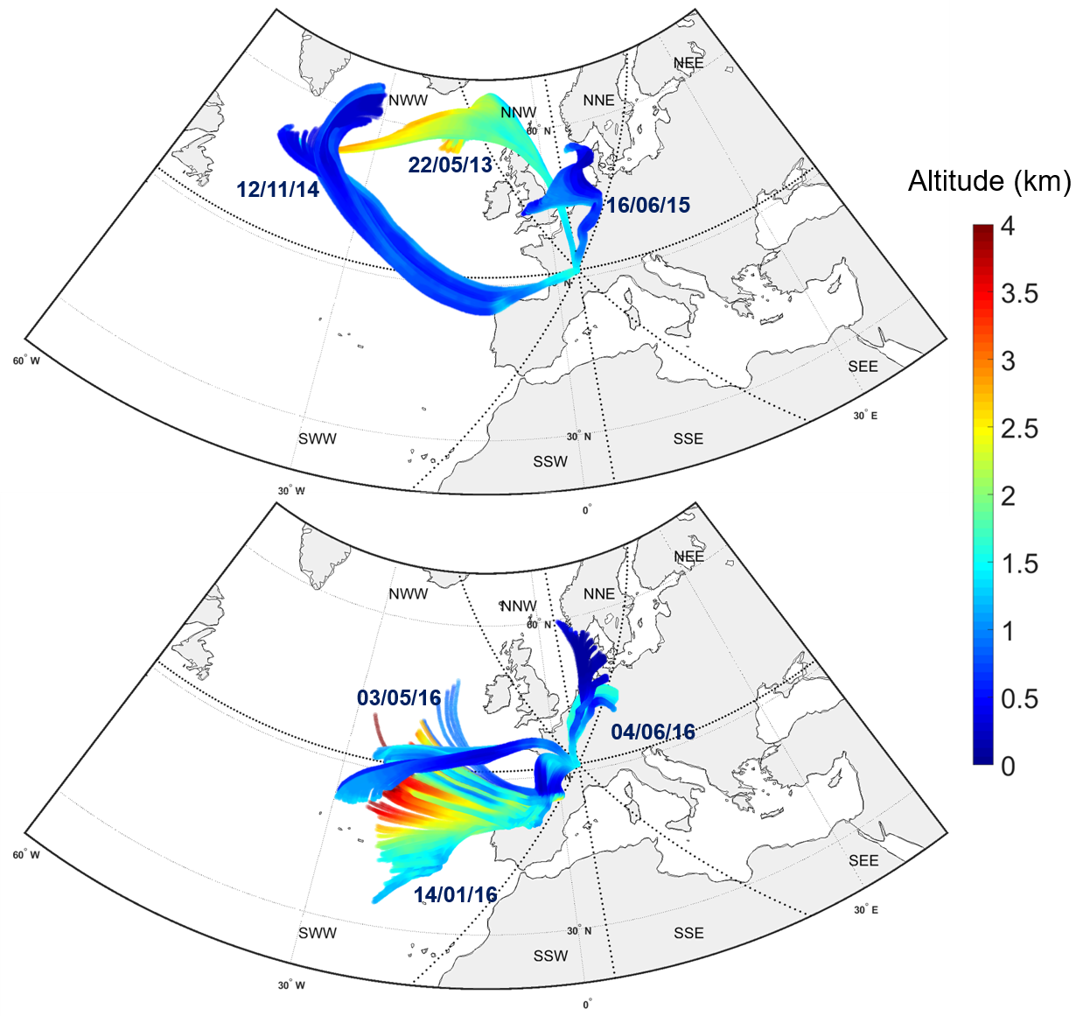

**Figure S1: Back trajectory plots of air masses reaching PUY. Thin black lines depict the four different sectors identified by Deguillaume et al. (2014) for air masses reaching PUY. Colours indicate the air mass altitude. Each trajectory plot is the mean value of a cluster of 150 LACYTRAJ trajectories calculated over 72 h. Trajectory points are calculated every 15 min.**

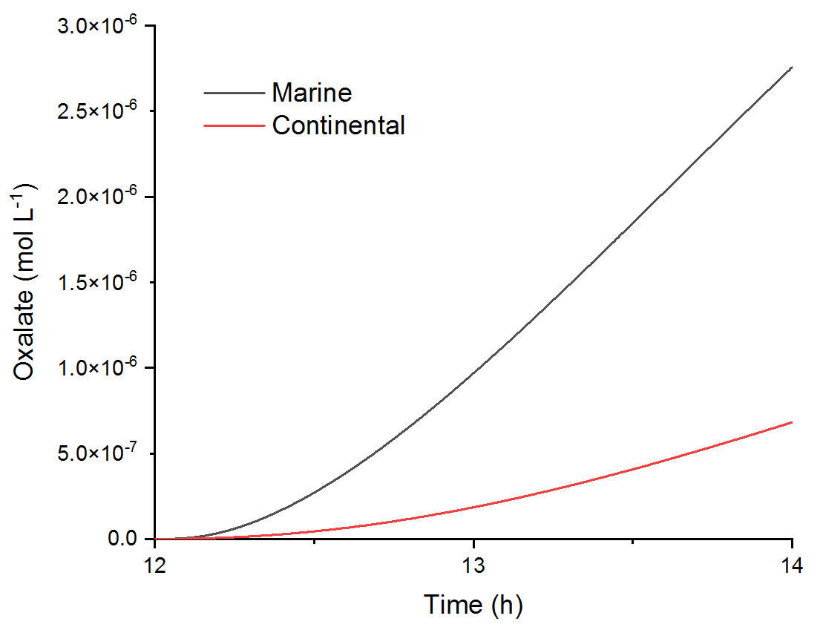

**Figure S1: Evolution of oxalate concentration in marine and continental scenario for the case No Oxalate No Ligand**

1. Brantner, B., Fierlinger, H., Puxbaum, H. & Berner, A. Cloudwater chemistry in the subcooled droplet regime at Mount Sonnblick (3106 M A.S.L., Salzburg, Austria). *Water, Air, and Soil Pollution* **74**, 363–384 (1994).

2. Bianco, A. *et al.* A better understanding of hydroxyl radical photochemical sources in cloud waters collected at the puy de Dôme station – experimental versus modelled formation rates. *Atmospheric Chemistry and Physics* **15**, 9191–9202 (2015).

3. Wirgot, N., Vinatier, V., Deguillaume, L., Sancelme, M. & Delort, A.-M. H2O2 modulates the energetic metabolism of the cloud microbiome. *Atmospheric Chemistry and Physics* **17**, 14841–14851 (2017).

4. Aldrich, A. P. & van den Berg, C. M. G. Determination of Iron and Its Redox Speciation in Seawater Using Catalytic Cathodic Stripping Voltammetry. *Electroanalysis* **10**, 369–373 (1998).

5. Cheize, M. *et al.* Iron organic speciation determination in rainwater using cathodic stripping voltammetry. *Analytica Chimica Acta* **736**, 45–54 (2012).

6. Nagai, T., Imai, A., Matsushige, K., Yokoi, K. & Fukushima, T. Voltammetric determination of dissolved iron and its speciation in freshwater. *Limnology* **5**, 87–94 (2004).

7. Cutter, G. *et al.* Sampling and sample-handling protocols for GEOTRACES cruises. (2010).

8. Cutter, G. A. *et al.* Sampling and sample-handling protocols for GEOTRACES Cruises, Version 3.0. (2017).

9. Gledhill, M. & Buck, K. The Organic Complexation of Iron in the Marine Environment: A Review. *Frontiers in Microbiology* **3**, 69 (2012).

10. Omanović, D., Garnier, C. & Pižeta, I. ProMCC: An all-in-one tool for trace metal complexation studies. *Marine Chemistry* **173**, 25–39 (2015).

11. Rose, C. *et al.* Modeling the partitioning of organic chemical species in cloud phases with CLEPS (1.1). *Atmospheric Chemistry and Physics* **18**, 2225–2242 (2018).

12. Mouchel-Vallon, C. *et al.* CLEPS 1.0: A new protocol for cloud aqueous phase oxidation of VOC mechanisms. *Geoscientific Model Development* **10**, 1339–1362 (2017).

13. Emmerson, K. M. & Evans, M. J. Comparison of tropospheric gas-phase chemistry schemes for use within global models. *Atmos. Chem. Phys.* **9**, 1831–1845 (2009).

14. Sandu, A. & Sander, R. Technical note: Simulating chemical systems in Fortran90 and Matlab with the Kinetic PreProcessor KPP-2.1. *Atmos. Chem. Phys.* **6**, 187–195 (2006).

15. Schwartz, S. E. Mass-Transport Considerations Pertinent to Aqueous Phase Reactions of Gases in Liquid-Water Clouds. in *Chemistry of Multiphase Atmospheric Systems* (ed. Jaeschke, W.) 415–471 (Springer Berlin Heidelberg, 1986). doi:10.1007/978-3-642-70627-1_16.

16. Raventos-Duran, T., Camredon, M., Valorso, R., Mouchel-Vallon, C. & Aumont, B. Structure-activity relationships to estimate the effective Henry’s law constants of organics of atmospheric interest. *Atmos. Chem. Phys.* **10**, 7643–7654 (2010).

17. Madronich, S. & Flocke, S. Theoretical Estimation of Biologically Effective UV Radiation at the Earth’s Surface. in *Solar Ultraviolet Radiation* (eds. Zerefos, C. S. & Bais, A. F.) 23–48 (Springer Berlin Heidelberg, 1997).

18. Renard, P. *et al.* Classification of Clouds Sampled at the Puy de Dôme Station (France) Based on Chemical Measurements and Air Mass History Matrices. *Atmosphere* **11**, 732 (2020).

19. Passananti, M., Vinatier, V., Delort, A.-M., Mailhot, G. & Brigante, M. Siderophores in Cloud Waters and Potential Impact on Atmospheric Chemistry: Photoreactivity of Iron Complexes under Sun-Simulated Conditions. *Environmental Science & Technology* **50**, 9324–9332 (2016).

20. Vinatier, V. *et al.* Siderophores in Cloud Waters and Potential Impact on Atmospheric Chemistry: Production by Microorganisms Isolated at the Puy de Dôme Station. *Environmental Science & Technology* **50**, 9315–9323 (2016).