Earthquake triggering in Bute Inlet
Although Bute Inlet is not directly in a seismically active location, many earthquakes occur along the plate boundaries between the Pacific plate, Juan de Fuca plate, and North American plate as well as (Juan de Fuca Ridge, Cascadia subduction zone, Queen charlotte Fault. However, it is unclear how close earthquakes need to be to be able to trigger turbidity currents. We used the USGS ‘DYFI’ and ‘shakemaps’ to determine the radius to search for different magnitude earthquakes in the area (https://earthquake.usgs.gov/earthquakes/search/; Supplementary table 1).
Magnitude | Radius searched
> 6 | 2000 km
4 – 6 | 1000 km
3 – 4 | 500 km
1 – 3 | 250 km
Supplementary table 1: Radius around the head of the Bute Inlet searched for different magnitude earthquakes based on the USGS

We used these radii to search for earthquake that might have been felt in Bute Inlet (https://earthquake.usgs.gov/earthquakes/search/). The resulting earthquakes are grouped per period of activity on the lobe (Supplementary fig. 1; Supplementary table 2). Many earthquakes are found that could be potential triggers, however most are weak (< 6 magnitude). A full overview of all earthquakes can be found in Supplementary table 3. One strong (> 6 magnitude) earthquake occurred relatively close to the head of Bute Inlet, which could be a potential trigger for a flushing event (supplementary fig. 1). However, no clear earthquake signal can be linked to the deposition on the lobe that occurred between June 2014 and February 2015.
Magnitude | March 2008 – November 2010 | November 2010 – June 2014 | June 2014 –February 2015 | February 2015 –November 2018
Deposition on the lobe? | No | Yes | Yes | No
> 6 | 2 | 12 | 3 | 10
4 – 6 | 243 | 403 | 32 | 188
3 – 4 | 81 | 72 | 12 | 79
1 – 3 | 22 | 80 | 17 | 66
Supplementary table 2: Amount of earthquakes recorded in different periods of lobe activity.
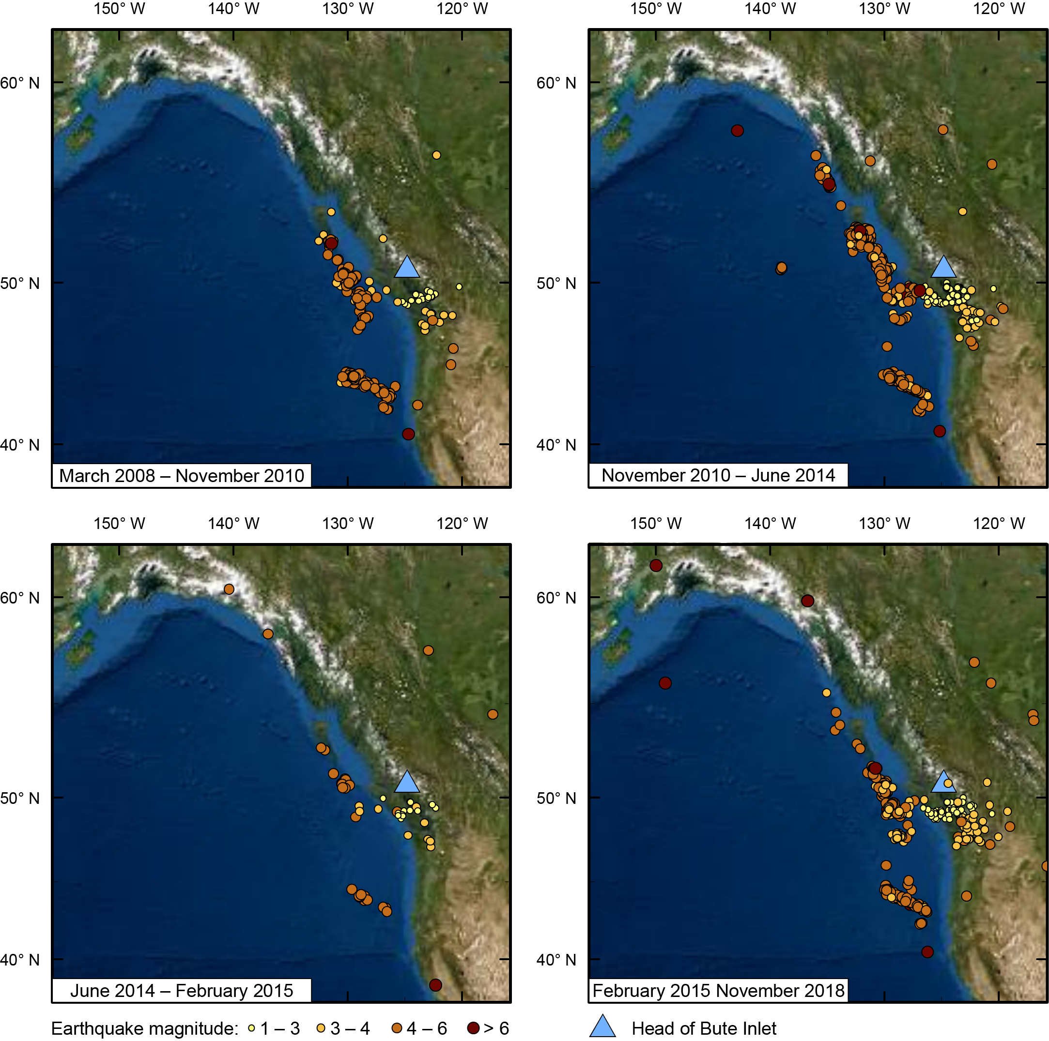
Supplementary Figure 1: Earthquakes around Bute Inlet in different periods of lobe activity.
Rates of knickpoint migration relative to frequency of flows
The rate of knickpoint migration does not appear to obviously relate to the frequency of turbidity currents, and it is therefore likely that only certain types of turbidity current result in knickpoint migration (Chen et al., 2021). Knickpoint Zone 1 (8-10 km along channel) had an average annual migration rate of 280 m/year (Heijnen et al., 2020), and it was traversed by at least 28 turbidity currents during the two 6-month ADCP monitoring periods. Knickpoint Zone 2 (14-22 km along channel) experienced at least 6 turbidity currents in the 6-month monitoring period, and migrated at an average annual rate of 255 m/year. Knickpoint Zone 3 (27-33 km along channel) experienced at least 4 turbidity currents, with an average annual migration rate of 178 m/year.

Will knickpoint-related erosion and deposition balance over time?
Turbidity currents can cause groups of knickpoints in submarine channels to migrate upstream. This upstream migration is associated with headward erosion and downstream dumping of sediment. This results in alternating zones of erosion and deposition along knickpoint-dominated channels that move along the channel (Heijnen et al. 2020). Repeat seafloor mapping shows that this deposition and erosion can balance over time within a knickpoint zone, effectively generating a bypass zone (Fig 4). However, the timescale of this study is too short to observe whether upstream-migrating knickpoint-zones result in the generation of larger bypass zones in the channel (Fig. 3).
However, an erosion rate can be predicted based on the observed migration rate of the knickpoints, cumulative height of the knickpoint in the knickpoint-zones, and distance to the next knickpoint-zone upstream (table 2):
- The deposition rate in the depositional zone downstream of a knickpoint is determined by dividing the maximum thickness of the deposition just upstream of the next knickpoint zone by the time between the two surveys (11 years in this case).
- The erosion rate is determined by, first, measuring the the distance between the fronts of two knickpoint zones and then dividing this by the upstream migration rate of the downstream knickpoint zone. This gives the time for an entire knickpoint zone and associated depositional zone to migrate past a certain point. Then the cumultative height of all knickpoints within the knickpoint-zone is divided by this time for a knickpoint zone to migrate past. This approach assumes that the total erosion in a knickpoint-zone is equal to the height of the knickpoints within that zone.
 | Knickpoint-zone 2 | Knickpoint-zone 3
Deposition just upstream of the knickpoint-zone | 12 m | 8 m
Deposition rate upstream of the knickpoint-zone | 1.1 m/y | 0.7 m/y
Average distance to next knickpoint-zone upstream | 4.2 km | 11.1 km
Average knickpoint-zone migration rate | 255 m/y | 178 m/y
Migration time for the entire knickpoint-zone | 17 y | 62 y
Typical combined knickpoint-zone height | 30 m | 45 m
Predicted erosion rate upstream of the knickpoint-zone | 1.8 m/y | 0.7 m/y
Supplementary table 3: Deposition rates and prediction of erosion rates associated with knickpoint-zones 2 and 3
The resulting estimations show that knickpoint erosion and deposition were balanced around knickpoint-zone 3, whilst the erosion exceeded the deposition around knickpoint-zone 2, however they are in the same order of magnitude. This suggests that erosion and deposition related to upstream-migrating knickpoints can generate bypass.
Estimating stratigraphic completeness of channel deposits in Bute Inlet over 10s to 100s of years
Stratigraphic completeness is the used to describe how deposited sediment is persevered over a given timescale (Sadler, 1981; Straub and Esposito, 2013; Strauss and Sadler, 1989; Vendettuoli et al., 2019). Areas where all deposits are preserved have 100% stratigraphic completeness, and if only half of the deposits are preserved the stratigraphic completeness is 50%, etc. Here we estimate the stratigraphic completeness of the knickpoint-dominated channel in Bute Inlet over decades to centuries by comparing the observed deposition in the channel over 11 years (this study) with modelled longer-term aggradation rates for the system (Syvitski et al., 1988). The submarine channel in Knight Inlet, a similar system to Bute Inlet, has been modelled to aggrade by 1–5 cm/yr on timescales of 1000s of years (Syvitski et al., 1988). However, sediment accumulates in the depositional zones between the knickpoints with in the order 1 m/yr (Fig. 3c; Supplementary table 1; Heijnen et al., 2020). This suggests that the resulting stratigraphic completeness for the knickpoint-dominated channel-axis deposits in Bute Inlet is 1–5%.
Bute Inlet submarine channel long profile
Supplementary Figure 2 presents a long profile along the axis of the submarine channel in Bute Inlet.
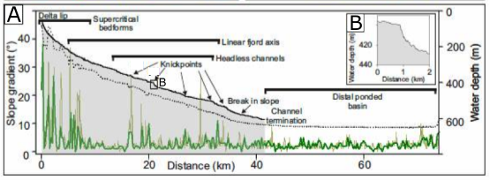
Supplementary Figure 2: (A) Long profile of submarine channel in Bute Inlet (solid black line), modified from Gales et al. (2019). Dark green line is the fjord axis gradient, while light green line is a smoother gradient plot. Inset figure B shows a single knickpoint.

Supplementary information on turbidity current characteristics
The supplementary spreadsheet “BUTE FLOW DATA.xlsx” provides information on the characteristics of turbidity currents monitoring using ADCPs during 2016 and 2018 mooring deployments. This includes: i) Tab 1 “Arrival times all moorings” which details the arrival times (day and time in UTC) of flows at the different moorings, the minimum runout distance, and the maximum measured velocity from the ADCP; and ii) Tab 2 “TC characteristics” which details the maximum velocity and duration of turbidity currents as recorded at each mooring location.
References for supplementary material
Heijnen, M.S., Clare, M.A., Cartigny, M.J.B., Talling, P.J., Hage, S., Lintern, D.G., Stacey, C., Parsons, D.R., Simmons, S.M., Chen, Y., Sumner, E.J., Dix, J.K., Hughes Clarke, J.E., 2020. Rapidly-migrating and internally-generated knickpoints can control submarine channel evolution. Nat. Commun. 11. https://doi.org/10.1038/s41467-020-16861-x
Gales, J.A., Talling, P.J., Cartigny, M.J., Hughes Clarke, J., Lintern, G., Stacey, C. and Clare, M.A., 2019. What controls submarine channel development and the morphology of deltas entering deep‐water fjords?. Earth Surface Processes and Landforms, 44(2), pp.535-551.

Sadler, P.M., 1981. Sediment accumulation rates and the completeness of stratigraphic sections. J. Geol. 89, 569–584. https://doi.org/10.1086/628623
Straub, K.M., Esposito, C.R., 2013. Influence of water and sediment supply on the stratigraphic record of alluvial fans and deltas: Process controls on stratigraphic completeness. J. Geophys. Res. Earth Surf. 118, 625–637. https://doi.org/10.1002/jgrf.20061
Strauss, D., Sadler, P.M., 1989. Stochastic models for the completeness of stratigraphic sections. Math. Geol. 21, 37–59. https://doi.org/10.1007/BF00897239
Syvitski, J.P.M., Smith, J.N., Calabrese, E.A., Boudreau, B.P., 1988. Basin sedimentation and the growth of prograding deltas. J. Geophys. Res. 93, 6895–6908. https://doi.org/10.1029/JC093iC06p06895
Vendettuoli, D., Clare, M.A., Clarke, J.E.H., Vellinga, A., Hizzett, J., Hage, S., Cartigny, M.J.B., Talling, P.J., Waltham, D., Hubbard, S.M., Stacey, C., Lintern, D.G., 2019. Daily bathymetric surveys document how stratigraphy is built and its extreme incompleteness in submarine channels. Earth Planet. Sci. Lett. 515, 231–247. https://doi.org/10.1016/J.EPSL.2019.03.033

