**APPENDIX 4. RETRIEVED TREES.**

Morphological tree, bootstrap support values, Analysis 1



Morphological tree, Bremer support values, Analysis 1



Morphological tree, bootstrap support values, Analysis 2



Morphological tree, Bremer support values, Analysis 2



Morphological tree, bootstrap support values, Analysis 3



Morphological tree, Bremer support values, Analysis 3



Benthesicymidae BI molecular tree

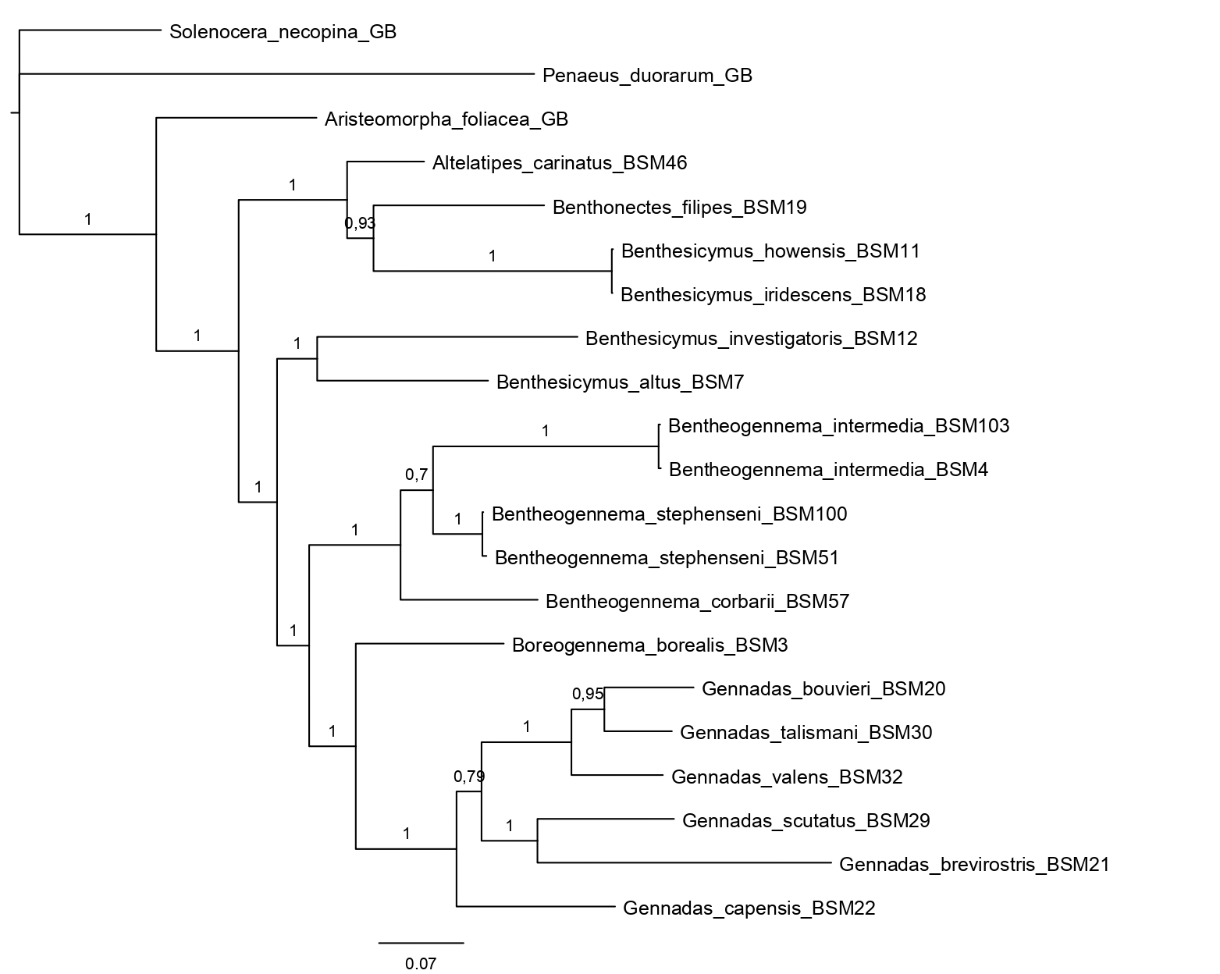

Benthesicymidae ML molecular tree

