APPENDIX 5. Supplementary morphological data

Bentheogennema corbariae sp.n.: photo (MNHN-IU-2016-11805), general view of mutilated specimen

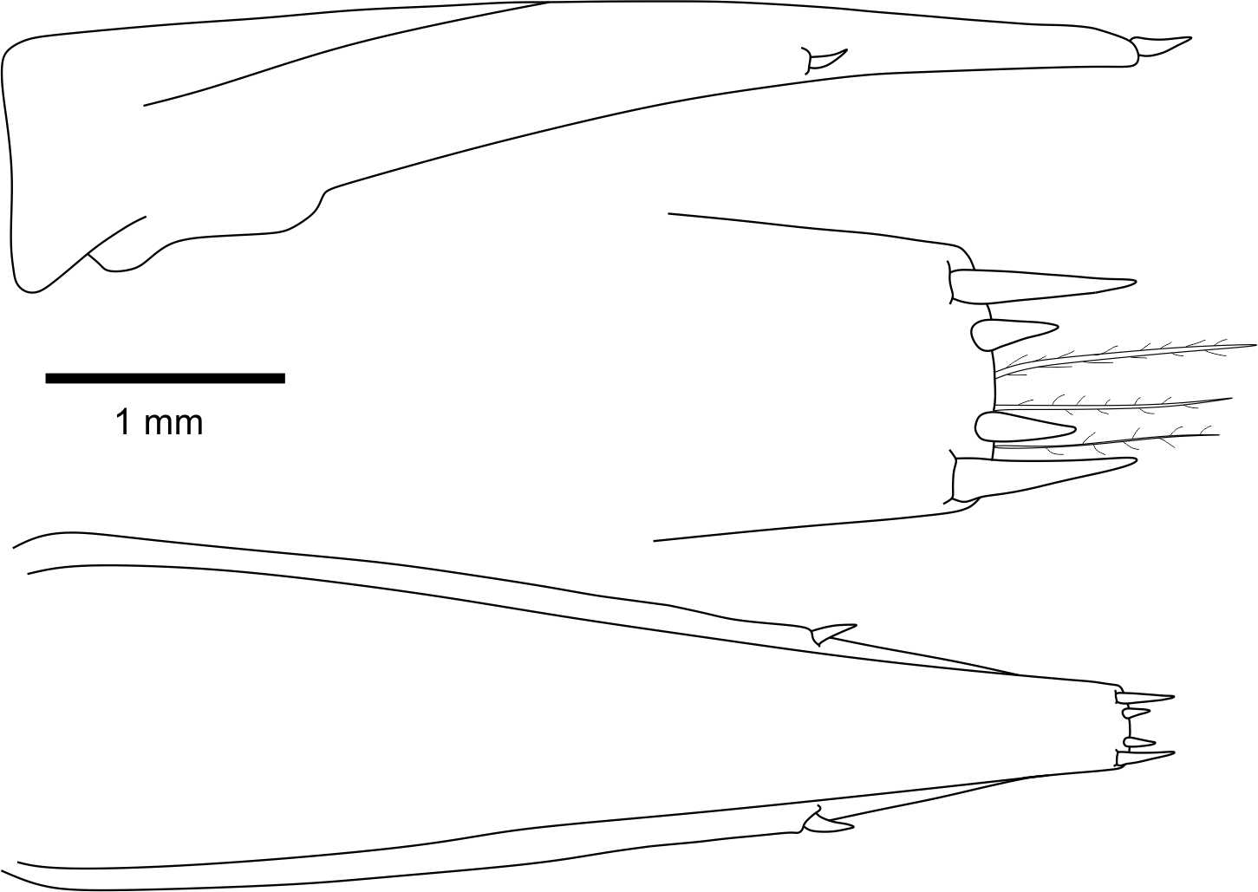

Telson of Bentheogennema borealis: scheme (MNHN-IU-2016-9205), telson, lateral and dorsal view.

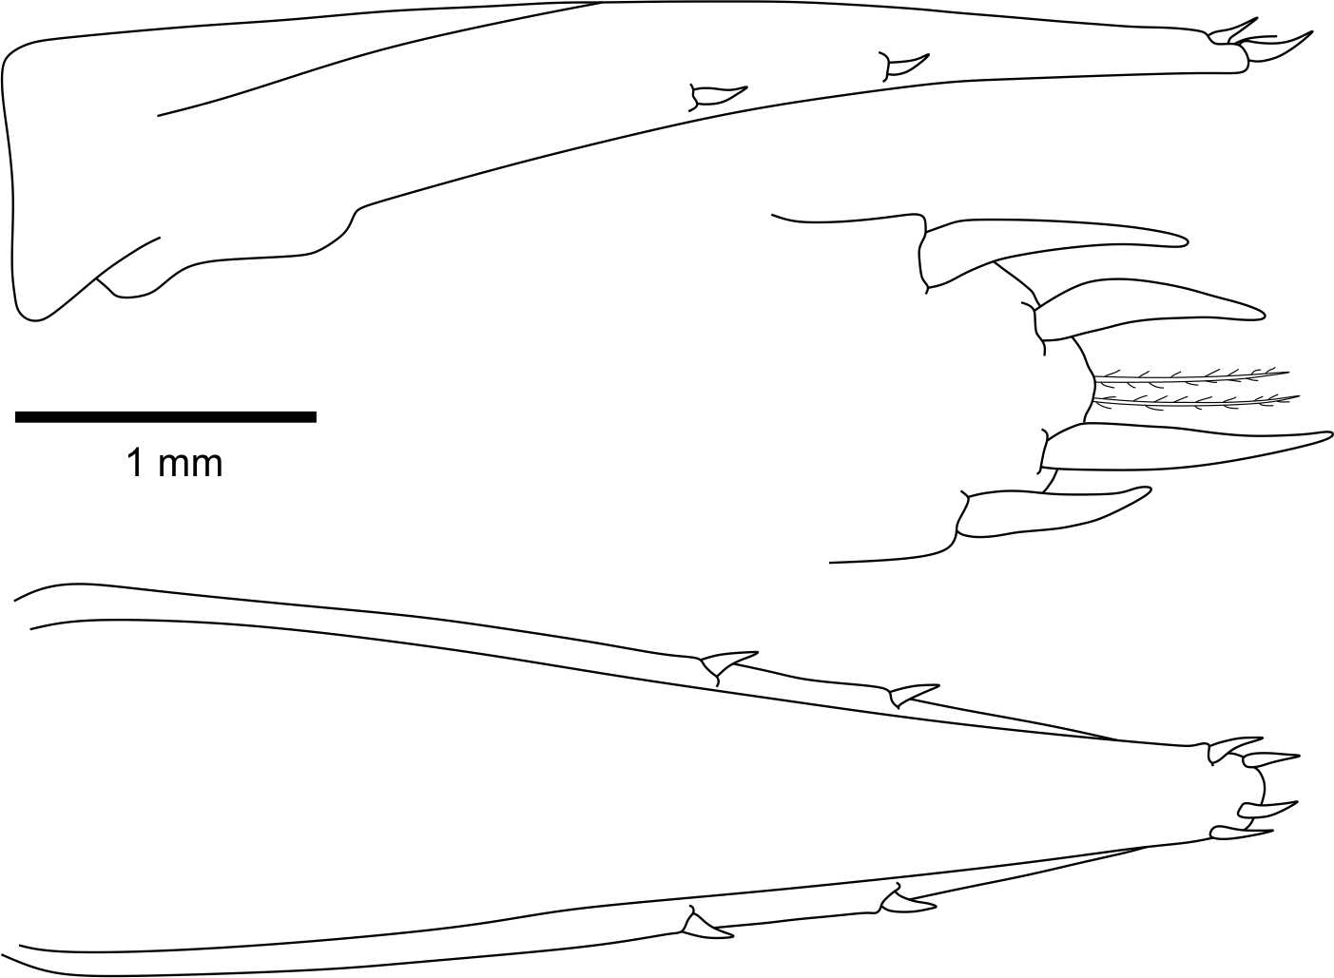

Telson of Bentheogennema intermedia: SEM (NHMD 228678), telson, dorsal view; scheme (MP-Na-12445), telson, lateral and dorsal view

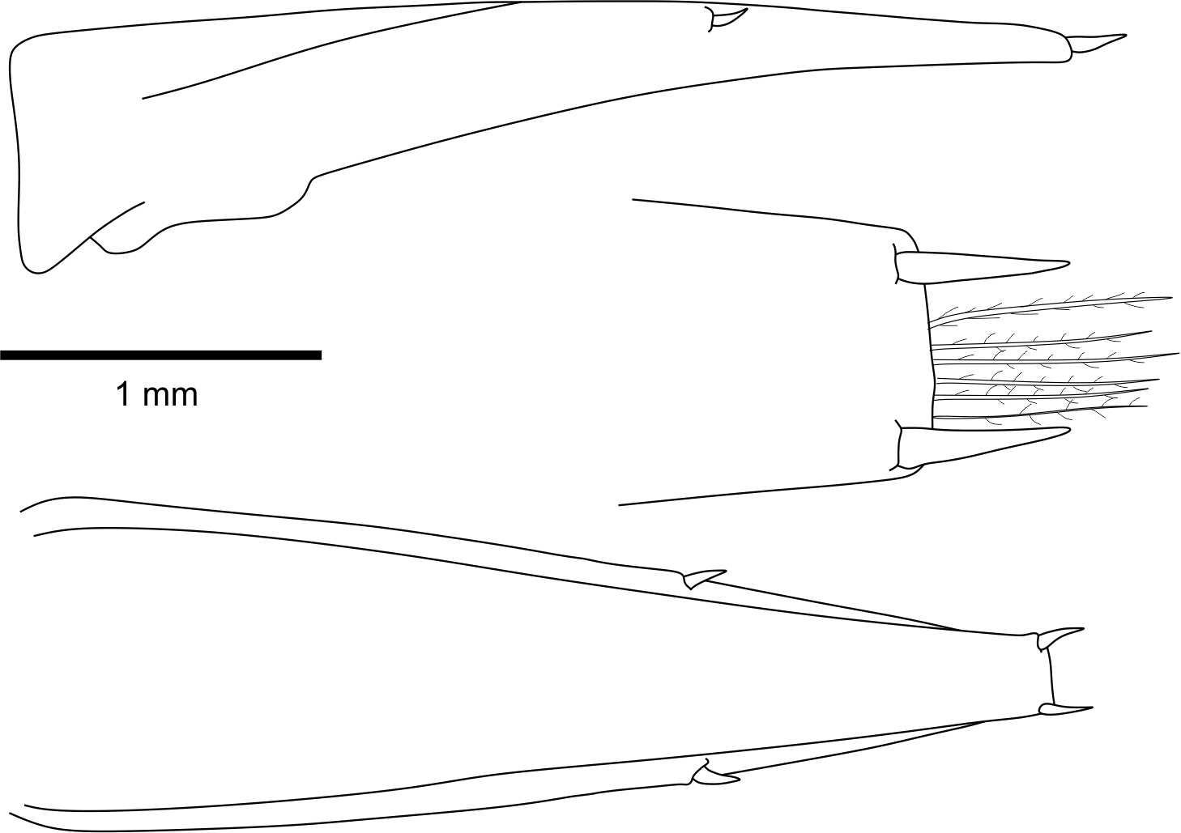
Telson of Bentheogennema stephenseni: scheme (MP-Na-6453), telson, lateral and dorsal view.

Bentheogennema corbariae sp.n: SEM (MNHN-Na-6453), telson, lateral view

Bentheogennema torbenwolffi sp.n : SEM (NHMD-228681), telson, lateral view
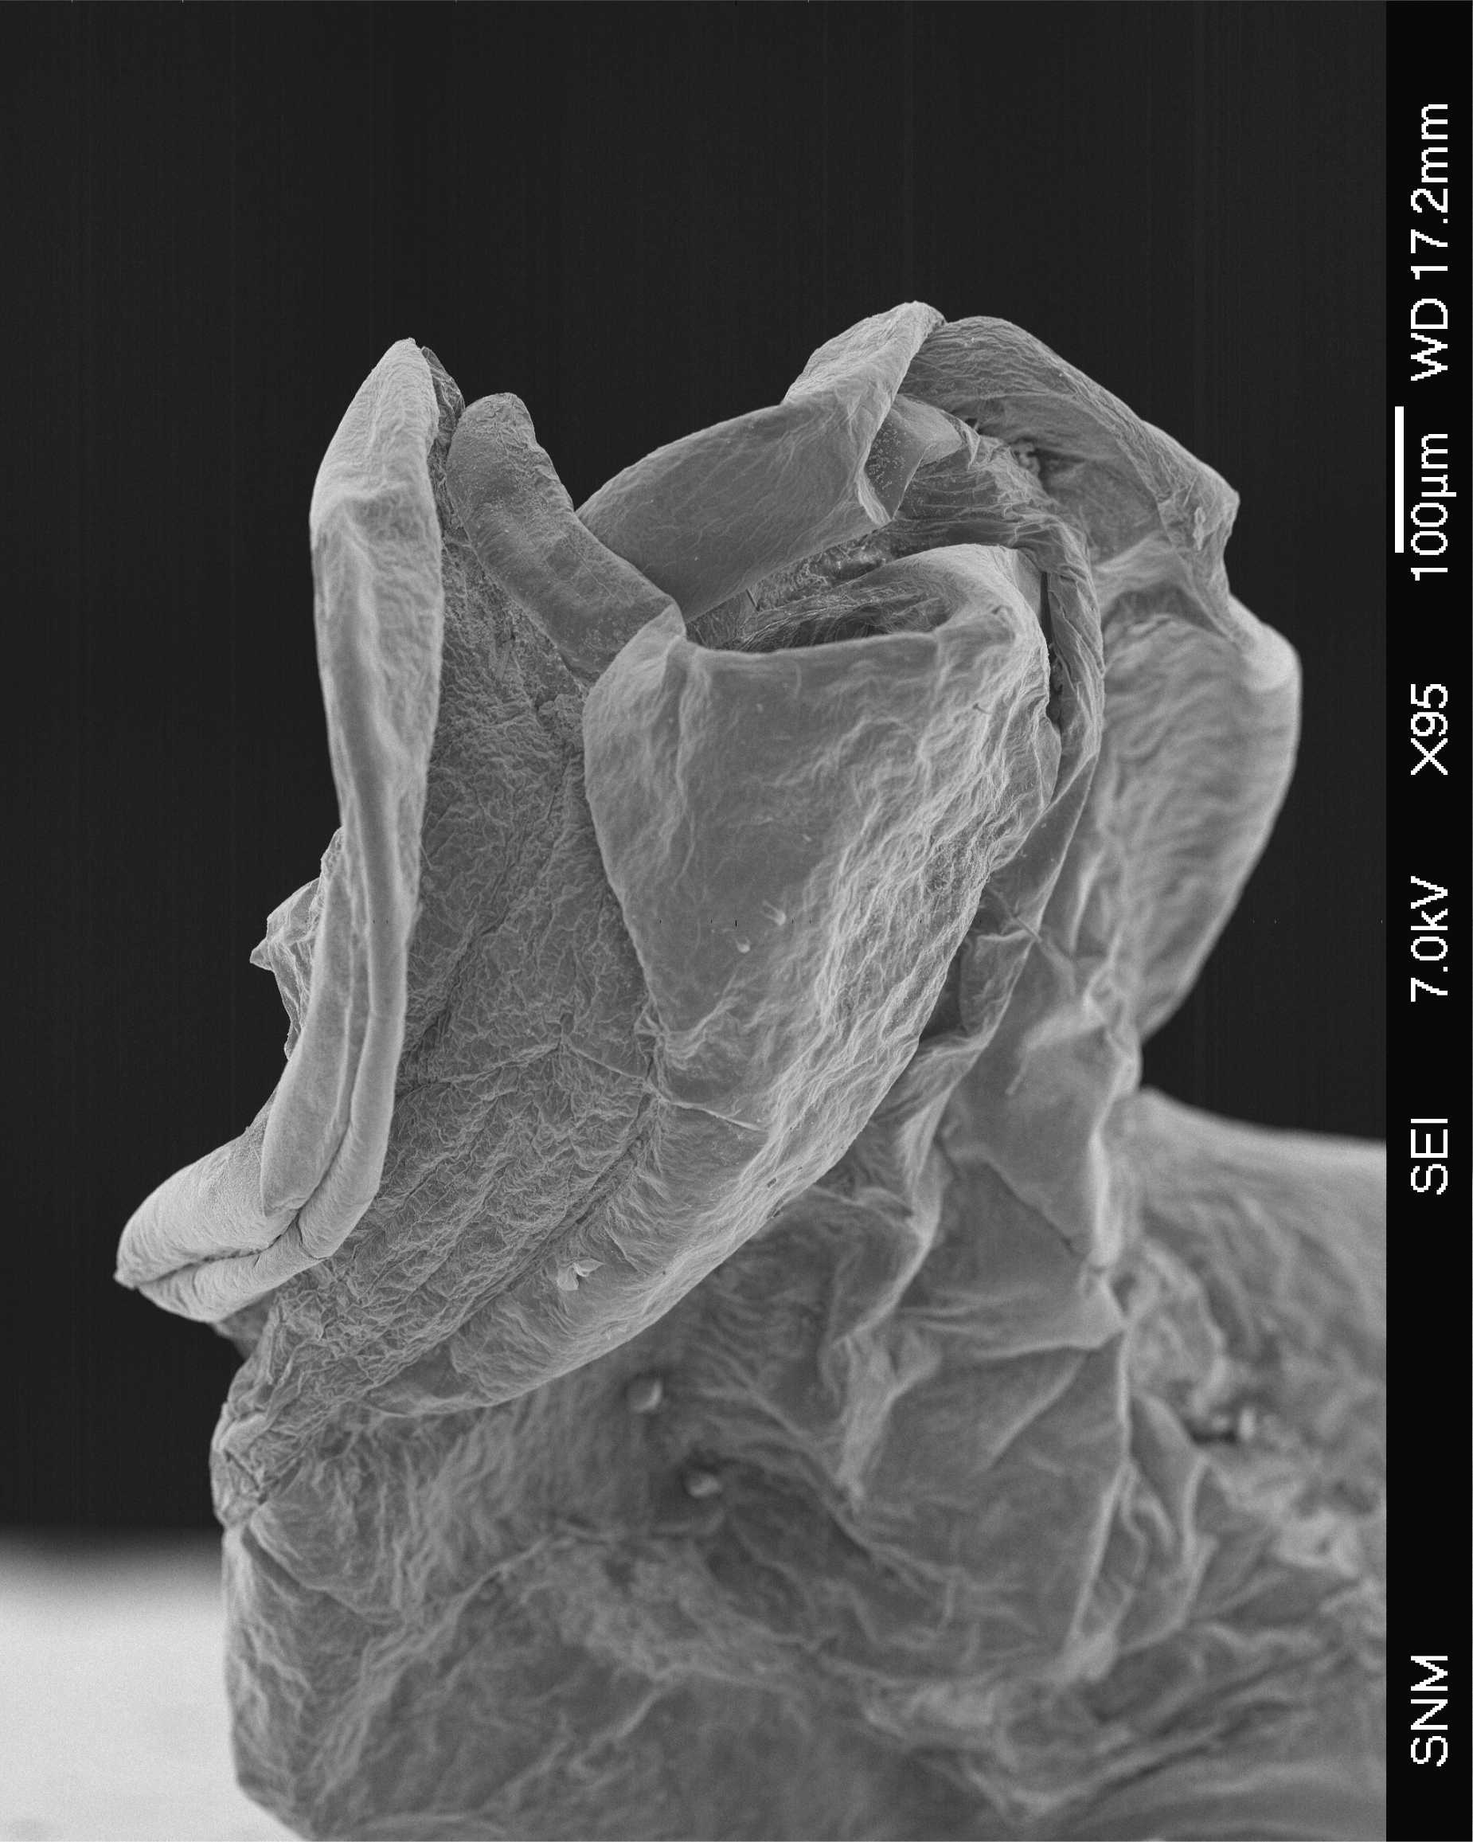
Bentheogennema corbariae sp.n: SEM (MNHN-IU-2016-11805), petasma, dorsal view

