Supplementary information about the modelling approach.
Here we use a Total Matrix Intercomparison (TMI; Gebbie and Huybers, 2010) model to study the effect of circulation and biological cycling on Ni cycling. The TMI is a global water mass decomposition that avoids subjective definitions of ocean interior water mass end-members by tracing the ocean interior waters back to their surface origins (Gebbie and Huybers, 2010). The TMI solution is constrained by observational climatologies of hydrographic and biogeochemical parameters as described by Gebbie and Huybers (2010). The TMI circulation is presented on a 4°×4° grid with 33 depth levels.
We first model the distribution of Ni and its isotopes only in terms of ocean circulation:

${Ni}_{pre}= A^{-1}×{Ni}_{b}$ (1)

${Ni}_{pre}^{60}= A^{-1}× {Ni}_{b}^{60}$ (2)

where the concentrations of Ni (${Ni}_{pre}$) and ⁶⁰Ni (${Ni}_{pre}^{60}$) in the ocean are modelled by propagating their surface boundary conditions (${Ni}_{b }$and ${Ni}_{b}^{60}$ respectively) using the circulation pathway matrix A. The resulting Ni_{pre} and ⁶⁰Ni_{pre} fields represent the preformed component of the dissolved pool.
We derive the surface boundary condition ${Ni}_{b }$using the surface (<100 m) Ni concentration data of the GEOTRACES IDP2021 (GEOTRACES Intermediate Data Product Group, 2021). We subdivide and average the data according to the surface ocean patches defined by TMI. In the high latitude surface regions including the Antarctic and Subantarctic Zones of the Southern Ocean, subpolar North Atlantic, subpolar North Pacific and Arctic, we use the data-based average Ni concentrations for the boundary condition. In the surface low latitude regions (~40°S to ~40°N; see Gebbie and Huybers, 2010), we take the boundary condition to be 2 nmol/L, which is the concentration found in these regions (Takano et al., 2017; Archer et al., 2020; Yang et al., 2020, 2021). The uncertainties on the boundary conditions of Ni concentration are propagated through the model (Fig. S1).
We then calculate the isotopic surface boundary condition as:

(3)

Where δ⁶⁰Ni_{b} is the ⁶⁰Ni/⁵⁸Ni ratio in δ-notation, 0.3852 is the ⁶⁰Ni/⁵⁸Ni ratio of reference material NIST SRM 986 and 0.68 is the natural abundance of ⁵⁸Ni. Presently, there is not enough δ⁶⁰Ni data to define the isotopic boundary condition (δ⁶⁰Ni_{b}) for each surface patch of TMI (Fig. S2). However, published studies suggest that surface waters in high latitudes have δ⁶⁰Ni values similar to the uniform deep ocean (Cameron and Vance, 2014; Wang et al., 2019), so we assign them a δ⁶⁰Ni value of +1.33 ‰ (world ocean average). In the low latitude surface, existing data converge to a heavy δ⁶⁰Ni value of ~+1.7 ‰ (Archer et al., 2020; Takano et al., 2017; Yang et al., 2021, 2020), which we assign to the surface low latitude patches in TMI. In the model we assume the uncertainty of the surface δ⁶⁰Ni boundary condition is ±0.07 ‰ (2σ) which is our analytical error. This error is then propagated through the model (Fig. S1).
We cannot explicitly model surface Ni biological cycling because TMI treats the surface as a boundary condition. However, we can add an interior biological cycling term by linking Ni remineralisation to that of PO₄³⁻:

${Ni}_{bio}= A^{-1}×({Ni}_{b}+ ∆{PO}_{4}×r_{Ni/PO4})$ (4)

${Ni}_{bio}^{60}= A^{-1}×({Ni}_{b}^{60}+∆{PO}_{4}× r_{{}_{.}^{60}{Ni/PO4}})$ (5)

where ΔPO₄ refers to the remineralised PO₄³⁻ determined by the TMI from PO₄³⁻ and O₂ concentrations, r_{Ni/PO4} and r_{60Ni/PO4} are the stoichiometric coefficients of Ni and ⁶⁰Ni to PO₄³⁻. In the high latitudes, we assign a value of 0.52 mmol/mol to r_{Ni/PO4} based on the Ni quota in diatoms, while in the low latitudes, we assign a value of 3.4 mmol/mol to r_{Ni/PO4} based on the Ni quota in cyanobacteria (Twining et al., 2012). In this way we try to simply capture the influence of the different ecosystems in the high and low latitude regions. For Ni isotopes, similar to equation (3) we have

(6)

where δ⁶⁰Ni_{r} is the isotope composition of remineralised Ni.

Model results generally reproduce the structure of the observations (Fig. 2; Figs. S1, S5). The root-mean square error (RMSE) of modelled δ⁶⁰Ni compares very well to the analytical error on isotope measurements (0.09 and 0.07 ‰, respectively; n=308). The RMSE of modelled Ni concentration, of 1.44 nmol/L, is computed against all the data in IDP2021 (n=8426; GEOTRACES Intermediate Data Product Group, 2021), i.e. representing much more data than we use for δ⁶⁰Ni. This error is relatively high because the model underestimates Ni concentrations in the deep Pacific. The error can be reduced, if we use a r_{Ni/PO4} ratio higher than the reported cyanobacterial Ni quota which will increase the amount of remineralised Ni. Alternatively, there may be a benthic source of Ni from the sediments that is not included in the model (Little et al., 2020; Gueguen and Rouxel, 2021). Along the GEOVIDE transect, modelled Ni concentrations are underestimated at depths of 100–400 m and 4000–4500 m in low latitude waters, with the latter depth range subject to Southern Ocean influence (Fig. 2a). Modelled Ni concentrations are also generally overestimated for the high latitude North Atlantic (Fig. 2c). This data-model difference likely stems from our assumption that uptake in the entire high latitude ocean has the same r_{Ni/PO4} ratio of 0.52 mmol/mol based on reported diatom Ni quotas (Twining et al., 2012), almost certainly an over-simplification. The data-model difference can be reduced by increasing the r_{Ni/PO4} ratio in the Southern Ocean while decreasing the r_{Ni/PO4} ratio in the North Atlantic. This is not unexpected given that phytoplankton communities in the two high latitude regions are not identical, though both are dominated by diatoms.

Figure S1.

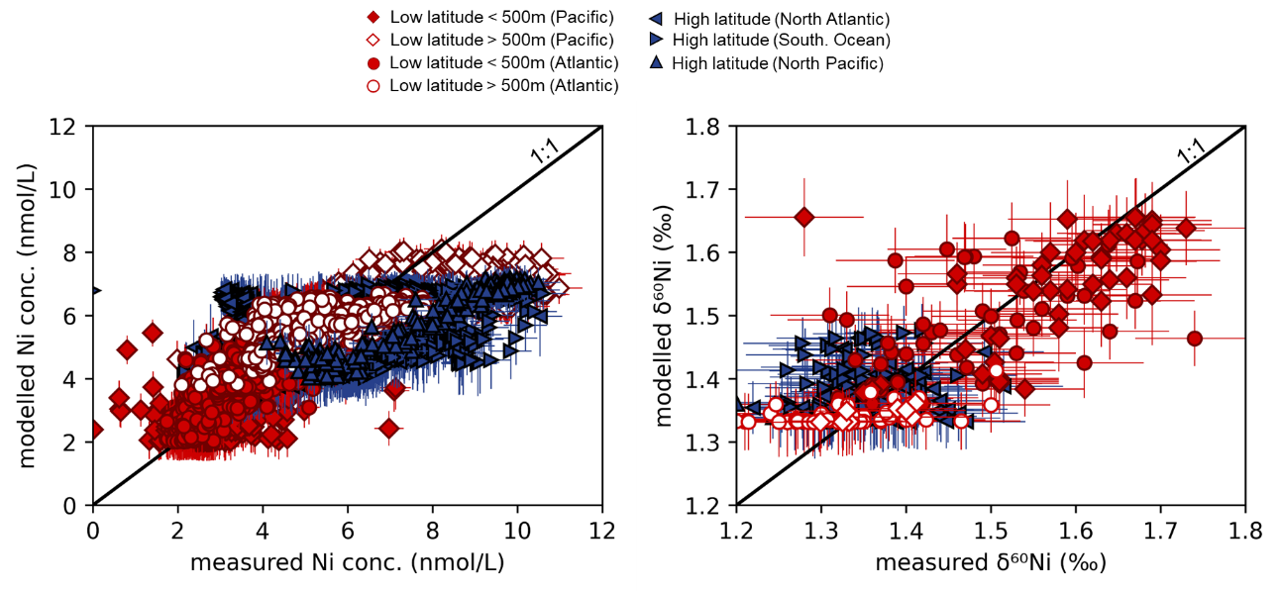

Fig. S1: Modelled versus measured Ni concentrations (for stations for which data are available in the IDP2021; left panel) and Ni isotope compositions (for stations where δ⁶⁰Ni data are available; right panel). Model results are from our standard model and identical to those shown in Fig. 6 of the main text. The model uncertainties for both Ni concentration and δ⁶⁰Ni are explained in the text.

Figure S2.
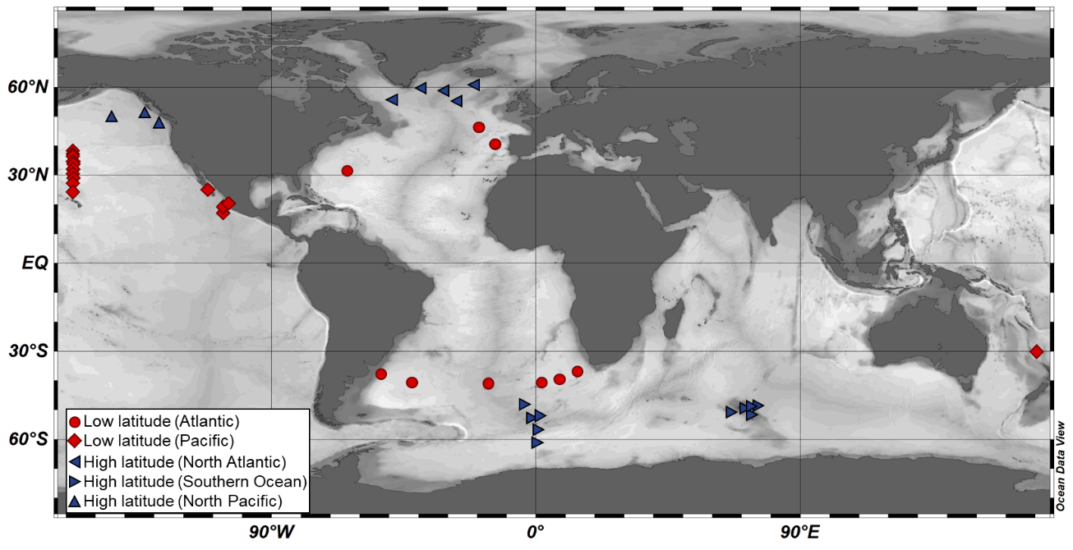

Fig. S2: Stations from this study (GEOVIDE) and from the world ocean where Ni concentrations and δ⁶⁰Ni are available (Cameron and Vance, 2014; Takano et al., 2017; Wang et al., 2019; Archer et al., 2020; Yang et al., 2020, 2021). Stations from the low latitude ocean are indicated by red symbols while stations from the high latitude ocean are indicated by blue symbols. The separation between both regions is set by the latitude 47° in the northern and southern hemispheres. A distinction is made between the subpolar North Atlantic (triangles pointing towards the left), the Southern Ocean (triangles pointing towards the right), the subpolar North Pacific (triangles pointing upwards), the low latitude Atlantic Ocean (circles) and the low latitude Pacific Ocean (diamonds).

Figure S3.
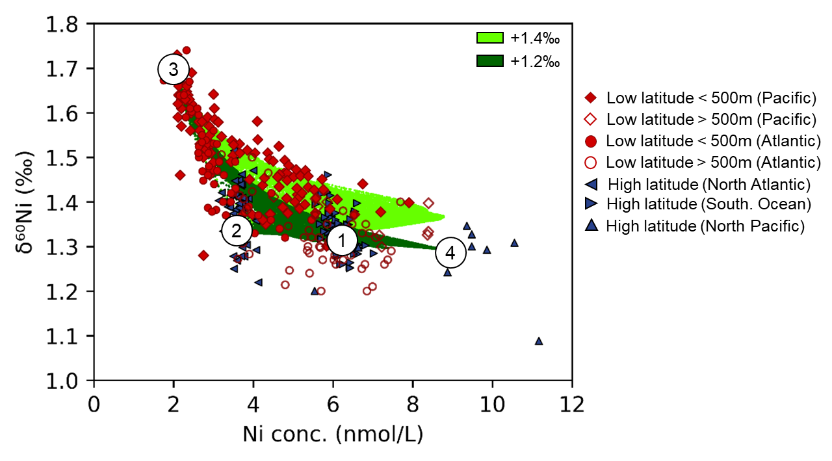

Fig. S3: Comparison of the dissolved Ni-δ⁶⁰Ni systematics observed in the world ocean (in blue and red, see previous captions) with the results of the Total Matrix Intercomparison model, simulating both the physical circulation and remineralisation. The results are shown for two different isotope compositions for the regenerated pool in the low latitudes, at +1.2 ‰ and +1.4 ‰ (the high latitude remineralised δ⁶⁰Ni remains +1.33 ‰). End-member 3 represents the surface low latitude region; end-member 2 represents the subpolar North Atlantic region; end-member 1 represents the Southern Ocean; and end-member 4 represents the North Pacific.

Figure S4.

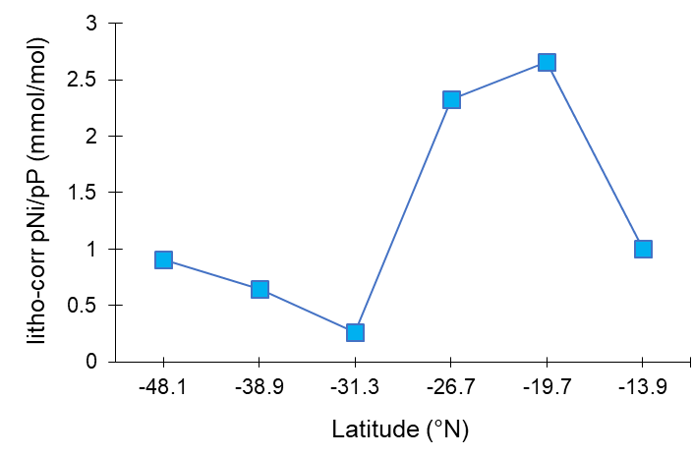
Fig. S4: Latitudinal variation of the lithogenic-corrected particulate Ni/P ratios (pNi/pP) along the GEOVIDE transect, with particulate data obtained from in-situ pumps (Lemaitre et al., 2020). The trend is confirmed by GoFlo data (Planquette et al., personal communication).

Figure S5.

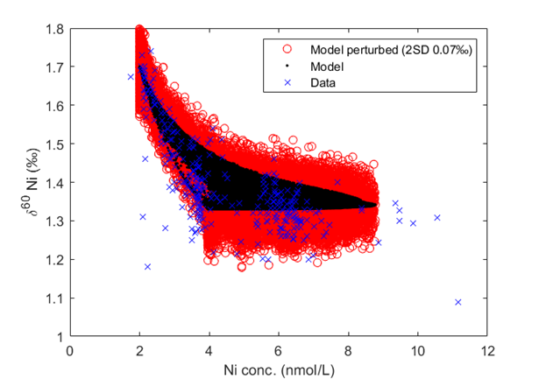

Fig. S5: Comparison of the dissolved Ni-δ⁶⁰Ni systematics from the world ocean (in blue) with the results of the Total Matrix Intercomparison model, simulating both the physical circulation and remineralisation (in black, see Figure S1 and Fig. 6 of the main text). Red circles represent model output (black) perturbed with normally-distributed noise (2SD ±0.07 ‰) in order to represent the observational data expected if the model distribution were sampled with current analytical uncertainty. This comparison shows that our standard model output is consistent with the vast majority of data within analytical uncertainty on δ⁶⁰Ni.

Figure S6.
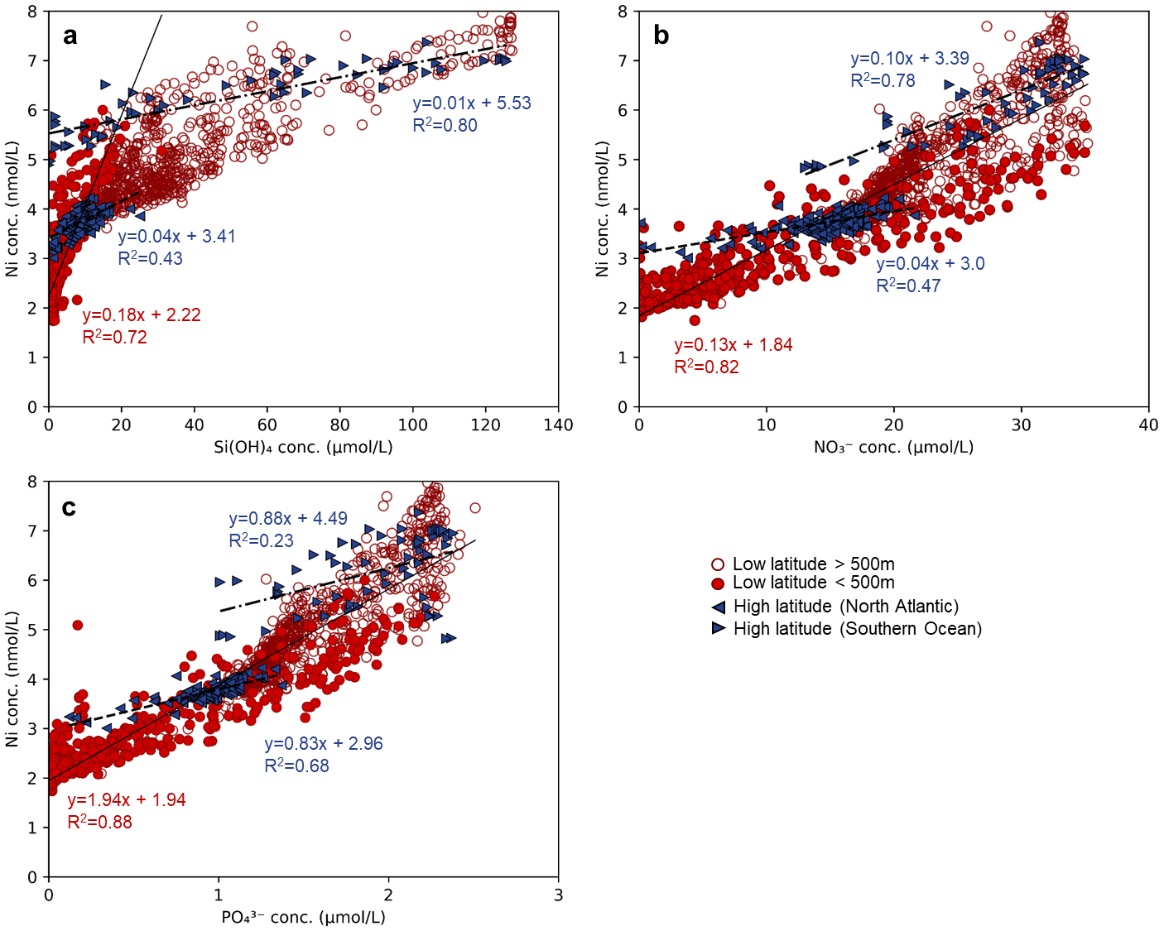

Fig. S6: Ni concentrations against Si(OH)₄ (a), NO₃⁻ (b) and PO₄³⁻ (c) concentrations in the Atlantic ocean (from the GEOVIDE, GA02, GA03, ANT XXIV/3, GA10, and RRS 354 cruises; GEOTRACES Intermediate Data Product, 2021). Red circles indicate stations from the low latitude ocean (filled symbols for depths <500 m) while blue triangles indicate stations from the high latitude ocean (triangles pointing towards the right for the Southern Ocean and triangles pointing towards the left for the subpolar North Atlantic). Correlations between data are also indicated: the continuous thin black line for low latitude stations (only for the upper 500 m for the Ni-Si(OH)₄ relationship), the dashed black lines for subpolar stations.

Table S1. Dissolved δ⁶⁰Ni, Ni concentrations, silicate (Si(OH)₄), nitrate (NO₃⁻), temperature and salinity for 6 stations across the GEOVIDE transect. There are no PO₄³⁻ data available for GEOVIDE.

Depth | δ⁶⁰Ni | 2SD | [Ni] | NO₃⁻ | SiOH₄ | Temperature | Salinity
m | ‰ | ‰ | nmol/L | µmol/L | µmol/L | °C | psu
Station 13: 41.4°N, -13.9°E, Bottom depth 5345m
15 | 1.64 | 0.08 | 2.14 | 0.1 | 0.5 | 15.46 | 35.85
60 | 1.60 | 0.08 | 2.45 | 2.9 | 0.9 | 13.27 | 35.76
99 | 1.52 | 0.08 | 2.63 | 6.8 | 1.8 | 12.88 | 35.74
149 | 1.45 | 0.06 | 2.74 |  |  | 12.75 | 35.73
199 | 1.47 | 0.04 | 2.72 | 7.8 | 2.3 | 12.56 | 35.70
298 | 1.54 | 0.03 | 2.80 | 10.3 | 3.1 | 12.20 | 35.66
495 | 1.38 | 0.09 | 3.06 | 11.6 | 3.7 | 11.69 | 35.62
595 | 1.51 | 0.08 | 3.20 | 13.9 | 5.0 | 11.31 | 35.59
790 | 1.36 | 0.04 | 3.66 | 18.4 | 8.7 | 10.76 | 35.73
990 | 1.39 | 0.09 | 3.84 |  |  | 9.26 | 35.64
1187 | 1.33 | 0.06 | 3.84 | 18.0 | 10.6 | 9.30 | 35.84
1975 | 1.42 | 0.05 | 3.97 | 19.1 | 16.3 | 3.97 | 35.03
2466 | 1.46 | 0.08 | 4.37 | 20.2 | 23.8 | 3.30 | 34.98
2952 | 1.35 | 0.06 | 4.88 | 21.4 | 33.3 | 2.85 | 34.95
3932 | 1.30 | 0.08 | 5.68 | 23.0 | 43.4 | 2.53 | 34.91
4904 | 1.32 | 0.05 | 5.46 | 23.3 | 46.5 | 2.52 | 34.90
5330 | 1.34 | 0.04 | 5.39 | 23.3 | 47.0 | 2.57 | 34.90
Station 21: 46.5°N, -19.7°E, Bottom depth 4518m
20 | 1.67 | 0.04 | 1.75 | 4.4 | 1.6 | 13.78 | 35.66
50 | 1.60 | 0.03 | 2.62 | 4.4 | 1.6 | 12.69 | 35.61
100 | 1.39 | 0.09 | 2.86 | 8.6 | 2.9 | 12.48 | 35.64
199 | 1.53 | 0.06 | 2.71 | 9.8 | 3.4 | 12.04 | 35.63
298 | 1.53 | 0.05 | 3.00 | 10.2 | 3.6 | 11.76 | 35.59
397 | 1.38 | 0.09 | 2.96 | 12.4 | 4.5 | 11.32 | 35.54
495 | 1.47 | 0.03 | 3.00 | 11.4 | 4.1 | 10.96 | 35.49
790 | 1.42 | 0.04 | 3.65 | 17.4 | 8.0 | 9.20 | 35.34
990 | 1.41 | 0.05 | 3.75 | 19.2 | 10.8 | 7.61 | 35.33
1237 | 1.38 | 0.05 | 3.79 | 18.8 | 11.0 | 5.76 | 35.15
1483 | 1.34 | 0.06 | 3.75 | 18.4 | 10.9 | 4.52 | 35.00
1975 | 1.31 | 0.06 | 3.74 | 18.3 | 12.2 | 3.71 | 34.93
2268 | 1.28 | 0.04 | 3.90 | 18.3 | 13.3 | 3.40 | 34.92
2759 | 1.27 | 0.05 | 3.61 | 18.5 | 15.9 | 3.07 | 34.94
3442 | 1.21 | 0.07 | 4.80 | 21.8 | 37.0 | 2.71 | 34.93
4415 | 1.29 | 0.04 | 5.41 | 22.9 | 43.7 | 2.56 | 34.91
4507 | 1.29 | 0.08 | 5.35 | 23.3 | 45.6 | 2.57 | 34.91

Depth | δ⁶⁰Ni | 2SD | [Ni] | NO₃⁻ | SiOH₄⁻ | Temperature | Salinity
m | ‰ | ‰ | nmol/L | µmol/L | µmol/L | °C | psu
Station 32: 55.5°N, -26.7°E, Bottom depth 3234m
30 | 1.33 | 0.05 | 3.24 | 9.2 | 2.2 | 10.34 | 35.12
50 | 1.39 | 0.08 | 3.36 |  |  | 8.46 | 35.04
99 | 1.42 | 0.09 | 3.20 | 9.5 | 2.0 | 8.71 | 35.13
198 | 1.31 | 0.06 | 3.45 | 13.9 | 5.8 | 8.12 | 35.11
298 | 1.37 | 0.09 | 3.97 | 15.5 | 7.5 | 6.65 | 34.92
397 | 1.41 | 0.03 | 3.87 | 16.5 | 8.4 | 6.77 | 35.06
496 | 1.30 | 0.04 | 3.83 | 19.0 | 10.8 | 5.71 | 34.99
792 | 1.28 | 0.04 | 3.78 | 17.7 | 9.8 | 4.47 | 34.94
990 | 1.44 | 0.08 | 3.69 | 17.1 | 9.6 | 4.11 | 34.92
1236 | 1.46 | 0.10 | 3.71 | 16.9 | 9.8 | 3.90 | 34.91
1482 | 1.41 | 0.07 | 3.65 | 17.0 | 10.5 | 3.78 | 34.92
1973 | 1.39 | 0.06 | 3.65 | 17.6 | 11.9 | 3.45 | 34.93
2953 | 1.47 | 0.06 | 4.00 | 18.2 | 22.3 | 2.90 | 34.97
3177 | 1.40 | 0.08 | 3.79 |  |  | 2.85 | 34.99
3218 | 1.39 | 0.05 | 3.85 | 18.5 | 25.1 | 2.86 | 34.99
Station 38: 58.8°N, -31.3°E, Bottom depth 1341m
19 | 1.40 | 0.03 | 3.29 | 7.1 | 0.5 | 9.24 | 35.06
50 | 1.36 | 0.04 | 3.33 | 8.8 | 1.2 | 7.94 | 35.07
98 | 1.40 | 0.05 | 3.35 | 14.3 | 5.9 | 7.51 | 35.10
197 | 1.39 | 0.03 | 3.41 | 14.6 | 6.4 | 7.34 | 35.11
297 | 1.42 | 0.03 | 3.42 | 14.8 | 6.6 | 7.12 | 35.09
397 | 1.37 | 0.05 | 3.49 | 15.0 | 6.6 | 6.78 | 35.06
495 | 1.38 | 0.04 | 3.56 | 16.6 | 8.3 | 6.58 | 35.07
792 | 1.35 | 0.04 | 3.66 | 17.8 | 10.3 | 5.17 | 35.03
940 | 1.41 | 0.04 | 3.63 | 17.2 | 10.3 | 4.54 | 34.99
1149 | 1.36 | 0.05 | 3.64 |  |  | 4.03 | 34.99
1285 | 1.37 | 0.03 | 3.64 | 16.8 | 10.6 | 4.01 | 34.99
1337 | 1.28 | 0.06 | 3.69 | 16.7 | 10.9 | 4.01 | 34.99

Depth | δ⁶⁰Ni | 2SD | [Ni] | NO₃⁻ | SiOH₄⁻ | Temperature | Salinity
m | ‰ | ‰ | nmol/L | µmol/L | µmol/L | °C | psu
Station 44: 59.6°N, -38.9°E, Bottom depth 2928m
20 | 1.51 | 0.03 | 3.52 | 16.5 | 8.1 | 6.79 | 34.85
50 | 1.43 | 0.03 | 3.55 |  |  | 4.97 | 34.86
159 | 1.49 | 0.04 | 3.52 | 16.4 | 8.0 | 4.14 | 34.90
199 | 1.33 | 0.04 | 3.74 | 16.5 | 8.2 | 4.06 | 34.90
297 | 1.41 | 0.04 | 3.72 | 16.3 | 8.1 | 3.97 | 34.90
466 | 1.32 | 0.04 | 3.76 | 16.3 | 8.3 | 3.86 | 34.89
595 | 1.34 | 0.04 | 3.72 | 16.4 | 8.4 | 3.68 | 34.87
694 | 1.45 | 0.05 | 3.65 | 16.4 | 8.4 | 3.62 | 34.87
890 | 1.40 | 0.06 | 3.70 | 17.1 | 9.4 | 3.58 | 34.86
1087 | 1.36 | 0.08 | 3.72 | 17.3 | 10.6 | 3.73 | 34.90
1580 | 1.44 | 0.08 | 3.72 |  | 11.5 | 3.54 | 34.93
1973 | 1.36 | 0.09 | 3.68 | 17.0 | 12.7 | 3.23 | 34.93
2217 | 1.39 | 0.09 | 3.76 | 16.9 | 13.6 | 3.04 | 34.93
2561 | 1.38 | 0.08 | 3.67 | 14.1 | 7.6 | 2.65 | 34.91
2756 | 1.45 | 0.04 | 3.54 | 13.8 | 7.3 | 1.59 | 34.87
2851 | 1.36 | 0.05 | 3.52 | 13.8 | 7.4 | 1.34 | 34.88
2916 | 1.33 | 0.06 | 3.47 | 13.8 | 7.4 | 1.29 | 34.89
Station 69: 55.8°N, -48.1°E, Bottom depth 3692m
15 | 1.38 | 0.07 | 3.72 | 0.1 | 3.6 | 6.22 | 34.62
41 | 1.32 | 0.09 | 3.59 | 11.8 | 7.0 | 3.60 | 34.74
70 | 1.33 | 0.10 | 3.68 | 15.4 | 7.4 | 3.89 | 34.82
178 | 1.34 | 0.04 | 3.57 | 15.9 | 8.0 | 3.71 | 34.85
496 | 1.44 | 0.08 | 3.68 | 16.0 | 8.1 | 3.49 | 34.85
792 | 1.35 | 0.05 | 3.69 | 16.2 | 8.2 | 3.48 | 34.85
1087 | 1.36 | 0.10 | 3.69 | 16.2 | 8.3 | 3.46 | 34.85
1580 | 1.31 | 0.07 | 3.76 | 16.8 | 9.1 | 3.62 | 34.89
2071 | 1.34 | 0.07 | 3.72 | 17.1 | 10.8 | 3.45 | 34.92
2364 | 1.35 | 0.09 | 3.73 | 17.2 | 11.6 | 3.22 | 34.92
2756 | 1.39 | 0.08 | 3.64 | 16.8 | 12.5 | 2.93 | 34.92
3196 | 1.30 | 0.07 | 3.72 | 16.4 | 14.0 | 2.48 | 34.91
3439 | 1.25 | 0.05 | 3.51 | 15.4 | 11.5 | 2.00 | 34.90
3635 | 1.27 | 0.06 | 3.59 |  |  | 1.68 | 34.90
3660 | 1.28 | 0.09 | 3.49 | 14.3 | 8.4 | 1.67 | 34.90

Supplementary Information - References

Archer, C., Vance, D., Milne, A., Lohan, M.C., 2020. The oceanic biogeochemistry of nickel and its isotopes: New data from the South Atlantic and the Southern Ocean biogeochemical divide. Earth Planet. Sci. Lett. 535, 116118. doi:10.1016/j.epsl.2020.116118
Cameron, V., Vance, D., 2014. Heavy nickel isotope compositions in rivers and the oceans. Geochim. Cosmochim. Acta 128, 195–211. doi:10.1016/j.gca.2013.12.007
Gebbie, G., Huybers, P., 2010. Total matrix intercomparison: A method for determining the geometry of water-mass pathways. J. Phys. Oceanogr. 40, 1710–1728. doi:10.1175/2010JPO4272.1
GEOTRACES Intermediate Data Product Group, 2021. The GEOTRACES GEOTRACES Intermediate Data Product 2021 (IDP2021). NERC EDS Br. Oceanogr. Data Cent. NOC. doi:doi:10.5285/cf2d9ba9-d51d-3b7c-e053-8486abc0f5fd
Gueguen, B., Rouxel, O., 2021. The Nickel isotope composition of the authigenic sink and the diagenetic flux in modern oceans. Chem. Geol. 563, 120050. doi:10.1016/j.chemgeo.2020.120050
Lemaitre, N., Planquette, H., Dehairs, F., Planchon, F., Sarthou, G., Gallinari, M., Roig, S., Jeandel, C., Castrillejo, M., 2020. Particulate Trace Element Export in the North Atlantic (GEOTRACES GA01 Transect, GEOVIDE cruise). ACS Earth Sp. Chem. 4, 2185–2204. doi:10.1021/acsearthspacechem.0c00045
Little, S.H., Archer, C., McManus, J., Najorka, J., Wegorzewski, A. V., Vance, D., 2020. Towards balancing the oceanic Ni budget. Earth Planet. Sci. Lett. 547, 116461. doi:10.1016/j.epsl.2020.116461
Takano, S., Tanimizu, M., Hirata, T., Shin, K.-C., Fukami, Y., Suzuki, K., Sohrin, Y., 2017. A simple and rapid method for isotopic analysis of nickel, copper, and zinc in seawater using chelating extraction and anion exchange. Anal. Chim. Acta 967, 1–11. doi:10.1016/j.aca.2017.03.010
Twining, B.S., Baines, S.B., Vogt, S., Nelson, D.M., 2012. Role of diatoms in nickel biogeochemistry in the ocean. Global Biogeochem. Cycles 26, 1–9. doi:10.1029/2011GB004233
Wang, R.M., Archer, C., Bowie, A.R., Vance, D., 2019. Zinc and nickel isotopes in seawater from the Indian Sector of the Southern Ocean: The impact of natural iron fertilization versus Southern Ocean hydrography and biogeochemistry. Chem. Geol. 511, 452–464. doi:10.1016/j.chemgeo.2018.09.010
Yang, S., Kelly, R.L., Bian, X., Conway, T.M., Huang, K., Ho, T., Neibauer, J.A., Keil, R.G., Moffett, J.W., John, S.G., 2021. Lack of redox cycling for nickel in the water column of the Eastern tropical north pacific oxygen deficient zone : Insight from dissolved and particulate nickel isotopes. Geochim. Cosmochim. Acta 309, 235–250. doi:10.1016/j.gca.2021.07.004
Yang, S.C., Hawco, N.J., Pinedo-González, P., Bian, X., Huang, K.-F., Zhang, R., John, S.G., 2020. A new purification method for Ni and Cu stable isotopes in seawater provides evidence for widespread Ni isotope fractionation by phytoplankton in the North Pacific. Chem. Geol. 547, 119662. doi:10.1016/j.chemgeo.2020.119662

