Physical controls on oxygen distribution and denitrification potential in the north west Arabian Sea

B. Y. Queste¹, C. Vic², K. J. Heywood¹, S. A. Piontkovski³

¹ Centre for Ocean and Atmospheric Sciences, University of East Anglia, Norwich, NR4 7TJ, UK. ² Department of Ocean and Earth Sciences, University of Southampton, Southampton, UK. ³ College of Agricultural and Marine Sciences, Sultan Qaboos University, PO Box 34, Al-Khod 123, Sultanate of Oman.

Corresponding author: Bastien Y. Queste (b.queste@uea.ac.uk)

Key Points:
- Climatologies overestimate oxygen concentrations and underestimate denitrification in the Gulf of Oman because of insufficient sampling
- Submeso- and mesoscale processes regulate oxygen concentrations by stirring oxygenated Persian Gulf Water throughout the oxygen minimum zone
- Spiciness serves as a physical proxy for determining low oxygen concentrations in the Gulf of Oman

Supplementary Materials

SM.1 Glider data
Two Seagliders, autonomous buoyancy-driven underwater vehicles, were deployed in the Gulf of Oman approximately 10 km from Muscat, at the 120 m isobath. Both gliders repeatedly surveyed a 76 km section across the shelf, continental slope and open ocean between 24°15’ N, 59° E and 23°39.5’ N, 58°39’ E (Figure 1). SG579 obtained 1424 vertical profiles over a 91 day period (4 March 2015 to 3 June 2015), repeating the section 24 times. SG510 obtained 1646 vertical profiles over a 109 day period (9 December 2015 to 27 March 2016), repeating the section 28 times. The glider data were processed using the UEA Seaglider Toolbox (bitbucket.org/bastienqueste/uea-seaglider-toolbox, 24 February 2016) following Queste (2014). Conductivity data were corrected for thermal hysteresis following Garau et al. (2011) using the Seaglider flight model regressed following a method adapted from Frajka-Williams et al. (2011). Oxygen was measured using Aanderaa 4330F optodes with pre-aged foils. The sensors were calibrated by the manufacturer prior to launch. Oxygen measurements were further calibrated by performing both 0% and atmospheric measurements of oxygen partial pressure (pO₂). 0% saturation calibrations were obtained by sealing the calibration mount in an air-tight container with a surplus of sodium sulfite to bind all dissolved oxygen. Samples were collected at 0.2Hz for 5 minutes once concentrations had stabilized. Atmospheric validation of calibration and correction of drift were performed by comparing pO₂ detected by the sensor during pre and post deployment tests to atmospheric pO₂, using pressure and humidity data from the ERA-Interim reanalysis product (Dee et al., 2011). Glider oxygen concentrations were recalculated using adjusted estimates of sensor pO₂ using the Benson and Krause (1984) coefficients. Sensor response was corrected for using a lag dependent on flow speed and temperature. The oxygen sensor calibration could not be validated using in situ Winkler titrations as the vessel used for launch and recovery did not provide the capability to collect samples at relevant depths.

SM.2 Model specification
We use the Regional Oceanic Modeling System (ROMS, (Shchepetkin & McWilliams, 2005)) in a one-way nested configuration with a 2 km horizontal resolution set up from a parent solution covering the whole Arabian Sea at 6.6-km horizontal resolution (Vic et al., 2014, 2015). The model is spun up for 2 years and is forced by monthly climatological atmospheric fields at the surface and by the parent solution at lateral boundaries, except at the Strait of Hormuz where synthetic fields (temperature, salinity and horizontal velocity) are generated based on in situ measurements (Johns et al., 2003) to accurately represent the two-layer (inflow/outflow) exchange system and water mass properties. Wind stress is from QuikSCOW (Risien & Chelton, 2008), a ¼° resolution monthly climatology derived from QuikSCAT scatterometer winds that resolves small-scale features such as corner acceleration and island sheltering. Air-sea fluxes are from the International Comprehensive Ocean Atmosphere Dataset (Worley et al., 2005), a monthly climatology at ½° resolution based on in situ measurements including a daily cycle. Boundary conditions are provided by the mesoscale-resolving parent model with a period of 10 days. The model is physics-only and does not incorporate oxygen or represent ecosystem processes. Further details on the model configuration and validation are given by Vic et al. (2014, 2015). The hydrostatic model does not resolve the range of mixing processes occurring at the Strait of Hormuz (Thoppil et al., 2009; Vic et al., 2015) and the resulting PGW is slightly shallower (core at 200 m) and lighter (26 σ_{θ}) than in the observations (250 m and 26.2 σ_{θ}; Figure 1). To best represent the PGW core, the analysis of the model output is performed on the 26 σ_{θ} isopycnal.

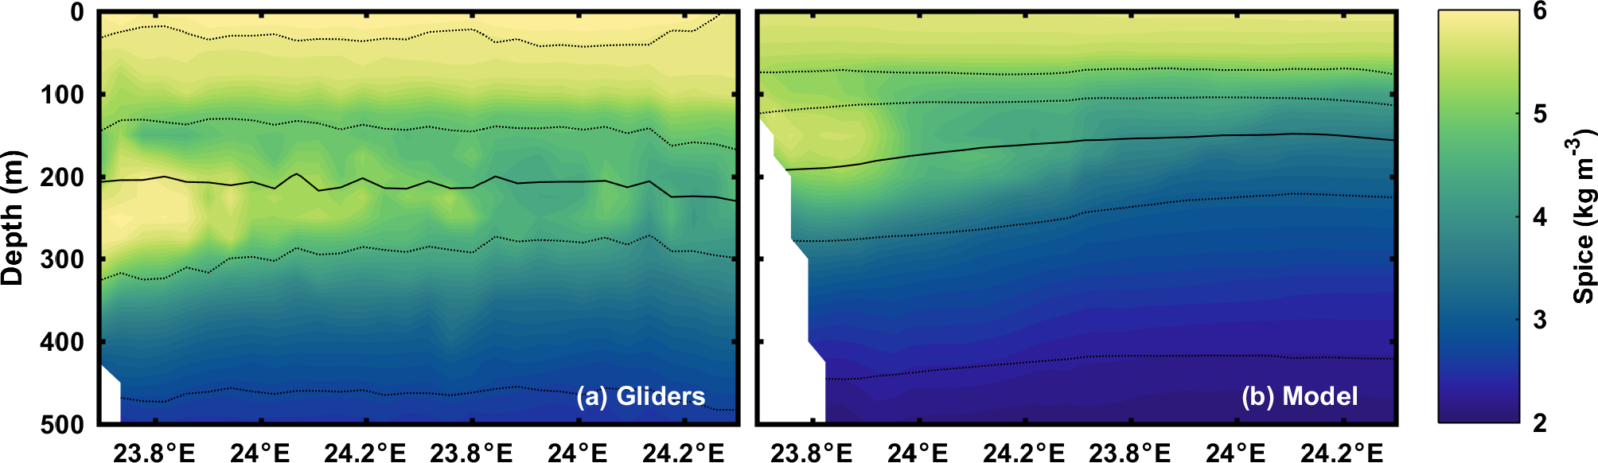
Figure 1: Example mean spice (kg m⁻³) sections from the month of March from (a) gliders and (b) model. Density contours at 0.5 kg m⁻³ intervals with the 26 σ_{θ} isopycnal as the solid line.

SM.3 Video animation of two years of model data
The animation provided as supplementary materials illustrates sea surface height (cm), relative vorticity (non-dimensionalized by f) at 200 m, and practical salinity at 200 m over two years of model data.

See attached file: Queste_et_al_Oman_SuppMat.mp4

References
Benson, B. B., & Krause Jr., D. (1984). The concentration and isotopic fractionation of oxygen dissolved in freshwater and seawater in equilibrium with the atmosphere. Limnology and Oceanography, 29, 620–632.
Dee, D. P., Uppala, S. M., Simmons, A. J., Berrisford, P., Poli, P., Kobayashi, S., … Vitart, F. (2011). The ERA-Interim reanalysis: configuration and performance of the data assimilation system. Quarterly Journal of the Royal Meteorological Society, 137(656), 553–597. https://doi.org/10.1002/qj.828
Frajka-Williams, E., Eriksen, C. C., Rhines, P. B., & Harcourt, R. R. (2011). Determining Vertical Water Velocities from Seaglider. Journal of Atmospheric and Oceanic Technology, 28(12), 1641–1656. https://doi.org/10.1175/2011JTECHO830.1
Garau, B., Ruiz, S., Zhang, W. G., Pascual, A., Heslop, E., Kerfoot, J., & Tintoré, J. (2011). Thermal Lag Correction on Slocum CTD Glider Data. Journal of Atmospheric and Oceanic Technology, 28(9), 1065–1071. https://doi.org/10.1175/JTECH-D-10-05030.1
Johns, W. E., Yao, F., Olson, D. B., Josey, S. A., Grist, J. P., & Smeed, D. A. (2003). Observations of seasonal exchange through the Straits of Hormuz and the inferred heat and freshwater budgets of the Persian Gulf. Journal of Geophysical Research C: Oceans, 108(12), 21–1. https://doi.org/10.1029/2003JC001881
Queste, B. Y. (2014). Hydrographic observations of oxygen and related physical variables in the North Sea and Western Ross Sea Polynya. University of East Anglia.
Risien, C. M., & Chelton, D. B. (2008). A Global Climatology of Surface Wind and Wind Stress Fields from Eight Years of QuikSCAT Scatterometer Data. Journal of Physical Oceanography, 38(11), 2379–2413. https://doi.org/10.1175/2008JPO3881.1
Shchepetkin, A. F., & McWilliams, J. C. (2005). The regional oceanic modeling system (ROMS): a split-explicit, free-surface, topography-following-coordinate oceanic model. Ocean Modelling, 9(4), 347–404. https://doi.org/10.1016/j.ocemod.2004.08.002
Thoppil, P. G., Hogan, P. J., Thoppil, P. G., & Hogan, P. J. (2009). On the Mechanisms of Episodic Salinity Outflow Events in the Strait of Hormuz. Journal of Physical Oceanography, 39(6), 1340–1360. https://doi.org/10.1175/2008JPO3941.1
Vic, C., Roullet, G., Carton, X., & Capet, X. (2014). Mesoscale dynamics in the Arabian Sea and a focus on the Great Whirl life cycle: A numerical investigation using ROMS. Journal of Geophysical Research C: Oceans, 119(9), 6422–6443. https://doi.org/10.1002/2014JC009857
Vic, C., Roullet, G., Capet, X., Carton, X., Molemaker, M. J., & Gula, J. (2015). Eddy-topography interactions and the fate of the Persian Gulf Outflow. Journal of Geophysical Research: Oceans, 120(10), 6700–6717. https://doi.org/10.1002/2015JC011033
Worley, S. J., Woodruff, S. D., Reynolds, R. W., Lubker, S. J., & Lott, N. (2005). ICOADS release 2.1 data and products. International Journal of Climatology, 25(7), 823–842. https://doi.org/10.1002/joc.1166

